Kotak Issues on TRS
1. Introduction:
Tetherfi WFH empowers your agent and supervisors to work from remote location ensuring highest compliance monitoring Standards. Tetherfi Remote Security provides
*Agent Console: browser based; no installation required.
*Employee Collaboration: improves collaboration with agents and supervisors with inbuilt chat.
*Gesture Recognition: emotion detection is used for agent well- being.
*Supervisor Console: monitor Agent state.
Product Explanation:
TRS was created for customer experience with highest monitoring standards. It uses web cam to monitor the agent.
2. ISSUES ON TRS:
- The login authentication window freezes frequently and gets rectified on its own which is making it hard for the customer to login.
- The logged in user gets locked from using the screen for some minutes.
- The supervisor could not peep into the violations created by the agent, despite having the master OTP.
- When gadget is brought in front of the camera, instead of showing Gadget Detected it shows Multifaced error!
- When agents move their face slightly, the screen gets blocked!
- Liveness error despite of face recognition.
- The agent camera gets blocked after a long break which makes them unable to resume work immediately, makes them wait for some time.
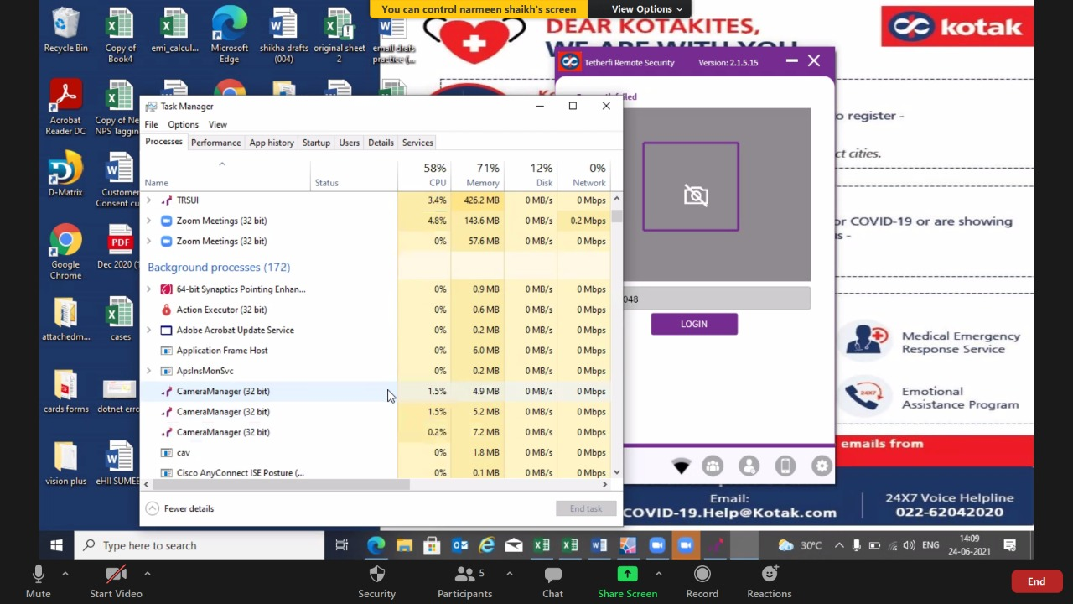

- The face authentication failure for mass Agent on 29-09-2021.No one was unable to access the TRSUI despite good background and proper credentials. The container with Face auth cache images got full capacity which led to this issue at server level.
- Priyanka face found takes longer than expected, longer than 25min. supposed to be a fix with camera manager. Issue might be there even in the next release on July 7th.
(“Issue might be in her system or camera manager need to find out”)

3. New Scenario:
- There was a different scenario, where in the customer violations could not be seen on call despite of camera manager, where in we asked the customer to show the violations. the violations could be seen by the user agent, but it was not reported to the supervisor or the backend. During the blocked screen we could see her wave her hand, it should not happen as the screen is blocked.
- Only way for her to get access was to use master OTP. As she could not chat via TRS which did not go to the supervisor.

4. Troubleshooting:
1. login failure you need to check if the login credentials are correct if yes once clear offlineVioaltion Cache to see if it helps.
2. For liveness error that occurred today we checked the logs and restarted the TRSUI, the problem was rectified.
6. The issue was rectified by making Agents move to a different position without variable light reflection and a proper background, the issue was resolved most of the time.
7. The issue was resolved by changes in pipeline.json {preferExternalCameraWhenAvailable":
"captureBothCamerasWhenAvailable"} these instances where true which made the camera manager pop up three times in the background disabling the ability for the TRSUI to use camera.
The fix was to changes these instances to false as shown below:
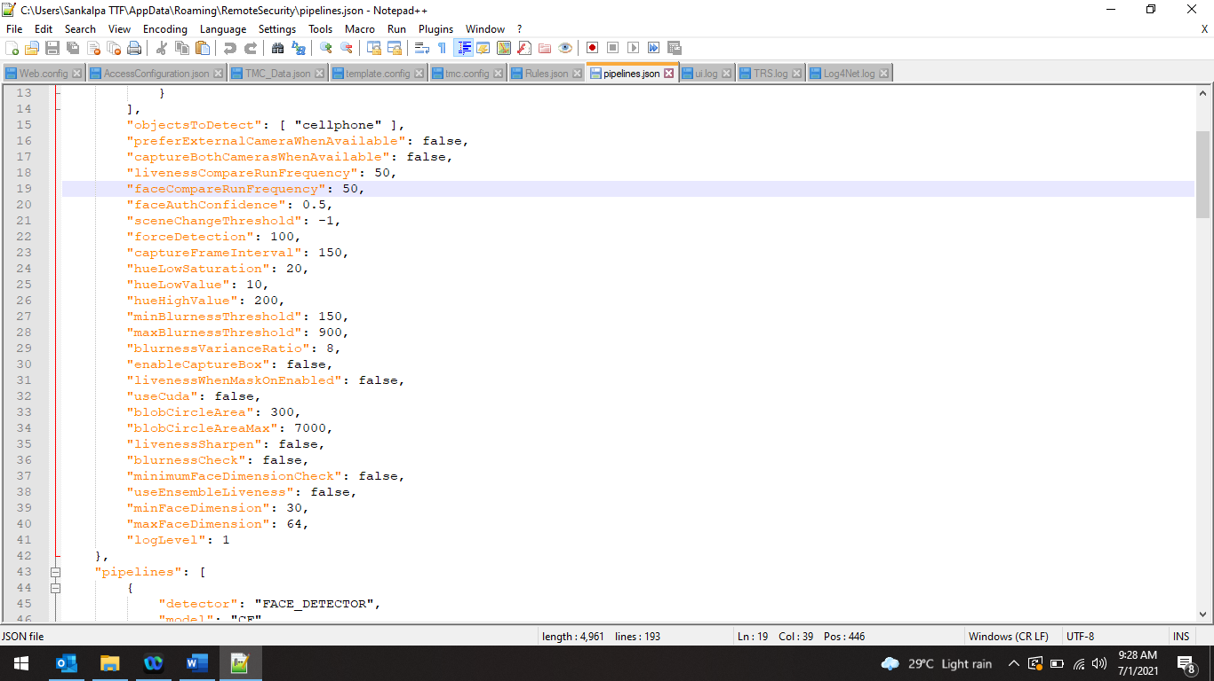
9. For Priyanka the current fix was to kill the camera manager so that the face found would appear as expected in a normal build. full fix to be expected on (7th July 2021)
10. TRS stuck at bootstrapping or validation.
Sol: kill pipeline.json and relaunch the app again.

11. face not found / face found, you can login now appears late.
Check for the photo updated and adjust the agent, accordingly, check for proper background no partition, switchboard etc. should not be there.
12. improper installation might lead to continuous pop up of TRS without showing the UI.
This could be due to schannel error, where the AV might stop some .dll files from installing, so better to disable AV and launch once again.
13. Ldap issue, people cannot login to IAM page but can through OCM with same credentials.
Need to reset password from Ldap team which worked later.
14.Issue Regarding Camerablock Detected and No face Found Answered

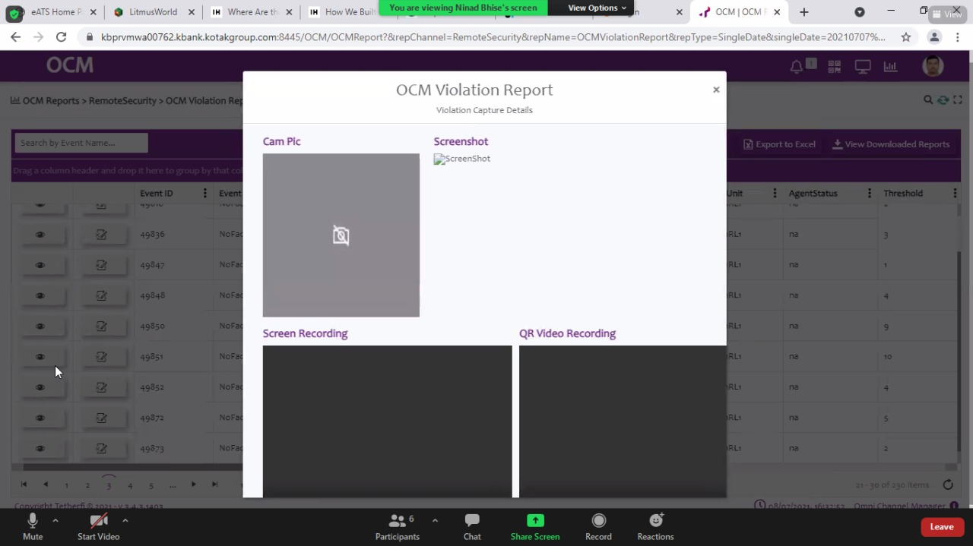

The cam pic here for no face found happens when she moves out of the window or tries to obstruct camera in anyways. This cam pic is because of privacy filter of Lenovo, as it is done through system level pushing there will be conflict between TRS integrated camera and Lenovo system camera.
Lenovo Privacy Filters help keep sensitive information like login credentials, company financial records and other essentials credibility with optimum safety.

2nd screenshot
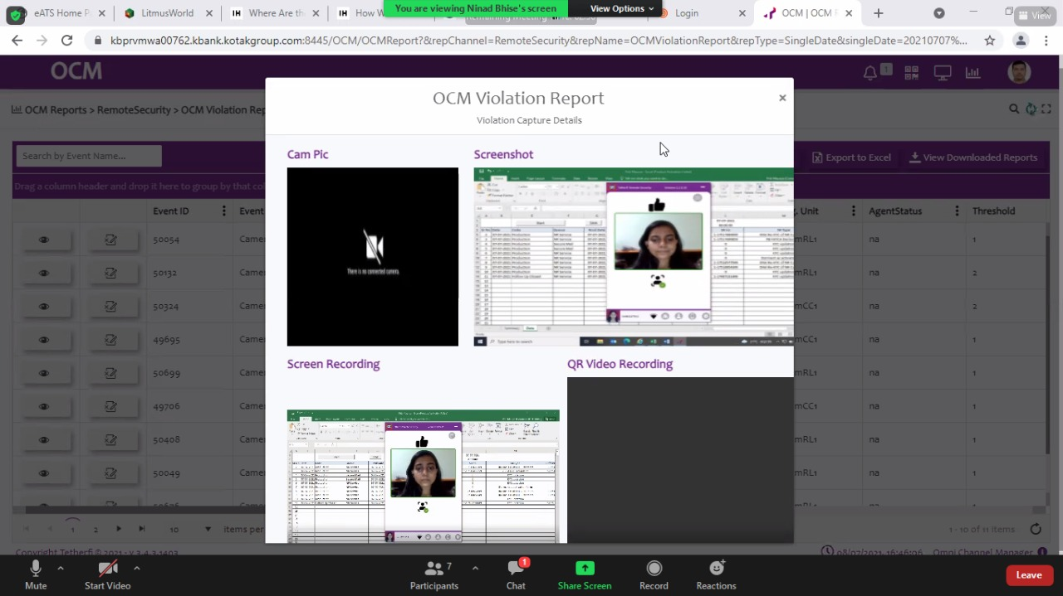

Issues:
- Why is her photo captured instead of the violation done?
- The cam pic seems to be standardized one.
The screen capture happens once every 200ms, the screenshot is just before the violation, if it has to be an accurate capture on demand it is quite difficult as we have to wait for a few frames to pass after the violations are done.

The pic is configurable as you can set desirable path in app.json
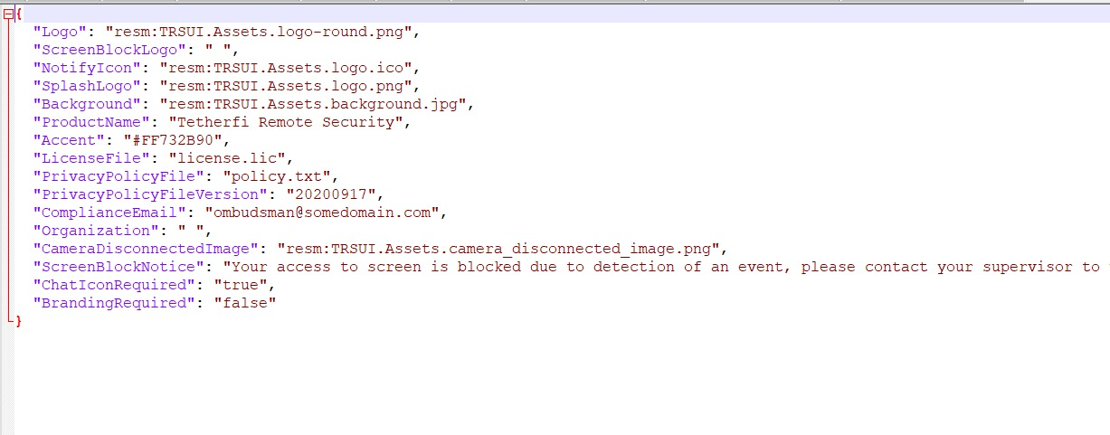

15. face found issue for initial login.
My system:
Face found come as soon as I open UI.
Scenario:
Check C:\Users\Sankalpa TTF\AppData\Local\Temp\opencv\4.5\opencl_cache\Intel_R__Corporation--Intel_R__UHD_Graphics--27_20_100_9749
Everything is already loaded.
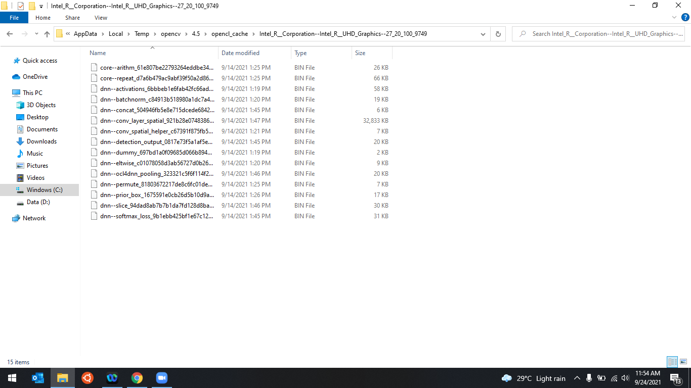

But for some Kotak system face found is taking 1 hr Example: C:\Users\KMBL138939\AppData\Local\Temp\opencv\4.5\opencl_cache\Intel_R__Corporation--Intel_R__UHD_Graphics--27_20_100_8336

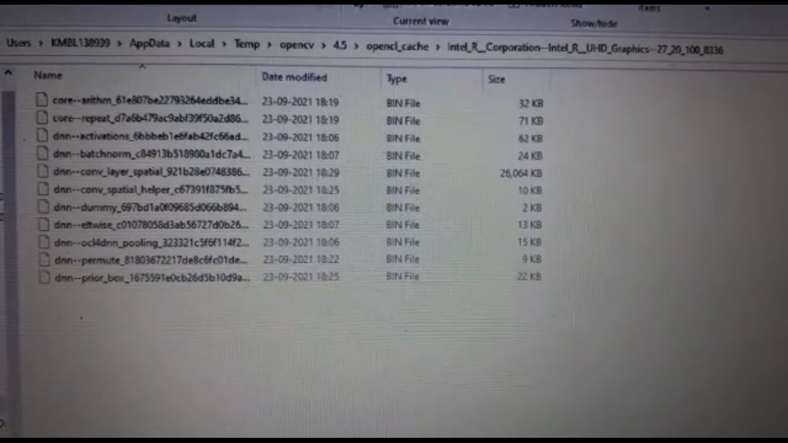
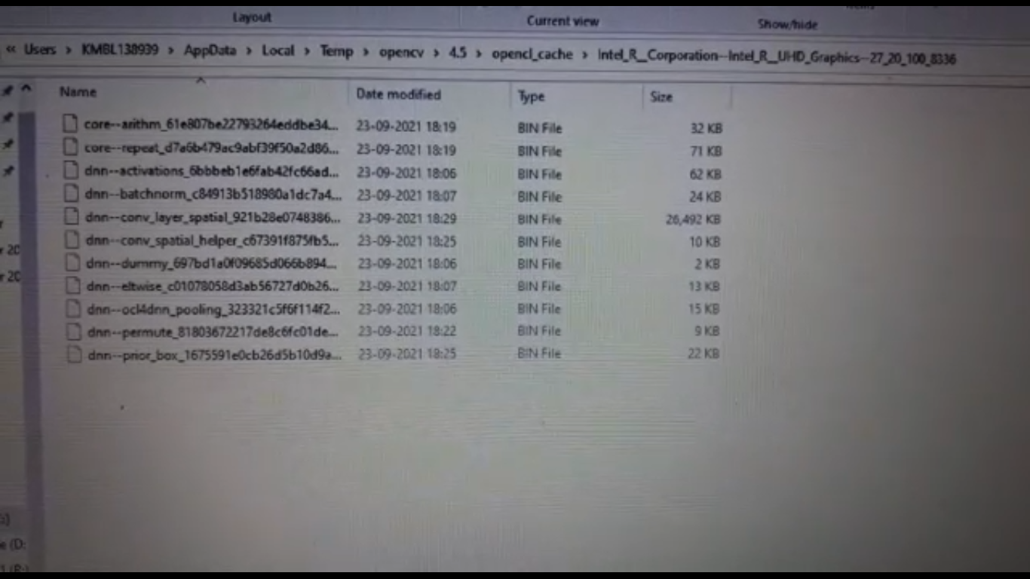

Screenshots of it loading slowly.
Fix:
- Wait until face found appears on its own.
- Set environment variable OPENCV_OPENCL_CACHE_DIR and value C:\Users\Sankalpa TTF\AppData\Roaming\RemoteSecurity\opencl , this worked for all agents .
- Copy loaded files from Temp and paste here , since u pasted loaded files from next time instead of searching files from temp it will search from here C:\Users\Sankalpa TTF\AppData\Roaming\RemoteSecurity\opencl
- The path of your home directory might be changing
Temporary fix, complete fix must be in 2.1.6.1601.
This happens if your system graphic card is not updated. Make sure the Driver in the system is upto
date.
16. Supervisor unable to login and Agent showing logged in even though she is on leave.
For supervisor login Empty cache and hard reload on the module.
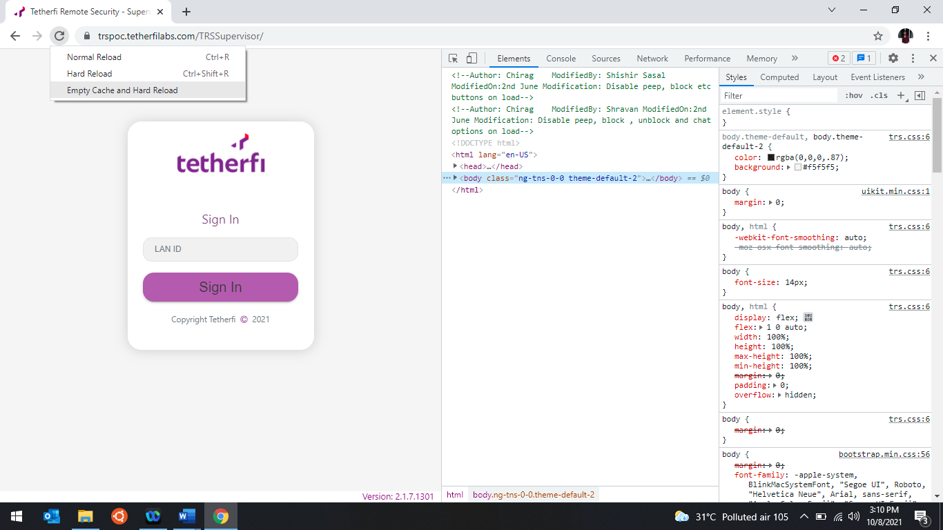

For the below pic of agent Nikita, clearing cache didn’t work so need to clear Redis cache in server.
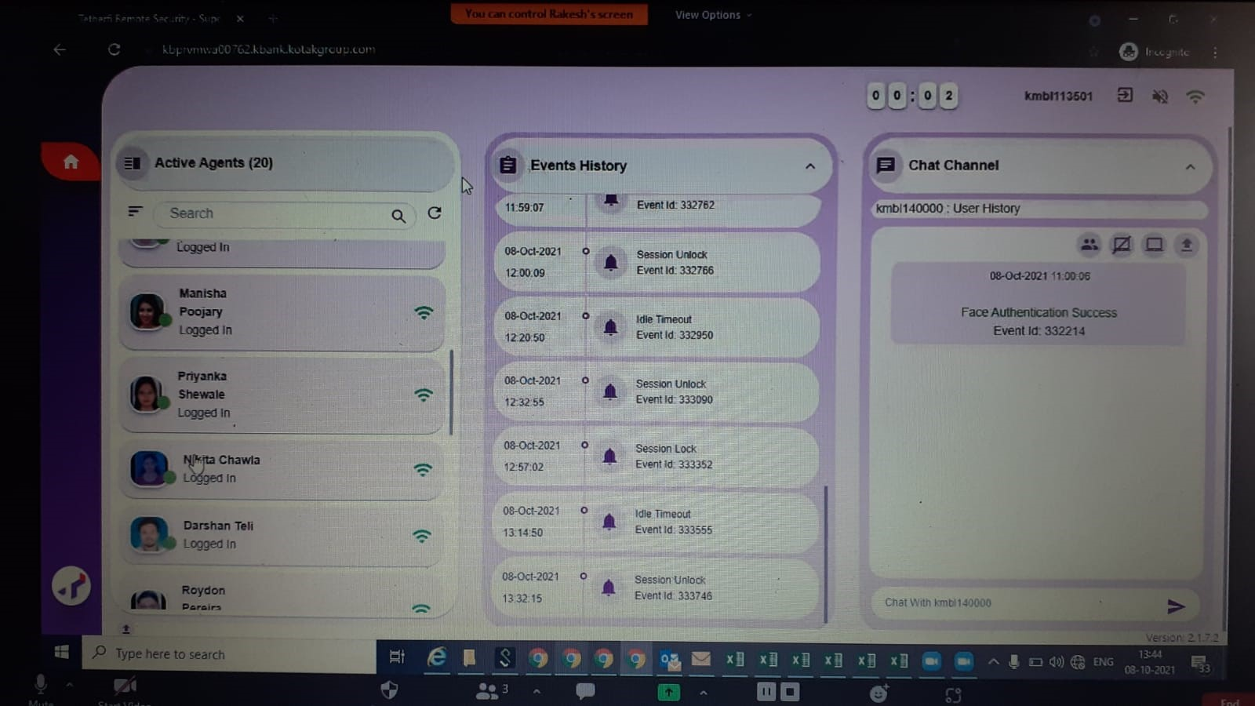

17. camera unplugged
Stop window camera frame server.
18. continuous notifications popping up saying face auth failed, login failed, screen gets blocked.
I3, 10th gen has the issue of delayed notifications.
this event is not particularly related to TRS application or internet speed/network. it depends upon how efficiently system processor can handle these windows notifications. i3 processors are known to have poor efficiency while popping up these windows notifications (these events should come up faster in the notification tray though)
19. Trs not popping up, not running in background services are running, manual intervention not working. Agents able to work on google which shouldn’t be the case unless TRS is running or one has successfully logged in.

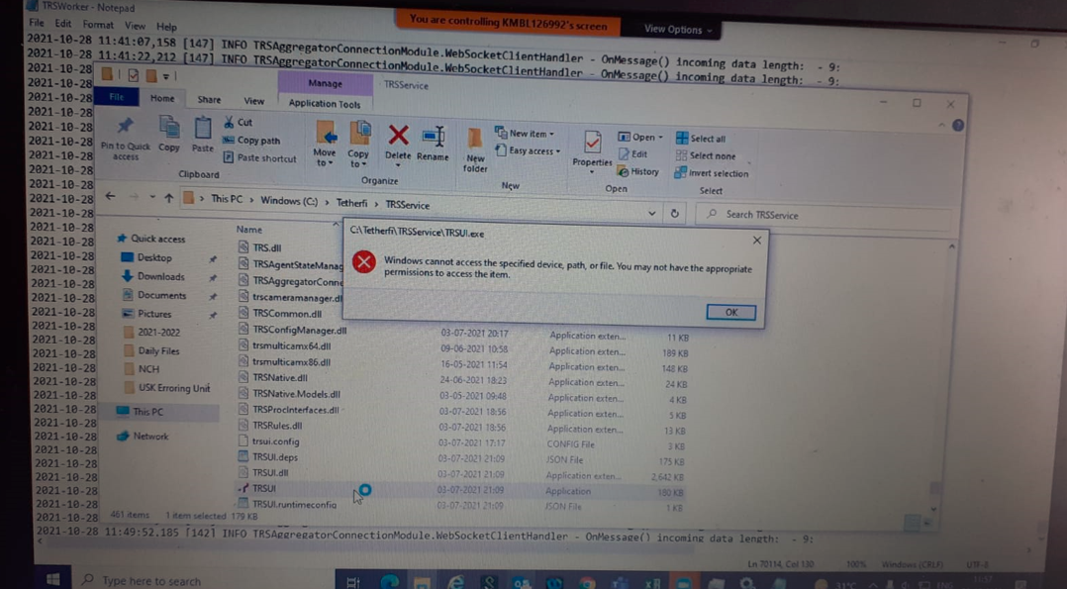

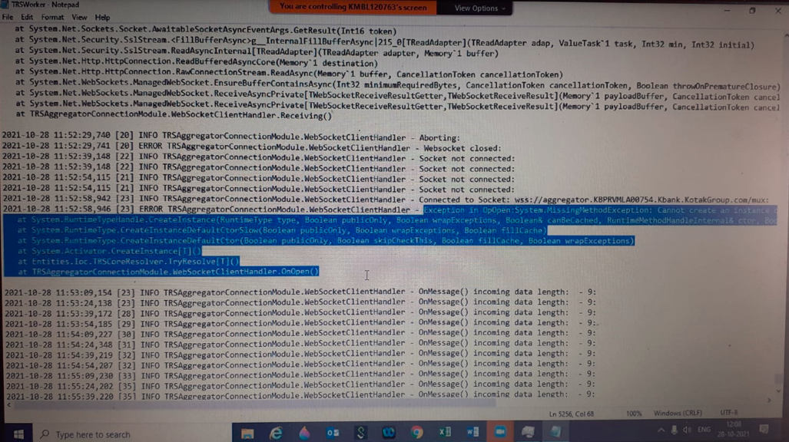

This is due to something blocking from trend micro (AV) , this can only be solved by Sccm team by allowing the right permission and updating trend micro after sometime.
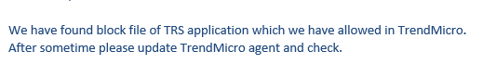
20.Display IST instead of UTC in Unique user connect report.
Sol: custom Report -> Edit 200 rows. Add the Query as shown below.
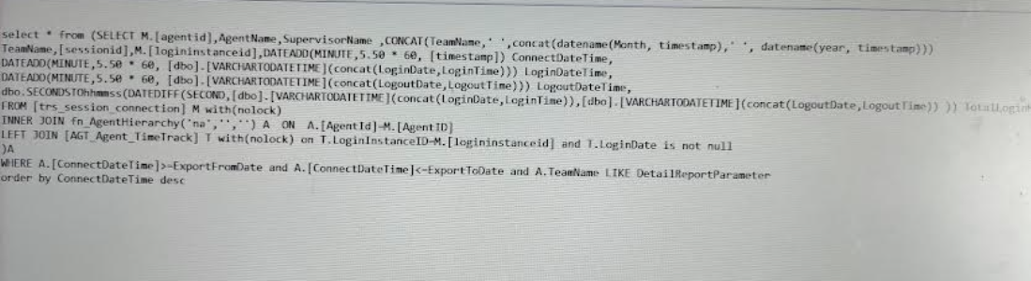

21. If it shows face auth in progress for MSI 2.1.10.19 after face found you can login.
Sol: Delete files from %temp%
The count usually will be under 10k if you see more than that delete as many files as possible until face auth succeeds. Deleting 10k files would be sufficient for that moment but its better to delete the rest.
22. face not visible after login around 30 min later.
Sol: camera is being used by zoom or skype, uninstall, later install by choosing TRS Multicamera.
23.Supervisor not showing ant details in event history.
Sol: hdel “urn:tmc_agg:trs:sessions/hashset” urn:tmc_agg:session:kmbl_ID
24.in supervisor agents are showing logged out.
Soln: hdel “urn:tmc_agg:trs:sessions/hashset” urn:tmc_agg:session:kmbl_ID.
25.screenblock is not happening even thou agents are in ICC_agents rule.
Soln: keys *role
- hkeys “urn:tmc_agg:rules:role”
- ICC_Agents
- hdel “ICC_Agents” ICC_Agents
- hdel “urn:tmc_agg:rules:role” “ICC_Agents”
26. for 2 agents its not giving any event history.
Sol: internet explorer-> ALT +X-> internet options-> connection->Lan Settings it should be blank

