Unable to find TRSUI to login

There are 4 reasons to know why TRSUI is not launching
- Make sure the installation is done properly, check C:\Tetherfi\TRSService to see if the application is present if its not it would look like the screenshot below.
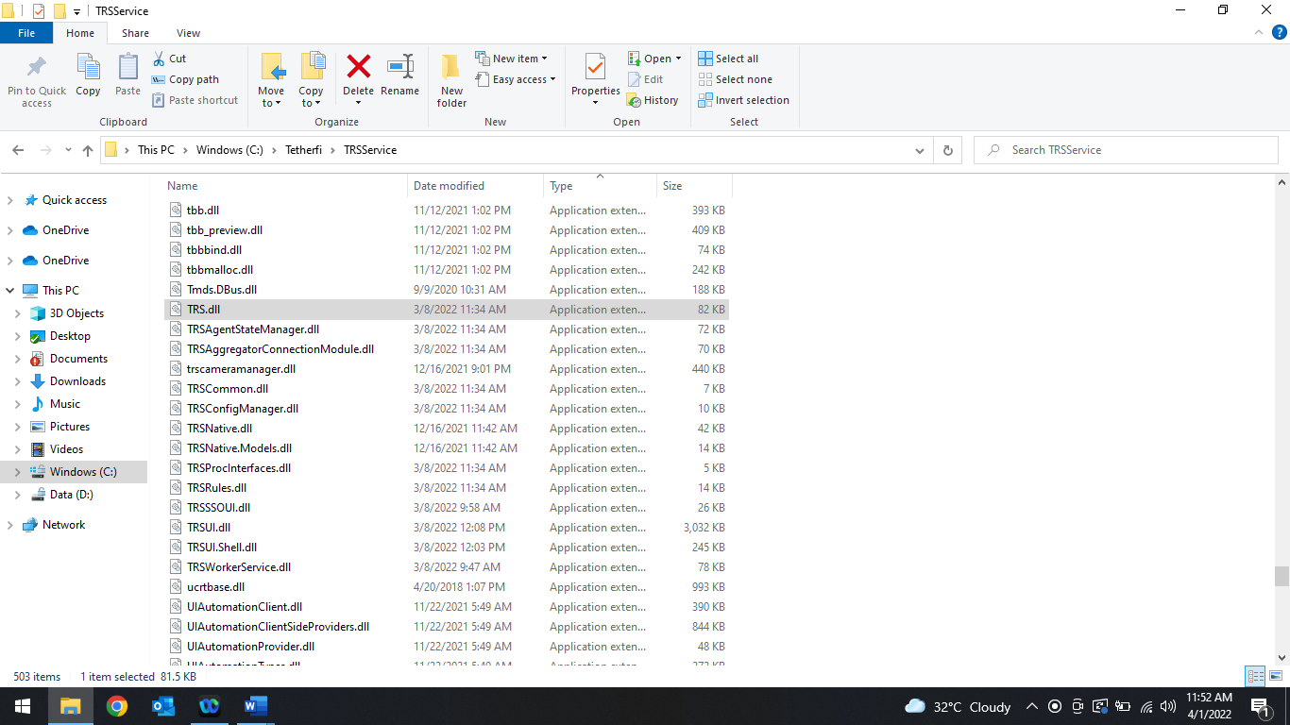

- Make sure there is no restriction set from the TM team on the path C:\Tetherfi\TRSService.
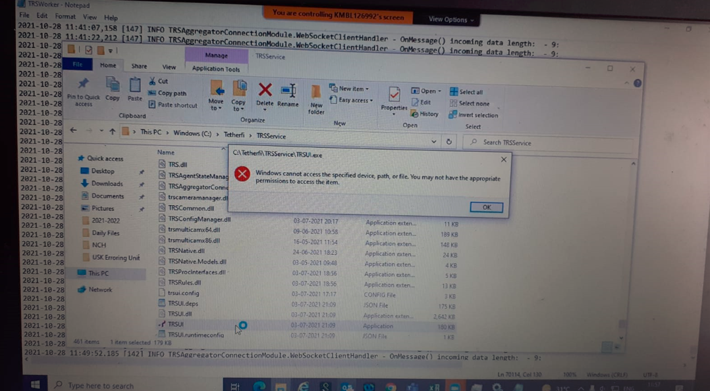

- Check for TRSWorkerService to see if its running in the services or not. Start if Stopped.
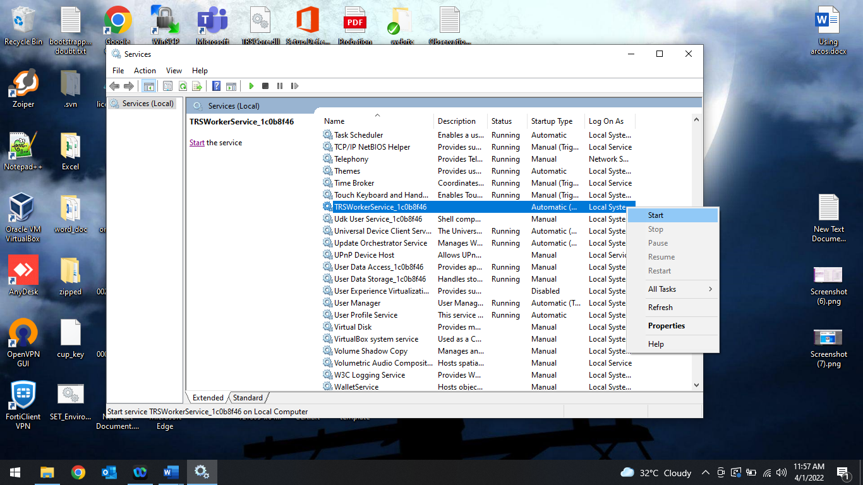
- Check the agent Pulse secure is connected. Only when the BCP is connected TRS will launch itself.
