- This is what I have received and in the report.
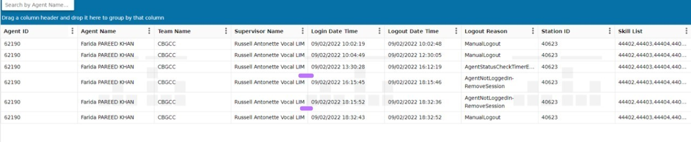
- The corresponding table
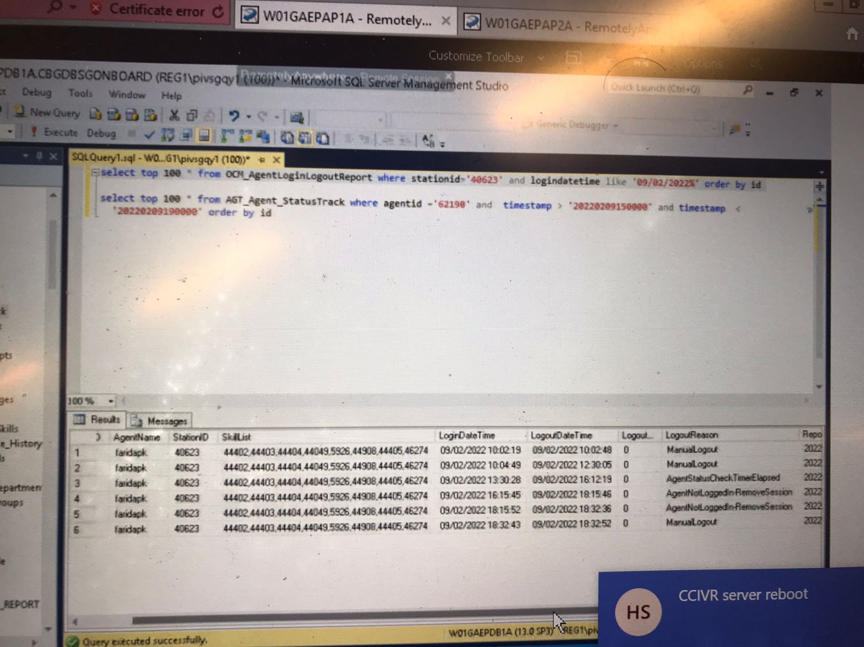
- I can see the login happen at 16:15:40 but in table the login time shows 16:15:45. Some issue maybe.
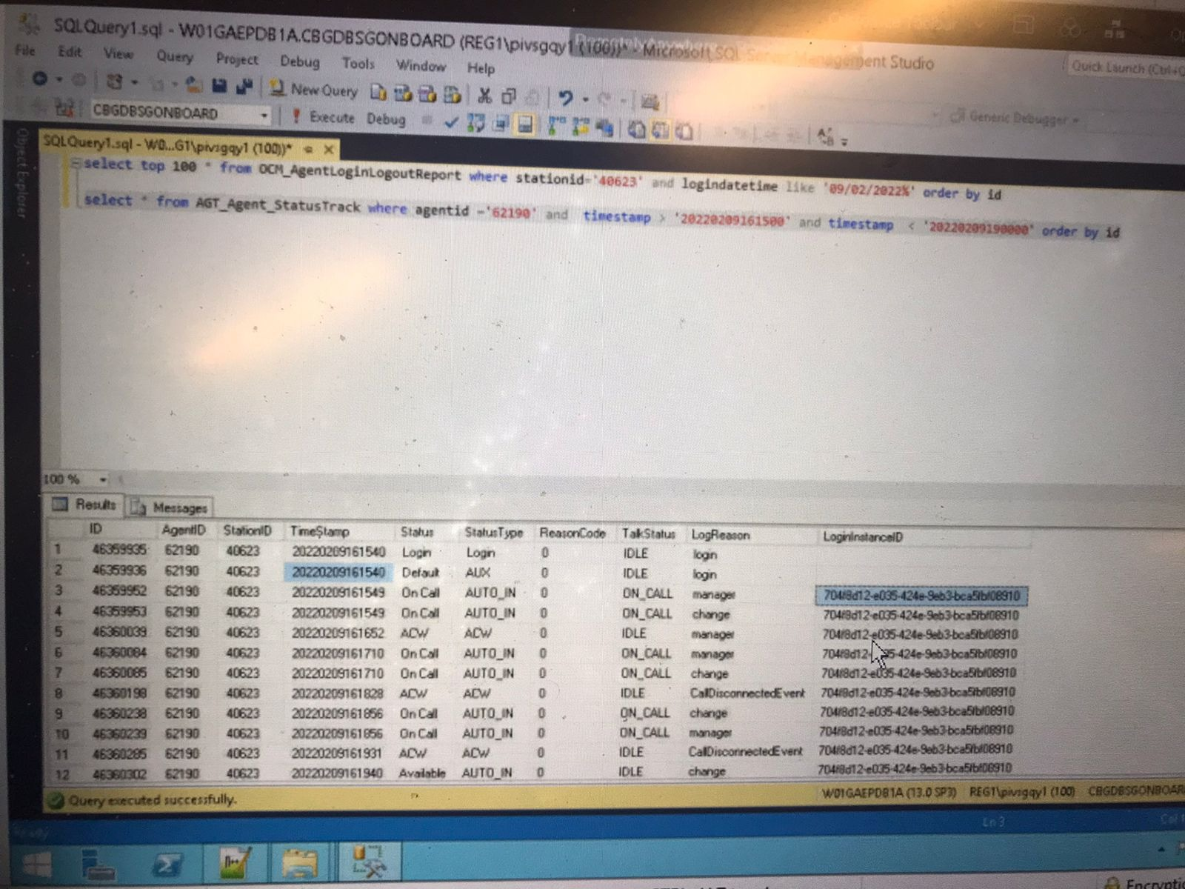
- This is one interaction where it remained open for a long time. Agent could not close this. Close tab fail.
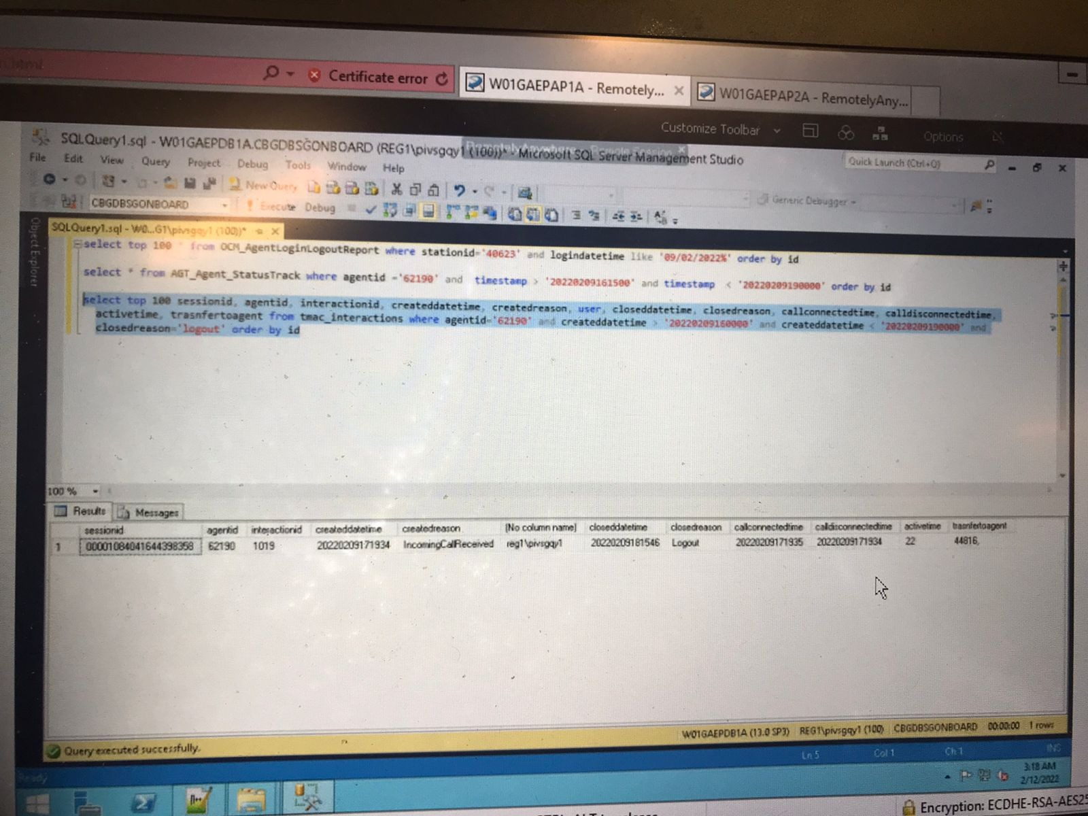
- He tries to close. But it fails. Error -100 is check call status before close tab. I think it was still on call or something
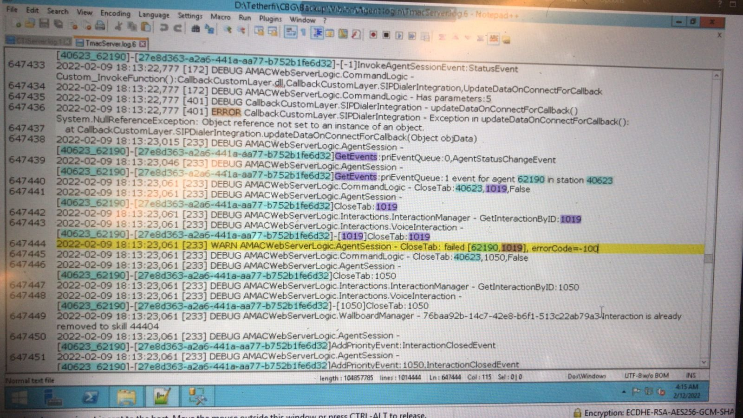
- 1019 got connected successfully
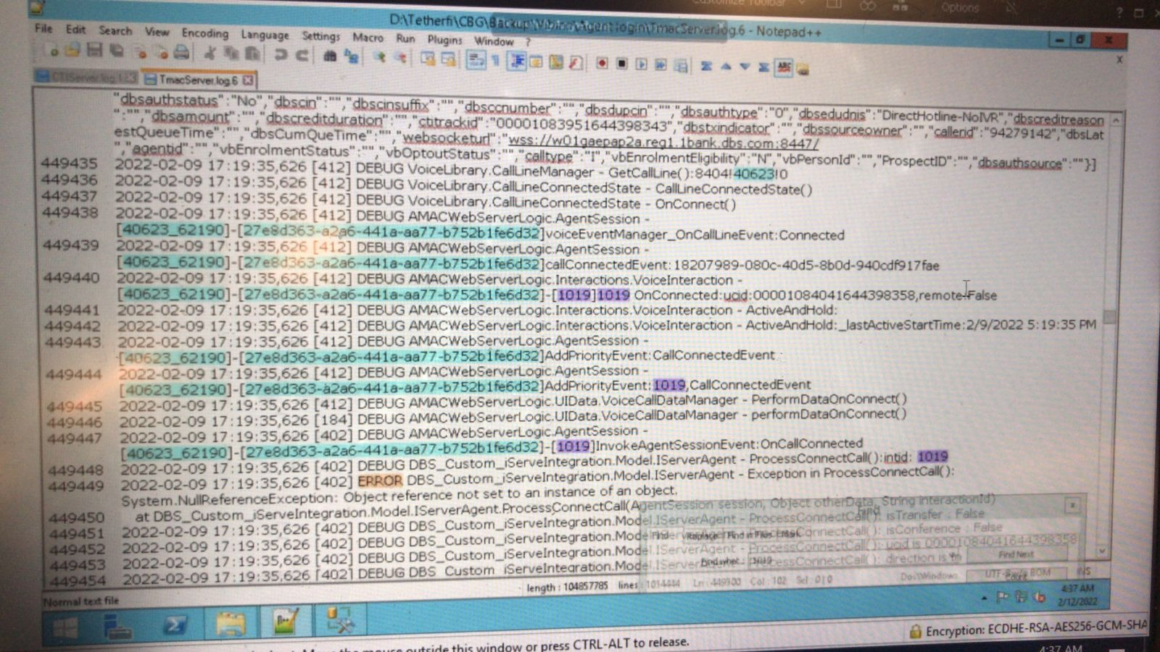

- Transfer initiated
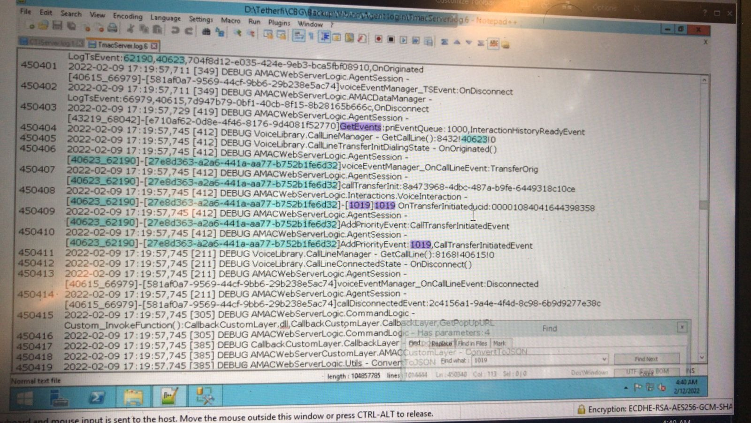
- Later cancelled transfer. But I can see it shows transfer completed. But also call disconnected.
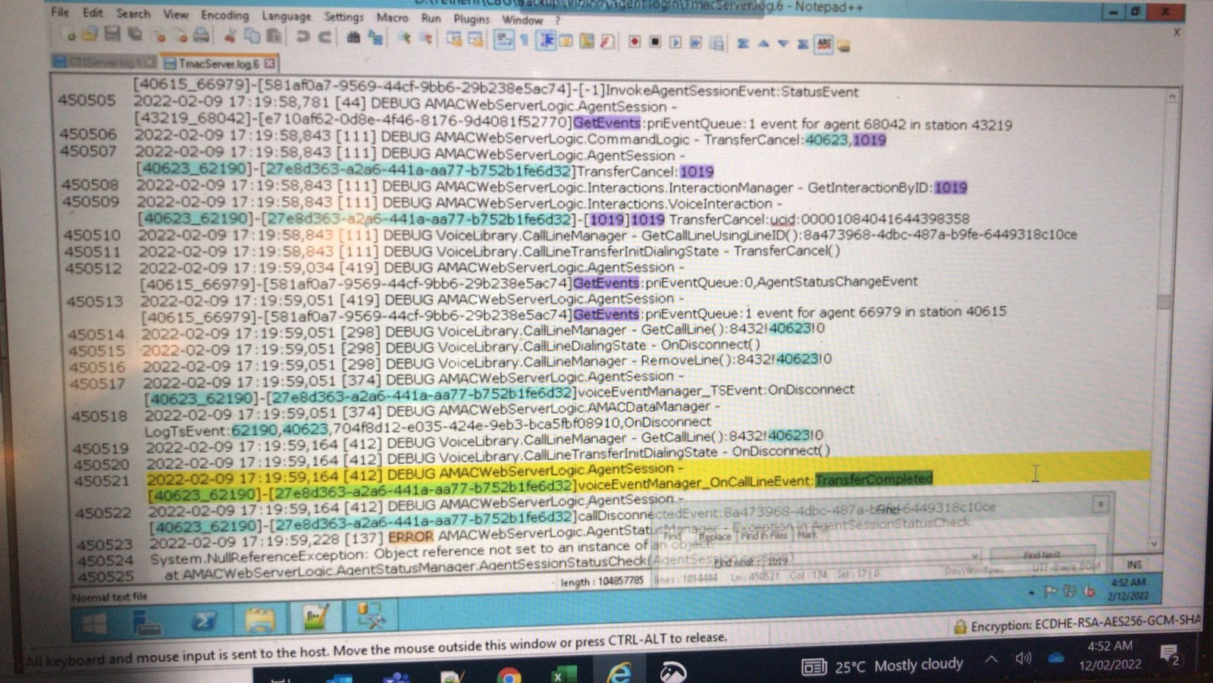
- This is main line disconnected
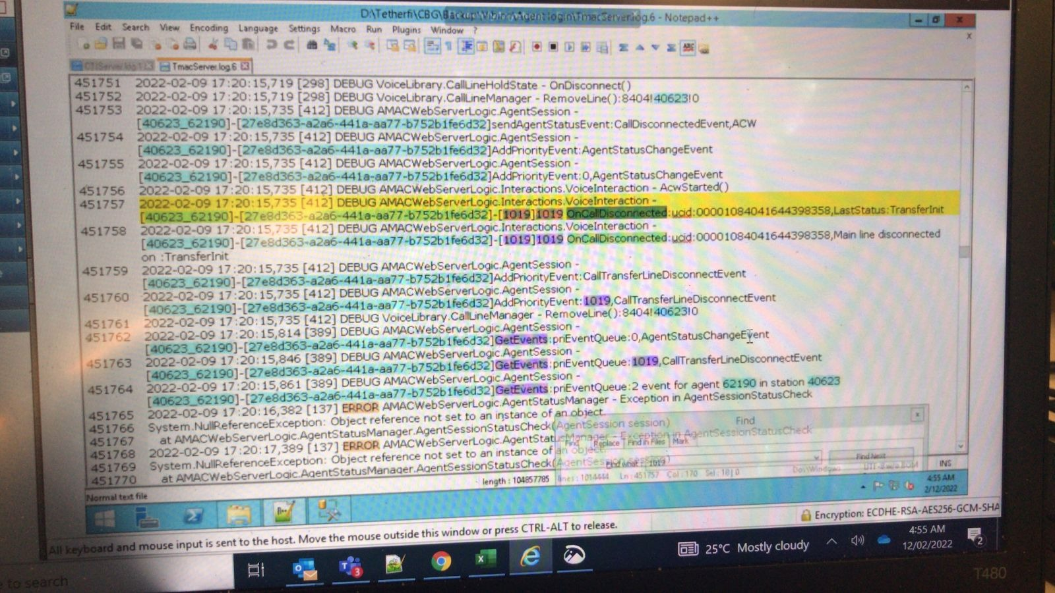
- 1019 could not be closed by agent. -100 means interaction not disconnected.
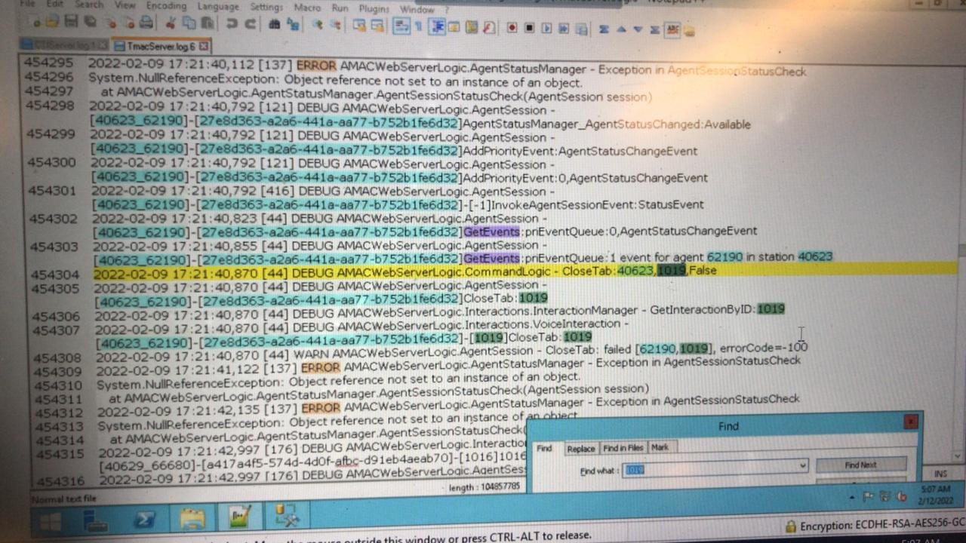
- The agent who it was transferred could close this interaction
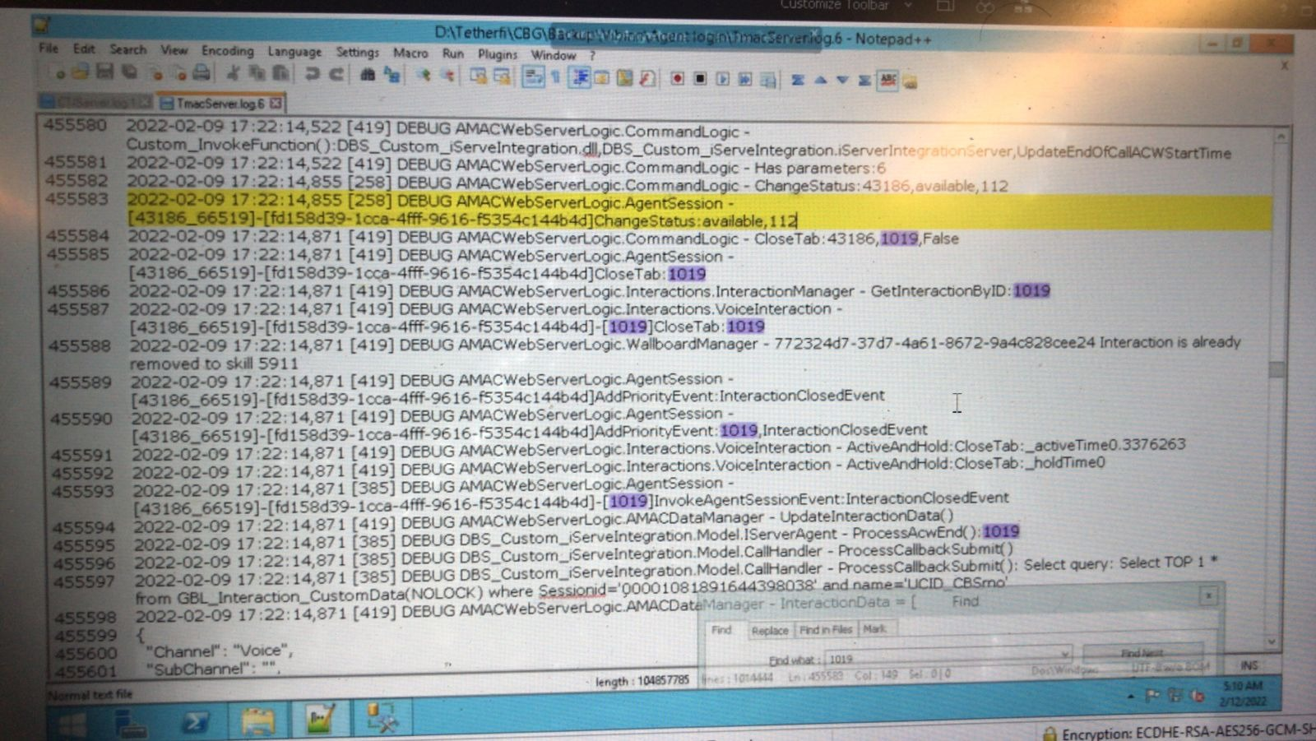
- I can see many occurrences where the agent is trying to close the tab. But it fails. Meaning status change.
- So, when the next call comes into this agent, auto answer fails because of this. See below highlighted line. 1019 interaction for this agent is still shows not disconnected. Add a result auto answer fails. This is first call.
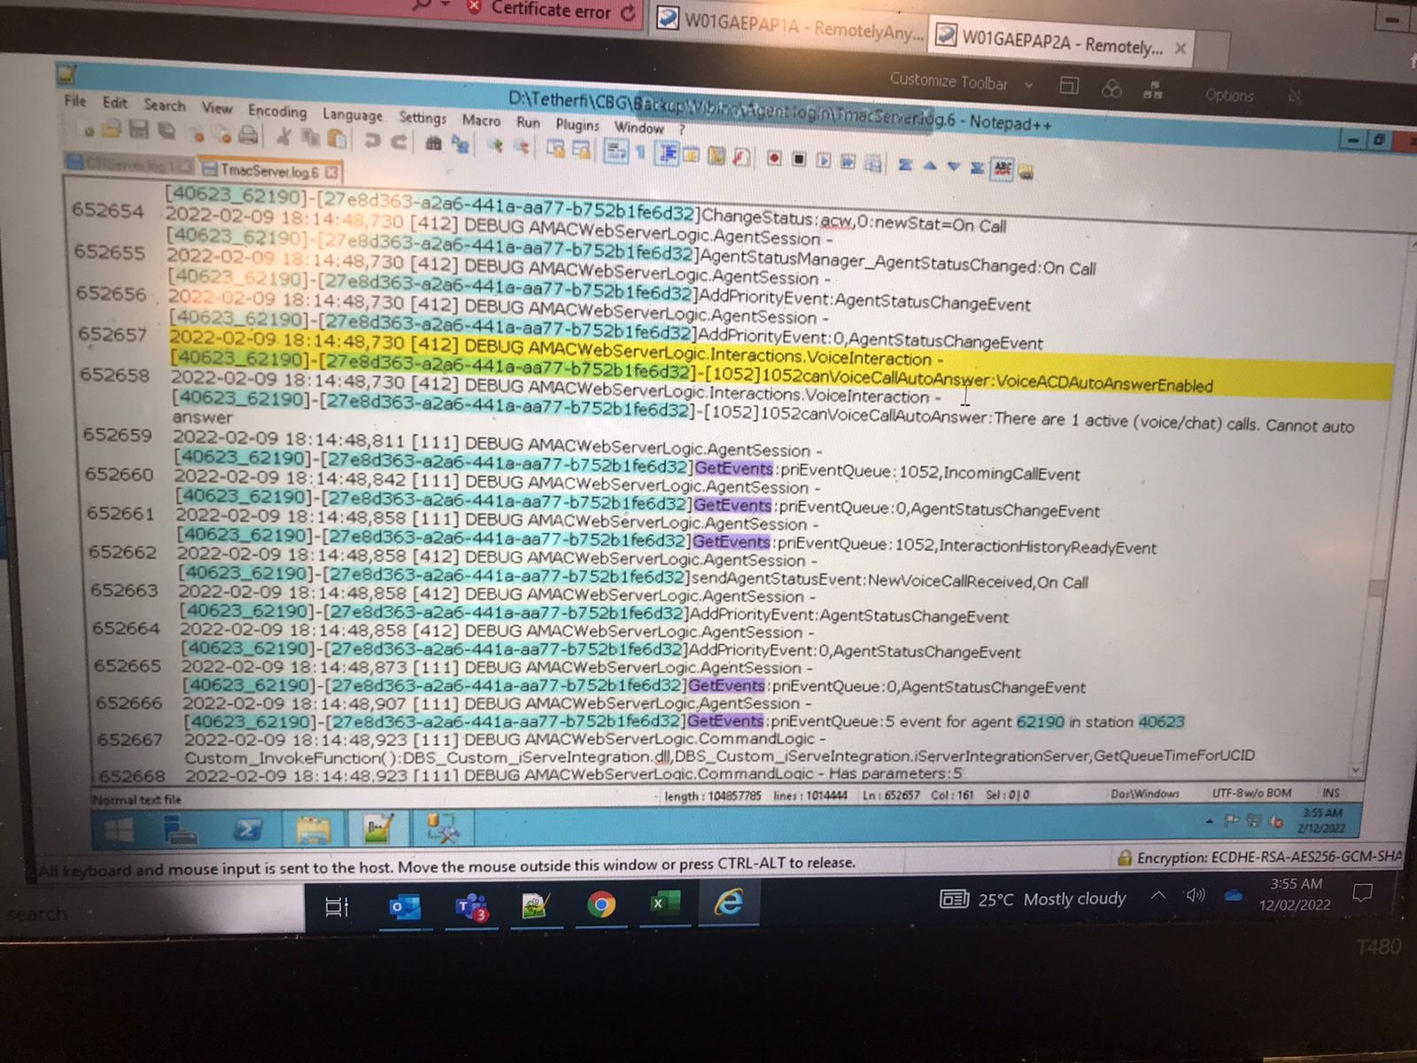
- 1019 interaction status is not proper in TMAC server. Basically according to server it's not disconnected. So it will not auto answer. But agent can manually answer. We can see in logs. From 1020- 1052 interactions id, there are all logs of cannot auto answer. Many are actually picked. I found the calls which are not answered. The agent is received them. But he's not picking all of them manually.
- 1020 is the first call after 1019. Thisis not getting auto answered. But the agent can pick manually. But he isn't.
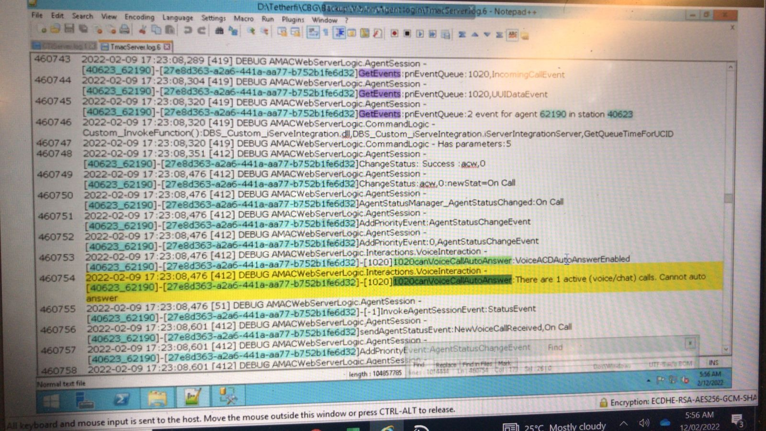
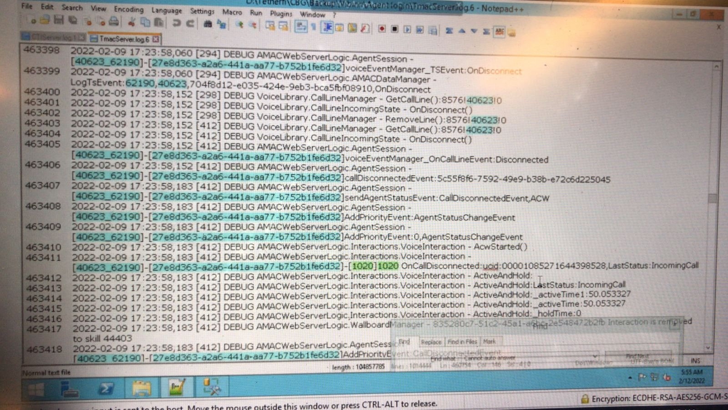
- It's getting disconnected in 50 seconds. There are around 19 calls in total for this agent which didn't get auto answered
