IW Dashboards
Application User Guide
Document Version: 2.0.9.29
Last Updated Date: 2021 September 29

User Guide – Tetherfi Dashboards

Version History
Version  # | Implemented  By | Revision  Date | Approved  By | Approval  Date | Description of  Change
1.0.10.15 | Shriraksha B Rai |  |  | 16/10/2019 | Initial version of dashboard user guide
1.0.11.21 | Shriraksha B Rai |  |  | 21/11/2019 | Historical KPI Dashboard:  Configuring maximum 15 top menus, Modules and Transfer VDN  Apple style naming convention  Date range option is provided for data analysis  "Transfer intent" multi line graph is provided  Session Dashboard:  "First" and "Last" button is added  "Go to page" option is provided  Repeat Call Count is added  "Contact" column is provided in the grid
1.0.12.02 | Shriraksha B Rai |  |  | 2/12/2019 | Realtime Voice Stat Dashboard
1.1.01.28 | Shriraksha B Rai |  |  | 17/02/2020 | New UI for Realtime Voice Stat Dashboard  Interpreter dropdown option is provided  Data
1.1.03.26 | Shriraksha B Rai |  |  | 26/3/2020 | Brand logo is added  Unique colour combination is maintained to differentiate the data received from Interpreter, CM and TRealTime Service
1.1.04.07 | Shriraksha B Rai |  |  | 07/04/2020 | KPI dashboard callflow list display option is changed as that of Voice stat dashboard
1.1.05.15 | Shriraksha B Rai |  |  | 15/5/2020 | Group level color coding  More filter options are provided
1.1.05.28 | Shriraksha B Rai |  |  | 28/5/2020 | Heat map option is provided in menu, module and Transfer Intent graph
2.0.10.06 | Shriraksha B Rai |  |  | 06/10/2020 | Repeat Caller Dashboard  Real time Interaction Stat Dashboard
2.0.9.29 | Deepthi Shetty |  |  | 29/09/2021 | Implemented Utterances

Copyright
All rights reserved. No part of this product may be reproduced, transmitted, transcribed, stored in a retrieval system, or translated into any language in any form by any means without the express written permission of Tetherfi.

Warranty Information
Tetherfi makes no representations or warranties with respect to the contents or use of this product and specifically disclaims any express or implied warranties of merchantability or fitness for any purpose. Information in this document is subject to change without notice and does not represent a commitment on the part of Tetherfi.

Trademark Information
Tetherfi is a registered trademark of Tetherfi. Other product names may be trademarks or registered trademarks of their respective companies.

Contact Information
For customer inquiries, contact: For technical support inquiries, call:
support@tetherfi.com
Tetherfi +65 6715 7408
60 Paya Lebar Road,
#06-01 Paya Lebar Square,
Singapore

Contents
1 Introduction 6
1.1 Intended Audience 6
1.2 Scope of document 6
1.3 Glossary 6
2 Session Dashboard 7
2.1 Grid Section 9
2.2 Search Filter 10
2.3 Node Section 13
2.4 Customer Journey 14
3 Repeat Caller Dashboard 16
4 KPI Dashboard 19
4.1 Hourly Volume 20
4.2 Utterances 22
4.3 Language 23
4.4 Authentication 26
4.5 Top 5 Menu, Module and Intent 29
4.5.1 Top 5 Menus 29
4.5.2 Top 5 Modules 32
4.5.3 Top 5 Transfer Intent 35
4.6 Word Cloud 39
4.7 Interactions on the Day selected 41
4.8 Interactions on the Date-range selected 44
4.9 Analysis on the Date-range selected(Historical) 44
4.9.1 Interactions 46
4.9.2 Self Service 49
4.9.3 Avg.Time 51
4.9.4 Agent Transfer 53
4.9.5 Hourly Volume 55
4.9.6 Transfer Intent 57
5 Real Time CC Dashboard 60
5.1 CC Level Grid Details 64
5.1.1 CC Level Grid Technical Information 65
5.2 Group Level Grid Details 67
5.2.1 Group Level Grid Technical Information 69
6 Real Time Interaction Stat Dashboard 71
6. Technical Information 73

1 Introduction
Tetherfi Dashboard application gives complete information of current as well as historical session to the users. It also gives the option to the users to analyse the data based on date range selected.

Intended Audience
This user guide document is intended for the following audience:
- Business Users
- IT team
- Project Manager
- Application implementation team
- Application maintenance team

Scope of document
This is a systematically written guide for users to use ‘Tetherfi IW Dashboards’. By accessing and managing the Tetherfi Dashboard application, users will be able to see current as well as historical session information.
Web based GUI application will be provided for accessing the Dashboard application.

Glossary
Term or Acronym | Definition or Description
KPI | Key Performance Indicator
VDN | Vector Directory Number
DNIS | Dialled Number Identification Service
IIS | Internet Information Services
UI | User Interface
GUI | Graphical User Interface
IVR | Interactive Voice Response
CC | Call Center

Sl.No | Dashboard | Data Displayed
1 | Session Dashboard | - 24 hours Session information is displayed here  - Customer journey and option entered/ selected by Customer in Each node  - Total count of the nodes hit  - Repeat caller count
2 | Repeat Caller Dashboard | - Customer of the customer in last 24 hours, if he is a repeat caller
3 | KPI Dashboard | - Callflow and Hotline based Hourly Volume, Language and Authentication Count, Top 5 Menu, Module and Intent transfer for current as well as Historical data  - Callflow and Hotline based Analysis graph displaying the Interaction, Average Time, Self Service, Agent Transfer for the historical data
4 | Real Time CC Dashboard | - Real Time data in Call center level as well as group level
5 | Real Time Interaction Stat | - Realtime data along with Active and Agent transfer node count

Session Dashboard
Session dashboard displays the real time session information which lasts for 24 hours. It also displays the total count of the nodes hit on the right panel along with Customer journey and option entered/ selected by Customer in Each node.
It also redirects to repeat caller dashboard, if a customer call more than once.
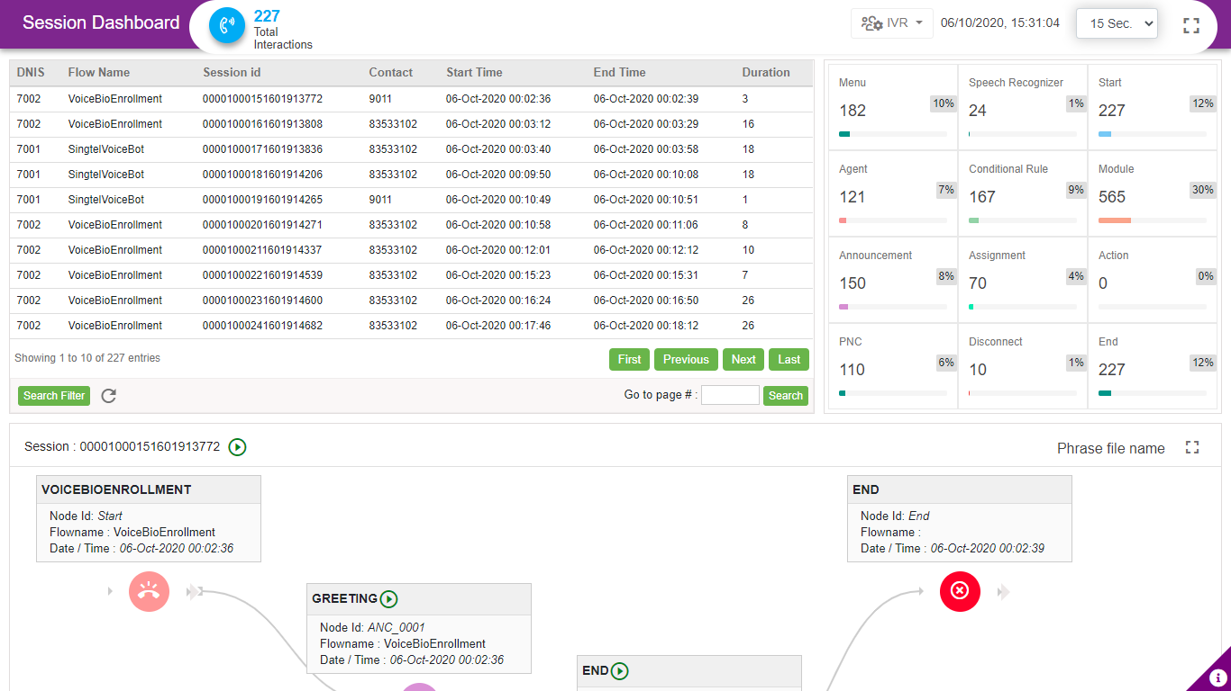

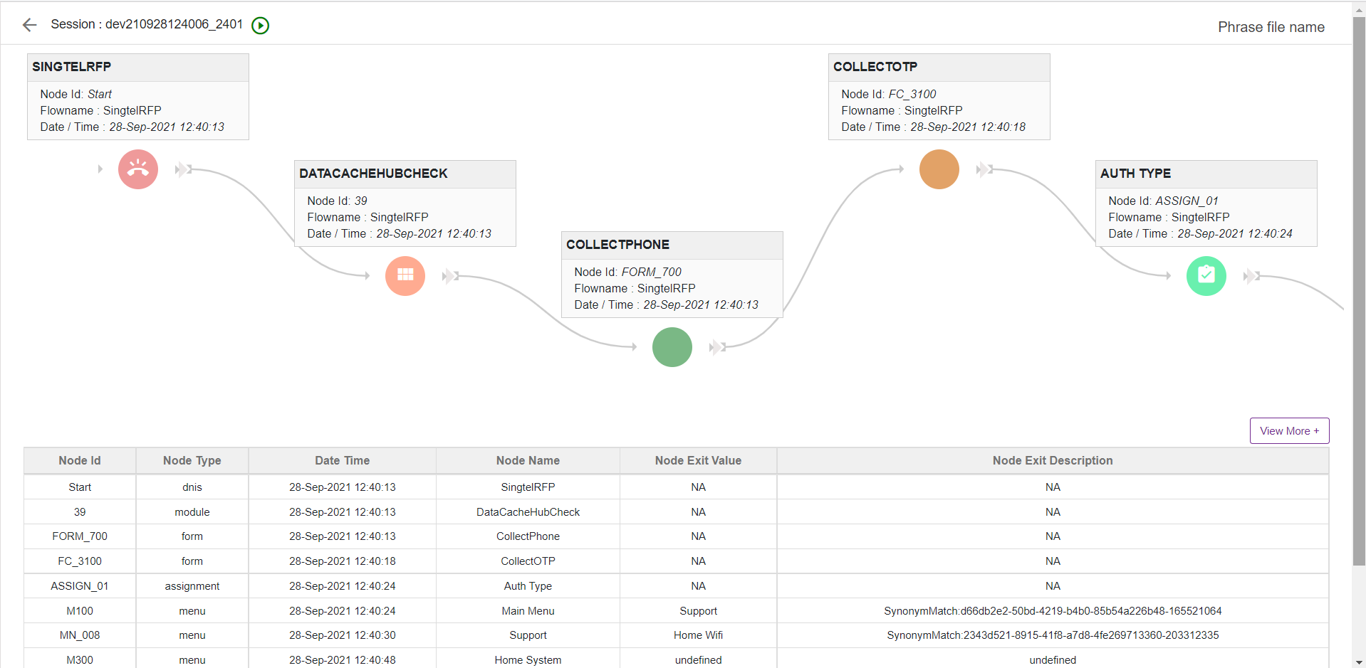
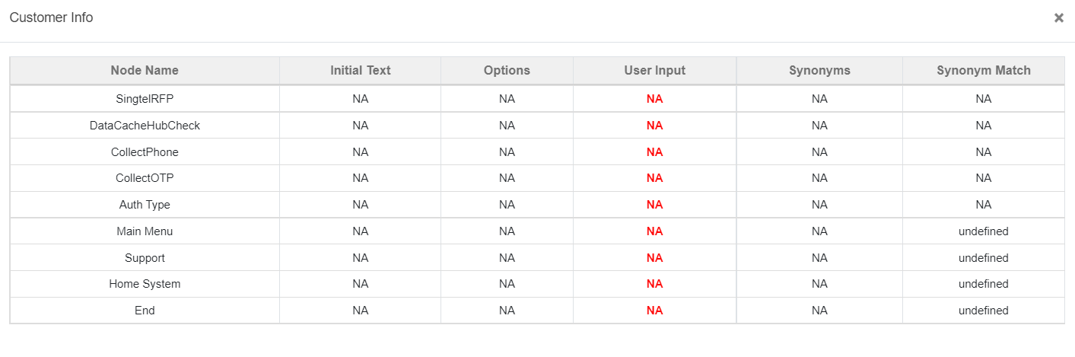
At the top left corner, Total Interaction (IVR/Chat/Email) count is displayed.
And at the top right corner, following options are displayed
Interpreter Dropdown: Interpreters configured at the back end will be listed here. User can select the interpreters (IVR Server) to see the sessions present in that interpreter (IVR Server)
Date and time: This display current date and time.
Set Refresh Rate: This option is present at the top right corner of dashboard. Dashboard will auto refresh for the time specified here
Maximize: This option is used to maximize the dashboard

Grid Section
Following options are displayed in the grid
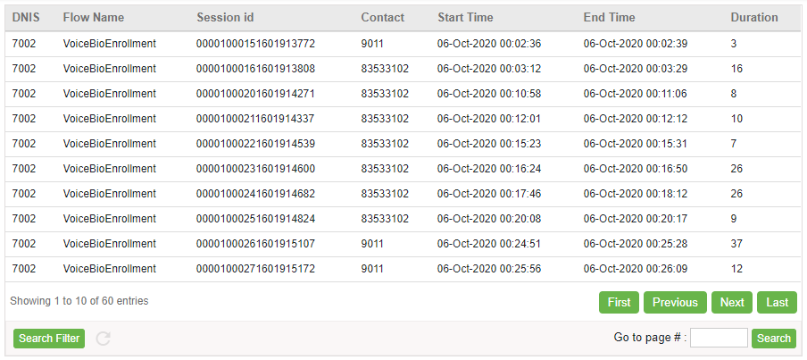
DNIS: DNIS i.e Hotline to which call is been landed will be displayed here
Flow Name: Flow name will be displayed here
Session id: Each call or Chat can be uniquely identified by Session id. Session id will be displayed here
Contact: Customer phone number will be displayed here.
Start time: This shows the time at which session (Call or Chat) has started
End Time: This shows the time at which session (Call or Chat) has ended
Duration: displays total duration of session is displayed here.
First: Loads first 10 session data i.e. redirects to initial page
Previous: Loads previous 10 session data
Next: Loads next 10 session data
Last: Loads last 10 session data i.e. redirects to last page
Go to Page: user can enter the page number here and click enter, to redirect to the exact page number.
Search Filter: refer section Search Filter

Search Filter
User can search for any record based on session ID, DNIS, Flow name, customer identification, customer mobile number, transfer VDN and transfer intent. Upon clicking on this button following popup will be displayed.
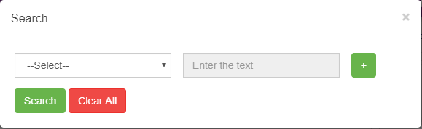
User can search for a record based on multiple conditions. ‘ADD’ button is provided as shown below to enter multiple search criteria.
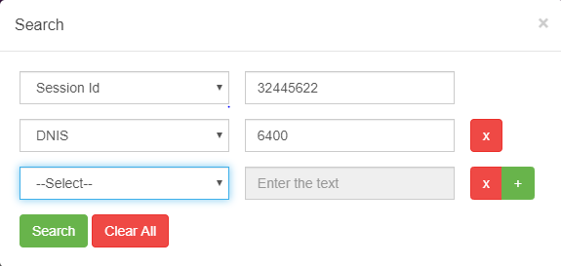
Error message is thrown when user try to use same search criteria again for the search as shown below.
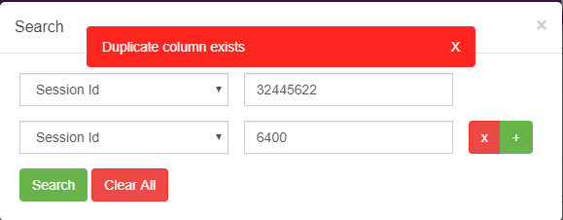
On success, following success toaster is displayed along with the result
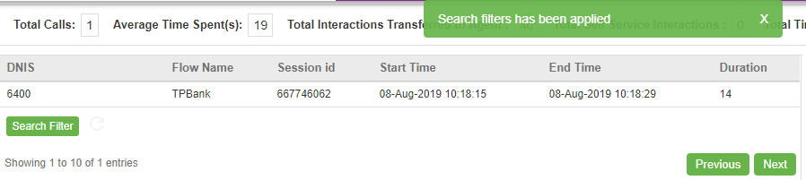
Reset Grid:
Reset grid button is provided right next to ‘Search’ button to remove search filter applied. This button will be blinking when search filter is applied. Upon clicking this button, search filter will be removed, and grid will be loaded with original data. ‘CLEAR ALL’ button present in search popup will also reset the grid as shown below.
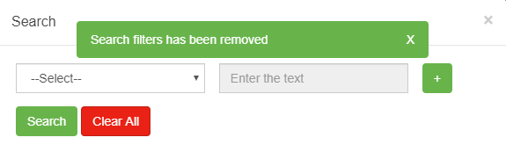

Node Section
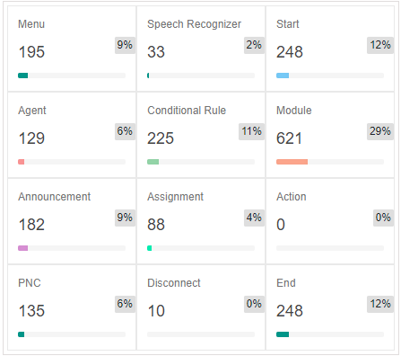
This section is used to display overall(total) count of node hit, during all the session in all the callflow. As shown above, in the last 24 hours, menu node present in all the callflow was hit 195 times and Assignment node 88 times.
Upon clicking on any node in node section, following popup will generate, which will display the node name along with Exact count
Exp: Upon clicking Menu node, Following popup will open, which shows the menu node names along with the count
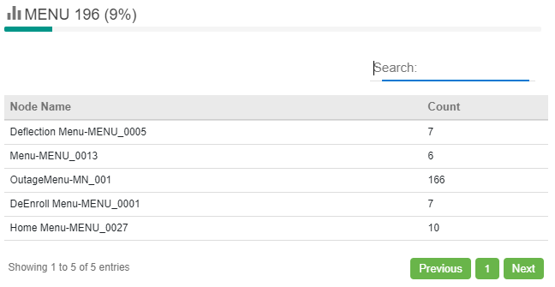

Customer Journey
When user clicks on any of the session listed, pictorial representation of the call flow will be displayed as shown below. Only the menu, announcement, agent and PNC nodes for which tracking is enabled in IW will be displayed here.
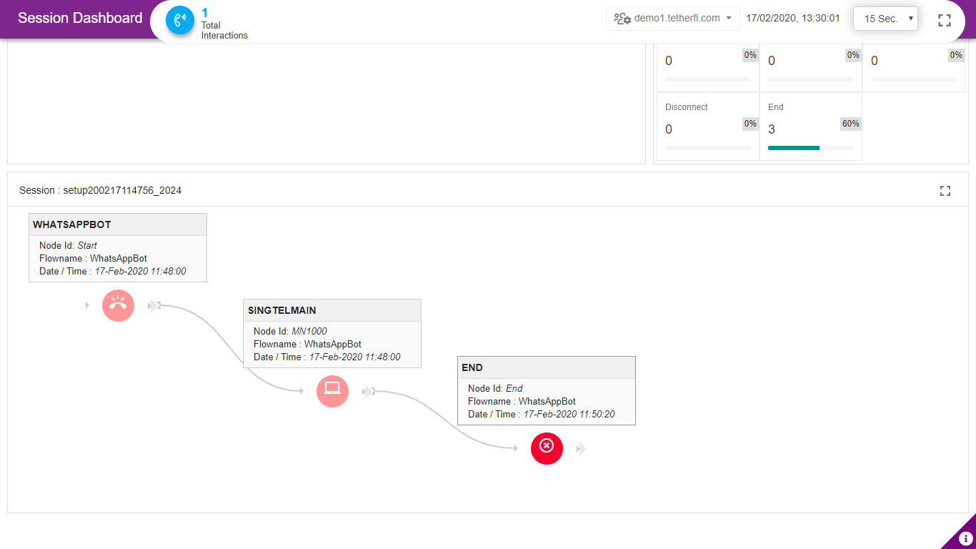
Each node displays node id, Date/time and flow/subflow name. Node Id in End node must display as ‘End’ without Flow name.
Upon maximizing the pictorial representation of the callflow, following popup will generate, along with node Info, customer Info table.
Node Info Table: Displays Node id, node type, date and time, node name along with Node exit value and description. For conditional node and Module, exit node name will be displayed in Node exit value section, whereas in menu node, menu option selected is displayed at node exit value section and tag is displayed in node exit description section.
Customer Info table: Displays customer identification, repeat call count i.e how many times this customer has been called previously, transfer Intent, transfer VDN and shows whether customer is authenticated or not. Transfer Intent field updates with intent to which call is been transferred and transfer VDN field updates with the Skill number.
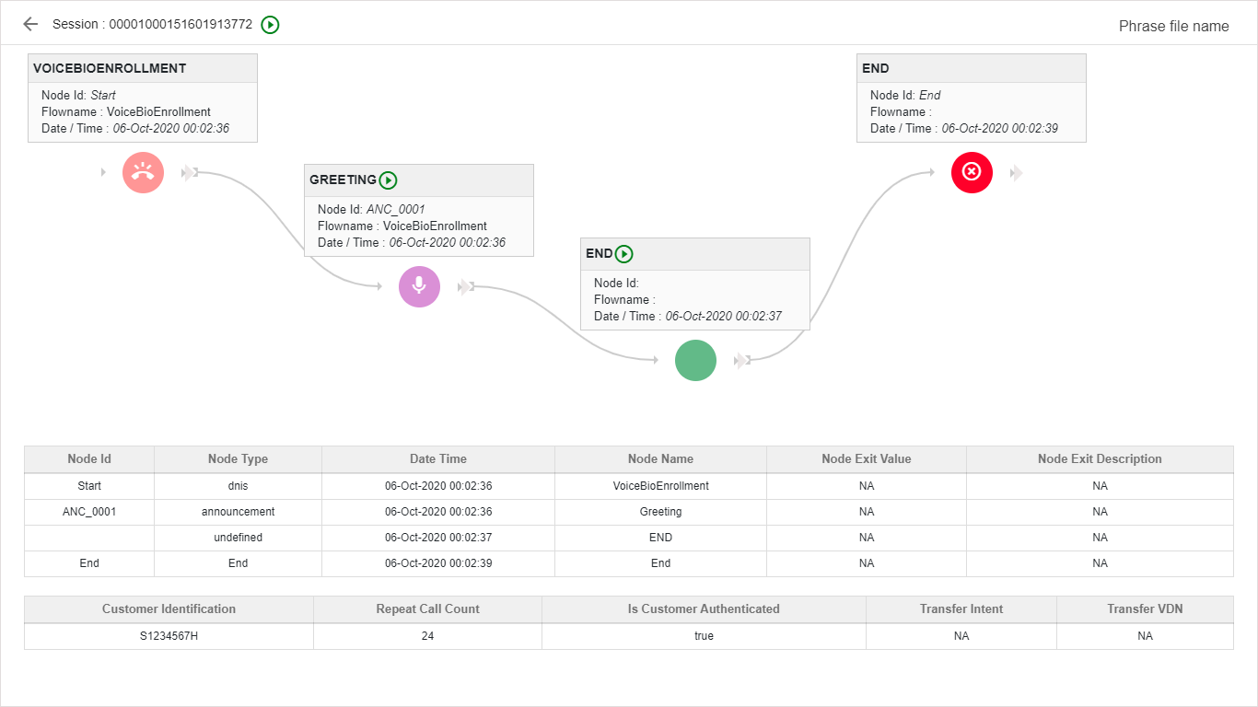

Repeat Caller Dashboard
This dashboard displays the journey of the repeat caller. Upon clicking ‘Repeat Call Count’ in session Dashboard ‘Customer Info Table’, this dashboard will open in a new window.
Session Dashboard:
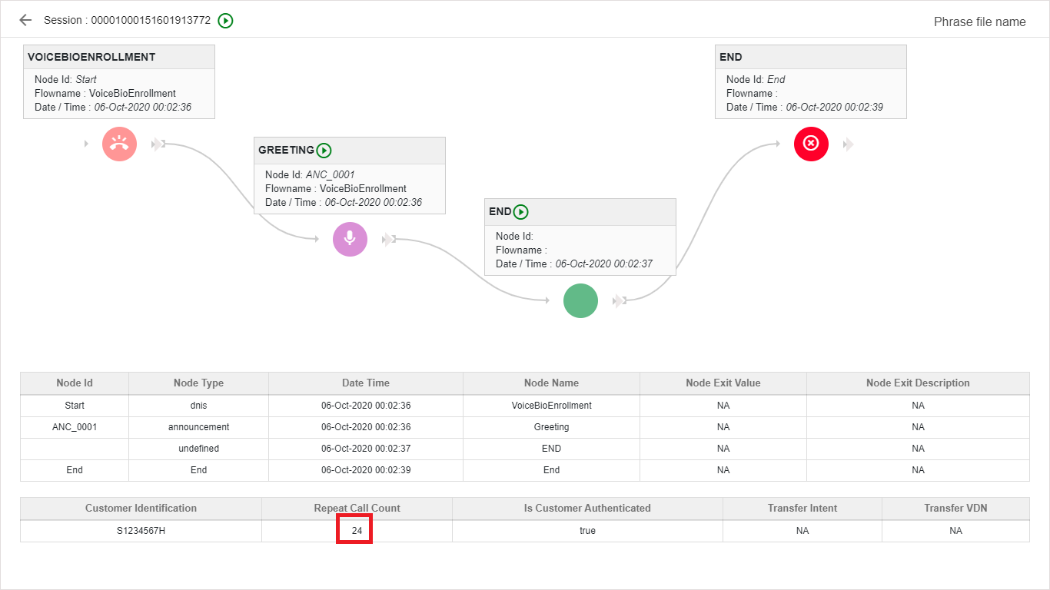
Upon clicking repeat call count, following repeat caller dashboard will open up.
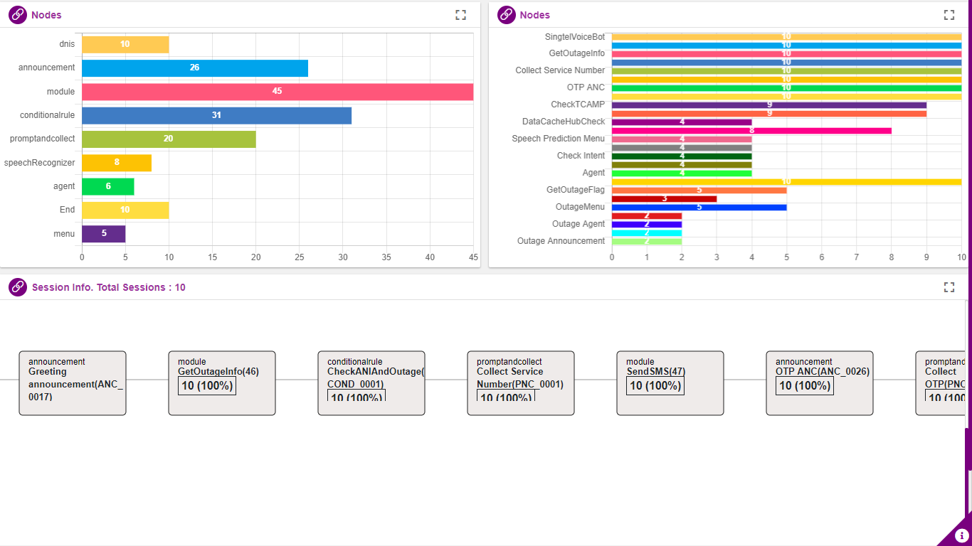
On the left-hand side, overall Node type count is displayed, whereas on right hand side, callflow node names are displayed along with count.
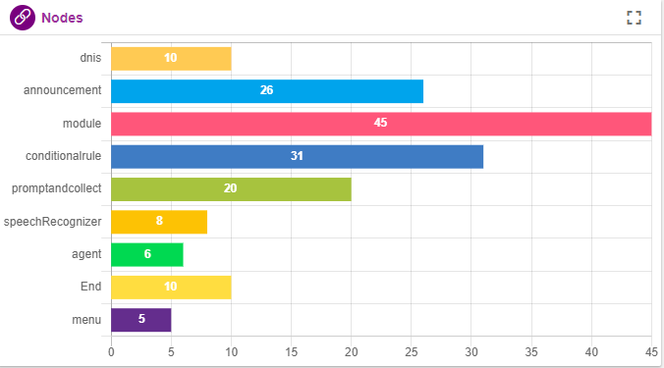
Foe Exp: Announcement node count on left hand side is 26, whereas on right hand side, OTP_Announcement is played 20 times and CreditCard_Announcement is played 6 times
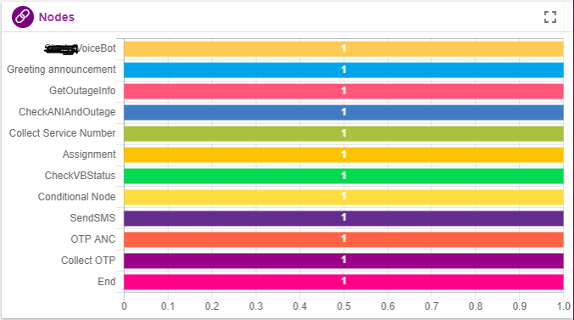
Journey of the repeat caller is displayed at the bottom of the page as shown below.
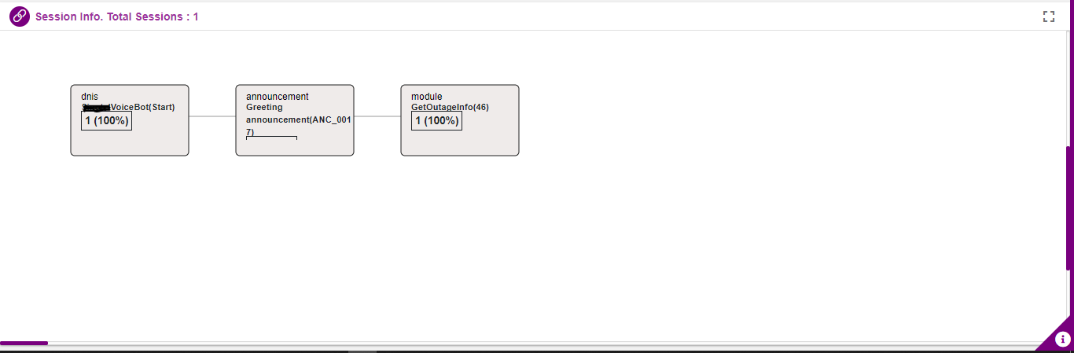

KPI Dashboard
KPI Dashboard displays Callflow and Hotline based Hourly Volume, Utterances, Language and Authentication Count, Top 5 Menu, Module and Intent transfer for current as well as Historical data
It also shows the callflow and Hotline based Analysis graph displaying the Interaction, Average Time, Self Service and Agent Transfer for the historical data
User can access IW KPI dashboard by launching the IIS application suffixed with IWDashboard/kpi
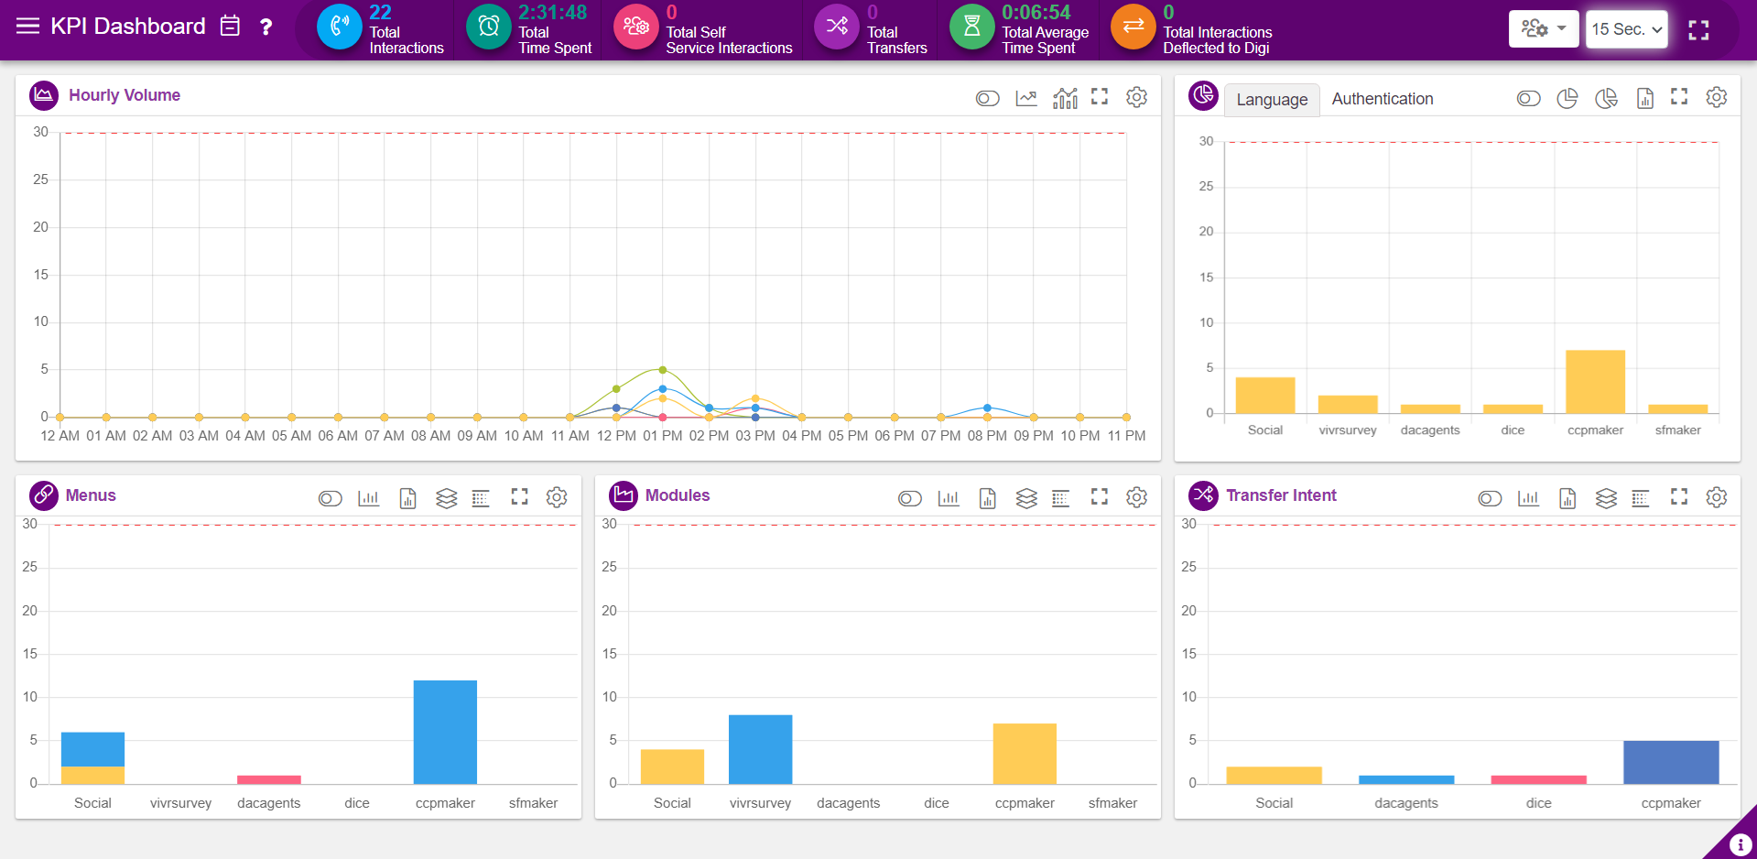

At the top bar, following options are displayed.
Horizontal Bar: This opens the callflow list along with a calendar. User can select the callflow and date to see the interaction history on that day for the callflow selected. Refer section Interactions on the Day selected
Notepad Icon: Callflow and the dnis selected will be displayed here
Question mark icon: Date selected will be displayed here
Key Performance Indicator
Total Calls: Total calls hit during the time stamp is displayed here.
Total Time Spent(sec): Total time spent in IVR is displayed here.
Average time spent(sec): Average time spent in IVR is displayed here.
Total Interactions Transferred to Agent: Total count of total calls that are transferred to Agent is displayed here.
Total Self-Service Interactions: Total count of total calls that are not transferred to Agent i.e that are served by IVR are displayed here.
Auto Refresh: grid will be auto refreshed for the configured seconds (15 sec, 30 sec, 1min, 5 min)
Interpreter Dropdown: Interpreters configured at the back end will be listed here. User can select the interpreters to see the sessions present in that interpreter

Hourly Volume
This graph shows the interaction count for 24 hours. Upon hovering on each point, interaction count is displayed as shown below.
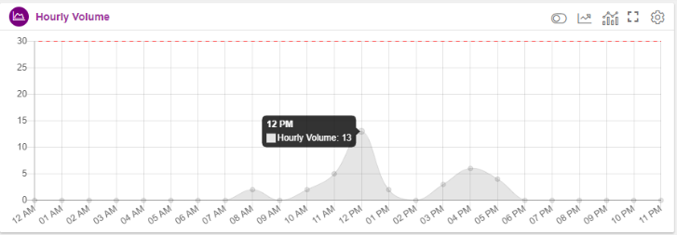
Legend ON/Off: Upon enabling, legends will be displayed at the top as shown below. User can check or uncheck legends as they wish, just by clicking on them.
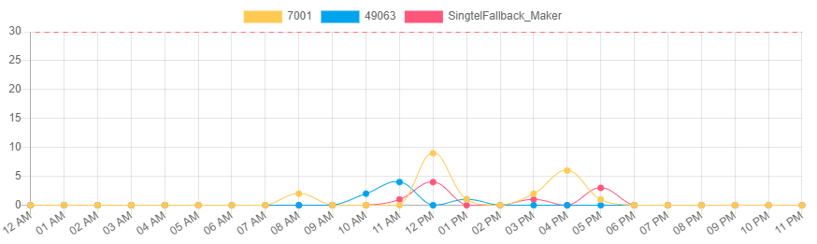
Callflow based Hourly Volume: Upon clicking this option hourly volume of the callflow selected will display
Hotline based Hourly Volume: Hourly interaction information can also be displayed on hotline basis as below
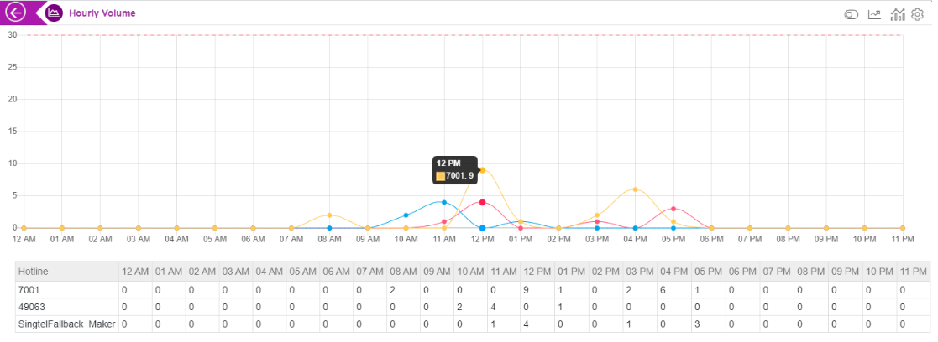
Maximize: Used to maximize the window. In the maximized screen, count of interaction on each hour will be displayed as below.
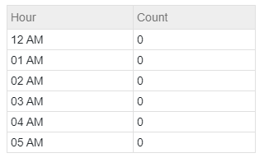
Threshold Setting: Threshold is set to 30 by default. When the interaction count goes above than this a horizontal red line will be displayed, indicating that, interaction count exceeding the threshold set.
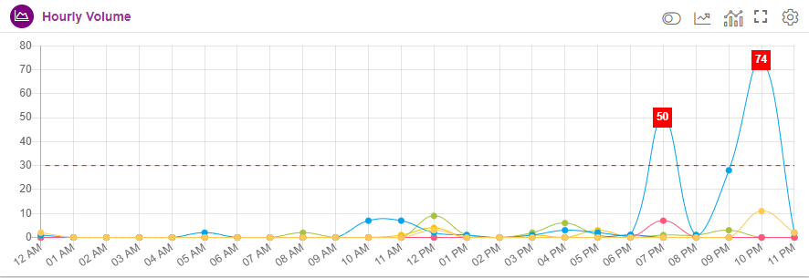

Utterances
This graph shows the interaction of customers with an agent for 24 hours. Upon hovering on each point, interaction is displayed as shown below.
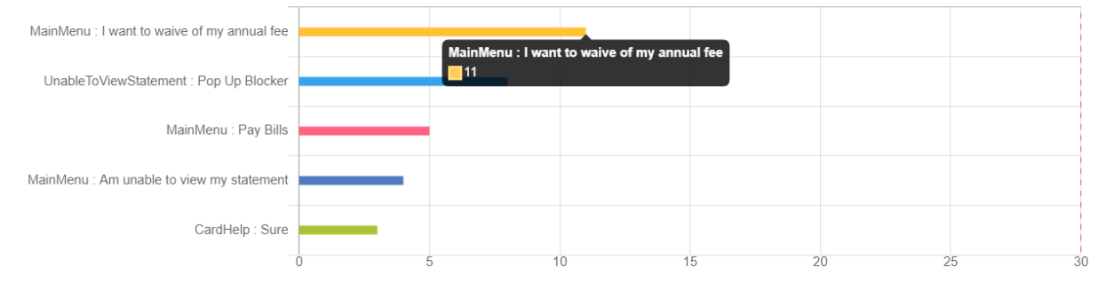
Maximize: Used to maximize the window. In the maximized screen, count of interaction on each hour will be displayed as below.
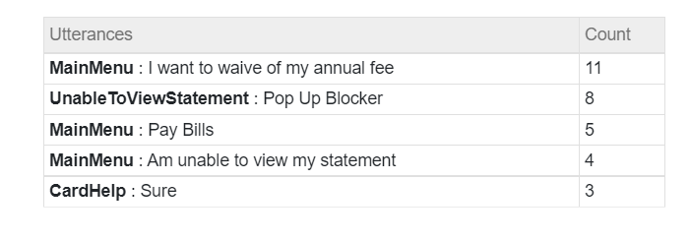
Threshold Setting: Threshold is set to 30 by default. When the interaction count goes above than this a horizontal red line will be displayed, indicating that, interaction count exceeding the threshold set.
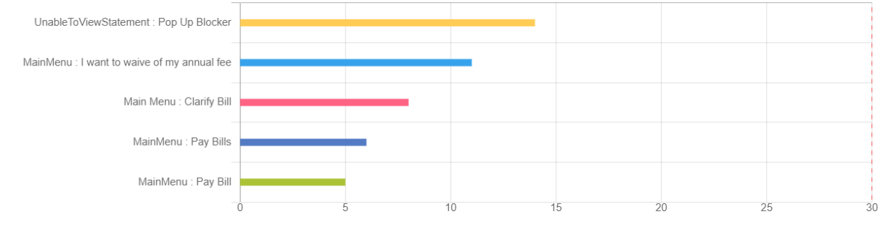

Language
Languages preferred by user will be displayed in the form of graph in this section.
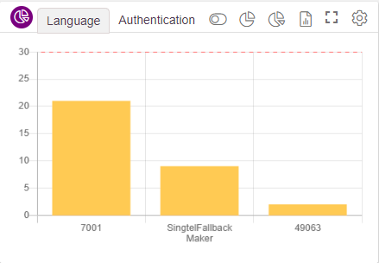
Legend ON/Off: Upon enabling, legends will be displayed at the top as shown below. User can check or uncheck legends as they wish, just by clicking on them.
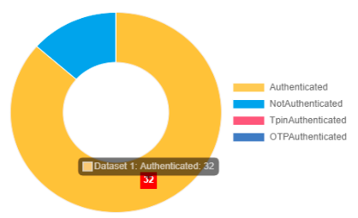
Callflow based Donut Chart: This chart will display the language preferred count in the form of donut. Upon hovering on the chart, count will be displayed
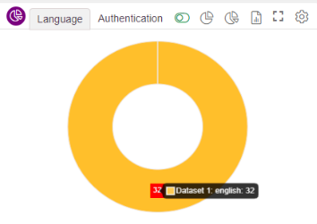
Hotline based Donut Chart: This chart will display the language preferred count in the form of donut based on the hotline selected. Upon hovering on the chart, count will be displayed along with hotline as shown below
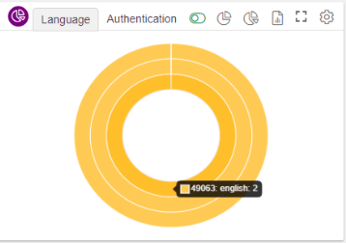
Hotline based Bar Chart: This chart will display the language preferred count in the form of Bar based on the hotline selected. Upon hovering on the chart, count will be displayed along with hotline as shown below

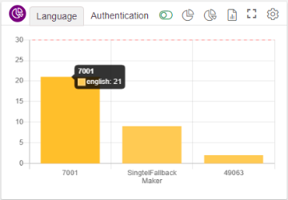
Maximize: Used to maximize the window. In the maximized screen, count will be displayed as below. Value that exceeds the threshold set, will be highlighted in red.
Threshold Setting: Threshold is set to 30 by default. When the count goes above than this, value in the graph gid will be highlighted in red, indicating that, language count exceeding the threshold set.
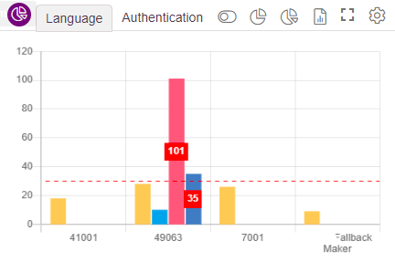

Authentication
User authentication will be displayed in the form of graph in this section.

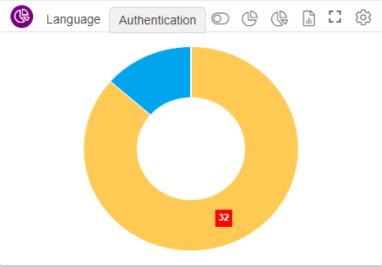
Legend ON/Off: Upon enabling, legends will be displayed at the top as shown below. User can check or uncheck legends as they wish, just by clicking on them.
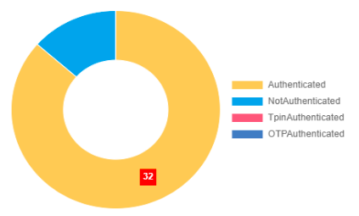
Callflow based Donut Chart: This chart will display the authentication count in the form of donut. Upon hovering on the chart, count will be displayed
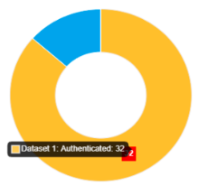

Hotline based Donut Chart: This chart will display the authentication count in the form of donut based on the hotline selected. Upon hovering on the chart, count will be displayed along with hotline as shown below
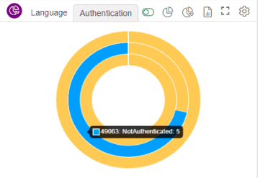
Hotline based Bar Chart: This chart will display the authentication count in the form of Bar based on the hotline selected. Upon hovering on the chart, count will be displayed along with hotline as shown below

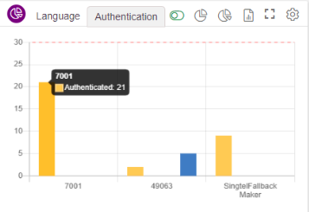
Maximize: Used to maximize the window. In the maximized screen, count will be displayed as below. Value that exceeds the threshold set, will be highlighted in red.
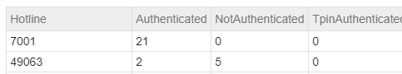
Threshold Setting: Threshold is set to 30 by default. When the count goes above than this, value in the graph gid will be highlighted in red, indicating that, language count exceeding the threshold set.
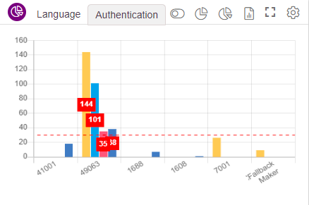

Top 5 Menu, Module and Intent
At the bottom of the page, top 5 menu, module and intent count is displayed
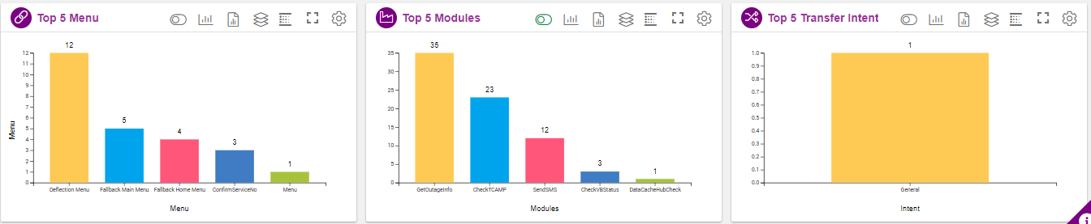

Top 5 Menus
Among the callflow and date selected, top 5 menus, which we selected by the user most will be displayed here.
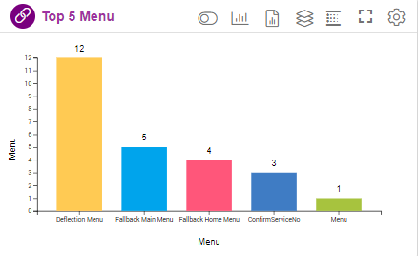
Legend ON/Off: Upon enabling, legends will be displayed at the bottom as shown below. User can check or uncheck legends as they wish, just by clicking on them.
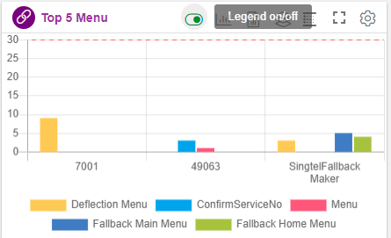
Callflow based Bar Chart: This chart will display the top 5 menu count in the callflow selected in the form of bar chart. Upon hovering on the chart, count will be displayed
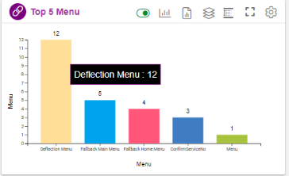
Hotline based Bar Chart: This chart will display the top 5 menus count specific to hotline in the callflow selected in the form of bar chart. Upon hovering on the chart, count will be displayed
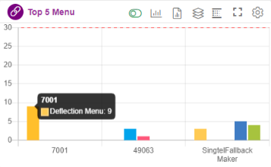
Hotline based Stacked Bar Chart: This chart will display the top 5 menus count specific to hotline in the callflow selected in the form of stacked bar chart. Upon hovering on the chart, count will be displayed
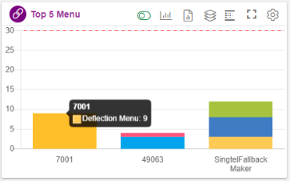
Word Cloud: refer section Word Cloud
Maximize: Used to maximize the window. In the maximized screen, count will be displayed as below. Value that exceeds the threshold set, will be highlighted in red
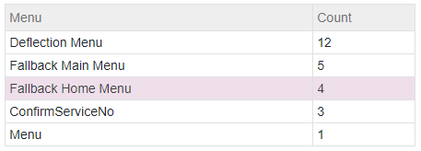
Threshold Setting: Threshold is set to 30 by default. When the count goes above than this, value in the graph gid will be highlighted in red, as well as indicator is provided in the ui, indicating that, menu count exceeding the threshold set.
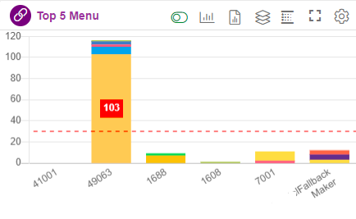
Can also set number of menus to be displayed in the graph. By default it is set to 5.
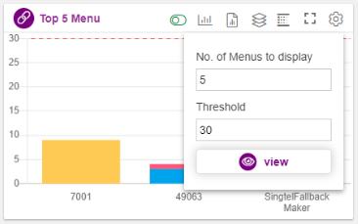

Top 5 Modules
Among the callflow and date selected, top 5 modules, which we selected by the user most will be displayed here.
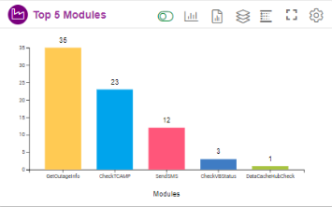
Legend ON/Off: Upon enabling, legends will be displayed at the bottom as shown below. User can check or uncheck legends as they wish, just by clicking on them.
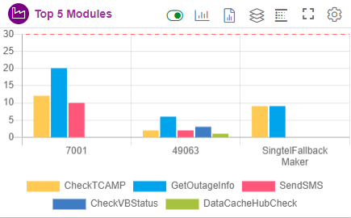
Callflow based Bar Chart: This chart will display the top 5 module count in the callflow selected in the form of bar chart. Upon hovering on the chart, count will be displayed
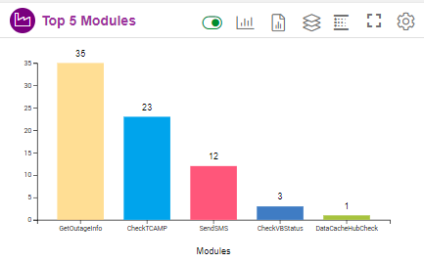
Hotline based Bar Chart: This chart will display the top 5 module count specific to hotline in the callflow selected in the form of bar chart. Upon hovering on the chart, count will be displayed
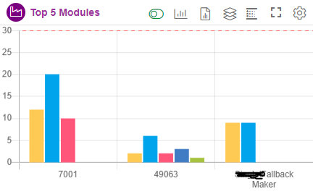
Hotline based Stacked Bar Chart: This chart will display the top 5 module count specific to hotline in the callflow selected in the form of stacked bar chart. Upon hovering on the chart, count will be displayed
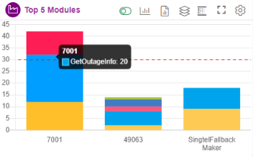
Word Cloud: refer section Word Cloud
Maximize: Used to maximize the window. In the maximized screen, count will be displayed as below. Value that exceeds the threshold set, will be highlighted in red
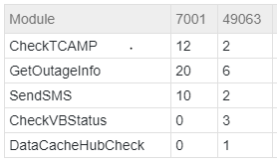
Threshold Setting: Threshold is set to 30 by default. When the count goes above than this, value in the graph gid will be highlighted in red, as well as indicator is provided in the ui, indicating that, module count exceeding the threshold set.
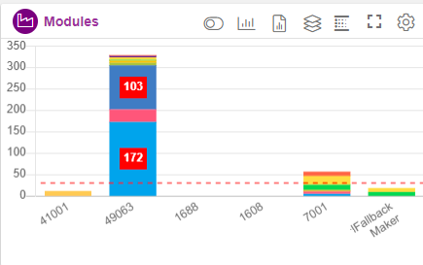
Can also set number of modules to be displayed in the graph. By default, it is set to 5.
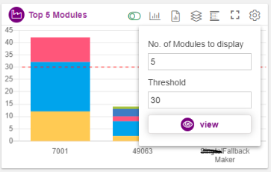

Top 5 Transfer Intent
Among the callflow and date selected, top 5 agent transfer, which is selected by the user most will be displayed here.
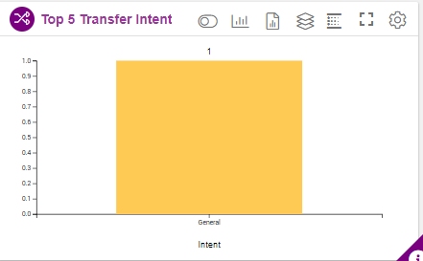
Legend ON/Off: Upon enabling, legends will be displayed at the bottom as shown below. User can check or uncheck legends as they wish, just by clicking on them.
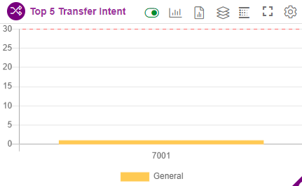
Callflow based Bar Chart: This chart will display the top 5 intent transfer count in the callflow selected in the form of bar chart. Upon hovering on the chart, count will be displayed
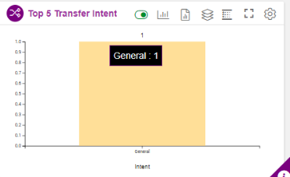
Hotline based Bar Chart: This chart will display the top 5 intent transfer count specific to hotline in the callflow selected in the form of bar chart. Upon hovering on the chart, count will be displayed
Hotline based Stacked Bar Chart: This chart will display the top 5 menus count specific to hotline in the callflow selected in the form of stacked bar chart. Upon hovering on the chart, count will be displayed
Word Cloud: refer section Word Cloud
Maximize: Used to maximize the window. In the maximized screen, count will be displayed as below. Value that exceeds the threshold set, will be highlighted in red
Threshold Setting: Threshold is set to 30 by default. When the count goes above than this, value in the graph gid will be highlighted in red, as well as indicator is provided in the ui, indicating that, intent transfer count exceeding the threshold set.
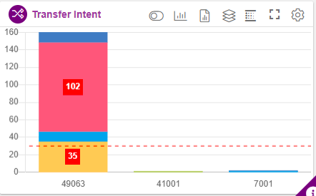
Can also set number of menus to be displayed in the graph. By default it is set to 5.
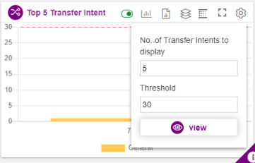

Word Cloud
Top 5 menu, Top 5 Module and Top 5 Transfer intent graph data can be displayed in Heat map/word cloud.
Click on the icon highlighted below.
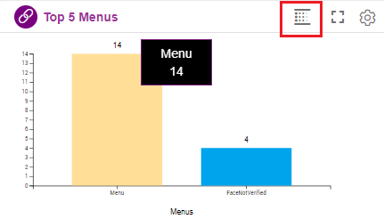
Upon clicking ‘Heat map/word cloud option’ following page will be opened where the data is displayed in horizontal way, as shown below
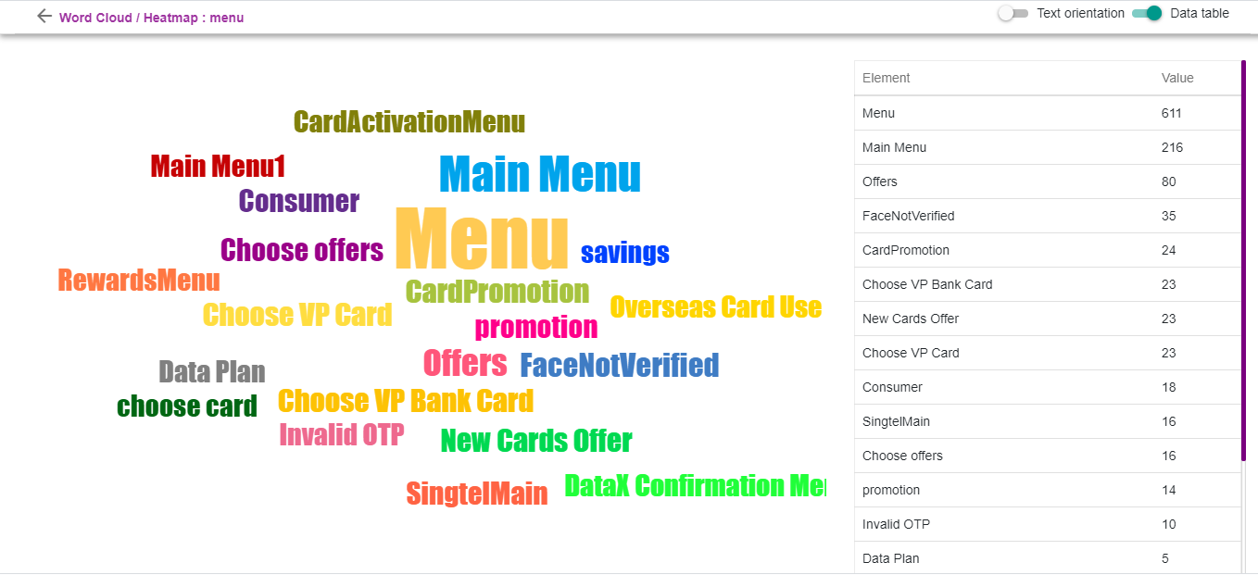
Can display the data in vertical format by enabling the ‘Text Orientation’ option present at top right corner.
Upon enabling the text orientation option, data is displayed in vertical format as shown below.
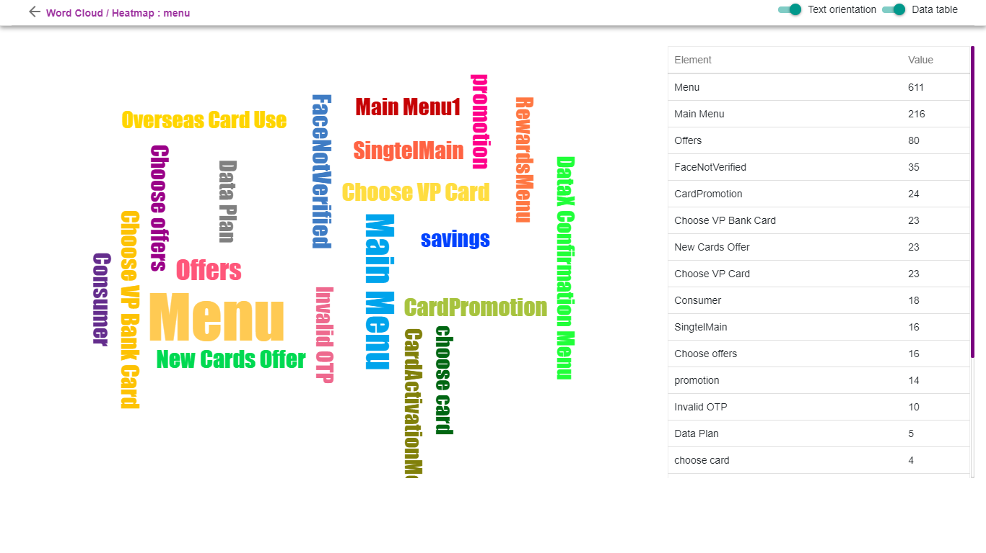

Interactions on the Day selected
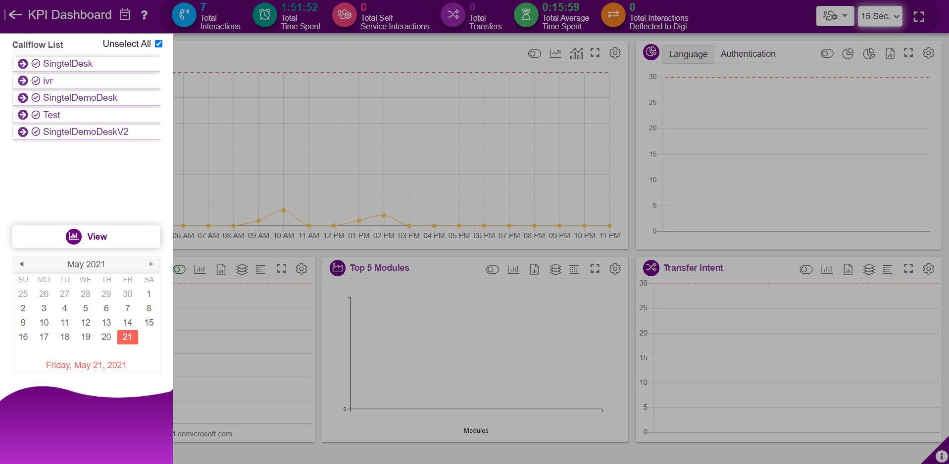
All the callflows created in IW will be displayed in the dropdown as shown below,
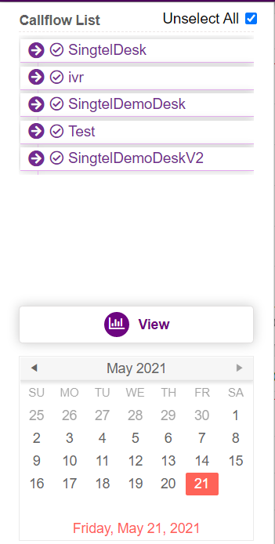
User can check the required callflow and hotlines for which he wants to see the historical data as shown below. User can also remove the dnis displayed here by unchecking the hotline option. User can select or unselect the callflow based on requirement.
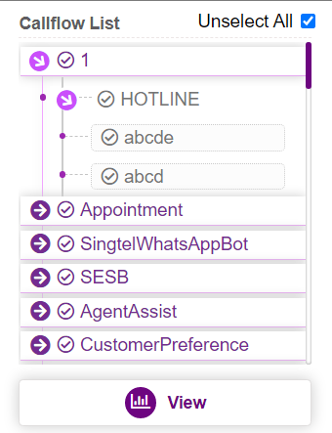
Upon clicking on ‘View’ button, historical information like Total Interaction, Total Time spent, Total self-service interactions, Total transfer, Average time spent, hourly volume, Top menu(configured value), modules and transfer VDN hit, Language and Authentication ratio related to the callflow and dnis selected will be displayed in the UI as shown below.
Key performance indicators (KPI’s) are displayed at the top of the page.
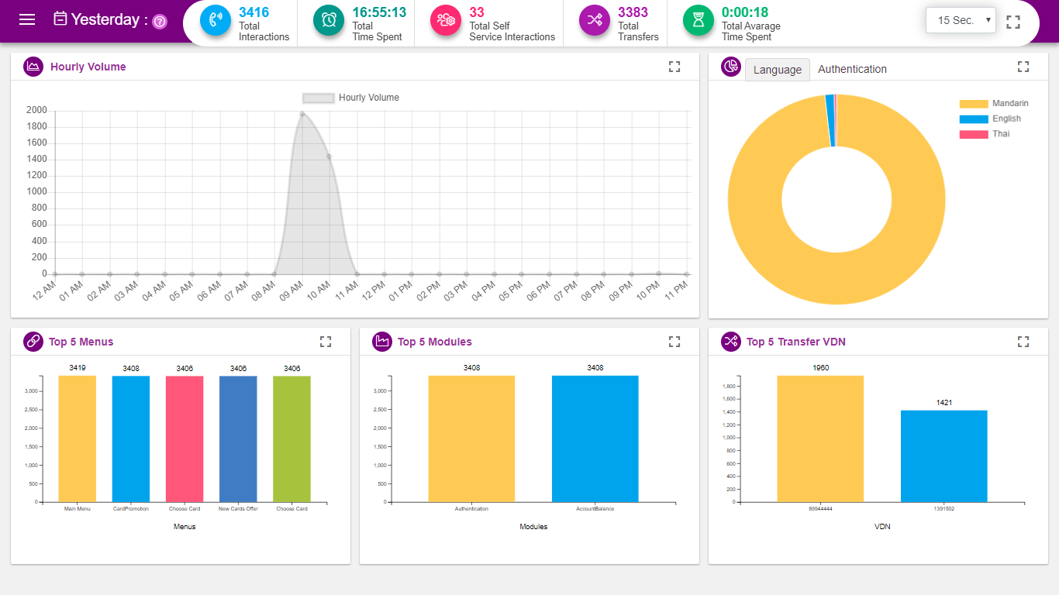
Hourly Volume: Call or chat session at a given time is displayed in hourly graph. As shown below, upon hovering on a point, session count is displayed along with time. Refer section Hourly Volume
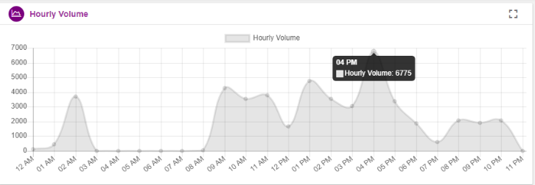
Language: Language ratio for a given date range can be displayed in a donut chart as shown below. Upon hovering on the chart, language session count is highlighted as shown below. Refer section Language
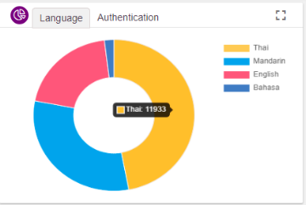
Authentication: authentication ratio i.e. number of users who has been authenticated will be displayed for a given date range in a pie chart as shown below. Upon hovering on pie chart, authenticated session count is highlighted as shown below. Refer section Authentication
Top 5 Menus: The top 5 menus which are used mostly will be displayed in a bar graph along with the count i.e. User can configure maximum 15 menu bars here. This count is also displayed in the heat map. Refer section Top 5 Menus
Top 5 Modules: The top 5 modules which are used mostly will be displayed in a bar graph along with the count i.e. how many times the module is being hit. User can configure maximum 15 module bars here. . This count is also displayed in the heat map. Refer section Top 5 Modules
Top 5 Transfer VDN: The top 5 transfers which are used mostly will be displayed in a bar graph along with the count. User can configure maximum 15 agent bars here. This count is also displayed in the heat map. Refer section Top 5 Transfer Intent

Interactions on the Date-range selected
User can select the multiple dates from the calendar by clicking ‘SHIFT’ button in the keyboard and can select the date range. Upon clicking ‘View’ button, interaction details for the days selected will be displayed.

Analysis on the Date-range selected(Historical)
KPI Dashboard gives the option to user to analyse the session information for a date range. Shift and select the date for which user wants to analyse the data.

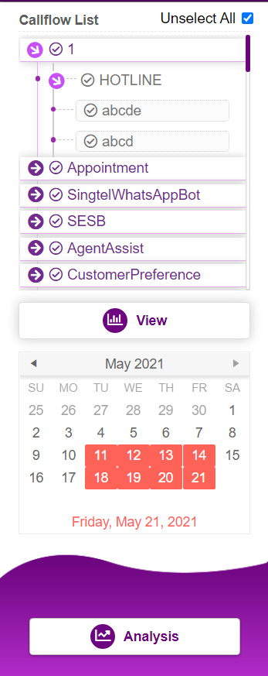
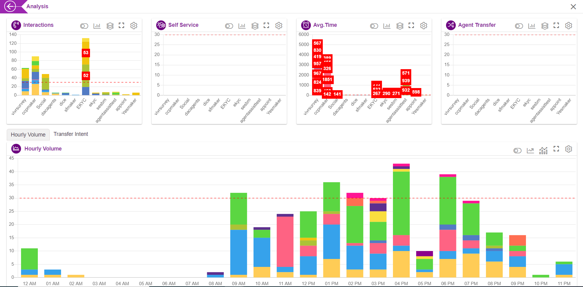

Interactions
Interaction history of the date range selected is displayed in this graph.
Legend ON/Off: Upon enabling, legends will be displayed at the bottom as shown below. User can check or uncheck legends as they wish, just by clicking on them.
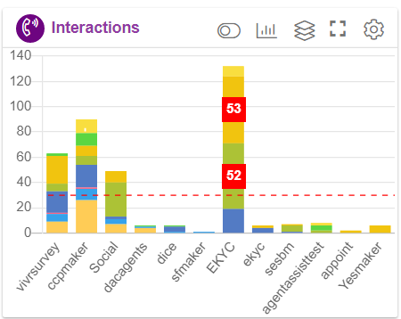
Callflow based Interaction Bar Chart: for the date selected, interaction count will be displayed in the form of bar chart here.
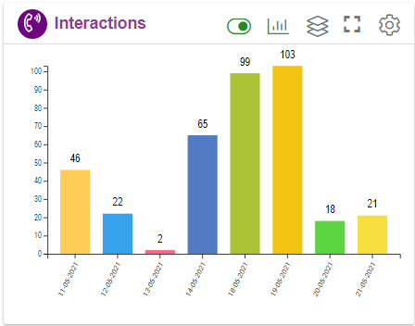
Hotline based Interaction Stacked Bar Chart: for the date selected, hotline interaction count will be displayed in the form of stacked bar chart here.

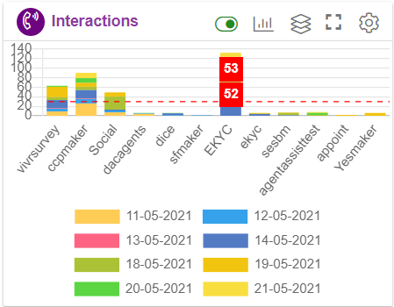
Maximize: Used to maximize the window. In the maximized screen, count will be displayed as below. Value that exceeds the threshold set, will be highlighted in red
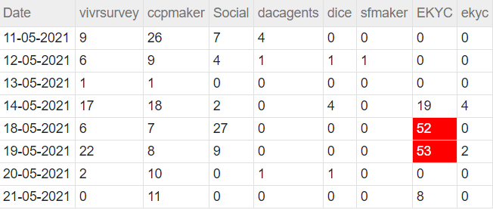
Threshold Setting: Threshold is set to 30 by default. When the count goes above than this, value in the graph gid will be highlighted in red, as well as indicator is provided in the ui, indicating that, interaction count exceeding the threshold set.
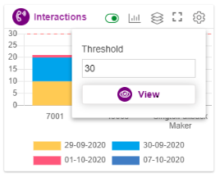
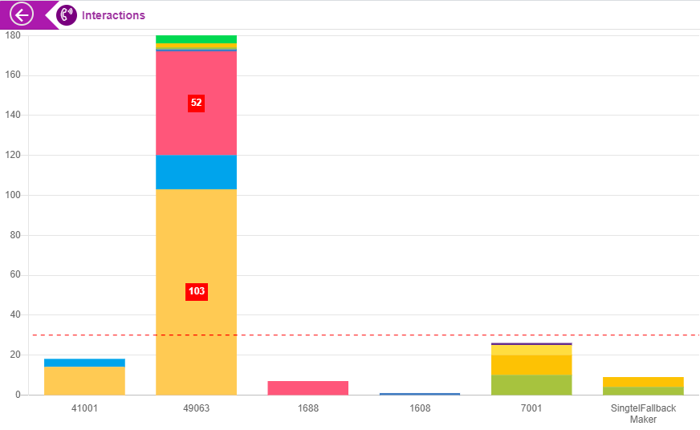

Self Service
Self-service interaction history of the date range selected is displayed in this graph.
Legend ON/Off: Upon enabling, legends will be displayed at the top as shown below. User can check or uncheck legends as they wish, just by clicking on them.
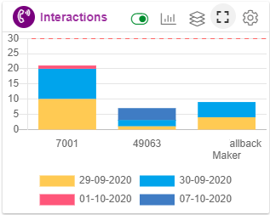
Callflow based Self service Bar Chart: for the date selected, interaction count will be displayed in the form of bar chart here.
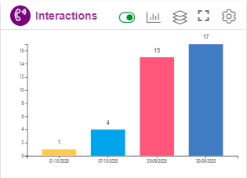
Hotline based self service Stacked Bar Chart: for the date selected, hotline interaction count will be displayed in the form of stacked bar chart here.

Maximize: Used to maximize the window. In the maximized screen, count will be displayed as below. Value that exceeds the threshold set, will be highlighted in red
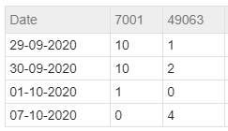
Threshold Setting: Threshold is set to 30 by default. When the count goes above than this, value in the graph gid will be highlighted in red, as well as indicator is provided in the ui, indicating that, interaction count exceeding the threshold set.

Avg.Time
Average time of the interaction history of the date range selected is displayed in this graph.
Legend ON/Off: Upon enabling, legends will be displayed at the top as shown below. User can check or uncheck legends as they wish, just by clicking on them.
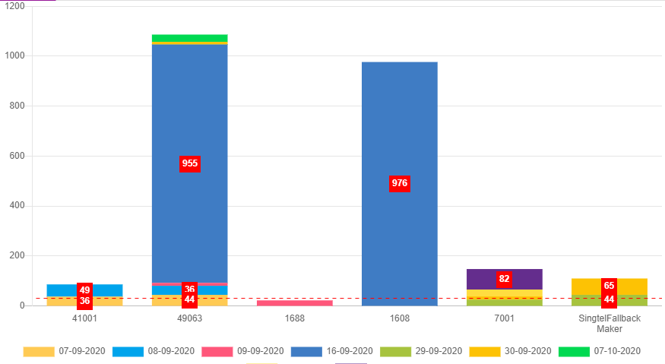
Callflow based Average Time Bar Chart: for the date selected, interaction count will be displayed in the form of bar chart here.
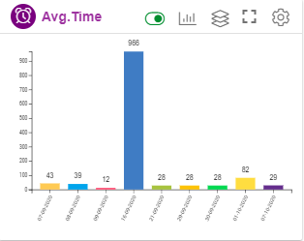
Hotline based Average Time Stacked Bar Chart: for the date selected, hotline interaction count will be displayed in the form of stacked bar chart here.

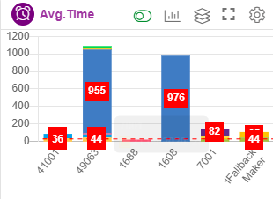
Maximize: Used to maximize the window. In the maximized screen, count will be displayed as below. Value that exceeds the threshold set, will be highlighted in red.
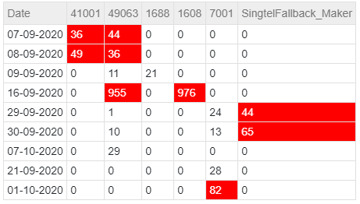
Threshold Setting: Threshold is set to 30 by default. When the count goes above than this, value in the graph gid will be highlighted in red,
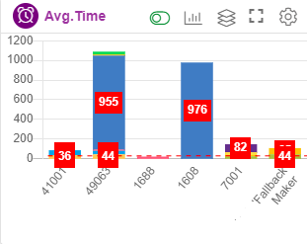

Agent Transfer
Agent transfer of the interaction history of the date range selected is displayed in this graph.
Legend ON/Off: Upon enabling, legends will be displayed at the top as shown below. User can check or uncheck legends as they wish, just by clicking on them.
Callflow based Agent Transfer Bar Chart: for the date selected, Agent transfer count will be displayed in the form of bar chart here.
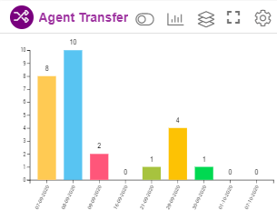
Agent Transfer Hotline based Stacked Bar Chart: for the date selected, hotline agent transfer count will be displayed in the form of stacked bar chart here.
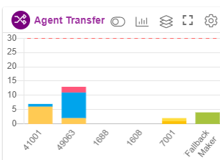
Maximize: Used to maximize the window. In the maximized screen, count will be displayed as below. Value that exceeds the threshold set, will be highlighted in red.
Threshold Setting: Threshold is set to 30 by default. When the count goes above than this, value in the graph gid will be highlighted in red.
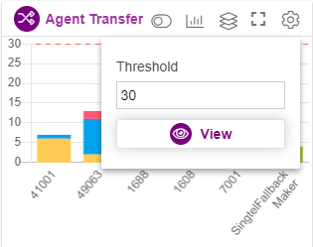

Hourly Volume
Hourly Volume of the interaction history of the date range selected is displayed in this graph.
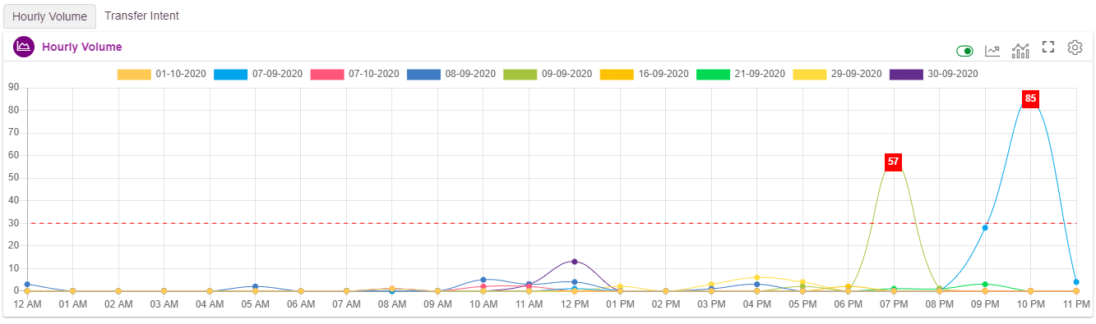
Legend ON/Off: Upon enabling, legends will be displayed at the top as shown below. User can check or uncheck legends as they wish, just by clicking on them.
Callflow based Hourly Volume: for the date selected, Hourly volume count will be displayed.
Hotline based Hourly Volume: Hourly interaction information can also be displayed on hotline basis as below
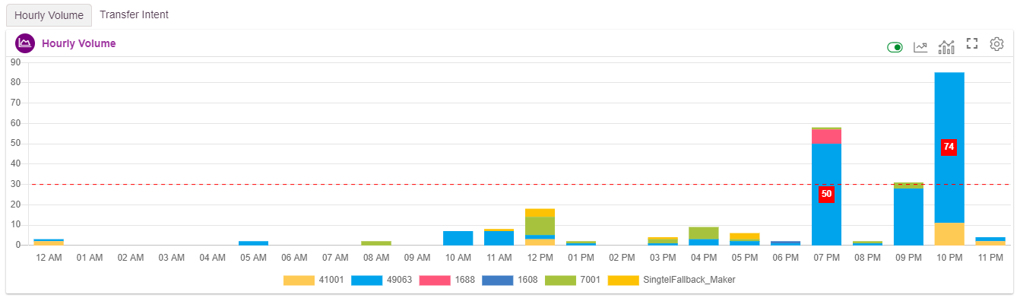
Maximize: Used to maximize the window. In the maximized screen, count will be displayed as below. Value that exceeds the threshold set, will be highlighted in red.
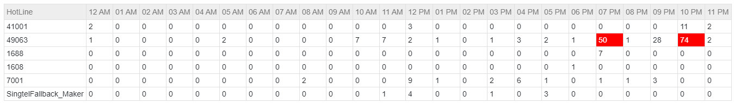
Threshold Setting: Threshold is set to 30 by default. When the count goes above than this, value in the graph gid will be highlighted in red.
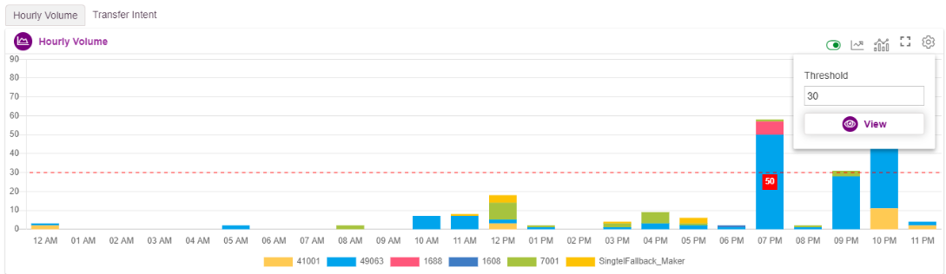

Transfer Intent
Agent Transfer of the interaction history of the date range selected is displayed in this graph.
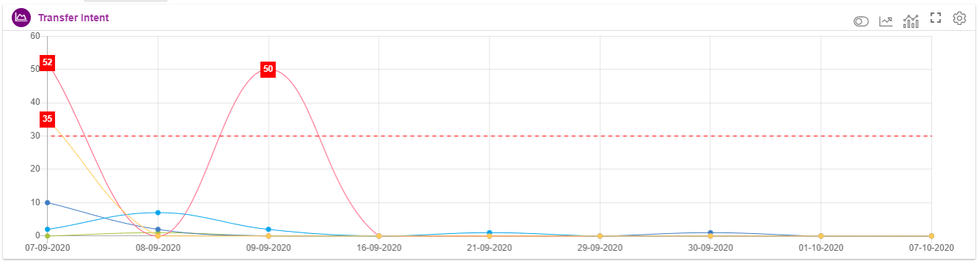
Legend ON/Off: Upon enabling, legends will be displayed at the Bottom as shown below. User can check or uncheck legends as they wish, just by clicking on them.
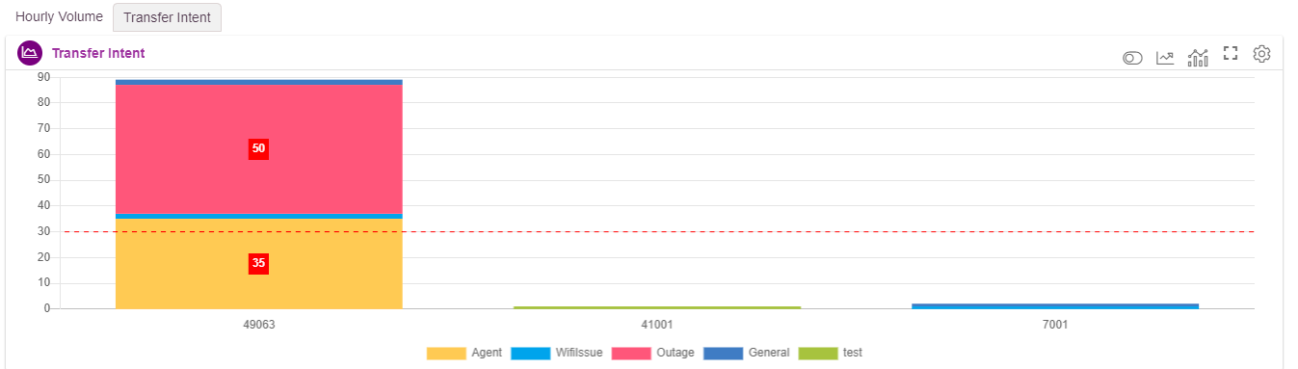
Callflow based Transfer Intent: : for the date selected, transfer intent count will be displayed .
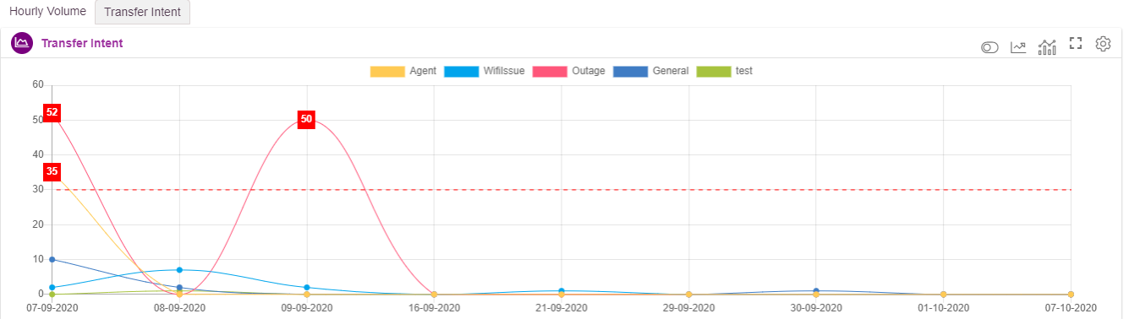

Hotline based Hourly Volume Stacked Bar Chart: Transfer Intent information can also be displayed on hotline basis as below

Maximize: Used to maximize the window. In the maximized screen, count will be displayed as below. Value that exceeds the threshold set, will be highlighted in red.
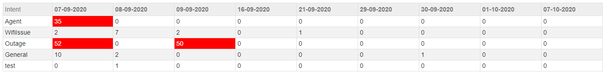
Threshold Setting: Threshold is set to 30 by default. When the count goes above than this, value in the graph gid will be highlighted in red. 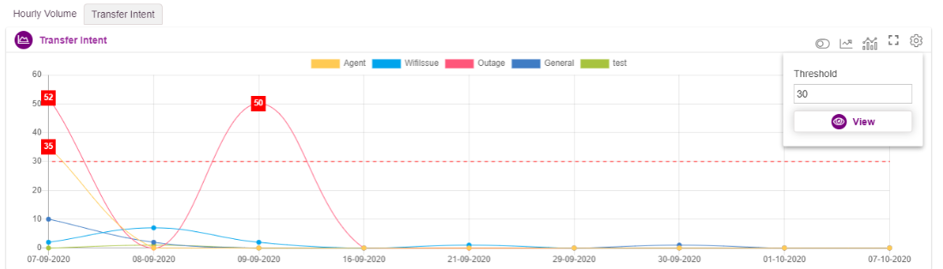

Real Time CC Dashboard
This dashboard displays the real time data in Call center level as well as group level.
User can access IW Realtime CC dashboard by launching the IIS application suffixed with VoiceStatsDashboard/RealTimeCC
This option is used to view the Realtime voice static information.
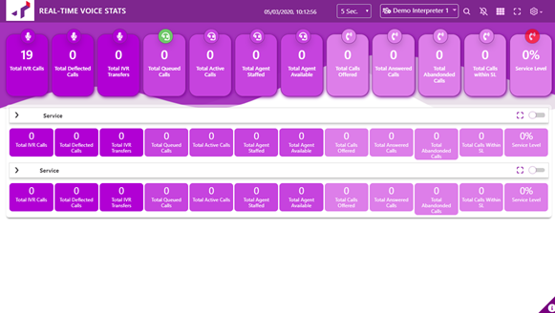
At the top left corner, logo will be displayed
At the top right corner, following options will be displayed.
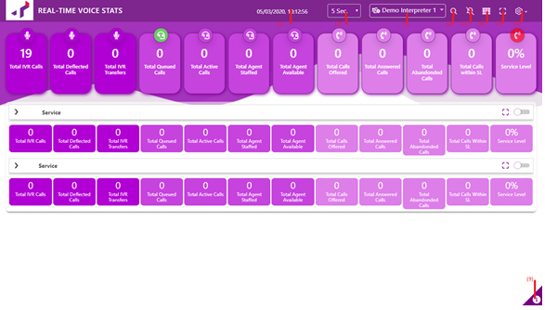
- Date and Time: Current date and time will be updated here for every second
- Dashboard Refresh Rate: Dashboard refresh rate can be set here starting from 5 sec to 5min
- Interpreter Dropdown: Interpreters configured at the back end will be listed here. User can select the interpreters to see the sessions present in that interpreter
- Filter: All the callflow names will be listed here along with hotline and skill. User can manually enable/disable the options based on business needs.
To Enable: Check the checkbox present right in front of the options
To Disable: Uncheck the checkbox present right in front of the options
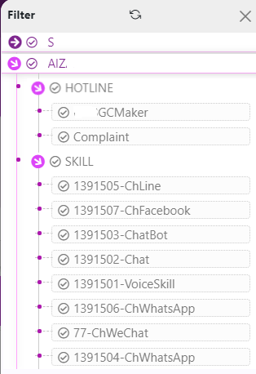
Only enabled callflow details will be displayed in UI as shown below
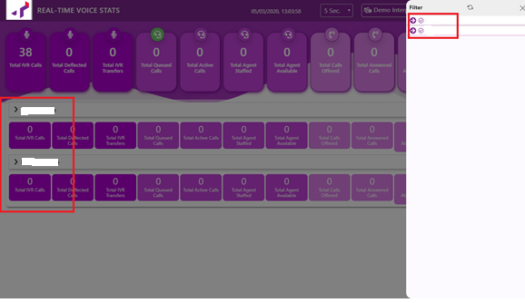
- Notification: Service level notification will be popped in the UI, if this option is enabled
- Grid View: This will move top grids displayed, horizontally or vertically as per business needs

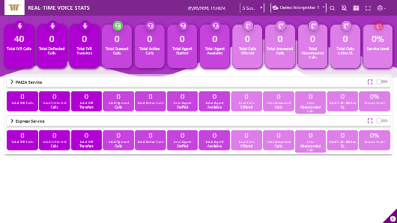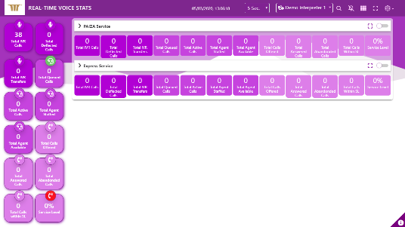

- Full Screen: Click on this icon to maximize the screen
- Settings: Use can enable/disable the dashboard counters here.
To Enable: Check the checkbox present right in front of the options
To Disable: Uncheck the checkbox present right in front of the options

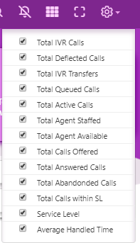
Only enabled options will be displayed in UI as shown below
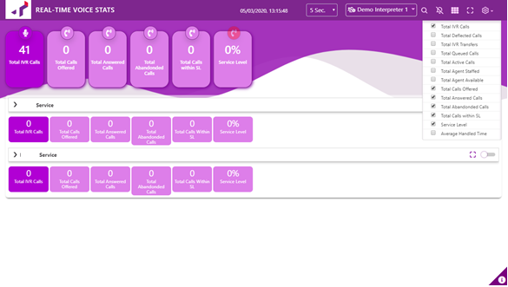

- System File version: Application dll and js file version numbers will be displayed here

CC Level Grid Details
All the callflows which are enabled will be displayed in UI as shown below.
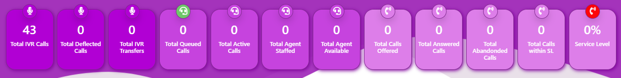
- Total IVR Calls: total count of ivr calls will be displayed here.
- Total Calls Dropped at IVR: total count of calls will is transferred to Agent, but dropped at IVR end will be displayed here.
- Total Deflected Calls: total count of deflected calls hit will be displayed here
- Total IVR Transfers: total calls which are transferred to Agents will be displayed here
- Total Queued Calls: total number of calls which are in queue will be displayed here
- Total Active Calls: total number of active calls will be displayed here
- Total Agent Staffed: total number of agents who are staffed (agents in all the status) will be displayed here
- Total Agent Available: total number of agents who are in AVAILABLE status will be displayed here
- Total Calls Offered: total number of calls which are offered to the agents will be displayed here
- Max waiting time at the CM: Maximum waiting time of the call at CM will be displayed here
- Average Handling Time: Average handling time of the call at CM will be displayed here
- Average Hold Time: Average call hold time at CM will be displayed here
- Average Waiting Time: Average waiting time of the call at CM will be displayed here
- Average ACW Time: Average ACW time at CM will be displayed here
- Total Answered Calls: total number of calls which are answered by the agents will be displayed here
- Total Abandoned Calls: Total number of rejected/unanswered calls will be displayed here
- Total Calls within SL: Total number of calls which are completed within SL will be displayed here
- Service Level: Overall Service level will be displayed here

CC Level Grid Technical Information
Field | Data Source | Data Point | Calculation
Total IVR Calls | Interpreter | totalCalls | totalCalls in each callflow dnis/intent selected will be summed up here
Total Deflected Calls | Interpreter | totalSelfServiceInteractions | totalSelfServiceInteractions in each callflow dnis/intent selected will be summed up here
Total Calls Dropped at IVR | Interpreter | totalInteractionsDisconnected | totalInteractionsDisconnected in each callflow dnis/intent selected will be summed up here
Total IVR Transfers | Interpreter | totalInteractionsTransferToAgent | totalInteractionsTransferToAgent in each callflow dnis/intent selected will be summed up here
Total Queued Calls | Tetherfi TRealtimeData Service-TMAC Proxy | interactionsInQueue | Sum (Calls In Queue)
Total Active Calls | Tetherfi TRealtimeData Service- TMAC Proxy | activeInteractions
Total Agents Staffed | Tetherfi TRealtimeData Service- TMAC Proxy | totalAgentStaffed
Total Agents Available | Tetherfi TRealtimeData Service- TMAC Proxy | totalAgentAvailable | Sum (Agents in ready state)
Total Calls Offered | Tetherfi TRealtimeData Service--DB | (activeInteractionsSummary)+ (abandonInteractionsSummary) | Total Call Offered = Total ACD Calls + Total Abandoned Calls
Max Waiting Time at CM | Tetherfi TRealtimeData Service—DB | oldestInteractionWaitTime
Average Waiting Time at CM | Tetherfi TRealtimeData Service—DB | averageWaitingTime | Sum of averageWaitingTime value from Skills in the callflow)/(Number of Skills
Average ACW Time | Tetherfi TRealtimeData Service—DB | averageACWTime | (Sum of averageACWTime value from Skills in the callflow)/(Number of Skills)
Average Hold Time | Tetherfi TRealtimeData Service—DB | averageHoldTime | (Sum of averageHoldTime value from Skills in the callflow)/(Number of Skills)
Average Handling Time | Tetherfi TRealtimeData Service--DB | Aht | (Sum of aht value from Skills in the callflow)/(Number of Skills)
Total Answered Calls | Tetherfi TRealtimeData Service--DB | activeInteractionsSummary | Sum of activeInteractionsSummary value from Skills in the callflow
Total Abandoned Calls | Tetherfi TRealtimeData Service--DB | abandonInteractionsSummary | Sum of abandonInteractionsSummary value from Skills in the callflow
Total Calls Within SL | Tetherfi TRealtimeData Service--DB | callsAnsweredWithinSL | Sum of callsAnsweredWithinSL value from Skills in the callflow
Service Level | Tetherfi TRealtimeData Service--DB | slPercentage | Average SL =(Sum of SL value from Skills in the callflow)/(Number of Skills)

Group Level Grid Details
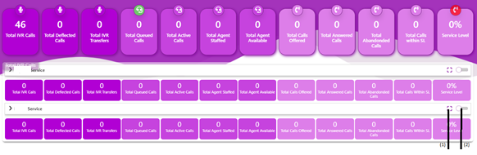
- Maximize: Users can also see the detailed information of each callflow in a maximized screen upon clicking on this button
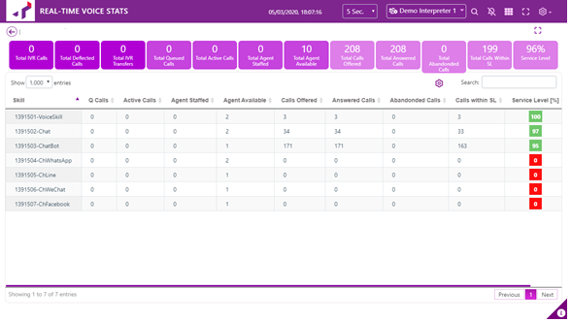
- Skill: all skill assigned present in the CM will be displayed here
- Q Calls: Calls present in the queue for the specified skill of the callflow will be displayed here
- Active Calls: Active Calls for the specified skill of the callflow will be displayed here
- Agents Staffed: Agent staffed for the specified skill of the callflow will be displayed here
- Agents Available: Agent available for the specified skill of the callflow will be displayed here
- Calls Offered: total number of the calls offered to the specified skill of the callflow will be displayed here
- Answered Calls: total number of the calls answered by the agents who has the specified skill of the callflow will be displayed here
- Abandoned Calls: total number of the abandon calls hit to the specified skill of the callflow will be displayed here
- Calls within SL: total number of the calls answered by the agents within SL to the specified skill of the callflow will be displayed here
- Service Level: service level for each skill will be displayed here
- AHT: Average handled time will be displayed here
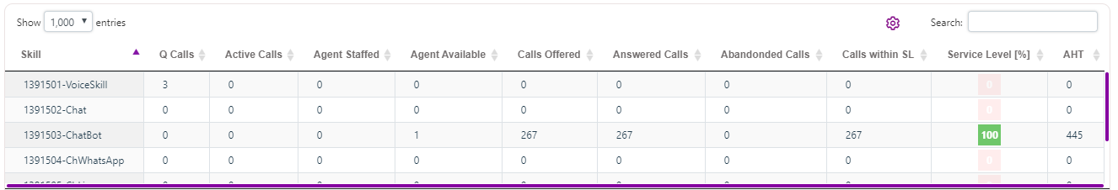
- Expand: Upon expanding the callflow, detailed information like number of active calls, number of calls in queue, agent available, agents staffed, call offered, call answered, abandon calls, service level specific to each skill will be displayed.

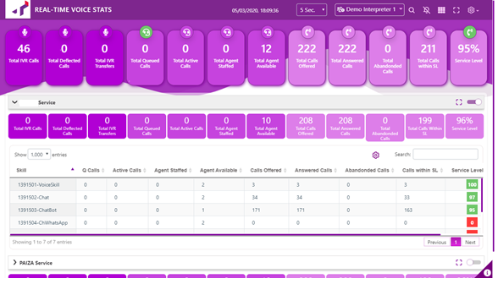
Each group can be displayed in different color based on user’s requirement as shown below.
To display, each group in colour, set the color in MBSVoiceStats.js file as shown below
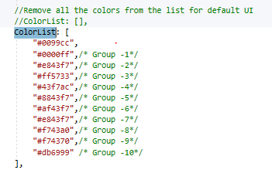
File Location: Script/AppSpecific/AppEvents
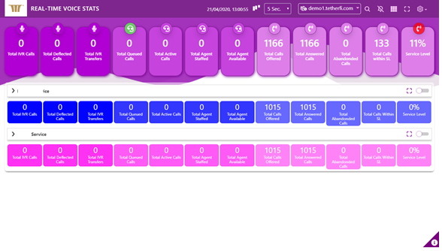

Group Level Grid Technical Information
Field | Data Source | Data Point | Calculation
Hotline | Interpreter
Skill Name | Tetherfi TRealtimeData Service--DB | realtimeSkillBean->skillName
Skill ID | Tetherfi TRealtimeData Service--DB | realtimeSkillBean->skillId
Q Calls | Tetherfi TRealtimeData Service--DB | realtimeSkillBean->interactionsInQueue
Active Calls | Tetherfi TRealtimeData Service--DB | realtimeSkillBean->activeInteractions
Agents Staffed | Tetherfi TRealtimeData Service--DB | realtimeSkillBean->totalAgentStaffed
Agents Available | Tetherfi TRealtimeData Service--DB | realtimeSkillBean->totalAgentAvailable
Calls Offered | Tetherfi TRealtimeData Service--DB | (realtimeSkillBean->activeInteractionsSummary)+ (realtimeSkillBean->abandonInteractionsSummary) | [Total ACD + Total Abandonded Calls]
Answered Calls | Tetherfi TRealtimeData Service--DB | realtimeSkillBean->activeInteractionsSummary
Abandoned Calls | Tetherfi TRealtimeData Service--DB | realtimeSkillBean->abandonInteractionsSummary
Calls within SL | Tetherfi TRealtimeData Service--DB
Service Level | Tetherfi TRealtimeData Service--DB | realtimeSkillBean->slPercentage
Average Handle Time [AHT] | Tetherfi TRealtimeData Service--DB | realtimeSkillBean->aht

Real Time Interaction Stat Dashboard
This dashboard shows the real time Active node count along with skill information.
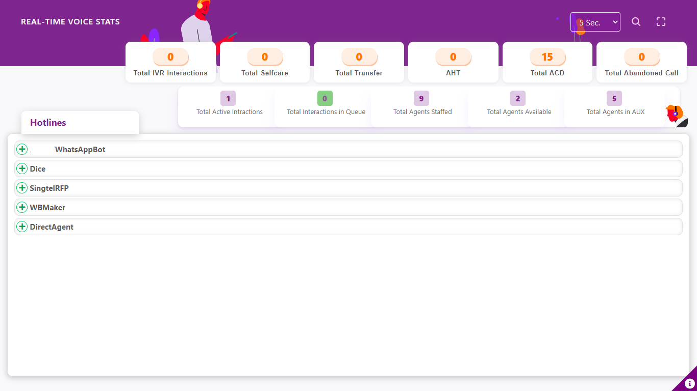
For a live Call, Active node count will be displayed in ‘Active Node Count’ Section. When there is a Agent Transfer, ‘Agent Node Count’ section will be updated.
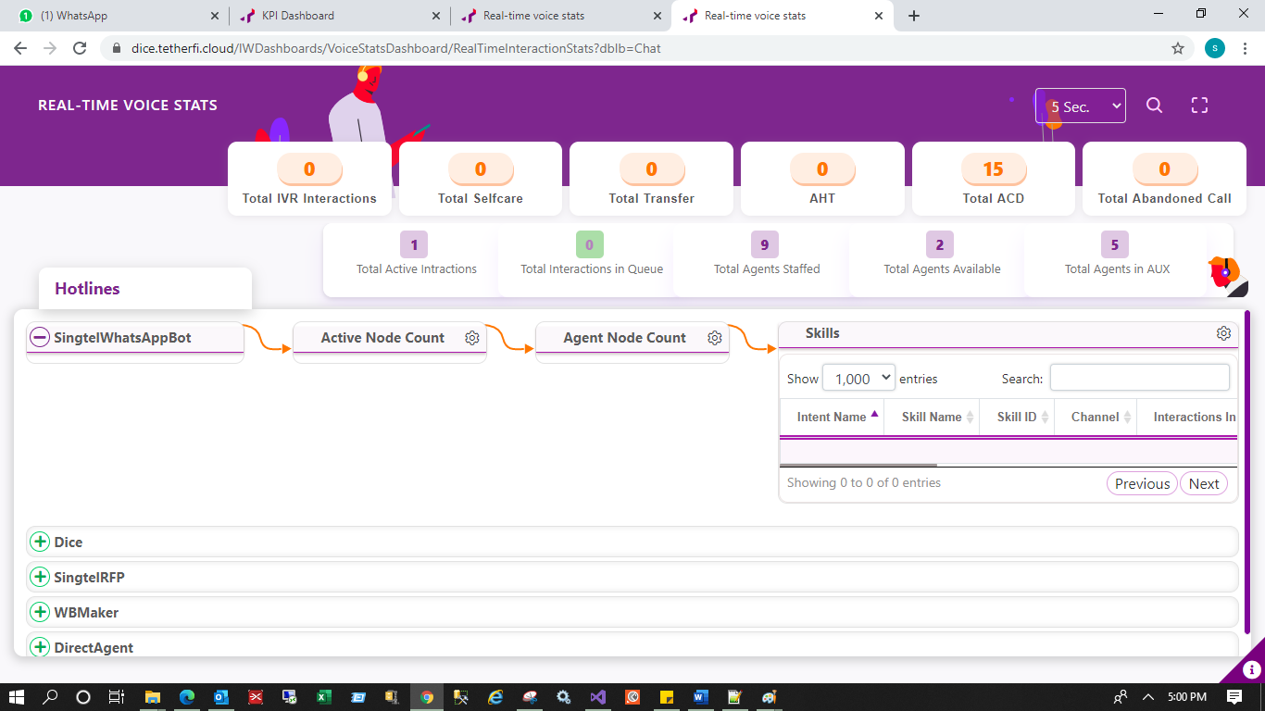
Skill information for the callflow selected is also be displayed as shown below.
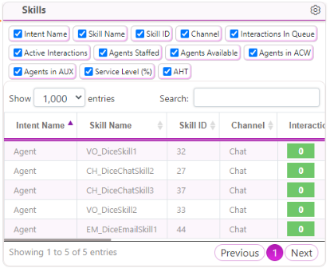

6. Technical Information
No | IW Method | Interpreter Method | Component | Dashboard | Output
1 | GetCallFlow | GetCallFlow | Interpreter | KPI | Sends all the callflow list along with DNIS
3 | GetCallFlowObjects | GetCallFlowObjects | Interpreter | 1.KPI  2.RealTimeInteractionStats | Sends all the callflow list along with DNIS
3 | GetDashboardData | GetDashboardData | Interpreter | RealTimeInteractionStats | 1.callFlow  2.intentRealtimeCountMap  3.dnisRealtimeCountMap  4.realtimeSkillBean  5.realtimeNodeCountMap  6.callFlowVolumeInfo
4 | GetGlobalSessionInfoPage | GetGlobalSessionInfoPage | Interpreter | Session | 1.Total Session  2.Node details
5 | GetIntentSkillMap | GetIntentSkillMap | Interpreter | RealTimeInteractionStats | Agent transfer intent and associated skill id
6 | GetRealtimeDataForAllSkills | GetRealtimeDataForAllSkills | TRealTimeService | 1.RealTimeCC  2.RealTimeInteractionStats | Individual Skill datais returned
7 | HistoricalKPICallflow | GetFlowDnisMap | Interpreter | KPI | Analysis Data
8 | HistoricalKPIDurationBasedNodeCount | HistoricalKPIDurationBasedNodeCount | Interpreter | KPI | Callflow data on each date
9 | SearchFilterSessionInfo | SearchFilterSessionInfo | Interpreter | Session | Search
10 | HistoricalKPIGetDayFlowDnisBasedNodeCount | GetDayFlowDnisBasedNodeCount | Interpreter | KPI | Entire Callflow info for Historical Dates
11 | GetDurationBasedNodeCount?duration=Today | GetDurationBasedNodeCount?duration=Today | Interpreter | KPI | Callflow data on currents date

