|  |
| --- |
| **Interaction Workflow** |
| **Queueflow Designer User Guide** |
| Document Version: 6.0  Last Updated Date: 2021 April 9 |
|  |

**Version History**

|  |  |  |  |  |  |
| --- | --- | --- | --- | --- | --- |
| **Version #** | **Implemented**  **By** | **Revision**  **Date** | **Approved**  **By** | **Approval**  **Date** | **Description of Change** |
| 1.0 | Deepthi Shetty | 23/02/2021 |  |  | Initial version of Queueflow Designer user guide |

**Copyright**

All rights reserved. No part of this product may be reproduced, transmitted, transcribed, stored in a retrieval system, or translated into any language in any form by any means without the express written permission of Tetherfi.

**Warranty Information**

Tetherfi makes no representations or warranties with respect to the contents or use of this product and specifically disclaims any express or implied warranties of merchantability or fitness for any purpose. Information in this document is subject to change without notice and does not represent a commitment on the part of Tetherfi.

**Trademark Information**

Tetherfi is a registered trademark of Tetherfi. Other product names may be trademarks or registered trademarks of their respective companies.

**Contact Information**

For customer inquiries, contact: For technical support inquiries, call:

Tetherfi +65 6715 7408

60 Paya Lebar Road,

#06-01 Paya Lebar Square,

Singapore

**Contents**

1 Introduction 6

1.1 **Intended Audience** 6

1.2 **Scope of document** 7

1.3 **Glossary** 7

2 Overview 8

2.1 **System Architecture** 10

2.2 **Interface Design** 11

3 Access Details 12

3.1 **OCM Access** 12

3.1.1 Role Based Access Management 13

3.1.2 User Role Mapping 14

3.1.3 IW Role Based Access Matrix 16

3.1.4 IW Master Access Matrix 20

3.2 **Database Table Access** 23

4 Interaction Workflow User Roles 25

4.1 **Maker** 25

4.1.1 Import Callflow 28

4.1.2 Copy Callflow 29

4.1.3 Callflow Version Control 32

4.1.4 Rule Master 33

4.1.5 Intent Master 38

4.1.6 Rules Viewer 39

4.1.7 Comments 41

4.1.8 Search for Nodes and Modules 42

4.1.9 File System Version 43

4.1.10 Session Master 44

4.2 **Checker** 44

4.2.1 Approve Now 47

4.2.2 Scheduled Later 47

4.3 **Previewer** 48

4.4 **Maker and Checker** 51

5 Creating/Editing Workflows 54

5.1 **Configure Callflow** 54

5.1.1 Callflow List 55

5.1.2 Preview 55

5.1.3 New Workqueue Flow 56

5.1.4 Delete 57

5.2 **Designing the Workflow** 57

5.2.1 Tabs 57

5.2.2 More Menu Option 63

5.2.3 Set Rules 66

5.2.4 Callflow Sync Notification 67

6 Nodes and Modules 72

6.1 **Nodes** 72

6.1.1 Queue to Skill Node 73

6.1.2 Conditional Node 74

6.1.3 Assignment Node 76

6.1.4 Entry Point Node 78

6.1.5 Exit Point Node 80

6.1.6 Flow Connector node 82

6.1.7 Return Node 84

6.1.8 Node Connectivity 86

6.2 **Modules** 88

6.2.1 IW Module Designer 91

6.3 **Connecting Nodes and Modules** 91

7 Context Menu 92

7.1 **Drag Nodes** 93

7.2 **Remove ALL nodes Connected to This** 93

7.3 **Cut and Paste** 93

7.4 **Copy and Paste** 94

7.5 **Sticky Note** 95

8 Dashboard 97

9 Flow Status 99

9.1 **Flow status for various users** 99

9.2 **Draft** 100

9.3 **Saved** 100

9.4 **Send to approval** 101

9.5 **Checker Draft** 102

9.6 **Checker Save** 102

9.7 **Approved** 103

9.8 **Rejected** 104

9.9 **Scheduled** 105

9.10 **Static Flow related Buttons** 107

9.11 **Node Blink** 108

10 Use Case 109

Step 1: Creating a new MAIN NODE node- Skill (Level 1) 109

Step 2: Adding a new Queue to Skill (Level 2) 110

Step 3: Adding tab One Alongside Main tab (Level 3) 111

Step 4: Adding a new Entry Point to Tab One (Level 4) 112

Step 5: Adding an Exit points - (Level 5) 114

Step 6: Connecting Nodes and Modules (Level 6) 115

Step 7: Approval of Workflow: (Level 7) 116

# **Introduction**

Workflow is the definition, execution and automation of business processes where tasks, information or documents are passed from one participant to another for action, according to a set of procedural rules.

Tetherfi Interaction Workflow makes the process of Queueflow Designer more efficient, compliant, agile, and visible by ensuring that every process step is explicitly defined, monitored over time, and optimized for maximum productivity, reducing the time the process takes to complete as well as potential errors caused by human interaction. Given optimal, up-to-the-minute process data, managers and employees can take quicker action and make smarter decisions.

Tetherfi Interaction Workflow empowers business users and IT to work together to rapidly modify systems and processes to reflect changes in the business.

## **Intended Audience**

This user guide document is intended for the following audience:

* Business Users
* IT team
* Project Manager
* Application implementation team
* Application maintenance team

## **Scope of document**

This is a systematically written guide for users to manage the ‘Interaction Workflow’ application. By accessing and managing the Interaction Workflow application, users will be able to define/change certain behaviour of Queueflow Designer application according to their preferences or business requirements without needing any code change.

Web based GUI application will be provided for accessing the User Admin (Maker/Checker) & Reporting module and these modules will be deployed on the IIS web server provided by the Client.

## **Glossary**

|  |  |
| --- | --- |
| **Term or Acronym** | **Definition or Description** |
| **OCM** | Omni Channel Management |
| **IW** | Interaction Workflow |
| **QD** | QueueFlow designer |
| **DTMF** | Dual tone multi frequency |
| **GUI** | Graphical User Interface |
| **UI** | User Interface |
| **VDN** | Vector Directory Number |

# **Overview**

An Interaction Workflow is a series of connected blocks that performs various tasks for decision making and routing. Tetherfi Interaction Workflow Designer is a powerful, integrated development environment (IDE) that you can use to create, assemble, and customize workflows. With Tetherfi Interaction Workflow, you can:

* Create the custom nodes and modules in Interaction Workflow and reuse the same in different workflows. You do not need any external tools or block definition languages.
* You do not need to convert the flowchart. You can directly integrate the newly created/ edited workflow into production.

**Rearranging connection**:

Any of the nodes can be moved in the Workflow Designer interface to a different part of the call flow. To move an interface element:

1. Use the mouse to select and hold the items.
2. Drag the element to the desired position and release.

Connection points can be rearranged, if the default connection points, on a block do not meet the needs of the workflow. For example, if the Yes connection of a decision block is on the right, that connection can be moved to the bottom.

**IW Features**:

List of tasks that can be achieved using interaction workflow:

1. Create menus with options.
2. Add/Remove options.
3. Rearranging the option sequence.
4. Enable/disable options based on the rule.
5. Attach the self-help module to an option.
6. Configure the input parameters required for the modules.
7. Perform conditional checks based on rule.
8. Add routing configuration node and assign VDN’s.
9. Maker/Checker/Previewer.
10. Copy and paste the nodes.
11. Reversion/Scheduling
12. Highlight the specific changes when submitted to checker. This would avoid the need to look at each node to understand the changes.
13. Add rules based on time, date, date range and operational variables.
14. Multiple tabs. It helps to create the reusable flows and break the complex flows into multiple tabs
15. Comments from the maker/checker is displayed under notifications.
16. Text to Voice option is provided.
17. Anonymous user Access
18. IW Role Based Access Matrix
19. Rearranging Tabs
20. Copy- paste Tabs
21. Node search
22. Sub Flow design

**Workflow Preview**:

The Workflow Preview is a virtual window of your workflow. Use the Workflow Preview to:

* Navigate the workflow
* Change the amount of workflow that you view at one time
* Zoom in on a section of the workflow
* See the whole workflow

Workflows save time and certainly ensure transparency and reproducibility. They also can do a lot more. Consider these ten benefits of incorporating workflows in your project management.

1. Workflows reduce project risk. When a project is at risk, it elevates project complexity and the number of team members can increase. Workflows can ensure that there are decreased delays in the schedule. It can also be responsible for reducing possible disputes and costs by limiting the need to redo work.
2. Effect organizational change. When a team works cohesively, it limits the need for management to intervene on the business process side and can provide an improved understanding of the workflow.
3. Implementing workflows can lead to process change. As part of developing a workflow, businesses must scrutinize their current processes. This can lead to improvements and optimizations.
4. Workflows give increased access to information. Critical processes may be reviewed at every point, ensuring that there are no bottlenecks or issues. This oversight allows project managers to determine how well the process is running from end-to-end.
5. Workflows delineate work responsibility to different people. Instead of your staff being uncertain about whose responsibility it is to complete a task or where their own duties lie, a workflow defines it for them.
6. Improves project timeline estimates. Gives project managers a basis to estimate how long a task or the overall project will take.
7. Provides visibility. Workflows are a way to visually communicate the process to stakeholders.
8. Managers can focus on strategy. When a system is running smoothly, managers don’t need to spend time focusing on operations. Instead, they can pay attention to other parts of their job, which can promote business growth and development.
9. Workflows provide an audit trail. This is especially true when using a workflow management software system. Records are kept of the progress and completion of tasks, along with pertinent details such as who completed the action, when it was done, and any changes made.
10. Businesses can input rules. Instead of people deciding in the moment when issues arise, workflows refer to the predefined rules. This eliminates some of the guesswork, saving time and boosting confidence in the organization’s work capacity.

## **System Architecture**

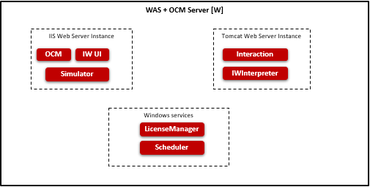

* OCM (Omni Channel Management): Web based application to administer the data and generate the reports.
* IW (Interaction Workflow): Web based application to create and manage the call flows.
* IWInterpreter: It interprets the data submitted from IW and converts it into expected format. It does Callflow validations.
* Interaction: It process the call flows configured using IW.
* License Manager: It maintains the license details and indicates whether the software can run on the system.
* Scheduler: It process the scheduled task.
* Simulator: It provides the details required to enable simulator.

## **Interface Design**

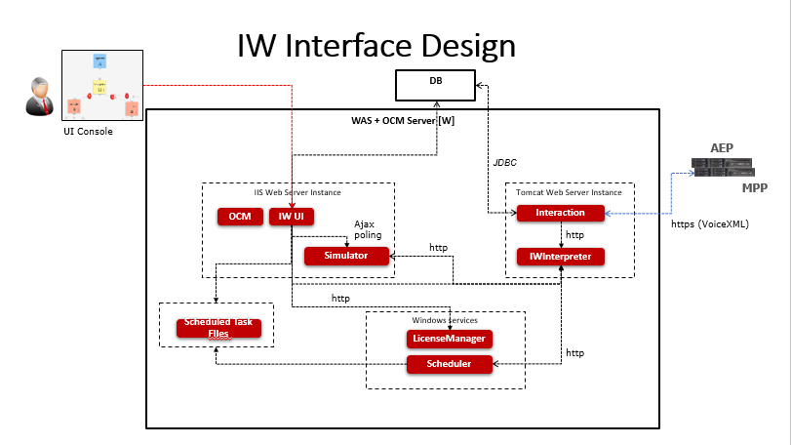

* IW UI talks to License Manager to very whether license is available when launching IW UI.
* Changes made in UI is saved locally in JSON format and submitted to IWInterpreter.
* IWInterpreter validates the JSON submitted and stores the data in memory. It also stores the data in JSON file. It would read the data from file when server restarted.
* Interaction Engine retrieves the flow details from IWInterpreter based on DNIS and renders the VXML.
* IW UI saves the scheduled task details in JSON.
* IW Scheduler retrieves the scheduled task from JSON and submits updated Callflow to IWInterpreter. IWInterpreter updates the memory and local JSON file.
* IW Simulator provides the data required to simulate the flow in IW UI.
* Reporting information is stored in DB.

# **Access Details**

Interaction Workflow is designed to be compatible with below web browser:

* Microsoft Internet Explorer (IE 11 or above)
* Google Chrome (Chrome version 23, 39, 43, 45, 50 or above)
* Firefox (version 41)
* Microsoft Internet Information Services (IIS version 7 and above)

## **OCM Access**

For accessing Interaction Workflow, OCM must be accessed first. The procedure for accessing OCM is mentioned below.

The user must type the provided OCM link(http://IP:PORT/OCM) in the browser and press ‘Enter’ key, OCM will prompt user to enter his Windows username and password.

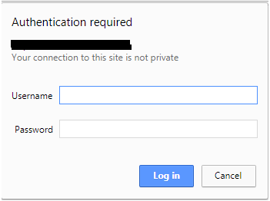

After successful authentication, the below screen will be displayed.

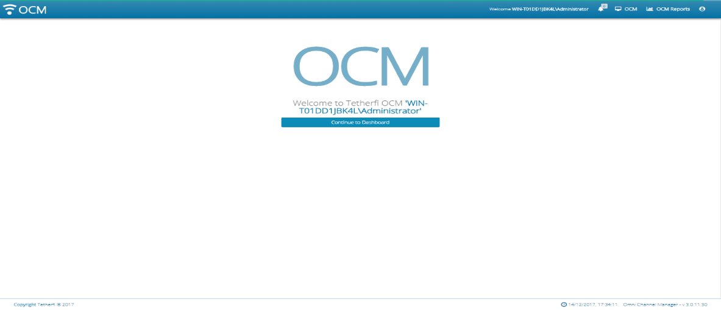

All Users will be presented with the OCM Dashboards.

Administrator is allowed to create maker/checker (or both)/previewer:

Upon logging into OCM, IW Role Based Access Matrix, Role Based Access Management and User Role Mapping modules will be displayed in Home section.

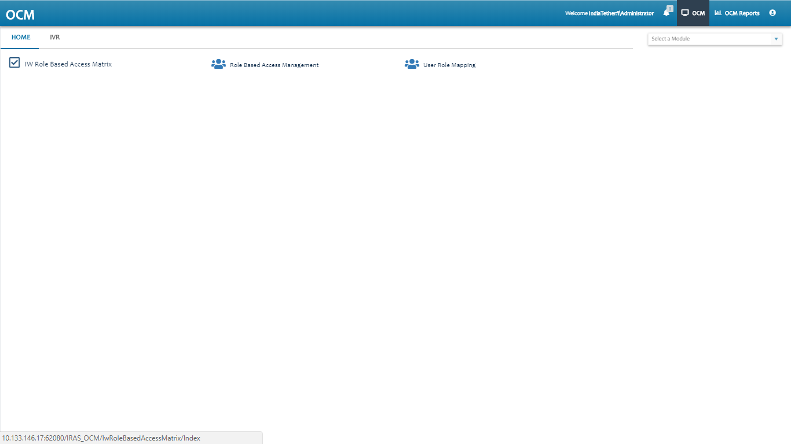

### Role Based Access Management

This module is used to add the roles. Upon clicking this module following window will open and all the roles added will display here.

User can add new role, by clicking ‘Add New Role Based Access Management Record’ button present at top left corner.

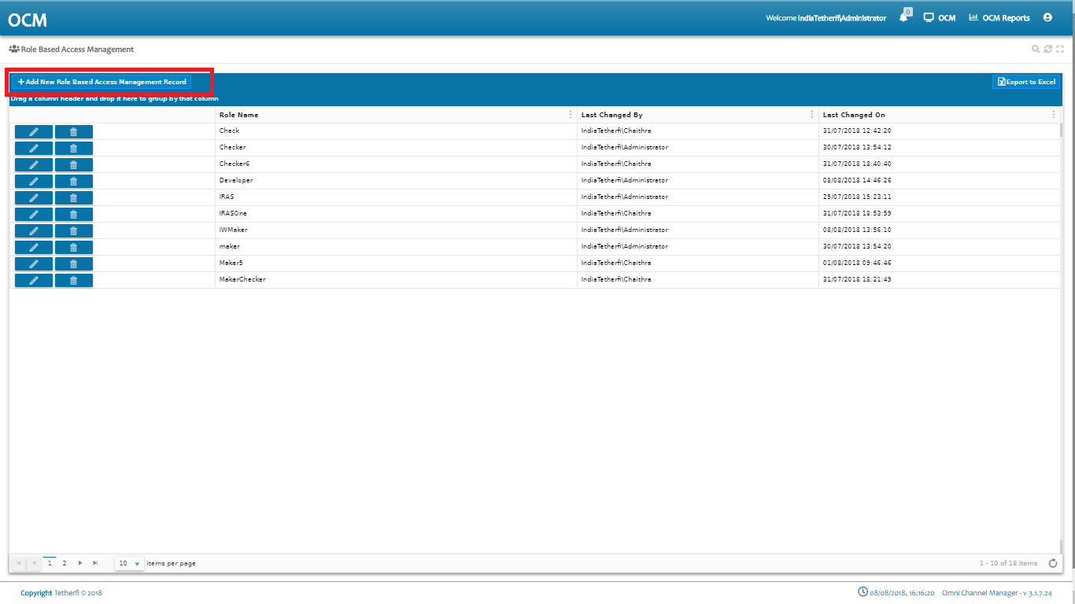

Upon clicking ‘Add New Role Based Access Management Record’, Following popup will generate. User can create new Role here.

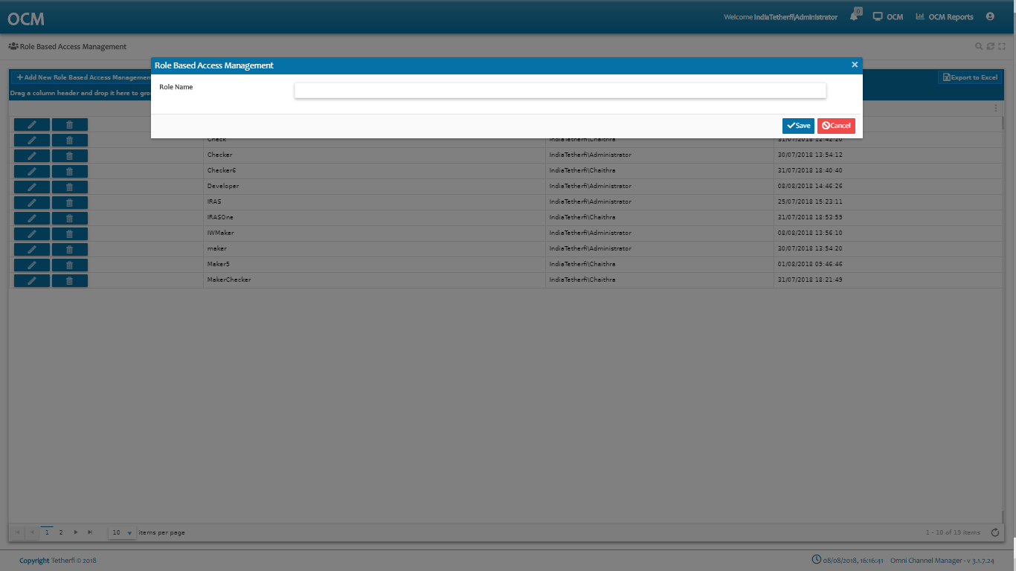

Functionalities to the newly added role can be given, by clicking on the new role added.

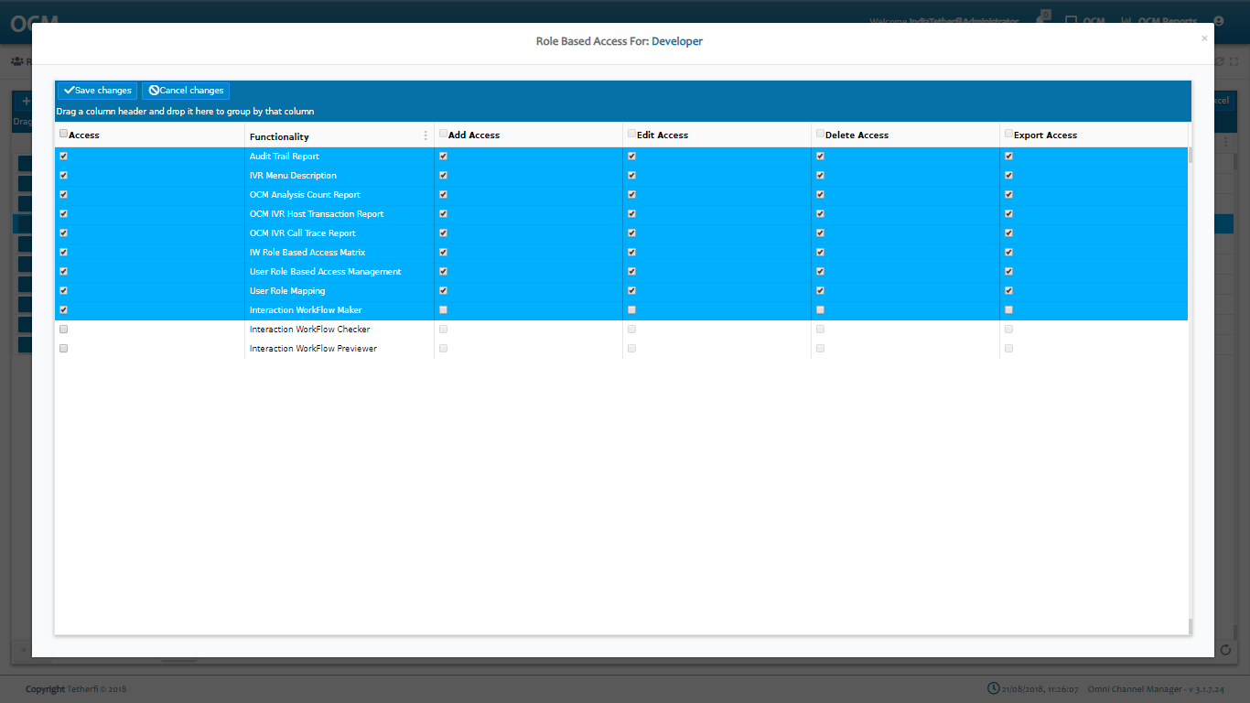

### User Role Mapping

This module is used to add new role mapping record. Upon clicking this module following window will open and all the previously added records will be displayed.

User can add new role mapping record, by clicking ‘Add New User Role Mapping Record’ button present at top left corner.

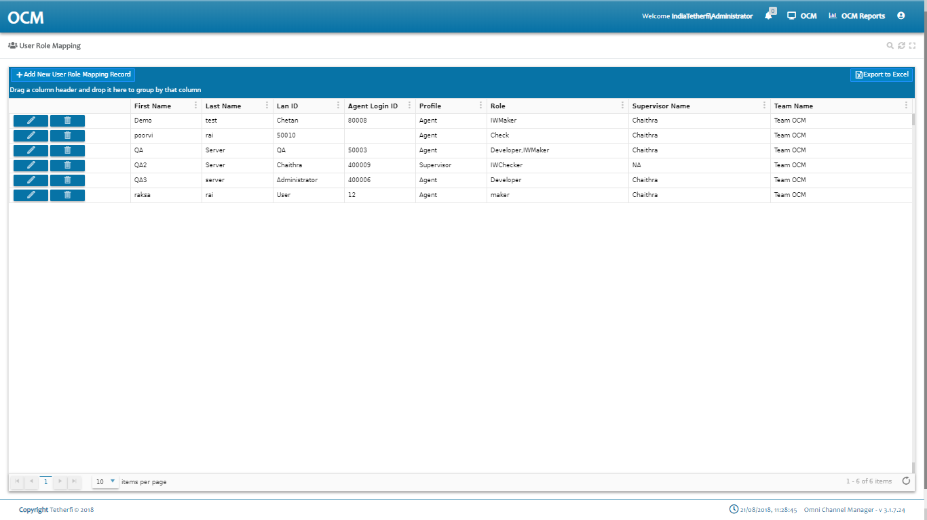

Upon clicking ‘Add New User Role Mapping Record’, Following popup will generate. User can create new Role mapping record here.

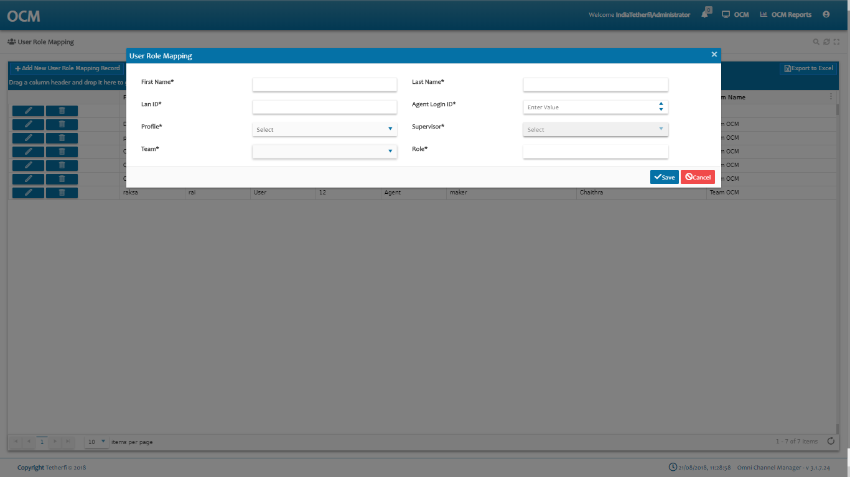

The Admin must assign a role to the user added here which is created in ‘Role Based Access Management’ module, like: Maker, Checker etc

Lan ID is user system name.

Login ID is Avaya login id.

### IW Role Based Access Matrix

Upon clicking ‘IW Role Based Access Matrix’ module, all the roles created will be displayed as shown below.

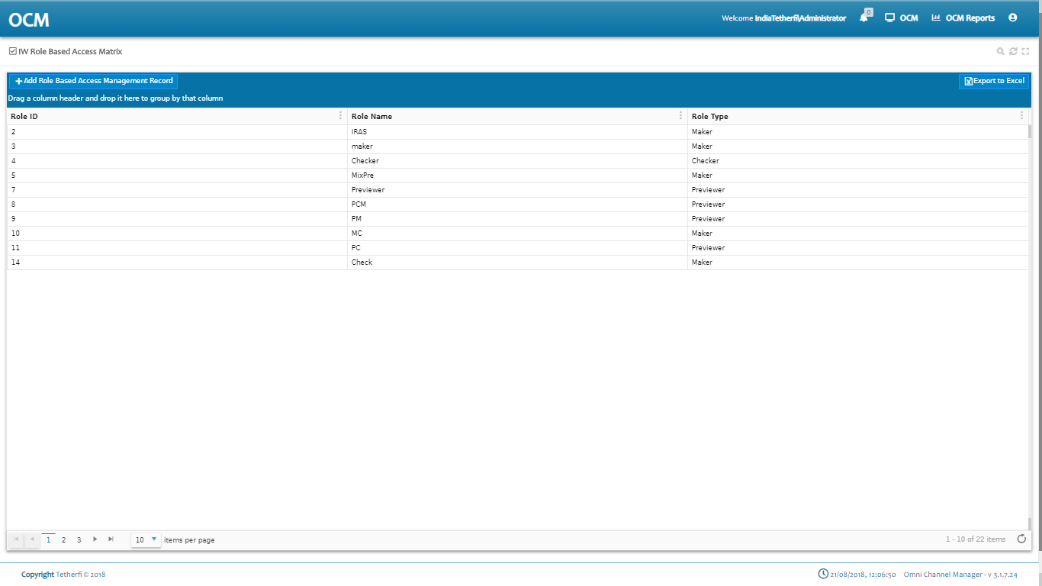

Upon selecting the any role, all the callflows created at IW page will be displayed as shown below.

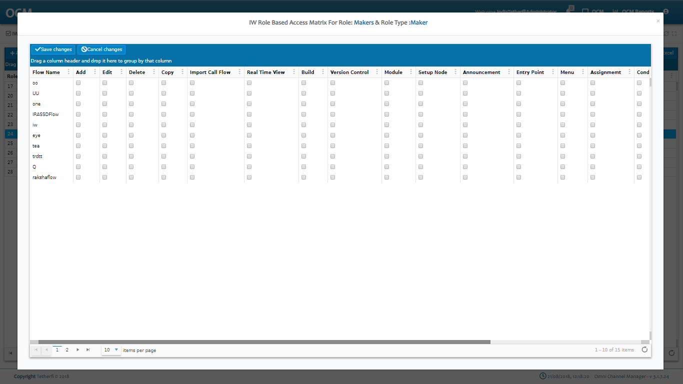

Note: *For a newly created callflows, entry will be made in OCM only after saving the callflow in IW*.

*Upon saving the callflow in IW, entry is made in ‘IW Role Based Access Matrix’ page and all the functionalities are disabled by default*.

Admin must give the permission to user by checking the options provided in OCM for user to perform any activities on callflows.

When user has 2 or more roles, access to the callflows will be provided as per below table.

|  |  |  |  |  |
| --- | --- | --- | --- | --- |
| **Sl.No** | **Role1** | **Role2** | **Role3** | **Output** |
| 1 | Maker | Checker | Previewer | Access Provided to **Previewer** Role will be in effect. For any combination with **Previewer** role, access provided to P**reviewer** will be in effect |
| 2 | Maker | Checker |  | Access provided to **Maker** Role will be in effect (Maker Role has higher priority than Checker) |
| 3 | Maker | Maker |  | Query will check for the higher Role Id (2 is higher than 1) in CMM_Roles table and Access provided to that role will be in effect. |
| 4 | Checker | Checker |  | Query will check for the higher Role Id (2 is higher than 1) in CMM_Roles table and Access provided to that role will be in effect. |
| 5 | Previewer | Previewer |  | Query will check for the higher Role Id (2 is higher than 1) in CMM_Roles table and Access provided to that role will be in effect. |

#### Callflow Level Roles

|  |  |
| --- | --- |
| **Action** | **Description** |
| **Flow Name** | Callflow names will be displayed here after saving the callflow |
| **Edit** | Enable or Disable Edit permission to callflow in IW. This option must be checked in OCM page for giving the permission for the roles to edit callflow, send the callflow for approval, approve, schedule, reject or put checker comments to the callflows  Upon Enabling Owner Level Callflow option, only the callflows for which edit option is enabled will be displayed for the user in dashboard as well as configure callflow drop down list. |
| **Delete** | Enable or Disable Delete callflow option in IW (ref section Delete Callflow)  *Note: only owner of the callflow can delete the callflows.* |
| **Copy** | Enable or disable copy callflow in IW (ref section Copy Callflow) |
| **Import Callflow** | Enable or disable Import callflow in IW (ref section Import Callflow) |
| **Real Time View** | Enable or disable Realtime callflow view in IW (ref section Real-Time View/Report) |
| **Build** | Enable or disable build/package a callflow (ref. section Import Callflow) |
| **Version Control:** | This option must be checked in OCM page for giving the permission for the roles to revert the callflow to previously approved version and only owner of the callflow can revert to the previous approved version. (ref section Callflow Version Control ) |
| **Module** | This option must be checked in OCM page for giving the permission for the roles to add, edit (including adding or removing existing connections and checker comments) and delete the modules present in the callflow. |
| **Setup Node**: | This option must be checked in OCM page for giving the permission for the roles to edit (including adding or removing existing connections and checker comments) the DNIS node present in the callflow. |

#### Node Level Roles

|  |  |
| --- | --- |
| **Action** | **Decryptions** |
| **Announcement** | This option must be checked in OCM page for giving the permission for the roles to add, edit (including adding or removing existing connections and checker comments) and delete the announcement nodes present in the callflow. (ref section Announcement Node ) |
| **Entry Point** | This option must be checked in OCM page for giving the permission for the roles to add, edit (including adding or removing existing connections and checker comments) and delete the entry nodes present in the callflow. (ref section Entry Point Node) |
| **Menu** | This option must be checked in OCM page for giving the permission for the roles to add, edit (including adding or removing existing connections and checker comments) and delete the menu nodes present in the callflow. (ref section Menu node) |
| **Assignment** | This option must be checked in OCM page for giving the permission for the roles to add, edit (including adding or removing existing connections and checker comments) and delete the assignment nodes present in the callflow. (ref section Assignment Node) |
| **Conditional** | This option must be checked in OCM page for giving the permission for the roles to add, edit (including adding or removing existing connections and checker comments) and delete the conditional nodes present in the callflow. (ref section Conditional Node) |
| **Disconnect** | This option must be checked in OCM page for giving the permission for the roles to add, edit (including adding or removing existing connections and checker comments) and delete the disconnect nodes present in the callflow.(ref section Disconnect Node) |
| **Agent** | This option must be checked in OCM page for giving the permission for the roles to add, edit (including adding or removing existing connections and checker comments) and delete the Agent nodes present in the callflow. (ref section Agent Node) |
| **Exit Point** | This option must be checked in OCM page for giving the permission for the roles to add, edit (including adding or removing existing connections and checker comments) and delete the Exit point nodes present in the callflow.(ref section Exit Point Node) |
| **Prompt and Collect** | This option must be checked in OCM page for giving the permission for the roles to add, edit (including adding or removing existing connections and checker comments) and delete the announcement nodes present in the callflow.(ref section Prompt and Collect Node) |
| **Return** | This option must be checked in OCM page for giving the permission for the roles to add, edit (including adding or removing existing connections and checker comments) and delete the Return nodes present in the callflow. (ref section Return Node) |
| **Flow Connector** | This option must be checked in OCM page for giving the permission for the roles to add, edit (including adding or removing existing connections and checker comments) and delete the Flow connector nodes present in the callflow. (ref section Flow Connector node) |

### IW Master Access Matrix

This option will be displayed in OCM ‘Home’ channel. This module is used to provide access to the IW Masters for a particular Roles/ security group. Upon clicking ‘IW Master Access Matrix’ module, all the roles created will be displayed as shown below.



Upon selecting the any role/security group, all the masters along with Create new IWFlow, OrderTake Flow and Subflow options will be displayed as shown below.

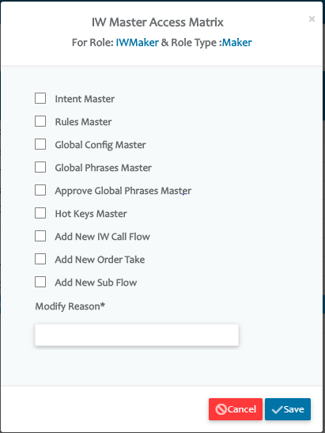

When ‘EnableAccessRules’ option in IW Webconfig is set to 1, then by default, user won’t be having access to any masters including options to create new IW, OrderTake or Subflows. Error toaster **‘This option is not enabled for current user’** is displayed when user clicks on any master options.

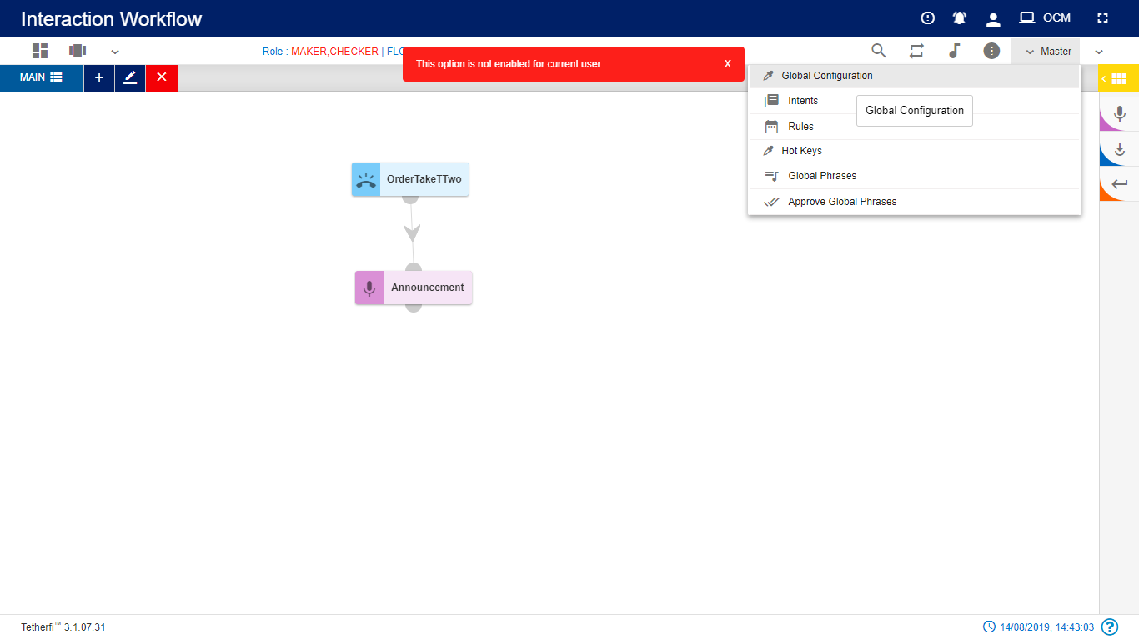

Admin must give the permission to user by checking the options provided in OCM ‘IW Master Access Matrix’ for the roles assigned to the user to edit the masters.

For Role Type Checker and Previewer, ‘Add New IW Callflow’, ‘Add New OrderTake’ and ‘Add New Sub Flow’ options will be disabled.

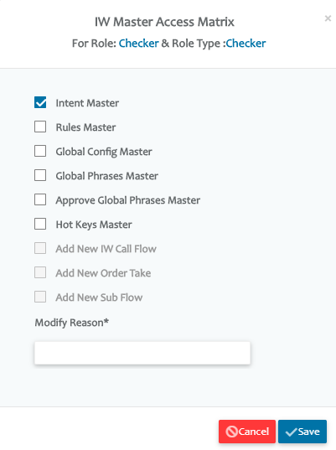

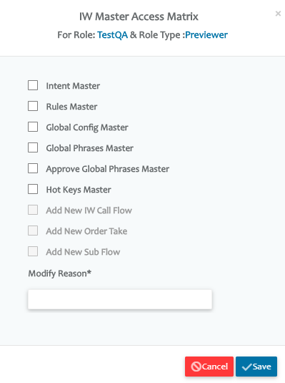

When user has 2 or more roles, access to the master will be provided as per below table.

|  |  |  |  |  |
| --- | --- | --- | --- | --- |
| **Sl.No** | **Role1** | **Role2** | **Role3** | **Output** |
| 1 | Maker | Checker | Previewer | Access Provided to **Previewer** Role will be in effect. For any combination with **Previewer** role, access provided to P**reviewer** will be in effect |
| 2 | Maker | Checker |  | Access provided to **Maker** Role will be in effect (Maker Role has higher priority than Checker) |
| 3 | Maker | Maker |  | Query will check for the higher Role Id (2 is higher than 1) in CMM_Roles table and Access provided to that role will be in effect. |
| 4 | Checker | Checker |  | Query will check for the higher Role Id (2 is higher than 1) in CMM_Roles table and Access provided to that role will be in effect. |
| 5 | Previewer | Previewer |  | Query will check for the higher Role Id (2 is higher than 1) in CMM_Roles table and Access provided to that role will be in effect. |

## **Database Table Access**

To add the users directly to the db tables instead of using OCM, follow below steps

* 1. Add a new Role in **CMM_Roles** table

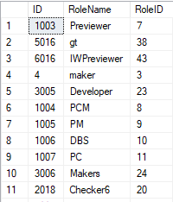

* 1. Provide IW Chat Maker/ Checker/ Previewer access to the roles in **CMM_Role_Pages** Table

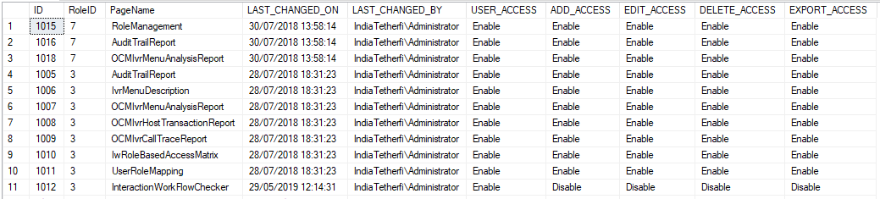

# **Interaction Workflow** **User Roles**

The Interaction Workflow application will have following user roles:

1. Maker
2. Checker
3. Previewer
4. Maker and Checker

When the product is first delivered, the Admin user of OCM (details to be provided by business users) will allot the users as Interaction Workflow Maker/Checker (or both) by using OCM User Management module (ref section OCM Access).

Only the Admin can add new user, change user role and delete user.

|  |  |  |  |  |
| --- | --- | --- | --- | --- |
| **User Functionality** | **Previewer** | **Maker** | **Checker** | **Maker and Checker** |
| **Create** | No | Yes | No | Yes |
| **Edit** | No | Yes | No | Yes |
| **Delete** | No | Yes | No | Yes |
| **Schedule** | No | No | Yes | Yes |
| **Approve** | No | No | Yes | Yes |
| **Reject** | No | No | Yes | Yes |
| **Preview** | Yes | Yes | Yes | Yes |
| **Comment** | No | Yes | Yes | Yes |

## **Maker**

Interaction Workflow Maker has the privileges to create / view / edit / delete workflows.

All the changes made to Interaction Workflow by Maker **need to be approved by Checker** before being implemented to the system.

When user login as a maker (without loading any callflow), following page will be displayed.

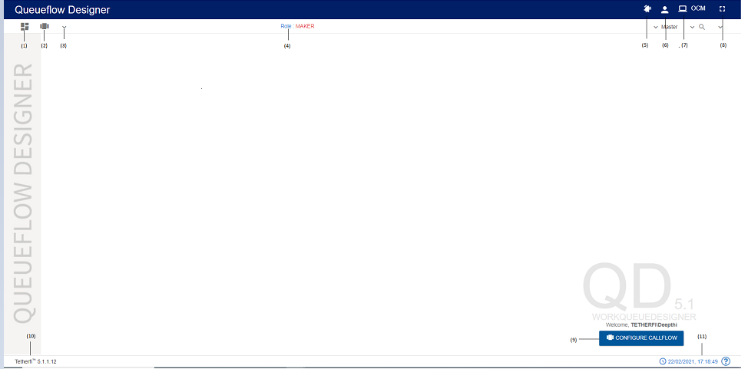

1. Dashboard: callflow dashboard. (ref section Dashboard )
2. Configure Callflow: This option is used to create a new flow/ Preview a flow/Order Take/Delete a callflow. (ref section Configure Callflow)
3. More Menus: Upon clicking this button following options will appear.
4. Import callflow: (ref section Import Callflow)
5. Copy callflow: refer section Copy Callflow
6. Real-Time View/Report: refer section Real-Time View/Report
7. Text to Voice: refer section Text to Voice
8. Role: Displays the role of the user i.e. Checker
9. Callflow Notifications: Notifications related to Callflow status.
10. Current User Info: User’s domain name/ user name and for logging out of Interaction Workflow module.
11. Redirect to OCM: This option will redirect to OCM page.
12. Full Screen: This option is used to view the Interaction Workflow in full screen. (Press “Esc”/F11 button to go back to normal view.
13. At the bottom right corner of the page, welcome message is displayed along with user’s domain name/user name. Configure callflow option is also provided here.
14. Current IW version
15. System date and time will be displayed here.

When user login as a maker and load a callflow, following page will be displayed.

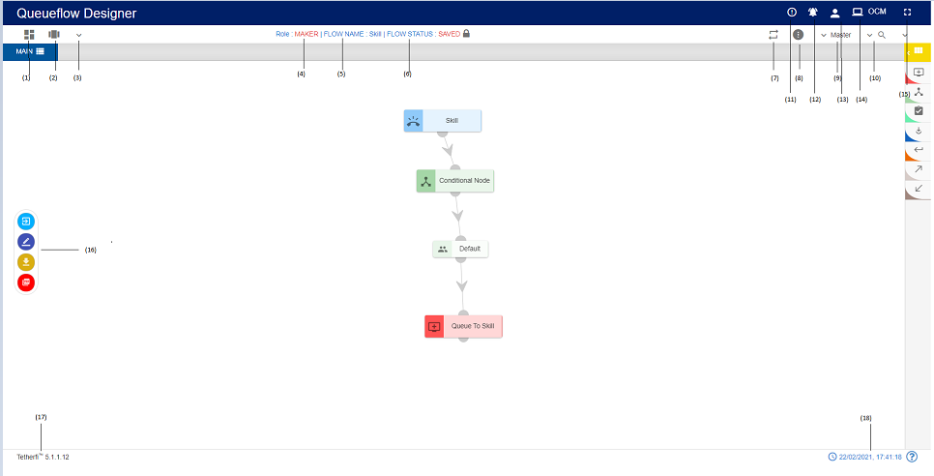

1. Dashboard: callflow dashboard. (ref section Dashboard )
2. Configure Callflow: This option is used to create a new flow/ Preview a flow/Order Take/Delete a callflow. refer section Configure Callflow
3. More Menus: Upon clicking this button following options will appear.
4. Import callflow: ref section Import Callflow)
5. Copy callflow: refer section Copy Callflow
6. Role: Displays role of the user i.e. Maker
7. Flow Name: Name of the flow will be displayed here
8. Flow Status: Current callflow flow status will be displayed here
9. Rules Viewer: refer section [Rules Viewer](Rules%20Viewer)
10. Information: This option is used for information related to the user and Interaction Workflow version.
11. Master: Upon clicking this button following options will appear.
12. Intents: refer section Intent Master
13. Rules: refer section Rule Master
14. Session Master: refer section Session Master
15. Search for Nodes: refer section Search for nodes
16. Flow Comments: refer section Comments
17. Flow Notification: This option is used to check all the notifications related to Interaction Workflow
18. Current User Info: This option is used to know User’s domain name/ user name and for logging out of Interaction Workflow module.
19. Redirect to OCM: This option will redirect to OCM page.
20. Full Screen: This option is used to view the Interaction Workflow in full screen. (Press “Esc”/F11 button to go back to normal view)
21. More Menus: refer section More Menu Option
22. Current IW version is displayed here.
23. Current system date and time will be displayed here.

### Import Callflow

Import callflow option is used to import external callflow that we build/packaged in other systems.

Click ‘More Menus’ option from top left corner in maker/maker-checker page, following popup will be generating.

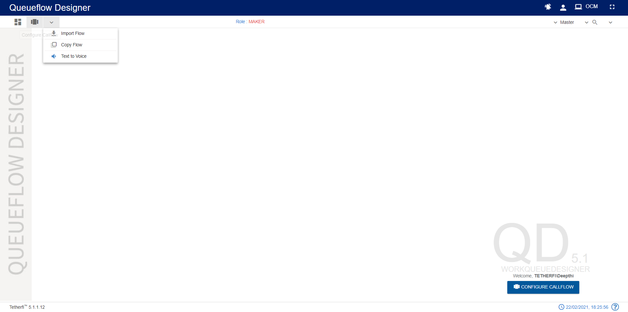

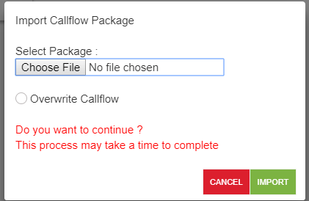

The package that is generated/zipped using ‘Callflow Build/Package’ (refer section Dashboard) option in IW can be imported here.

Note: phrases of the Imported flow are also uploaded to the interpreter. All the imported flows will be in draft status and user is automatically changed to the user of the page where imported the flow.

Imported flow must have a wav files uploaded.Only zip files can be imported here.

User can import only the flows, whose version number is greater than the APPROVED status flow present in the system. ‘Flow with higher version number already present in the system’ error message is displayed.

If there is no APPROVED status flow for a flow, then UNAPPROVED version of the flow is overridden when importing the flow.

Upon successfully importing the flow to the system, success message will be generating in UI as shown below.

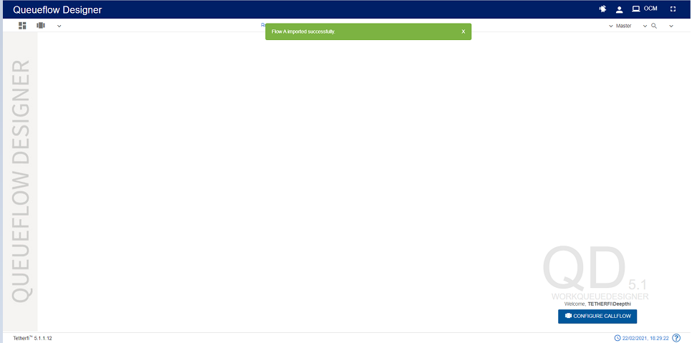

### Copy Callflow

This option is to create the copy of the callflow. Copied callflow will be in DRAFT status and created and modified date will be same.

Upon clicking on ‘More Menus’ option present at top left corner in maker/maker-checker page, following popup will be generating.



Upon clicking this option, following popup will be generated.

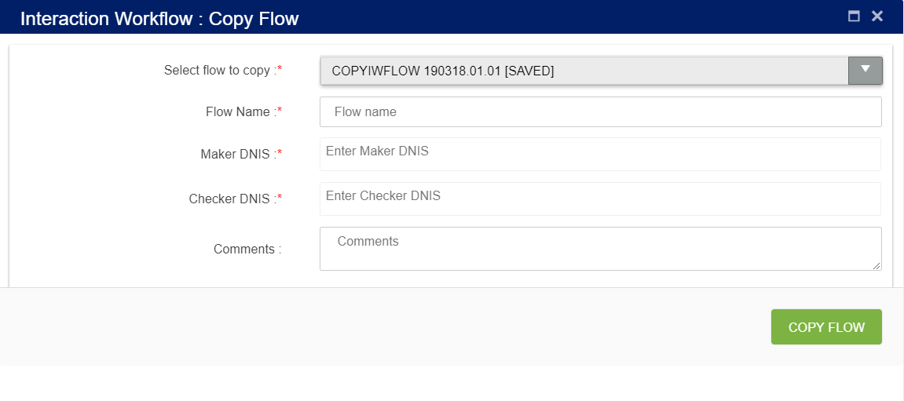

**Select callflow to copy**: upon clicking on this drop down main flow, sub flows and order take flows will appear as shown below.

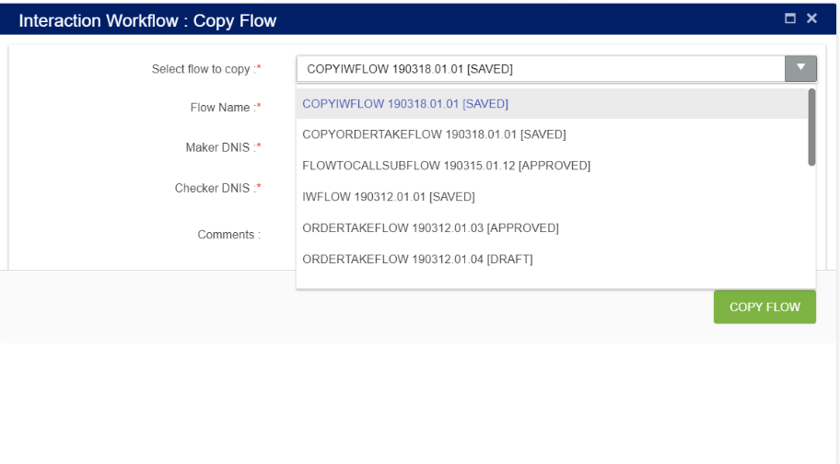

#### Copying IW Flow:

when user selects order take flow from the drop-down following screen will appear

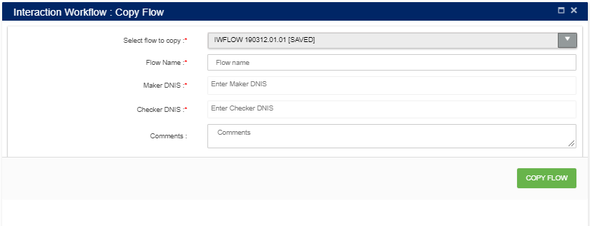

Flow name**:** name of the call flow.

Maker DNIS and Checker DNIS: Create a new callflow with unique name and DNIS (Maker and Checker DNIS should be unique throughout callflow). This option is provided only for the user who has ‘Maker’ credentials and Maker can copy only callflow with status ‘**Draft’** and ‘**Saved’**.

Upon clicking ‘COPY FLOW’ button, new callflow will be created based on the callflow name specified, which will be exact copy of selected callflow.

### Callflow Version Control

Callflow version control option will appear in ‘More Menus’ option only when the selected callflow is in ‘draft status. Version control is a system that records changes over time so that you can recall specific versions later. In callflow version control system, user can revert their changes to specific approved version.

Only Makers have the privilege to revert callflows that are in draft state.

Click the ‘Callflow version control’ option as shown below.

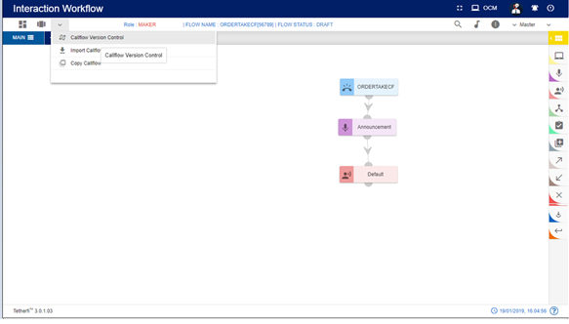

On click of “Call flow version control” button, below screen will be displayed.

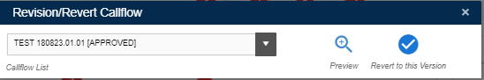

* Select the workflow that has to be revised/ reverted from the “Callflow List”. The previously ‘approved’ callflow names will be shown in the callflow list.
* “Preview” helps the users to confirm to which callflow they want to revert.
* ‘Revert to this version’ – Reverts the opened DRAFT callflow to selected APPROVED callflow.

Upon clicking ‘Revert to this Version’ button, following confirmation popup will generate.

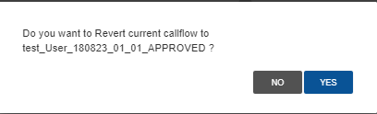

Upon reverting, callflow will be in saved status.

If there is no previous APPROVED version of the selected DRAFT callflow, then ‘Reversion Callflow does not exist’ error message will generate.

### Rule Master

This option will appear for the Maker, Checker and Previewer also. But only Maker can add rules. Checker and Previewer will be in read-only mode.

A rule is a principle or regulation or governing procedure for operation of IVR with respect to a node or module.

Only Makers have the privilege of creating/ editing rules.

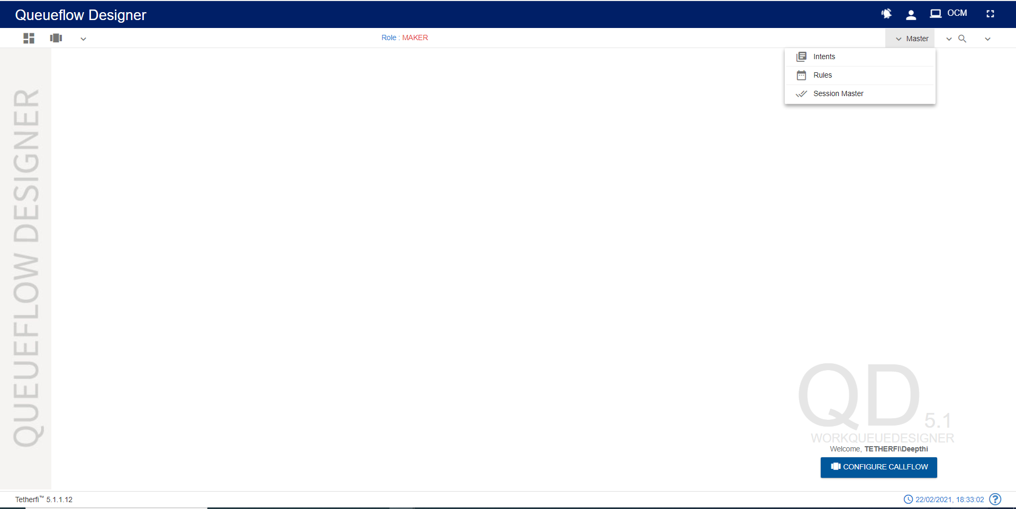

Maker can create/ edit rules by clicking on the button shown in the above figure.

Upon clicking ‘Rule Master’ icon, following popup will generate.

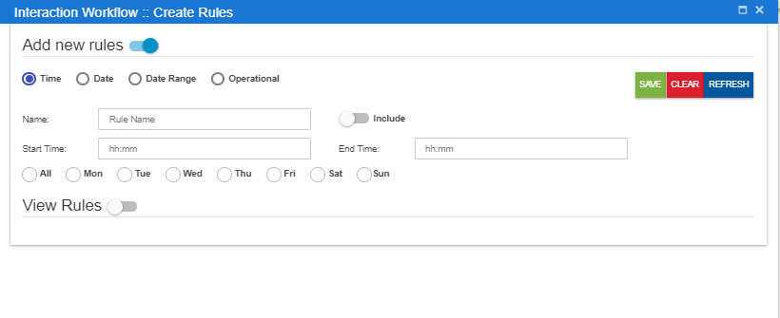**Save**: This button is used to add the rules to the grid i.e. Save the rule.

**Clear**: This option is used to clear the fields entered.

**Refresh:** This option is used to refresh the rule master window and load the latest rules to the grid.

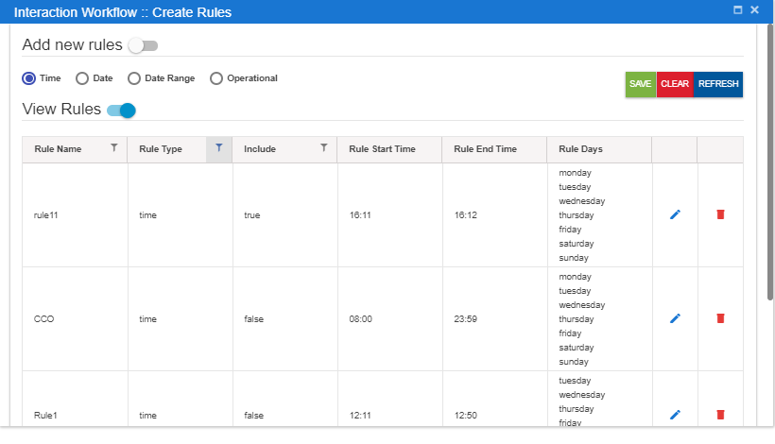

* For creating new rules, the Maker needs to select “Add new rules” option.
* There are four main types of rules: Time, Date, Date Range and Operational.
* On enabling of “Add new rules” option, the above popup will generate

#### Time

You need to set the Name of this rule, Start and End time alongside the weekdays that you want the rule to be active and whether you want to include this rule in the Callflow. You need to click Save, for saving the rule and Clear, for discarding the rule.

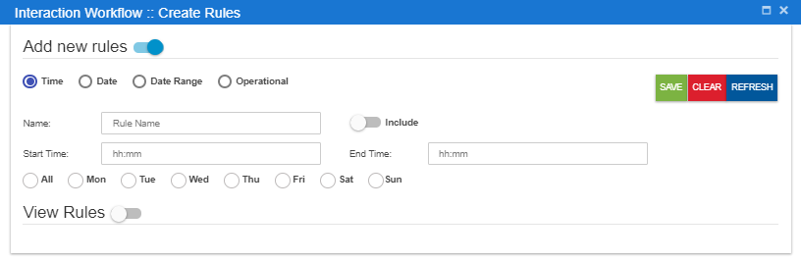

#### Date

You need to set the Name of this rule, date at which you want the rule to be active and whether you want to include this rule in the Callflow. You need to click Save, for saving the rule and Clear, for discarding the rule.

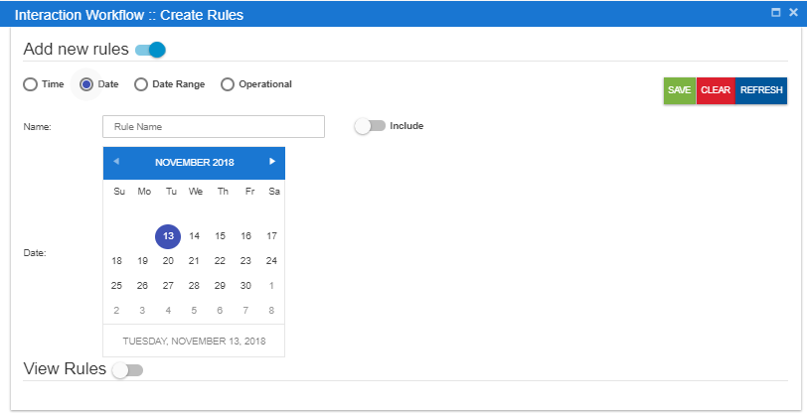

#### Date Range

You need to set the Name of this rule, Start and End date range you want the rule to be active. Click Save, for saving the rule and Clear, for discarding the rule.

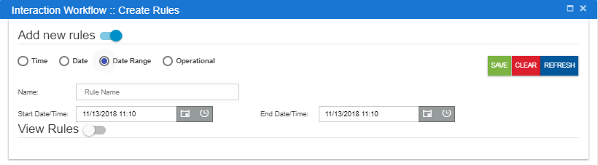

#### Operational

You need to set the Name of this rule, Variable 1 and Variable 2 alongside the operator you want the rule to be consist of and whether you want to include this rule In the Callflow. You need to click Save, for saving the rule and Clear, for discarding the rule.

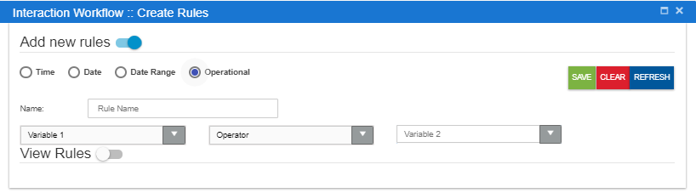

For editing/deleting the rule, click on the edit/ delete icon and make the necessary changes. Click Save, for saving the rule and Clear, for discarding the rule.

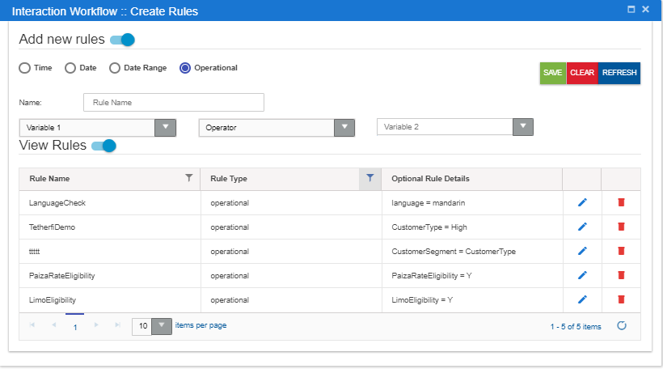

#### Callflow specific Rules

Rules can also be displayed specific to the callflow. Upon setting CallflowSpecific the key to TRUE, only the rules specific to the callflow will be displayed.

In this case, upon adding a new rule. It won’t be displayed in the **View Rules** grid. But user can use the rules added, in nodes as well as in legs in the callflow

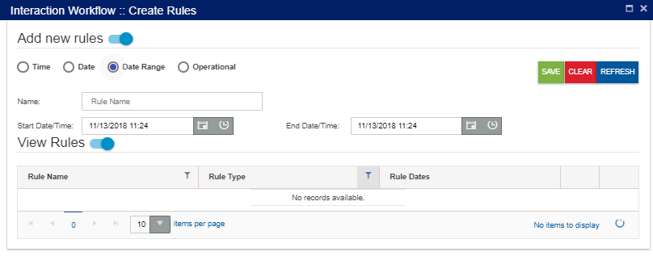

All the Rules added in rule master will be displayed in Set Rules window and user can use the rules in the callflow based on the requirements.

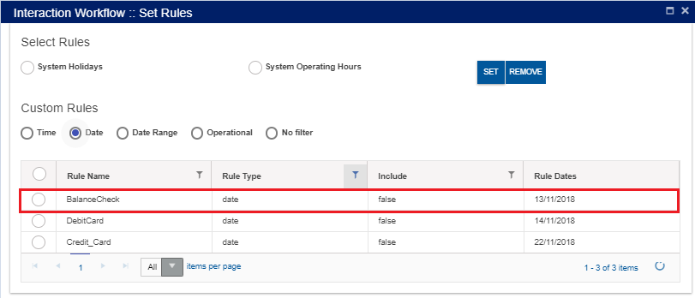

Only the rules used in the callflow will be displayed in the rule master in callflow specific rules option.

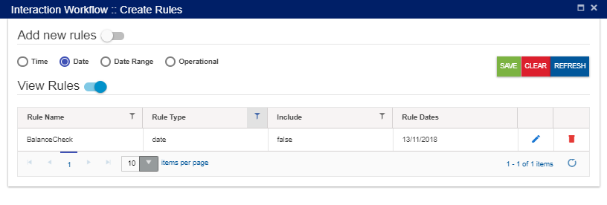

### Intent Master

This option will appear for the Maker, Checker and Previewer also. But only Maker can add intents. Checker and Previewer will be in read-only mode.

Upon clicking intent master icon following page will be displayed.

Intents are mapped to the VDN in the intent master page in IW. If the user gives any intent which is not mapped to VDN in intent master, it becomes invalid flow. User can add the intents in ‘intent master’ and map to the VDN.

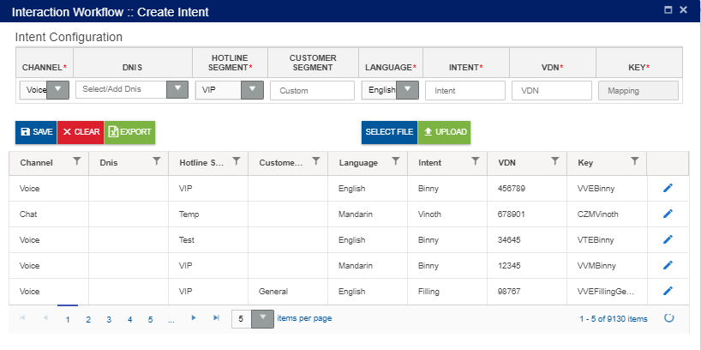

* + - Channel: This drop down contains list of configured channels
    - DNIS: DNIS is added here or user can select DNIS from the drop down.
    - Hotline Segment: User can select a Hotline segment from the drop down.
    - Customer Segment: This field accepts customer segment
    - **Language**: This drop down contains list of configured languages
    - Inten**t**: Intent provided here is added to the grid as well as Agent node. Intent need not be unique.
    - VDN: This field accepts VDN.
    - Key: Unique key is provided for every entry. This key is auto generated.

**Save**: Upon clicking ‘Save’ button, entries must be added to the grid and intent must be shown in Agent drop down.

**Clear**: This option is used to clear the entered field.

**Export**: Upon clicking this button, .csv extension file will be downloaded. This file contains all the contents of the grid.

**File Selection**: This option is used to select the file to be uploaded. Note that only .csv extension file can be uploaded. User can upload bulk amount of data.

**Upload**: This option is used to upload selected file. Upon clicking upload option, following popup will be generated. Duplicate files will not be uploaded.

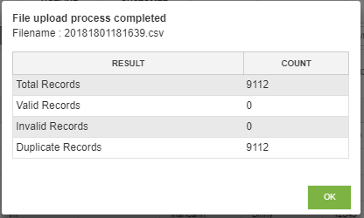

**Edit**: Click on the edit icon (right corner of each entry) to edit the details. User can edit only VDN field.

### Rules Viewer

This option will appear for all the roles i.e. maker, checker and previewer for the callflows of all the status.

Upon clicking rule viewer icon following pop window will be loaded.

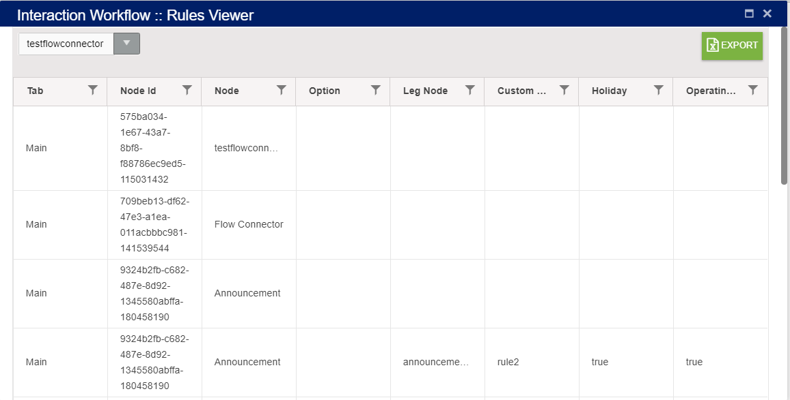

Rules viewer option shows all the rules added in menu leg, pnc leg and Validation, announcement and conditional node legs in the callflow along with each node id. This a a common place where all the node id’s used in the callflow can be viewed. user can select callflow from dropdown to view rules.

* Tab: specifies the tab of callflow
* NodeId: Id of that node.
* Node: this option displays node name.
* Option: node leg option will be displayed here.
* Leg Node: specifies leg node.
* Custom Rules: this is used to display rule name
* Holiday: this option will be true or false based on user selecting this when adding rules.
* Operating hours: this will display operating hours of rule.

Rule set for **Menu Node leg** will be displayed like this:

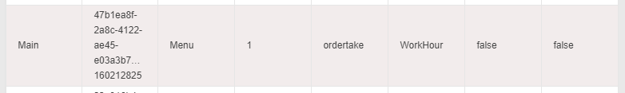

Rule set for **PNC Node leg and validation** will be displayed like this:

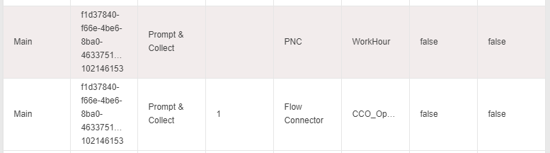

### Comments

Upon clicking comments icon following pop window will be displayed.

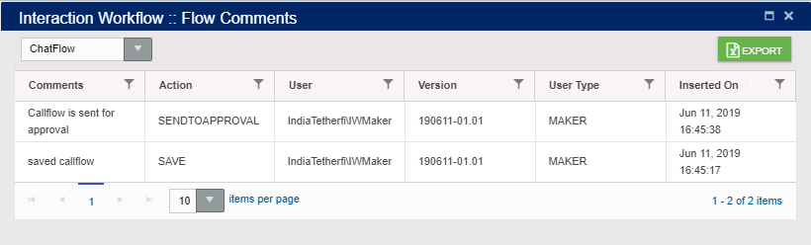

Comment option shows all the comments entered by the user whenever he does actions like ‘Save’ (both maker and checker) flow, ‘Send to approval’, ’Reject’, ’Approve’, ‘Scheduled’ the flow.

* Comments: specifies comments provided by the user.
* Action: specifies the status of the flow.
* User: shows username logged-in. The format as <Domain name \ username>.
* Version: specifies version number of the flow.
* User type: specifies type of the user like Maker, Checker.
* Inserted on specifies the date and time when user does add the comment.

Each columns header has the option to select and sort the records in ascending/descending order. These actions can be performed on clicking on table header.

Export:

Upon clicking this button, .csv extension file will be downloaded. This file contains all the contents of the grid. This option is available for all the roles i.e. maker, checker and previewer.

Dropdown:

Upon clicking on dropdown, all subflow connected to the flow will be listed. User can view the comments added to the subflows connected to the main flow here.

### Search for Nodes and Modules

This option is used to search for a node and module in a callflow using id or name. Upon clicking ‘Search for nodes’ icon following pop window will be displayed.

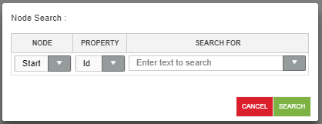

Node: This drop down contains list of nodes and module used in IW IVR except Entry, Exit and flow connector nodes.

Property: This drop down contains list of search criteria used to search for a node (Id and Name)

Search For: Text area where user will provide ID/Name detail.

For a valid search, control goes to the specific node and node starts blinking.

For an invalid search, ‘Given text does not exists in the current callflow’ error toaster is generated as shown below.

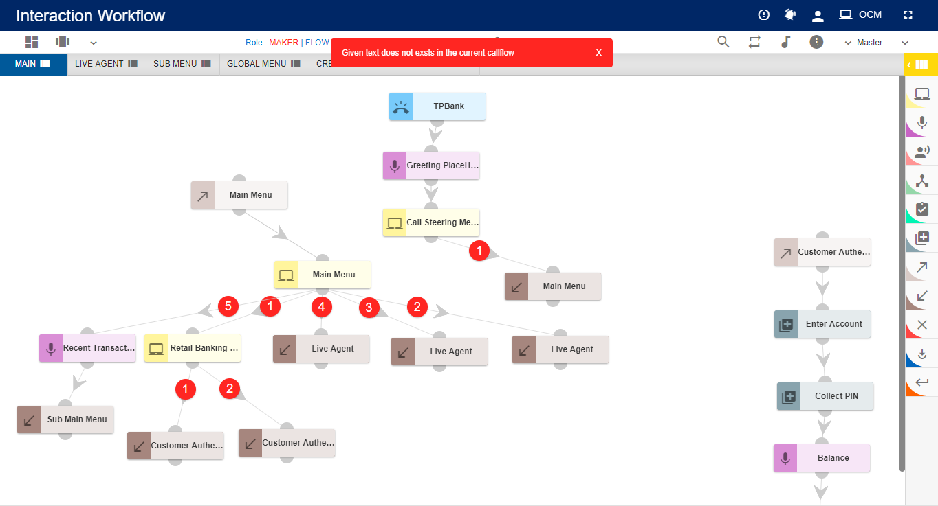

### File System Version

All the server components version number, interpreter link and websync link used by the application is displayed here.

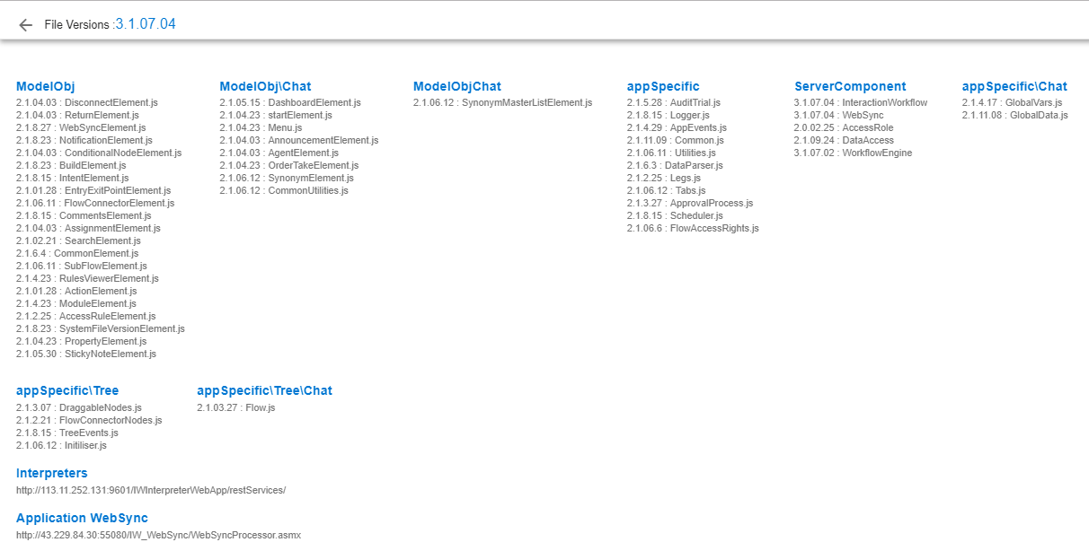

### Session Master

This option will appear for the Maker, Checker and Previewer also. But only Maker can add the session variable. Checker and Previewer will be in read-only mode.

This option is used for updating commonly used session variables in global master. User can configure the operational variables here. Session variable added here will be available in Module designer too.

Upon clicking session master icon following page will be displayed.

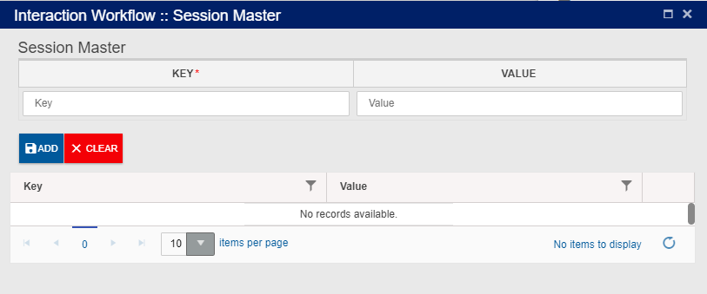

KEY: It is a mandatory field. Can accept characters as well as digits

Value: Not mandatory. Can accept characters as well as digits

**ADD**: Upon clicking the button, new entry will be added to the grid.

**Clear**: This button is used to clear the field

**Edit**: User can edit the Value field, except keys

## **Checker**

Interaction Workflow Checker has the privilege to preview/ approve / reject / schedule workflows.

***Note****: Checker cannot delete the callflows.*

When a user login as a checker (without loading any callflow), following page will be displayed.

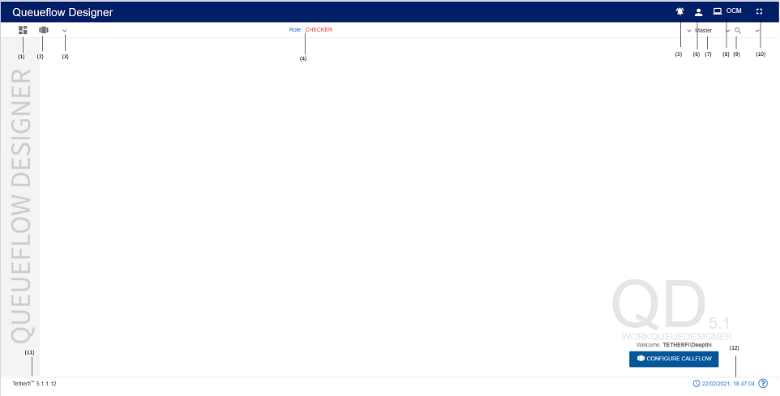

1. Dashboard: This option will redirect to dashboard. refer section Dashboard
2. Configure callflow: This option is used to Preview a flow. refer section Configure Callflow
3. More Menus: Upon clicking this button, following options will appear

(1) Real-Time View/Report – refer section Real-Time View/Report

1. Role: Displays the role of the user i.e. Checker
2. Flow Notifications: This option is used to check all the notifications related to Interaction Workflow
3. Current User Info: This option is used to know User’s domain name/ user name and for logging out of Interaction Workflow module.
4. Master: Upon clicking this button following options will appear.
5. Intents: refer section Intent Master
6. Rules: refer section Rule Master
7. Session Master: refer section Session Master
8. OCM: This option will redirect to OCM page.
9. Search for Nodes: refer section Search for nodes
10. Full Screen: This option is used to view the Interaction Workflow in full screen. (Press “Esc” button to go back to normal view)
11. Current IW version is displayed here.
12. System date and time will be displayed here
13. At the bottom right corner of the page, welcome message is displayed along with user’s domain name/user name. Configure callflow option is also provided here.

When a user login as a checker and load a callflow, following page will be displayed.

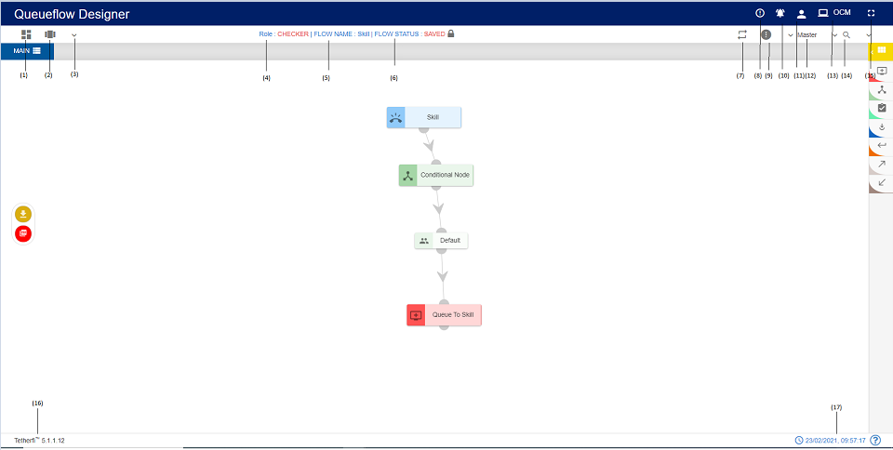

(1) Dashboard: This option will redirect to dashboard. refer section Dashboard

1. Configure callflow: This option is used to Preview a flow. refer section Configure Callflow
2. More Menus: Upon clicking this button, following options will appear
3. Role: Displays the role of the user i.e. Checker
4. Flow Name: Flow name will be displayed here.
5. Flow Status: Current callflow status will be displayed here.
6. Rules Viewer: refer section [Rules Viewer](Rules%20Viewer)
7. Flow Comments: refer section Comments
8. Information: This option is used for information related to the user and Interaction Workflow version.
9. Callflow Notifications: This option is used to check all the notifications related to Interaction Workflow
10. Current User Info: This option is used to know User’s domain name/ user name and for logging out of Interaction Workflow module.
11. Master: Upon clicking this button following options will appear.

1. Intents: refer section Intent Master

2.Rules: refer section Rule Master

3.Session Master: refer section Session Master

1. OCM: This option will redirect to OCM page
2. Search for Nodes: refer section Search for nodes
3. Full Screen: This option is used to view the Interaction Workflow in full screen. (Press “Esc” button to go back to normal view)
4. There are modules and nodes available here. But checker cannot use them (Checker cannot modify any callflow. He can either approve or reject a callflow)
5. Current IW version is displayed here.
6. Current system date and time will be displayed here.

The Maker is notified about Checker’s verification activity.

The Nodes/Modules to be modified/rechecked are highlighted.

Once the changes are approved or rejected it will reflect in IW- Maker as “Approved” or “Rejected”

All the changes and modifications done in Interaction Workflow will be displayed in OCM’s Audit trail report.

### Approve Now

Approve a callflow immediately. Checker has to enter comment section before approving any callflows. And callflow should be in SENTTOAPPROVAL or CEHCKERSAVED State before callflow apporve

*Note: in order to approve the callflow, there must be atleast 1 phrase uploaded to callflow.*

Upon approving, callflow status will be changed to APPROVED.

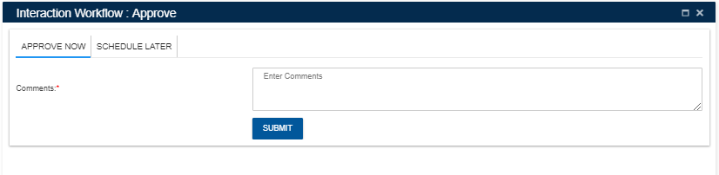

### Scheduled Later

A Checker can schedule a callflow approval to a specific date time.

When we select schedule later option tab, following popup is generated. Checker has to enter comments before scheduling a callflow approval.

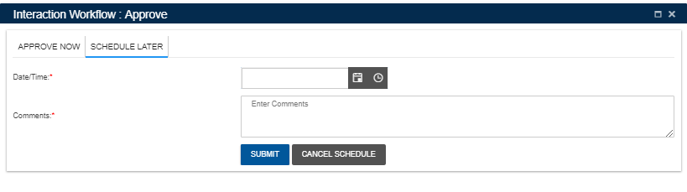

* Select scheduling date and time with comments
* Press ‘SUBMIT’ button.
* ‘CANCEL SCHEDULE’ button is used to cancel a scheduled callflow. This button will be disabled once callflow is added to schedule process.

Upon clicking ‘SUBMIT’ button, following confirmation popup will generate.

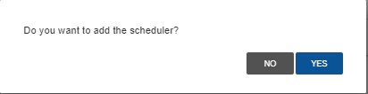

**Note**:

* *Scheduled callflow cannot be approved by the checker.*
* *Once the checker cancels the scheduler, status of the callflow is changed to ‘CHECKERSAVED’ Once the callflow status changed to CHECKERSAVED, the checker can approve that callflow.*
* *Only checker who schedule the callfow can cancel the scheduler*.

## **Previewer**

Interaction Workflow Previewer has the privilege to preview workflows.

**Note**: Previewer neither create the callflow nor delete the callflows and comments. When anonymous authentication is enabled for IW UI application, user will be redirected to Previewer page. User must login to IW only through OCM when anonymous authentication is enabled.

When a user login as a previewer (without loading a callflow), following page will be displayed.

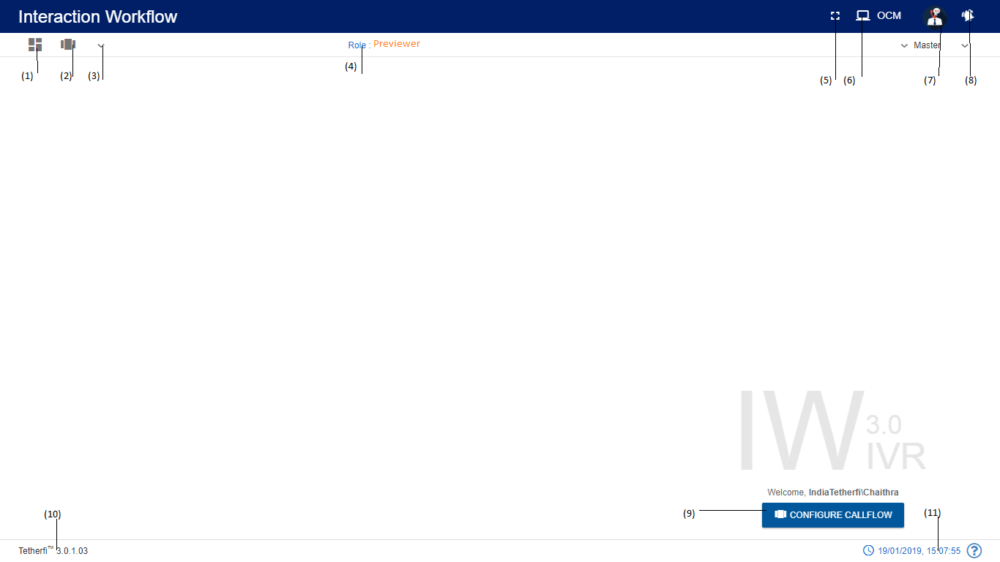

1. Dashboard: This option will redirect to dashboard. refer section Dashboard
2. Configure callflow: This option is used to Preview a flow. refer section Configure Callflow
3. More Menus: Upon clicking this button, following options will appear

(1) Real-Time View/Report – refer section Real-Time View/Report

1. Role: Displays the role of the user i.e. Previewer
2. Full Screen: This option is used to view the Interaction Workflow in full screen. (Press “Esc” button to go back to normal view)
3. OCM: This option will redirect to OCM page.
4. Current User Info: This option is used to know User’s domain name/ user name and for logging out of Interaction Workflow module.
5. Callflow Notifications: This option is used to check all the notifications related to Interaction Workflow
6. At the bottom right corner of the page, welcome message is displayed along with user’s domain name/user name. Configure callflow option is also provided here.
7. Current IW version is displayed here.
8. System date and time will be displayed here

When a user login as a Previewer and load a callflow, following page will be displayed.

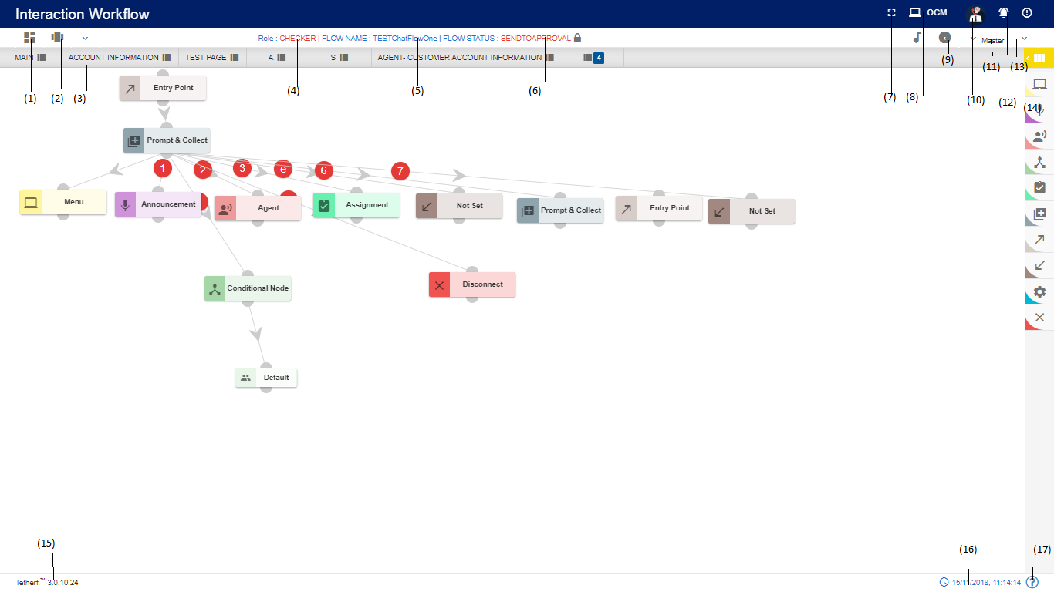

1. Dashboard: This option will redirect to dashboard. refer section Dashboard
2. Configure callflow: This option is used to Preview a flow. refer section Configure Callflow
3. More Menus: Upon clicking this button, following options will appear

(1) Real-Time View/Report – refer section Real-Time View/Report

1. Role: Displays the role of the user i.e. Previewer
2. Callflow Name: Displays the callflow name.
3. DNIS/Intent: Displays Maker DNIS for IW flow and Intent for OrderTake flow.
4. Flow Status: Displays callflow status here.
5. Full Screen: This option is used to view the Interaction Workflow in full screen. (Press “Esc” button to go back to normal view)
6. Search for Nodes: refer section Search for nodes
7. OCM: This option will redirect to OCM page.
8. Current User Info: This option is used to know User’s domain name/ user name and for logging out of Interaction Workflow module.
9. Callflow Notifications: This option is used to check all the notifications related to Interaction Workflow
10. Comments: refer section Comments
11. There are modules and nodes available here. But previewer cannot use them (Previewer cannot modify any callflow. He can just preview the callflow)
12. Phrase: refer section Phrases
13. Information: This option is used for information related to the user and Interaction Workflow version.
14. Master: Upon clicking this button following options will appear.
    1. Global Configuration: Previewer can view the global keys added here. He cannot add new/edit the global keys present here. refer section Global Configuration
    2. Intents: Previewer can view the intents added here. He cannot add new/edit the intents present here. refer section Intent Master
    3. Rules: Previewer can view the rules added here. He cannot add new/edit the rules present here. refer section Rule Master
    4. Global Phrases: Previewer can view the global phrases added here. He cannot add any new global phrases refer section Global Phrases
15. Current IW version is displayed here.
16. System date and time will be displayed here

When user login as Previewer and load the dashboard, following page will be displayed.’ Callflow Build/Package’ and delete option won’t be appear for Previewer in dashboard.

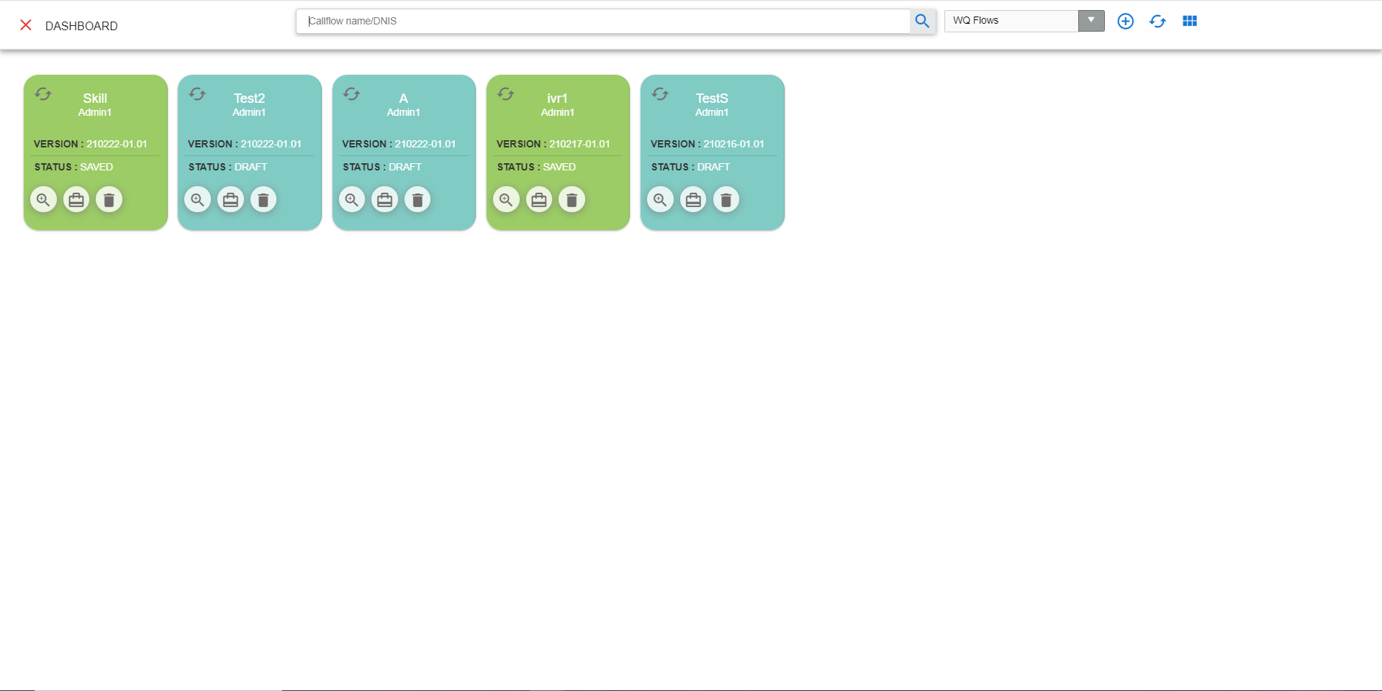

## **Maker and Checker**

Interaction Workflow Maker-Checker has the privilege to create / view / edit /approve/schedule/delete workflows.

**Note**: *Owner of the callflow can only delete the callflows. Owner of the callflow cannot approve his callflow even though he is a checker. Once the user rejects a callflow, he cannot edit that same callflow. But once the user approves a callflow, he can edit that same callflow.*

User who has both the roles i.e. maker-checker, can edit any callflow other than the callflows rejected by him.

When a user has both the roles i.e maker and checker, user role will be shown as MAKER, CHECKER. This will be configurable, and we can even set visible false in Configuration.

User cannot do any changes with the callfow with the status ‘Checkersaved’, when callflow status is Checkersaved by some other user.

When user login as a maker-checker (without loading any callflow), following page will be displayed.

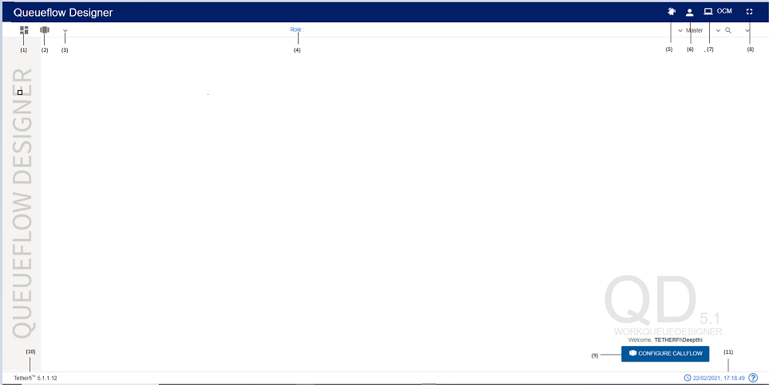

1. Dashboard: This option will redirect to dashboard.
2. Configure Callflow: This option is used to create a new flow/ Preview a flow/Order Take/Delete a callflow.
3. More Menus: Upon clicking this button following options will appear.
   * 1. Import callflow: refer section Import Callflow
     2. Copy callflow: refer section Copy Callflow
4. Role : Maker/Checker/Previewer
5. Callflow Notifications: This option is used to check all the notifications related to Interaction Workflow
6. Current User Info: This option is used to know user’s domain name/ user name and for logging out of Interaction Workflow module
7. Redirect to OCM: This option will redirect to OCM page.
8. Full Screen: This option is used to view the Interaction Workflow in full screen. (Press “Esc”/F11 button to go back to normal view)
9. At the bottom right corner of the page, welcome message is displayed along with user’s domain name/user name. Configure callflow option is also provided here.
10. Current IW version is displayed here
11. System date and time will be displayed here.

When user login as a maker-checker and load a callflow, following page will be displayed.

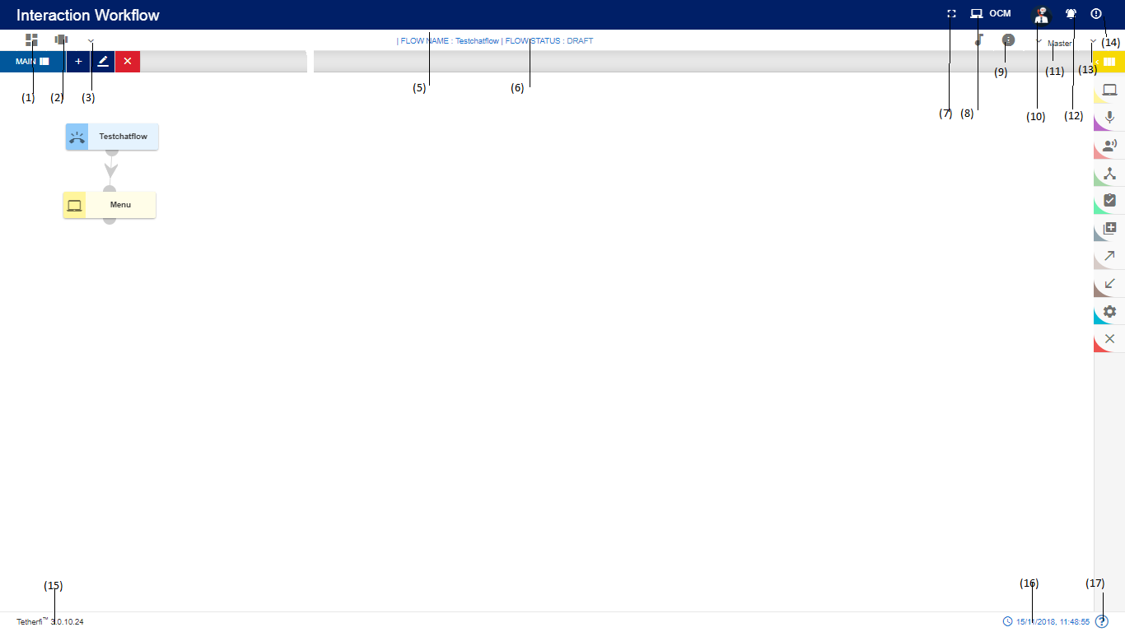

1. Dashboard: This option will redirect to dashboard.
2. Configure Callflow: This option is used to create a new flow/ Preview a flow/Order Take/Delete a callflow.
3. More Menus:

(1) Callflow version control: refer section Callflow Version Control

(2) Import callflow: refer section Import Callflow

(3) Copy callflow: refer section Copy Callflow

(4) Text to Voice: refer section Text to Voice

(4) Flow Name: Name of the flow will be displayed here

1. DNIS/Intent: Maker DNIS will be displayed when the status of the callflow is draft/save/send to approval and checker DNIS will be displayed when status of the callflow is checkerdraft/checker saved/approved/scheduled/rejected. Intent will be displayed for OrderTake flow.
2. Flow Status: Current callflow flow status will be displayed here
3. Full Screen: This option is used to view the Interaction Workflow in full screen. (Press “Esc”/F11 button to go back to normal view)
4. Search for Nodes: refer section Search for nodes
5. Redirect to OCM: This option will redirect to OCM page.
6. Phrases: refer section Phrases
7. Current User Info: This option is used to know User’s domain name/ user name and for logging out of Interaction Workflow module.
8. Information: Information about the callflow like user, role, Maker DNIS/intent, Status and version is displayed.
9. Callflow Notifications: This option is used to check all the notifications related to Interaction Workflow
10. Master: Upon clicking this button following options will appear.
    1. Intents: refer section Intent Master
    2. Rules: refer section Rule Master
    3. Session Master: refer section Session Master
11. Callflow Comments: refer section Comments
12. More Menus: refer section More Menu Option
13. There are modules and nodes available here. Maker can make use of these nodes/module as per requirement.

(18) Current IW version is displayed here.

(19) Current system date and time will be displayed here.

# **Creating/Editing Workflows**

## **Configure Callflow**

Configure callflow option is provided for Maker, Checker and Previewer. This option will be displayed at the centre of the page in IW landing page as well as right next to dashboard icon.

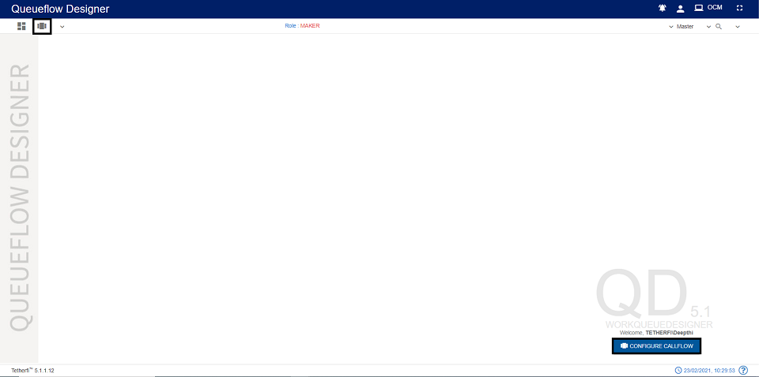

Upon clicking ‘Configure Callflow’ button in maker page and maker-checker page, below window will popup.

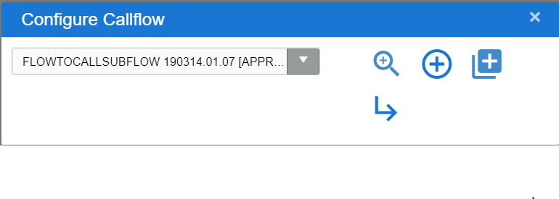

In maker page upon clicking on ‘Configure callflow’ button following options will appear.

1. Flow List: refer section Callflow List
2. Preview: refer section Preview
3. New Workqueue Flow: refer section New IW Flow
4. Delete Flow: refer section Delete

Upon clicking ‘Configure Callflow’ button in checker/Previewer page, below window will popup.

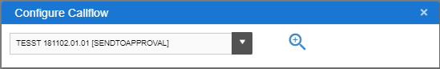

In checker and previewer page, upon clicking on ‘Configure callflow’ button following options will appear.

1. Callflow List: refer section Callflow List
2. Preview: refer section Preview

### Callflow List

This list consists of all the callflows created using Tetherfi Interaction Workflow which is also displayed in dashboard.

On click of the dropdown button, the below screen will be displayed.

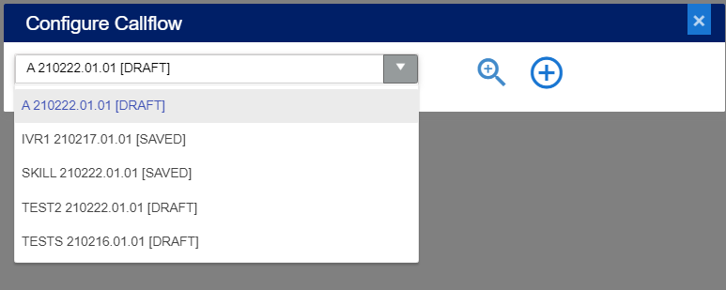

### Preview

Select the callflow from callfow list dropdown and click preview icon/button to load callfow data

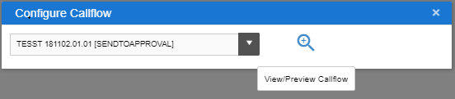

When user try to load a new callflow on top of existing active callflow, save confirmation popup will be generating as shown below.

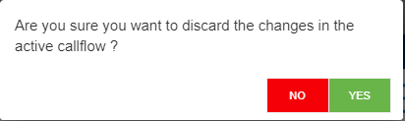

If Yes, Changes done in the active callflow will be discarded and new callflow selected here will be loaded

If No, User can continue with the existing active callflow

### New Workqueue Flow

This option is only provided for ‘Maker’. On click of the “**+**” button, the below screen will be displayed:

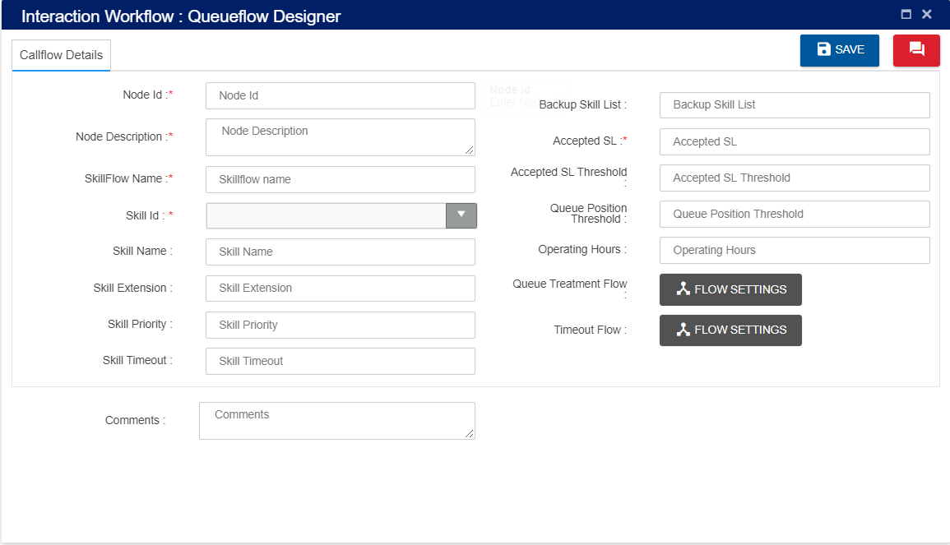

1. **Node Id**: Accepts characters, numbers and special characters too. This option is used to track the announcements played.
2. **Node Description:** Brief characterization of the node. (Mandatory)
3. **Skill Flow Name**: Name of the Flow should be unique.
4. **Skill id**: Skill Id should be unique
5. **Skill Name**: specific to skill id skill name can be auto populated
6. **Skill Extension:** specific to skill id skill extension will be auto populated
7. **Skill Priority:** Priority of specific skill
8. **Skill Timeout:** Skill timeout is added here
9. **Backup Skill list:** Backup for specific skill
10. **Accepted SL**: specific to skill id accepted SL will be auto populated
11. **Accepted SL Threshold**: specific to skill id accepted SL THRESHOLD will be auto populated
12. **Queue Position Threshold:** queue position threshold (in secs)
13. **Operating Hours:** this will display operating hours of rule.
14. **Queue Treatment Flow:** This option is used to configure the queue treatment flow.
15. **Timeout Flow:** This option is used to configure the timeout flow.
16. **Comment**: Providing a comment before saving is not mandatory.

### 5.1.4 Delete

Delete option will appear only when callflow is in DRAFT and SAVED status. Selected callflow from the drop down in ‘Callflow List’ in Maker page.

*Note that only owner of the callflow can delete his callflow in DRAFT and SAVED status.*

## **Designing the Workflow**

After successfully saving the DNIS Details, you can create/ edit the workflow depending on your requirement. 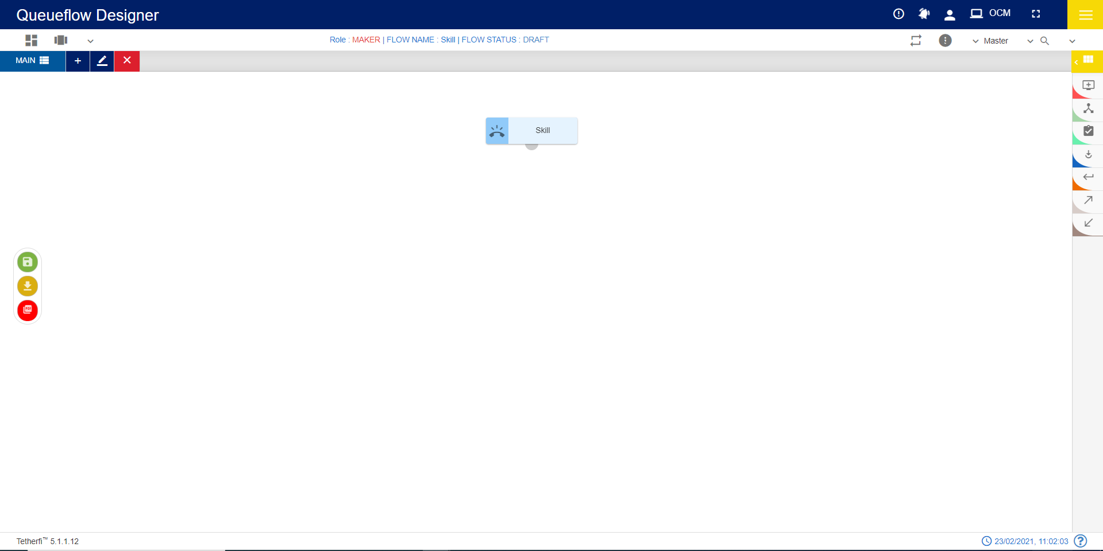

### Tabs

The new Workflow will have the TAB functionalities. It would help to break the bigger call flows into multiple tabs. User can add the tabs only when the callflow is in ‘Draft’ status.

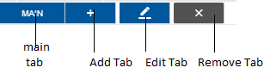

The above shown toolbar has the following functionalities:

* Main button can be used for navigating back to the Main tab.
* Add new tab button can be used when there is a need to create a new section of workflow by adding a new tab.
* Edit tab button can be used for making changes to the selected tab of workflow
* Remove tab button can be used for deleting the selected tab of workflow

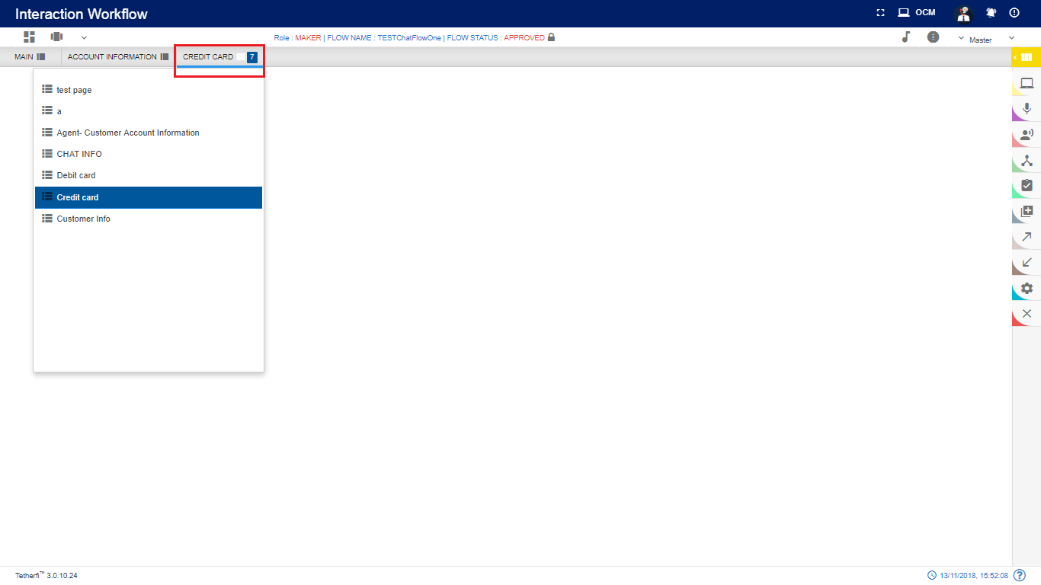

When a tab is selected from the dropdown, its name will be displayed at the top as shown above and Configured number of Tab are set in horizontal and all other tabs should be displayed in drop down list.

#### Add New Tab

This button is shown when the callflow is in ‘Draft’ status. When clicked on ‘Add new Tab’ button Tab pop window is generated

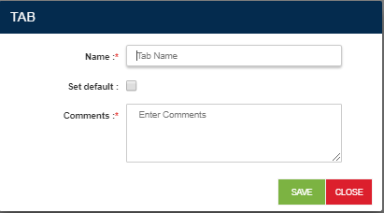

* + - Name: Name of Tabs should be unique.
    - Set default: Checkbox is used to set the Tab as default Tab, whenever user views the callflow default tab is shown, only one tab can be set as default. ‘MAIN’ tab will be set as default for the first time. When a new tab is set as default, previous tab set option will be cleared i.e. latest entry will be updated.
    - Comments: User can set add suitable comments regarding to the Tab.

**Save**: Upon clicking ‘Save’ button, Tab entries must be saved.

**Close**: Upon clicking ‘Close’ button, Tab pop window must be closed.

When new tab is added to the callflow, newly created tab should be open by-default upon clicking ‘Yes’ as shown below.

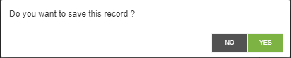

#### Edit Tab

Upon clicking the ‘Edit selected tab’ button to make changes to the selected tab, Tab pop window is open.

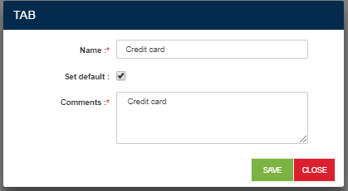

1. Name: Edit the new tab name.
2. Set default: Checkbox is used to set the Tab as default Tab, whenever user views the callflow default tab is shown. ‘MAIN’ tab will be set as default for the first time. When a new tab is set as default, previous tab set option will be cleared i.e. latest entry will be updated.
3. Comments: User can set edit the suitable comments regarding to the Tab.

**Save:** Upon clicking ‘Save’ button, Tab entries must be saved.

**Close:** Upon clicking ‘Close’ button, Tab pop window must be closed.

#### Delete/Remove Tab

Upon clicking on ‘Remove Selected tab’ confirmation pop window must generate.

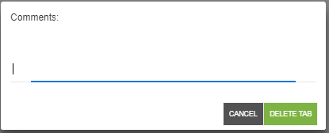

**Delete Tab button**: Upon clicking ‘Delete Tab’, tab will be successfully deleted.

**Cancel button:** Upon clicking ‘Cancel’, delete tab window will closed.

*Default tabs cannot be deleted. Error message will be shown when try to delete default tab.*

#### Copy Tab

Tab contents can be copied from one callflow to another callflow or other tabs within same callflow using **Ctrl +C** and **Ctrl+V** options (other than IE browsers).

Upon copying the tab contents using **Ctrl+C** option, confirmation popup will generate. Note that user can copy the tab contents of a callflow at any callflow status.

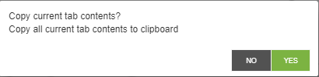

Upon successfully copying tab contents, success message will generate.

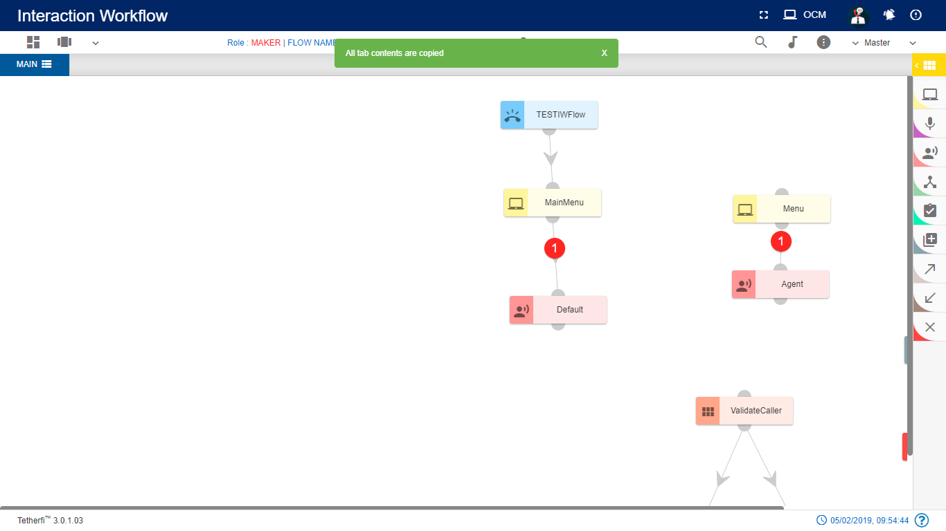

**Ctrl+V** option is used to paste the tab contents copied. Upon pasting the tab contents using **Ctrl+V** option, following confirmation popup will generate.

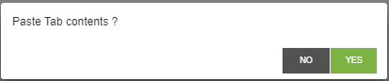

Upon clicking “Yes”, copied contents will be pasted to the respected tabs.

Note that user can paste the tab contents only in DRAFT callflow status. Copy tab feature not only copies the structure but also copies phrases, rules and other related information set for each node.

User cannot copy-paste the tab which has DNIS node. Upon pasting the tab contents which has DNIS node, ‘dnis node already exists in this callflow. cannot copy-paste data’ error message will generate.

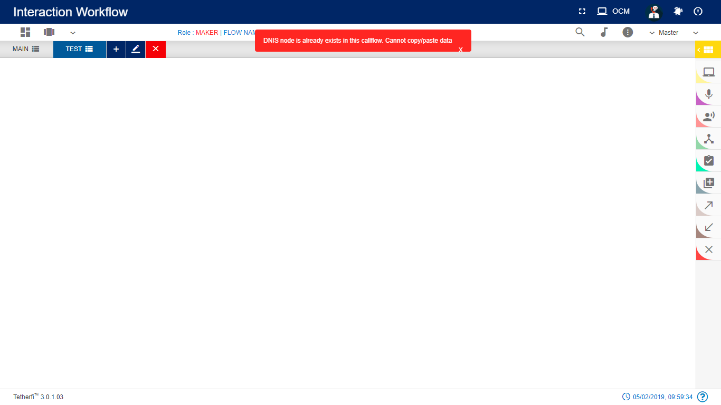

#### Tab Shuffling

User can move/shuffle the tabs present in the callflow. User can shuffle only the tabs present in drop down as shown below.

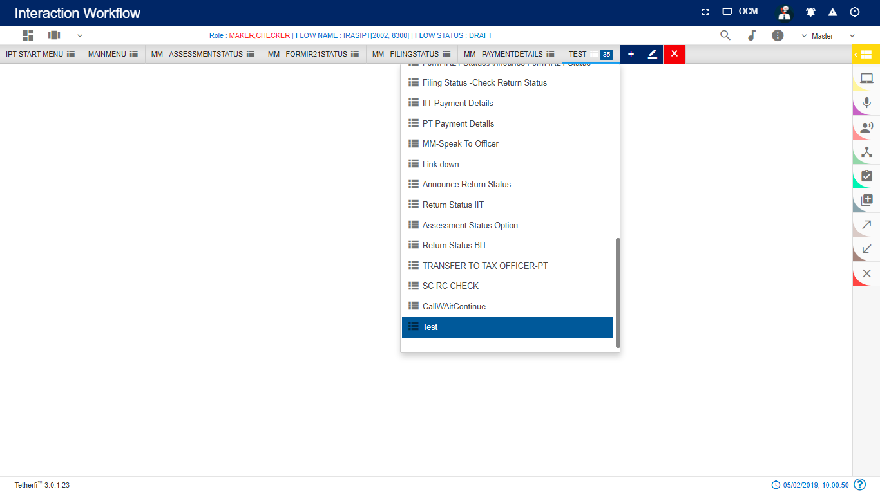

The new tab added after shuffling the tabs present in the drop down, will be added at the beginning of the drop down as shown above.

### More Menu Option

Upon clicking more menu option, present at top right and left corner at different status of the callflow, following options will appear. refer section Flow Status:

When user loads his own callflow:

|  |  |  |  |  |
| --- | --- | --- | --- | --- |
| **User Permission** | | **Callflow Status** | **More Menu(left)** | **More Menu(right)** |
| Maker | Draft | | 1.Callflow Version Control  2.Import Callflow  3.Copy Callflow | Save callflow |
| Maker | Saved | | 1.Import Callflow  2.Copy Callflow | 1.Send to approval  2.Edit callflow |
| Maker | Send to Approval | | 1.Import Callflow  2.Copy Callflow | No options |
| Maker | Checker Draft | | 1.Import Callflow  2.Copy Callflow | No options |
| Maker | Checker Saved | | 1.Import Callflow  2.Copy Callflow | No options |
| Maker | Approved | | 1.Import Callflow  2.Copy Callflow | Edit callflow |
| Maker | Scheduled | | 1.Import Callflow  2.Copy Callflow | No options |
| Maker | Rejected | | 1.Import Callflow  2.Copy Callflow | Edit callflow |
| Checker | Send to Approval | |  | 1.Reject  2.Approve  3.Edit |
| Checker | Checker Draft | |  | Save Callflow |
| Checker | Checker Saved | |  | 1.Reject Callflow  2.Approve Callflow  3.Edit Callflow |
| Checker | Approved | |  | No options |
| Checker | Rejected | |  | No options |
| Checker | Scheduled | |  | Approve Callflow |
| Previewer | Draft | |  | No options |
| Previewer | Saved | |  | No options |
| Previewer | Send to Approval | |  | No options |
| Previewer | Checker Draft | |  | No options |
| Previewer | Checker Saved | |  | No options |
| Previewer | Approved | |  | No options |
| Previewer | Rejected | |  | No options |
| Previewer | Scheduled | |  | No options |

When user loads some other user’s flow:

|  |  |  |  |
| --- | --- | --- | --- |
| User Permission | Callflow Status | More Menu(left) | More Menu(right) |
| Maker | Draft | 1.Import Callflow  2.Copy Callflow | Save callflow |
| Maker | Saved | 1.Import Callflow  2.Copy Callflow | 1.Send to approval  2.Edit callflow |
| Maker | Send to Approval | 1.Import Callflow  2.Copy Callflow | No options |
| Maker | Checker Draft | 1.Import Callflow  2.Copy Callflow | No options |
| Maker | Checker Saved | 1.Import Callflow  2.Copy Callflow | No options |
| Maker | Approved | 1.Import Callflow  2.Copy Callflow | Edit callflow |
| Maker | Scheduled | 1.Import Callflow  2.Copy Callflow | No options |
| Maker | Rejected | 1.Import Callflow  2.Copy Callflow | Edit callflow |
| Checker | Send to Approval |  | 1.Reject  2.Approve  3.Edit |
| Checker | Checker Draft |  | Save Callflow |
| Checker | Checker Saved |  | 1.Reject Callflow  2.Approve Callflow  3.Edit Callflow |
| Checker | Approved |  | No options appear |
| Checker | Rejected |  | No options appear |
| Checker | Scheduled |  | Approve Callflow |

When user with Maker-Checker role loads his own callflow:

|  |  |  |  |  |  |  |  |
| --- | --- | --- | --- | --- | --- | --- | --- |
| **User Permission** | | **Callflow Status** | | **More Menu(left)** | | **More Menu(right)** | |
| Maker-Checker | Draft | | 1.Callflow version control  2.Import Callflow  3.Copy Callflow | | Save callflow | |
| Maker-Checker | Saved | | 1.Import Callflow  2.Copy Callflow | | 1.Send to approval  2.Edit callflow | |
| Maker-Checker | Send to Approval | | 1.Import Callflow  2.Copy Callflow | | 1.Reject  2.Approve  3.Edit | |
| Maker-Checker | Checker Draft | | 1.Import Callflow  2.Copy Callflow | | Save | |
| Maker-Checker | Checker Saved | | 1.Import Callflow  2.Copy Callflow | | 1.Reject  2.Approve  3.Edit | |
| Maker-Checker | Approved | | 1.Import Callflow  2.Copy Callflow | | Edit callflow | |
| Maker-Checker | Scheduled | | 1.Import Callflow  2.Copy Callflow | | Approved | |
| Maker-Checker | Rejected | | 1.Import Callflow  2.Copy Callflow | | Edit callflow | |

When user with Maker-Checker role loads some other User’s callflow:

|  |  |  |  |  |  |  |  |
| --- | --- | --- | --- | --- | --- | --- | --- |
| **User Permission** | | **Callflow Status** | | **More Menu(left)** | | **More Menu(right)** | |
| Maker-Checker | Draft | | 1.Import Callflow  2.Copy Callflow | | Save callflow | |
| Maker-Checker | Saved | | 1.Import Callflow  2.Copy Callflow | | 1.Send to approval  2.Edit callflow | |
| Maker-Checker | Send to Approval | | 1.Import Callflow  2.Copy Callflow | | 1.Reject  2.Approve  3.Edit | |
| Maker-Checker | Checker Draft | | 1.Import Callflow  2.Copy Callflow | | Save | |
| Maker-Checker | Checker Saved | | 1.Import Callflow  2.Copy Callflow | | 1.Reject  2.Approve  3.Edit | |
| Maker-Checker | Approved | | 1.Import Callflow  2.Copy Callflow | | Edit callflow | |
| Maker-Checker | Scheduled | | 1.Import Callflow  2.Copy Callflow | | Approved | |
| Maker-Checker | Rejected | | 1.Import Callflow  2.Copy Callflow | | Edit callflow | |

### Set Rules

User can set the rules in Conditional, Announcement, menu node. ‘Set Rule’ icon will be displayed in these nodes to set the rules as shown below.

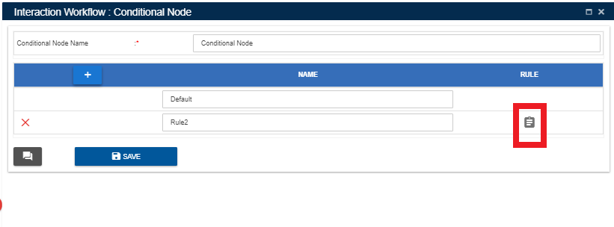

Upon clicking set rules icon following window will popup.

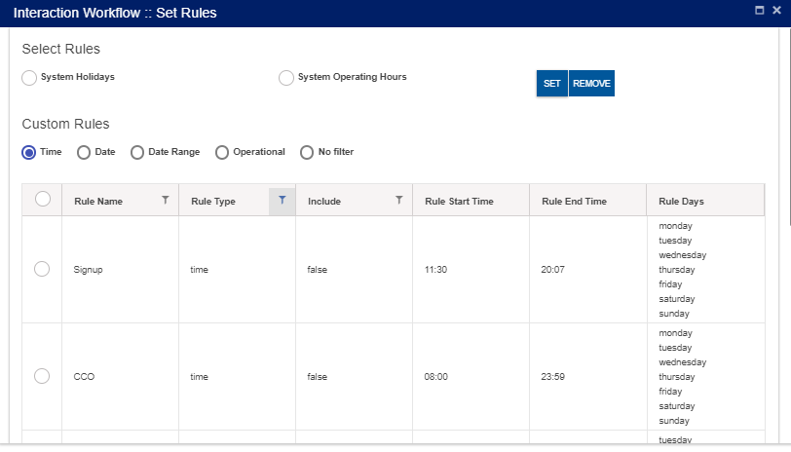

Rules added at ‘Rule Master’ will be displayed here. User can set these rules for the nodes.

Upon clicking ‘SET’ after selecting the rules, following confirmation popup will generate.

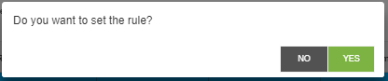

Upon clicking ‘YES’, rule will be successfully set to the nodes.

### Callflow Sync Notification

While saving a callflow, adding/editing intents, adding/editing rules, adding session master if the interpreter is down, data will not reflected in IVR. At those situation ‘Calllow sync notification’ icon will appear in UI as shown below.

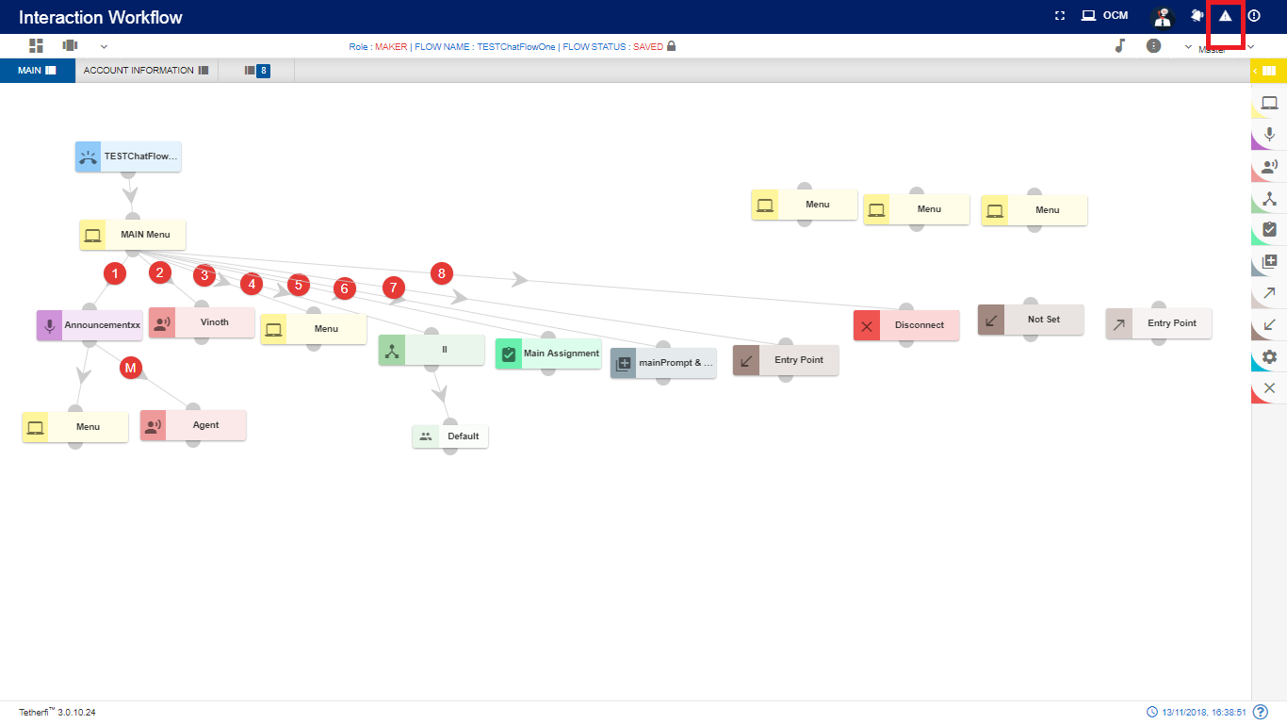

In this situation user can upload these files to interpreter once it is up, by clicking ‘Resubmit’ button. ’Clear’ option is also provided here to remove the notification.

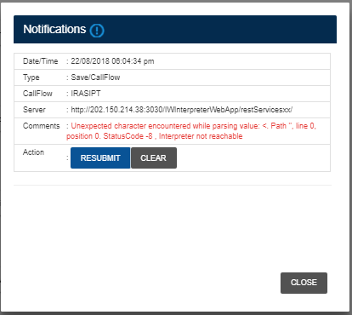

Sync notification icon also displayed in landing page if the interpreter was down while updating intent master rule master, global configuration, global phrases. User can resubmit the data to interpreter from landing page too. Callflow specific resubmit sync notification will appear only after loading the callflow in UI.

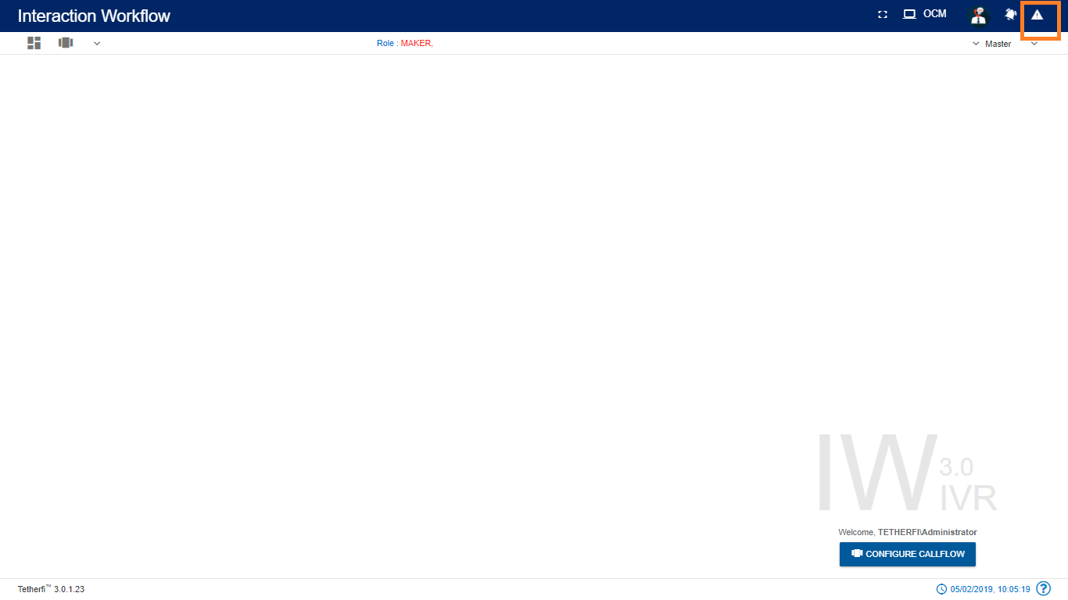Intent master and rule master sync notification

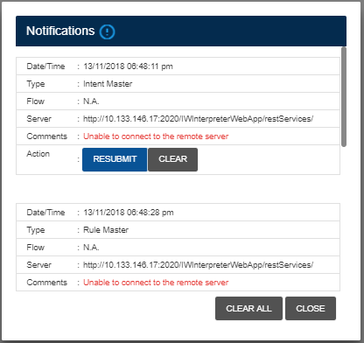

Global configuration and global phrase sync notification is shown below:

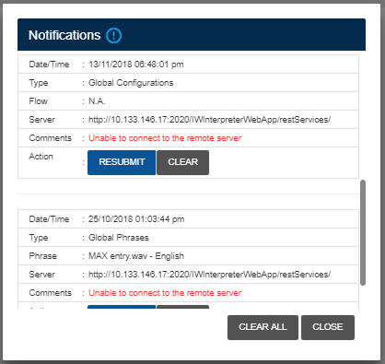

Interpreter phrase and grammar phrase sync notification is shown below:

Save callflow and synonym sync notification is shown below:

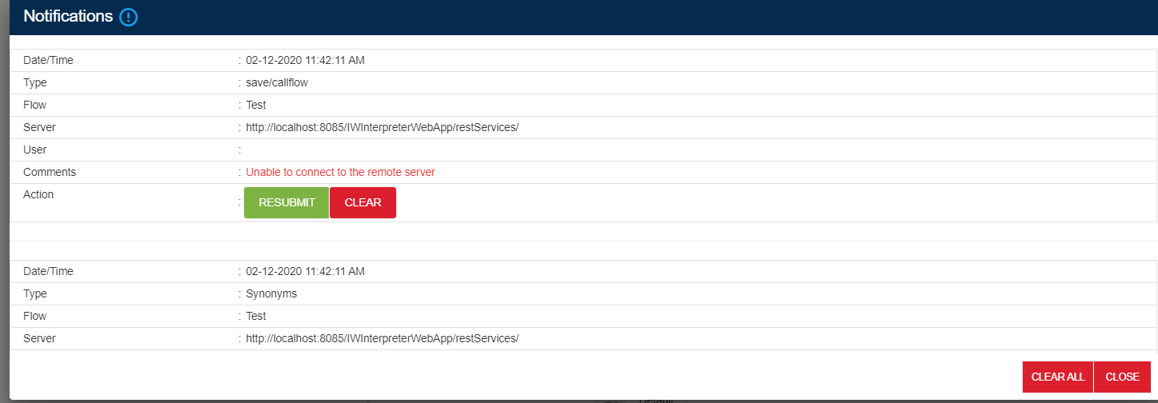

*Note: This option will appear in UI, only when interpreter is down.* ‘CLEAR ALL’ option is provided to remove all the notification.

Following error message will be generating while uploading the phrases if the interpreter is down. In such case, user can upload these phrases to interpreter once it is up, by clicking ‘Resubmit’ button. ’Clear’ option is also provided here to remove the notification.

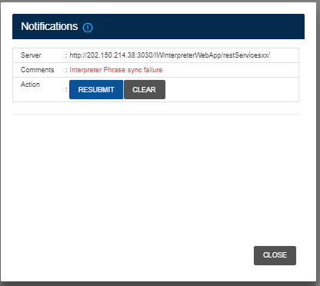

# **Nodes and Modules**

## **Nodes**

Nodes are often arranged into tree structures. These structures are [binary trees](https://en.wikipedia.org/wiki/Binary_tree).

A node represents the information contained in a single structure. These nodes may contain a value or condition, or possibly serve as another independent data structure. There are nine types of nodes in Interaction Workflow:

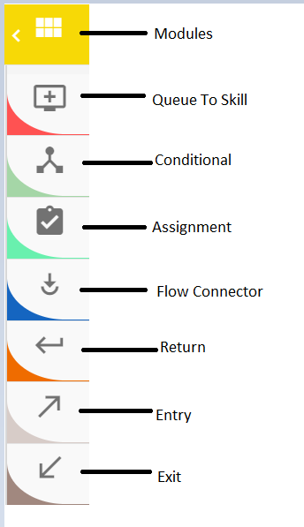

### Queue to Skill Node

For adding a new Queue to skill node to the callflow, click on the “Queue to skill” icon and drag it to the main screen.

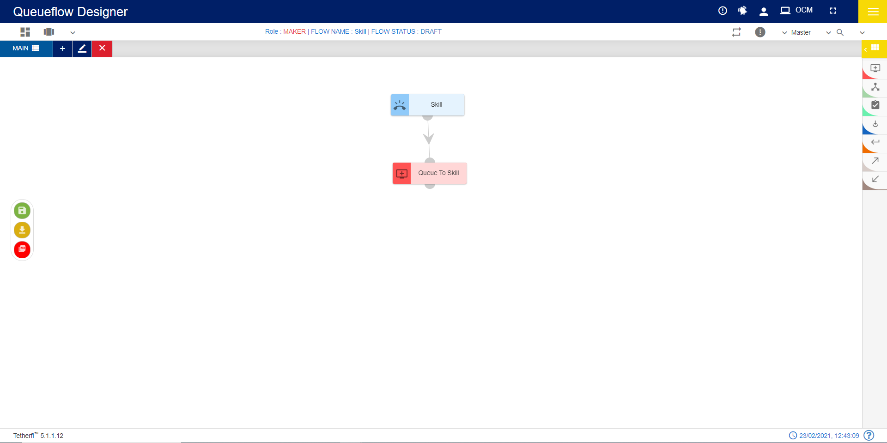

For editing/ configuring the Queue to skill, hover over the Queue to skill icon you added and edit/ delete functionalities for the menu will be displayed.



On click of edit button, the below screen will popup

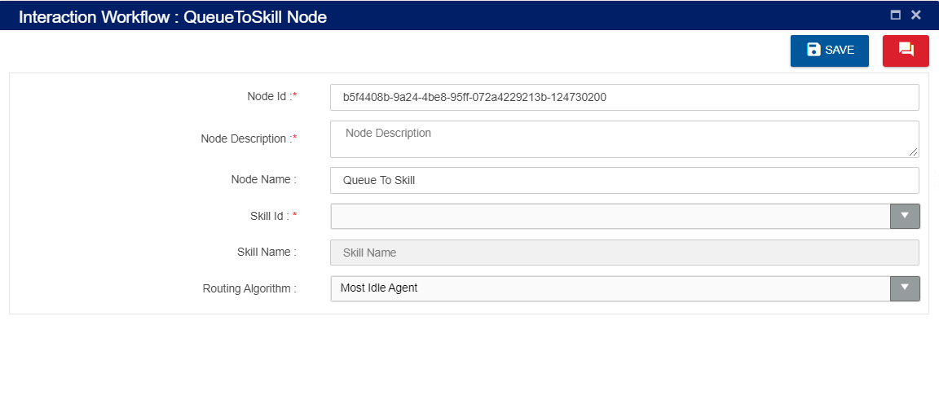

* + Node ID: By default, the Node ID for a Queue to skill is autogenerated, but the Users have the privilege to assign their own Node ID. Each Node ID should be unique. (Mandatory)
  + Node Description: Brief characterization of the Queue to skill. (Mandatory)
  + Node Name: By default, the Menu Name is Menu, but the Users have the privilege to assign their own Menu Name. Each Menu Name should be unique. This Menu Name will only be displayed in the Interaction workflow’s UI (Mandatory)
  + Skill Id: Skill Id should be unique
  + Skill Name: specific to skill id skill name can be auto populated
  + Routing Algorithm: for most idle agent or least occupied agent.

**Delete Queue to skill Node:**

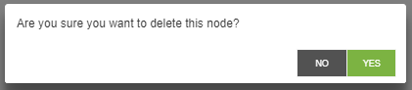

### Conditional Node

For adding a new Conditional Node to the flow, click on the “Conditional Node” icon and drag it to the main screen. Conditional node is associated with a default node.

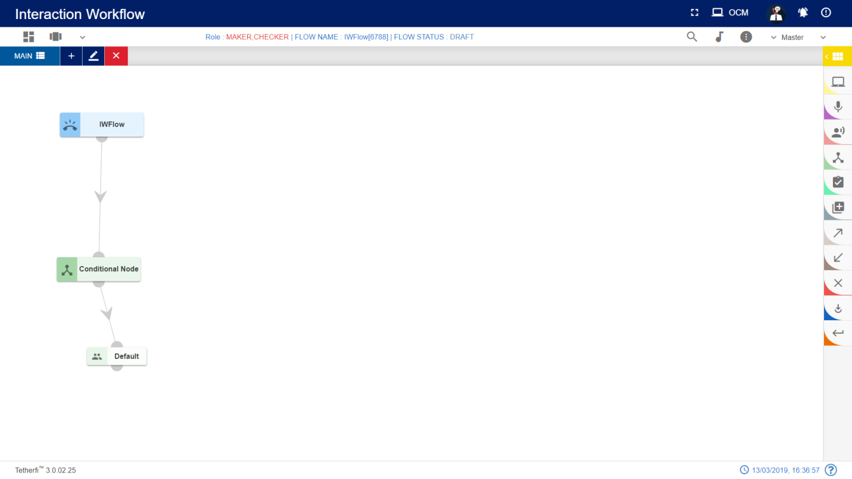

For editing/ configuring the Conditional Node, hover over the Conditional Node icon you added and edit/ delete functionalities for the menu will be displayed.



On click of edit button, the below screen will popup

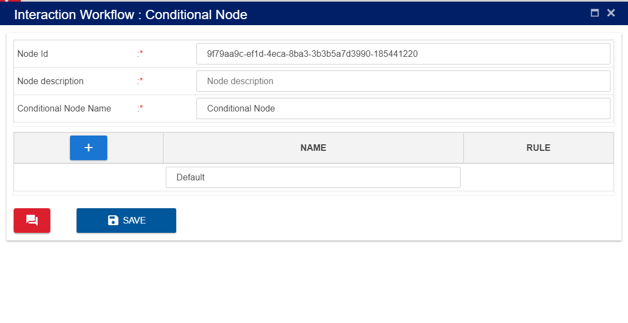

**Node ID:** By default, the node ID for a Conditional node is autogenerated, but the Users have the privilege to assign their own ID. Each node ID should be unique. (Mandatory)

**Node Description**: Brief characterization of the conditional Node. (Mandatory)

**Name**: This is a mandatory field. Name provided here will be reflected in UI. By default, the name is Conditional Node. but the Users have the privilege to assign their own name.

**Adding Rules:**

Click on “**+**” icon, to add rules.

Click on the ’Set Rules’ icon present at the Rule column to add conditional rules. refer section Set Rules

Upon clicking this icon following popup will be displayed and rule leg will be shown in UI. Conditional node is associated with default node. *User should not be allowed to connect to default node directly from other nodes.*



**Delete Conditional Node:**

On click of delete button, the below screen will popup



### Assignment Node

For adding a new Assignment Node to the callflow, click on the “Assignment” icon and drag it to the main screen. Assignment node can be connected to only 1 node and it is a default connection (without label).

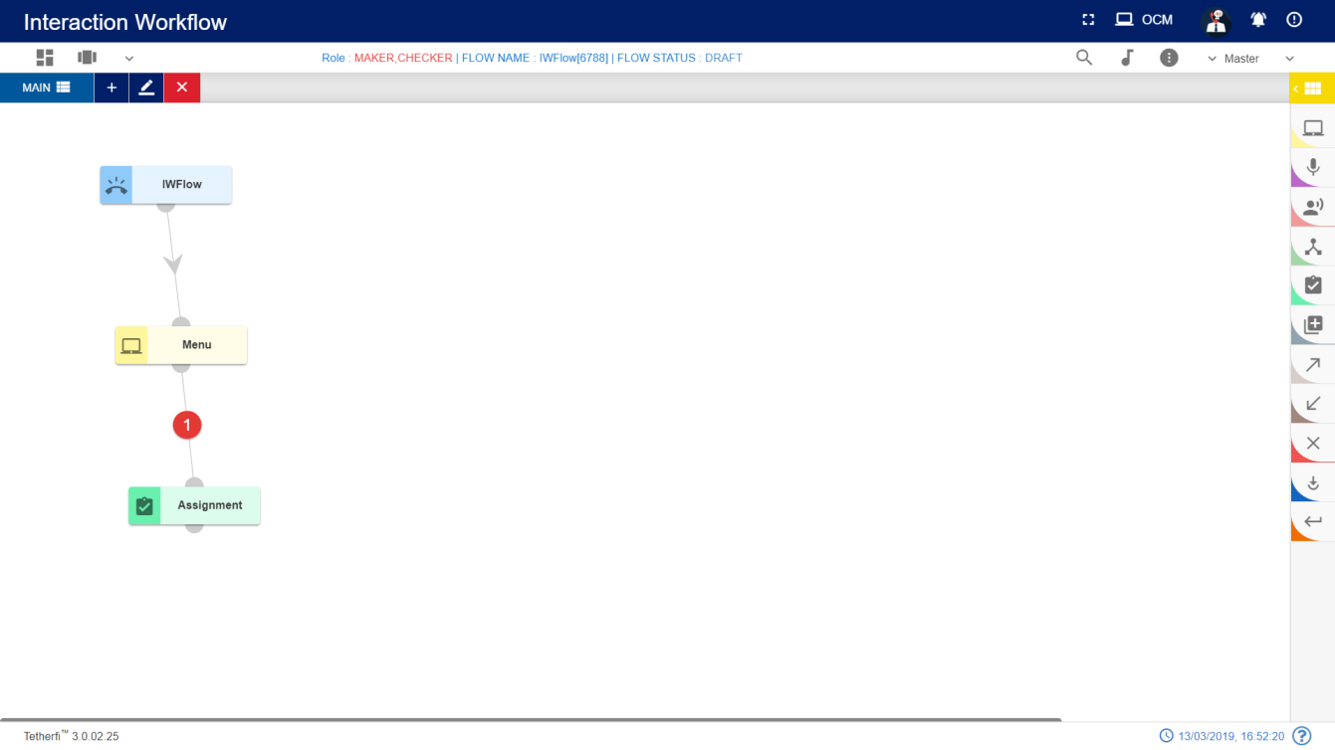

For editing/ configuring the Assignment Node, hover over the Assignment Node icon you added and edit/ delete functionalities for the Assignment node will be displayed



On click of edit button, the below screen will popup. Operational variables will be displayed in both the drop downs.

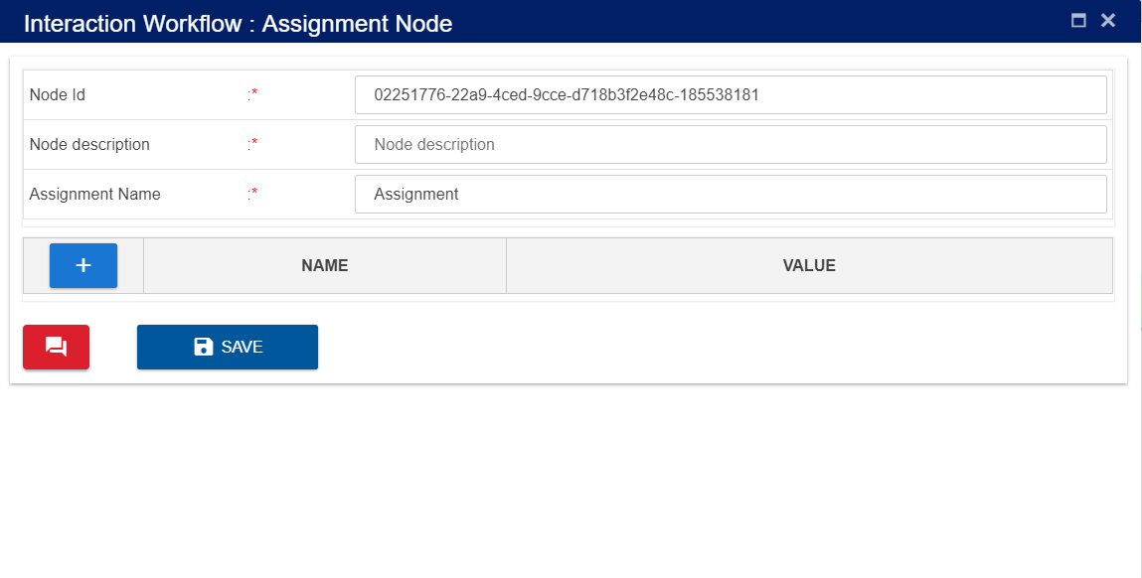

**Node ID:** By default, the node ID for an Agent node is autogenerated, but the Users have the privilege to assign their own ID. Each node ID should be unique. (Mandatory)

**Node Description**: Brief characterization of the agent Node. (Mandatory)

User can select the operational variables added at the backend from the first drop down and assign the values to them in the **value** field provided. User can also select operational variables for value field by clicking drop down icon shown above.

**Delete Assignment node:**

On click of delete button, the below screen will popup



### Entry Point Node

Some of the callflows can contain many nodes. It becomes difficult to manage or fit the entire callflow in a single screen. Such callflows are broken into smaller flows for better readability and to also reduce frequent scrolls on the page. Each of these small flows are connected through the Entry and Exit node.

To add an Entry Point:

* Click on the node menu and drag and drop the Entry point to the screen
* Click on the three dots and then click on Edit details icon
* Entry Point pop up box is displayed
* Enter the Entry Point name and save
* Entry Point node should have the Entry Point name updated

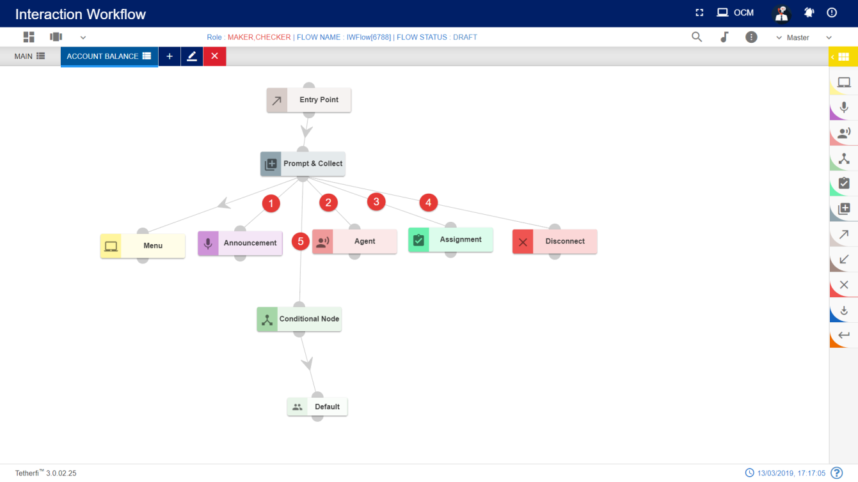

Entry Points can be connected to multiple flows which means technically multiple exits points are connected to entry points. To view the connections to the Entry Point, ‘view connection’ option is provided.

To view Entry Point connections:

* Click on the three dots on the Entry Point node and then click on View Connections icon
* ‘Following Connections found:’ pop up window with the Tab name and Entry Point name will be displayed
* Tab name will have the tabs which are connected to this flow. There can be multiple tab names and exit points connected to a single-entry point.

Entry Point should not have any incoming connections. Alert message ‘Entry Point should not have any incoming connections’ will be displayed when try to connect a node to Entry point node.

For editing/ configuring the Entry point, hover over the Entry point icon you added and edit/ delete/ view connections functionalities for the menu will be displayed.



On click of edit button, the below screen will popup wherein you need to specify the name of the Entry Point.

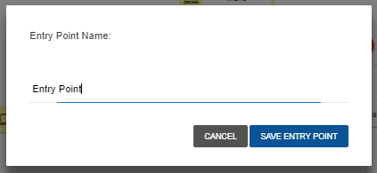

To delete the Entry Point:

* Double click on each connection of the Entry Point and delete them individually.
* When all the connections are broken then click on ‘delete details’ icon on the node.
* Entry Point will be deleted. This Entry Point will not be available for setting entry point for any of the exit points.

### Exit Point Node

Exit Node cannot be a source node. It is the last node of the flow. If there is an effort to set connection between Exit node to any of the nodes, an alert message ‘Source can’t be an exit point. Exit point cannot have any exits.’ Will be displayed.

Every Exit Point will be pointing to the next Entry Point. This navigation details are provided by editing the Exit Point and then setting the entry point.

For adding a new Exit point to the callflow, click on the “Exit point” icon and drag it to the main screen. 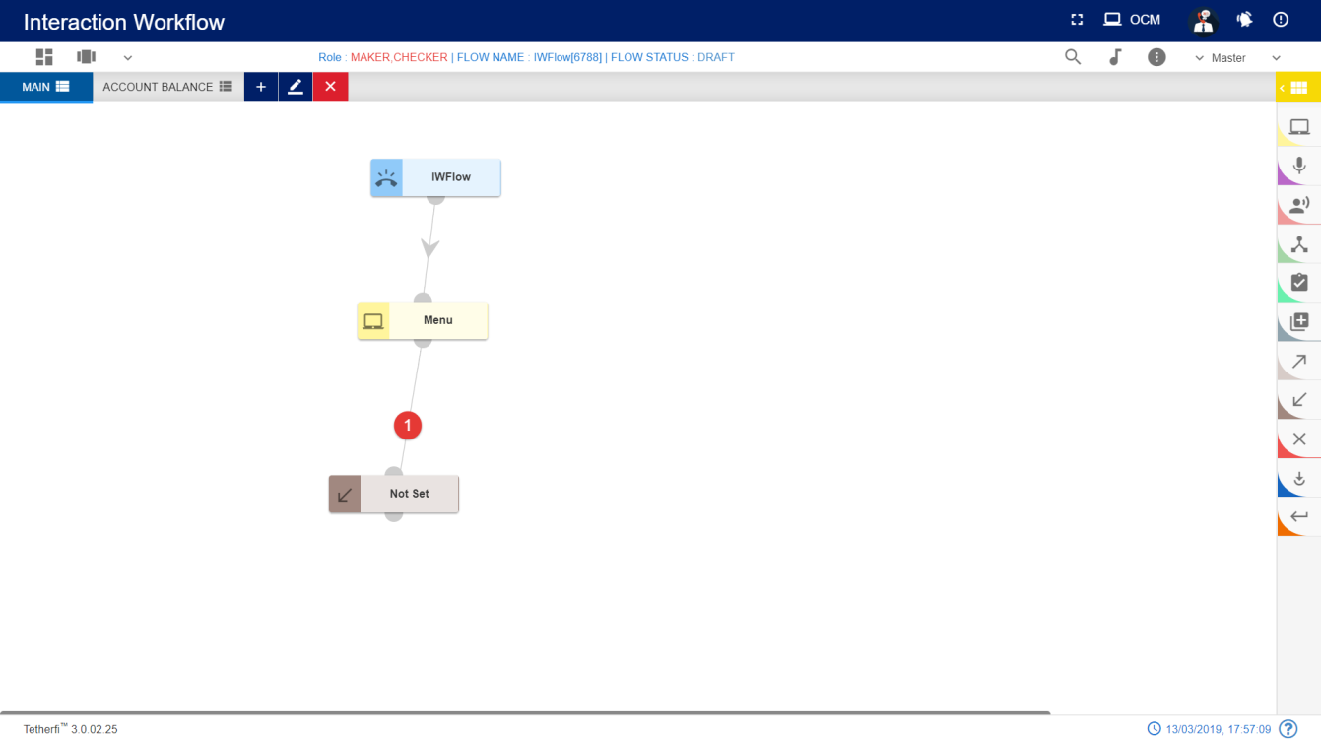

For editing/ configuring the Exit point, hover over the Exit point icon you added and edit/ delete functionalities for the menu will be displayed.

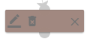

To set the Entry Point:

* Click on the Exit Point to which the entry point has to be set and click on the ‘Edit details’ icon
* Set Entry Point’ pop up window will be displayed. This window has tab name, Entry Point name and Comments. All the fields are mandatory. By default, the tab name will have ‘select tab’ in the drop down.
* Choose the tab name to which the control has to navigate from Exit Point. After choosing the tab name, only then the ‘Entry Point name’ will be populated. It will have all the entry points for the selected tab.
* Enter the comments and save. Exit Point node will have the name of the set Entry point.

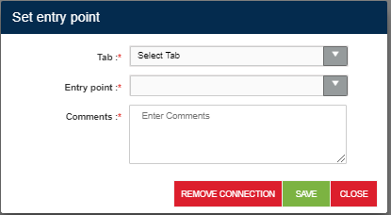 C:\Users\Deepthi\Downloads\Project1\Project1\Project1\Program.cs

Exit Point can have only one Entry Point set. It cannot be set to multiple entry points. Set connections can be deleted.

To remove the connections:

* Click on edit details button of the Exit Point. It should have the set Entry Point.
* Click on remove connections’ button.
* ‘Are you sure you want to remove this Entry point connection?’ confirmation message should be displayed. On clicking Yes, the connection will be removed between the Exit Point and set Entry Point.
* ‘Entry Point connection removed’ message will be displayed confirming the deletion.
* If the ‘edit details’ button is clicked again, ‘Set entry point’ window will not have connection details. Also, ‘Remove connections’ button will not be present.

Exit Point can be deleted.

To delete the Exit Point:

* Double click on each connection of the Exit Point and delete them individually.
* When all the connections are broken then click on ‘delete details’ icon on the node
* Exit Point will be deleted.

### Flow Connector node

Flow connector node is used to jump to subflow. Every Flow connector will be pointing to the next Entry Point. This navigation details are provided by editing the flow connector and then setting the entry point. Flow connector node can be connected to only 1 node and it is a default connection (without label).

For adding a new flow connector to the callflow, click on the “flow connector” icon and drag it to the main screen.

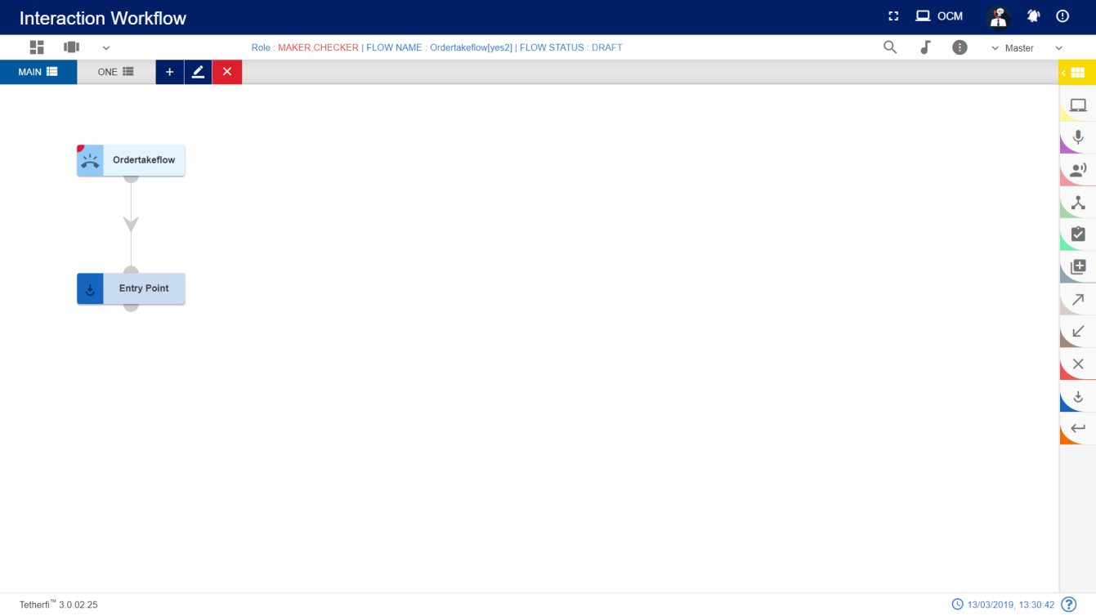

For editing/ configuring, hover over the flow icon you added and edit/ delete functionalities for the flow icon will be displayed.

On click of edit button, the below screen will popup

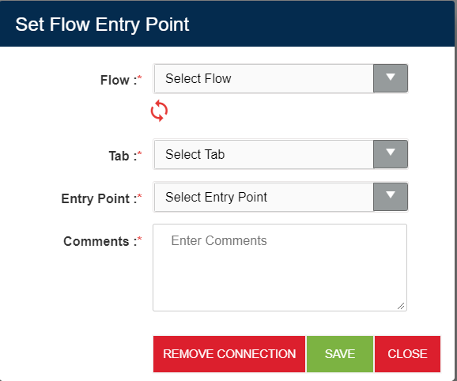

To set the Flow Entry Point:

* Drag and drop flow connector node and click on the ‘Edit details’ icon
* ‘Set Flow Entry Point’ pop up window will be displayed. This window has Flow name, tab name, Entry Point name and Comments. All the fields are mandatory. By default, the tab name will have ‘select tab’ in the drop down.
* Choose the subflow/mainflow name and tab name to which the control must navigate from flow connector Point. All the approved/saved subflows/mainflows will be displayed here. After choosing the tab name, only then the ‘Entry Point name’ will be populated. It will have all the entry points for the selected tab.
* Enter the comments and save. Flow connector node will have the name of the set Entry point.
* If there is both SAVED and APPROVED copy of the flow, then SAVED copy information will be displayed in the dropdown

Flow connector can have only one Entry Point set. It cannot be set to multiple entry points. Set connections can be deleted.

To remove the connections:

* Click on edit details button of the flow connector. It should have the set Entry Point.
* Click on remove connections’ button.
* ‘Are you sure you want to remove this flow connection?’ confirmation message should be displayed. On clicking Yes, the connection will be removed between the flow connector and Entry Point.
* ‘Flow connection removed’ message will be displayed confirming the deletion.

### Return Node

Return node should be the last node of a callflow. This node is used to return the control to the calling flow. Upon encountering this node in the subflow, control will be redirect to flow connector node where the subflow is being called.

For adding a new Return Node to the callflow, click on the “Return” icon and drag it to the main screen.

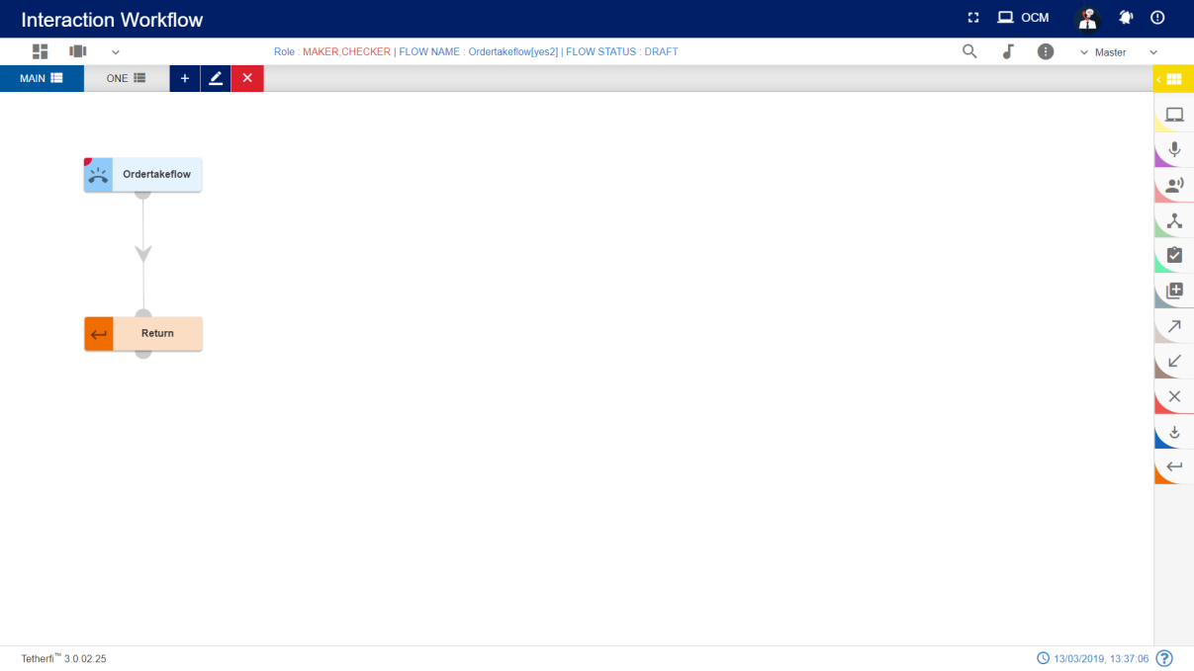

For editing/ configuring the return node, hover over the return node icon you added and edit/ delete functionalities for the return icon will be displayed.



On click of edit button, the below screen will popup

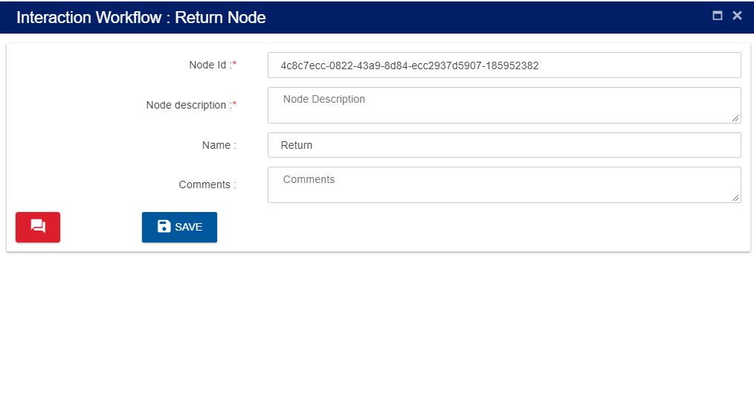

**Node ID:** By default, the node ID for a return node is autogenerated, but the Users have the privilege to assign their own ID. Each node ID should be unique. (Mandatory)

**Node Description**: Brief characterization of the announcement return Node. (Mandatory)

**Name**: Name of return node.

**Delete Return Node**

On click of delete button, the below screen will popup

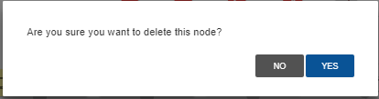

### Node Connectivity

|  |  |  |  |
| --- | --- | --- | --- |
| **Start Node** | **End Node** | **Connection status (outgoing)** | **Connection status (incoming)** |
| DNIS | All other nodes except Entry point node, module exit and conditional exit nodes | Single connection from DNIS node | No incoming connection to DNIS node |
| Queue to skill | All other nodes except Entry point node, module exit and conditional exit nodes | Single connection from queue to skill node | Single connection to queue to skill node |
| Conditional node |  | No outgoing connection from conditional node | Multiple connection to conditional node |
| Conditional node legs | All other nodes (including Conditional node) except Entry point node, module exit and conditional exit nodes | Single connection from one leg of the conditional node | No incoming connection to Conditional node legs |
| Assignment | All other nodes (including assignment node) except Entry point node, module exit and conditional exit nodes | Single connection from assignment node | Multiple connection to assignment node |
| Entry Point Node | All other nodes except Entry point node, module exit and conditional exit nodes | Single connection from Entry point node | No incoming connection to Entry Point node |
| Exit Point Node |  | No outgoing connection from Exit point node | Multiple connection to Exit Point node |
| Module Node |  | No outgoing connection from Module node | Multiple connection to Module node |
| Module Node legs | All other nodes (including Module node) except Entry point node, module exit and conditional exit nodes | Single connection from one leg of the Module node | No incoming connection to Module node legs |
| Return Node |  | No outgoing connection from Return node | Multiple connection to return node |
| Flow Connector Node | All other nodes (including Module node) except Entry point node, module exit and conditional exit nodes | Single connection from flow connector node | Multiple connection to flow connector node |

## **Modules**

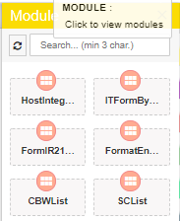

Modules are separable component, frequently one that is interchangeable with others, for assembly into units of differing size, complexity or function. Self-service transactions are implemented in module. Size of the default node which is associated with module node is smaller than module node.

For adding a new Module to the callflow, click on the “Module” icon and drag it to the main screen.

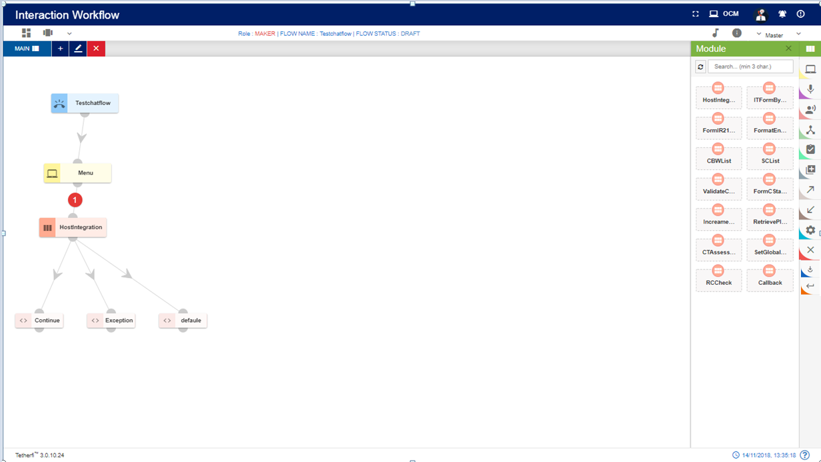

For editing/ configuring/ refreshing the Module, hover over the Module icon you added and edit/ delete functionalities for the menu will be displayed.

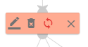

On click of edit button, module configuration details can be updated. ‘serviceID’ is the parameter for HostIntegration Module.

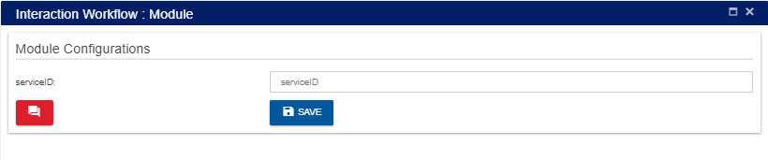

When a user adds new labels to the modules, he can update all the existing modules in the callflow by clicking refresh/reload button as shown below.

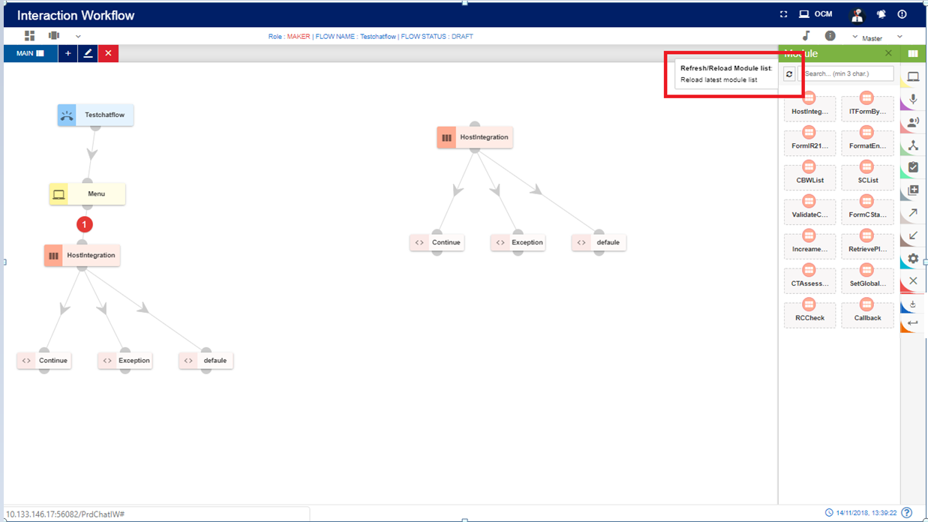

Upon clicking *refresh/reload button* following popup will generate to update existing modules in the callflow. Callflow must be in DRAFT status.

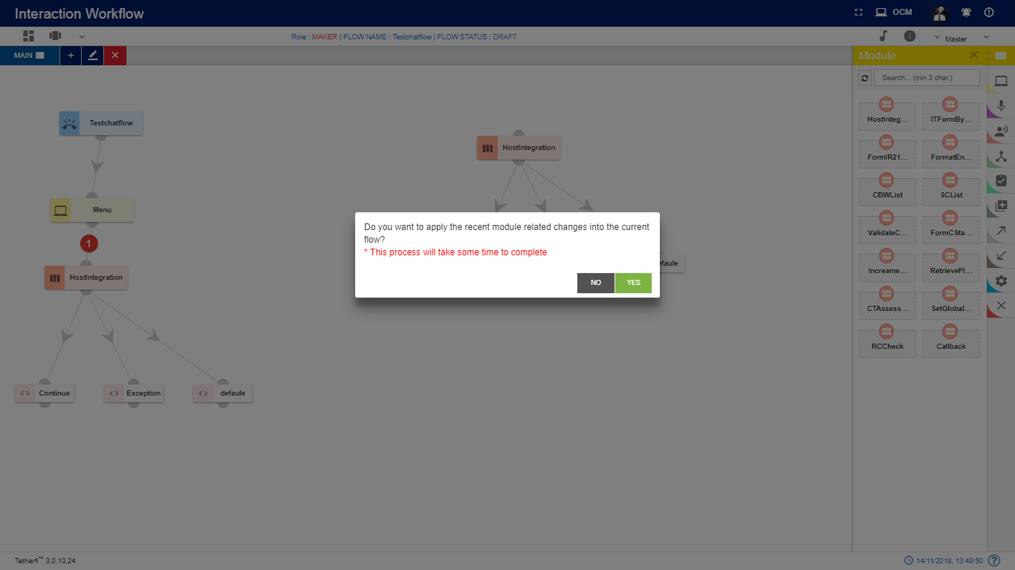

‘Yes’: all the modules present in the callflow will be updated.

‘No’: changes will not reflect in the existing modules present in the callflow.

### IW Module Designer

This is the new Tetherfi application with is used to design the Module Flow. Just like Interaction workflow, there are set of nodes used to design the module flow. If there is a module flow designer in IW Module Designer application for the module dropped in IW, then IW will redirect the user to this IW Module designer application upon opening the module. If there is no Module flow designed in IW Module designer application for the module used in IW, then control will be there in IW.

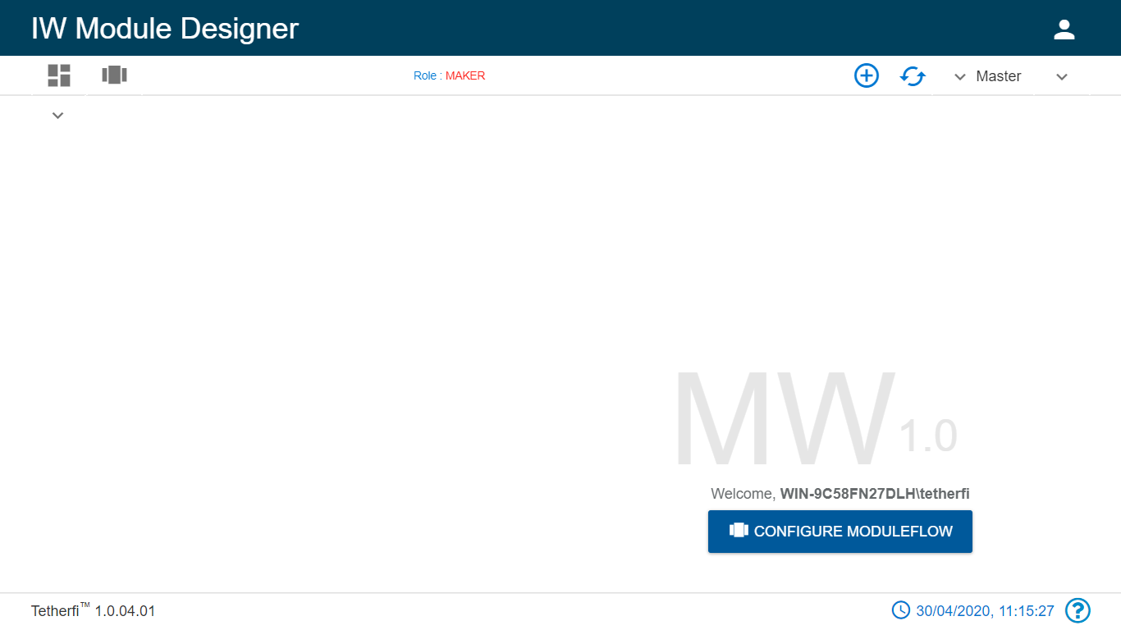

Refer the document attached.



## **Connecting Nodes and Modules**

For interconnecting two or more Nodes/ Modules, you need drag the connecting link as shown below:

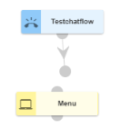

For deleting a node, double click on the connecting link and the below screen will be displayed:

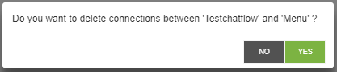

# **Context Menu**

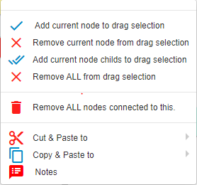

* **Add current node to drag selection: Adds** selected/current node to draggable. refer section Drag Nodes
* **Remove current node from drag selection** removes current node from drag selection. refer section Drag Nodes
* **Add current node child’s to drag selection:** Adds selected /current node and its child elements to draggable collection. refer section Drag Nodes
* **Remove all from drag selection** removes all the nodes from draggable collection. refer section Drag Nodes
* **Cut and Paste:** refer section **Cut and Paste**
* **Copy and Paste:** refer section **Copy and Paste**

## **Drag Nodes**

If user wants to drag the set of the nodes to a different position in a tab, they can user ‘Add current node to drag selection’ , to include child nodes while dragging, can use ‘Add current node child’s to drag selection’.

To remove the nodes from drag selection, ‘Remove current node from drag selection’ and ‘Remove ALL from drag selection’ option can be used.

## **Remove ALL nodes Connected to This**

This option is used if the user wants to delete a node along with immediate child nodes connected to this.

As shown below, user can delete menu node along with its child node at once, using this option.

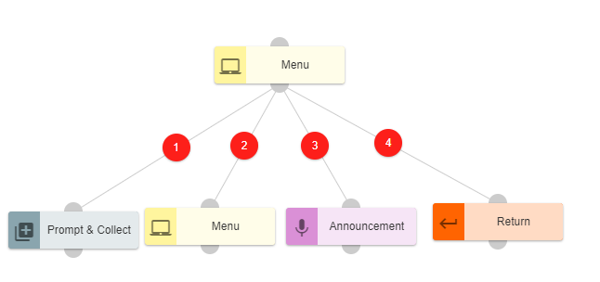

## **Cut and Paste**

User is provided with Cut and Paste feature to manage the callflow creation/updation efficiently.

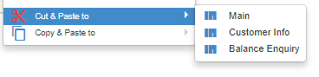

Steps to create a node/flow using Cut and Paste feature:

* Right click on the node to be copied.
* Choose the tab to which the node must be copied. It cannot be the same tab. Error message is thrown to indicate the same.
* A confirmation message pops up.

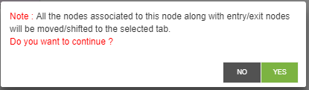

* Click on Yes to cut and paste.
* Node along with its connection will be pasted to selected tab. Node and its connection will not be available in the original tab.
* Click on No will close the window and node will not be cut and pasted.
* Node connection will be cut and pasted by default along with the node.

There are certain conditions which has to be considered while cut and pasting nodes. They are listed below.

1. DNIS node cannot be cut and pasted to the same tab as well as another tab.
2. Except DNIS node, all other nodes can be cut and pasted to another tab.
3. No nodes can be cut and pasted to the same tab
4. Cannot cut and paste Conditional rule node and Module exit nodes. This feature does not exist for these 2 nodes. Error message will be generated. ‘Cannot move/shift conditional rule node’.
5. A node cannot be cut and pasted if it has a parent node. If there is an attempt to cut and paste the node, error message ‘Please break connections from this node’s parent.’ Will be displayed.

## **Copy and Paste**

Copy and Paste feature is an important feature that can be used to ease the workload of the users. Nodes that are frequently used and need to be created multiple times with minimal changes.

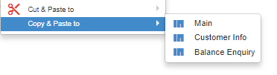

Steps to create a node/flow using Copy Paste feature:

* Right click on the node to be copied.
* Choose the tab to which the node must be copied.
* A confirmation message pops up. Include node connections can either be checked for opting node connections along with the node copy paste or not.

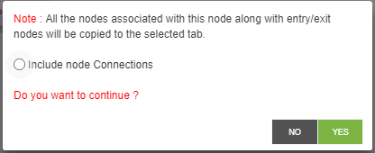

* Click on Yes to copy and paste.
* Node along with its connection will be copied to the same or another tab based on inclusion or exclusion of node connections.
* Click on No will close the window and node will not be copied.

There are certain conditions which has to be considered while copy pasting nodes. They are listed below.

* DNIS node cannot be copied to the same tab as well as another tab.
* Except DNIS node, all other nodes can be copied to the same tab as well as another tab.
* Cannot copy Conditional rule node and Module exit nodes. This feature does not exist for these 2 nodes which means user will not be able to see the copy
* A node can be copied if it has a parent node. But the copied node does not have a parent node. It will have the entire flow from the copied node.
* Node connections can be included or excluded while copying. If the node connections are excluded, all the nodes are copied from there onwards except for the node connections.
* If an exit node connected to an entry node which is present in other tab, upon coping the exit node, entry node will not be copied.
* If an exit node connected to an entry node which is present in same tab, upon coping the exit node, entry node will also be copied.

## **Sticky Note**

User is provided with sticky note feature to add information about particular node

Steps to create sticky note:

* click on the note option and following note will appear

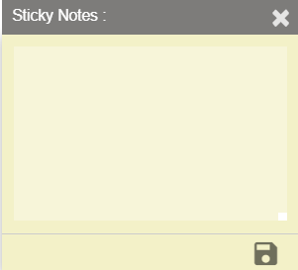

User can add notes here and save using save button which is present at right bottom of sticky note. Upon saving the note, indication will be provided in the node level as shown below.

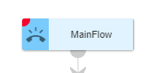

Note: User can add the sticky note to any node/node legs only in DRAFT status of the callflow. Error message is generated when user try to add sticky note to a node in a callflow whose status is not DRAFT.

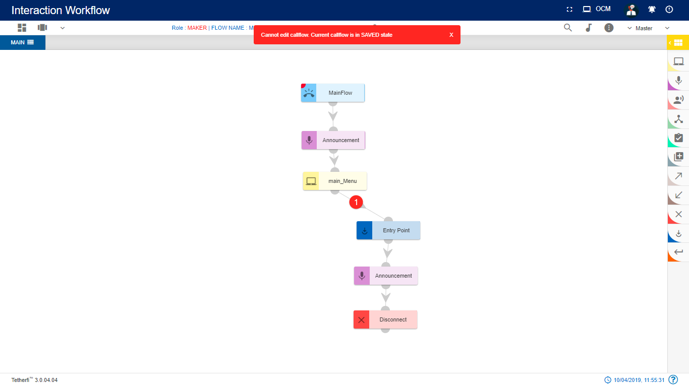

# **Dashboard**

Upon clicking dashboard icon, following page will be displayed.

All the created as well as imported callflows will be displayed here. Callflows of all the status are displayed for Maker, Checker and Previewer.

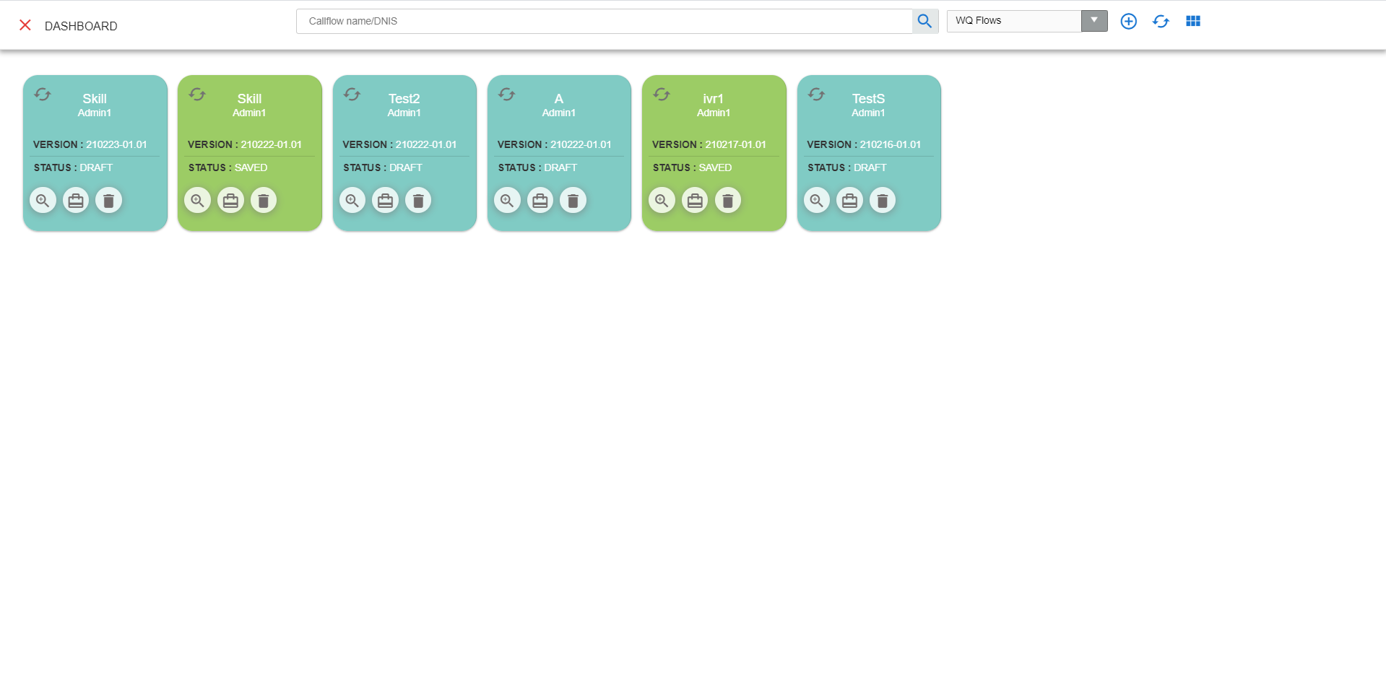

* + - 1. Callflow Name/DNIS: Enter Callflow name or Dnis number to search
      2. Search for Callflow: This option is used to search the particular callflow based on callflow name and DNIS.
      3. Add New Workqueue flow: Configure a new callflow (refer section New Workqueue Flow). This option is only provided for Maker.
      4. Refresh Dashboard: Refresh the dashboard.Update the callflow lists with latest changes
      5. Refresh: This option is used to refresh individual callflow.
      6. Preview Callflow: This option is used preview a callflow (refer section Preview )
      7. Callflow Build/Package: Callflow will be packed and zip file will be downloaded. This zip file will contain callflow related data. This zip file can be imported (refer section Import Callflow) at other systems. This option is not available for previewer.
      8. Delete Callflow: This option is used to delete a callflow. Only Owner of the callflow can delete callflow. And Callflow should be in DRAFT and SAVED state.
      9. dropdown: This dropdown contains option to display callflow, Subflow and ordertake flow in dashboard. User can select which option is required.

Callflow: upon selecting callflow option, all the IW flows will be displayed. This callflow contains skill id .

***Note****: flow which has only DNIS node is cannot be deleted*.

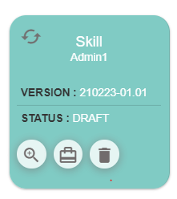

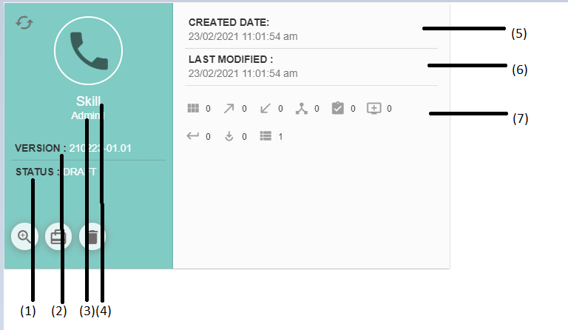

1. Status: This option is used to display current status of the callflow
2. Version: Current version of the callflow.
3. User: Last modified user.
4. Flow Name: Flow name
5. Created Date: Created date and time. (during imported callflow, created and modified date and time will be same).
6. Last Modified: Last modified date and time. The time at which user has saved/ sent for approval/ approved/ rejected/scheduled is updated here.
7. Nodes, Modules, tab count: All the nodes/modules/tabs used in a callflow along with their count will be displayed here.

When a callflow is imported, it will be displayed in dashboard and its status will be ‘DRAFT’.

When user try to load a new callflow on top of existing active callflow, save confirmation popup will be generating as shown below.



If Yes, Changes done in the active callflow will be discarded and new callflow selected here will be loaded

If No, User can continue with the existing active callflow

# **Flow Status**

## **Flow status for various users**

|  |  |  |  |
| --- | --- | --- | --- |
| **Flow Status** | **Previewer** | **Maker** | **Checker** |
| **DRAFT** | Yes | Yes | Yes |
| **SAVED** | Yes | Yes | Yes |
| **SENDTOAPPROVAL** | Yes | Yes | Yes |
| **CHECKERDRAFT** | Yes | Yes | Yes |
| **CHECKERSAVED** | Yes | Yes | Yes |
| **APPROVED** | Yes | Yes | Yes |
| **SCHEDULED** | Yes | Yes | Yes |
| **REJECTED** | Yes | Yes | Yes |

## **Draft**

Initially when callflow is created, a status of the callflow will be in ‘DRAFT state and only the owner(maker) of the callflow can edit the callfow until owner release the callfow(callfow state to ‘SAVED).

Maker can delete a callflow whose current status is ‘DRAFT’. Callflow which has only DNIS node cannot be deleted even if it is in ‘DRAFT’ status.

In order to change the current status to ‘DRAFT’, click on ‘Edit callflow’ button as shown below. Upon clicking this button status of the flow will change to ‘DRAFT’. User can add, delete or edit a tab in draft status only.

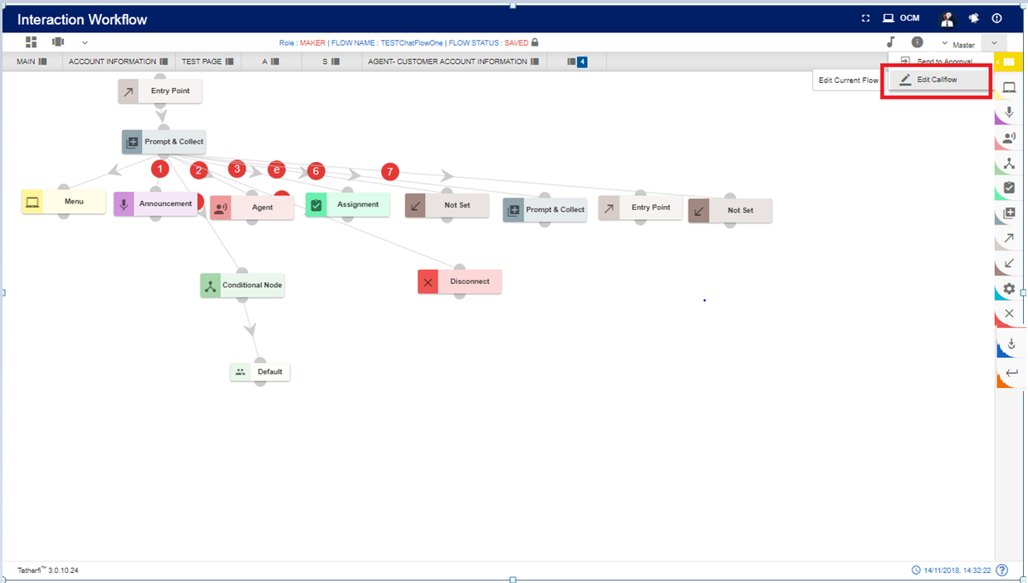

## **Saved**

In order to run a callflow and to send a callflow for approval, its status must be in ‘SAVED’ state. Click on the ‘Save callflow’ button as shown below to save a callflow.

Upon clicking this button status of the flow will be changed to ‘SAVED’. Maker can delete a callflow whose current status is ‘SAVED’. Callflow which has only DNIS node cannot be deleted even if it is in ‘Saved’ status. Callflows whose status is saved, can be accessed by other user (other than owner) and make changes by changing its state to ‘DRAFT’.

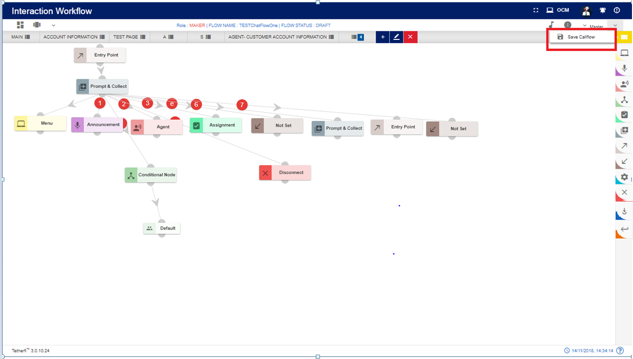

## **Send to approval**

All the callflows created by maker must be approved by the checker to complete its cycle. ’SENDTOAPPROVAL’ option is used to send a callflow to checker for approval. Upon clicking this button status of the flow is will change to ‘SENDTOAPPROVAL’.

Maker cannot delete a callflow whose status is ‘SENDTOAPPROVAL’.

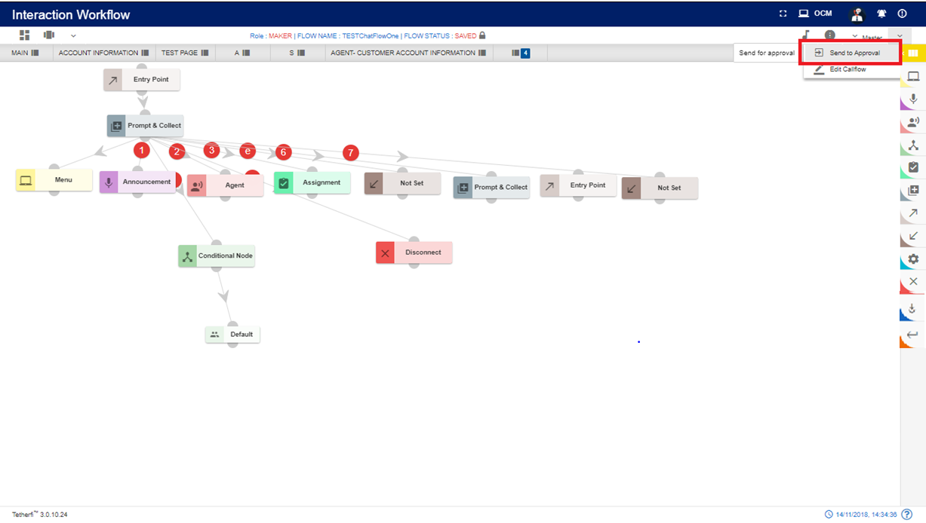

## **Checker Draft**

A callflow will be in this status when checker edits a callflow. Note that checker can only put comments on each node. He can neither edit a callflow (i.e. adding new nodes) nor delete a flow. Upon clicking ‘Edit Callflow’ button in checker page, status of the callflow is changed to ‘CHECKERDRAFT’.

Maker cannot delete a callflow whose status is ‘CHECKERDRAFT’.

Upon clicking ‘Edit Details’ option from node level as shown above, following page will be displayed.

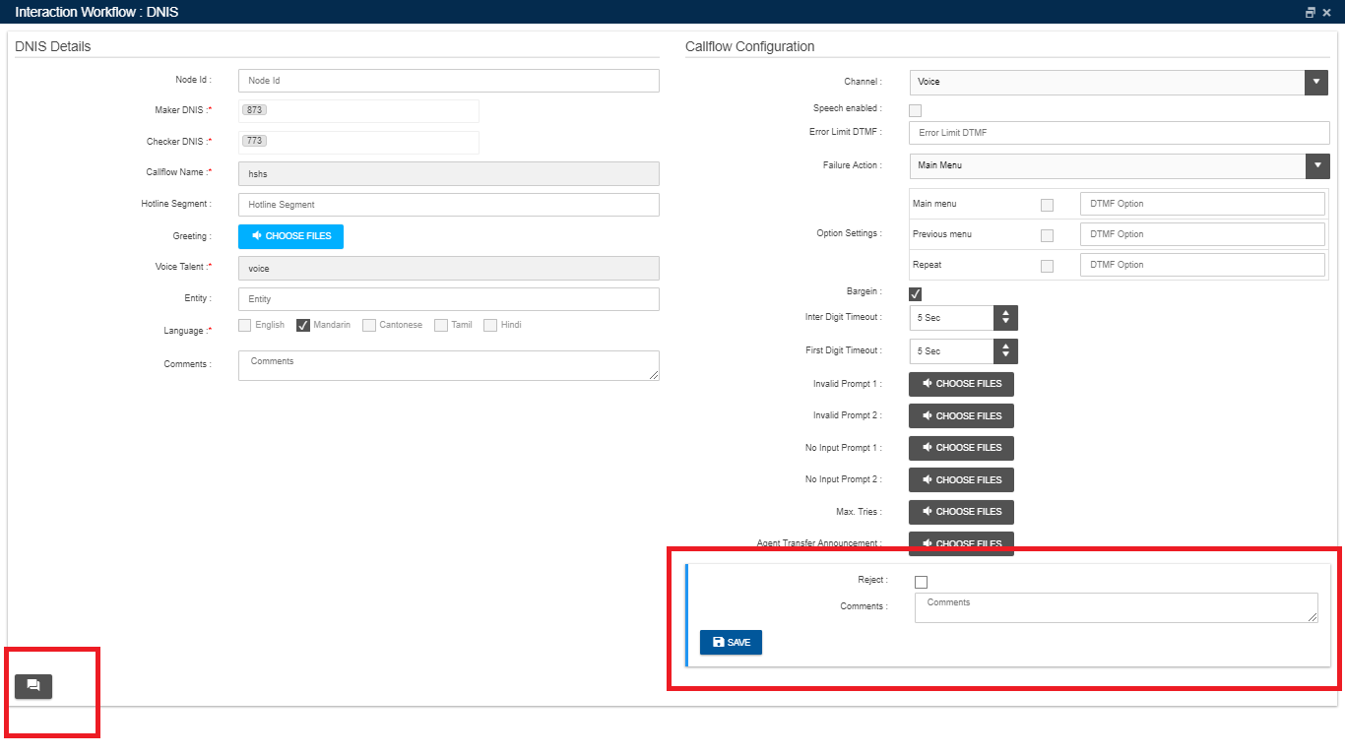

Now checker can enter ‘comments’ specific to the nodes and also can ‘view comments’ from either maker or previous checkers

Upon clicking ‘View Comments’ icon, following window will be displayed.

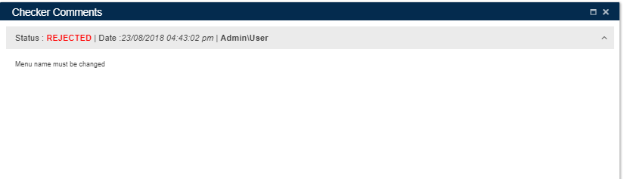

## **Checker Save**

To approve/reject a callflow, it’s status must be either SENDTOAPPROVAL or CHECKERSAVED. When checker Clicks ‘Save callflow’ button, flow status will be changed to ‘CHECKERSAVE’. Checker can approve a callflow even after putting comments. When a Checker cancel the scheduler, callflow status will be changed to ‘CHECKERSAVED’.

Callflow whose status is ‘CHECKERSAVE’ cannot be deleted.

## **Approved**

When a checker approves a callflow, its status will be changed to ‘APPROVED’. Click on the button as shown below in order approve a callflow. Note that, node blink will be stopped once the callflow is APPROVED.

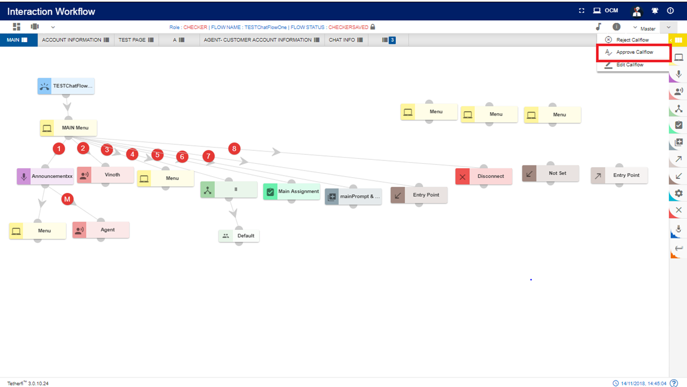

Once the checker approves a callflow, it cannot be deleted. Upon clicking on ‘Edit’ button on loading an approved callflow, new version of the callflow is created. In order to approve the callflow, there must be atleast 1 phrase uploaded to callflow.

***Note****: user can create only 1 draft callflow from approved callflow. User cannot create the draft version callflow from approved version if there is already a callflow with same name which is in SAVED, SENDTOAPPROVAL, CHECKERDRAFT, CHECKERSAVED, REJECTED, SCHEDULED status.*

*Error message will be generating when user try to create 2 nd draft version of the callflow from approved version, where first version of the callflow is still not approved.*

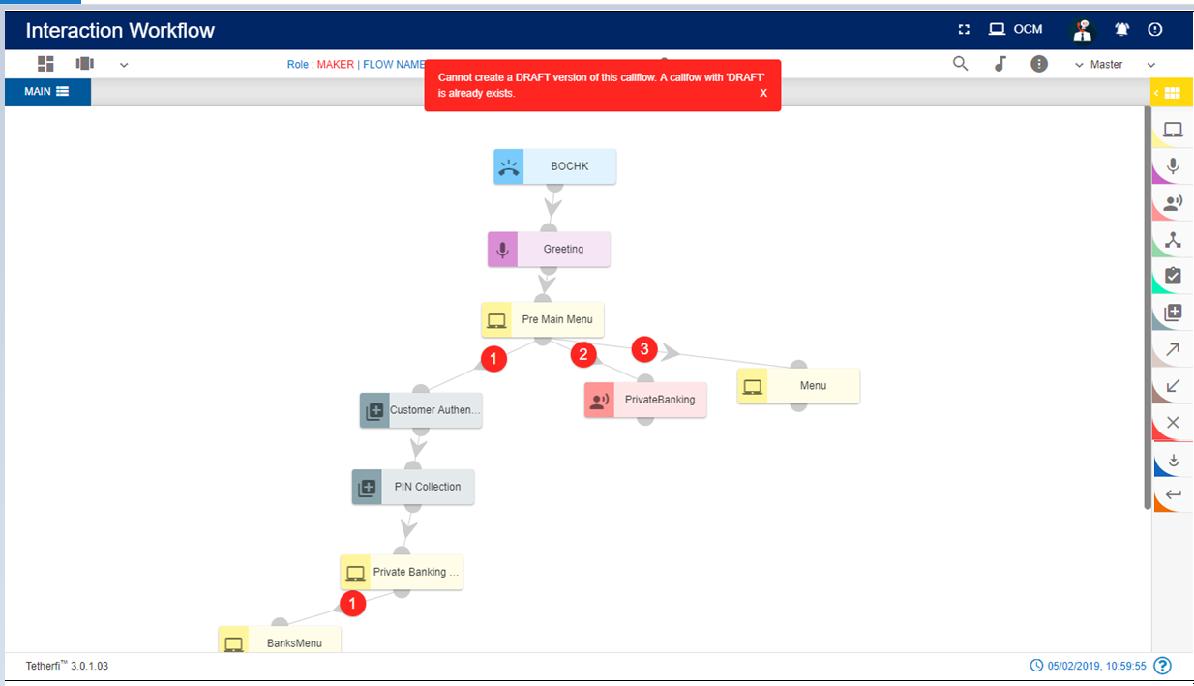If the global phrase used in the callflow is not approved, then a confirmation popup will be generated as shown below, which shows the pending phrases to approve.

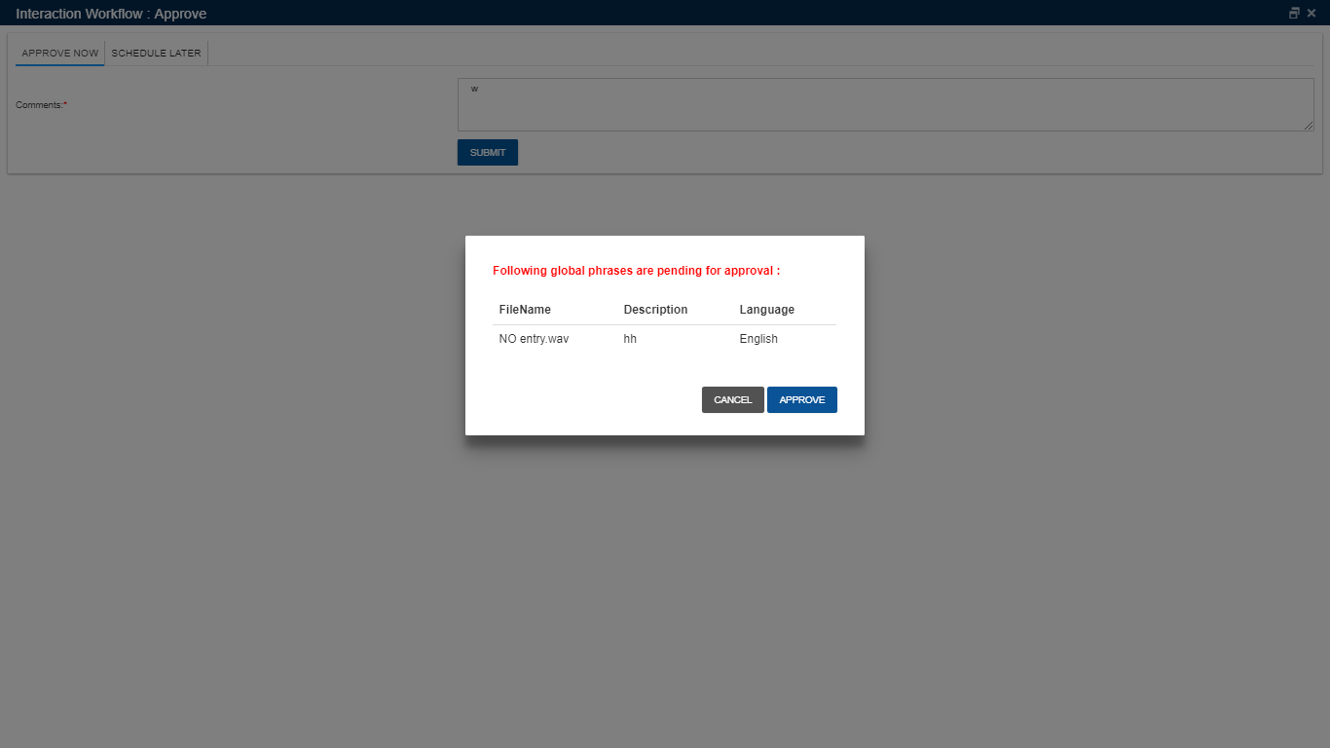

## **Rejected**

Once the checker rejects the callflow, flow status is changed to ‘REJECTED’. Maker can again edit the rejected callflow and send for approval. Checker can reject the callflow without adding any comments to the nodes. Click on the button as shown below in order reject a callflow.

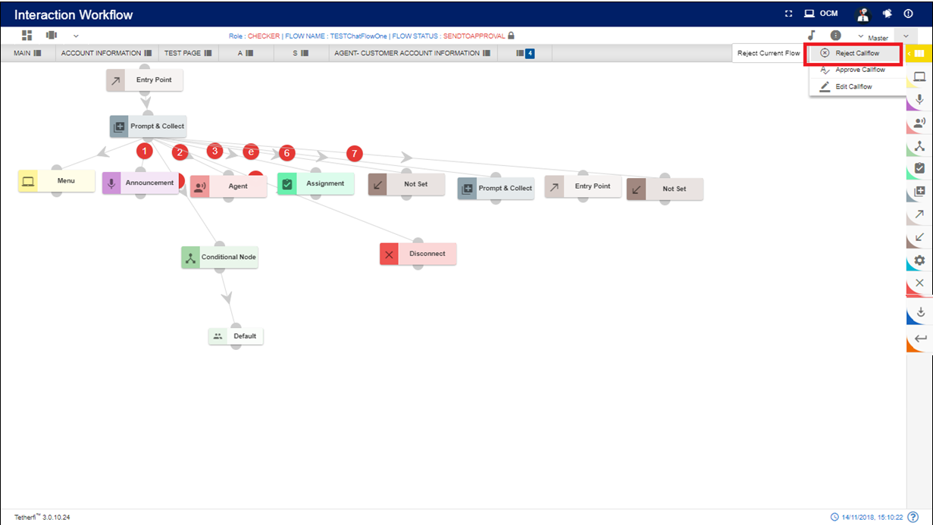

## **Scheduled**

Checker can also schedule a callflow. Upon scheduling a callflow, it’s status is changed to ‘SCHEDULED’. Note that scheduled callflow cannot be deleted. Scheduled callflow cannot be approved by the checker. Once the checker cancels the scheduler, status of the callflow is changed to ‘CHECKERSAVED’. Then the checker can approve this callflow.

Note that, Node blink will be stopped once the callflow is SCHEDULED.

Click on the ‘Approve callflow’ button as shown below.

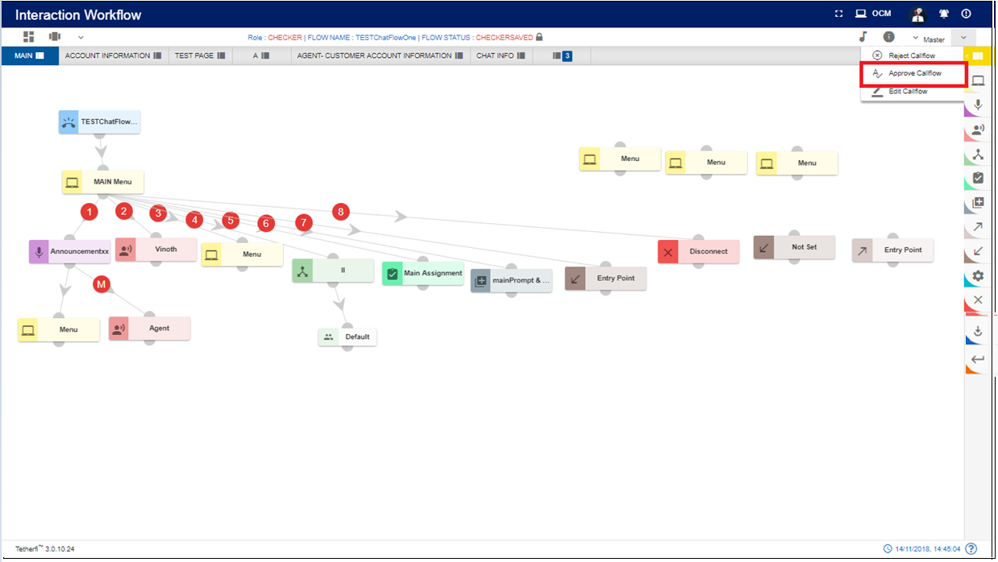

Click on ‘SCHEDULE LATER’ option as shown below.

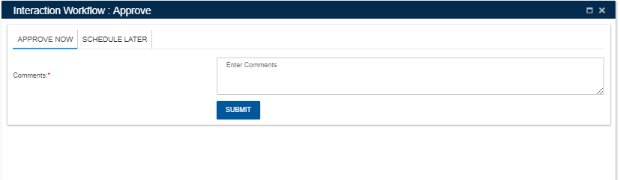

Enter scheduling date and time with comments to schedule a callflow and press ‘SUBMIT’ button.

‘Cancel Schedule’ button is used to cancel a scheduled callflow. Upon cancelling the schedule, callflow status is changed to ‘CHECKERSAVED’. Once the user schedules the callflow, same user can only cancel the Scheduled callflow. Another user cannot cancel the scheduled callfow.

## **Static Flow related Buttons**

There are static flow related buttons provided when flows are in different status. As shown below, when flow is in DRAFT status, ‘Save flow’ button will be displayed.

User can move this button to anywhere in the page and click them to perform SAVE, SEND TO APPROVAL, APPOVE operation on callflow

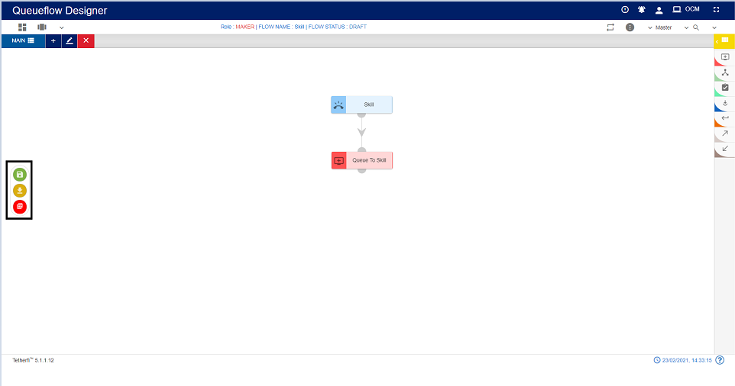

|  |  |  |
| --- | --- | --- |
| Sl.No | Callflow Status | Static Buttons Displayed |
| 1 | DRAFT | Save Callflow |
| 2 | SAVED | Edit Callflow, Send to approval |
| 3 | SEND TO APPROVAL | Reject Callflow, Approve Callflow, Edit Callflow |
| 4 | CHECKER DRAFT | Save Callflow |
| 5 | CHECKER SAVED | Reject Callflow, Approve Callflow, Edit Callflow |
| 6 | APPROVED | Edit Callflow |
| 7 | REJECTED | Edit Callflow |

When callflow is in DRAFT status, SAVED button will start blinking after a configured time expires, which will indicate the user to save the flow, as shown below.

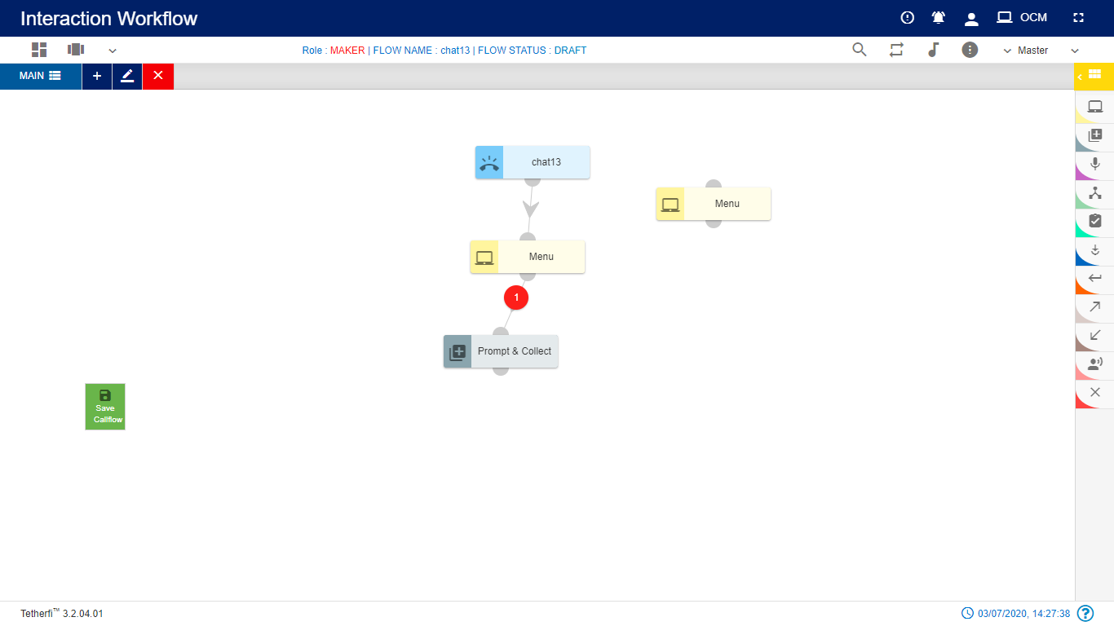

## **Node Blink**

When checker rejects the node, node will blink in maker and maker-checker page. Tab will also blink in maker and maker-checker page, when a node in the tab is rejected by a checker.

Only maker modified nodes will blink in checker page. Note that rejected nodes will not blink in checker page unless maker modify the nodes.

For Exp: When a new callflow is created, all the nodes will blink in checker page, since all the nodes are new (i.e. modified).

When a callflow is approved / scheduled node blink will be stopped. If the callflow status changed to CHECKERSAVED after cancelling the SCHEDULE, nodes will not blink even though they are modified

# **Use Case**

Please consider the below shown example:

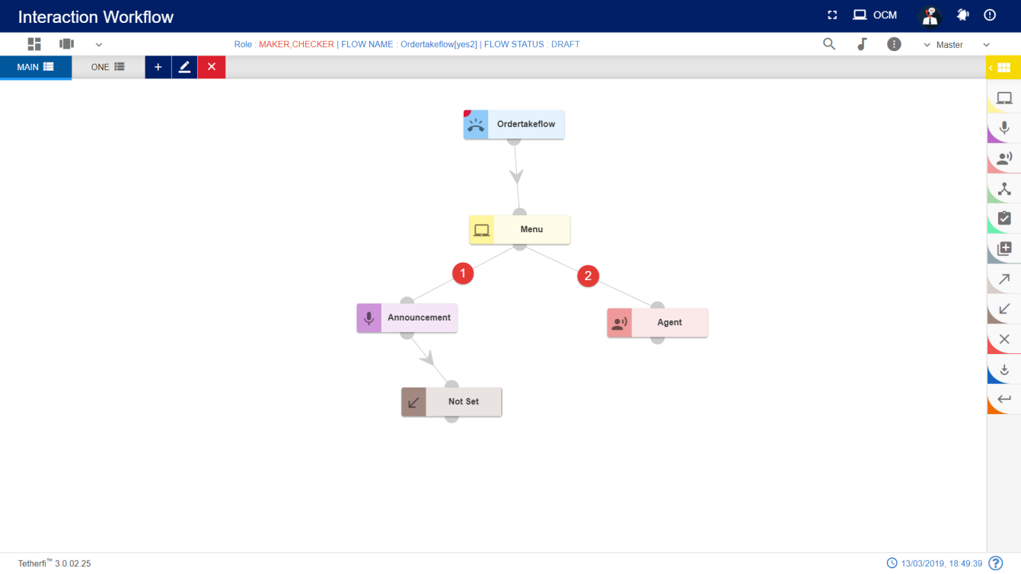

Below are the mentioned are the steps for recreating the above workflow

## Step 1: Creating a new MAIN NODE node- Skill (Level 1)

1. On click of Configure Callflow button, the below window will pop up:

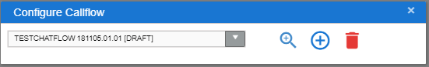

1. Click on ‘Create New Workqueue flow’
2. Enter the details into the MAIN NODE details screen as shown below:
3. Enter the details screen as shown below:

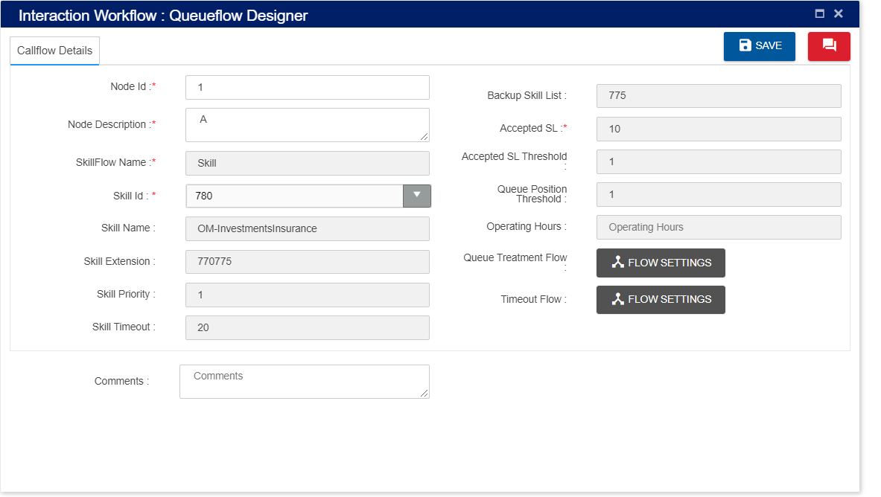

While creating a new queueflow designer Details please note the below points:

1. Skill Flow Name: Enter “skill” as call flow name
2. Skill id: Select skill id from dropdown. Skill related values are auto populated.
3. Comment: Providing a comment before saving is not mandatory.

## Step 2: Adding a new Queue to Skill (Level 2)

1. For adding a new queue to skill node to the callflow, click on the “Queue to skill” icon and drag it to the main screen. 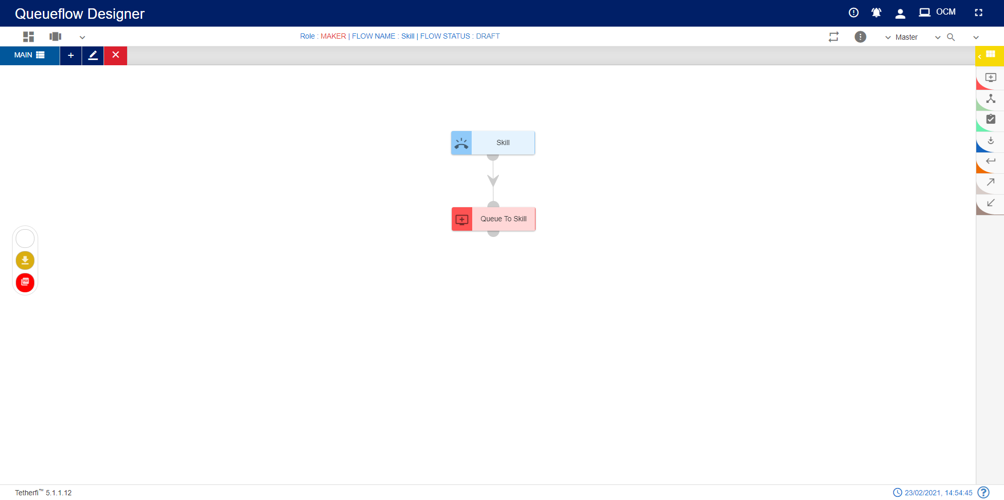
2. For editing/ configuring the Queue to Skill, hover over the Queue to Skill icon you added and edit/ delete functionalities for the Queue to Skill will be displayed.



1. On click of edit button, the below screen will popup. Enter the details into the Queue to Skill details screen as shown below:

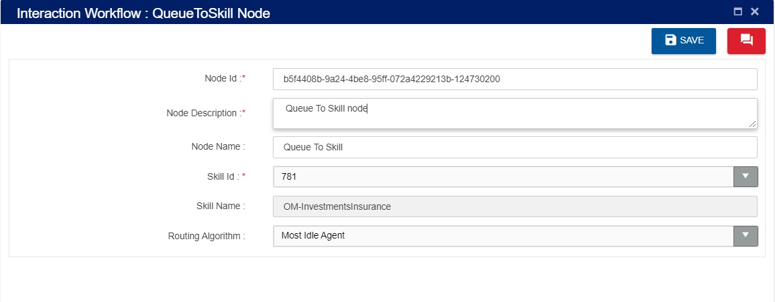

1. Node ID: By default, the Node ID for a Queue to Skill is autogenerated.
2. Node Name: By default, the Node Name is Queue to Skill.
3. Node Description: Enter brief characterization of the Queuetoskill. (Mandatory)
4. Skill id: Select from dropdown.
5. Skill Name: Specific to skill id skill name is auto populated.
6. Routing Algorithm: for most idle agent or least occupied agent.

## Step 3: Adding tab One Alongside Main tab (Level 3)

1. For adding a new tab alongside the Main tab, click on the “Add New Tab” icon present on the top left corner of the main screen.



1. On click of the “Add New Tab” button a new popup will be displayed. Enter the details into the Tab details screen:

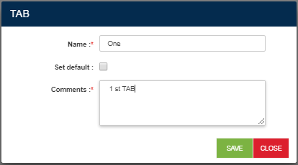

## Step 4: Adding a new Entry Point to Tab One (Level 4)

1. For adding an Entry point to tab ONE, click on the “Entry point” icon and drag it to the Tab ONE screen.

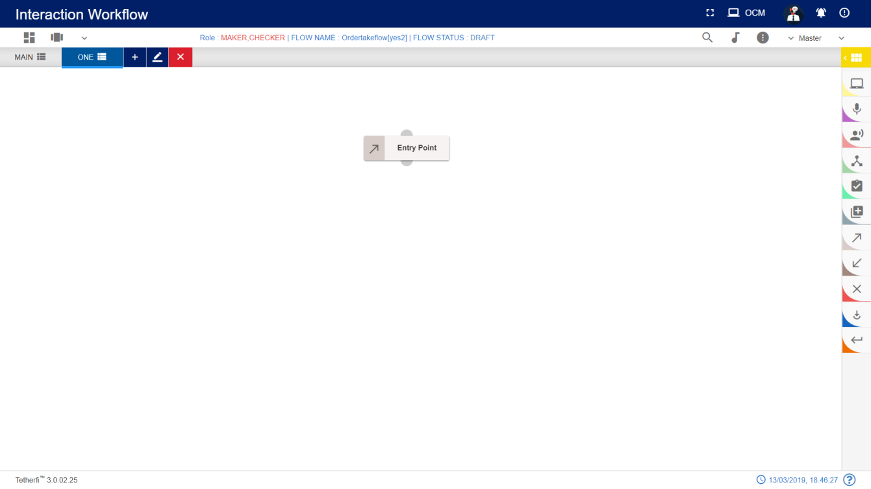

1. For editing/ configuring the Entry point, hover over the Entry point icon you added and edit/ delete/ view connections functionalities for the menu will be displayed.



1. On click of edit button, the below screen will popup wherein you need to specify the name of the Entry Point. Enter the details into the Entry Point details screen as shown below:

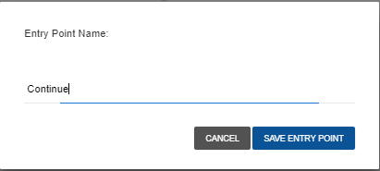

1. For adding a new Continue Queue to skill node to the flow, click on the “Queue to Skill” icon and drag it to the main screen.

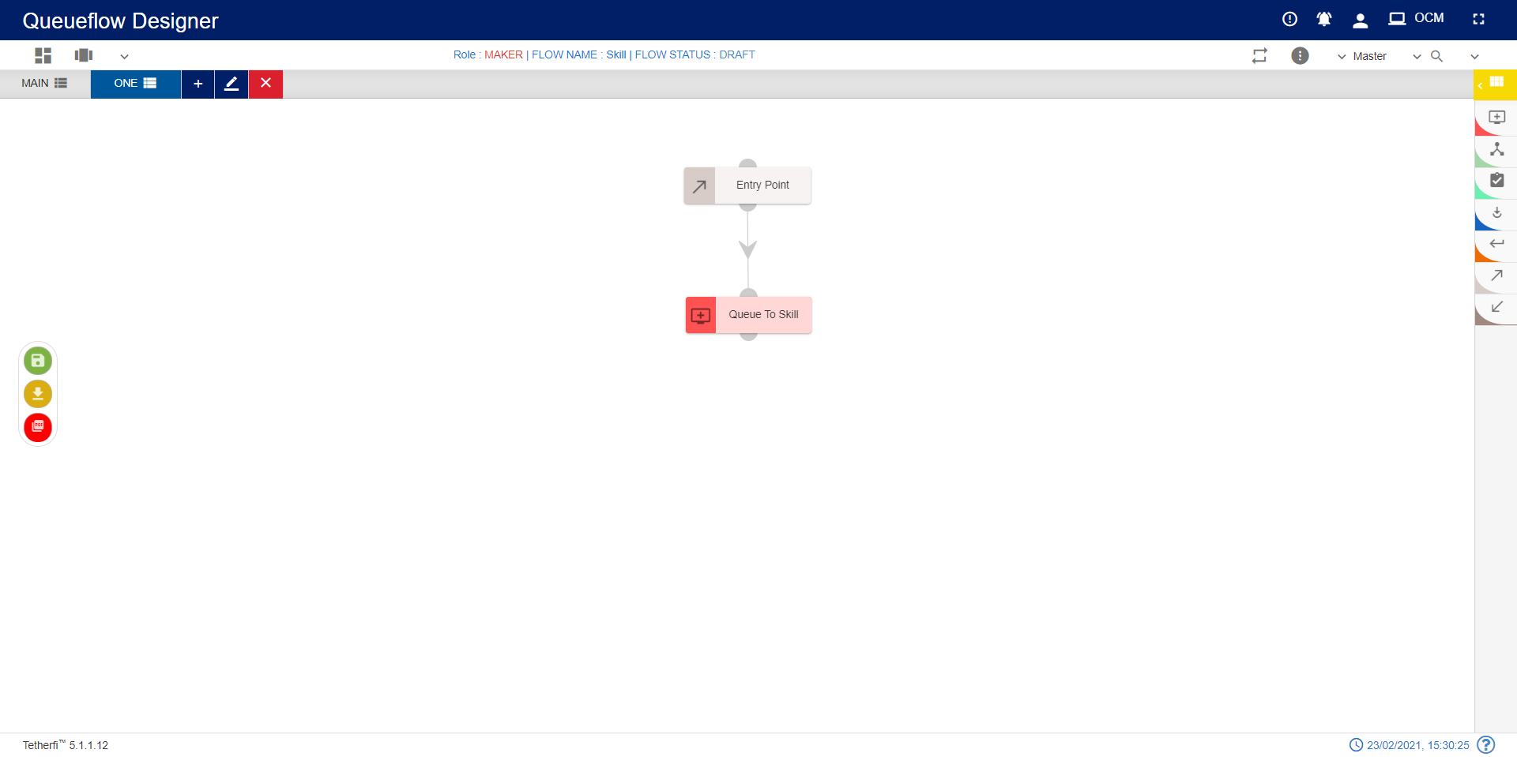

1. For editing/ configuring the Queue to Skill, hover over the Queue to Skill icon you added and edit/ delete functionalities for the menu will be displayed.



1. On click of edit button, the below screen will popup. Enter the details into the Queue to Skill details screen:

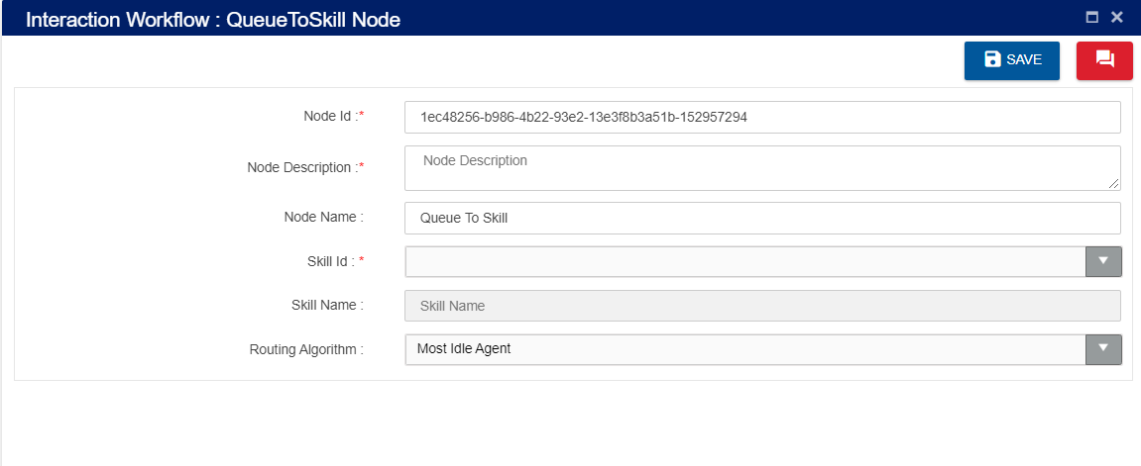

## Step 5: Adding an Exit points - (Level 5)

1. For adding a “continue” Exit point to Main tab, click on the “Exit point” icon and drag it to the Tab Main screen.



1. For editing/ configuring the Exit point, hover over the Exit point icon you added and edit/ delete functionalities for the menu will be displayed.



1. On click of edit button, the below screen will popup wherein you need to configure the Entry point for the selected Exit point. Enter the details into the Menu details screen as shown below:

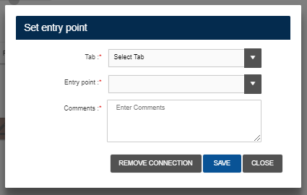

## Step 6: Connecting Nodes and Modules (Level 6)

1. For interconnecting one or more Nodes/ Modules, you need drag the connecting link as shown below:

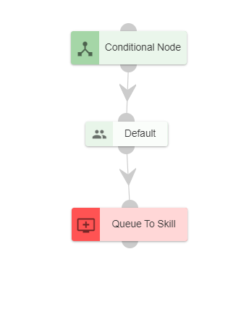

1. For deleting a node, double click on the connecting and the below screen will be displayed:

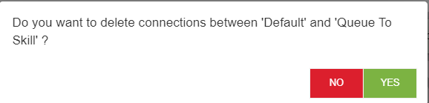

## Step 7: Approval of Workflow: (Level 7)

1. After Maker is done with creating and configuring a workflow, the workflow needs to be sent to Checker for approval. The Maker can do this by clicking on the “Send for Approval” button present on the top right corner of the screen.

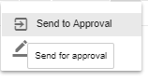

1. The checker needs to select the corresponding callflow from the list of callflows, analyze the callflow and depending upon the analysis determine whether the callflow is to be approved or rejected.

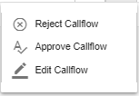

1. On click of approve button, the below screen will be displayed
2. For approving the workflow, providing comment for the approval is mandatory.
3. Can also schedule the approval as shown below. Providing comment for the scheduling is also mandatory.



While Interpreter is down:

1.In the sync notifications error notification will be generated.

When callFlow is sent for approval while interpreter is down.

