Interaction Workflow
IVR User Guide
Document Version: 8.0.12.23
Last Updated Date: 2022 January 4



Version History
Version  # | Implemented  By | Revision  Date | Approved  By | Approval  Date | Description of  Change
1.0 | Nishchith Shetty | 20/04/2016 | Vinoth Raj | 29/04/2016 | Initial version of Interaction Workflow user guide
1.1 | Nishchith Shetty | 18/09/2016 | Vinoth Raj | 10/10/2016 | Added more details under each section.
1.2 | Nishchith Shetty | 10/12/2016 | Vinoth Raj | 07/01/2017 | Added approval process details
1.3 | Nishchith Shetty | 07/03/2017 | Binny Mathew | 12/03/2017 | Added scheduler process details.
1.4 | Nishchith Shetty | 17/07/2017 | Binny Mathew | 19/07/2017 | Updated Reversion process details
1.5 | Nishchith Shetty | 24/07/2017 | Vinoth Raj | 27/07/2017 | Updated the rule configuration details and latest screen shots for each page.
1.6 | Nishchith Shetty | 22/08/2017 | Vinoth Raj |  | Added overview, entry point, exit point and use case sections
1.7 | Nishchith Shetty | 23/08/2017 | Vinoth Raj |  | Reformatted the document and modified Use Case section
1.8 | Nishchith Shetty | 27/08/2017 | Vinoth Raj |  | Reformatted the Maker/Checker section and added border to all the images
1.9 | Nishchith Shetty | 15/09/2017 | Vinoth Raj |  | Added Simulation Section
1.10 | Shriraksha B Rai | 04/12/2017 | Vinoth Raj |  | Screenshots are changed  Added dashboard, flow status, previewer, import callflow, copy callflow, real-time view report, text to voice, callflow version control, rule master, Intent master, configure callflow, designing the workflow, Node Connectivity, More menu option, Tabs, Phrases, Maker and Checker, Comment section.  Reformatted the Maker and Checker section.  Updated simulation section.
1.11 | Shriraksha B Rai | 16/7/2018 |  |  | Is Dynamic Menu and masking-unmasking option is added to Menu node.  Masking -unmasking, play with next menu option is added to Announcement node.  Refresh button is added in Rule master  Logo has been changed in document.
1.12 | Shriraksha B Rai | 21/8/2018 | Prakash Dsouza | 3/9/2018 | Giving access through IW Role based access matrix module in OCM  Global phrase upload  Global Configuration  Menu and PNC node option shuffling  Max length validation rule for PNC node  Support for Anonymous user Access  Node sizes are reduced (UI Changed)
1.13 | Shriraksha B Rai | 17/9/2018 | Prakash Dsouza |  | Copy Tab  Global Configuration and Rules specific to the callflow  Tab shuffling  Multiple draft version restriction  Digit time out option allows decimals  Restricting Multiple DRAFT version
1.14 | Shriraksha B Rai | 01/11/2018 |  |  | Wav file name validation  Enabling Owner level callflow  Assignment node auto search disabling  System Architecture  Interface Design  Master form enable for Checker and Previewer  Node blink section added
1.15 | Shriraksha B Rai | 19/01/2019 |  |  | Node search feature implemented  Node ID field is added for all the node except Entry and Exit node  UI Changed
1.16 | Shriraksha B Rai | 16/03/2019 |  |  | Updated screenshots of callflows  Updated Comments, Dashboard, Node connectivity, Node level roles and Phrase section  Updated overview section
3.0.04.04 | Shriraksha B Rai | 10/04/2019 |  |  | Sticky note section added  Updated real time session dashboard section.  Subflow feature is implemented  Added flow connector node and return node  Updated copy callflow section
3.1.06.11 | Shriraksha B rai | 09/04/2019 |  |  | Rules viewer section is added.  Updated Real time session dashboard Section  Updated Comment Section  Updated phrase section.
3.1.7.4 | Shriraksha B Rai | 18/7/2019 |  |  | File system version section added  Database Table Access  Import section is updated
3.1.7.30 | Shriraksha B Rai | 31/7/2019 |  |  | Session Dashboard:  - Flow name is displayed in the grid.  - Following KPI's are displayed: Total Time Spent, Average Time Spent, Total Interactions Transferred to Agent, Total Self-Service Interactions  - Clear option is provided  - Transfer Skill and Transfer VDN option is provided
3.1.08.02 | Shriraksha B Rai | 02/08/2019 |  |  | - Search option is provided in Real time session dashboard
3.1.08.13 | Shriraksha B Rai | 13/08/2019 |  |  | - IW Master Access matrix
3.1.09.05 | Shriraksha B Rai | 05/09/2019 |  |  | - New UI for Historical KPI Dashboard is privided  - Hotkey option is provided for IW IVR
3.1.10.17 | Shriraksha B Rai | 17/10/2019 |  |  | - Enable Tracking Property introduced for Menu, Announcements, PNC and Agent nodes to track in real-time reporting
3.2.01.31 | Shriraksha B Rai | 17/2/2020 |  |  | - Synonym master option is provided  - Flow connector node will display mainflows too along with subflows
3.2.04.23 | Shriraksha B Rai | 23/4/2020 |  |  | - Option to delete multiple nodes at a time is provided  - Save confirmation popup  - ‘Is Global Main Menu’ option in all the nodes  - DTMF display option  - Order of the nodes displayed in node panel is changed  - Image option is provided in menu and PNC leg  - Initial text image option is provided in all the nodes
3.2.04.29 | Shriraksha B Rai | 29/4/2020 |  |  | - Same callflow size is maintained for subflow as well as main flow in dashboard.  - Redirect to IW Module Designer page  - 'Synonym option is provided in IW IVR  - Phrase Master
3.2.05.07 | Shriraksha B Rai | 08/05/2020 |  |  | - Rules Viewer section is updated  - Maker level node comments are displayed in all the nodes along with checker comments.
3.2.06.08 | Shriraksha B Rai | 08/06/2020 |  |  | - Additional options like Min threshold, confirmation, confirmation Entry, Functional Entry, Hotline and Segment is provided in Synonym Master
4.0.07.07 | Shriraksha B Rai | 07/07/2020 |  |  | - Static flow related buttons  - IW Speech  - Session Master
5.0.12.25 | Deepthi Shetty | 28/12/2020 |  |  | - Fetching VDN from external source in Agent node
6.0.6.7 | Deepthi Shetty | 07/06/2021 |  |  | - Added Contingency Audio Master section.  - Implemented Masters in Dashboard
8.0.12.23 | Deepthi Shetty | 23/12/2021 |  |  | - Added new canvas changes

Copyright
All rights reserved. No part of this product may be reproduced, transmitted, transcribed, stored in a retrieval system, or translated into any language in any form by any means without the express written permission of Tetherfi.

Warranty Information
Tetherfi makes no representations or warranties with respect to the contents or use of this product and specifically disclaims any express or implied warranties of merchantability or fitness for any purpose. Information in this document is subject to change without notice and does not represent a commitment on the part of Tetherfi.

Trademark Information
Tetherfi is a registered trademark of Tetherfi. Other product names may be trademarks or registered trademarks of their respective companies.

Contact Information
For customer inquiries, contact: For technical support inquiries, call:
Tetherfi +65 6715 7408
60 Paya Lebar Road,
#06-01 Paya Lebar Square,
Singapore

Contents
1 Introduction 10
1.1 Intended Audience 10
1.2 Scope of document 10
1.3 Glossary 11
2 Overview 12
2.1 System Architecture 14
2.2 Interface Design 15
3 Access Details 16
3.1 OCM Access 16
3.1.1 Role Based Access Management 17
3.1.2 User Role Mapping 18
3.1.3 IW Role Based Access Matrix 20
3.1.4 IW Master Access Matrix 24
3.2 Database Table Access 27
4 Interaction Workflow User Roles 29
4.1 Maker 29
4.1.1 Import Callflow 32
4.1.2 Copy Callflow 34
4.1.3 Callflow Version Control 37
4.1.4 Rule Master 38
4.1.5 Intent Master 43
4.1.6 Phrases 45
4.1.7 Rules Viewer 47
4.1.8 Comments 48
4.1.9 Global Configuration 49
4.1.10 Global Phrases 50
4.1.11 Approve Global Phrases 53
4.1.12 Search for Nodes and Modules 54
4.1.13 File System Version 55
4.1.14 Hot Keys 55
4.1.15 Synonym 58
4.1.16 Synonym Master 59
4.1.17 Session Master 62
4.1.18 TMAC Widget Master 63
4.1.19 Contingency Audio Master 64
4.2 Checker 66
4.2.1 Approve Now 69
4.2.2 Scheduled Later 69
4.3 Previewer 70
4.4 Maker and Checker 74
5 Creating/Editing Workflows 77
5.1 Configure Callflow 77
5.1.1 Callflow List 78
5.1.2 Preview 79
5.1.3 New IW Flow 79
5.1.4 New Order Take Flow 83
5.1.5 Sub Flow 85
5.1.6 Delete 87
5.1.6 Phrase Selection Window 87
5.2 Designing the Workflow 90
5.2.1 Tabs 90
5.2.2 More Menu Option 95
5.2.3 Set Rules 99
5.2.4 Callflow Sync Notification 101
6 Nodes and Modules 104
6.1 Nodes 104
6.1.1 Menu Node 105
6.1.2 Agent Node 109
6.1.3 Conditional Node 112
6.1.4 Announcement Node 114
6.1.5 Assignment Node 117
6.1.6 Prompt and Collect Node 119
6.1.7 Entry Point Node 122
6.1.8 Disconnect Node 124
6.1.9 Exit Point Node 125
6.1.10 Flow Connector node 127
6.1.11 Return Node 129
6.1.12 Node Connectivity 130
6.1.13 IW Speech 133
6.1.14 Node Changes 133
6.2 Modules 134
6.2.1 IW Module Designer 137
6.3 Connecting Nodes and Modules 137
7 Simulation 138
7.1 Drag Nodes 139
7.2 Remove ALL nodes Connected to This 139
7.3 Play 139
7.4 Cut and Paste 140
7.5 Copy and Paste 141
7.6 Sticky Note 142
8 Dashboard 143
9 Flow Status 146
9.1 Flow status for various users 146
9.2 Draft 147
9.3 Saved 147
9.4 Send to approval 148
9.5 Checker Draft 148
9.6 Checker Save 149
9.7 Approved 149
9.8 Rejected 151
9.9 Scheduled 151
9.10 Static Flow related Buttons 153
9.11 Node Blink 154
10 Use Case 154
Step 1: Creating a new DNIS node- test (Level 1) 155
Step 2: Adding a new Menu- Language Selection (Level 2) 159
Step 3: Adding a new Announcement and Agent- (Level 3) 162
Step 4: Adding tab One Alongside Main tab (Level 4) 164
Step 5: Adding a new Entry Point and menu to Tab One (Level 5) 165
Step 6: Adding an Exit points - (Level 6) 168
Step 7: Connecting Nodes and Modules (Level 7) 169
Step 9: Approval of Workflow: (Level 8) 169

Introduction
Workflow is the definition, execution and automation of business processes where tasks, information or documents are passed from one participant to another for action, according to a set of procedural rules.
Tetherfi Interaction Workflow makes the process of IVR workflow design more efficient, compliant, agile, and visible by ensuring that every process step is explicitly defined, monitored over time, and optimized for maximum productivity, reducing the time the process takes to complete as well as potential errors caused by human interaction. Given optimal, up-to-the-minute process data, managers and employees can take quicker action and make smarter decisions.
Tetherfi Interaction Workflow empowers business users and IT to work together to rapidly modify systems and processes to reflect changes in the business.

Intended Audience
This user guide document is intended for the following audience:
- Business Users
- IT team
- Project Manager
- Application implementation team
- Application maintenance team

Scope of document
This is a systematically written guide for users to manage the ‘Interaction Workflow’ application. By accessing and managing the Interaction Workflow application, users will be able to define/change certain behaviour of IVR application according to their preferences or business requirements without needing any code change.
Web based GUI application will be provided for accessing the User Admin (Maker/Checker) & Reporting module and these modules will be deployed on the IIS web server provided by the Client.

Glossary

Term or Acronym | Definition or Description
OCM | Omni Channel Management
IW | Interaction Workflow
IVR | Interactive Voice Response
DNIS | Dialled Number Identification Service
DTMF | Dual tone multi frequency
GUI | Graphical User Interface
UI | User Interface
VDN | Vector Directory Number
PNC | Prompt and Collect

Overview
An Interaction Workflow is a series of connected blocks that performs various tasks for decision making and routing. Tetherfi Interaction Workflow Designer is a powerful, integrated development environment (IDE) that you can use to create, assemble, and customize workflows. With Tetherfi Interaction Workflow, you can:
- Create the custom nodes and modules in Interaction Workflow and reuse the same in different workflows. You do not need any external tools or block definition languages.
- You do not need to convert the flowchart. You can directly integrate the newly created/ edited workflow into production.
- Use the Symbol Dictionary to maintain consistency among workflows created by different workflow designers.
With the Symbol Dictionary, a predefined set of symbols determines the workflow properties. For example, the Symbol Dictionary ensures that field names remain constant in certain types of workflows.
Rearranging connection:
Any of the nodes can be moved in the Workflow Designer interface to a different part of the call flow. To move an interface element:
- Use the mouse to select and hold the items.
- Drag the element to the desired position and release.
Connection points can be rearranged, if the default connection points, on a block do not meet the needs of the workflow. For example, if the Yes connection of a decision block is on the right, that connection can be moved to the bottom.
IW Features:
List of tasks that can be achieved using interaction workflow:
- Create menus with options.
- Add/Remove options.
- Rearranging the option sequence.
- Configure the initial, invalid and no input announcements (prompt) in a menu.
- Enable/disable options based on the rule.
- Configuration global invalid/no input/max tries prompt and max tries count.
- Attach the self-help module to an option.
- Configure the input parameters required for the modules.
- Perform conditional checks based on rule.
- Add routing configuration node and assign VDN’s.
- Maker/Checker/Previewer.
- Verify the Callflow nodes using simulator.
- Order Take
- Copy and paste the nodes.
- Reversion/Scheduling
- Option to configure specific menu as Language Menu/main Menu
- Add announcement between nodes. Up to 5 prompts can be configured based on the rule. It helps to configure different prompts for specific date ranges.
- Configure global options at menu/global level and enable/disable them.
- Highlight the specific changes when submitted to checker. This would avoid the need to look at each node to understand the changes.
- Add rules based on time, date, date range and operational variables.
- Multiple tabs. It helps to create the reusable flows and break the complex flows into multiple tabs
- Comments from the maker/checker is displayed under notifications.
- Text to Voice option is provided.
- Global Configurations
- Global Phrase upload
- Anonymous user Access
- IW Role Based Access Matrix
- Rearranging Tabs
- Copy- paste Tabs
- Node search
- Sub Flow design
Workflow Preview:
The Workflow Preview is a virtual window of your workflow. Use the Workflow Preview to:
- Navigate the workflow
- Change the amount of workflow that you view at one time
- Zoom in on a section of the workflow
- See the whole workflow
Workflows save time and certainly ensure transparency and reproducibility. They also can do a lot more. Consider these ten benefits of incorporating workflows in your project management.
- Workflows reduce project risk. When a project is at risk, it elevates project complexity and the number of team members can increase. Workflows can ensure that there are decreased delays in the schedule. It can also be responsible for reducing possible disputes and costs by limiting the need to redo work.
- Effect organizational change. When a team works cohesively, it limits the need for management to intervene on the business process side and can provide an improved understanding of the workflow.
- Implementing workflows can lead to process change. As part of developing a workflow, businesses must scrutinize their current processes. This can lead to improvements and optimizations.
- Workflows give increased access to information. Critical processes may be reviewed at every point, ensuring that there are no bottlenecks or issues. This oversight allows project managers to determine how well the process is running from end-to-end.
- Workflows delineate work responsibility to different people. Instead of your staff being uncertain about whose responsibility it is to complete a task or where their own duties lie, a workflow defines it for them.
- Improves project timeline estimates. Gives project managers a basis to estimate how long a task or the overall project will take.
- Provides visibility. Workflows are a way to visually communicate the process to stakeholders.
- Managers can focus on strategy. When a system is running smoothly, managers don’t need to spend time focusing on operations. Instead, they can pay attention to other parts of their job, which can promote business growth and development.
- Workflows provide an audit trail. This is especially true when using a workflow management software system. Records are kept of the progress and completion of tasks, along with pertinent details such as who completed the action, when it was done, and any changes made.
- Businesses can input rules. Instead of people deciding in the moment when issues arise, workflows refer to the predefined rules. This eliminates some of the guesswork, saving time and boosting confidence in the organization’s work capacity.

System Architecture
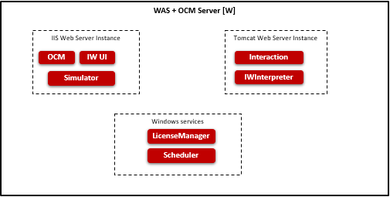
- OCM (Omni Channel Management): Web based application to administer the data and generate the reports.
- IW (Interaction Workflow): Web based application to create and manage the call flows.
- IWInterpreter: It interprets the data submitted from IW and converts it into expected format. It does Callflow validations.
- Interaction: It process the call flows configured using IW.
- License Manager: It maintains the license details and indicates whether the software can run on the system.
- Scheduler: It process the scheduled task.
- Simulator: It provides the details required to enable simulator.

Interface Design
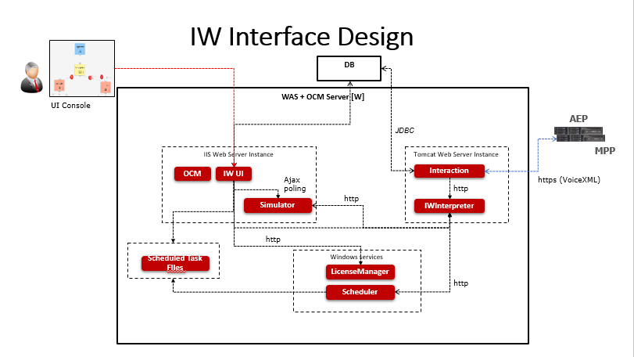
- IW UI talks to License Manager to very whether license is available when launching IW UI.
- Changes made in UI is saved locally in JSON format and submitted to IWInterpreter.
- IWInterpreter validates the JSON submitted and stores the data in memory. It also stores the data in JSON file. It would read the data from file when server restarted.
- Interaction Engine retrieves the Callflow details from IWInterpreter based on DNIS and renders the VXML.
- IW UI saves the scheduled task details in JSON.
- IW Scheduler retrieves the scheduled task from JSON and submits updated Callflow to IWInterpreter. IWInterpreter updates the memory and local JSON file.
- IW Simulator provides the data required to simulate the Callflow in IW UI.
- Reporting information is stored in DB.

Access Details
Interaction Workflow is designed to be compatible with below web browser:
- Microsoft Internet Explorer (IE 11 or above)
- Google Chrome (Chrome version 23, 39, 43, 45, 50 or above)
- Firefox (version 41)
- Microsoft Internet Information Services (IIS version 7 and above)

OCM Access
For accessing Interaction Workflow, OCM must be accessed first. The procedure for accessing OCM is mentioned below.
The user must type the provided OCM link(http://IP:PORT/OCM) in the browser and press ‘Enter’ key, OCM will prompt user to enter his Windows username and password.
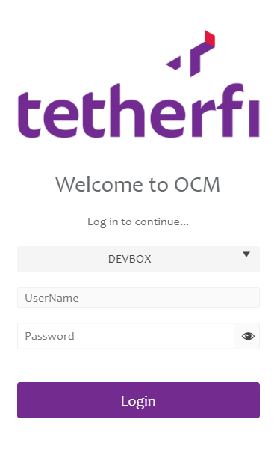
After successful authentication, the below screen will be displayed.
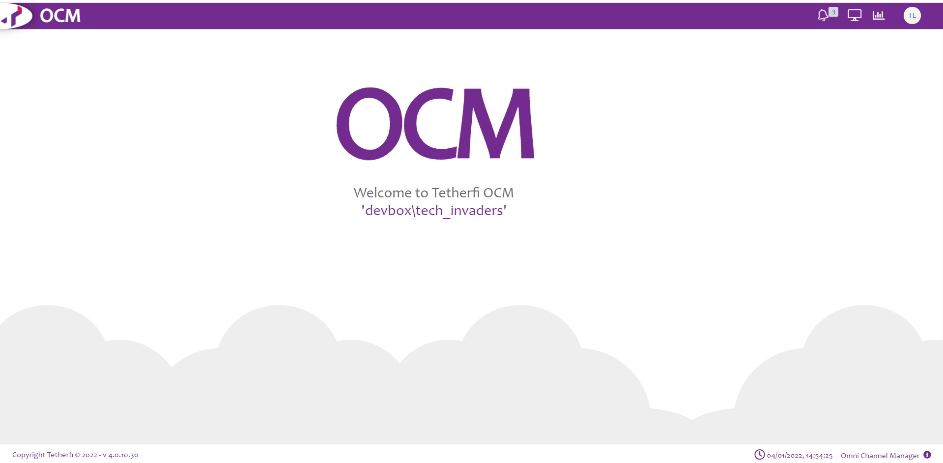
All Users will be presented with the OCM Dashboards.
Administrator is allowed to create maker/checker (or both)/previewer:
Upon logging into OCM, IW Role Based Access Matrix, Role Based Access Management and User Role Mapping modules will be displayed in Home section.
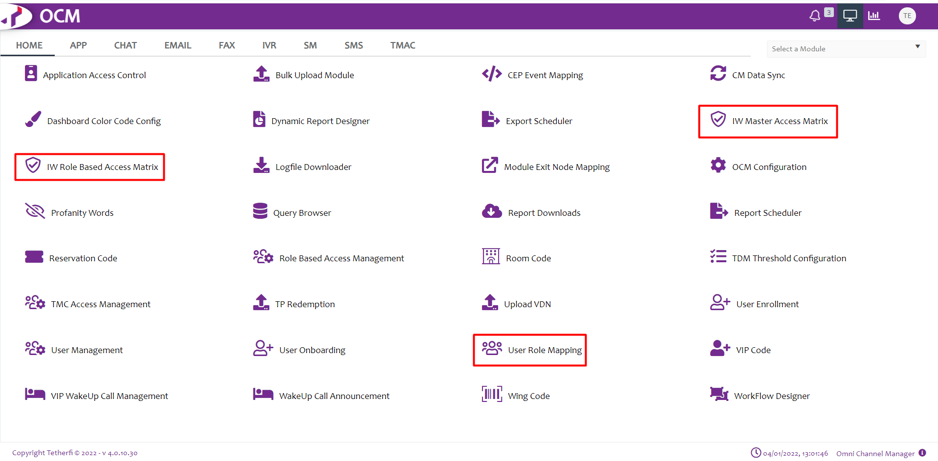

Role Based Access Management
This module is used to add the roles. Upon clicking this module following window will open and all the roles added will display here.
User can add new role, by clicking ‘Add New Role Based Access Management Record’ button present at top left corner.
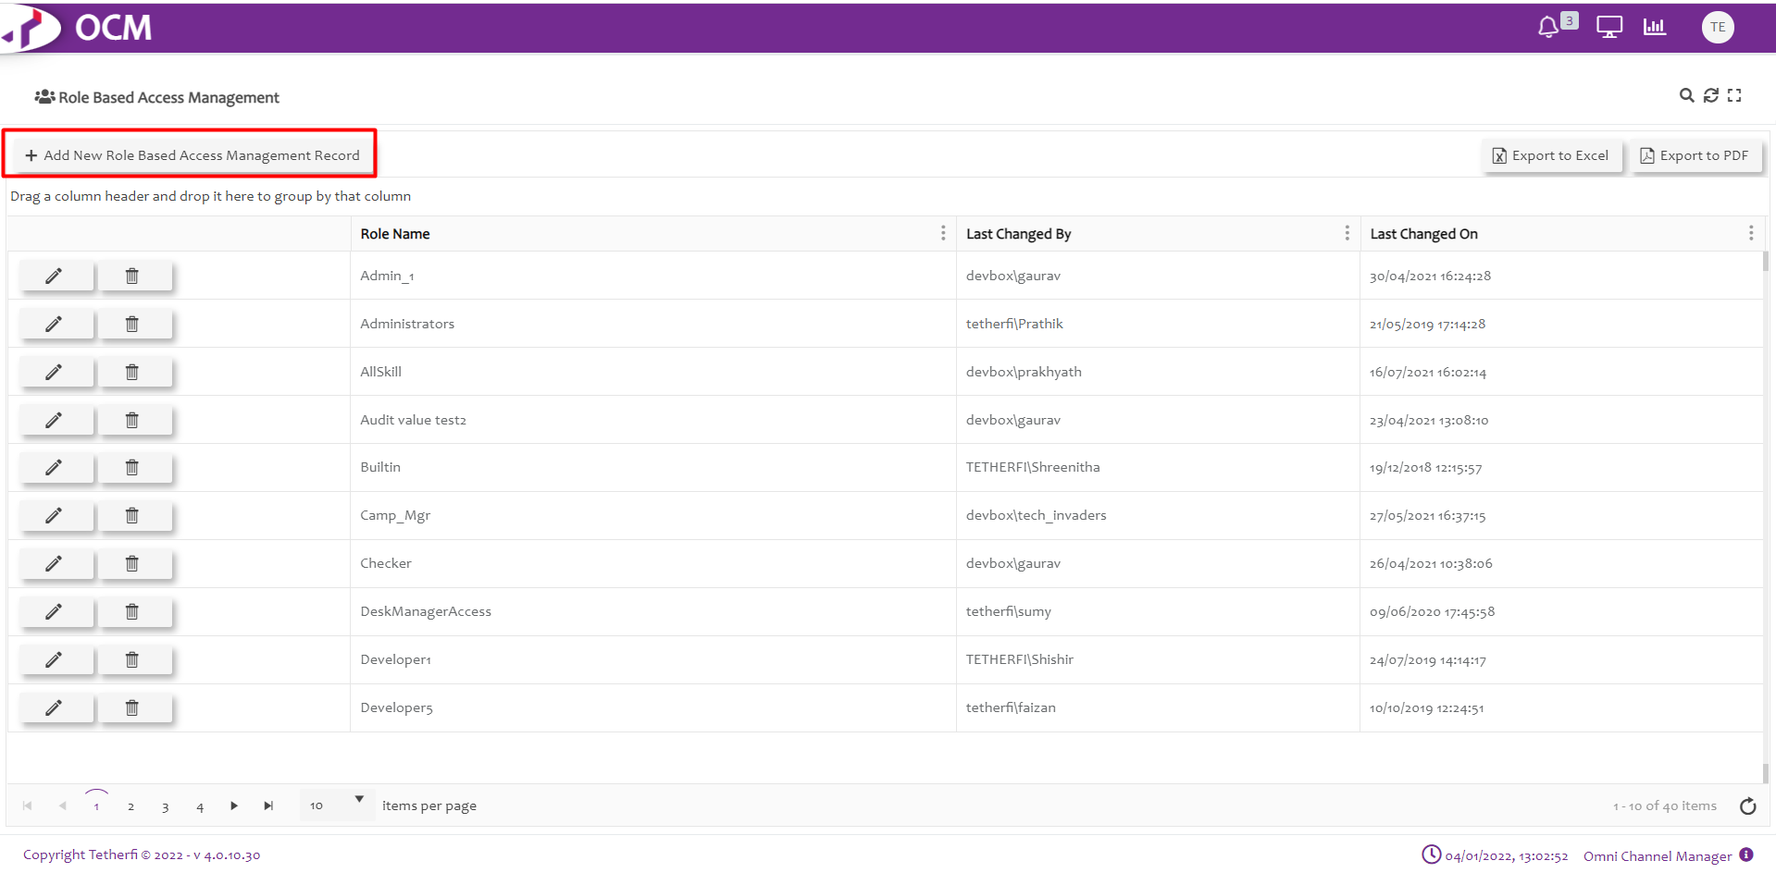
Upon clicking ‘Add New Role Based Access Management Record’, Following popup will generate. User can create new Role here.
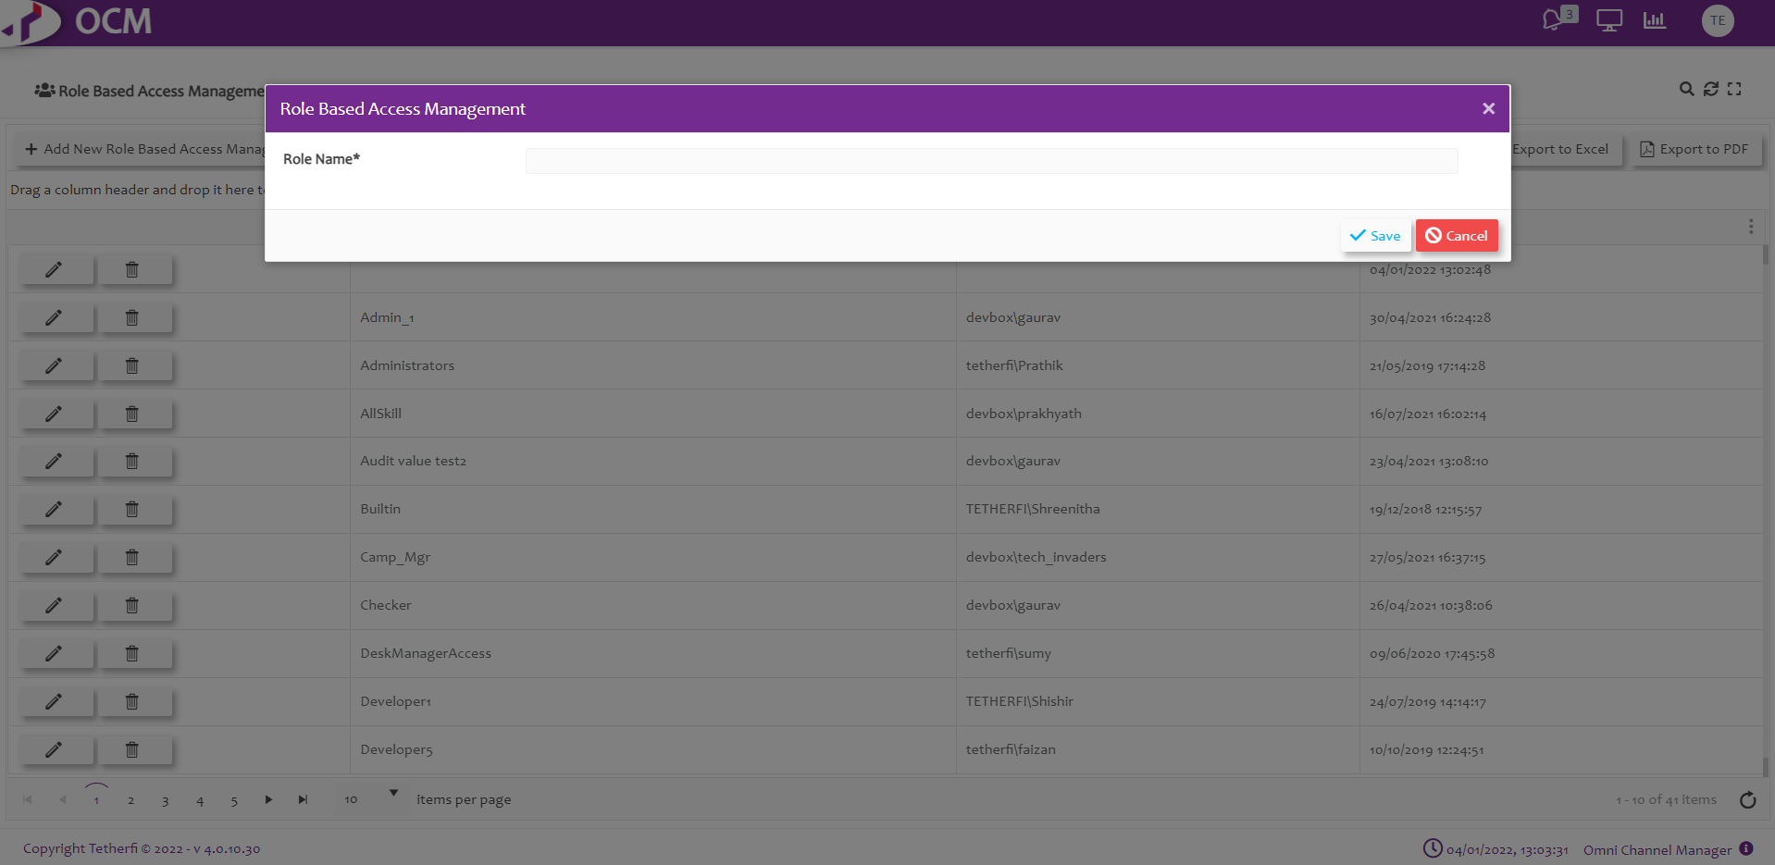
Functionalities to the newly added role can be given, by clicking on the new role added.
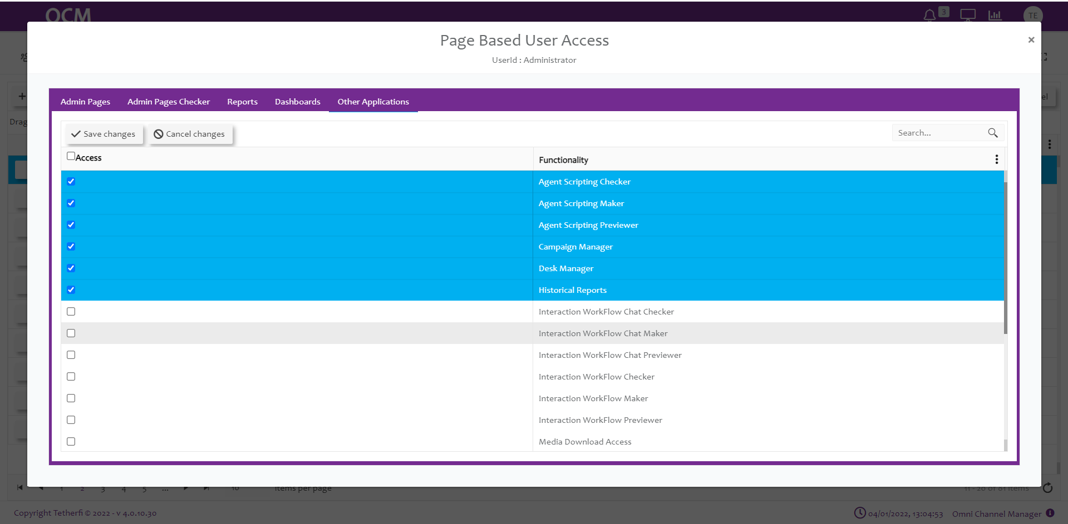

User Role Mapping
This module is used to add new role mapping record. Upon clicking this module following window will open and all the previously added records will be displayed.
User can add new role mapping record, by clicking ‘Add New User Role Mapping Record’ button present at top left corner.
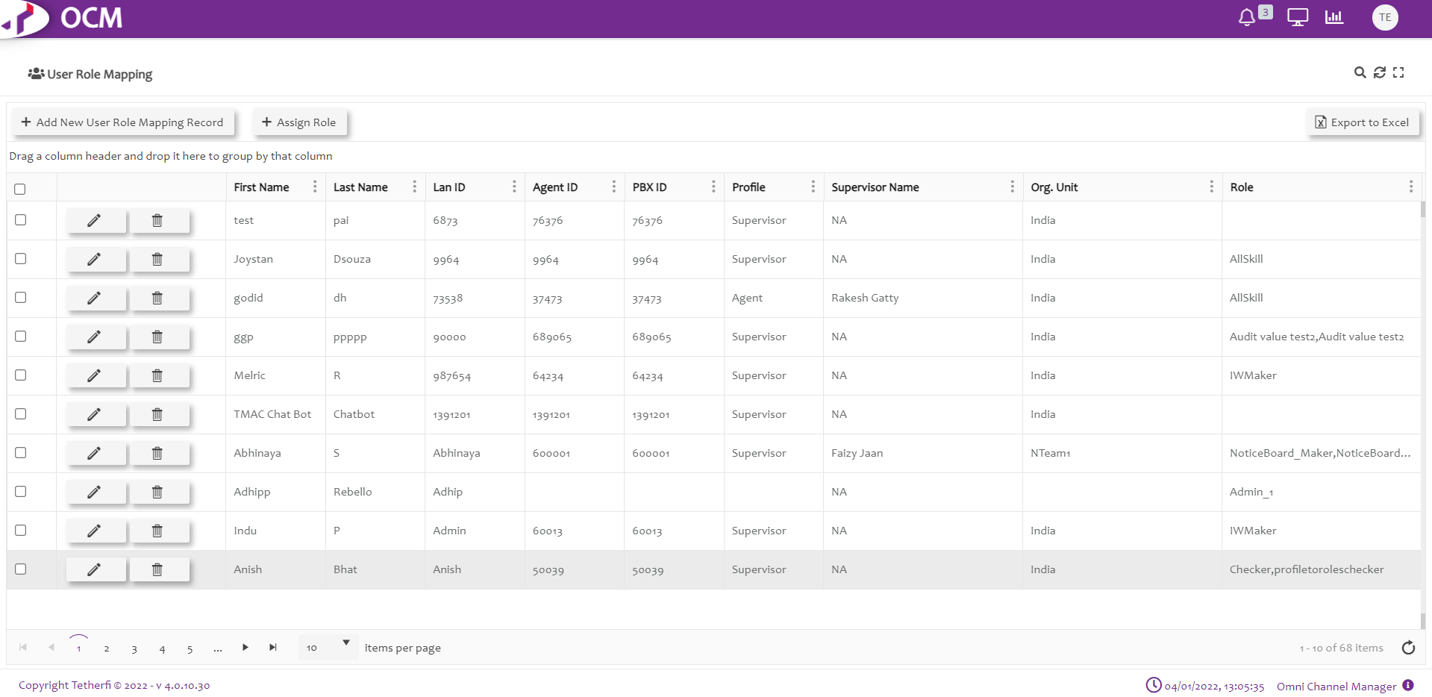
Upon clicking ‘Add New User Role Mapping Record’, Following popup will generate. User can create new Role mapping record here.
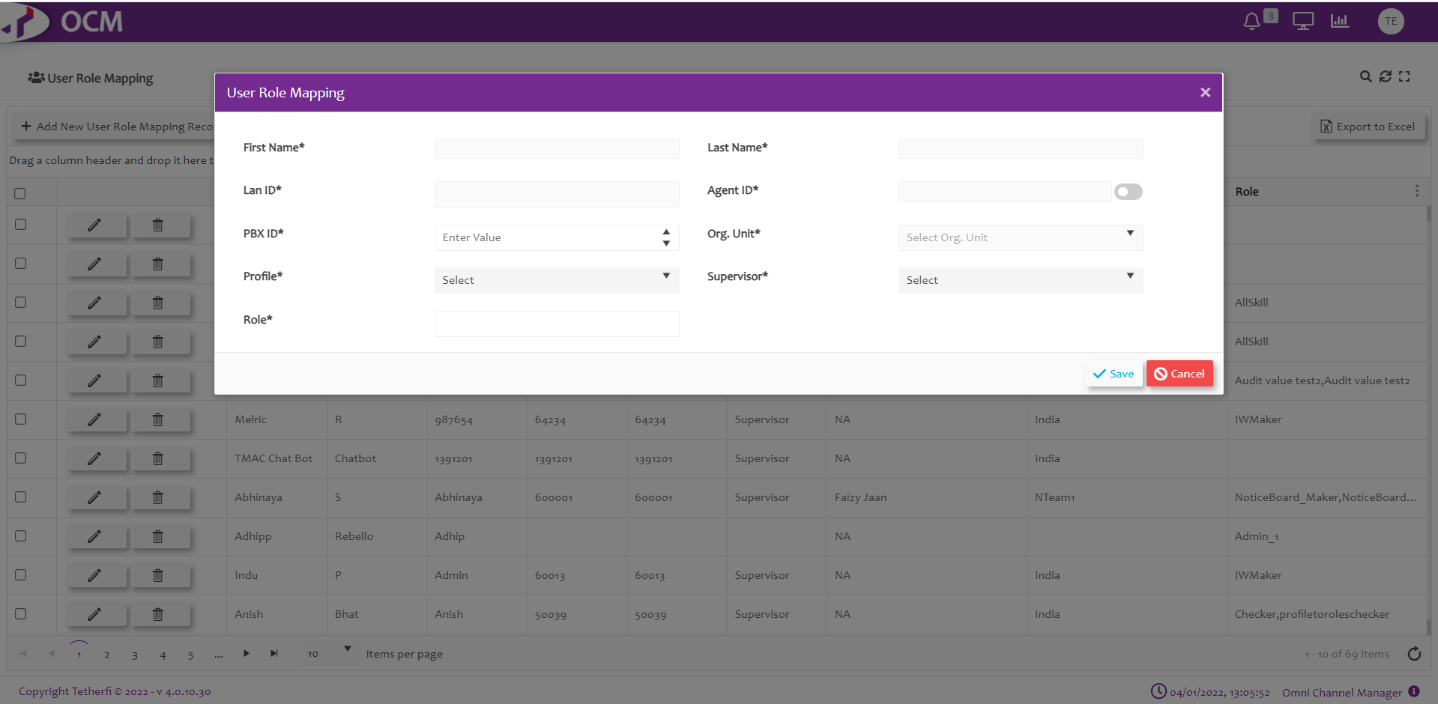
The Admin must assign a role to the user added here which is created in ‘Role Based Access Management’ module, like: Maker, Checker etc
Lan ID is user system name.
Login ID is Avaya login id.

IW Role Based Access Matrix
Upon clicking ‘IW Role Based Access Matrix’ module, all the roles created will be displayed as shown below.
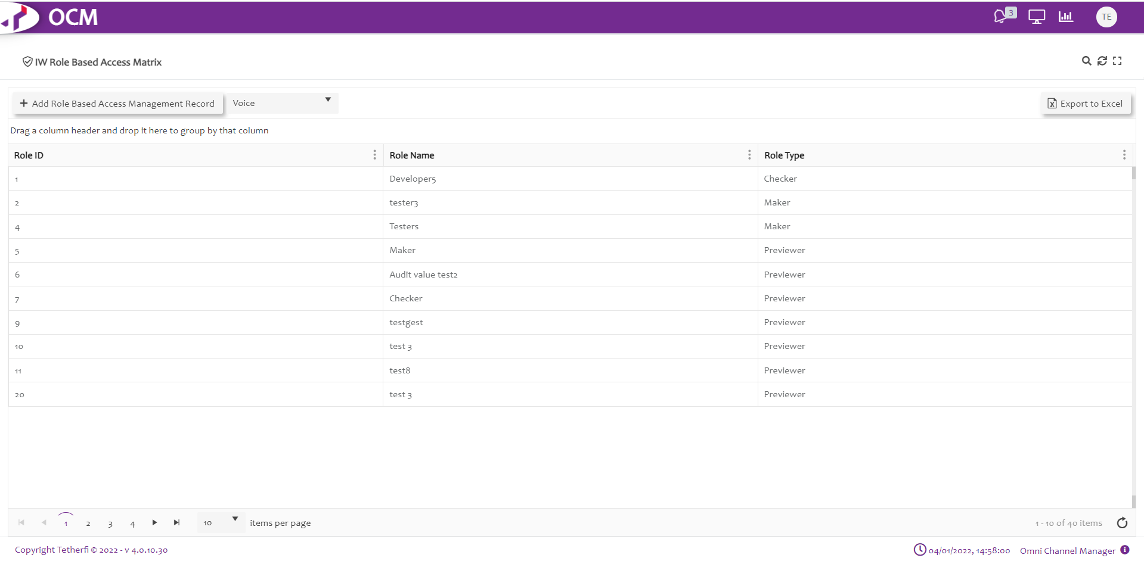
Upon selecting the any role, all the callflows created at IW page will be displayed as shown below.
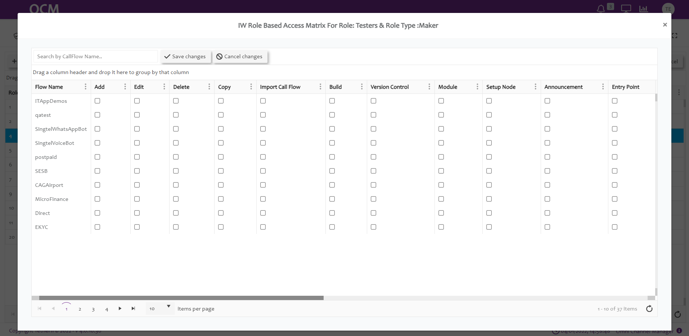
Note: For a newly created callflows, entry will be made in OCM only after saving the callflow in IW.
Upon saving the callflow in IW, entry is made in ‘IW Role Based Access Matrix’ page and all the functionalities are disabled by default.
Admin must give the permission to user by checking the options provided in OCM for user to perform any activities on callflows.
When user has 2 or more roles, access to the callflows will be provided as per below table.
Sl.No | Role1 | Role2 | Role3 | Output
1 | Maker | Checker | Previewer | Access Provided to Previewer Role will be in effect. For any combination with Previewer role, access provided to Previewer will be in effect
2 | Maker | Checker |  | Access provided to Maker Role will be in effect (Maker Role has higher priority than Checker)
3 | Maker | Maker |  | Query will check for the higher Role Id (2 is higher than 1) in CMM_Roles table and Access provided to that role will be in effect.
4 | Checker | Checker |  | Query will check for the higher Role Id (2 is higher than 1) in CMM_Roles table and Access provided to that role will be in effect.
5 | Previewer | Previewer |  | Query will check for the higher Role Id (2 is higher than 1) in CMM_Roles table and Access provided to that role will be in effect.

Callflow Level Roles

Action | Description
Flow Name | Callflow names will be displayed here after saving the callflow
Edit | Enable or Disable Edit permission to callflow in IW. This option must be checked in OCM page for giving the permission for the roles to edit callflow, send the callflow for approval, approve, schedule, reject or put checker comments to the callflows  Upon Enabling Owner Level Callflow option, only the callflows for which edit option is enabled will be displayed for the user in dashboard as well as configure callflow drop down list.
Delete | Enable or Disable Delete callflow option in IW (ref section Delete Callflow)  Note: only owner of the callflow can delete the callflows.
Copy | Enable or disable copy callflow in IW (ref section Copy Callflow)
Import Callflow | Enable or disable Import callflow in IW (ref section Import Callflow)
Real Time View | Enable or disable Realtime callflow view in IW (ref section Real-Time View/Report)
Build | Enable or disable build/package a callflow (ref. section Import Callflow)
Version Control: | This option must be checked in OCM page for giving the permission for the roles to revert the callflow to previously approved version and only owner of the callflow can revert to the previous approved version. (ref section Callflow Version Control )
Module | This option must be checked in OCM page for giving the permission for the roles to add, edit (including adding or removing existing connections and checker comments) and delete the modules present in the callflow.
Setup Node: | This option must be checked in OCM page for giving the permission for the roles to edit (including adding or removing existing connections and checker comments) the DNIS node present in the callflow.

Node Level Roles
Action | Decryptions
Announcement | This option must be checked in OCM page for giving the permission for the roles to add, edit (including adding or removing existing connections and checker comments) and delete the announcement nodes present in the callflow. (ref section Announcement Node )
Entry Point | This option must be checked in OCM page for giving the permission for the roles to add, edit (including adding or removing existing connections and checker comments) and delete the entry nodes present in the callflow. (ref section Entry Point Node)
Menu | This option must be checked in OCM page for giving the permission for the roles to add, edit (including adding or removing existing connections and checker comments) and delete the menu nodes present in the callflow. (ref section Menu node)
Assignment | This option must be checked in OCM page for giving the permission for the roles to add, edit (including adding or removing existing connections and checker comments) and delete the assignment nodes present in the callflow. (ref section Assignment Node)
Conditional | This option must be checked in OCM page for giving the permission for the roles to add, edit (including adding or removing existing connections and checker comments) and delete the conditional nodes present in the callflow. (ref section Conditional Node)
Disconnect | This option must be checked in OCM page for giving the permission for the roles to add, edit (including adding or removing existing connections and checker comments) and delete the disconnect nodes present in the callflow.(ref section Disconnect Node)
Agent | This option must be checked in OCM page for giving the permission for the roles to add, edit (including adding or removing existing connections and checker comments) and delete the Agent nodes present in the callflow. (ref section Agent Node)
Exit Point | This option must be checked in OCM page for giving the permission for the roles to add, edit (including adding or removing existing connections and checker comments) and delete the Exit point nodes present in the callflow.(ref section Exit Point Node)
Prompt and Collect | This option must be checked in OCM page for giving the permission for the roles to add, edit (including adding or removing existing connections and checker comments) and delete the announcement nodes present in the callflow.(ref section Prompt and Collect Node)
Return | This option must be checked in OCM page for giving the permission for the roles to add, edit (including adding or removing existing connections and checker comments) and delete the Return nodes present in the callflow. (ref section Return Node)
Flow Connector | This option must be checked in OCM page for giving the permission for the roles to add, edit (including adding or removing existing connections and checker comments) and delete the Flow connector nodes present in the callflow. (ref section Flow Connector node)

IW Master Access Matrix
This option will be displayed in OCM ‘Home’ channel. This module is used to provide access to the IW Masters for a particular Roles/ security group. Upon clicking ‘IW Master Access Matrix’ module, all the roles created will be displayed as shown below.
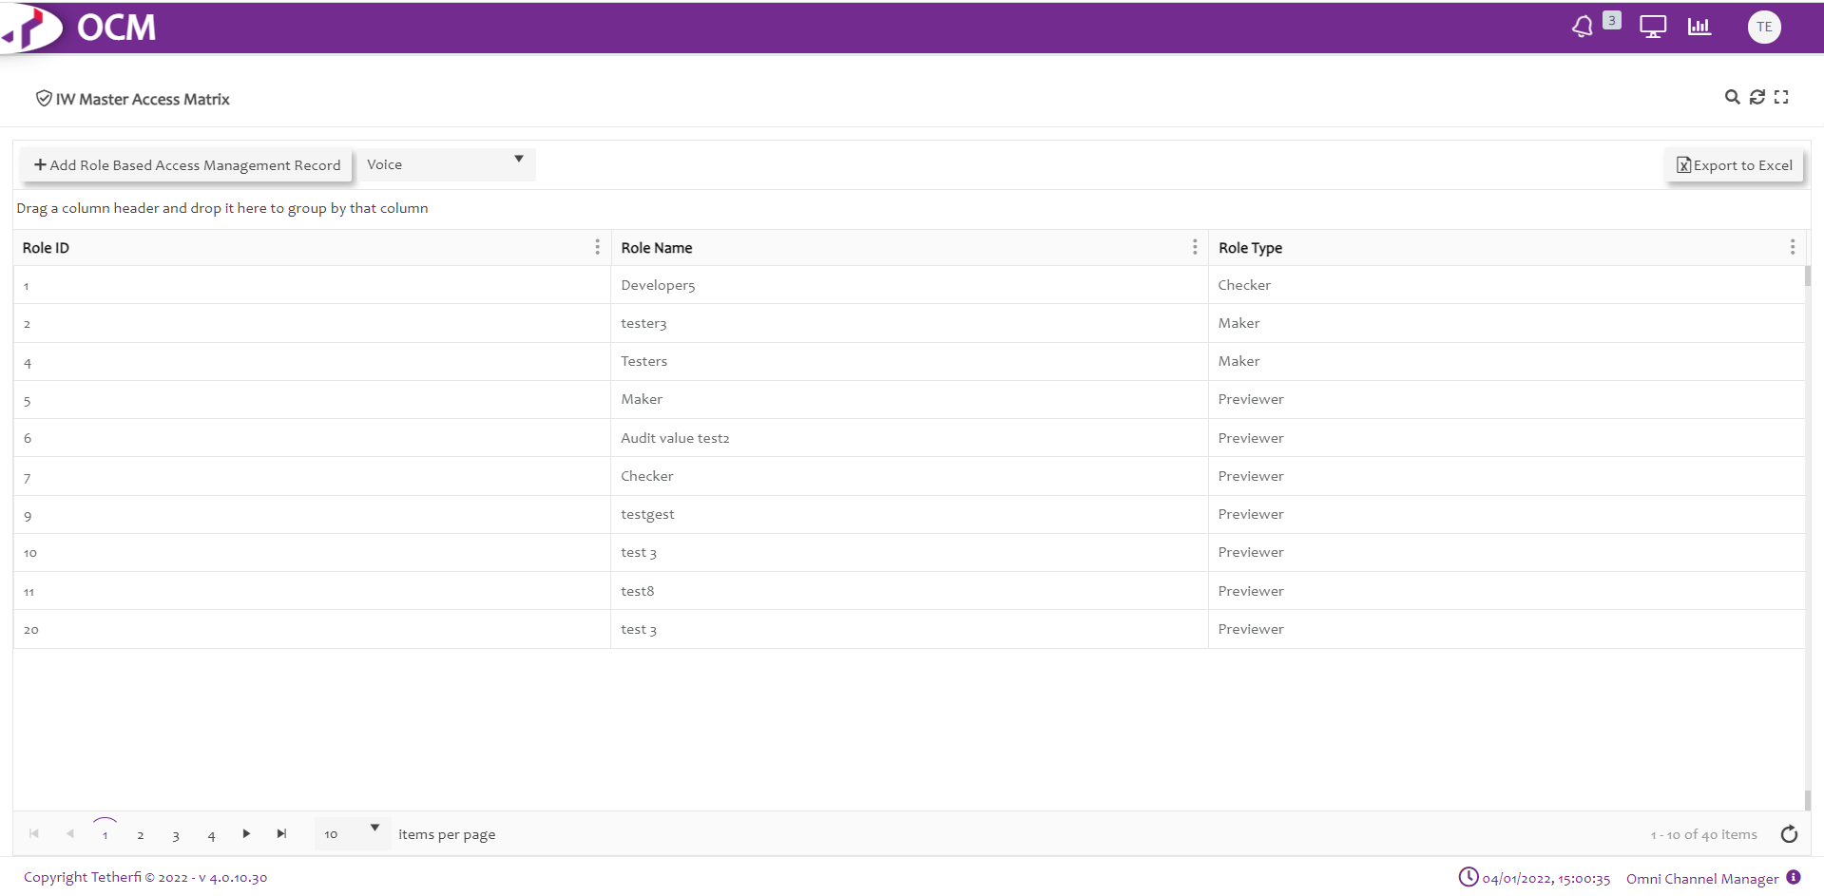
Upon selecting the any role/security group, all the masters along with Create new IWFlow, OrderTake Flow and Subflow options will be displayed as shown below.
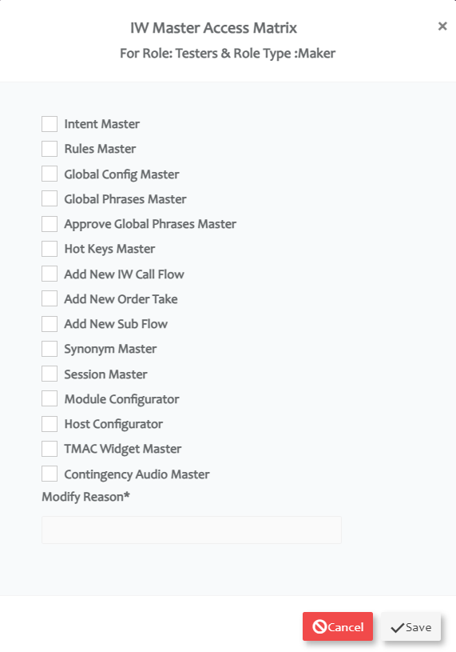
When ‘EnableAccessRules’ option in IW Webconfig is set to 1, then by default, user won’t be having access to any masters including options to create new IW, OrderTake or Subflows. Error toaster ‘This option is not enabled for current user’ is displayed when user clicks on any master options.
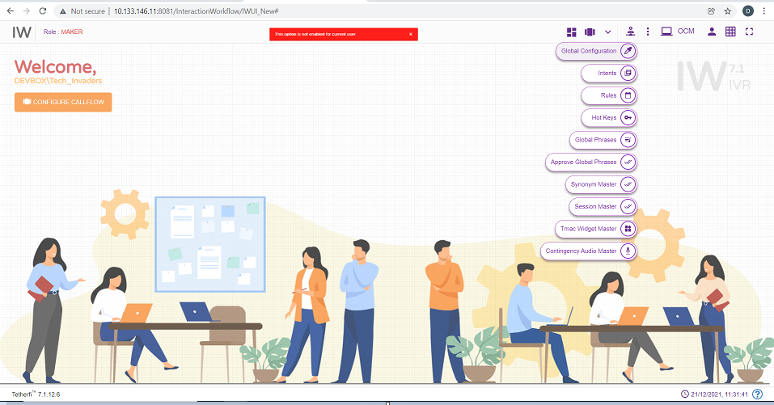
Admin must give the permission to user by checking the options provided in OCM ‘IW Master Access Matrix’ for the roles assigned to the user to edit the masters.
For Role Type Checker and Previewer, ‘Add New IW Callflow’, ‘Add New OrderTake’ and ‘Add New Sub Flow’ options will be disabled.
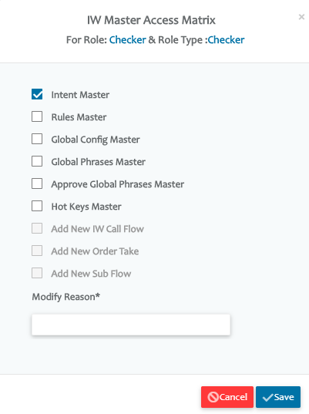
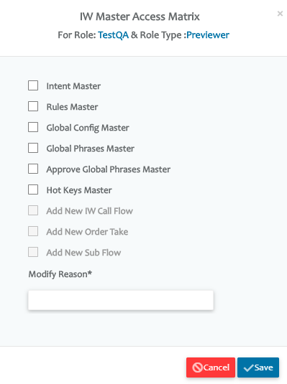
When user has 2 or more roles, access to the master will be provided as per below table.
Sl.No | Role1 | Role2 | Role3 | Output
1 | Maker | Checker | Previewer | Access Provided to Previewer Role will be in effect. For any combination with Previewer role, access provided to Previewer will be in effect
2 | Maker | Checker |  | Access provided to Maker Role will be in effect (Maker Role has higher priority than Checker)
3 | Maker | Maker |  | Query will check for the higher Role Id (2 is higher than 1) in CMM_Roles table and Access provided to that role will be in effect.
4 | Checker | Checker |  | Query will check for the higher Role Id (2 is higher than 1) in CMM_Roles table and Access provided to that role will be in effect.
5 | Previewer | Previewer |  | Query will check for the higher Role Id (2 is higher than 1) in CMM_Roles table and Access provided to that role will be in effect.

Database Table Access
To add the users directly to the db tables instead of using OCM, follow below steps
  - Add a new Role in CMM_Roles table
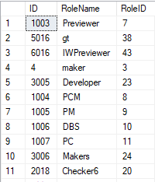
  - Provide IW Chat Maker/ Checker/ Previewer access to the roles in CMM_Role_Pages Table

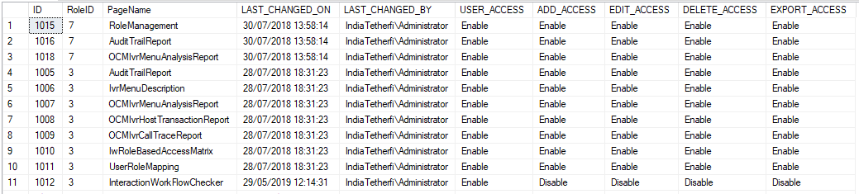

Interaction Workflow User Roles
The Interaction Workflow application will have following user roles:
- Maker
- Checker
- Previewer
- Maker and Checker

When the product is first delivered, the Admin user of OCM (details to be provided by business users) will allot the users as Interaction Workflow Maker/Checker (or both) by using OCM User Management module (ref section OCM Access).
Only the Admin can add new user, change user role and delete user.
User Functionality | Previewer | Maker | Checker | Maker and Checker
Create | No | Yes | No | Yes
Edit | No | Yes | No | Yes
Delete | No | Yes | No | Yes
Schedule | No | No | Yes | Yes
Approve | No | No | Yes | Yes
Reject | No | No | Yes | Yes
Preview | Yes | Yes | Yes | Yes
Comment | No | Yes | Yes | Yes

Maker
Interaction Workflow Maker has the privileges to create / view / edit / delete workflows.
All the changes made to Interaction Workflow by Maker need to be approved by Checker before being implemented to the system.
When user login as a maker (without loading any callflow), following page will be displayed.
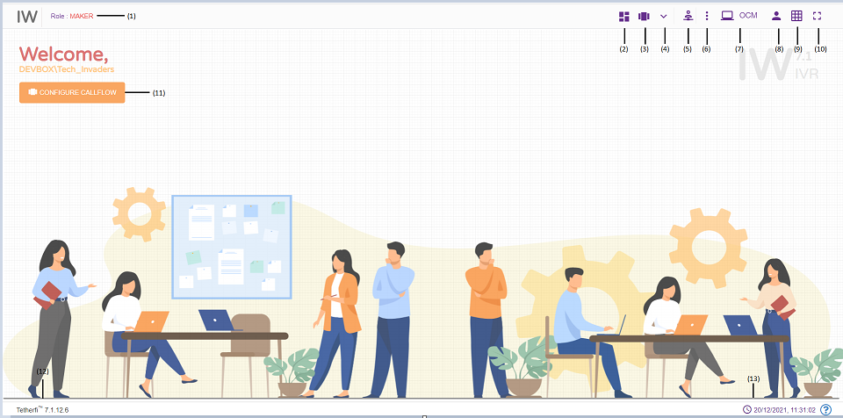
- Role: Displays the role of the user i.e. Maker
- Dashboard: callflow dashboard. (ref section Dashboard )
- Configure Callflow: This option is used to create a new flow/ Preview a flow/Order Take/Delete a callflow. (ref section Configure Callflow)
- More Menus: Upon clicking this button following options will appear.
- Import callflow: (ref section Import Callflow)
- Copy callflow: refer section Copy Callflow
- Text to Voice: refer section Text to Voice
- Master: Upon clicking this button following options will appear.
- Global Configuration: refer section Global Configuration
- Intents: refer section Intent Master
- Rules: refer section Rule Master
- Global Phrases: refer section Global Phrases
- Hot Keys: refer section Hot Keys
- Synonym Maser: refer section Synonym Master
- Session Master: refer section Session Master
- Tmac Widget Master: refer section TMAC Widget Master
- Contingency Audio Master: refer section Contingency Audio Master
- Callflow Notifications: Notifications related to Callflow statuses
- Redirect to OCM: This option will redirect to OCM page.
- Current User Info: User’s domain name/ user name and for logging out of Interaction Workflow module.
- Grid: Grid can be enabled/disabled.
- Full Screen: This option is used to view the Interaction Workflow in full screen. (Press “Esc”/F11 button to go back to normal view)
- At the top left corner of the page, welcome message is displayed along with user’s domain name/user name. Configure callflow option is also provided here.
- Current IW version
- System date and time will be displayed here.
When user login as a maker and load a callflow, following page will be displayed.
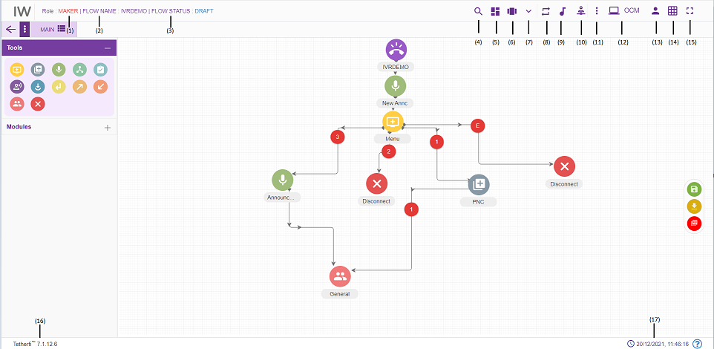
- Role: Displays role of the user i.e. Maker
- Flow Name: Name of the flow will be displayed here
- Flow Status: Current callflow flow status will be displayed here
- Search for Nodes: refer section Search for nodes
- Dashboard: callflow dashboard. (ref section Dashboard )
- Configure Callflow: This option is used to create a new flow/ Preview a flow/Order Take/Delete a callflow. refer section Configure Callflow
- More Menus: Upon clicking this button following options will appear.
- Callflow version control: refer section Callflow Version Control
- Import callflow: ref section Import Callflow)
- Copy callflow: refer section Copy Callflow
- Text to Voice: refer section Text to Voice
- Rules Viewer: refer section Rules Viewer
- Phrases: refer section Phrases
- Master: Upon clicking this button following options will appear.
- Global Configuration: refer section Global Configuration
- Intents: refer section Intent Master
- Rules: refer section Rule Master
- Global Phrases: refer section Global Phrases
- Hot Keys: refer section Hot Keys
- Synonym Maser: refer section Synonym Master
- Session Master: refer section Session Master
- Tmac Widget Master: refer section TMAC Widget Master
- Contingency Audio Master: refer section Contingency Audio Master
- Information: This option is used for information related to the user and Interaction Workflow version.
Callflow Notifications: This option is used to check all the notifications related to Interaction Workflow.
Callflow Comments: refer section Comments
- Redirect to OCM: This option will redirect to OCM page.
- Current User Info: This option is used to know User’s domain name/ user name and for logging out of Interaction Workflow module.
- Grid: Grid can be enabled/disabled.
- Full Screen: This option is used to view the Interaction Workflow in full screen. (Press “Esc”/F11 button to go back to normal view)
- Current IW version is displayed here.
- Current system date and time will be displayed here.
- More Menus: refer section More Menu Option
- There are modules and nodes available in UI. Maker can make use of these nodes/module as per requirement.

Import Callflow
Import callflow option is used to import external callflow that we build/packaged in other systems.
Click ‘More Menus’ option from top left corner in maker/maker-checker page, following popup will be generating.
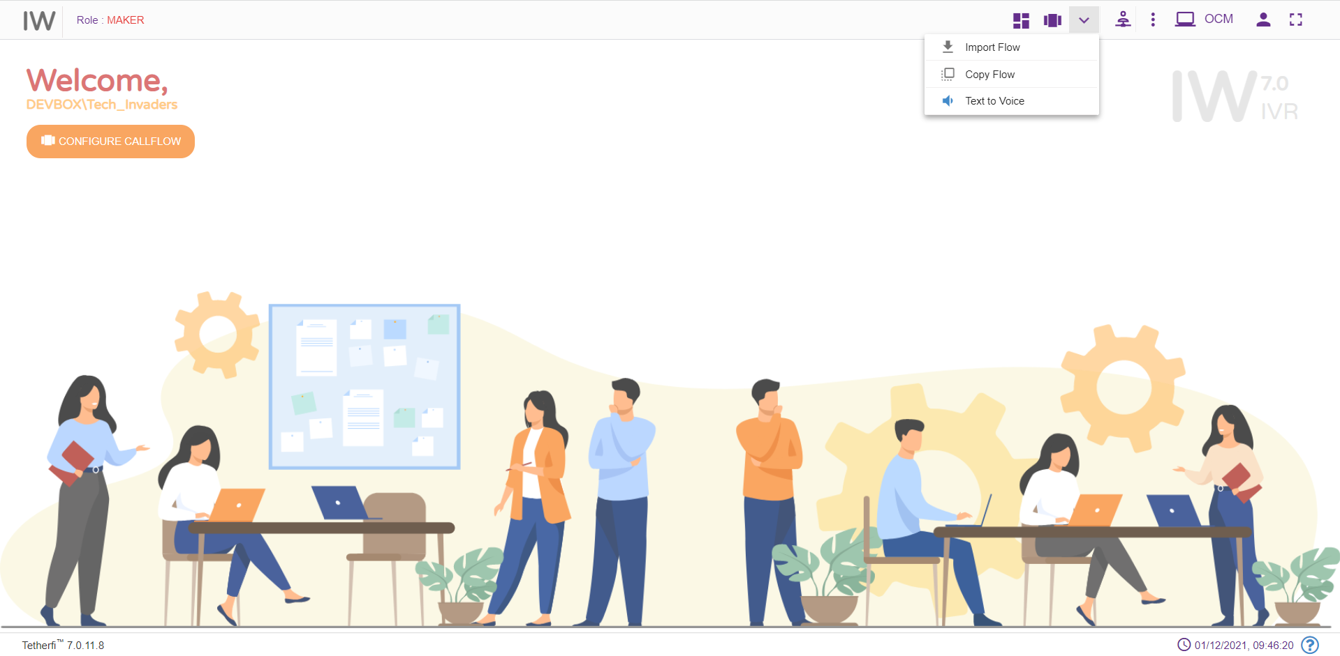
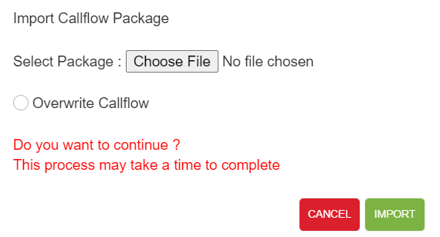
The package that is generated/zipped using ‘Callflow Build/Package’ (refer section Dashboard) option in IW can be imported here.
Note: phrases of the Imported callflow are also uploaded to the interpreter. All the imported callflows will be in draft status and user is automatically changed to the user of the page where imported the callflow.
Imported callflow must have a wav files uploaded.Only zip files can be imported here.
User can import only the flows, whose version number is greater than the APPROVED status flow present in the system. ‘Flow with higher version number already present in the system’ error message is displayed.
If there is no APPROVED status flow for a callflow, then UNAPPROVED version of the flow is overridden when importing the flow.
Upon successfully importing the callflow to the system, success message will be generating in UI as shown below.
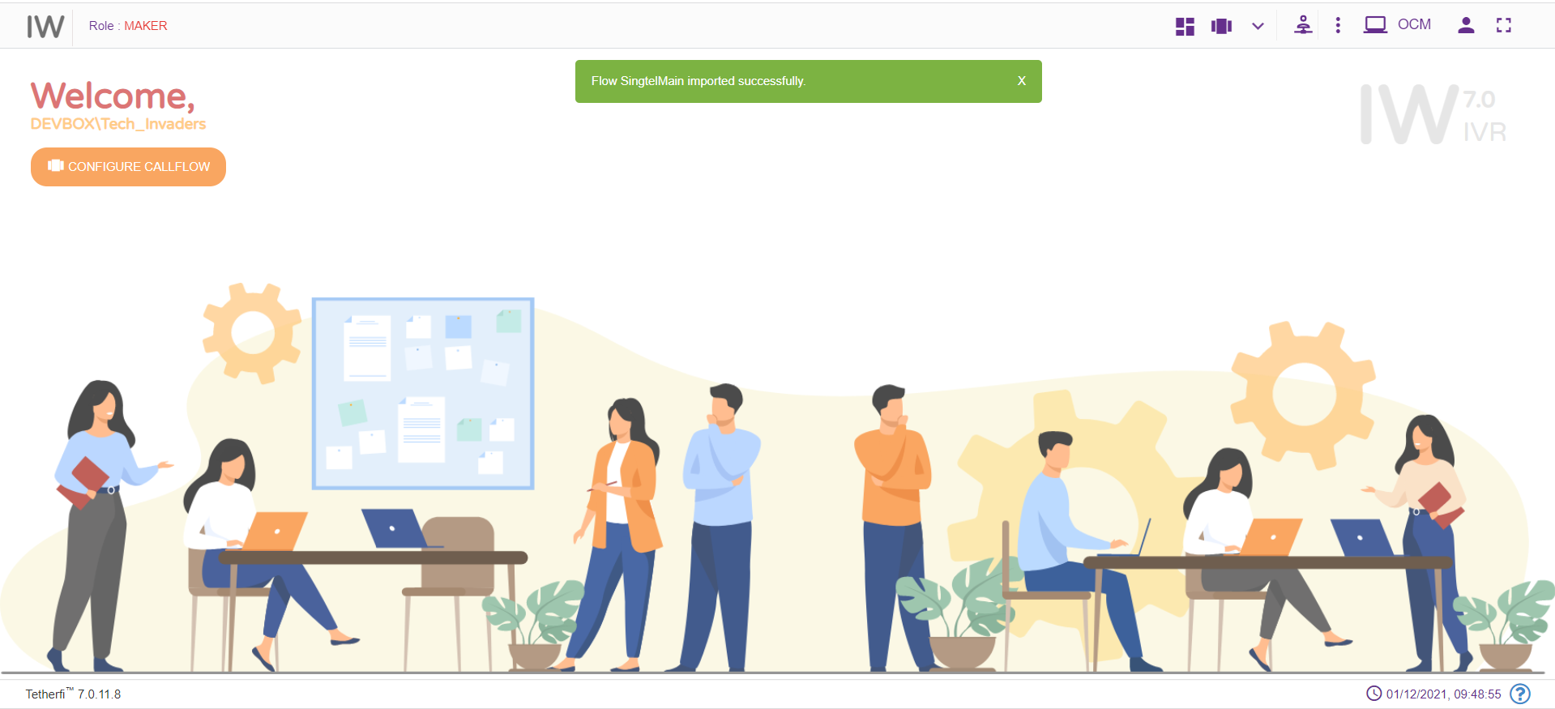

Copy Callflow
This option is to create the copy of the callflow. Copied callflow will be in DRAFT status and created and modified date will be same.
Upon clicking on ‘More Menus’ option present at top left corner in maker/maker-checker page, following popup will be generating.
Upon clicking this option, following popup will be generated.
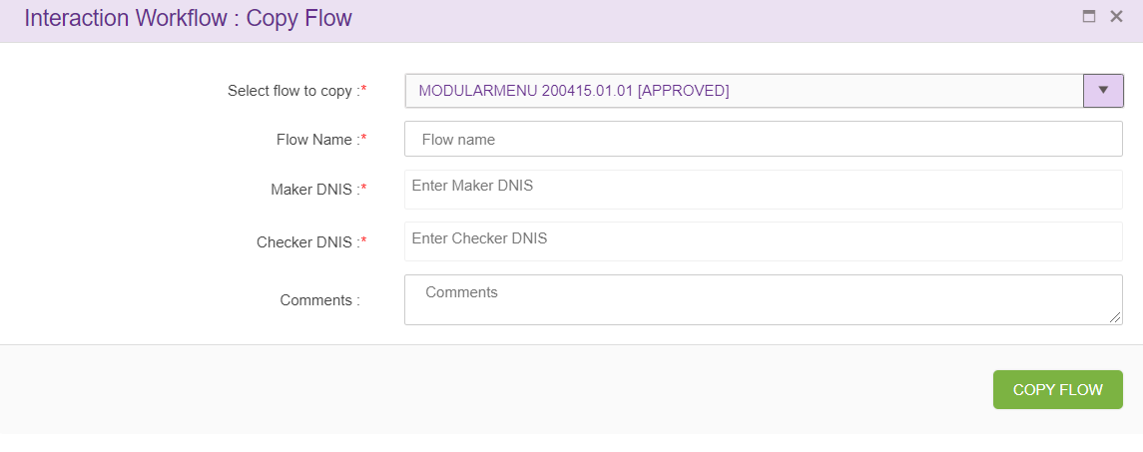

Select callflow to copy: upon clicking on this drop down main flow, sub flows and order take flows will appear as shown below.
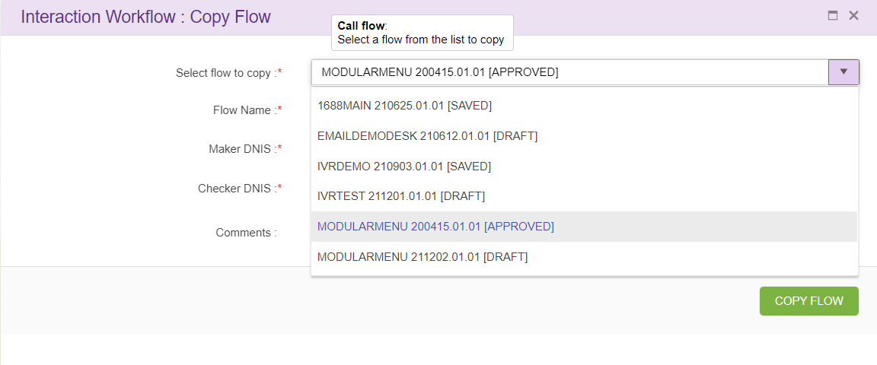

Copying IW Flow:
when user selects call flow from the drop-down following screen will appear
Flow name: name of the call flow.
Maker DNIS and Checker DNIS: Create a new callflow with unique name and DNIS (Maker and Checker DNIS should be unique throughout callflow). This option is provided only for the user who has ‘Maker’ credentials and Maker can copy only callflow with status ‘Draft’ and ‘Saved’.
Upon clicking ‘COPY FLOW’ button, new callflow will be created based on the callflow name specified, which will be exact copy of selected callflow.

Copying Order take Flow:
when user selects order take flow from the drop-down following screen will appear
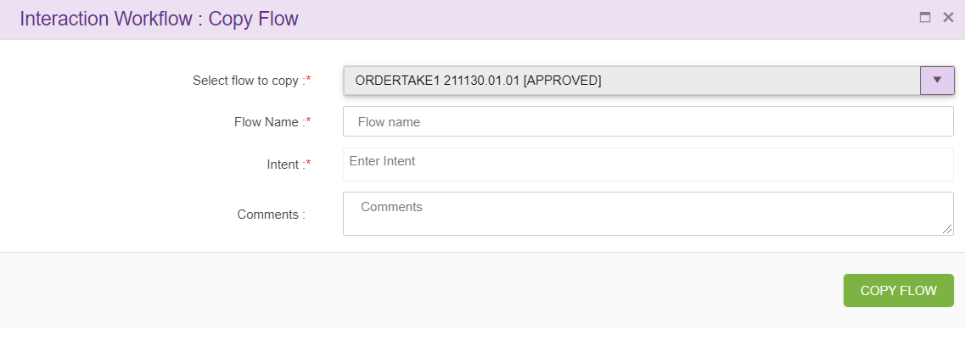
Flow name: name of the call flow to be created.
Intent option will be displayed when order take callflow is selected from the drop down. This option is provided only for the user who has ‘Maker’ credentials and Maker can copy only callflow with status ‘Draft’ and ‘Saved’.
Upon clicking ‘COPY FLOW’ button, new callflow will be created based on the callflow name specified, which will be exact copy of selected callflow.

Copying Subflow
when user selects subflow from the drop-down following screen will appear
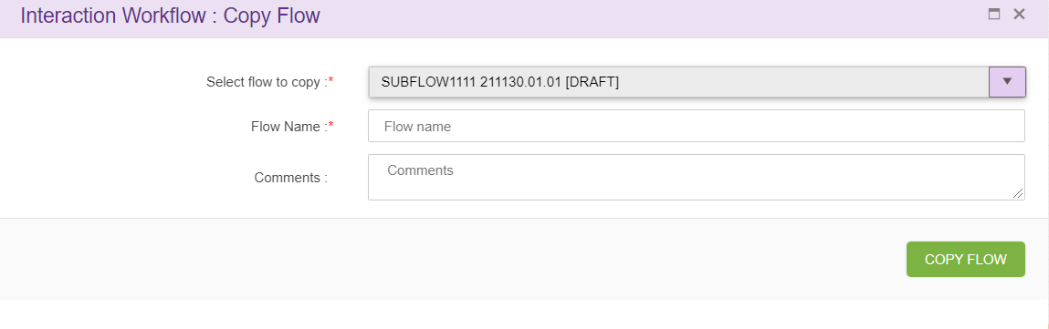
Flow name: name of the call flow to be created.
Upon clicking ‘COPY FLOW’ button, new callflow will be created based on the callflow name specified, which will be exact copy of selected callflow. This option is provided only for the user who has ‘Maker’ credentials and Maker can copy only callflow with status ‘Draft’ and ‘Saved’.

Callflow Version Control
Callflow version control option will appear in ‘More Menus’ option only when the selected callflow is in ‘draft status. Version control is a system that records changes over time so that you can recall specific versions later. In callflow version control system, user can revert their changes to specific approved version.
Only Makers have the privilege to revert callflows that are in draft state.
Click the ‘Callflow version control’ option as shown below.
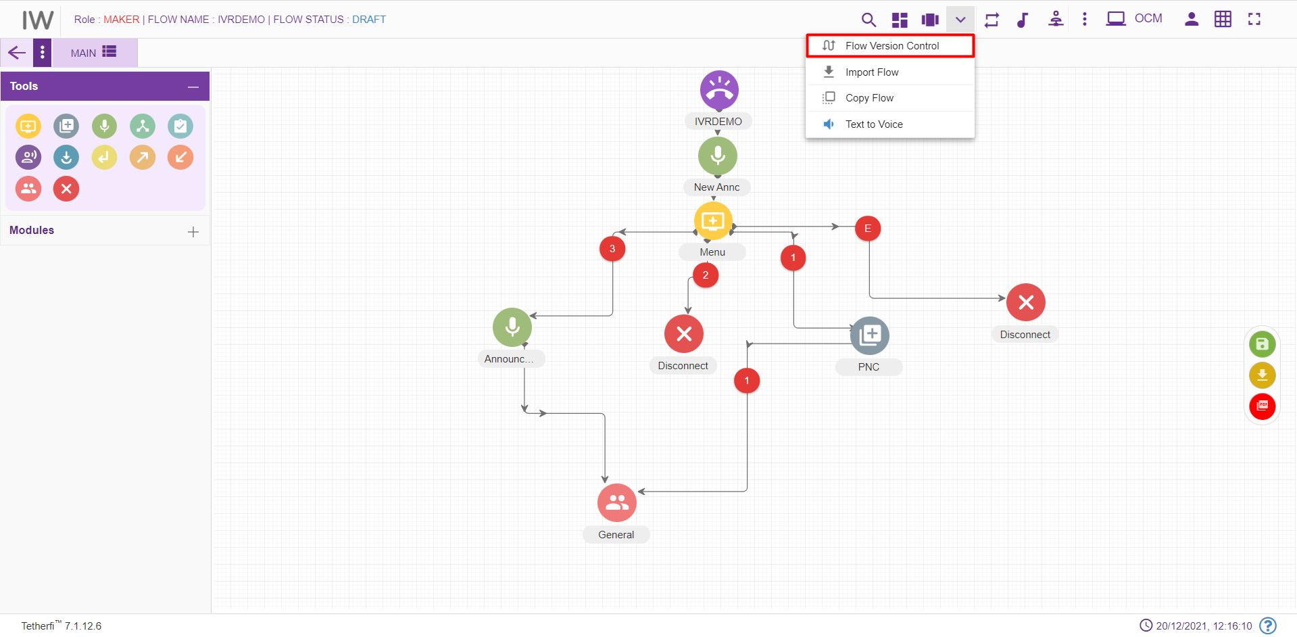

On click of “Call flow version control” button, below screen will be displayed.
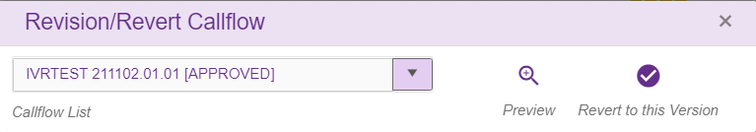
- Select the workflow that has to be revised/ reverted from the “Callflow List”. The previously ‘approved’ callflow names will be shown in the callflow list.
- “Preview” helps the users to confirm to which callflow they want to revert.
- ‘Revert to this version’ – Reverts the opened DRAFT callflow to selected APPROVED callflow.
Upon clicking ‘Revert to this Version’ button, following confirmation popup will generate.
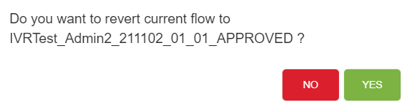
Upon reverting, callflow will be in saved status.
If there is no previous APPROVED version of the selected DRAFT callflow, then ‘Reversion Callflow does not exist’ error message will generate.

Rule Master
This option will appear for the Maker, Checker and Previewer also. But only Maker can add rules. Checker and Previewer will be in read-only mode.
A rule is a principle or regulation or governing procedure for operation of IVR with respect to a node or module.
Only Makers have the privilege of creating/ editing rules.
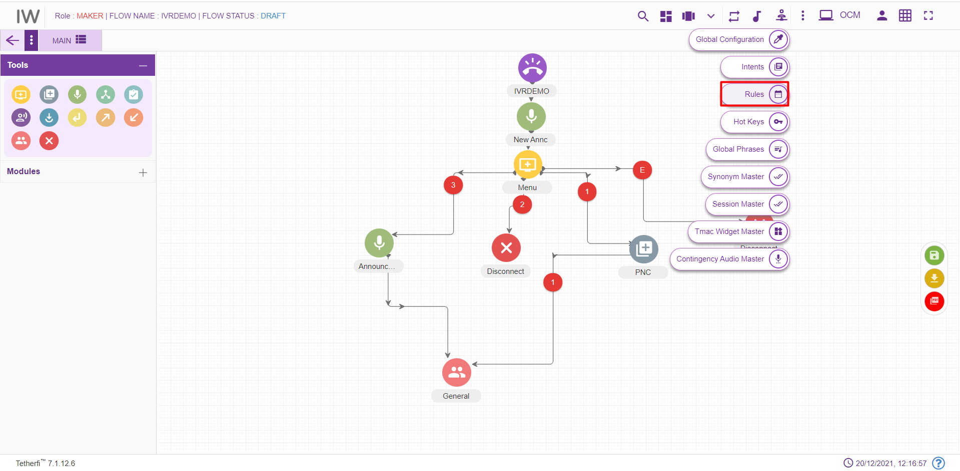
Maker can create/ edit rules by clicking on the button shown in the above figure.
Upon clicking ‘Rule Master’ icon, following popup will generate.
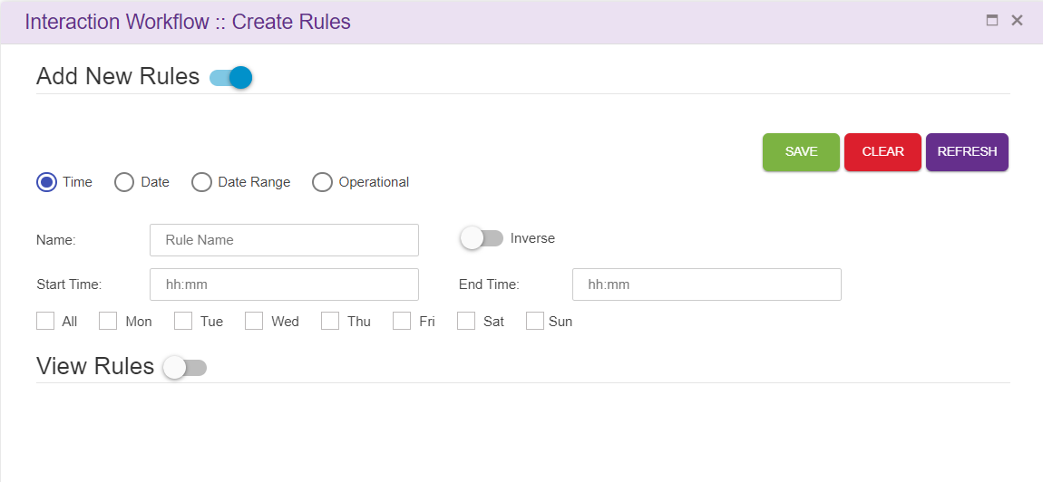Save: This button is used to add the rules to the grid i.e., Save the rule.
Clear: This option is used to clear the fields entered.
Refresh: This option is used to refresh the rule master window and load the latest rules to the grid.
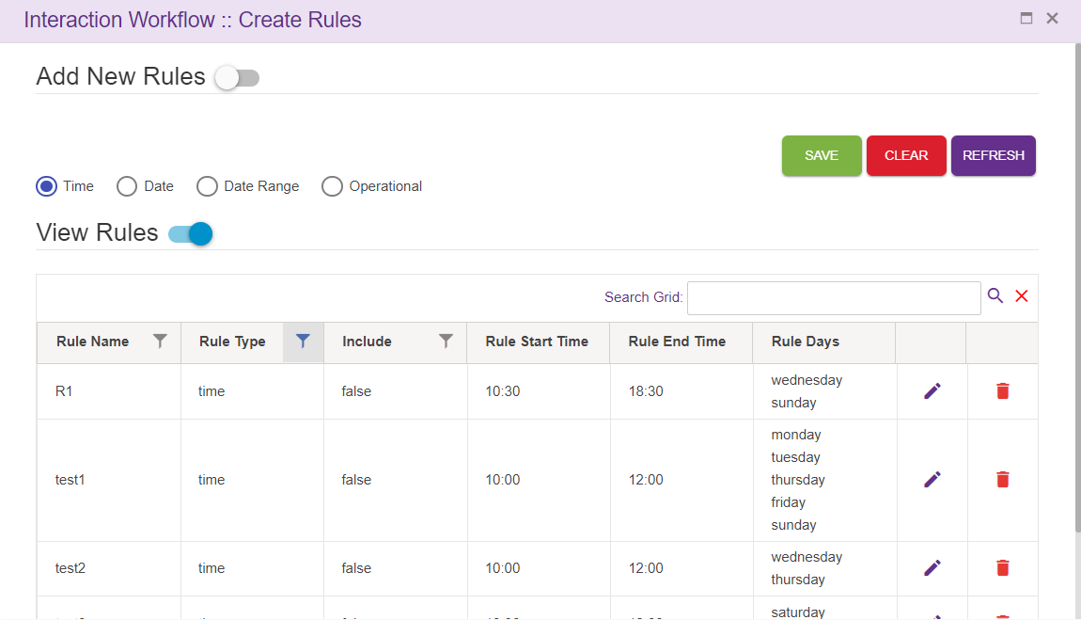
- Search Grid will help to search rules from records.
- For creating new rules, the Maker needs to select “Add new rules” option.
- There are four main types of rules: Time, Date, Date Range and Operational.
- On enabling of “Add new rules” option, the above popup will generate

Time
You need to set the Name of this rule, Start and End time alongside the weekdays that you want the rule to be active and whether you want to include this rule in the Callflow. You need to click Save, for saving the rule and Clear, for discarding the rule.

Date
You need to set the Name of this rule, date at which you want the rule to be active and whether you want to include this rule in the Callflow. You need to click Save, for saving the rule and Clear, for discarding the rule.
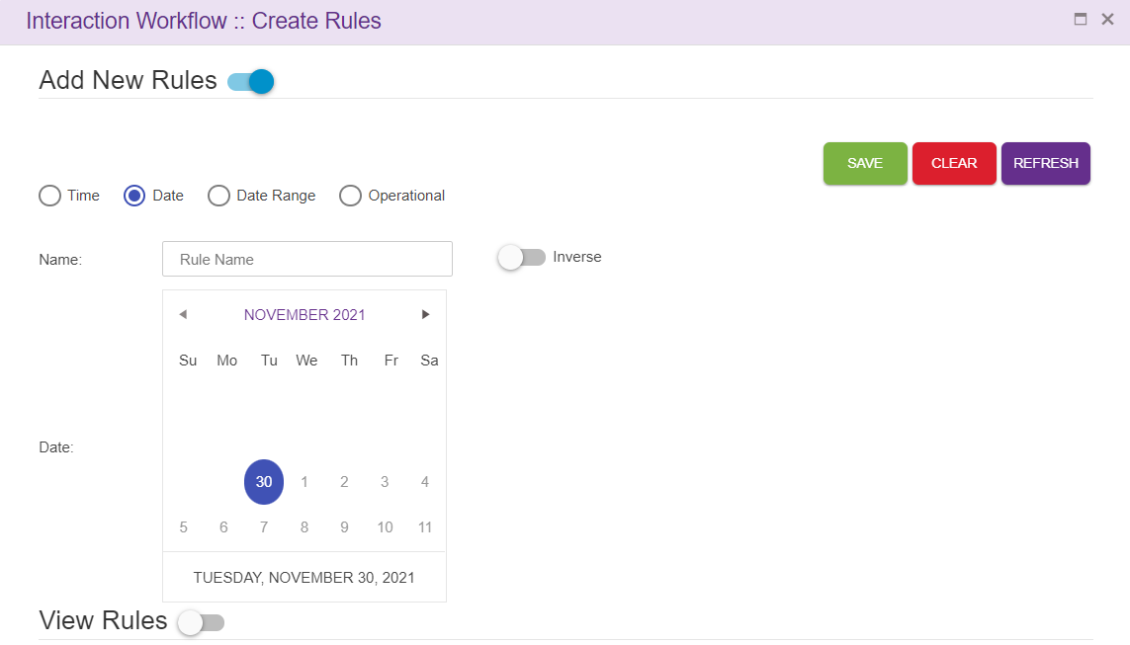

Date Range
You need to set the Name of this rule, Start and End date range you want the rule to be active. Click Save, for saving the rule and Clear, for discarding the rule.
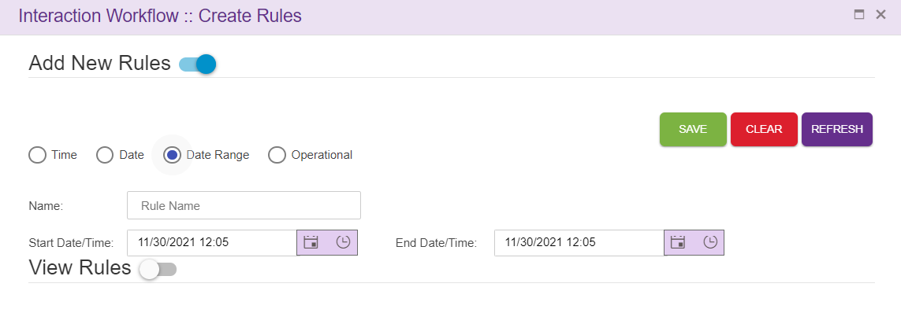

Operational
You need to set the Name of this rule, Variable 1 and Variable 2 alongside the operator you want the rule to be consist of and whether you want to include this rule In the Callflow. You need to click Save, for saving the rule and Clear, for discarding the rule.
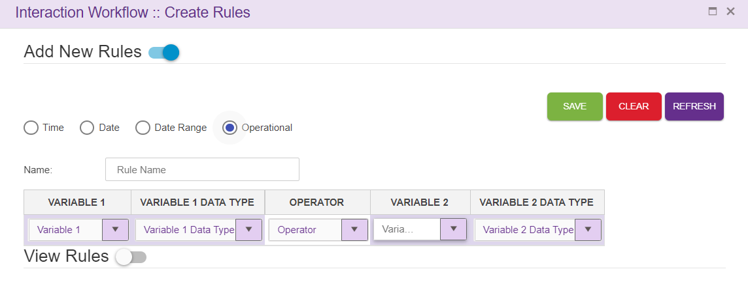
For editing/deleting the rule, click on the edit/ delete icon and make the necessary changes. Click Save, for saving the rule and Clear, for discarding the rule.
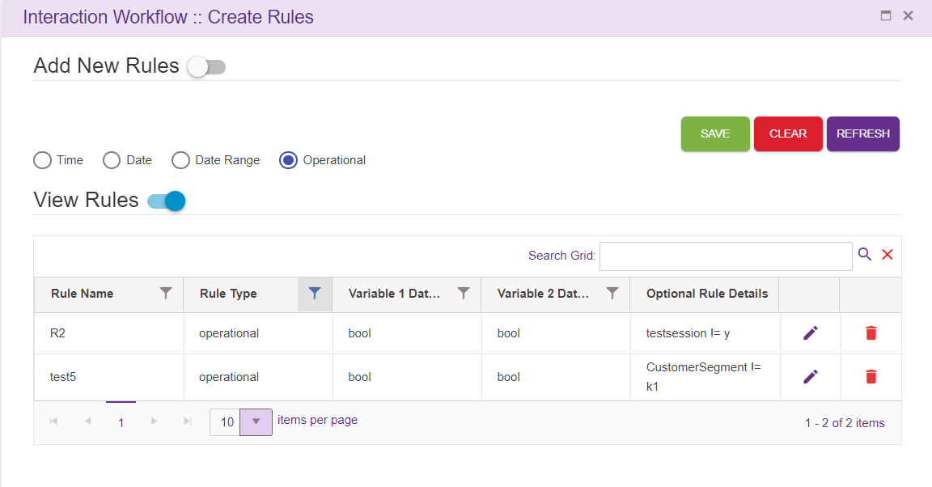

Callflow specific Rules
Rules can also be displayed specific to the callflow. Upon setting CallflowSpecific the key to TRUE in ClientSpecificConfiguration.json file, only the rules specific to the callflow will be displayed.
In this case, upon adding a new rule. It won’t be displayed in the View Rules grid. But user can use the rules added, in nodes as well as in legs in the callflow
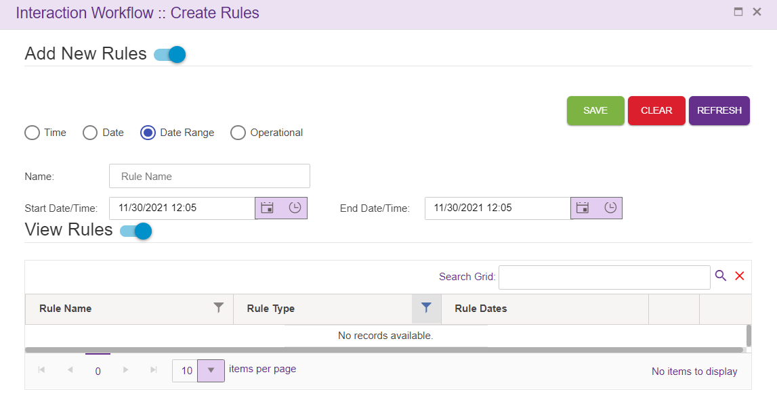
All the Rules added in rule master will be displayed in Set Rules window and user can use the rules in the callflow based on the requirements.
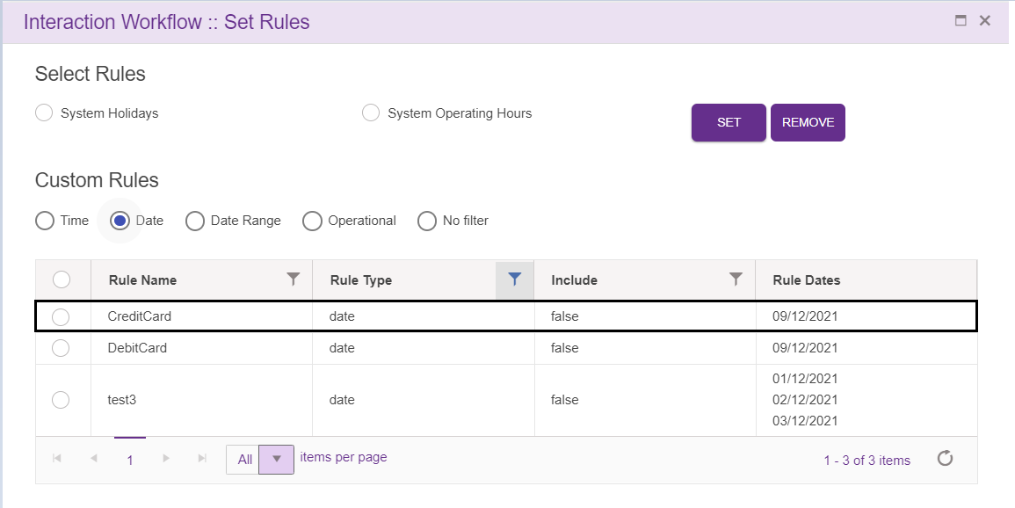
Only the rules used in the callflow will be displayed in the rule master in callflow specific rules option.
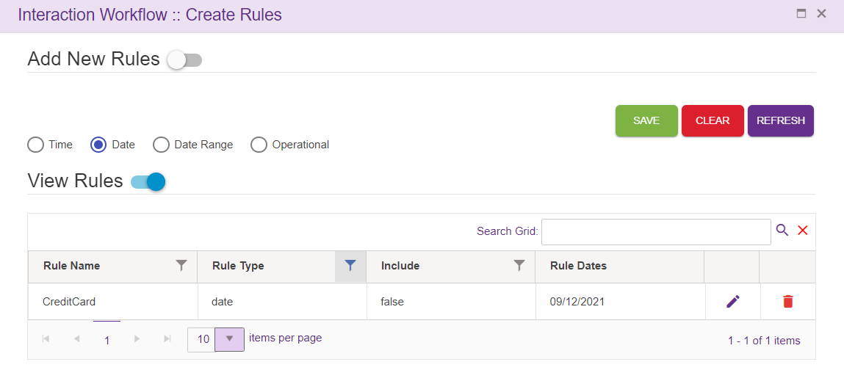

Intent Master
This option will appear for the Maker, Checker and Previewer also. But only Maker can add intents. Checker and Previewer will be in read-only mode.
Upon clicking intent master icon following page will be displayed.
Intents are mapped to the VDN in the intent master page in IW. If the user gives any intent which is not mapped to VDN in intent master, it becomes invalid flow. User can add the intents in ‘intent master’ and map to the VDN.
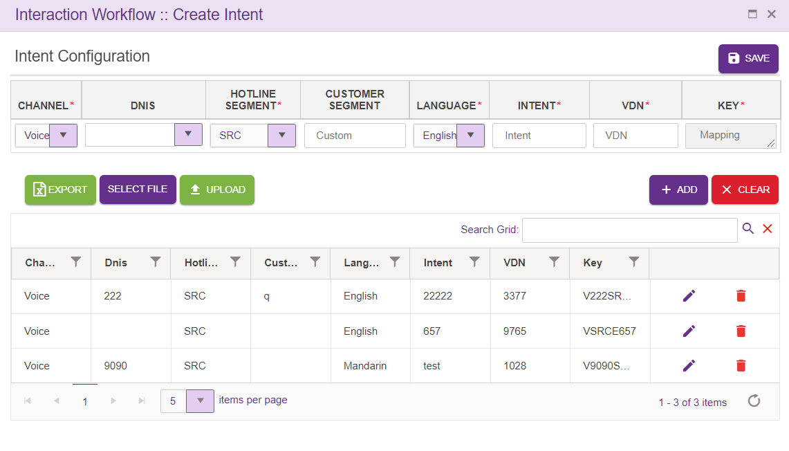
    - Channel: This drop down contains list of configured channels
    - DNIS: DNIS is added here, or user can select DNIS from the drop down.
    - Hotline Segment: User can select a Hotline segment from the drop down.
    - Customer Segment: This field accepts customer segment
    - Language: This drop down contains list of configured languages
    - Intent: Intent provided here is added to the grid as well as Agent node. Intent need not be unique.
    - VDN: This field accepts VDN.
    - Key: Unique key is provided for every entry. This key is auto generated.
Search Grid will help to search intents from records.
Save: Upon clicking ‘Save’ button, entries must be added to the grid and intent must be shown in Agent drop down.
Clear: This option is used to clear the entered field.
Export: Upon clicking this button, .csv extension file will be downloaded. This file contains all the contents of the grid.
File Selection: This option is used to select the file to be uploaded. Note that only .csv extension file can be uploaded. User can upload bulk amount of data.
Upload: This option is used to upload selected file. Upon clicking upload option, following popup will be generated. Duplicate files will not be uploaded.

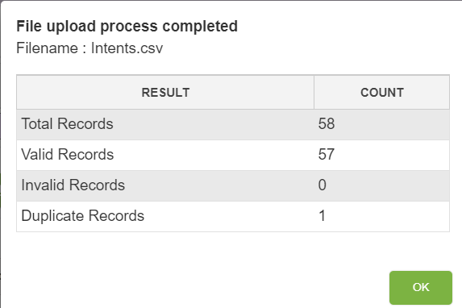
Edit: Click on the edit icon (right corner of each entry) to edit the details. User can edit only VDN field.

Phrases
This option will appear for all the roles i.e. maker, checker and previewer for the callflows of all the status.
Upon clicking Phrases icon following pop window will be loaded. This Option is used to upload phrase for a SAVED or APPROVED status callflow, without drafting them.
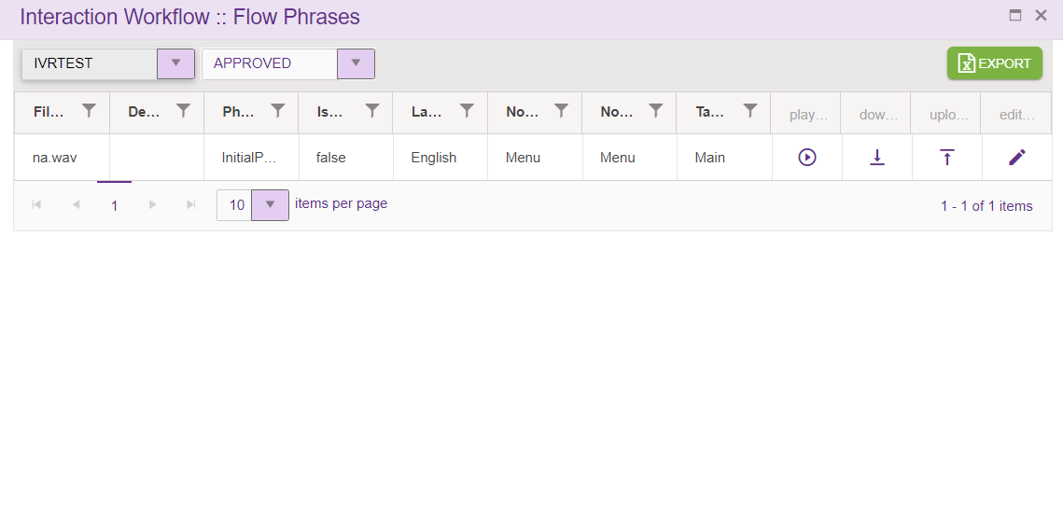
This window will show all the phrases used within a selected callflow as well as subflow which are in SAVED as well as APPROVED status
- Filename: specifies the Phrase selected by the user.
- Description: specifies the user provided description.
- Phrase type: Type of phrase used in the callflow i.e. greeting, invalid, No input etc.
- isGlobalPhrase: specifies’ true’ if the uploaded phrase is global phrase .if the uploaded phrase is local phrase it is ‘False’.
- Language: specifies the language for which phrase is uploaded.
- Node type: specifies the type of the node.
- Node name: specifies the node name.
- Tab name: specifies name of the Tab where the phrase exist.
- Play: This option is used to play the phrase. If user selects a SAVED status callflow, then phrases are played from MAKER location. If user selects an APPROVED status callflow, then phrases are played from CHECKER location.
- Download: This Option is used to download the phrase. If user selects a SAVED status callflow, then phrases are downloaded from MAKER location. If user selects an APPROVED status callflow, then phrases are downloaded from CHECKER location.
- Upload: This Option is used to upload phrase for a SAVED or APPROVED status callflow, without drafting them. Note that uploaded phrase file name must be same as existing phrase file name. Upon clicking this option, following popup is generated.
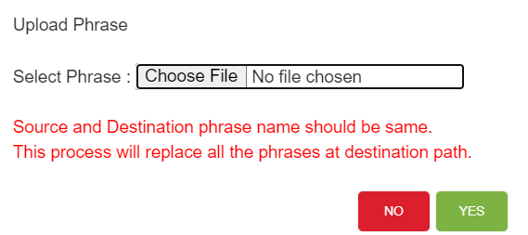

When phrase upload process is in progress, Uploading... text will be displayed in UI, as shown below. Phrases uploaded here will be added to Interpreter phrase folder as well as these phrases will sync to secondary server, if websync is enabled.

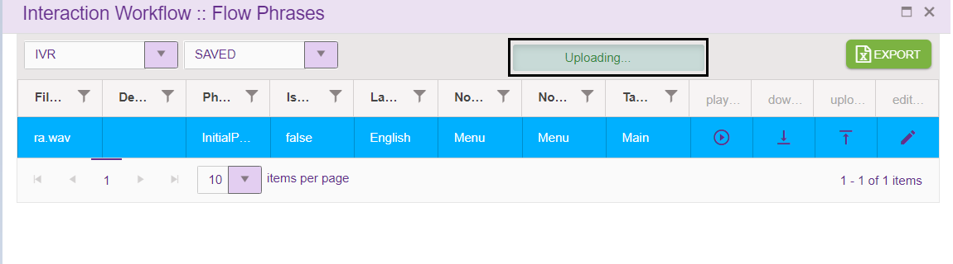
- Edit: this option is used to edit the phrase description.
Uploaded session variables are not shown in phrase grid.
Call flow Phrases pop window contains ‘Export’ button, which helps the user to export the phrases details into excel sheet.
Each columns header has the option to select and sort the records in ascending/descending order. These actions can be performed on clicking on table header.
Export:
Upon clicking this button, .csv extension file will be downloaded. This file contains all the contents of the grid. This option is available for all the roles i.e. maker, checker and previewer.

Rules Viewer
This option will appear for all the roles i.e. maker, checker and previewer for the callflows of all the status.
Upon clicking rule viewer icon following pop window will be loaded.
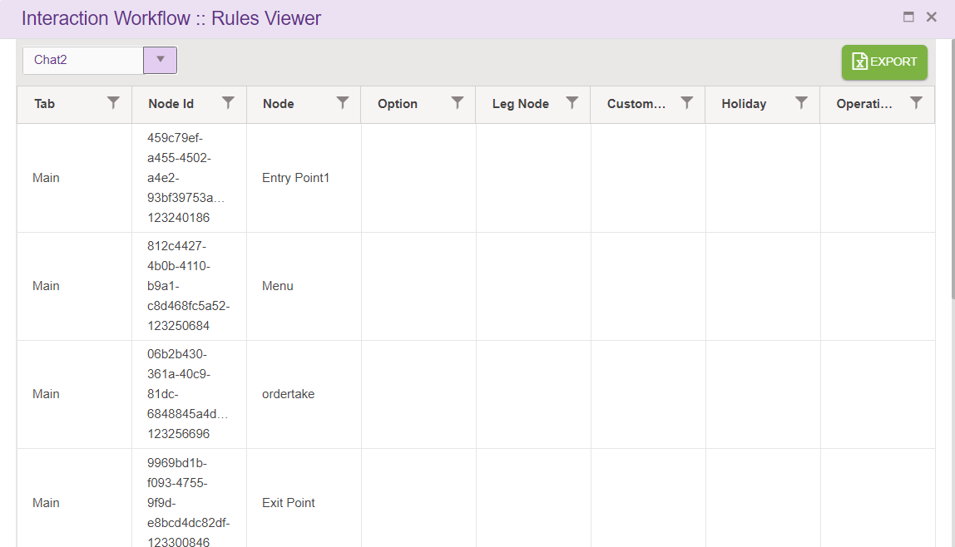
Rules viewer option shows all the rules added in menu leg, pnc leg and Validation, announcement and conditional node legs in the callflow along with each node id. This a a common place where all the node id’s used in the callflow can be viewed. user can select callflow from dropdown to view rules.
- Tab: specifies the tab of callflow
- NodeId: Id of that node.
- Node: this option displays node name.
- Option: node leg option will be displayed here.
- Leg Node: specifies leg node.
- Custom Rules: this is used to display rule name
- Holiday: this option will be true or false based on user selecting this when adding rules.
- Operating hours: this will display operating hours of rule.
Rule set for Menu Node leg will be displayed like this:
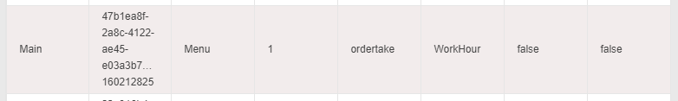
Rule set for PNC Node leg and validation will be displayed like this:
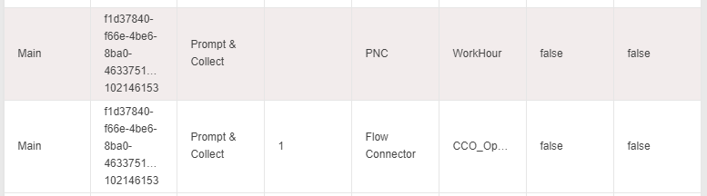
Rule set for Announcement Node will be displayed like this:
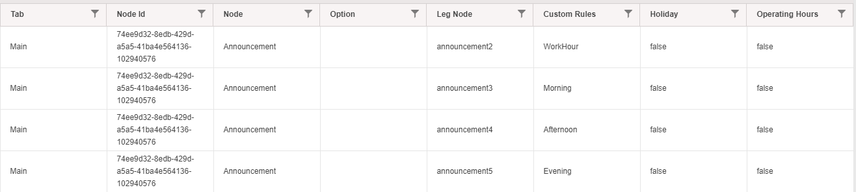

Comments
Upon clicking comments icon following pop window will be displayed.
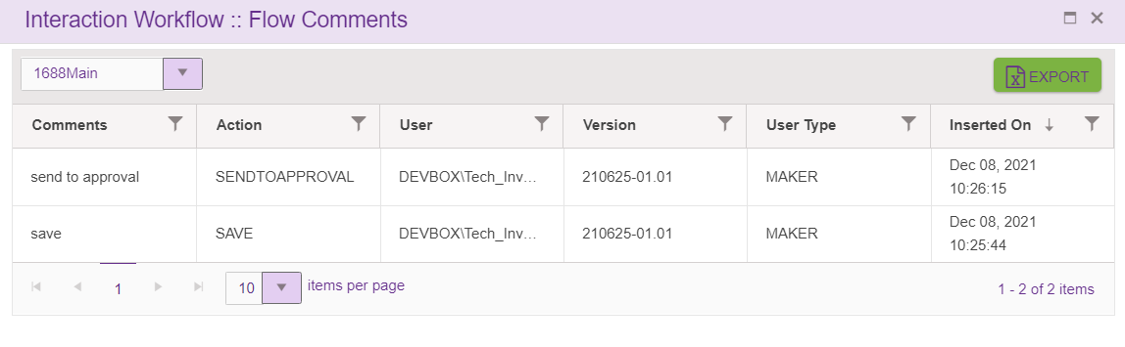
Comment option shows all the comments entered by the user whenever he does actions like ‘Save’ (both maker and checker) callflow, ‘Send to approval’, ’Reject’, ’Approve’, ‘Scheduled’ the callflow.
- Comments: specifies comments provided by the user.
- Action: specifies the status of the callflow.
- User: shows username logged-in. The format as <Domain name \ username>.
- Version: specifies version number of the callflow.
- User type: specifies type of the user like Maker, Checker.
- Inserted on specifies the date and time when user does add the comment.
Each columns header has the option to select and sort the records in ascending/descending order. These actions can be performed on clicking on table header.
Export:
Upon clicking this button, .csv extension file will be downloaded. This file contains all the contents of the grid. This option is available for all the roles i.e. maker, checker and previewer.
Dropdown:
Upon clicking on dropdown, all subflow connected to the flow will be listed. User can view the comments added to the subflows connected to the main flow here.

Global Configuration
This option will appear for the Maker, Checker and Previewer also. But only Maker can add Global Keys. Checker and Previewer will be in read-only mode.
Keys provided here will be used for IVR functionalities. It is available only in voice channel. For example: enable/disable specific modules.
Upon clicking Global Configuration icon following pop window will be displayed
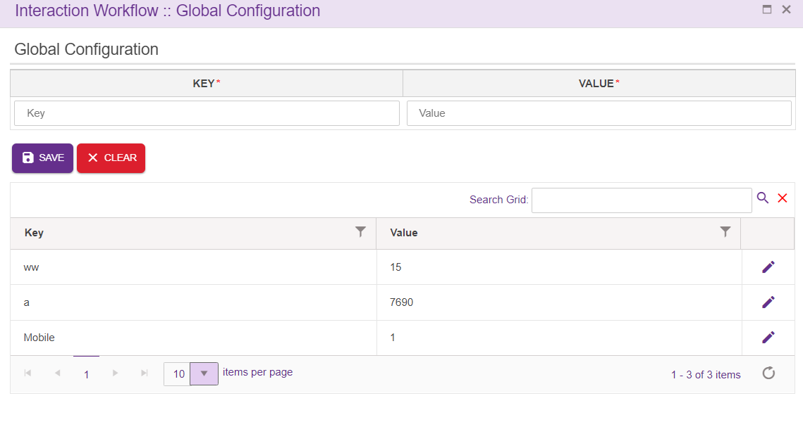
- Key: This field accepts characters, letters, underscore and keys must be unique.
- Value: This field accepts characters, letters, underscore and spaces.
Search Grid will help to search key or value from records.
Save:
Save global key/values pairs.
Clear:
This option is used to clear the entered field.
Edit:
Click on the edit icon (right corner of each entry) to edit the details. User can edit only Value field.
Callflow specific Global Configuration
Global keys can also be displayed specific to the callflow. Upon setting CallflowSpecific the key to TRUE in ClientSpecificConfiguration.json file, only the keys specific to the callflow will be displayed.
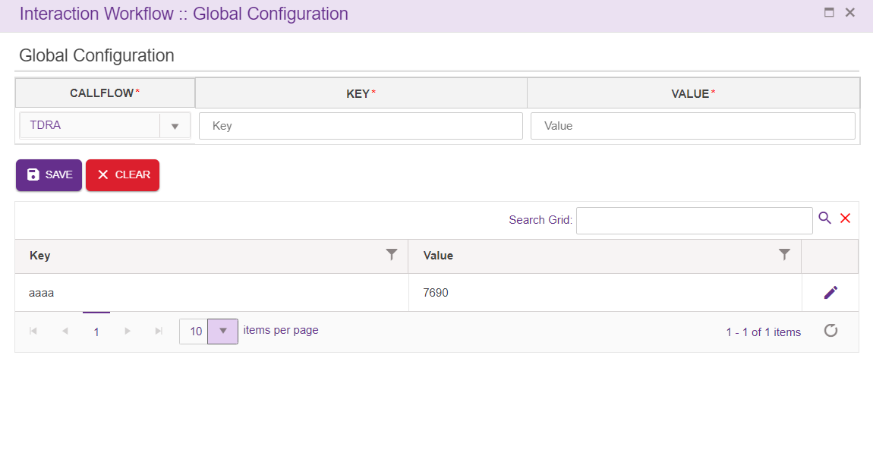

Global Phrases
This option will appear for the Maker, Checker and Previewer also. But only Maker can add Global phrases. Checker and Previewer will be in read-only mode.
User can able to add the global phrases based on the Languages.
Advantage of this global phrase is when user want to reuse phrase in different nodes or across the callflow, can use Global phrase. User can add the repeated phrase as Global Phrase.
Added Global phrase should get approved by the Checker. Once the checker approves the Global phrase, the existing phrase gets replaced with the newly approved phrase.
Here user did not have to replace phrases by moving to each node. Instead the Global phrase helps user to avoid the rework.
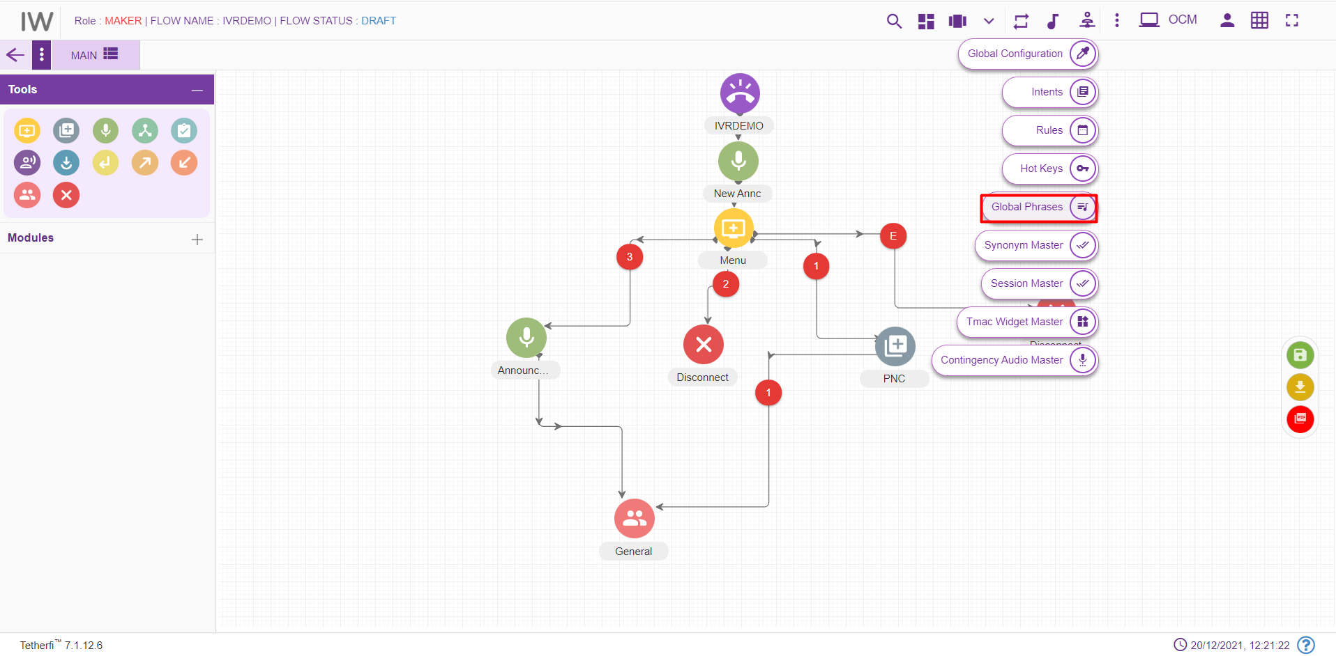
Upon clicking Global Phrase icon following pop window will be displayed, user can add the Global Phrases by clicking ‘Select Phrase’ button.
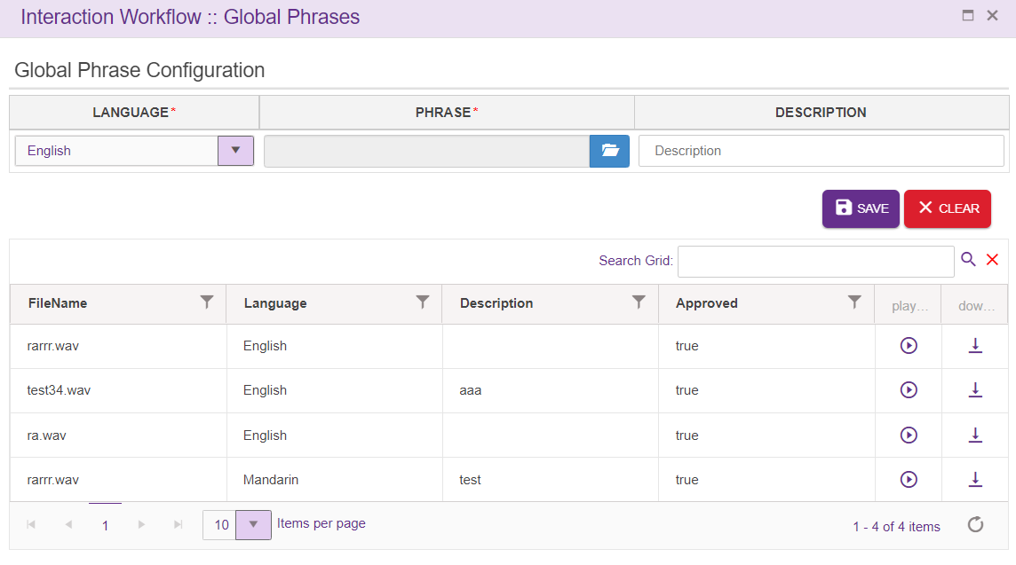
- Filename: specifies the Phrase selected by the user.
- Language: specifies the language for which phrase is uploaded.
- Description: specifies the user provided description.
- Approved: Specifies the Checker approved Phrase. If Phrase is Approved by Checker, column will update as the True else False.
Search Grid will help to search phrases from records.

Save: Upon clicking ‘Save’ button, entries must be added to the grid.
Clear: This option is used to clear the entered field.
When user select any node to upload phrase, following popup will generate.
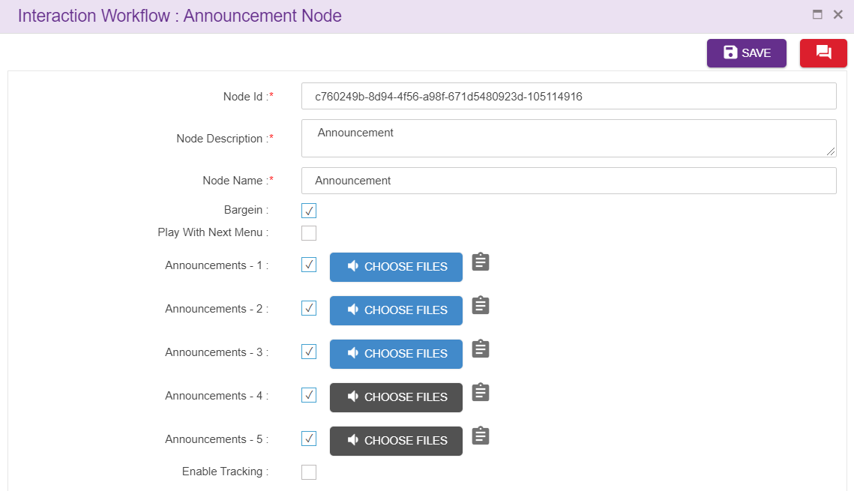
Upon clicking ‘CHOOSE FILES’ option, following popup will generate. User can add the Global Phrase by clicking on ‘Add Phrase from the Global List’ icon
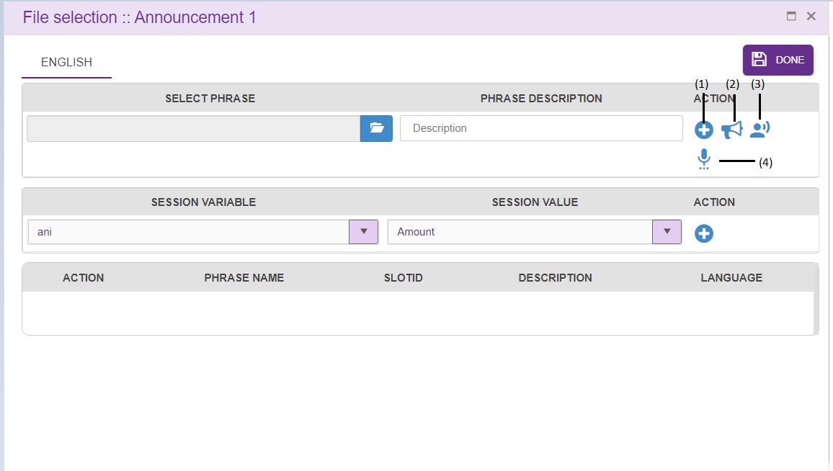
(1) Add phrase from local folder.
(2) Add phrase from global list.
(3) Text to voice converter.
(4) Add contingency phrases from contingency list.

Approve Global Phrases
This option will appear only for user with Checker and Maker-Checker role.
Upon clicking ‘Approve Global Phrase’ icon following pop window will be displayed,
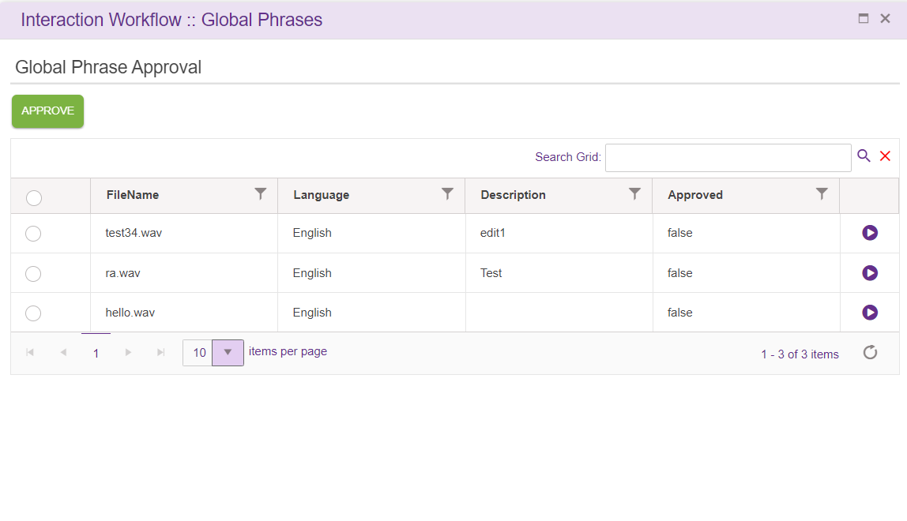
- Filename: specifies the Phrase selected by the user.
- Language: specifies the language for which phrase is uploaded.
- Description: specifies the user provided description.
- Approved: Specifies the Checker approved Phrase. If Phrase is Approved by Checker, column will update as the True else False.
Approve button: Select the phrase (enable the checkbox) to be approved, on clicking the ‘Approve’ button user can Approve the phrase. Once the phrase is approved the ‘Approved’ section for that particular phrase changes to True.
Once the Global Phrase is approved by the Checker, the particular existing Global phrase in callflow will be replaced with the approved Global phrase.
Global and Approved Options for Maker-Checker role:
The options appear when load any callfow, when click on the Master button,
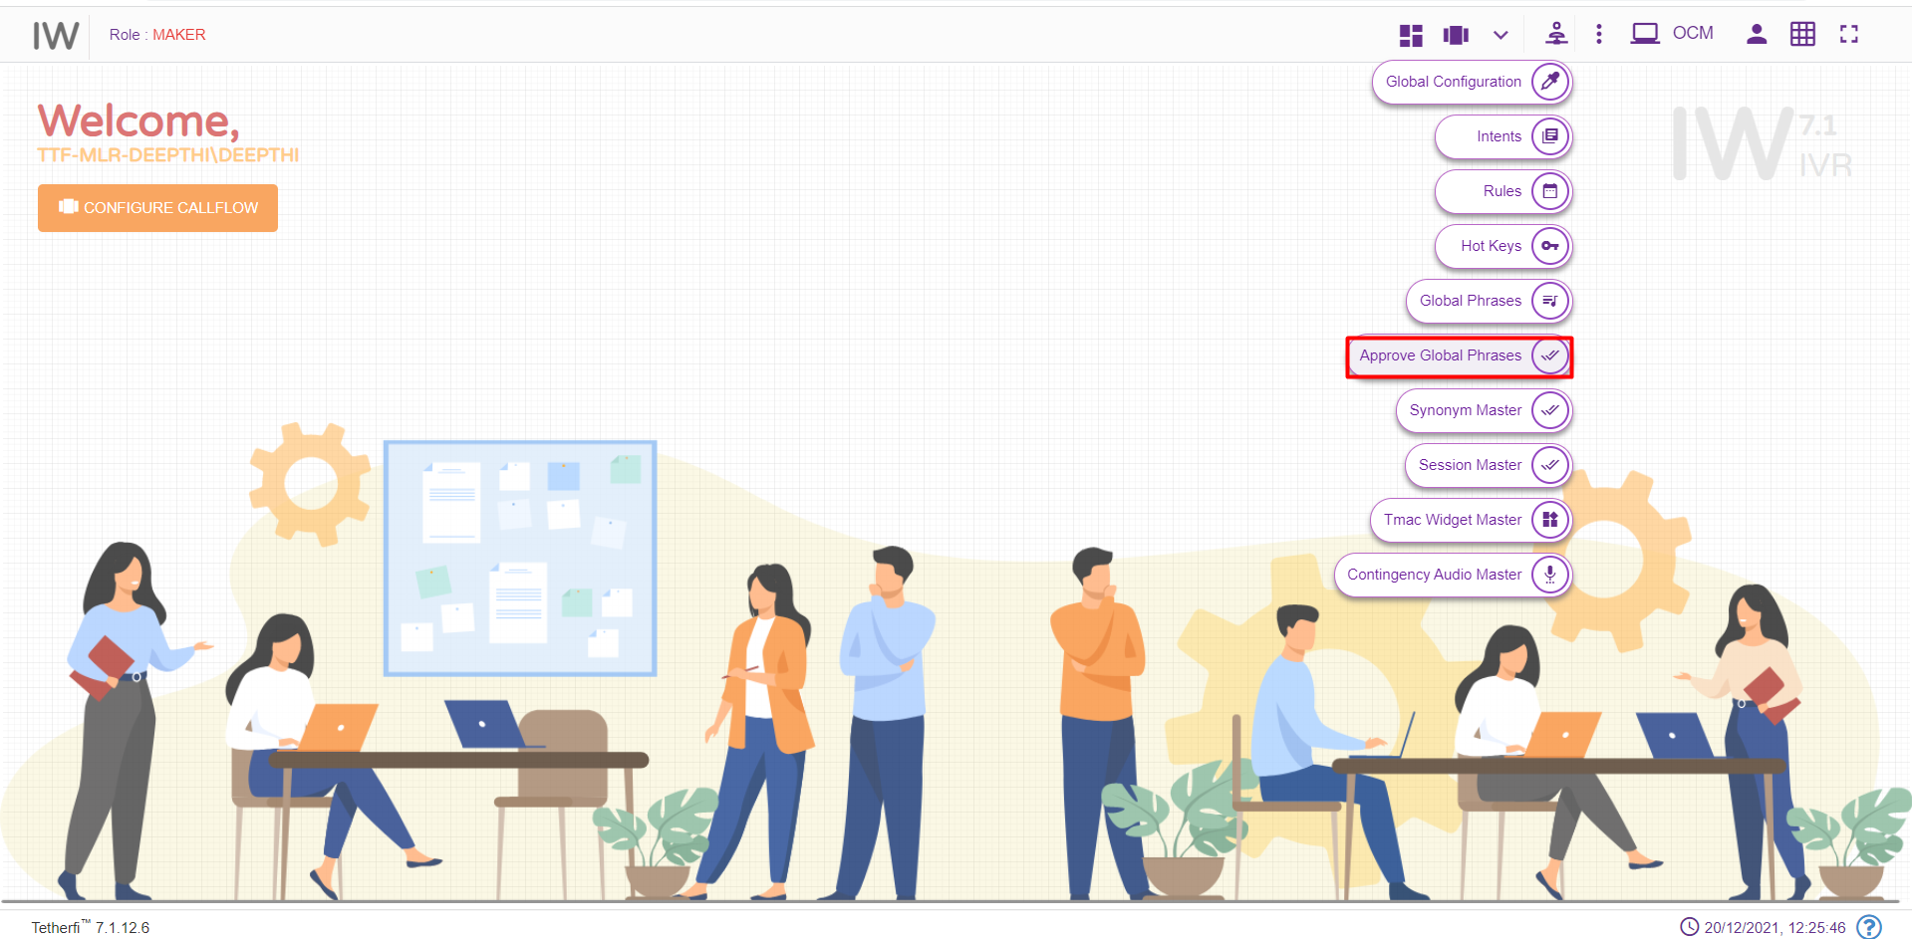 Note: User who has uploaded the global phrases cannot approve them even though he is a checker.

Search for Nodes and Modules
This option is used to search for a node and module in a callflow using id or name. Upon clicking ‘Search for nodes’ icon following pop window will be displayed.
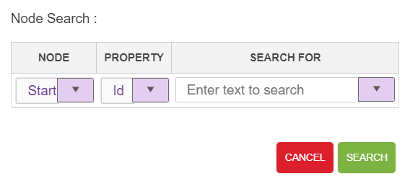
Node: This drop down contains list of nodes and module used in IW IVR except Entry, Exit and flow connector nodes.
Property: This drop down contains list of search criteria used to search for a node (Id and Name)
Search For: Text area where user will provide ID/Name detail.
For a valid search, control goes to the specific node and node starts blinking.
For an invalid search, ‘Given text does not exists in the current callflow’ error toaster is generated as shown below.
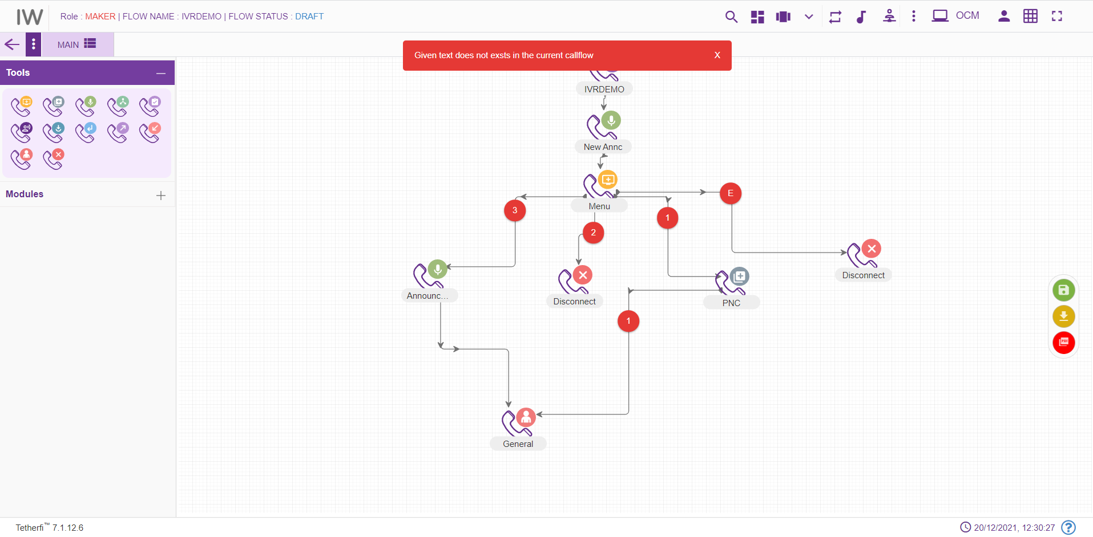

File System Version
All the server components version number, interpreter link and websync link used by the application is displayed here.
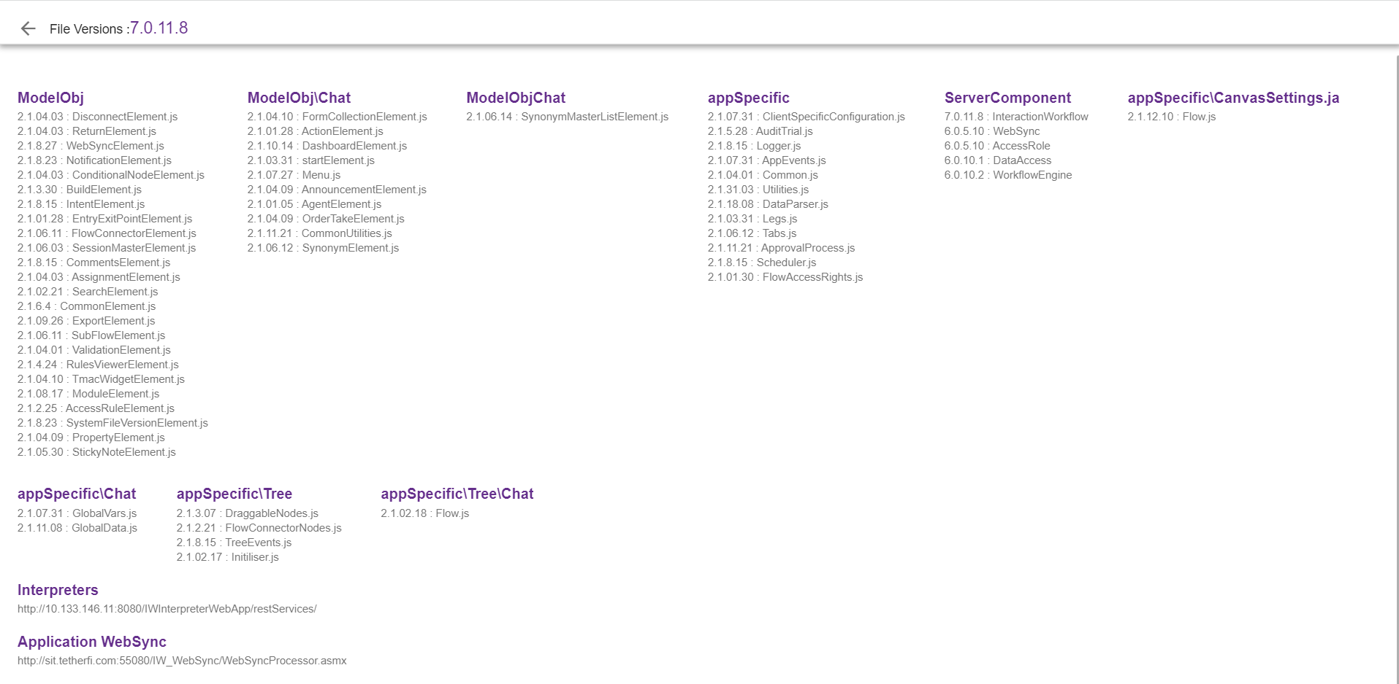

Hot Keys
There can be a scenario where we need to configure a same menu/PNC option like press 1 or press * in multiple menus. By using this hot key master option, we can configure the global option in the master and use it in every menu.
This option will appear for the Maker, Checker and Previewer also. But only Maker can add hotkeys. Checker and Previewer will be in read-only mode.
Upon clicking hot keys master icon following page will be displayed.
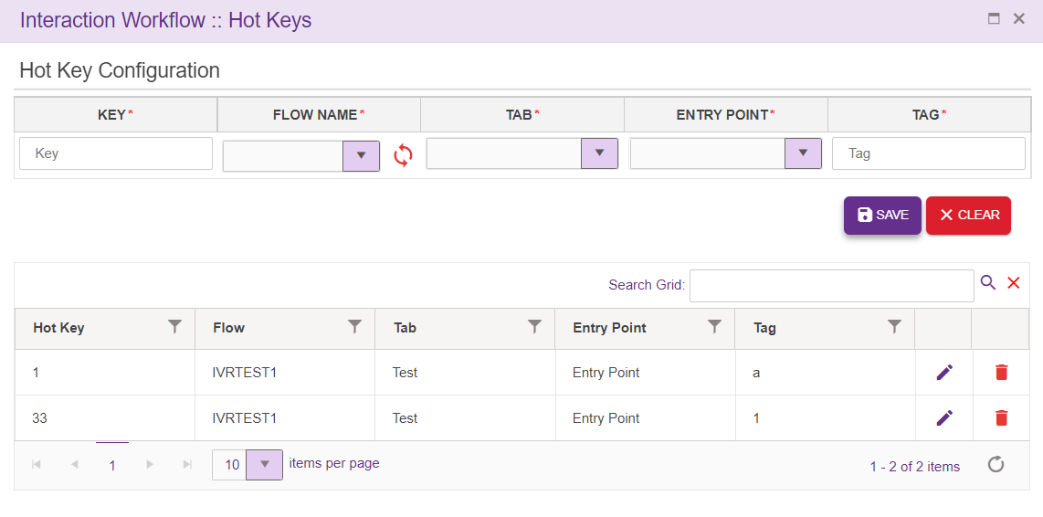
Key: This field will allow only digits (max 2 digits) and *, #, E, M and H. Any combination with E, M or H is not allowed
Flow Name: All Approved callflow (If saved copy is not there. Else Saved copy will be displayed in the dropdown).
Tab: Tabs present in the callflow will be shown here
Entry Point: Entry points present in the Tab selected is displayed here
Tag: A free text field, used to identify the hotkey. These keys need not be unique
Search Grid will help to search hot key from records.
Save: Upon clicking the button, new entry will be added to the grid.
Clear: This button is used to clear the field
Edit: User can edit the Flow name, tab, Entry point and Tabs once it is added to the grid, except keys
Delete: Unutilised keys can be deleted, and error toaster is generated as shown below, when user try to delete the hot key used in one of the callflow,
Hot key usage in Menu Node:
All the hot keys added at master is displayed in menu node for Main flow as well as for subflow as shown below.
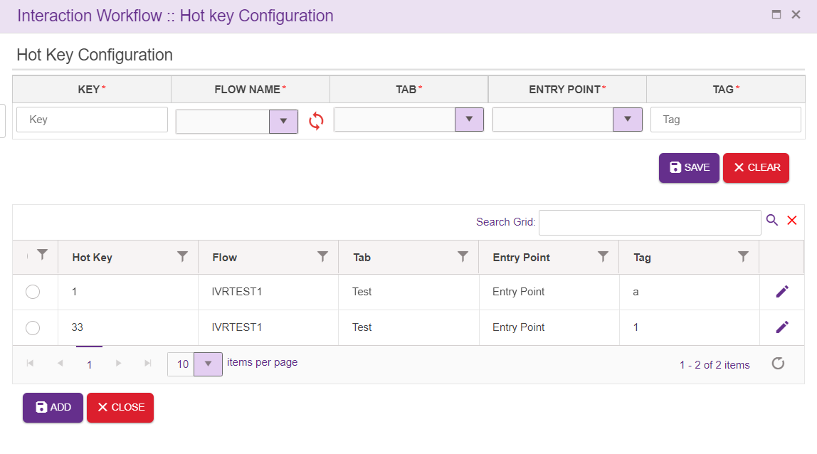
User can check the check box and click on ‘ADD’ button, to user the hot keys in the menu node. User can also change the hot key values by clicking on EDIT button present at the right corner of the grid. User cannot add a new key over here.
Hot key usage in Prompt and Collect Node:
All the hot keys added at master is displayed in PNC node for Main flow as well as for subflow as shown below.
User can check the check box and click on ‘ADD’ button, to user the hot keys in the PNC node. User can also change the hot key values by clicking on EDIT button present at the right corner of the grid. User cannot add a new key over here.

Synonym
For Each tag added in menu leg added, Designer can also add set of synonyms specific to the languages. Upon clicking synonym option, following popup will be generated
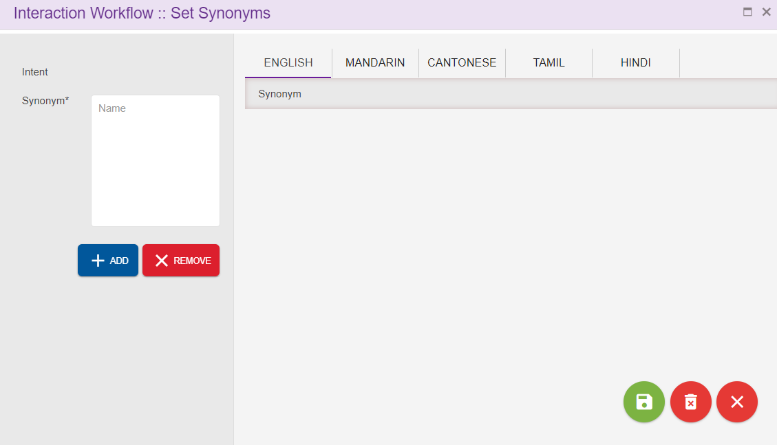
Intent: Tag added for each menu leg will be displayed here
Synonym: It’s a mandatory field. Synonym specific to the intent can be added here
SAVE: This is used to save the entries added
Remove All Synonyms: This option is used to remove all the synonyms added at once
Close: This option is used to close the synonym window.
In the below case, ‘Account Balance’ is the intent as ‘Acc Bal’ and ‘Balance’ are the synonyms
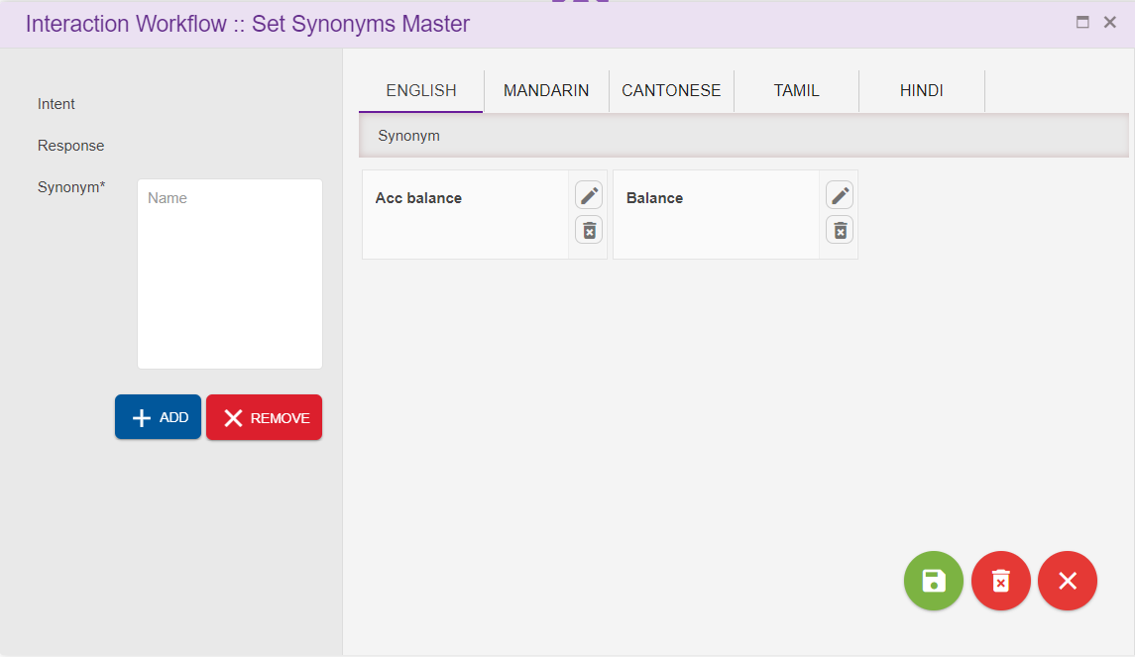

Synonym Master
This option is used for updating commonly used synonyms in global master. Here we can configure repeatedly used synonyms and can jump to a specific callflow, tab and entry point based on the intent provided. This option will appear only for the Maker.
Search Grid will help to search synonym from records.
Upon clicking global synonyms icon following page will be displayed.
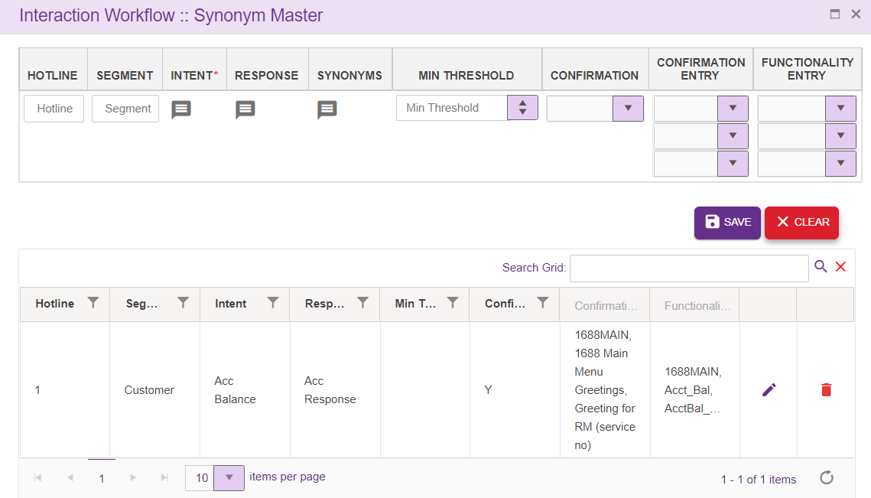
- Hotline: This field accepts only digits
- Segment: This field accepts both characters and digits
- Intent: Intents are added here. This is a mandatory field.
- Response: Response for the Intents, added in ‘Intent’ field is added here
- Synonyms: Can add synonyms for the intent added in ‘Intent’ section specific to language
- Minimum Threshold: Minimum threshold value is set here.
- Confirmation: User can select either Y or N from the dropdown

Confirmation Entry: Flow set here will be in effect when we receive confidence value of speech from speech engine equal or greater than confidence value configured.
- Flow name: Lists all SAVED/APPROVED subflows and main flows
- Tab: Lists all the tabs present in the flow selected in ‘Flow name’ dropdown
- Entry Point: Lists all the entry points present in the tabs selected in ‘Tabs’ dropdown

Functional Entry: Flow set here will be in effect when we receive confidence value of speech from speech engine is less than confidence value configured.
- Flow name: Lists all SAVED/APPROVED subflows and main flows
- Tab: Lists all the tabs present in the flow selected in ‘Flow name’ dropdown
- Entry Point: Lists all the entry points present in the tabs selected in ‘Tabs’ dropdown

Intent addition popup:
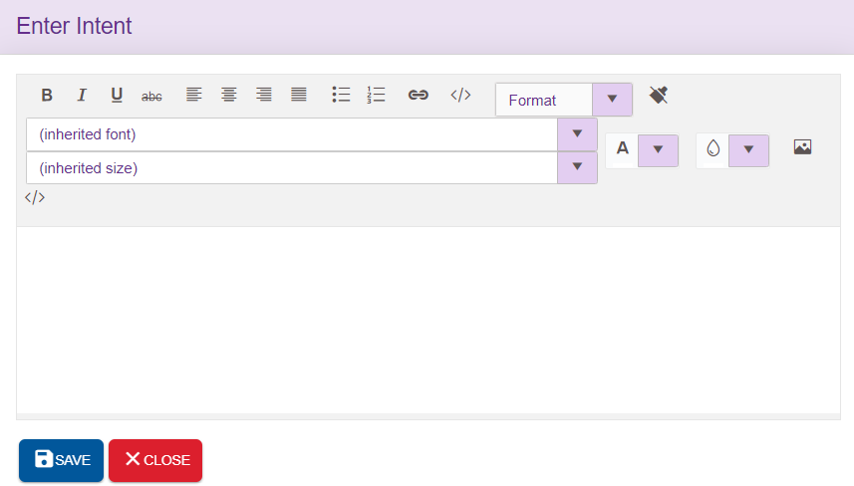
Response addition popup:
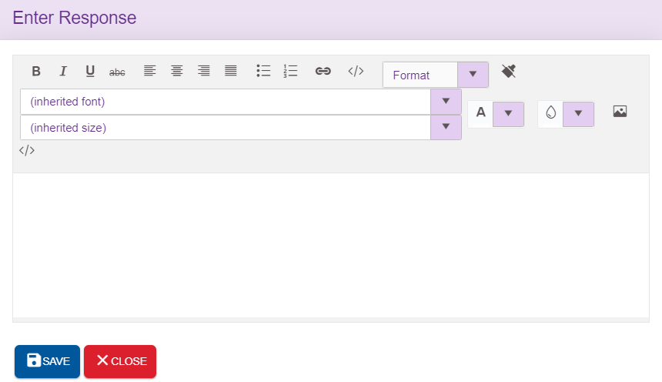
Synonym addition popup:
Synonyms related to the intents specific to the language can be added here. Upon clicking ‘ADD’ icon, synonyms will be added to the grid provided at the right end. ‘Remove’ option will clear the field.
SAVE: This icon will save the synonyms added
DELETE ALL: This option used to delete all the synonyms added at once
CLOSE: This icon is used to close the popup

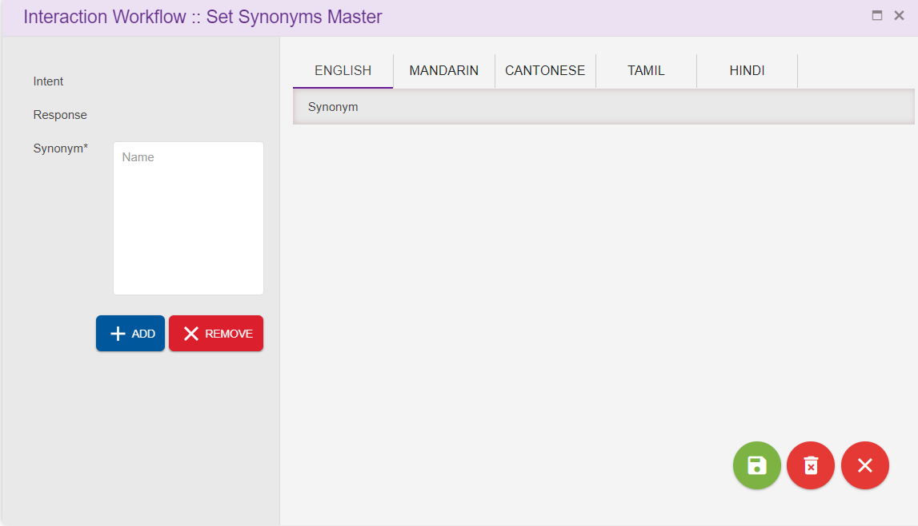
Save: Upon clicking ‘Save’ button, entries will be added to the grid
Clear: This option is used to clear the entered field.
Edit: Click on the edit icon (right corner of each entry) to edit the details. User can edit all the fields except intents

Session Master
This option will appear for the Maker, Checker and Previewer also. But only Maker can add the session variable. Checker and Previewer will be in read-only mode.
This option is used for updating commonly used session variables in global master. User can configure the operational variables here. Session variable added here will be available in Module designer too.
Upon clicking session master icon following page will be displayed.
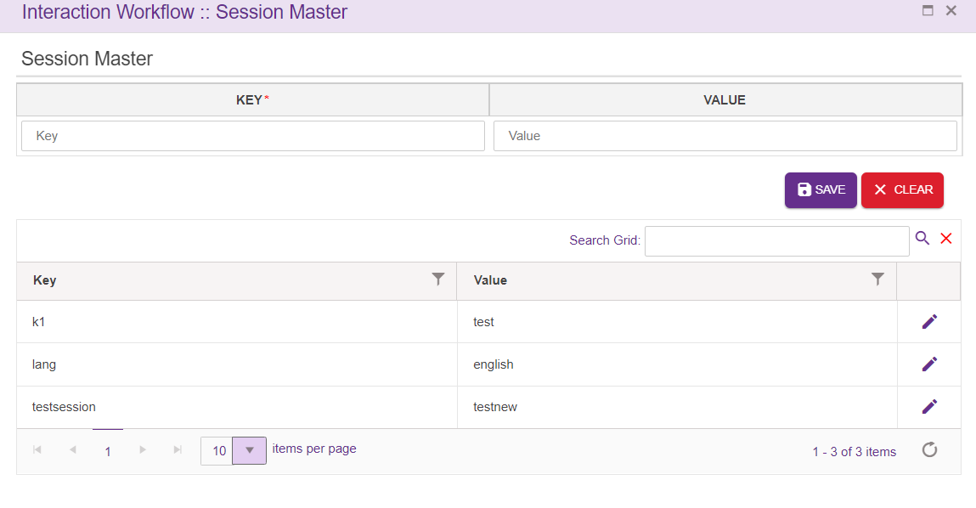
KEY: It is a mandatory field. Can accept characters as well as digits
Value: Not mandatory. Can accept characters as well as digits
Search Grid will help to search key or value from records.
ADD: Upon clicking the button, new entry will be added to the grid.
Clear: This button is used to clear the field
Edit: User can edit the Value field, except keys

TMAC Widget Master
This option will appear for the Maker, Checker and Previewer also. But only Maker can add the Tmac widgets and templates here. Checker and Previewer will be in read-only mode. This option is used for updating tmac widgets which will be displayed in Agent dashboard.
Upon clicking session master icon following page will be displayed.
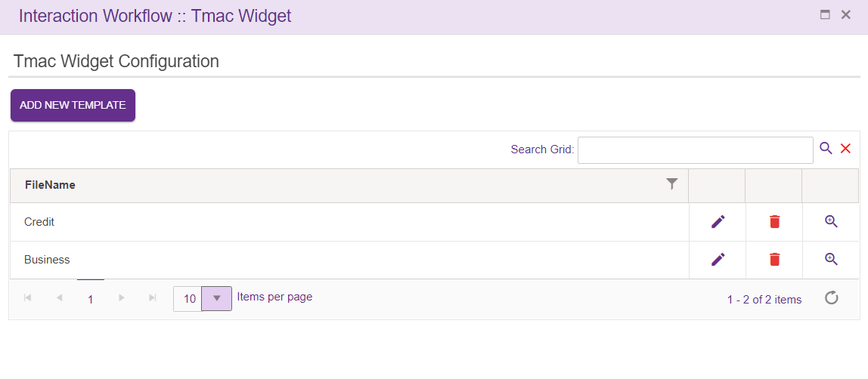
Search Grid will help to search FileName from records.
User can add the new template, edit existing one or delete template from the grid.
Upon clicking ‘ADD NEW TEMPLATE’ icon, following popup will generate, where user can select from list of key and widget configuration and save the template. Templates added here will display in Route node.
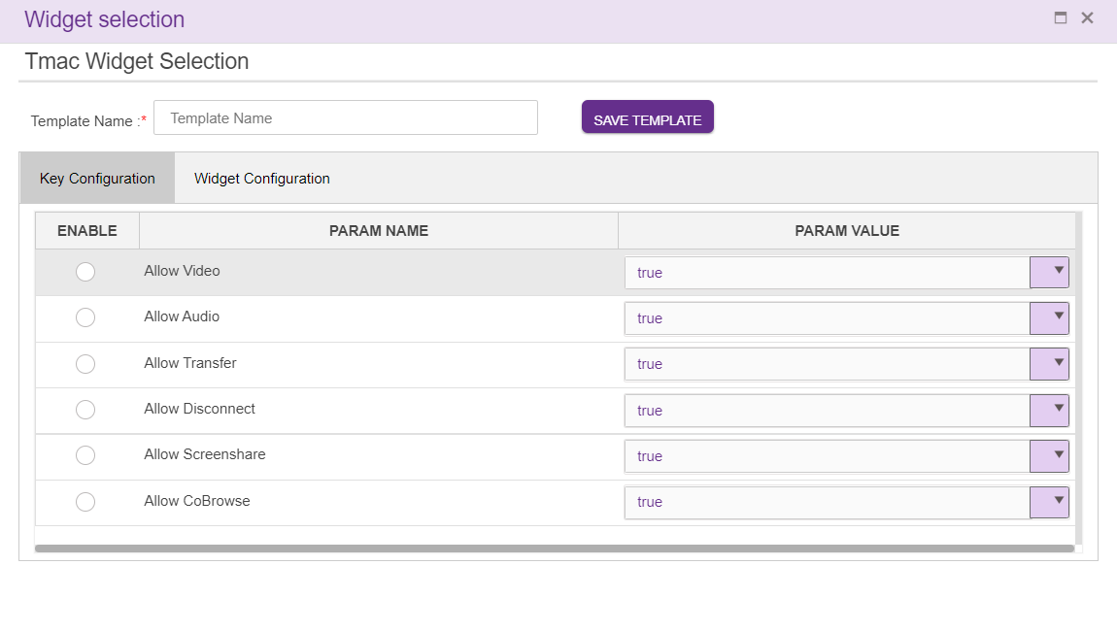

Contingency Audio Master
This option will appear for the Maker, Checker and Previewer also. But only Maker can add the contingency audio master. Checker and Previewer will be in read-only mode.
User can be able to add the contingency audio master based on the Languages.
User can select a callflow, based on callflow name user can select maker dnis/checker dnis number.
For saved callflow user can select maker dnis number.
For approved callflow user can select checker dnis number
Unique slot id is given for different audios.
Should not allow to delete the slot id until all the references are deleted.
Audio can be uploaded based on languages.
Search Grid will help to search slots or phrases from records.
Upon clicking contingency audios master icon following page will be displayed.
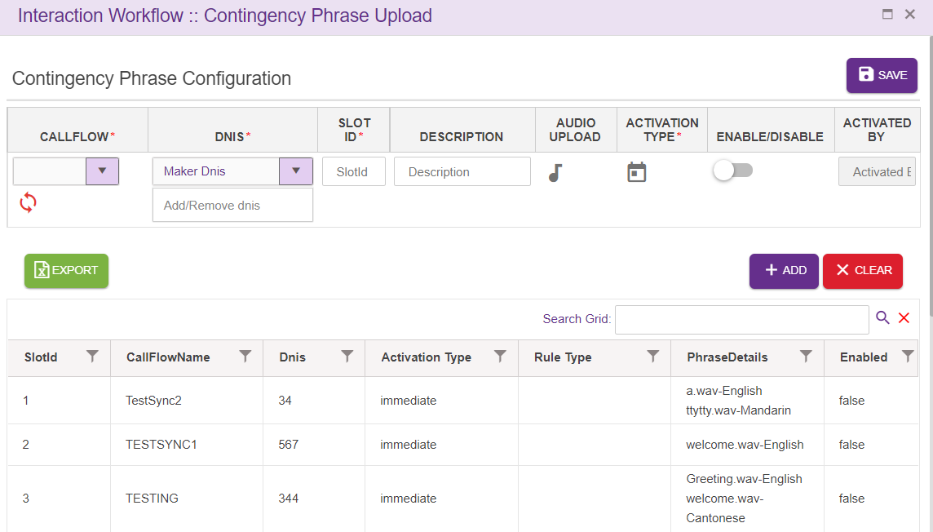
- Callflow: Name of the callflow.
- DNIS: Select Maker/Checker DNIS.
- Slot ID: Slot id is added here. This is a mandatory field.
- Description: Specifies the user provided description.
- Audio Upload: Popup will generate, based on language audio can be uploaded. Audio can be uploaded from local folder or using TTS.
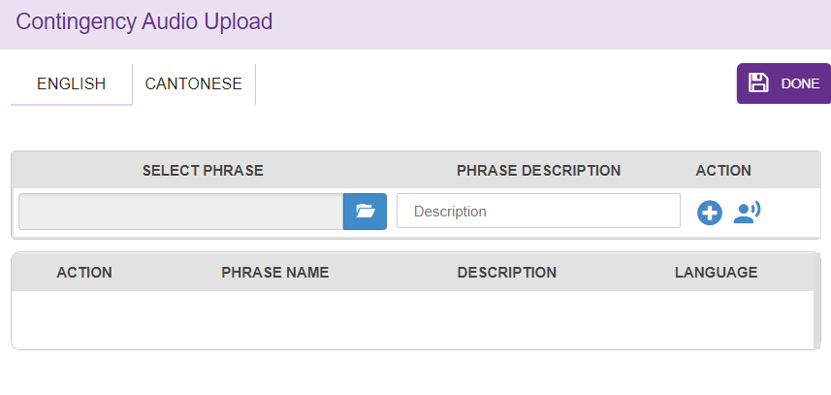
- Activation type: Immediate/Schedule can be selected based on user requirement.
In scheduled activation type
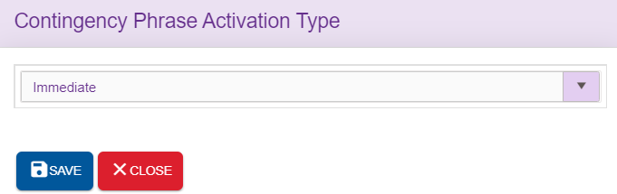
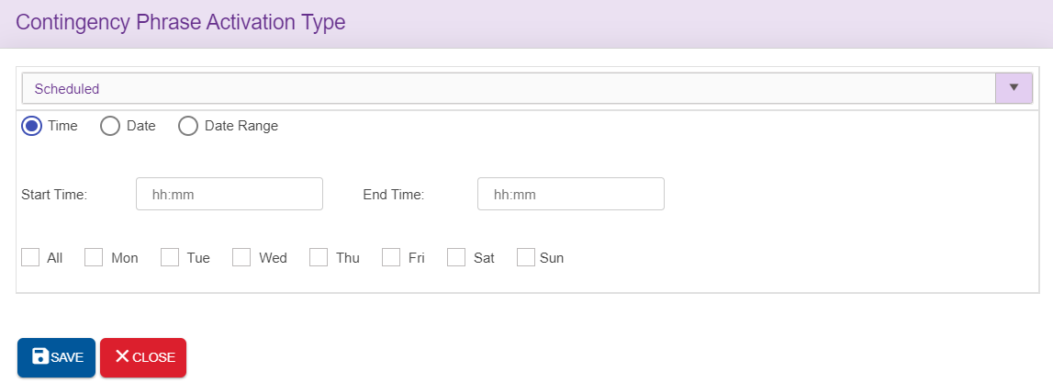

- Enable/Disable: Enabling or disabling the phrases based on user requirement.
- Activated by: Activated username will display here.
- Download: Pop up will generate to download required audio based on language.
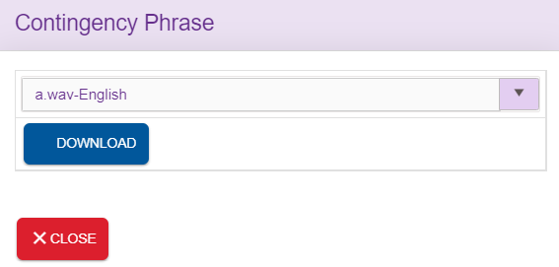
- Play: Pop up will generate to download required audio based on language.
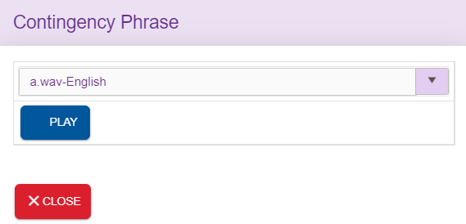
Save: Upon clicking ‘Save’ button, contingency master will be saved.
Add: Upon clicking the button, new entry will be added to the grid.
Clear: This option is used to clear the entered field.

Checker
Interaction Workflow Checker has the privilege to preview/ approve / reject / schedule workflows.
Note: Checker cannot delete the callflows.
When a user login as a checker (without loading any callflow), following page will be displayed.

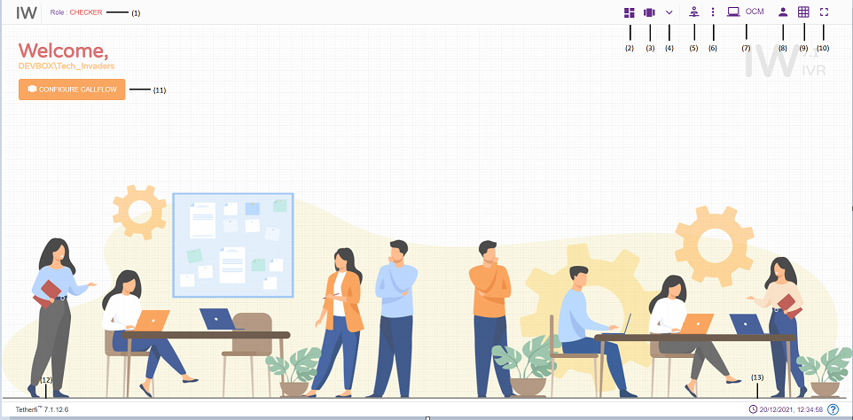

- Role: Displays the role of the user i.e. Maker
- Dashboard: callflow dashboard. (ref section Dashboard )
- Configure Callflow: This option is used to create a new flow/ Preview a flow/Order Take/Delete a callflow. (ref section Configure Callflow)
- More Menus: Upon clicking this button following options will appear.
- Import callflow: (ref section Import Callflow)
- Copy callflow: refer section Copy Callflow
- Text to Voice: refer section Text to Voice
- Master: Upon clicking this button following options will appear.
- Global Configuration: refer section Global Configuration
- Intents: refer section Intent Master
- Rules: refer section Rule Master
- Global Phrases: refer section Global Phrases
- Hot Keys: refer section Hot Keys
- Synonym Maser: refer section Synonym Master
- Session Master: refer section Session Master
- Tmac Widget Master: refer section TMAC Widget Master
- Contingency Audio Master: refer section Contingency Audio Master
- Callflow Notifications: Notifications related to Callflow statuses
- Redirect to OCM: This option will redirect to OCM page.
- Current User Info: User’s domain name/ user name and for logging out of Interaction Workflow module.
- Grid: Grid can be enabled/disabled.
- Full Screen: This option is used to view the Interaction Workflow in full screen. (Press “Esc”/F11 button to go back to normal view)
- At the top left corner of the page, welcome message is displayed along with user’s domain name/user name. Configure callflow option is also provided here.
- Current IW version
- System date and time will be displayed here.
When a user login as a checker and load a callflow, following page will be displayed.

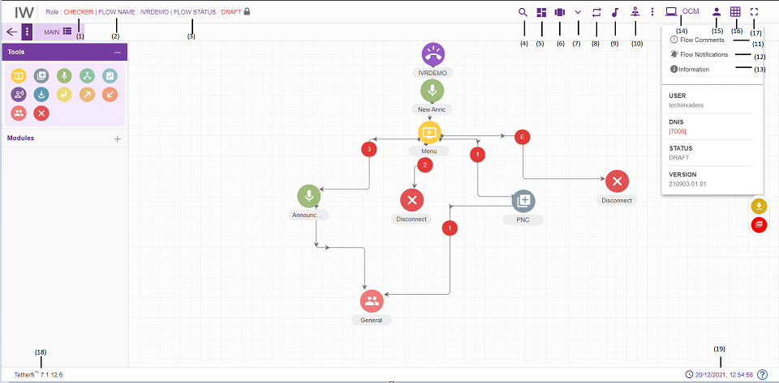
    - Role: Displays the role of the user i.e. Checker.
    - Flow Name: Flow name will be displayed here.
    - Flow Status: Current callflow status will be displayed here.
    - Search for Nodes: refer section Search for nodes
    - Dashboard: This option will redirect to dashboard. refer section Dashboard
    - Configure callflow: This option is used to Preview a flow. refer section Configure Callflow
    - More Menus: Upon clicking this button, following options will appear
- refer section More Menu Option
    - Rules Viewer: refer section Rules Viewer
    - Phrases: refer section Phrases
    - Master: Upon clicking this button following options will appear.
  - Global Configuration: refer section Global Configuration
  - Intents: refer section Intent Master
  - Rules: refer section Rule Master
  - Global Phrases: refer section Global Phrases
  - Hot Keys: refer section Hot Keys
  - Synonym Maser: refer section Synonym Master
  - Session Master: refer section Session Master
  - Tmac Widget Master: refer section TMAC Widget Master
  - Contingency Audio Master: refer section Contingency Audio Master
    - Comments: refer section Comments
    - Callflow Notifications: This option is used to check all the notifications related to Interaction Workflow
    - Information: This option is used for information related to the user and Interaction Workflow version.
    - OCM: This option will redirect to OCM page
    - Current User Info: This option is used to know User’s domain name/ user name and for logging out of Interaction Workflow module.
    - Grid: Grid can be enabled/disabled.
    - Full Screen: This option is used to view the Interaction Workflow in full screen. (Press “Esc” button to go back to normal view)
    - Current IW version is displayed here.
    - Current system date and time will be displayed here.

          - The Maker is notified about Checker’s verification activity.
          - The Nodes/Modules to be modified/rechecked are highlighted.
          - Once the changes are approved or rejected it will reflect in IW- Maker as “Approved” or “Rejected”
          - All the changes and modifications done in Interaction Workflow will be displayed in OCM’s Audit trail report.
          - There are modules and nodes available here. But checker cannot use them (Checker cannot modify any callflow. He can either approve or reject a callflow)

Approve Now
Approve a callflow immediately. Checker has to enter comment section before approving any callflows. And callflow should be in SENTTOAPPROVAL or CEHCKERSAVED State before callflow apporve
Note: in order to approve the callflow, there must be atleast 1 phrase uploaded to callflow.
Upon approving, callflow status will be changed to APPROVED.
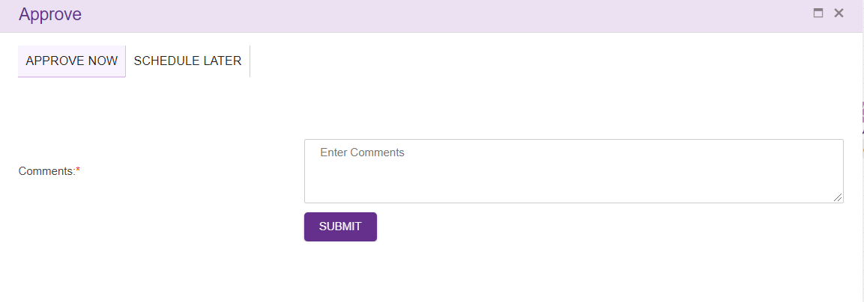

Scheduled Later
A Checker can schedule a callflow approval to a specific date time.
When we select schedule later option tab, following popup is generated. Checker has to enter comments before scheduling a callflow approval.
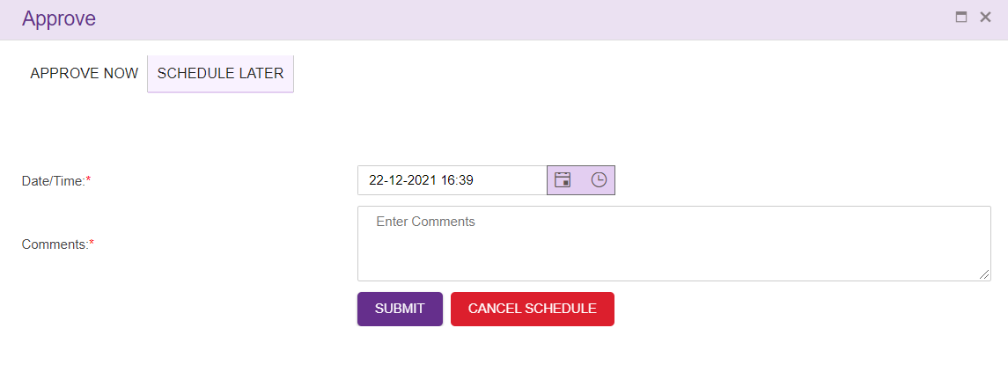
- Select scheduling date and time with comments
- Press ‘SUBMIT’ button.
- ‘CANCEL SCHEDULE’ button is used to cancel a scheduled callflow. This button will be disabled once callflow is added to schedule process.
Upon clicking ‘SUBMIT’ button, following confirmation popup will generate.
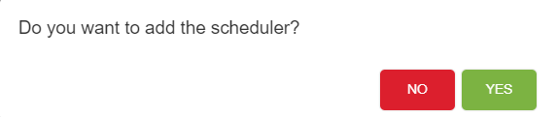
Note:
- Scheduled callflow cannot be approved by the checker.
- Once the checker cancels the scheduler, status of the callflow is changed to ‘CHECKERSAVED’ Once the callflow status changed to CHECKERSAVED, the checker can approve that callflow.
- Only checker who schedule the callfow can cancel the scheduler.

Previewer
Interaction Workflow Previewer has the privilege to preview workflows.
Note: Previewer neither create the callflow nor delete the callflows and comments. When anonymous authentication is enabled for IW UI application, user will be redirected to Previewer page. User must login to IW only through OCM when anonymous authentication is enabled.
When a user login as a previewer (without loading a callflow), following page will be displayed.

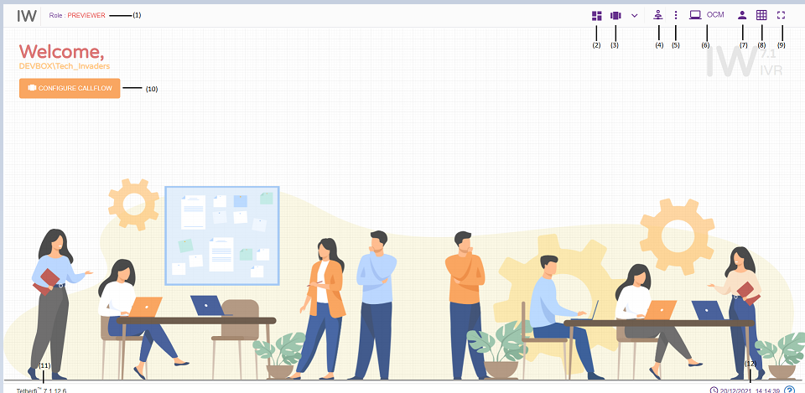
- Role: Displays the role of the user i.e. Previewer
- Dashboard: This option will redirect to dashboard. refer section Dashboard
- Configure callflow: This option is used to Preview a flow. refer section Configure Callflow
- Master: Upon clicking this button following options will appear.
- Global Configuration: refer section Global Configuration
- Intents: refer section Intent Master
- Rules: refer section Rule Master
- Global Phrases: refer section Global Phrases
- Hot Keys: refer section Hot Keys
- Synonym Maser: refer section Synonym Master
- Session Master: refer section Session Master
- Tmac Widget Master: refer section TMAC Widget Master
- Contingency Audio Master: refer section Contingency Audio Master
- Callflow Notifications: This option is used to check all the notifications related to Interaction Workflow
- OCM: This option will redirect to OCM page.
- Current User Info: This option is used to know User’s domain name/ user name and for logging out of Interaction Workflow module.
- Grid: Grid can be enabled/disabled.
- Full Screen: This option is used to view the Interaction Workflow in full screen. (Press “Esc” button to go back to normal view)
- At the top left corner of the page, welcome message is displayed along with user’s domain name/user name. Configure callflow option is also provided here.
- Current IW version is displayed here.
- System date and time will be displayed here

When a user login as a Previewer and load a callflow, following page will be displayed.
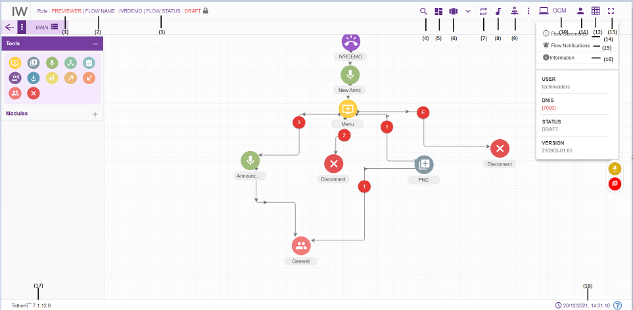
- Role: Displays the role of the user i.e. Previewer.
- Callflow Name: Displays the callflow name.
- Flow Status: Displays callflow status here.
- Search for Nodes: refer section Search for nodes
- Dashboard: This option will redirect to dashboard. refer section Dashboard
- Configure callflow: This option is used to Preview a flow. refer section Configure Callflow
- Rules Viewer: refer section Rules Viewer
- Phrases: refer section Phrases
- Master: Upon clicking this button following options will appear.
- Global Configuration: refer section Global Configuration
- Intents: refer section Intent Master
- Rules: refer section Rule Master
- Global Phrases: refer section Global Phrases
- Hot Keys: refer section Hot Keys
- Synonym Maser: refer section Synonym Master
- Session Master: refer section Session Master
- Tmac Widget Master: refer section TMAC Widget Master
- Contingency Audio Master: refer section Contingency Audio Master
    - Comments: refer section Comments
    - Callflow Notifications: This option is used to check all the notifications related to Interaction Workflow
    - Information: This option is used for information related to the user and Interaction Workflow version.
    - OCM: This option will redirect to OCM page
    - Current User Info: This option is used to know User’s domain name/ user name and for logging out of Interaction Workflow module.
    - Grid: Grid can be enabled/disabled.
- OCM: This option will redirect to OCM page.
- Current User Info: This option is used to know User’s domain name/ user name and for logging out of Interaction Workflow module.
- Grid: Grid can be enabled/disabled.
- Full Screen: This option is used to view the Interaction Workflow in full screen. (Press “Esc” button to go back to normal view)
- Comments: refer section Comments
- Callflow Notifications: This option is used to check all the notifications related to Interaction Workflow.
- Information: This option is used for information related to the user and Interaction Workflow version.
- Current IW version is displayed here.
- System date and time will be displayed here.
- There are modules and nodes available here. But previewer cannot use them (Previewer cannot modify any callflow. He can just preview the callflow)
When user login as Previewer and load the dashboard, following page will be displayed.’ Callflow Build/Package’ and delete option won’t be appear for Previewer in dashboard.
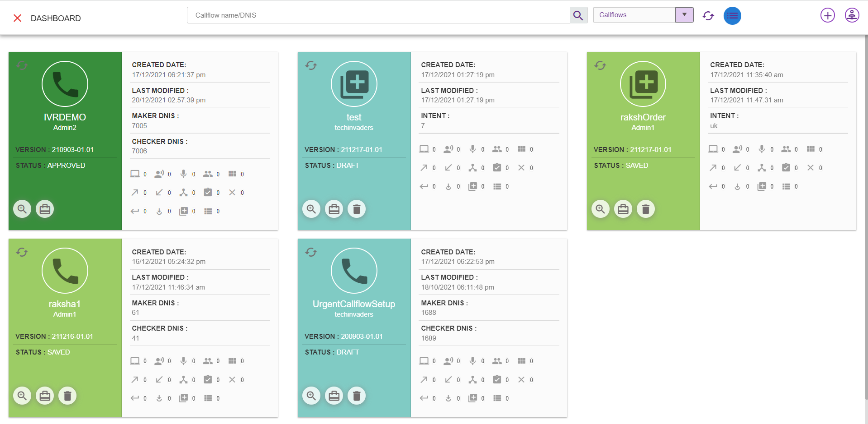
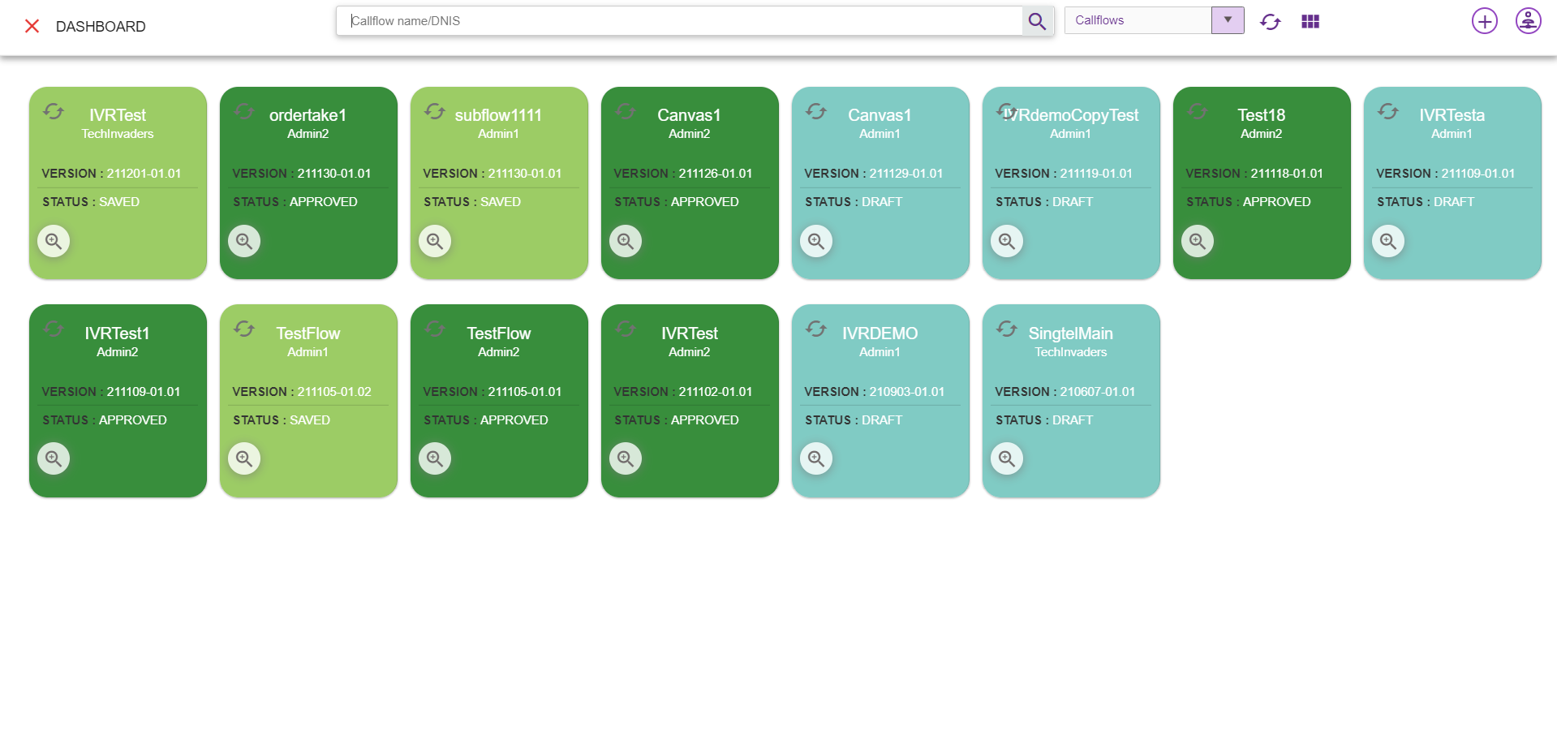

Maker and Checker
Interaction Workflow Maker-Checker has the privilege to create / view / edit /approve/schedule/delete workflows.
Note: Owner of the callflow can only delete the callflows. Owner of the callflow cannot approve his callflow even though he is a checker. Once the user rejects a callflow, he cannot edit that same callflow. But once the user approves a callflow, he can edit that same callflow.
User who has both the roles i.e. maker-checker, can edit any callflow other than the callflows rejected by him.
When a user has both the roles i.e maker and checker, user role will be shown as MAKER, CHECKER. This will be configurable, and we can even set visible false in Configuration.
User cannot do any changes with the callfow with the status ‘Checkersaved’, when callflow status is Checkersaved by some other user.
When user login as a maker-checker (without loading any callflow), following page will be displayed.
- Role: Displays the role of the user i.e. Maker-Checker
- Dashboard: callflow dashboard. (ref section Dashboard )
- Configure Callflow: This option is used to create a new flow/ Preview a flow/Order Take/Delete a callflow. (ref section Configure Callflow)
- More Menus: Upon clicking this button following options will appear.
- Import callflow: (ref section Import Callflow)
- Copy callflow: refer section Copy Callflow
- Text to Voice: refer section Text to Voice
- Master: Upon clicking this button following options will appear.
- Global Configuration: refer section Global Configuration
- Intents: refer section Intent Master
- Rules: refer section Rule Master
- Global Phrases: refer section Global Phrases
- Hot Keys: refer section Hot Keys
- Synonym Maser: refer section Synonym Master
- Session Master: refer section Session Master
- Tmac Widget Master: refer section TMAC Widget Master
- Contingency Audio Master: refer section Contingency Audio Master
- Callflow Notifications: Notifications related to Callflow statuses
- Redirect to OCM: This option will redirect to OCM page.
- Current User Info: User’s domain name/ username and for logging out of Interaction Workflow module.
- Grid: Grid can be enabled/disabled.
- Full Screen: This option is used to view the Interaction Workflow in full screen. (Press “Esc”/F11 button to go back to normal view)
- At the top left corner of the page, welcome message is displayed along with user’s domain name/user name. Configure callflow option is also provided here.
- Current IW version
- System date and time will be displayed here.
When user login as a maker-checker and load a callflow, following page will be displayed.
- Role: Displays role of the user i.e. Maker-Checker.
- Flow Name: Name of the flow will be displayed here
- Flow Status: Current callflow flow status will be displayed here
- Search for Nodes: refer section Search for nodes
- Dashboard: callflow dashboard. (ref section Dashboard )
- Configure Callflow: This option is used to create a new flow/ Preview a flow/Order Take/Delete a callflow. refer section Configure Callflow
- More Menus: Upon clicking this button following options will appear.
- Callflow version control: refer section Callflow Version Control
- Import callflow: ref section Import Callflow)
- Copy callflow: refer section Copy Callflow
- Text to Voice: refer section Text to Voice
- Rules Viewer: refer section Rules Viewer
- Phrases: refer section Phrases
- Master: Upon clicking this button following options will appear.
- Global Configuration: refer section Global Configuration
- Intents: refer section Intent Master
- Rules: refer section Rule Master
- Global Phrases: refer section Global Phrases
- Hot Keys: refer section Hot Keys
- Synonym Maser: refer section Synonym Master
- Session Master: refer section Session Master
- Tmac Widget Master: refer section TMAC Widget Master
- Contingency Audio Master: refer section Contingency Audio Master
- Information: This option is used for information related to the user and Interaction Workflow version.
Callflow Notifications: This option is used to check all the notifications related to Interaction Workflow.
Callflow Comments: refer section Comments
- Redirect to OCM: This option will redirect to OCM page.
- Current User Info: This option is used to know User’s domain name/ user name and for logging out of Interaction Workflow module.
- Grid: Grid can be enabled/disabled.
- Full Screen: This option is used to view the Interaction Workflow in full screen. (Press “Esc”/F11 button to go back to normal view)
- Current IW version is displayed here.
- Current system date and time will be displayed here.
- More Menus: refer section More Menu Option
- There are modules and nodes available in UI. Maker can make use of these nodes/module as per requirement.

Creating/Editing Workflows

Configure Callflow
Configure callflow option is provided for Maker, Checker and Previewer. This option will be displayed at the centre of the page in IW landing page as well as right next to dashboard icon.

Upon clicking ‘Configure Callflow’ button in maker page and maker-checker page, below window will popup.

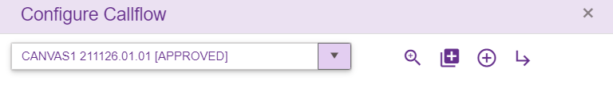
In maker page upon clicking on ‘Configure callflow’ button following options will appear.
- Callflow List: refer section Callflow List
- Preview: refer section Preview
- New IW Flow: refer section New IW Flow
- New Order Take Flow: refer section New Order Take Flow
- Delete Flow: refer section Delete
- Sub Flow: refer section Sub Flow
Upon clicking ‘Configure Callflow’ button in checker/Previewer page, below window will popup.
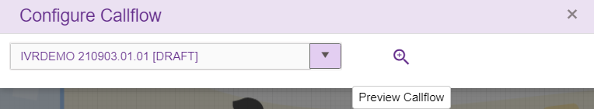
In checker and previewer page, upon clicking on ‘Configure callflow’ button following options will appear.
- Callflow List: refer section Callflow List
- Preview: refer section Preview

Callflow List
This list consists of all the callflows created using Tetherfi Interaction Workflow which is also displayed in dashboard.
On click of the dropdown button, the below screen will be displayed.
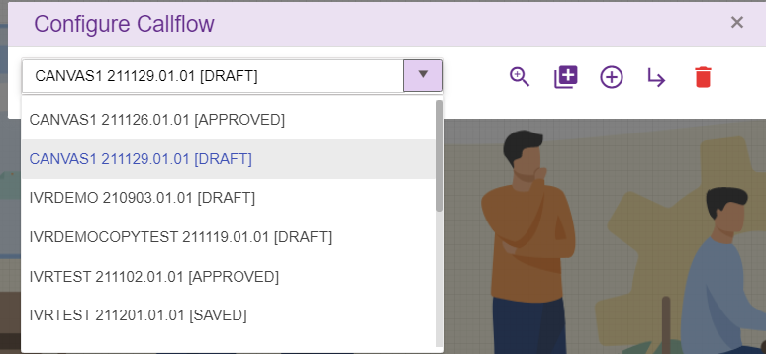

Preview
Select the callflow from callfow list dropdown and click preview icon/button to load callfow data
When user try to load a new callflow on top of existing active callflow, save confirmation popup will be generating as shown below.
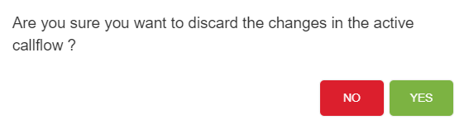
If Yes, Changes done in the active callflow will be discarded and new callflow selected here will be loaded
If No, User can continue with the existing active callflow

New IW Flow
This option is only provided for ‘Maker’. On click of the “₊” button, the below screen will be displayed:
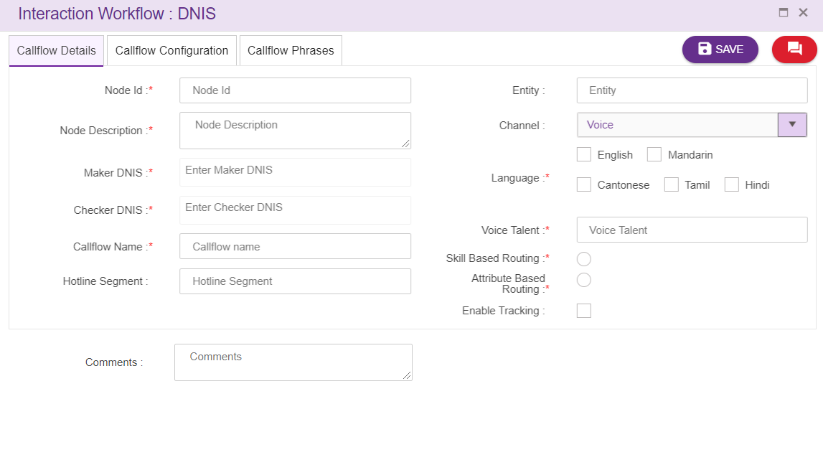
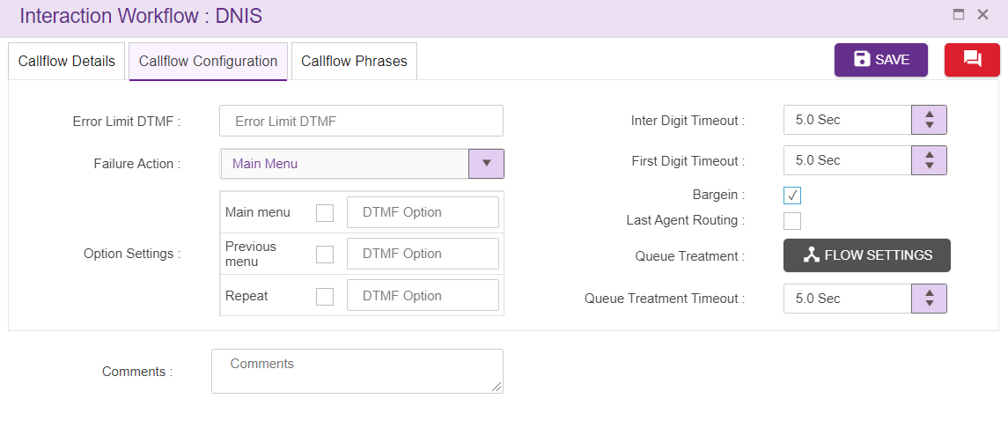
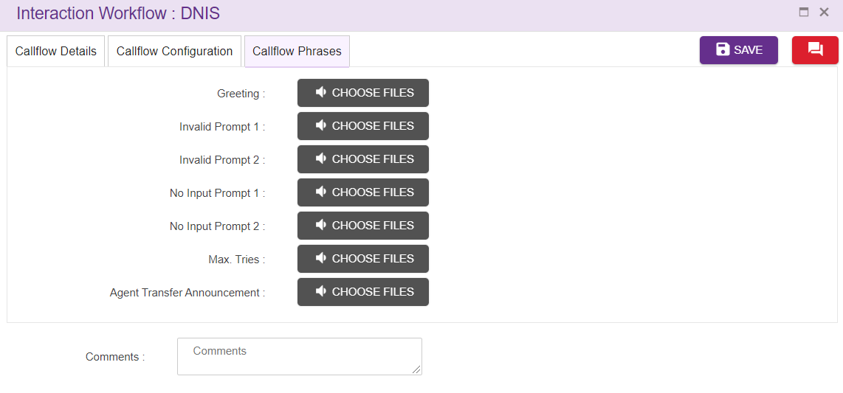
- Node Id: Accepts characters, numbers and special characters too. This option is used to track the announcements played.
- Maker and Checker DNIS: The DNIS should be unique. Type the Maker/ Checker DNIS number and click “Enter” button to apply the DNIS and/or type “,” (comma) to add another DNIS. Maker and Checker DNIS cannot be same.
Note: Enter only numeric values as DNIS (Alphabets and special characters are not allowed)
- Call Flow Name: Name of the Call Flow should be unique.
- Hotline Segment: Hotline segment is added here.
- Greeting Wave File: For selection of wav file for Greeting, click on choose file. (Validation for .wav files only). You can add / update / remove/listen announcement. Please upload the updated file using the same file name as your previous import (otherwise it will create a new file) (refer section Phrase Selection window)
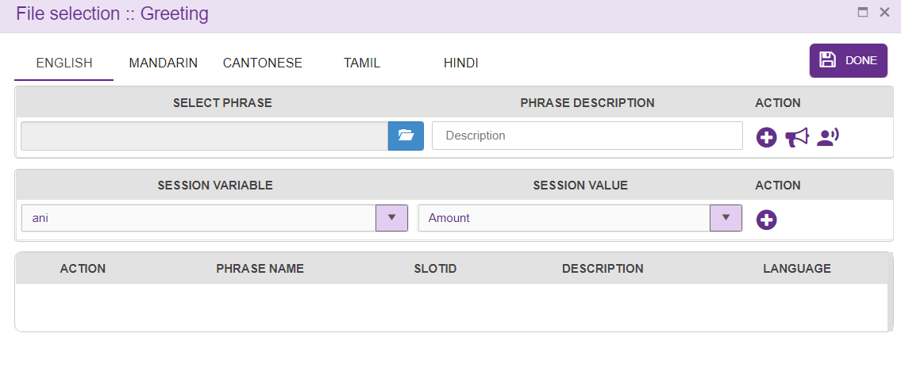
After selecting the file .wav file that has to be uploaded by clicking on “Choose file” button, click on “₊” button present in Action column for saving it.
Phrase file can also be played or deleted.
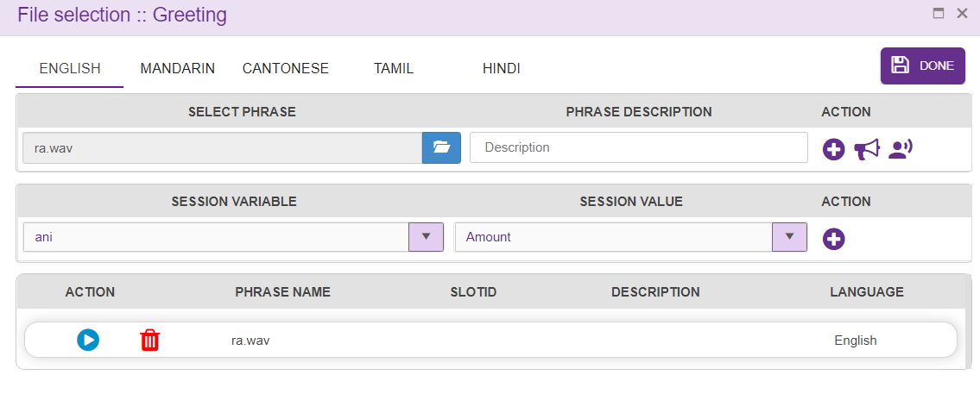
- Voice Talent: This is the folder which holds all the wav files uploaded while creating the callflow. For instance, if you specify Voice Talent as “Wavfolder” then all the wav files will be in the file upload path specified in OCM web config + Language + Wavfolder.
- Entity: This is used for indicating a business group. For example- Consumer, corporate, etc. This can be used by the application for identifying the business group.
- Language: The Language selection in Call flow configuration segment will be auto configured depending upon the languages selected in the DNIS details segment.
- Comment: Providing a comment before saving is not mandatory.
- Channel: Channel of communication for the callflow, “Voice” by default.
- Error Limit DTMF: Maximum attempts allowed in a DTMF in menu
- Failure Action: This field is to specify the action to be taken after exceeded Error Limit DTMF value. It can be transferred to ‘main menu’ or disconnect the call. In order take module ‘failure action’ is transferred to agent, if the caller is failed in order taking.
- Option Settings: we can set different DTMF options for main menu, previous menu and repeat here.
- Bargein: This option allows user to barge before IVR announcement is completely played. This checkbox is checked by default.
- Inter Digit Timeout: This specifies the elapse time to enter second digit after first digit. This field accepts decimal values too.
- First Digit Timeout: This specifies the elapse time to enter first digit. This field accepts decimal values too.
- Invalid Prompt 1 and 2: Allows the caller to upload the .wav files and these wave files are played when there is invalid input from caller. The wave file to be played on invalid prompt event. The Language section in Call flow configuration segment is auto configured depending upon the languages selected in the DNIS details segment. (refer section Phrase Selection window). Phrase uploaded here will be copied to newly added menu and PNC node.
- No Input Prompt 1 and 2: Allows the caller to upload the .wav files and these wave files are played when there is no input from caller. The wave file to be played on no input prompt event. The Language section in Call flow configuration segment is auto configured depending upon the languages selected in the DNIS details segment. (refer section Phrase Selection window). Phrase uploaded here will be copied to newly added menu and PNC node.
- Max Tries: These prompts are played when caller exceeds the Error Limit DTMF value. The wave file to be played when the max tries exceeded. The Language section in Call flow configuration segment is auto configured depending upon the languages selected in the DNIS details segment. (refer section Phrase Selection window). Phrase uploaded here will be copied to newly added menu and PNC node.
- Agent Transfer Announcements: These prompts are played before call transfer to an Agent. The Language section in Call flow configuration segment is auto configured depending upon the languages selected in the DNIS details segment. (refer section Phrase Selection window). Phrase uploaded here will be copied to newly agent node.

While making Call Flow Configurations for Speech IVR, please note the below points:
- Speech Enabled: On checking ‘Speech Enabled’ checkbox, Confidence threshold and Error limit speech will be enabled.
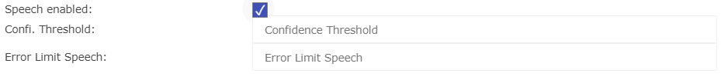

- Confidence Threshold: This is specified in case of speech recognition. The minimum confidence threshold that must be achieved before Analytics can clear validation. The higher the threshold, the more confident you can be in the result. A higher threshold can result in Analytics taking longer to clear validation.
- Error Limit Speech: This is specified in case of speech recognition. Maximum attempts allowed in a speech in menu
- Enable Tracking: When this option is checked, this node is tracked in session dashboard.

New Order Take Flow
Order take is new feature in IW. Only maker can create order take callflow.
On click of the “Order Take” button, the below screen will be displayed:
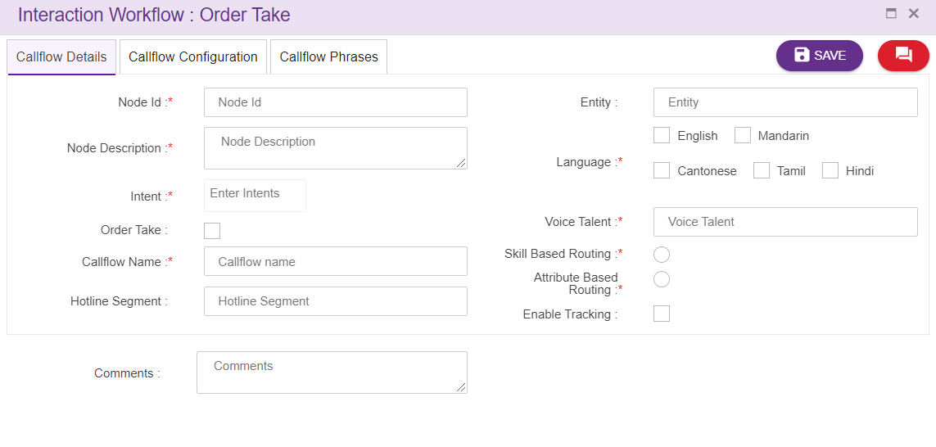
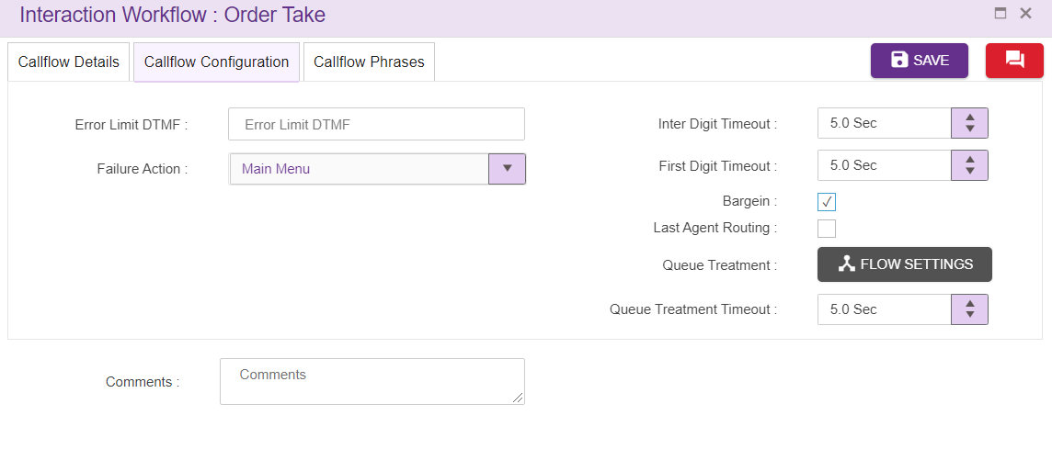
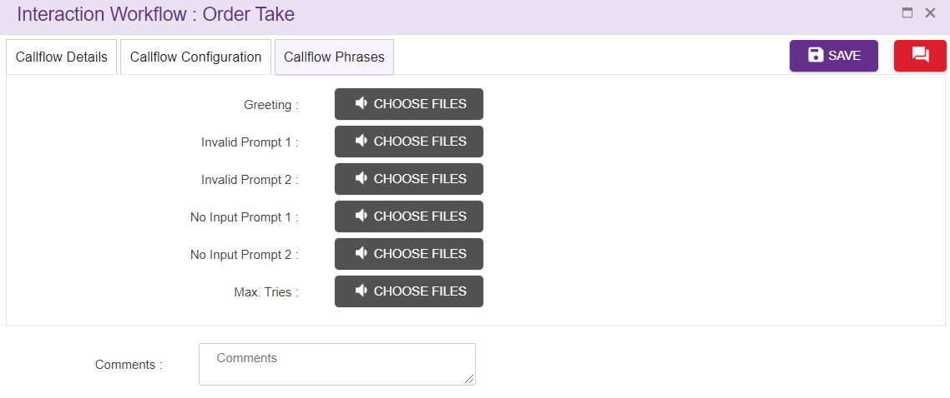
(1) Node Id: This field accepts numbers, characters and special characters too. This is not a mandatory field. This option is used to track the announcements played.
(2) Intent: User can the specify the intent in this field. These intents are mapped to the VDN in the intent master page in IW. If the user is gives intent which is not mapped to VDN in intent master, it becomes invalid flow. User can also add the intents in ‘intent master’ and map to the VDN.
(3) Order take: This check box is used to enable and disable the order take flow from Interaction workflow. This check box is available in start node of every workflow. When the user unchecks, the order take check box call flow becomes normal flow that is there will be no order take flow available for the particular intent.
(4) Call flow name: This field uniquely represents the call flow. Call flow is mandatory field in the configuration
(5) Greeting Wave files: Greeting wave files are the introductory audio file to be played when the call is connected. (refer section Phrase selection window)
(6) Voice Talent: This is the folder which holds all the wav files uploaded while creating the callflow. For instance, if you specify Voice Talent as “Wavfolder” then all the wav files will be in the file upload path specified in OCM web config + Language + Wavfolder. Below figure shows the configuration in web.config (Mandatory).
User given folder name is does not exist IW will create new file to hold wave files.
(7) Entity: Entity is group or business group name to categorize the call flow
(8) Hotline Segment: Indicates the different section in the organization example Mass, Wealth. Is mainly used for IVR reference.
(9) Language: Language menu is an option to get the list of language from the start node. These languages can be provided in language selection menu to proceed with the caller specific language.
(10) Comments: User can set add suitable comments regarding to the node and configuration in this field.
(11) Error Limit DTMF: These field indicates the maximum number error tries caller is allowed to enter. In the above screenshot error limit DTMF value is 3 which indicates that caller is only allowed to enter 3 error entries.
(12) Failure Action: This field is to specify the action to be taken after exceeded Error Limit DTMF value. It can be transferred to ‘main menu’ or disconnect the call. In order take module ‘failure action’ is transferred to agent, if the caller is failed in order taking.
(13) Bargein: This option allows user to barge before IVR announcement is completely played. This checkbox is checked by default.
(14) Inter Digit Timeout: This specifies the elapse time to enter second digit after first digit. This field accepts decimal values too.
(15) First Digit Timeout: This specifies the elapse time to enter first digit. This field accepts decimal values too.
(16) Invalid Prompt 1 and 2: Allows the caller to upload the .wav files and these wave files are played when there is invalid input from caller. The wave file to be played on invalid prompt event. The Language section in Call flow configuration segment is auto configured depending upon the languages selected in the DNIS details segment. (refer section Phrase Selection window). Phrase uploaded here will be copied to newly added menu and PNC node.
(17) No Input Prompt 1 and 2: Allows the caller to upload the .wav files and these wave files are played when there is no input from caller. The wave file to be played on no input prompt event. The Language section in Call flow configuration segment is auto configured depending upon the languages selected in the DNIS details segment. (refer section Phrase Selection window). Phrase uploaded here will be copied to newly added menu and PNC node.
(18) Max Tries: These prompts are played when caller exceeds the Error Limit DTMF value. The wave file to be played when the max tries exceeded. The Language section in Call flow configuration segment is auto configured depending upon the languages selected in the DNIS details segment. (refer section Phrase Selection window). Phrase uploaded here will be copied to newly added menu and PNC node.
(19) Enable Tracking: When this option is checked, this node is tracked in session dashboard.

Sub Flow
Sub Flow icon is used to create new sub flow which can be used by main call flows and other sub flows. User can create the commonly used modules in a separate flow and can call from main flow. There is no dnis node in this subflow.
On clicking this subflow icon, empty page should open as shown below.
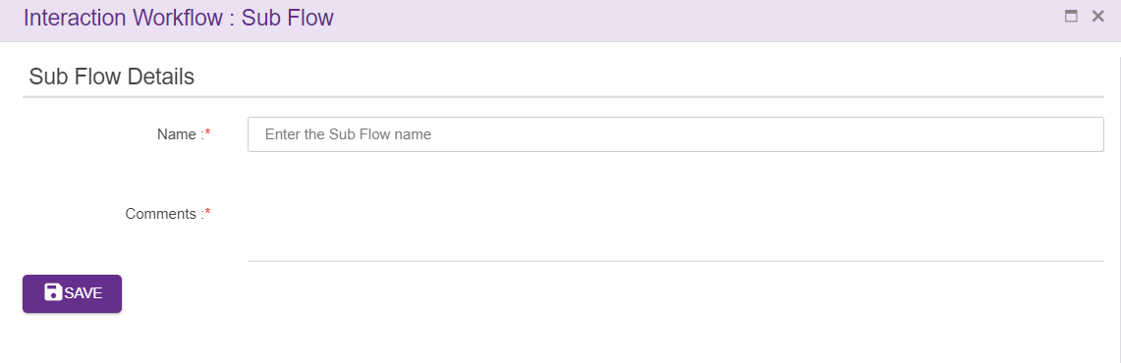
Name: Name of the Sub Flow can be added here. Sub flow name must be unique and should not accept any special characters

Comments: After entering all the details as mentioned above click on save button. Upon clicking on save button, empty page will be displayed as shown below, where user can create the callflow by dragging the nodes present in toolbox.
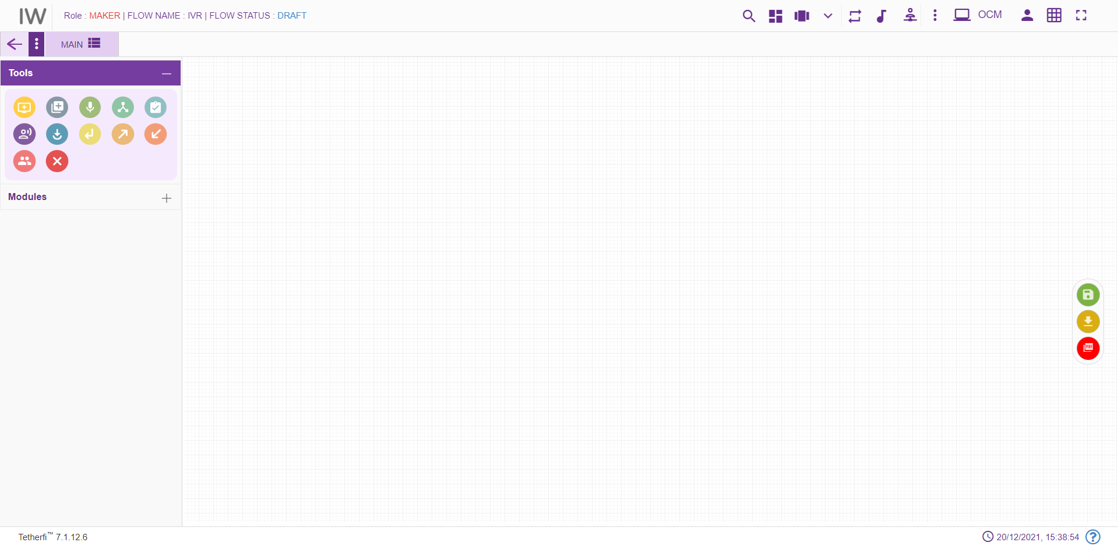
User can create the sub flow here by dragging and dropping available nodes from toolbox. The nodes used in the subflow has override configuration option which will override the calling flow configuration in subflow.
To jump to the sub flow, flow connector node must be used. To jump back to the main flow (where subflow is being called) from sub flow, return node can be used Multiple main callflows can be connected to single subflow and all the feature as that of main flow is provided to subflow

5.1.6 Delete
Delete option will appear only when callflow is in DRAFT and SAVED status. Selected callflow from the drop down in ‘Callflow List’ in Maker page.
Note that only owner of the callflow can delete his callflow in DRAFT and SAVED status

Phrase Selection Window
Upon clicking ‘CHOOSE FILES’ button in any node, file selection grid will be displayed.
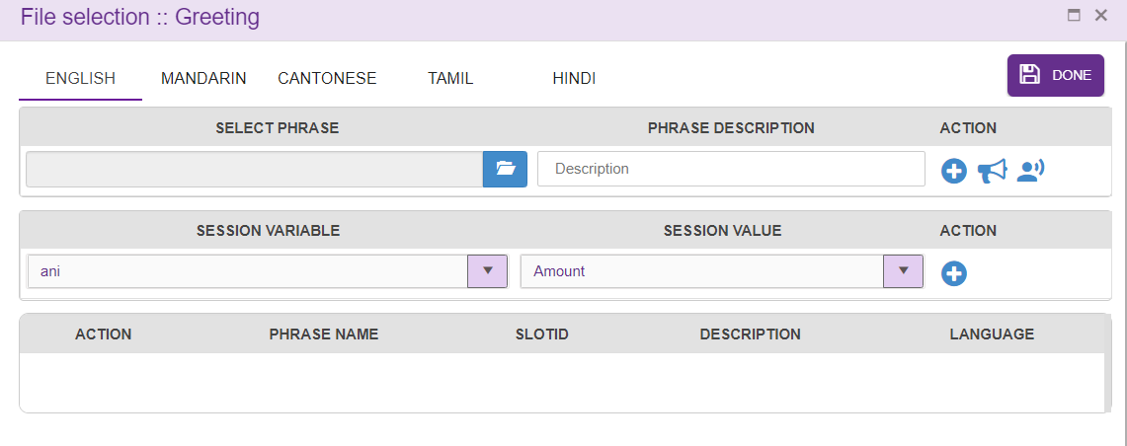
User can click on the file icon and click on ‘+’ icon present in Action field and upload the wav files to be played. Upon clicking ‘+’ button, selected wav file will be added in the grid below. User can also provide description about the phrases while adding them.
Note that user must click on ‘+’ button after selecting the wav file to add the phrases to the grid provided below. If the phrase is already added to the grid, then confirmation message will be displayed as shown below.
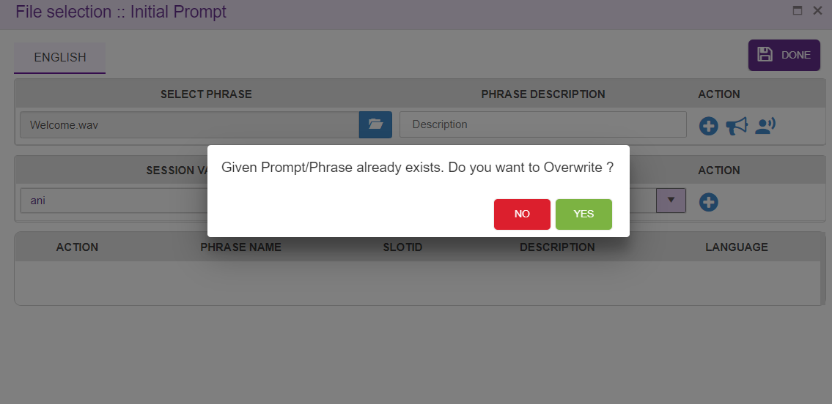
Upon clicking ‘Yes’, phrase will be successfully added to the grid.
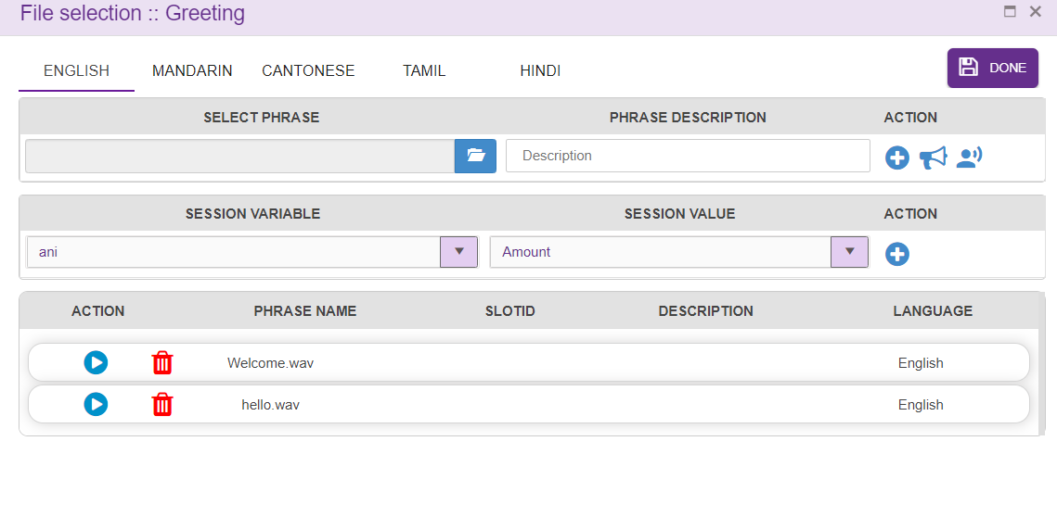
Wav files are uploaded in Greeting field will be played when the control comes to the node for the first time.
Wav file uploaded to the Invalid Prompt 1 will be played when user enters invalid input for the first time. Wav file uploaded to the Invalid Prompt 2 will be played when user enters invalid input for the second time. Wav file uploaded to the No Input Prompt 1 will be played when user does not enter any value for the first time. If user does not enter any value after playing No Input prompt 1, wav files uploaded to No Input prompt 2 will be played.
Wav file uploaded to Max Tries will be played when user exceeds maximum try limits, which is set in ‘Error Limit DTMF’ field in DNIS node. Wav file uploaded to Agent Transfer Announcement field will be played when call transfer to an Agent.
Time limit to collect the input from the user is set in first digit timeout and inter digit time out field.
Wav files added to the node need not be unique. User can add same wav file again to the node. All the wav files added to the callflow are displayed in phrase grid (refer section Phrase Selection Window). Session variables can also be added to the node as shown below.
Phrase file can also be played or deleted.
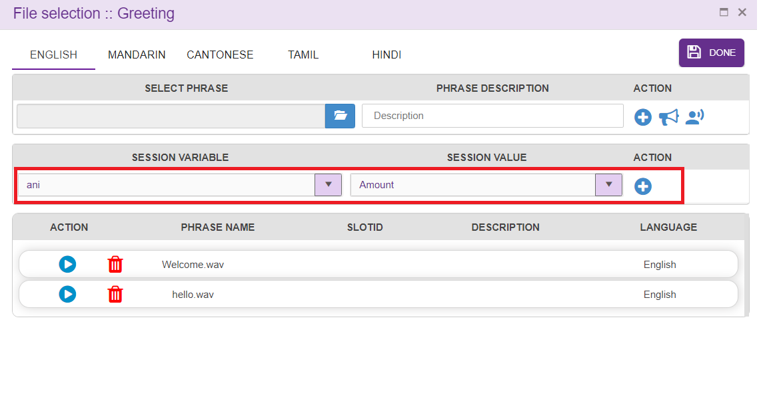
Session variables and operational variables are displayed in the drop down. User can add these session variables like adding wav files. These session variables are taken from PNC node.
User can shuffle phrase and variable list added to the grid.

Wav files
Wav files uploaded to the nodes should not have special characters except Underscore. Wav file name starting with underscore is also treated as invalid file.
Error message is generated when user try to upload invalid wav file to any node.
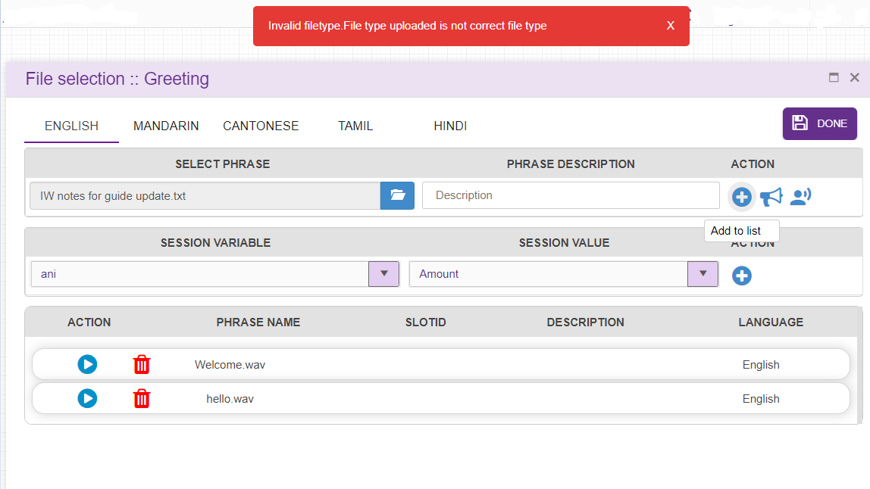

Designing the Workflow
After successfully saving the DNIS Details, you can create/ edit the workflow depending on your requirement. 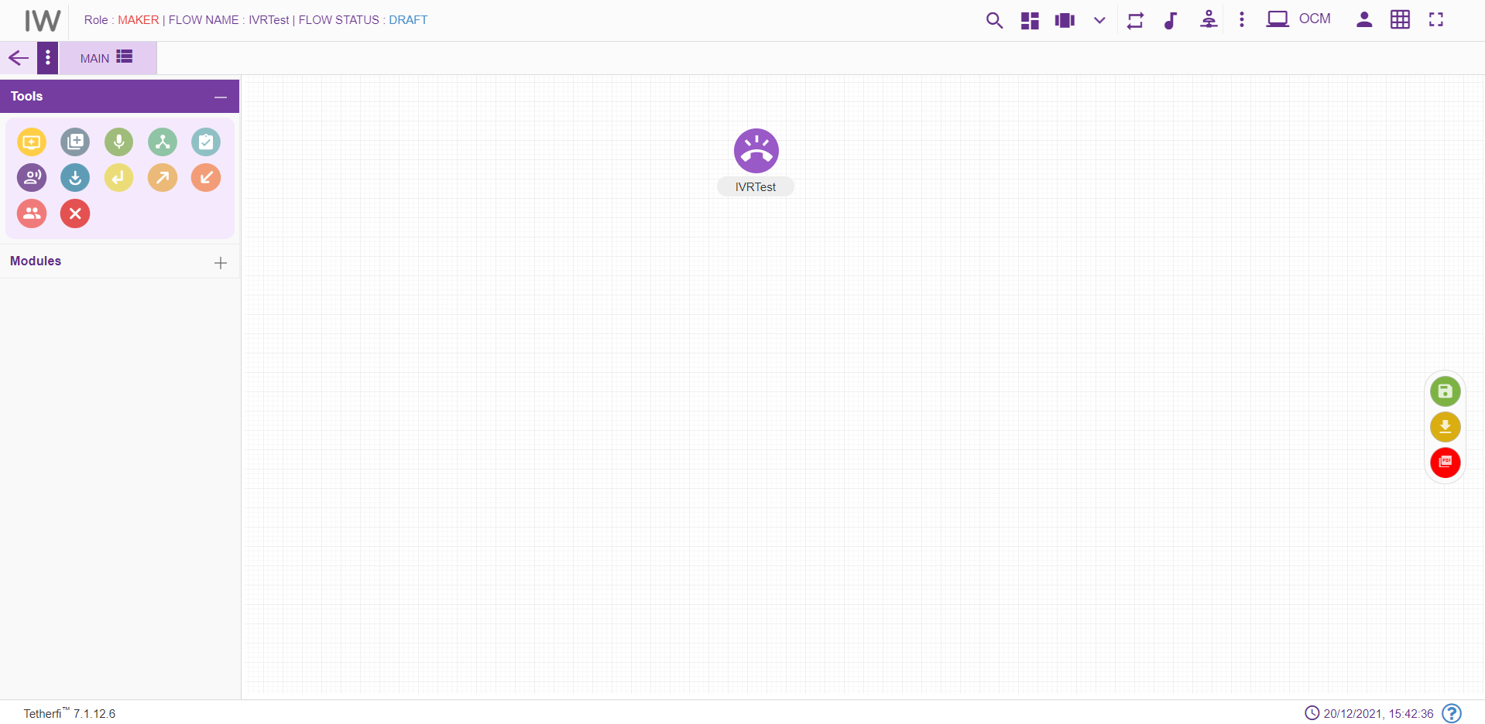

Tabs
The new Workflow will have the TAB functionalities. It would help to break the bigger call flows into multiple tabs. User can add the tabs only when the callflow is in ‘Draft’ status.
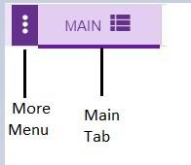
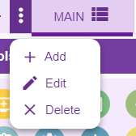
The above shown toolbar has the following functionalities:
- Main button can be used for navigating back to the Main tab.
- Add new tab button can be used when there is a need to create a new section of workflow by adding a new tab.
- Edit tab button can be used for making changes to the selected tab of workflow
- Remove tab button can be used for deleting the selected tab of workflow
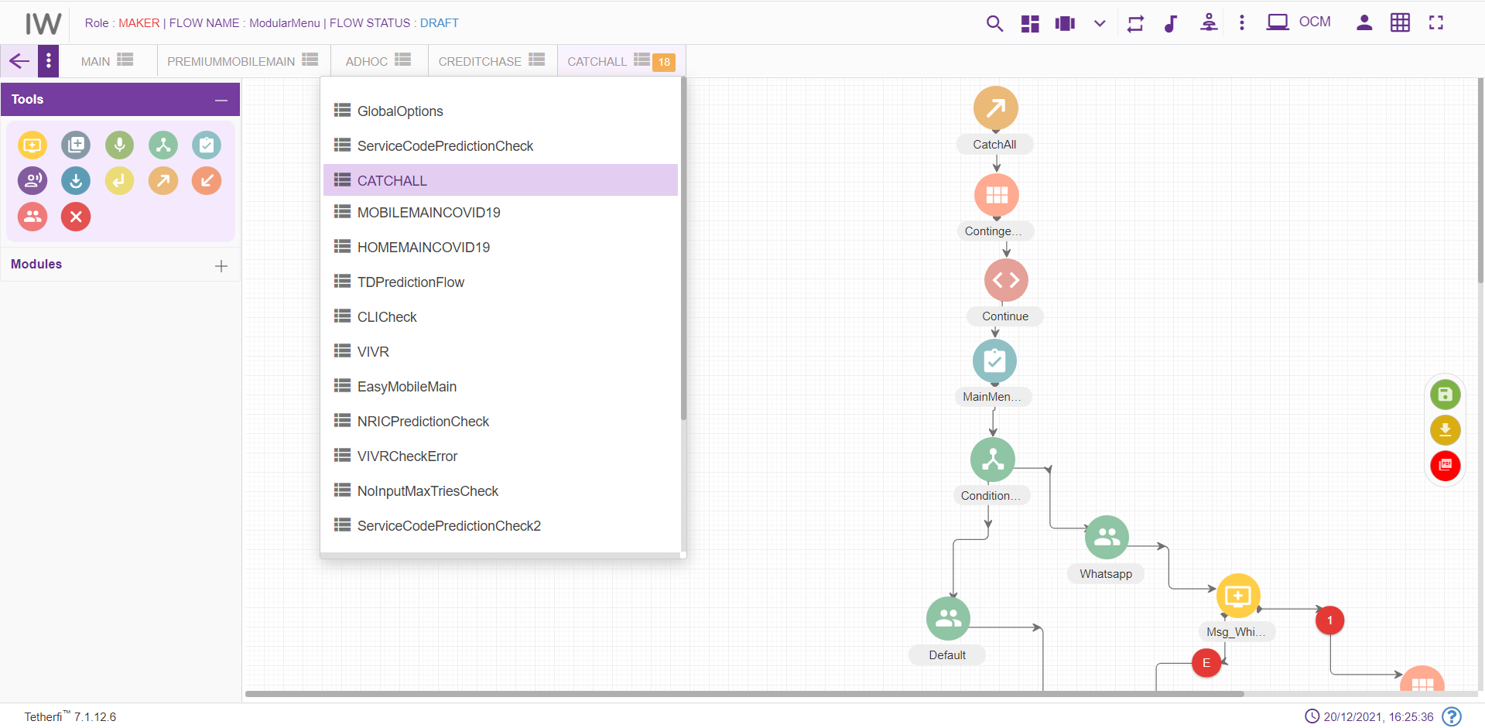
When a tab is selected from the dropdown, its name will be displayed at the top as shown above and Configured number of Tab are set in horizontal and all other tabs should be displayed in drop down list.

Add New Tab
This button is shown when the callflow is in ‘Draft’ status. When clicked on ‘Add new Tab’ button Tab pop window is generated
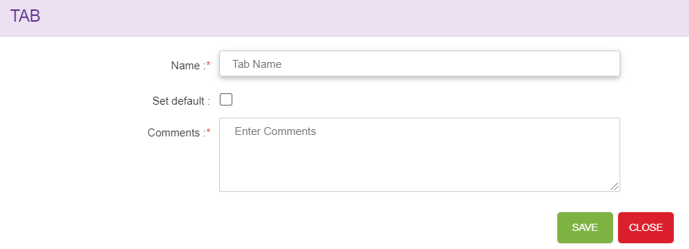
    - Name: Name of Tabs should be unique.
    - Set default: Checkbox is used to set the Tab as default Tab, whenever user views the callflow default tab is shown, only one tab can be set as default. ‘MAIN’ tab will be set as default for the first time. When a new tab is set as default, previous tab set option will be cleared i.e. latest entry will be updated.
    - Comments: User can set add suitable comments regarding to the Tab.
Save: Upon clicking ‘Save’ button, Tab entries must be saved.
Close: Upon clicking ‘Close’ button, Tab pop window must be closed.
When new tab is added to the callflow, newly created tab should be open by-default upon clicking ‘Yes’ as shown below.
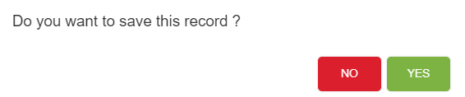

Edit Tab
Upon clicking the ‘Edit selected tab’ button to make changes to the selected tab, Tab pop window is open.
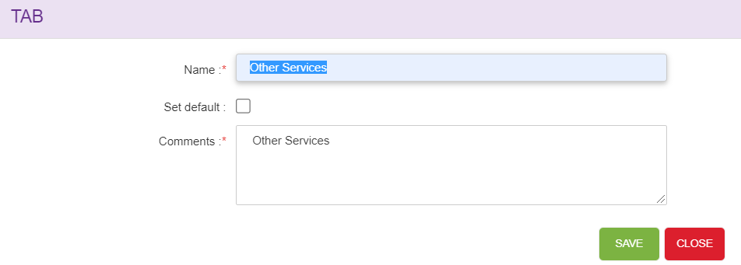
- Name: Edit the new tab name.
- Set default: Checkbox is used to set the Tab as default Tab, whenever user views the callflow default tab is shown. ‘MAIN’ tab will be set as default for the first time. When a new tab is set as default, previous tab set option will be cleared i.e. latest entry will be updated.
- Comments: User can set edit the suitable comments regarding to the Tab.
Save: Upon clicking ‘Save’ button, Tab entries must be saved.
Close: Upon clicking ‘Close’ button, Tab pop window must be closed.

Delete/Remove Tab
Upon clicking on ‘Remove Selected tab’ confirmation pop window must generate.
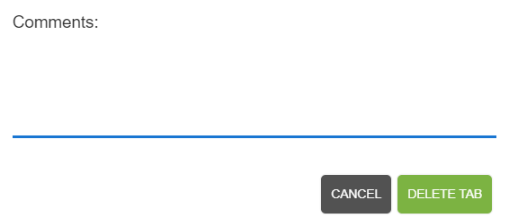
Delete Tab button: Upon clicking ‘Delete Tab’, tab will be successfully deleted.
Cancel button: Upon clicking ‘Cancel’, delete tab window will closed.
Default tabs cannot be deleted. Error message will be shown when try to delete default tab.

Copy Tab
Tab contents can be copied from one callflow to another callflow or other tabs within same callflow using Ctrl +C and Ctrl+V options (other than IE browsers).
Upon copying the tab contents using Ctrl+C option, confirmation popup will generate. Note that user can copy the tab contents of a callflow at any callflow status.
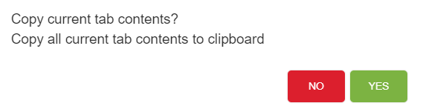
Upon successfully copying tab contents, success message will generate.
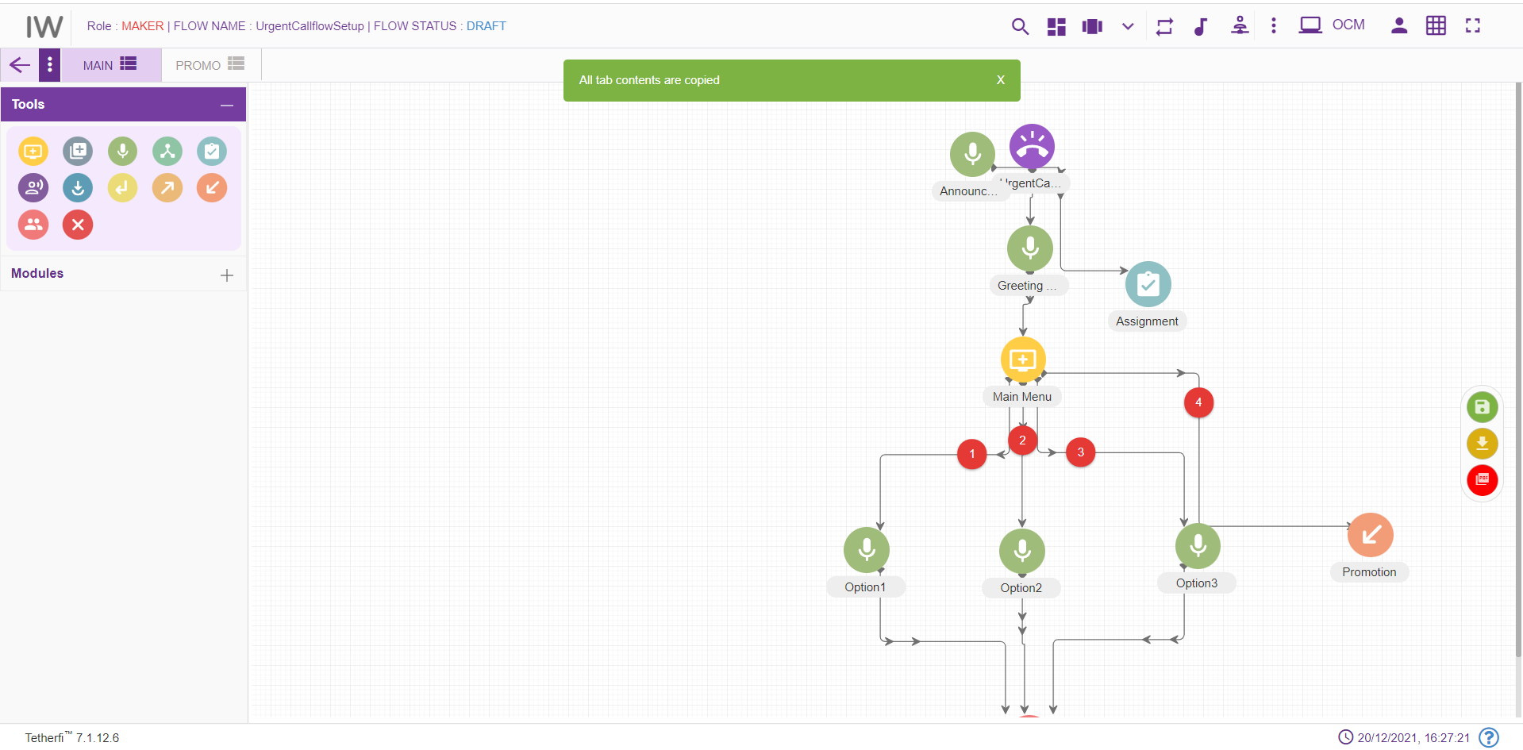
Ctrl+V option is used to paste the tab contents copied. Upon pasting the tab contents using Ctrl+V option, following confirmation popup will generate.
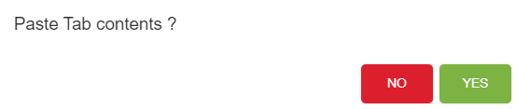
Upon clicking “Yes”, copied contents will be pasted to the respected tabs.
Note that user can paste the tab contents only in DRAFT callflow status. Copy tab feature not only copies the structure but also copies phrases, rules and other related information set for each node.
User cannot copy-paste the tab which has DNIS node. Upon pasting the tab contents which has DNIS node, ‘dnis node already exists in this callflow. cannot copy-paste data’ error message will generate.
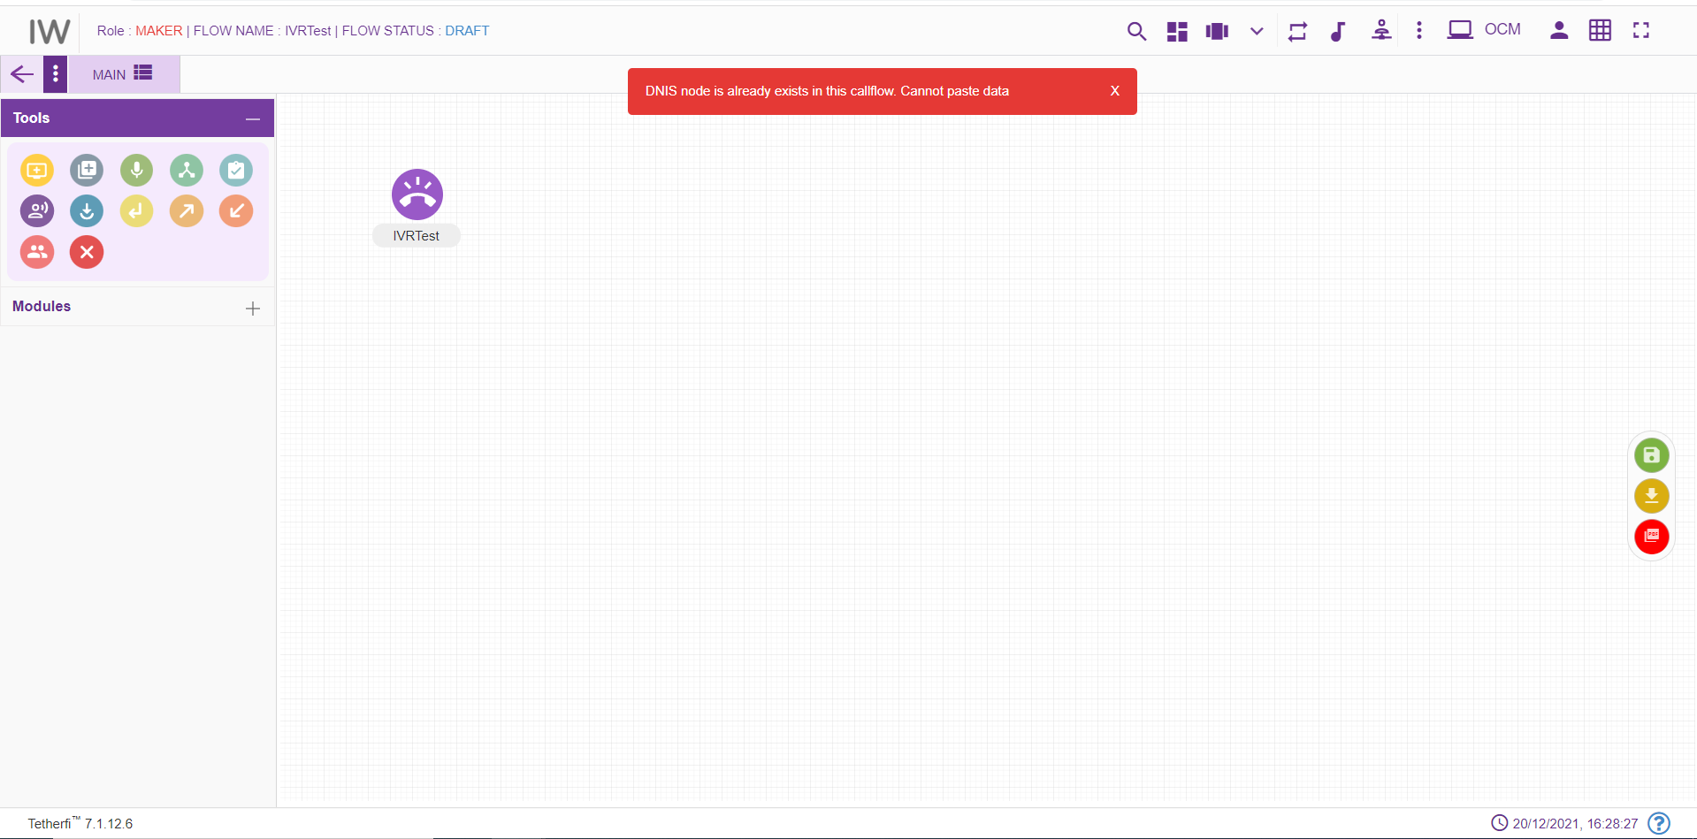

Tab Shuffling
User can move/shuffle the tabs present in the callflow. User can shuffle only the tabs present in drop down as shown below.
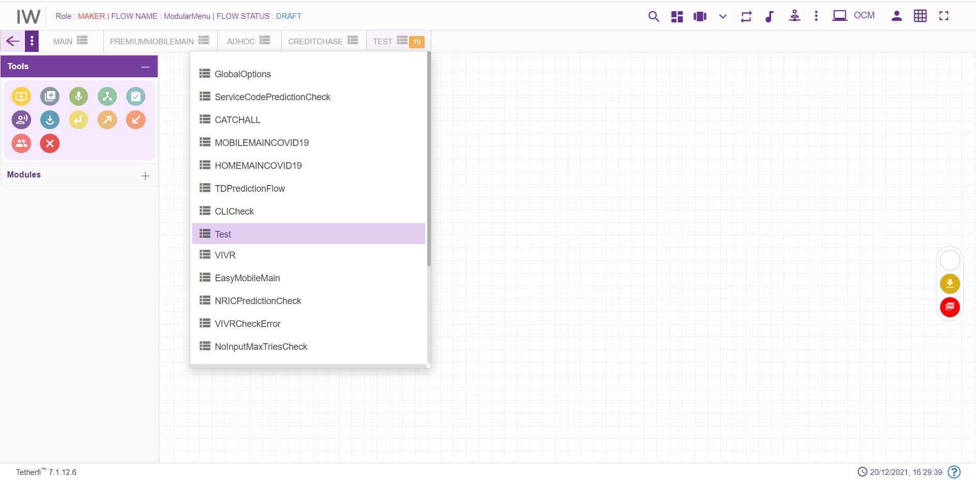
The new tab added after shuffling the tabs present in the drop down, will be added at the beginning of the drop down as shown above.

More Menu Option
Upon clicking more menu option, present at top right and left corner at different status of the callflow, following options will appear. refer section Flow Status:
When user loads his own callflow:
User Permission |  | Callflow Status | More Menu(left) | More Menu(right)
Maker | Draft |  | 1.Callflow Version Control  2.Import Callflow  3.Copy Callflow  4.Text to Voice | Save callflow
Maker | Saved |  | 1.Import Callflow  2.Copy Callflow  3.Text to Voice | 1.Send to approval  2.Edit callflow
Maker | Send to Approval |  | 1.Import Callflow  2.Copy Callflow  3.Text to Voice | No options
Maker | Checker Draft |  | 1.Import Callflow  2.Copy Callflow  3.Text to Voice | No options
Maker | Checker Saved |  | 1.Import Callflow  2.Copy Callflow  3.Text to Voice | No options
Maker | Approved |  | 1.Import Callflow  2.Copy Callflow  3.Text to Voice | Edit callflow
Maker | Scheduled |  | 1.Import Callflow  2.Copy Callflow  3.Text to Voice | No options
Maker | Rejected |  | 1.Import Callflow  2.Copy Callflow  3.Text to Voice | Edit callflow
Checker | Send to Approval |  |  | 1.Reject  2.Approve  3.Edit
Checker | Checker Draft |  |  | Save Callflow
Checker | Checker Saved |  |  | 1.Reject Callflow  2.Approve Callflow  3.Edit Callflow
Checker | Approved |  |  | No options
Checker | Rejected |  |  | No options
Checker | Scheduled |  |  | Approve Callflow
Previewer | Draft |  |  | No options
Previewer | Saved |  |  | No options
Previewer | Send to Approval |  |  | No options
Previewer | Checker Draft |  |  | No options
Previewer | Checker Saved |  |  | No options
Previewer | Approved |  |  | No options
Previewer | Rejected |  |  | No options
Previewer | Scheduled |  |  | No options

When user loads some other user’s callflow:
User Permission | Callflow Status | More Menu(left) | More Menu(right)
Maker | Draft | 1.Import Callflow  2.Copy Callflow  3. Text to Voice | Save callflow
Maker | Saved | 1.Import Callflow  2.Copy Callflow  3.Text to Voice | 1.Send to approval  2.Edit callflow
Maker | Send to Approval | 1.Import Callflow  2.Copy Callflow  3.Text to Voice | No options
Maker | Checker Draft | 1.Import Callflow  2.Copy Callflow  3.Text to Voice | No options
Maker | Checker Saved | 1.Import Callflow  2.Copy Callflow  3.Text to Voice | No options
Maker | Approved | 1.Import Callflow  2.Copy Callflow  3.Text to Voice | Edit callflow
Maker | Scheduled | 1.Import Callflow  2.Copy Callflow  3.Text to Voice | No options
Maker | Rejected | 1.Import Callflow  2.Copy Callflow  3.Text to Voice | Edit callflow
Checker | Send to Approval |  | 1.Reject  2.Approve  3.Edit
Checker | Checker Draft |  | Save Callflow
Checker | Checker Saved |  | 1.Reject Callflow  2.Approve Callflow  3.Edit Callflow
Checker | Approved |  | No options appear
Checker | Rejected |  | No options appear
Checker | Scheduled |  | Approve Callflow

When user with Maker-Checker role loads his own callflow:

User Permission |  | Callflow Status |  | More Menu(left) |  | More Menu(right)
Maker-Checker | Draft |  | 1.Callflow version control  2.Import Callflow  3.Copy Callflow  4.Text to Voice |  | Save callflow
Maker-Checker | Saved |  | 1.Import Callflow  2.Copy Callflow  3.Text to Voice |  | 1.Send to approval  2.Edit callflow
Maker-Checker | Send to Approval |  | 1.Import Callflow  2.Copy Callflow  3.Text to Voice |  | 1.Reject  2.Approve  3.Edit
Maker-Checker | Checker Draft |  | 1.Import Callflow  2.Copy Callflow  3.Text to Voice |  | Save
Maker-Checker | Checker Saved |  | 1.Import Callflow  2.Copy Callflow  3.Text to Voice |  | 1.Reject  2.Approve  3.Edit
Maker-Checker | Approved |  | 1.Import Callflow  2.Copy Callflow  3.Text to Voice |  | Edit callflow
Maker-Checker | Scheduled |  | 1.Import Callflow  2.Copy Callflow  3.Text to Voice |  | Approved
Maker-Checker | Rejected |  | 1.Import Callflow  2.Copy Callflow  3.Text to Voice |  | Edit callflow

When user with Maker-Checker role loads some other User’s callflow:

User Permission |  | Callflow Status |  | More Menu(left) |  | More Menu(right)
Maker-Checker | Draft |  | 1.Import Callflow  2.Copy Callflow  3.Text to Voice |  | Save callflow
Maker-Checker | Saved |  | 1.Import Callflow  2.Copy Callflow  3.Text to Voice |  | 1.Send to approval  2.Edit callflow
Maker-Checker | Send to Approval |  | 1.Import Callflow  2.Copy Callflow  3.Text to Voice |  | 1.Reject  2.Approve  3.Edit
Maker-Checker | Checker Draft |  | 1.Import Callflow  2.Copy Callflow  3.Text to Voice |  | Save
Maker-Checker | Checker Saved |  | 1.Import Callflow  2.Copy Callflow  3.Text to Voice |  | 1.Reject  2.Approve  3.Edit
Maker-Checker | Approved |  | 1.Import Callflow  2.Copy Callflow  3.Text to Voice |  | Edit callflow
Maker-Checker | Scheduled |  | 1.Import Callflow  2.Copy Callflow  3.Text to Voice |  | Approved
Maker-Checker | Rejected |  | 1.Import Callflow  2.Copy Callflow  3.Text to Voice |  | Edit callflow

Set Rules
User can set the rules in Conditional, Announcement, menu node. ‘Set Rule’ icon will be displayed in these nodes to set the rules as shown below.
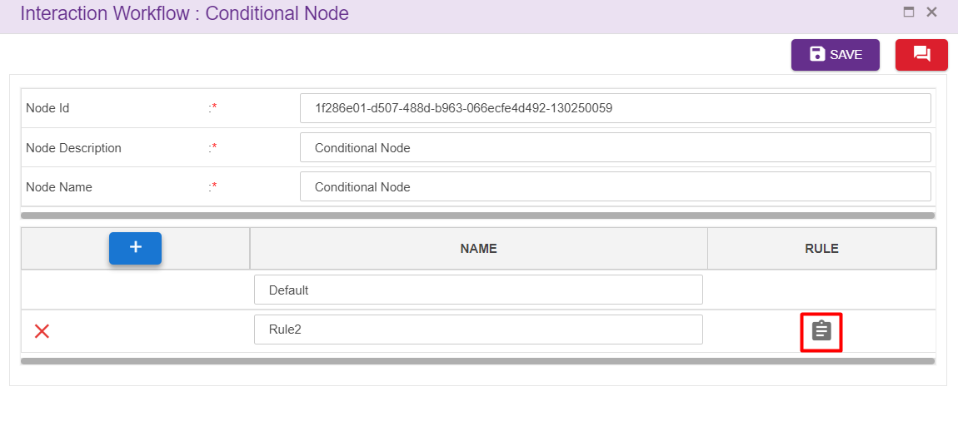
Upon clicking set rules icon following window will popup.
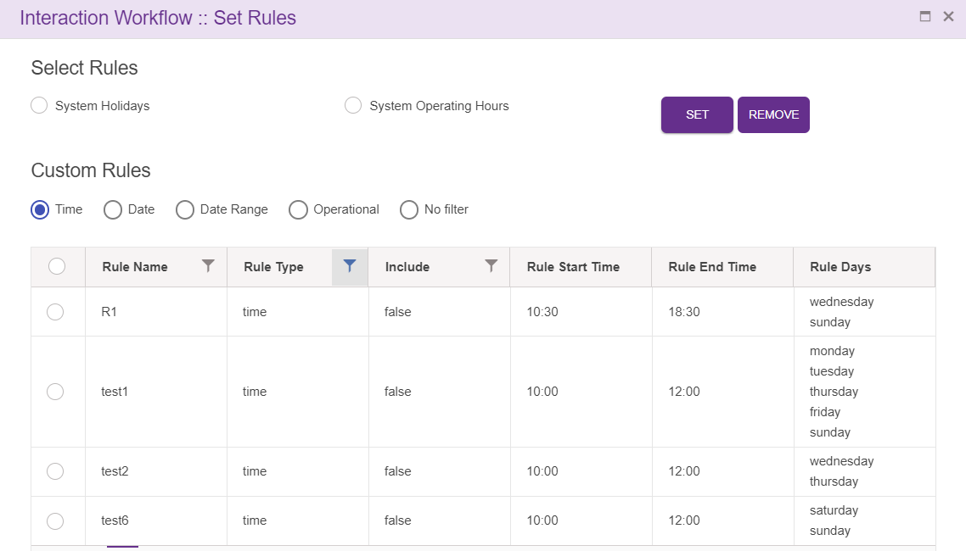
Rules added at ‘Rule Master’ will be displayed here. User can set these rules for the nodes.
Upon clicking ‘SET’ after selecting the rules, following confirmation popup will generate.
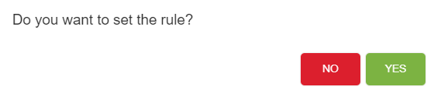
Upon clicking ‘YES’, rule will be successfully set to the nodes.
User can set the rules for the nodes which are connected to menu and PNC node as shown below. Upon hovering on menu/PNC node, name of the nodes connected to them will be displayed along with the options set.
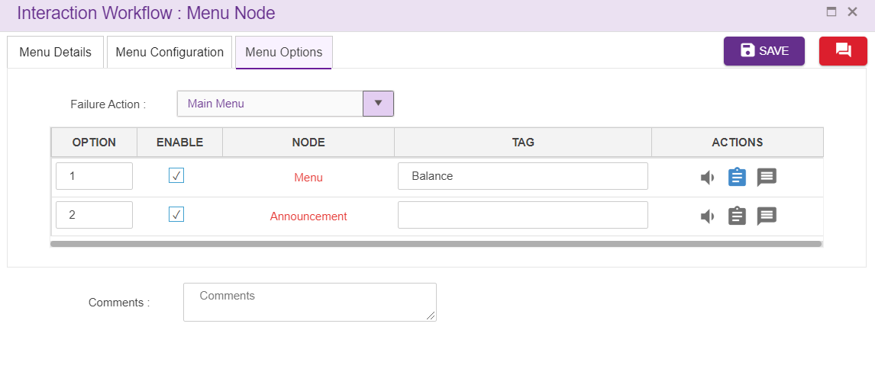

Callflow Sync Notification
While saving a callflow, adding phrases,adding/editing intents, adding/editing rules, adding global phrase, adding/editing global configuration if the interpreter is down, data will not reflected in IVR. At those situation ‘Calllow sync notification’ icon will appear in UI as shown below.
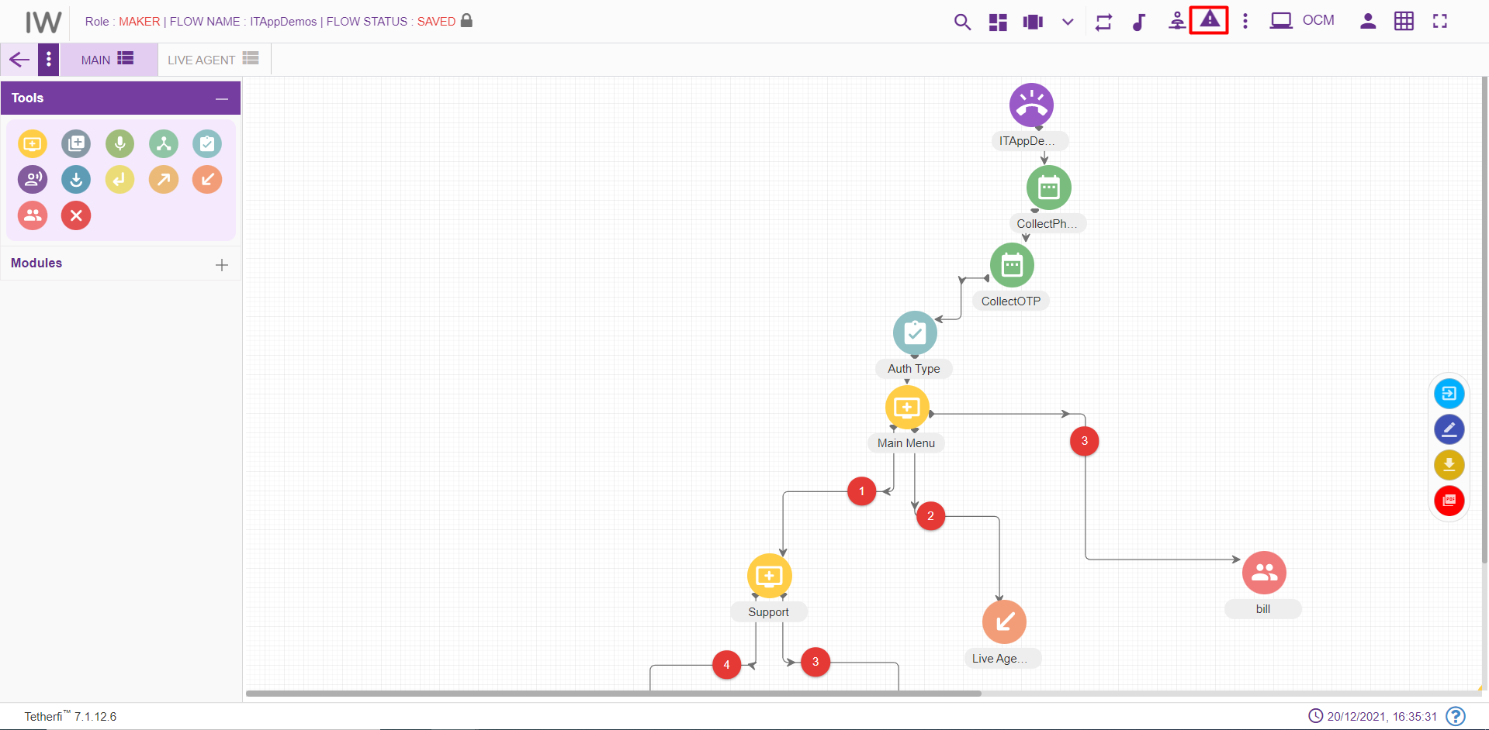
In this situation user can upload these files to interpreter once it is up, by clicking ‘Resubmit’ button. ’Clear’ option is also provided here to remove the notification.
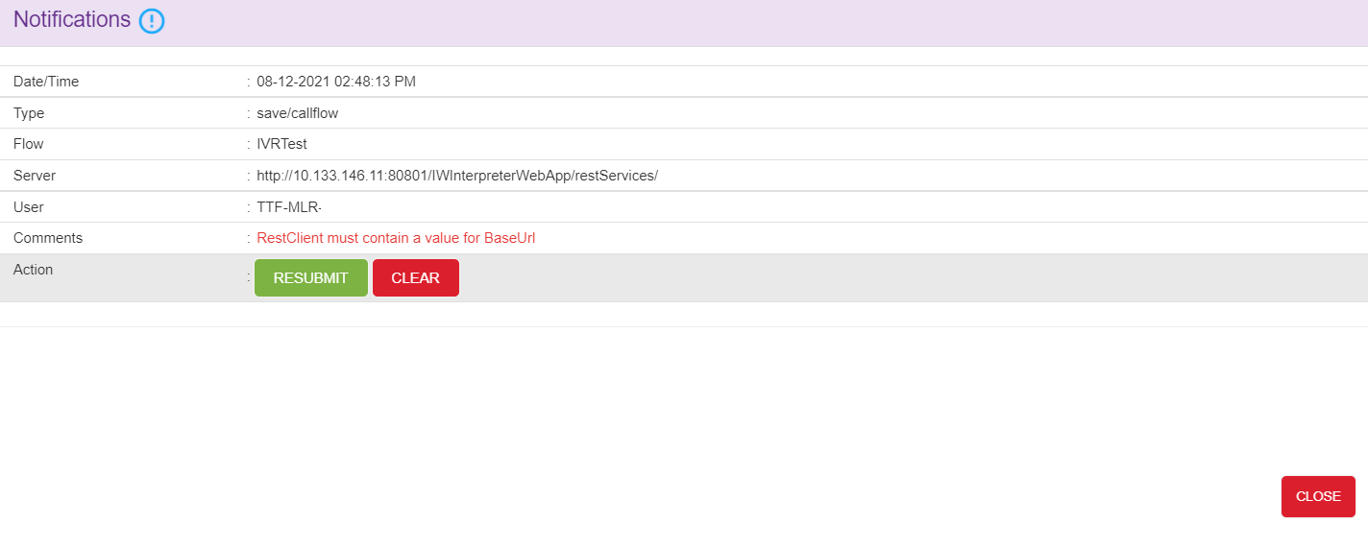
Sync notification icon also displayed in landing page if the interpreter was down while updating intent master rule master, global configuration, global phrases. User can resubmit the data to interpreter from landing page too. Callflow specific resubmit sync notification will appear only after loading the callflow in UI.
Intent master and rule master sync notification
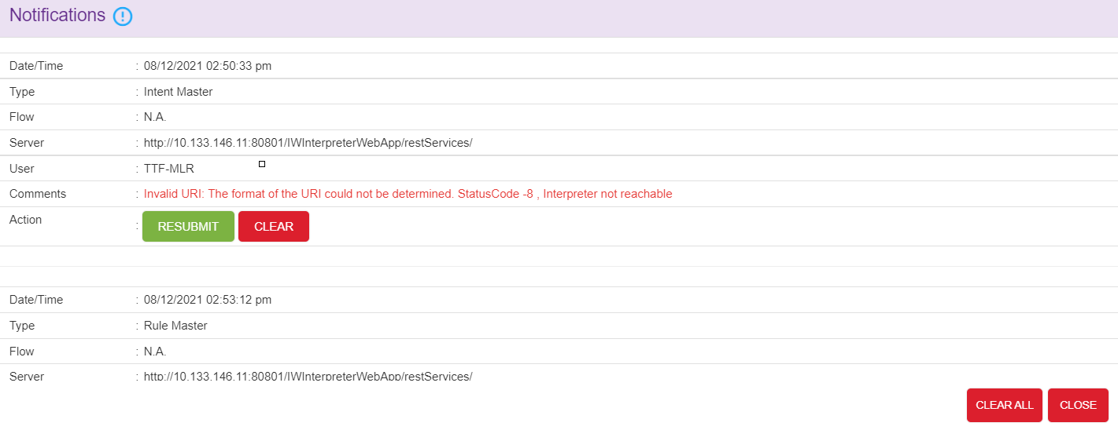
Global configuration and global phrase sync notification is shown below:
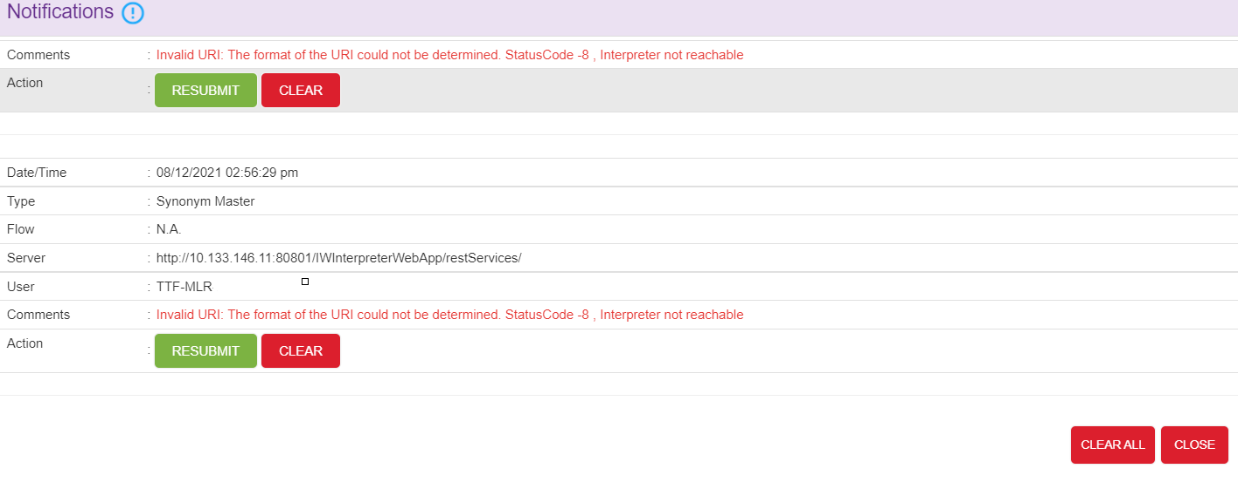
Interpreter phrase and grammar phrase sync notification is shown below:
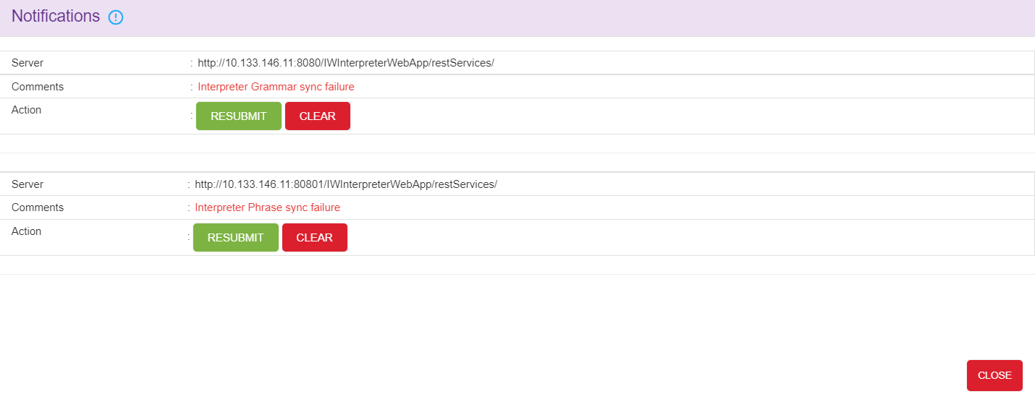

Save callflow and synonym sync notification is shown below:
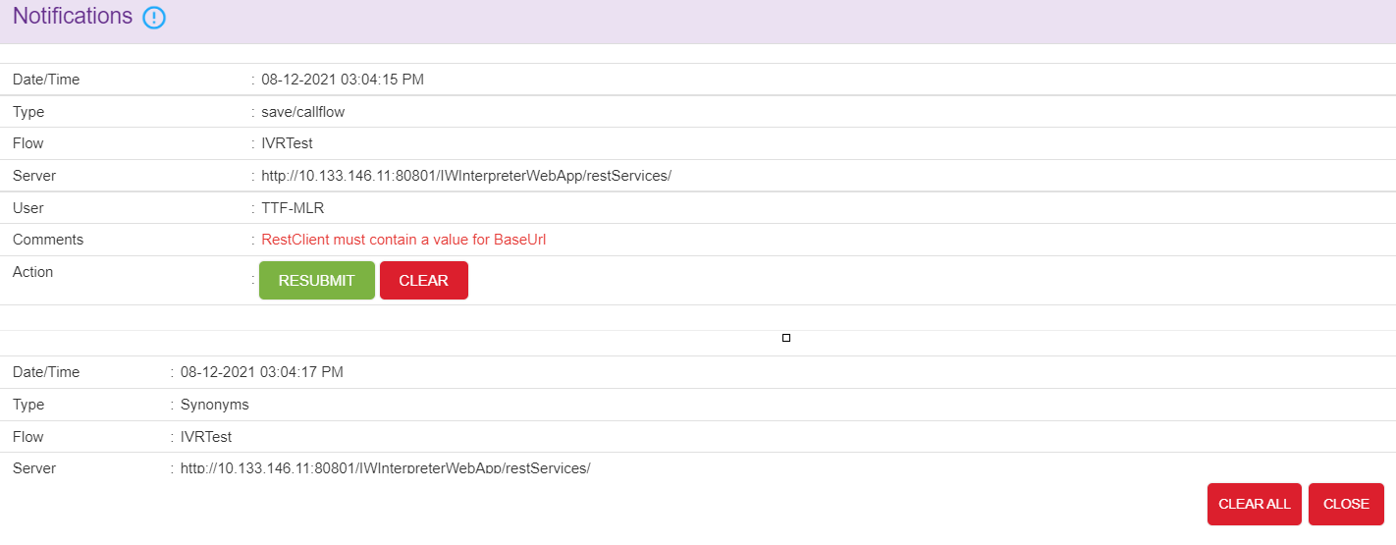
Note: This option will appear in UI, only when interpreter is down. ‘CLEAR ALL’ option is provided to remove all the notification.
Following error message will be generating while uploading the phrases if the interpreter is down. In such case, user can upload these phrases to interpreter once it is up, by clicking ‘Resubmit’ button. ’Clear’ option is also provided here to remove the notification.
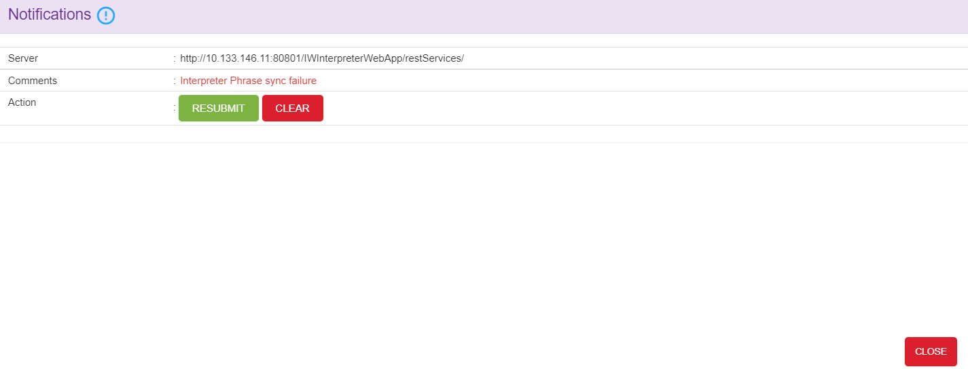

Nodes and Modules

Nodes
Nodes are often arranged into tree structures. These structures are binary trees.
A node represents the information contained in a single structure. These nodes may contain a value or condition, or possibly serve as another independent data structure. There are nine types of nodes in Interaction Workflow:
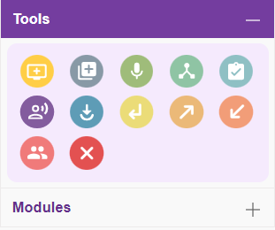

Menu Node
For adding a new Menu to the callflow, click on the “Menu” icon and drag it to the main screen.
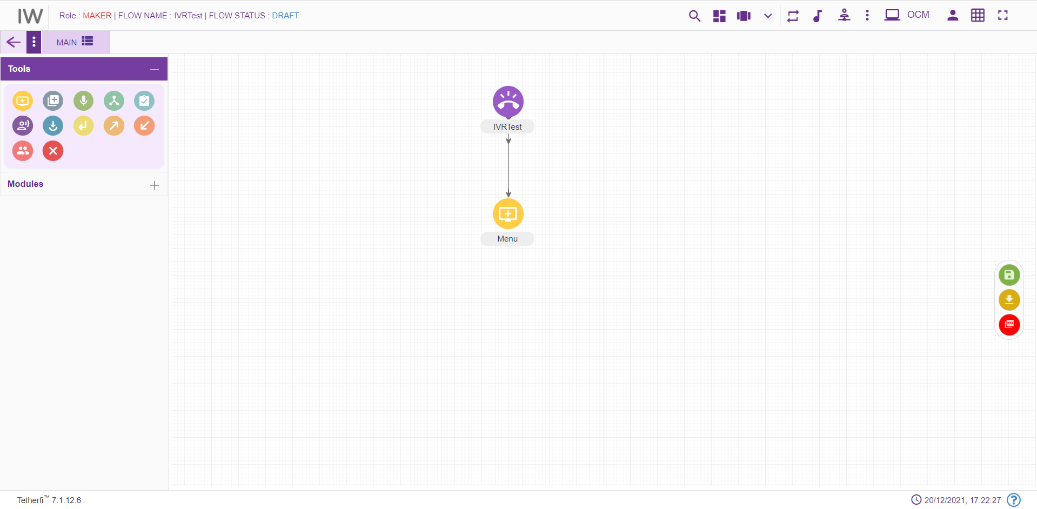
For editing/ configuring the Menu, hover over the Menu icon you added and edit/ delete functionalities for the menu will be displayed.
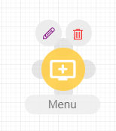
On click of edit button, the below screen will popup and node will be popped till node window is open.

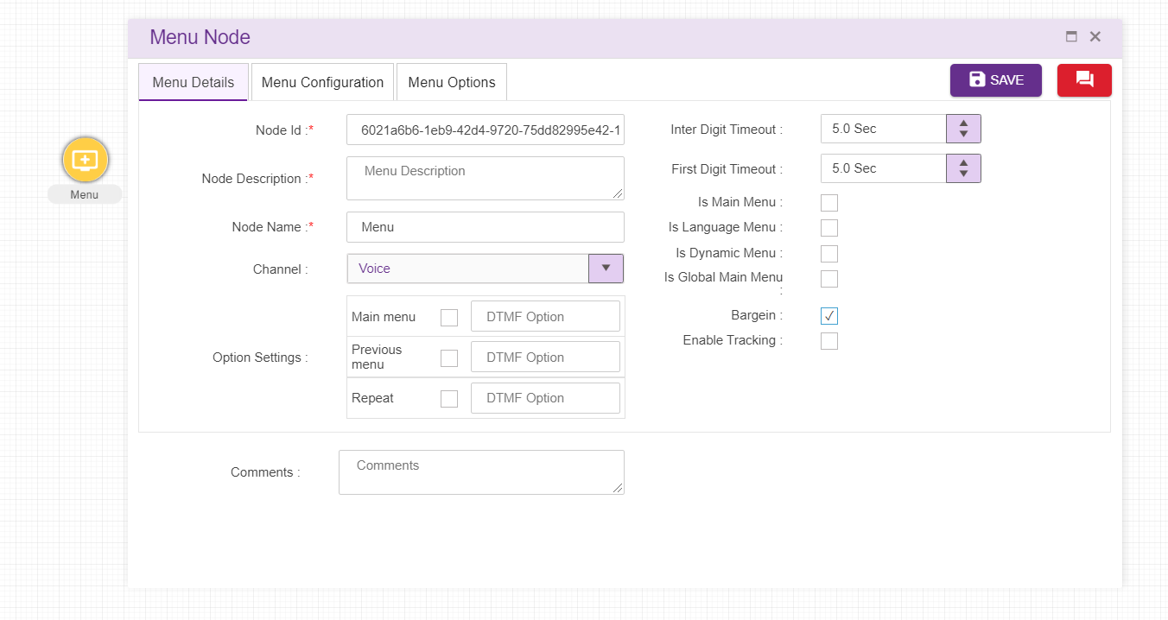
  - Menu ID: By default, the Menu ID for a Menu is autogenerated, but the Users have the privilege to assign their own Menu ID. Each Menu ID should be unique. (Mandatory)
  - Menu Name: By default, the Menu Name is Menu, but the Users have the privilege to assign their own Menu Name. Each Menu Name should be unique. This Menu Name will only be displayed in the Interaction workflow’s UI (Mandatory)
  - Menu Description: Brief characterization of the Menu. (Mandatory)
  - Is Main Menu: Whether the Menu is the Main Menu of the callflow. A single callflow may have multiple Main Menus. This option is present only for IW flow
  - Is Language Menu: Whether the Menu is the language Menu of the callflow. This option is present only for IW flow and only 1 node can be set as a language menu in a callflow.
  - Is Global Main Menu: Whether the Menu is the Global main menu of the callflow. This option is present for both IW flow as well as ordertake flow and only 1 node can be set as a Global Main menu in a callflow.
  - Is Dynamic Menu: Upon setting a menu as dynamic menu, wav files uploaded to the options can be dynamically altered/shuffled. This option is present for both IW as well as OrderTake flow.
  - Initial Prompt: The wave file to be played initially. The Language section in Call flow configuration segment is auto configured depending upon the languages selected in the DNIS details segment (refer section Phrase Selection)
  - Invalid Prompt 1 and 2: The wave file to be played on invalid prompt event. The Language section in Call flow configuration segment is auto configured depending upon the languages selected in the DNIS details segment (refer section Phrase Selection). For the new menu node, these texts are copied from Main node.
  - No Input Prompt 1 and 2: The wave file to be played on no input prompt event. The Language section in Call flow configuration segment is auto configured depending upon the languages selected in the DNIS details segment (refer section Phrase Selection). For the new menu node, these texts are copied from Main node.
  - Max Tries: The wave file to be played when the max tries exceeded. The Language section in Call flow configuration segment is auto configured depending upon the languages selected in the DNIS details segment (refer section Phrase Selection). For the new menu node, these texts are copied from Main node.
  - Hot Keys: User can use hot keys added in the master here. (refer section Hot Keys)
  - Comment: This field is used to write comments
  - Channel: Channel of communication for the callflow, “Voice” by default.
  - Error Limit DTMF: Maximum attempts allowed in a DTMF in menu
  - Failure Action: Upon failure action provided here will be performed
  - Option Settings: we can set different DTMF options for main menu, previous menu and repeat here. This option won’t appear for language menu.
  - Bargein: This option allows user to barge before IVR announcement is completely played. This checkbox is checked by default.
  - Inter Digit Timeout: This specifies the elapse time to enter second digit after first digit. This field accepts decimal values too.
  - First Digit Timeout: This specifies the elapse time to enter first digit. This field accepts decimal values too.
  - Enable Tracking: : When this option is checked, this node is tracked in session dashboard

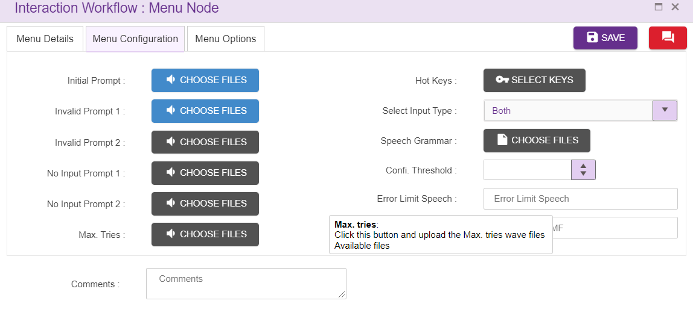
When user connects other nodes to menu node, options will appear inside menu node as shown above.
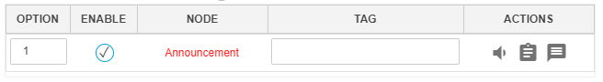
Option: DTMF will be displayed here by defaults starting from 1. Designer has the privilege to change the dtmf used. These DTMF’s provided will be displayed in UI in IW IVR. Designer can enter 1 or 2 digit numbers here along with options E, H and M. Designer can also inter comma separated values
E- This alphabet stands for Exception. ‘Failure Action’ in menu node must set to ‘Exception’ when Option ‘E’ is used as an option for menu legs.
H- This alphabet stands for Hold.
M- This alphabet stands for Maskable. When all the options/legs are disabled/masked, system will allow 'M' option node as shown above.
Enable: This option is used to enable or disable the menu legs. Only enabled menu legs will be played in IVR.
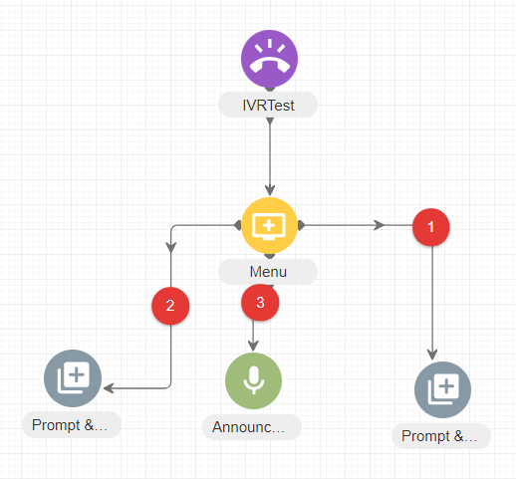
Callflow designers can easily shuffle menu legs by using drag and drop feature.
User can either enable/disable the options/legs by unchecking the checkbox provided as shown above. The checkbox will be checked by default.
DTMF will be in grey colour in UI when options are disabled as shown below. In the below figure, option 5 is disabled and option E, M and H are enabled by default. User cannot disable these options.
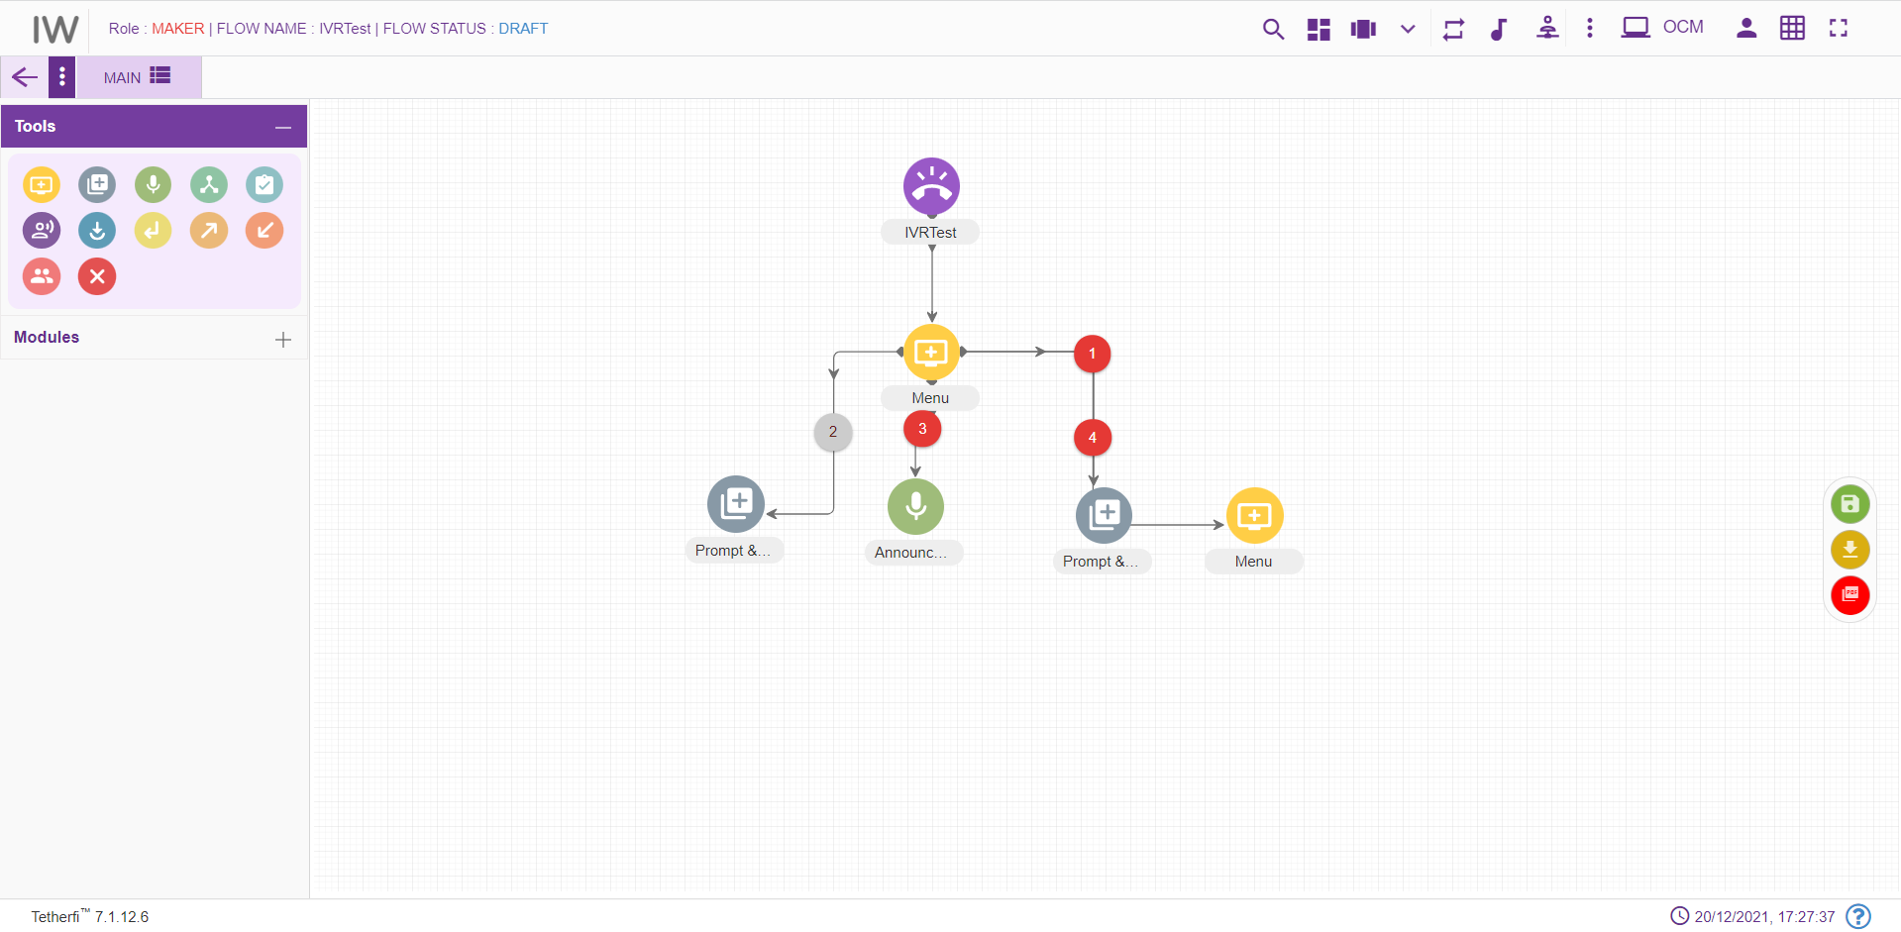

Node: Type of the Node connected to the menu as a leg will be displayed here
Tag: This is used to uniquely differentiate each menu leg option.
Phrase: User can also upload prompt which should be played when control transfer to specific node in ‘Phrase’ option of the Action field instead of doing it in initial prompt.
Rule: User can also set rules for the specific leg nodes here (refer section Set Rules).
Synonym: For each Tag, set of synonyms can be added. (Refer section Synonym)

Delete Menu Node:
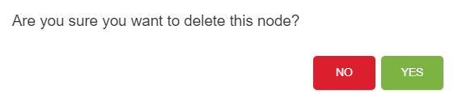

Agent Node
For adding a new transfer to Agent section to the callflow, click on the “Agent” icon and drag it to the main screen. Agent node should be the last node in a callflow (like Disconnect node).
Note that Agent node is not required, if the external module is called to perform agent transfer.
For editing/ configuring the Agent, hover over the Agent icon you added and edit/ delete functionalities for the menu will be displayed.
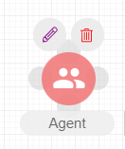

On click of edit button, the below screen will popup
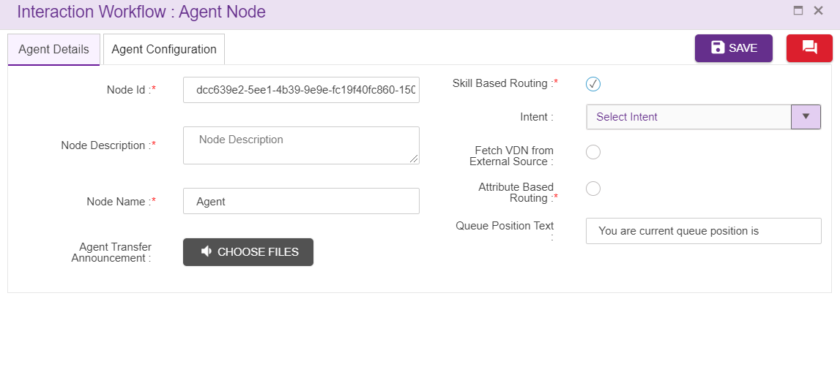
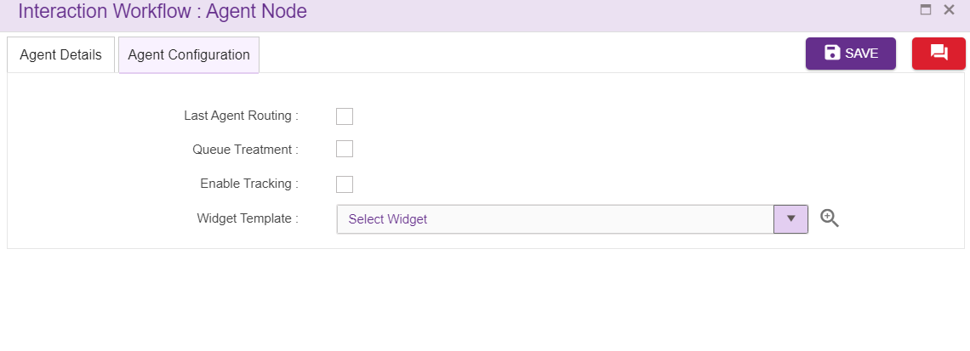
Node ID: By default, the node ID for an Agent node is autogenerated, but the Users have the privilege to assign their own ID. Each node ID should be unique. (Mandatory)
Node Description: Brief characterization of the agent Node. (Mandatory)
Name: This is a mandatory field. Name provided here will be reflected in UI, only when there are no intents
Enable Tracking: When this option is checked, this node is tracked in session dashboard
Fetch VDN from External Source: Fetching VDN from external source in Agent node
Agent Transfer Announcements:
wav file uploaded here will be played when control transfer to the Agent. refer section Phrase Selection. For the new Agent node, these texts are copied from Main node.
Upon clicking this option, following popup will generate
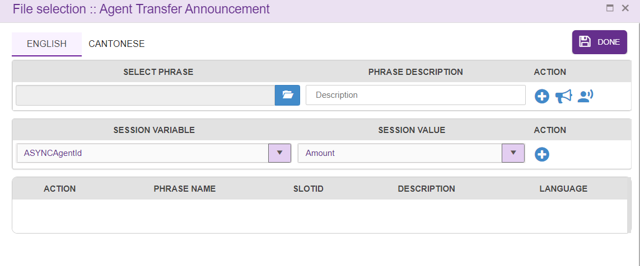
Select a wav file here which should be played upon transferring call to an Agent.
Intent:
Select one of the intents that corresponds to the purpose of selection of Agent shown in the auto populated dropdown. Intents present in intent master are displayed here. Intent selected here will be displayed in the label once the callflow is loaded.

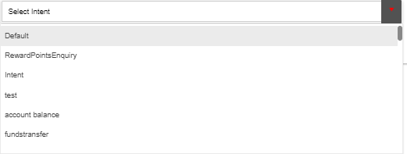
Delete Agent Node:
On click of delete button, the below screen will popup

Conditional Node
For adding a new Conditional Node to the callflow, click on the “Conditional Node” icon and drag it to the main screen. Conditional node is associated with a default node.
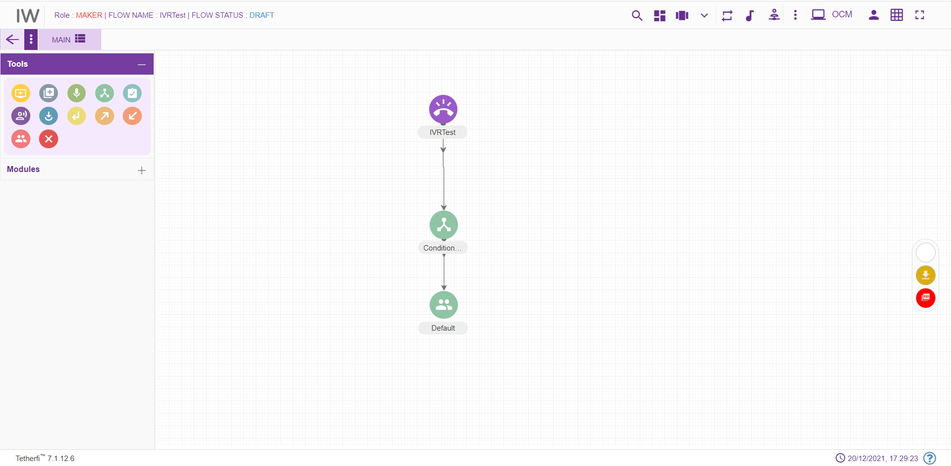
For editing/ configuring the Conditional Node, hover over the Conditional Node icon you added and edit/ delete functionalities for the menu will be displayed.
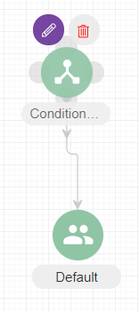
On click of edit button, the below screen will popup
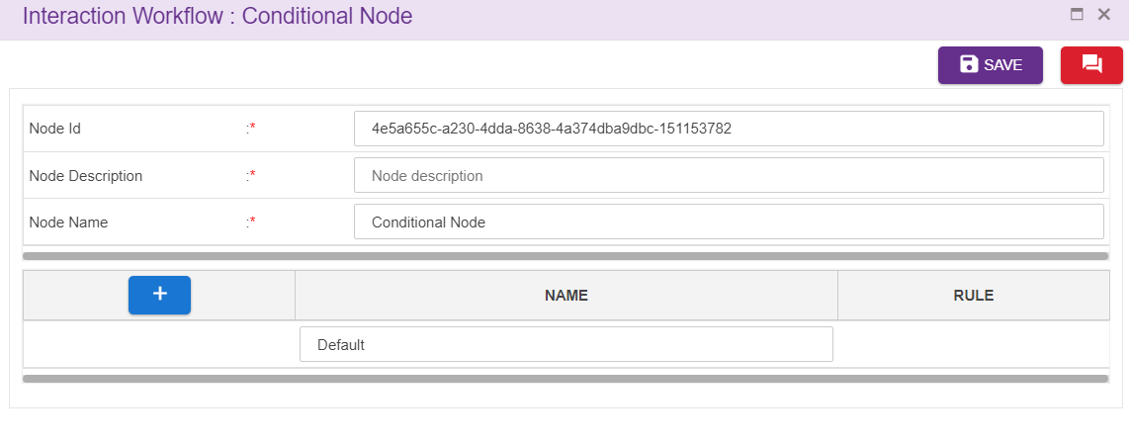
Node ID: By default, the node ID for a Conditional node is autogenerated, but the Users have the privilege to assign their own ID. Each node ID should be unique. (Mandatory)
Node Description: Brief characterization of the conditional Node. (Mandatory)
Name: This is a mandatory field. Name provided here will be reflected in UI. By default, the name is Conditional Node. but the Users have the privilege to assign their own name.
Adding Rules:
Click on “+” icon, to add rules.
Click on the ’Set Rules’ icon present at the Rule column to add conditional rules. refer section Set Rules
Upon clicking this icon following popup will be displayed and rule leg will be shown in UI. Conditional node is associated with default node. User should not be allowed to connect to default node directly from other nodes.
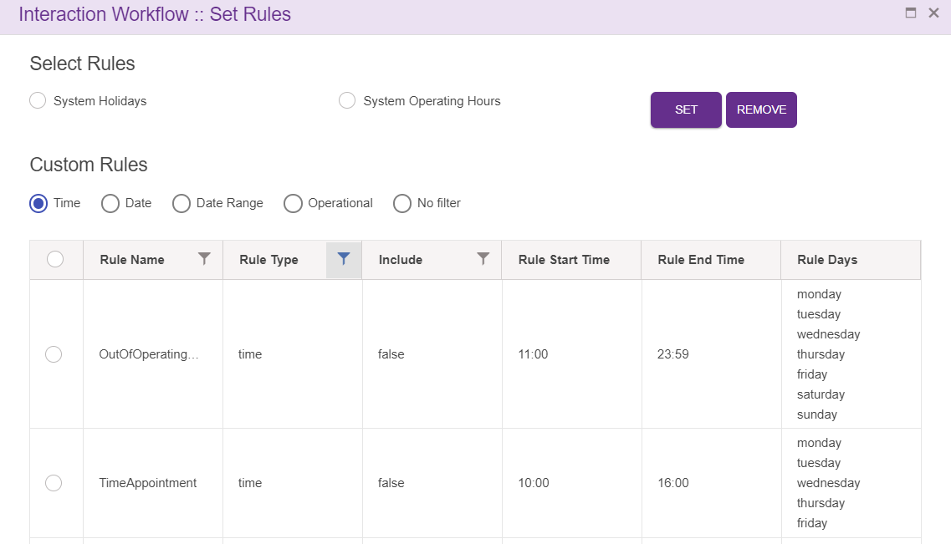
Delete Conditional Node:
On click of delete button, the below screen will popup

Announcement Node
For adding a new Announcement Node to the callflow, click on the “Announcement” icon and drag it to the main screen.
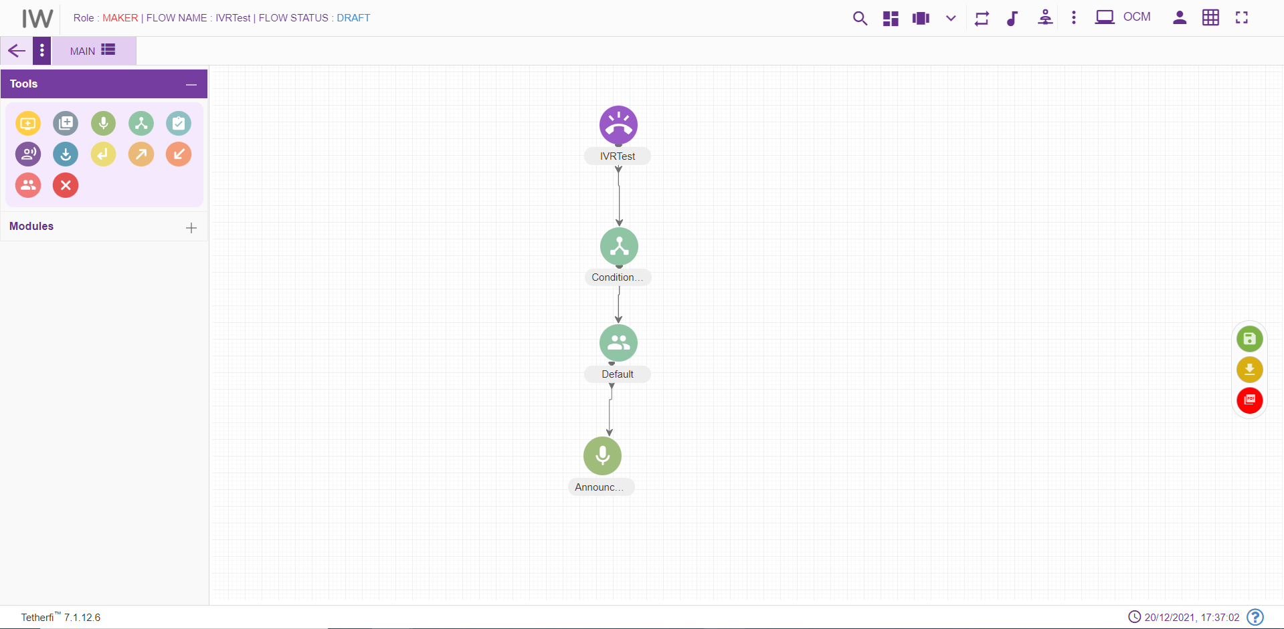
For editing/ configuring the Announcement Node, hover over the Announcement Node icon you added and edit/ delete functionalities for the Announcement node will be displayed
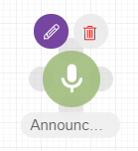
On click of edit button, the below screen will popup
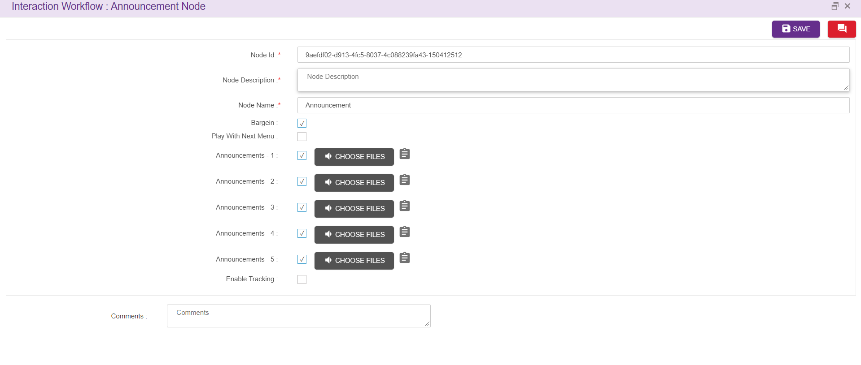
- Node id: This field accepts characters, numbers and special characters too. This option is used to track the announcements played.
- Node Description: Brief characterization of the announcement Node. (Mandatory)
- Name: This field refers to the name of the Announcement node. By default, name is announcement. but the Users have the privilege to assign their own name.
- Bargein: This option allows user to barge before IVR announcement is completely played. This checkbox is checked by default.
- Play with Next Menu: This option is used by Announcement node to indicate whether announcement must be grouped with next menu or play it there itself. Need it to group announcements for Repeat option. This checkbox will be unchecked by default.
- Enable Tracking: When this option is checked, this node is tracked in session dashboard
Announcements:
Mask- unmask option is given to all the five announcements in Announcement node as shown above. User need to check the checkbox to enable/mask the announcement. These checkboxes will be checked by default.
First connection from announcement node is a default connection and second connection are considered as masked connection which will be enabled when all the 5 announcements are disabled in Announcement node as shown below.
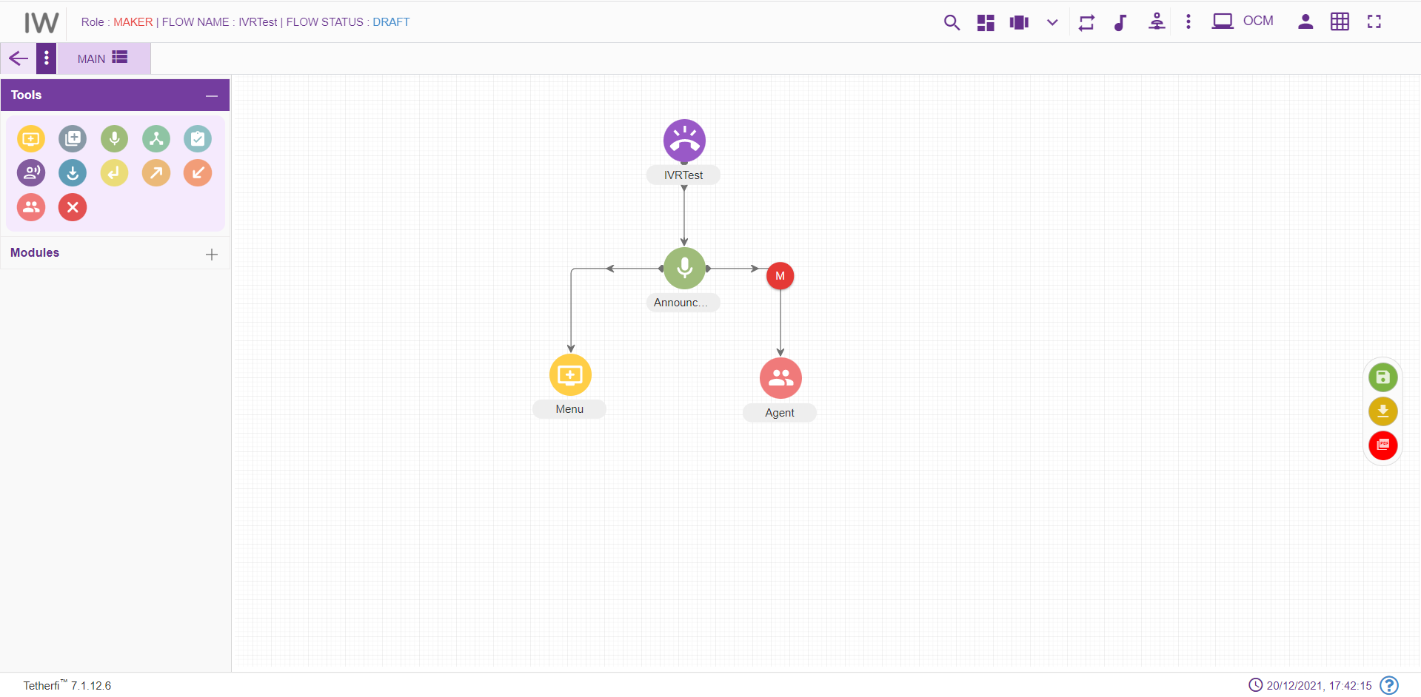
Upon clicking ‘CHOOSE FILES’ option, following popup will generate. Here user can select a wav file which should be played. In announcement node user can also add session variables to play. refer section Phrase Selection
As shown below, once the wav file is played, control transfers to ‘ani’ variable and value from ‘ani’ variable is played.
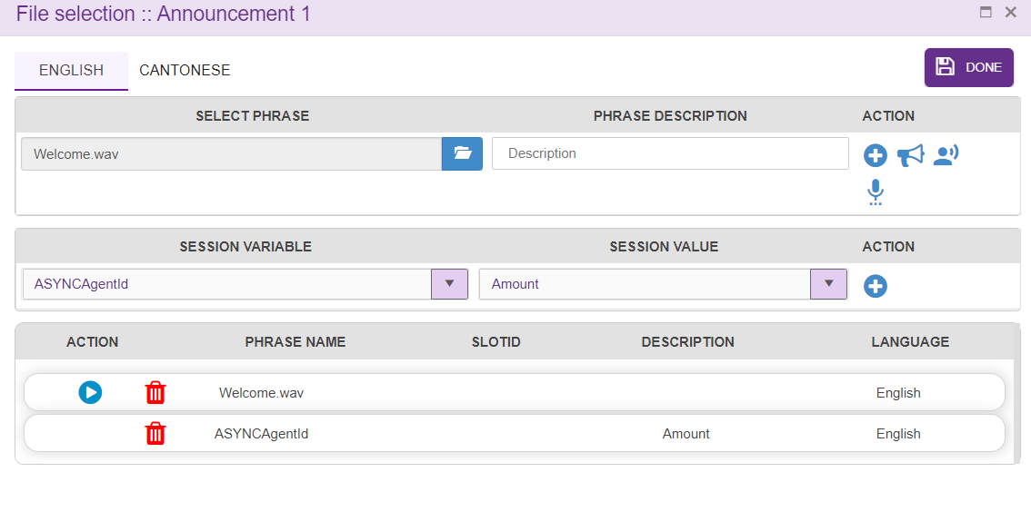
User can set the rules related to specific announcement by clicking the icon present at each announcement tag. refer section Set Rules
Upon clicking this icon following popup will be displayed
Delete Announcement node
On click of delete button, the below screen will popup

Assignment Node
For adding a new Assignment Node to the callflow, click on the “Assignment” icon and drag it to the main screen. Assignment node can be connected to only 1 node and it is a default connection (without label).
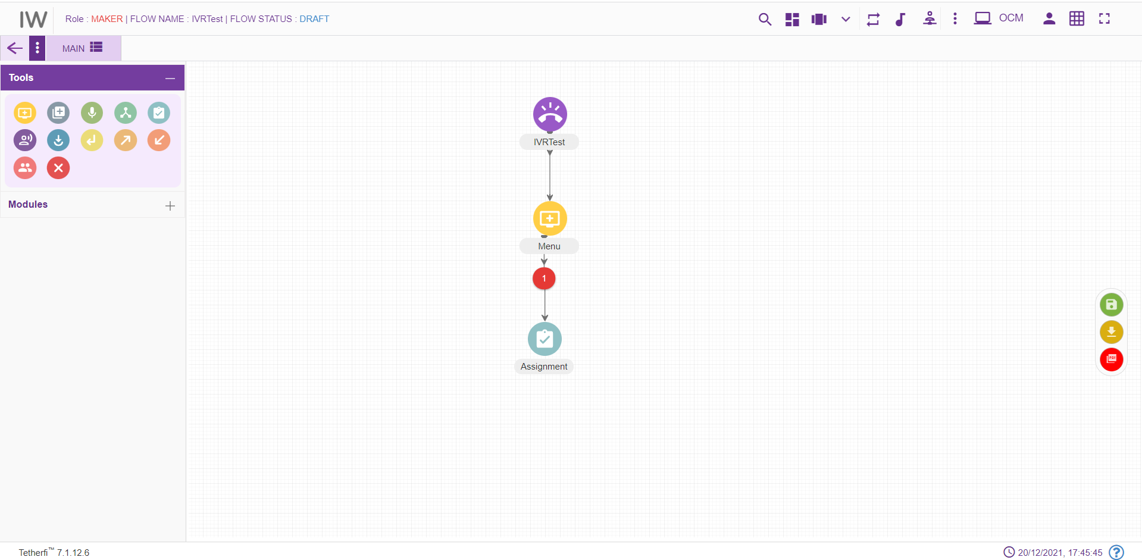
For editing/ configuring the Assignment Node, hover over the Assignment Node icon you added and edit/ delete functionalities for the Assignment node will be displayed
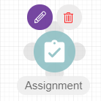
On click of edit button, the below screen will popup. Operational variables will be displayed in both the drop downs.
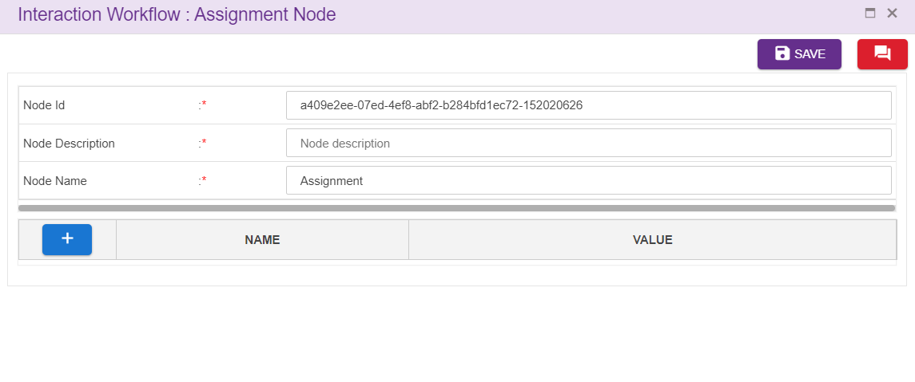
Node ID: By default, the node ID for an Agent node is autogenerated, but the Users have the privilege to assign their own ID. Each node ID should be unique. (Mandatory)
Node Description: Brief characterization of the agent Node. (Mandatory)
User can select the operational variables added at the backend from the first drop down and assign the values to them in the value field provided. User can also select operational variables for value field by clicking drop down icon shown above.
Delete Announcement node:
On click of delete button, the below screen will popup

Prompt and Collect Node
For adding a new Prompt and Collect Node to the callflow, click on the “Prompt and Collect” icon and drag it to the main screen. First connection from the PNC node is a default connection (without label) and when there is no default connection between PNC and node, immediate connection will be the default connection.
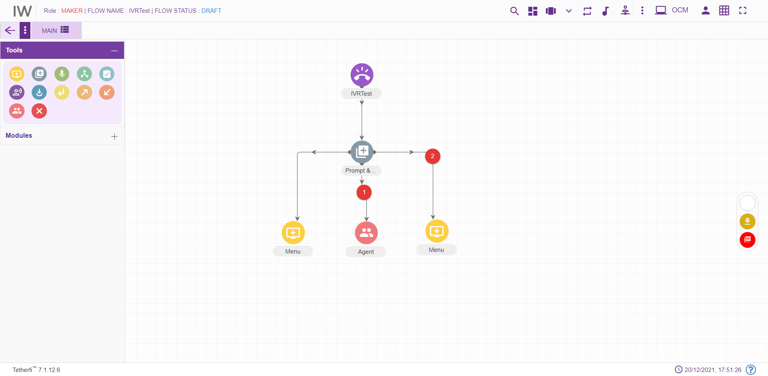
For editing/ configuring the prompt and collect Node, hover over the P&C Node icon you added and edit/ delete functionalities for the P&C node will be displayed
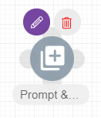
On click of edit button, the below screen will popup
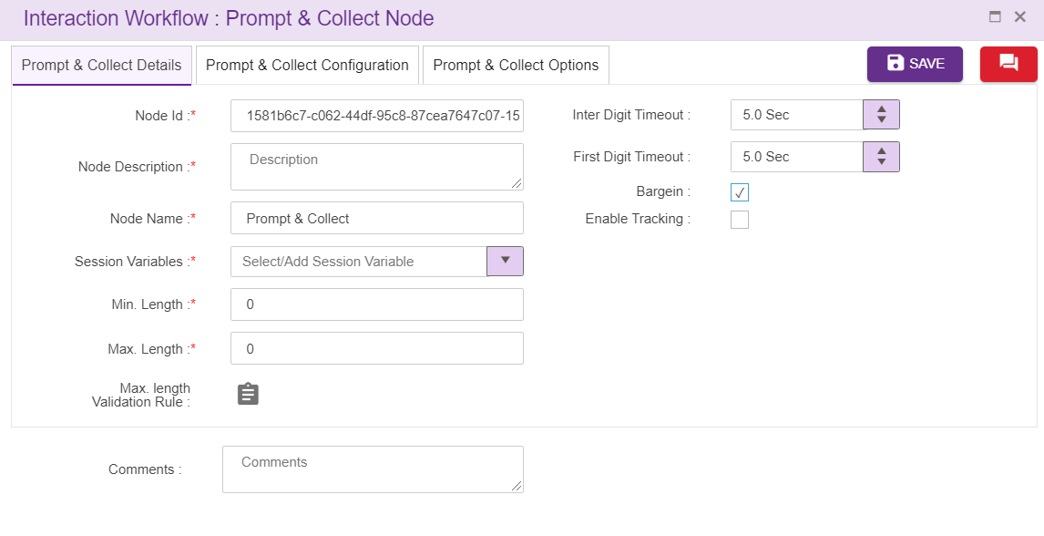
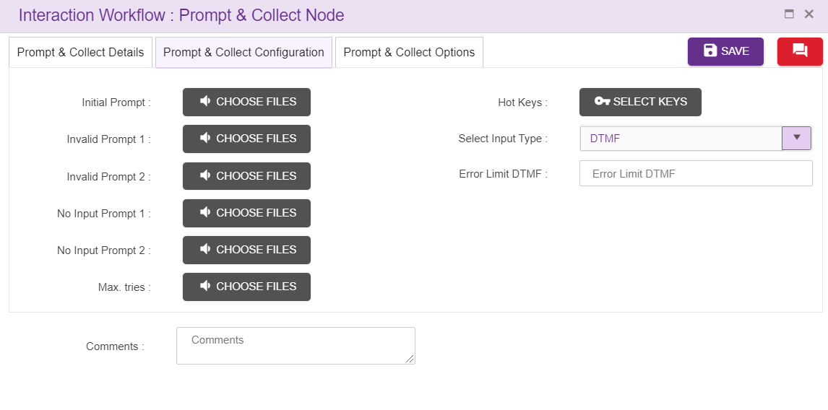
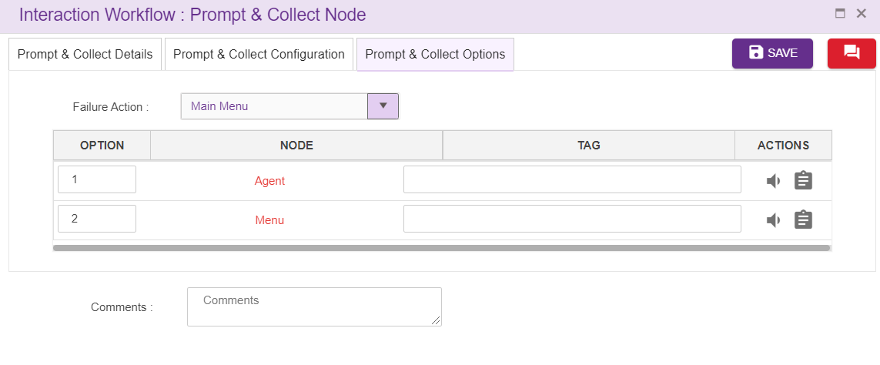
  - Prompt and Collect Id: These id’s are auto generated
  - Prompt and Collect Name: User can give names specific to the node in this field
  - Description: Description about P&C node is given here.
  - Session Variables: These are the variables corresponds to a call. This is a mandatory field. User can add session variable or select from the drop down. Duplicate session variables are not allowed here
  - Min. Length and Max. Length: This fields are the dialogues and collected from Prompt & Collect node. These fields are the allowed range for data e.g. for entering phone number and the allowed digits can be configurable to certain range. Once caller enters data IVR checks the digits entered with min and max length digits configured
  - Max length Validation Rule: Rule can be set here to validate data entered.
  - Initial Prompt: Allows the caller to upload the wave files and these are the first wave files which are played when flow hits prompt and collect node. refer section Phrase Selection window.
  - Invalid Prompt 1 & 2: Allows the caller to upload the wave files and these wave files are played when user entered wrong input. refer section Phrase selection window. For the new PNC node, these texts are copied from Main node.
  - No Input Prompt 1 & 2: Allows the caller to upload the wave files and these wave files are played when there is no input from caller. refer section Phrase Selection window. For the new PNC node, these texts are copied from Main node.
  - Max. tries: These prompts are played when caller exceeds the Error Limit DTMF value. refer section Phrase Selection window. For the new PNC node, these texts are copied from Main node
  - Hot Keys: User can use hot keys added in the master here. (refer section Hot Keys)
  - Error Limit DTMF: These field indicates the maximum number error tries caller is allowed to enter. In the above screenshot error limit DTMF value is 3 which indicates that caller is only allowed to enter 3 error entries.
  - Failure Action: This field is to specify the action to be taken after exceeded Error Limit DTMF value. It can be transferred to ‘main menu’ or disconnect the call. In order take module ‘failure action’ is transferred to agent, if the caller is failed in order taking.
  - Bargein: This option allows user to barge before IVR announcement is completely played. This checkbox is checked by default.
  - Inter Digit Timeout: This specifies the elapse time to enter second digit after first digit.
  - First Digit Timeout: This specifies the elapse time to enter first digit.
  - Enable Tracking:: When this option is checked, this node is tracked in session dashboard
  - Option: Tag option is also present for every node (other than default node) connected to PNC and option (DTMF) must be unique for every node. User can also upload prompt which should be played when control transfer to specific node in ‘Phrase’ option of the Action field instead of doing it in initial prompt and can set the rules for the nodes here. Default connection entry is not made here. Node section update as node type. Refer section Set Rules
Callflow designers can easily shuffle PNC legs by using drag and drop feature
Delete Prompt and Collect:
On click of delete button, the below screen will popup

Entry Point Node
Some of the callflows can contain many nodes. It becomes difficult to manage or fit the entire callflow in a single screen. Such callflows are broken into smaller flows for better readability and to also reduce frequent scrolls on the page. Each of these small flows are connected through the Entry and Exit node.
To add an Entry Point:
- Click on the node menu and drag and drop the Entry point to the screen
- Click on the three dots and then click on Edit details icon
- Entry Point pop up box is displayed
- Enter the Entry Point name and save
- Entry Point node should have the Entry Point name updated

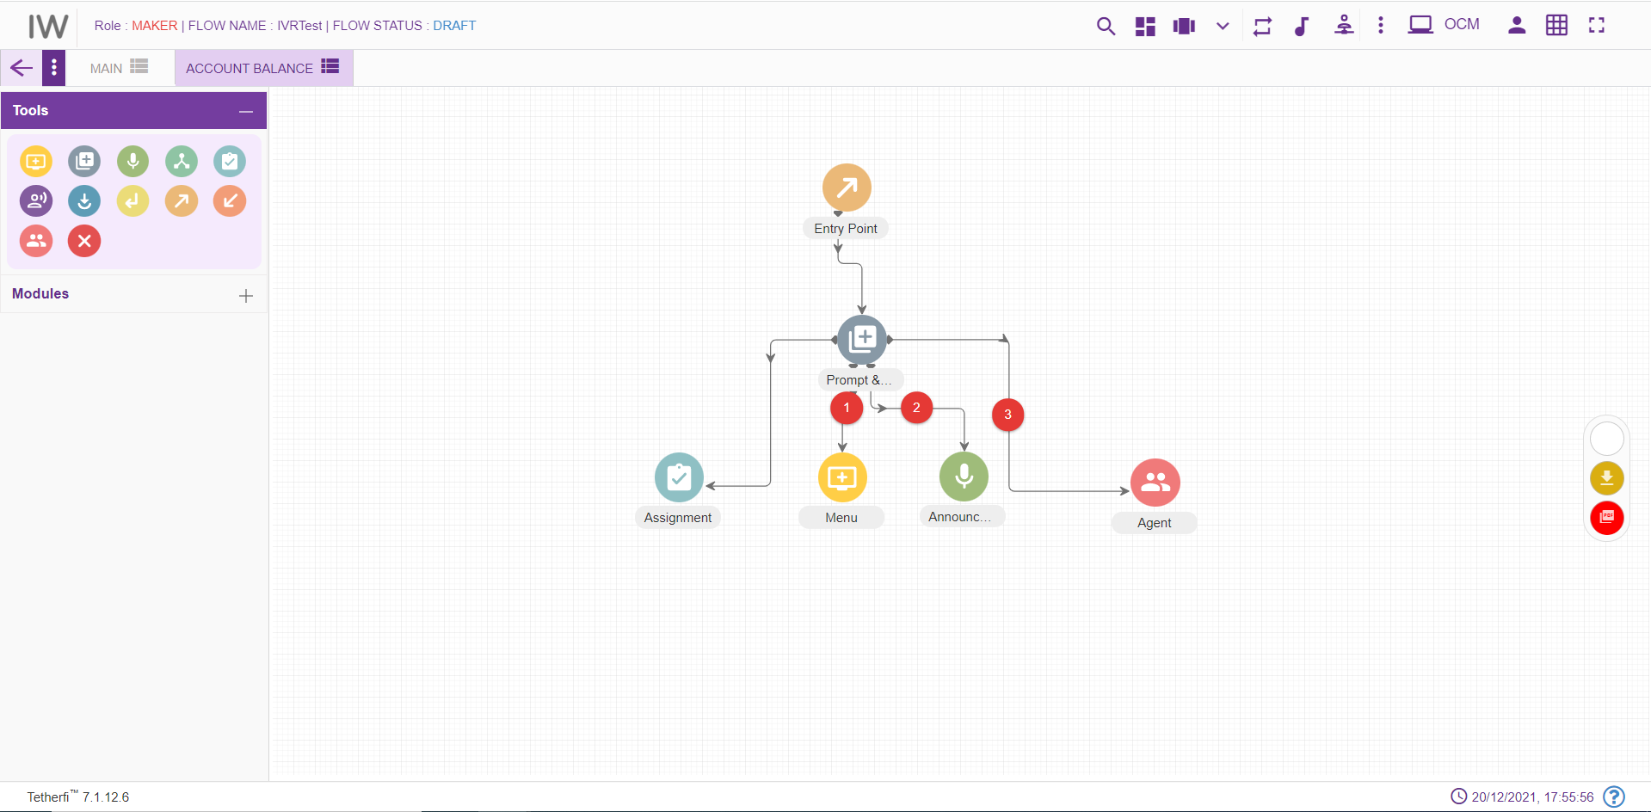

Entry Points can be connected to multiple flows which means technically multiple exits points are connected to entry points. To view the connections to the Entry Point, ‘view connection’ option is provided.
To view Entry Point connections:
- Click on the three dots on the Entry Point node and then click on View Connections icon
- ‘Following Connections found:’ pop up window with the Tab name and Entry Point name will be displayed
- Tab name will have the tabs which are connected to this flow. There can be multiple tab names and exit points connected to a single-entry point.

Entry Point should not have any incoming connections. Alert message ‘Entry Point should not have any incoming connections’ will be displayed when try to connect a node to Entry point node.
For editing/ configuring the Entry point, hover over the Entry point icon you added and edit/ delete/ view connections functionalities for the menu will be displayed.
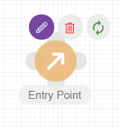
On click of edit button, the below screen will popup wherein you need to specify the name of the Entry Point.
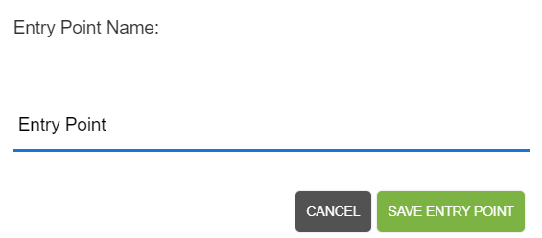
To delete the Entry Point:
- Double click on each connection of the Entry Point and delete them individually.
- When all the connections are broken then click on ‘delete details’ icon on the node.
- Entry Point will be deleted. This Entry Point will not be available for setting entry point for any of the exit points.

Disconnect Node
Disconnect node should be the last node in a callflow and user should not be able to connect other nodes after that. For adding a new Disconnect Node to the callflow, click on the “Disconnect” icon and drag it to the main screen.
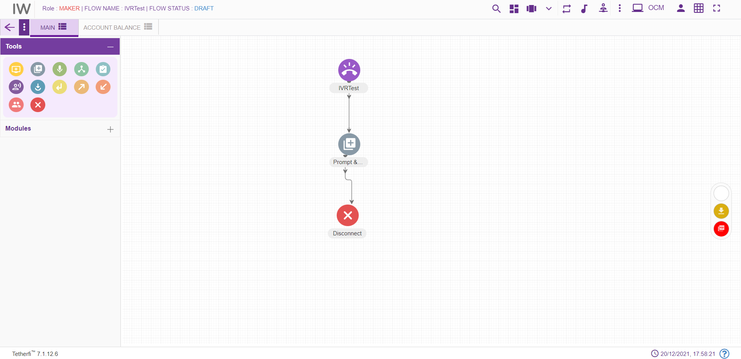
For editing/ configuring the Disconnect Node, hover over the Disconnect Node icon you added and edit/ delete functionalities for the disconnect node will be displayed.
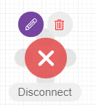
On click of edit button, the below screen will popup
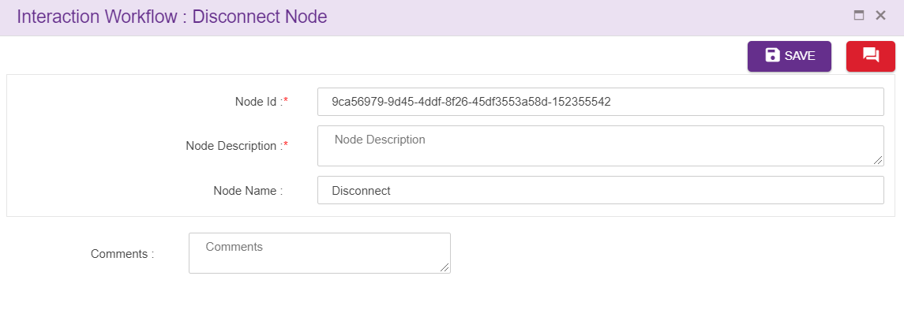
Node ID: By default, the node ID for an Agent node is autogenerated, but the Users have the privilege to assign their own ID. Each node ID should be unique. (Mandatory)
Node Description: Brief characterization of the agent Node. (Mandatory)
Delete Disconnect Node
On click of delete button, the below screen will popup

Exit Point Node
Exit Node cannot be a source node. It is the last node of the flow. If there is an effort to set connection between Exit node to any of the nodes, an alert message ‘Source can’t be an exit point. Exit point cannot have any exits.’ Will be displayed.
Every Exit Point will be pointing to the next Entry Point. This navigation details are provided by editing the Exit Point and then setting the entry point.
For adding a new Exit point to the callflow, click on the “Exit point” icon and drag it to the main screen. 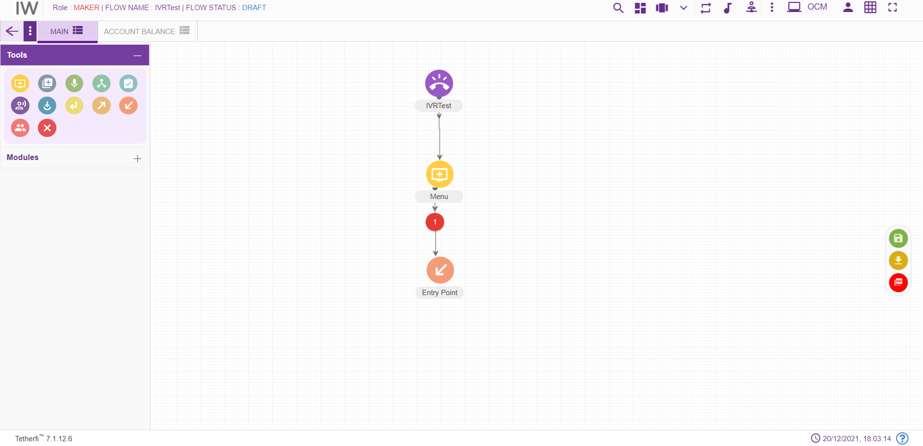
For editing/ configuring the Exit point, hover over the Exit point icon you added and edit/ delete functionalities for the menu will be displayed.
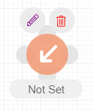
To set the Entry Point:
- Click on the Exit Point to which the entry point has to be set and click on the ‘Edit details’ icon
- Set Entry Point’ pop up window will be displayed. This window has tab name, Entry Point name and Comments. All the fields are mandatory. By default, the tab name will have ‘select tab’ in the drop down.
- Choose the tab name to which the control has to navigate from Exit Point. After choosing the tab name, only then the ‘Entry Point name’ will be populated. It will have all the entry points for the selected tab.
- Enter the comments and save. Exit Point node will have the name of the set Entry point.

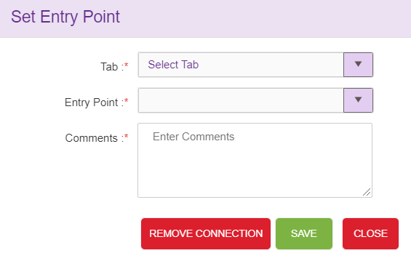

Exit Point can have only one Entry Point set. It cannot be set to multiple entry points. Set connections can be deleted.
To remove the connections:
- Click on edit details button of the Exit Point. It should have the set Entry Point.
- Click on remove connections’ button.
- ‘Are you sure you want to remove this Entry point connection?’ confirmation message should be displayed. On clicking Yes, the connection will be removed between the Exit Point and set Entry Point.
- ‘Entry Point connection removed’ message will be displayed confirming the deletion.
- If the ‘edit details’ button is clicked again, ‘Set entry point’ window will not have connection details. Also, ‘Remove connections’ button will not be present.

Exit Point can be deleted.
To delete the Exit Point:
- Double click on each connection of the Exit Point and delete them individually.
- When all the connections are broken then click on ‘delete details’ icon on the node
- Exit Point will be deleted.

Flow Connector node
Flow connector node is used to jump to subflow. Every Flow connector will be pointing to the next Entry Point. This navigation details are provided by editing the flow connector and then setting the entry point. Flow connector node can be connected to only 1 node and it is a default connection (without label).
For adding a new flow connector to the callflow, click on the “flow connector” icon and drag it to the main screen.
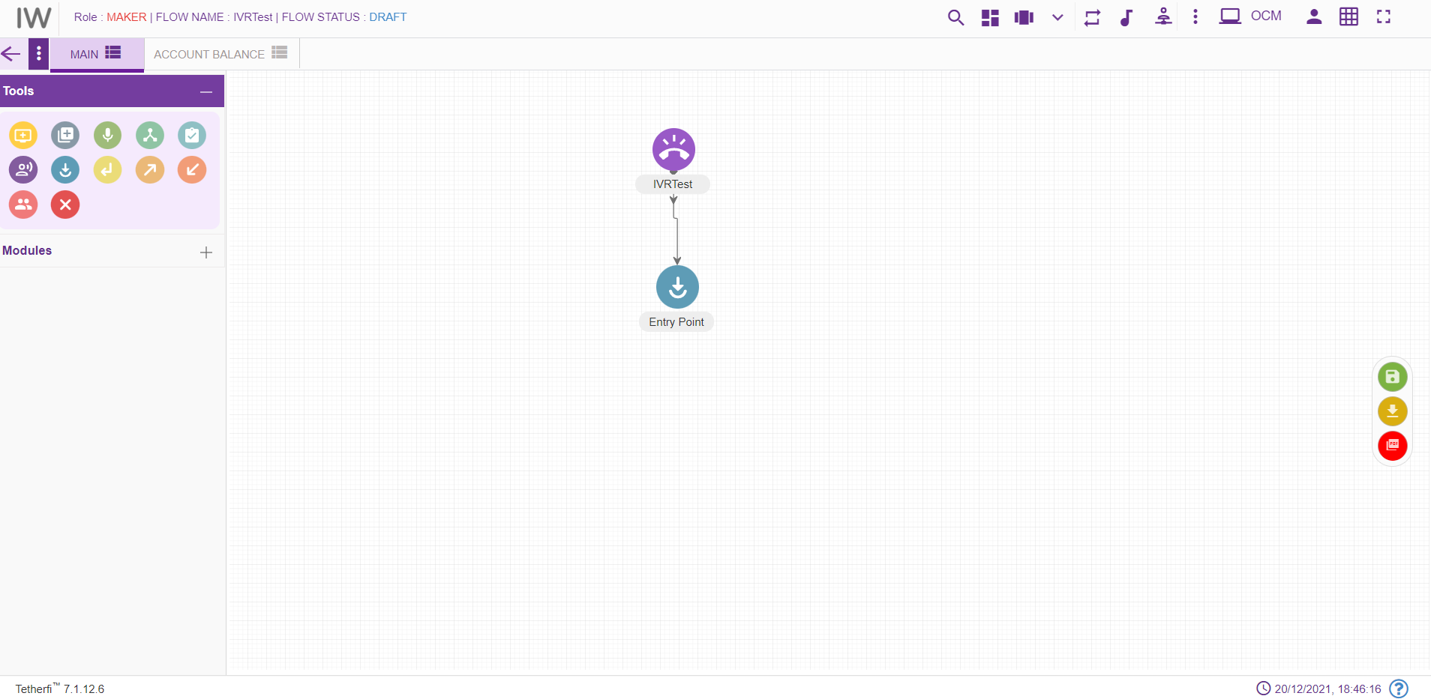
For editing/ configuring, hover over the flow icon you added and edit/ delete functionalities for the flow icon will be displayed.

On click of edit button, the below screen will popup
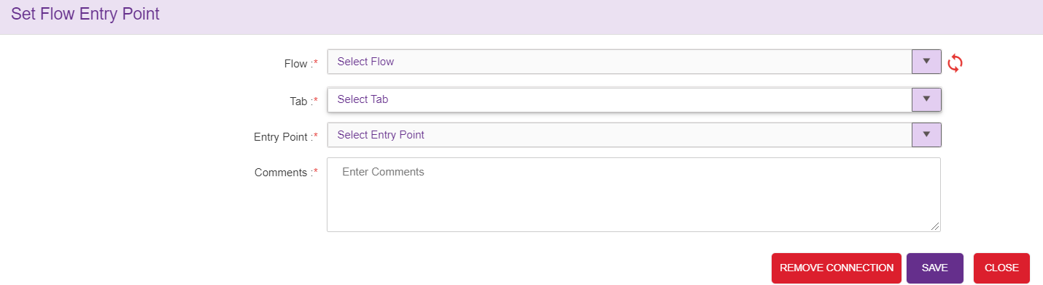

To set the Flow Entry Point:
- Drag and drop flow connector node and click on the ‘Edit details’ icon
- ‘Set Flow Entry Point’ pop up window will be displayed. This window has Flow name, tab name, Entry Point name and Comments. All the fields are mandatory. By default, the tab name will have ‘select tab’ in the drop down.
- Choose the subflow/mainflow name and tab name to which the control must navigate from flow connector Point. All the approved/saved subflows/mainflows will be displayed here. After choosing the tab name, only then the ‘Entry Point name’ will be populated. It will have all the entry points for the selected tab.
- Enter the comments and save. Flow connector node will have the name of the set Entry point.
- If there is both SAVED and APPROVED copy of the flow, then SAVED copy information will be displayed in the dropdown
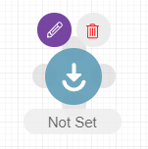
Flow connector can have only one Entry Point set. It cannot be set to multiple entry points. Set connections can be deleted.
To remove the connections:
- Click on edit details button of the flow connector. It should have the set Entry Point.
- Click on remove connections’ button.
- ‘Are you sure you want to remove this flow connection?’ confirmation message should be displayed. On clicking Yes, the connection will be removed between the flow connector and Entry Point.
- ‘Flow connection removed’ message will be displayed confirming the deletion.

Return Node
Return node should be the last node of a callflow. This node is used to return the control to the calling flow. Upon encountering this node in the subflow, control will be redirect to flow connector node where the subflow is being called.
For adding a new Return Node to the callflow, click on the “Return” icon and drag it to the main screen.
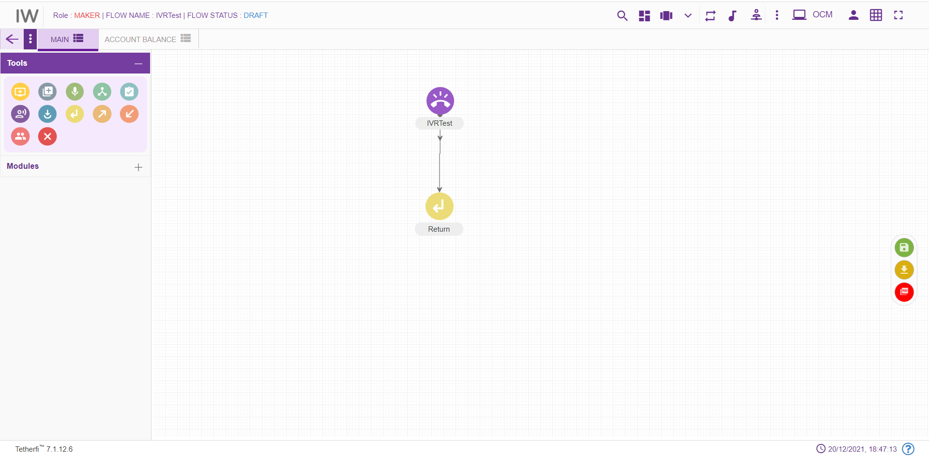

For editing/ configuring the return node, hover over the return node icon you added and edit/ delete functionalities for the return icon will be displayed.
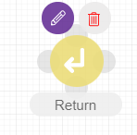
On click of edit button, the below screen will popup
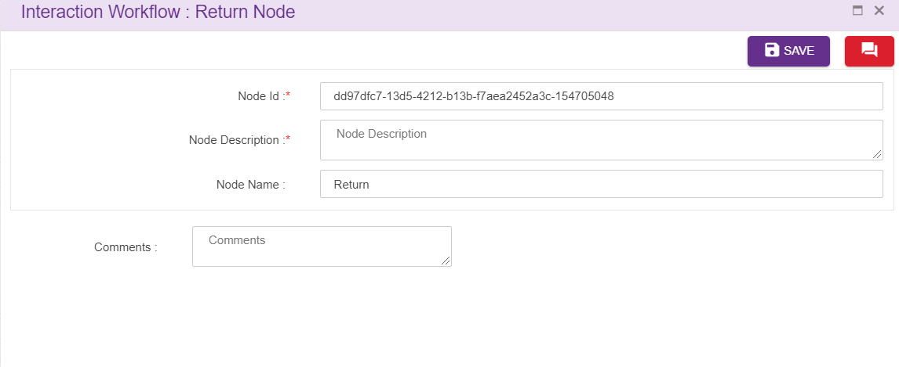
Node ID: By default, the node ID for a return node is autogenerated, but the Users have the privilege to assign their own ID. Each node ID should be unique. (Mandatory)
Node Description: Brief characterization of the announcement return Node. (Mandatory)
Name: Name of return node.
Delete Return Node
On click of delete button, the below screen will popup

Node Connectivity

Start Node | End Node | Connection status (outgoing) | Connection status (incoming)
DNIS | All other nodes except Entry point node, module exit and conditional exit nodes | Single connection from DNIS node | No incoming connection to DNIS node
Menu | All other nodes (including menu node) except Entry point node, module exit and conditional exit nodes | Multiple connection from menu node | Multiple connection to menu node
Announcement | All other nodes (including announcement node) except Entry point node, module exit and conditional exit nodes | Single connection from announcement node | Multiple connection to announcement node
Agent |  | No outgoing connection from Agent node | Multiple connection to agent node
Conditional node |  | No outgoing connection from conditional node | Multiple connection to conditional node
Conditional node legs | All other nodes (including Conditional node) except Entry point node, module exit and conditional exit nodes | Single connection from one leg of the conditional node | No incoming connection to Conditional node legs
Assignment | All other nodes (including assignment node) except Entry point node, module exit and conditional exit nodes | Single connection from assignment node | Multiple connection to assignment node
Prompt and Collect Node | All other nodes (including prompt and collect node) except Entry point node, module exit and conditional exit nodes | Multiple connection from menu node | Multiple connection to prompt and collect node
Entry Point Node | All other nodes except Entry point node, module exit and conditional exit nodes | Single connection from Entry point node | No incoming connection to Entry Point node
Disconnect Node |  | No outgoing connection from Disconnect node | Multiple connection to disconnect node
Exit Point Node |  | No outgoing connection from Exit point node | Multiple connection to Exit Point node
Module Node |  | No outgoing connection from Module node | Multiple connection to Module node
Module Node legs | All other nodes (including Module node) except Entry point node, module exit and conditional exit nodes | Single connection from one leg of the Module node | No incoming connection to Module node legs
Return Node |  | No outgoing connection from Return node | Multiple connection to return node
Flow Connector Node | All other nodes (including Module node) except Entry point node, module exit and conditional exit nodes | Single connection from flow connector node | Multiple connection to flow connector node

IW Speech
IW can also support speech. User can upload grammar files and set confidence threshold for menu as well as PNC node.
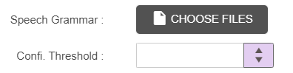
Only. gram and. grxml files can be added in speech grammar section. Any number of grammar files can be uploaded to a node and when same grammar file is uploaded again, existing file is overwritten. When uploading the grammar files, files will be stored in maker location and while approving, grammar files will be moved to checker location. User can upload the grammar files specific to the language
Confidence threshold can be set from UI. When the confidence threshold received is less than the configured value, then leg ‘C’ will be in effect.

Node Changes
Different types if icons can be configured for node in Email which is available in folder.
- Dark icons
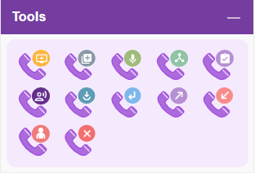
- Light icons
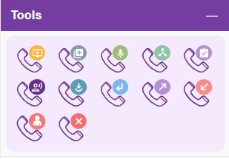

Modules

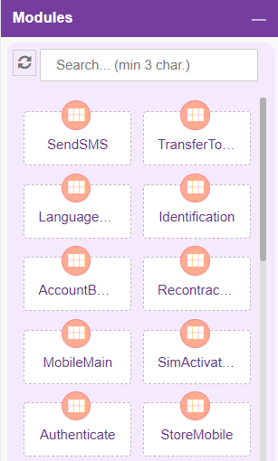
Modules are separable component, frequently one that is interchangeable with others, for assembly into units of differing size, complexity or function. Self-service transactions are implemented in module. Size of the default node which is associated with module node is smaller than module node.
For adding a new Module to the callflow, click on the “Module” icon and drag it to the main screen.
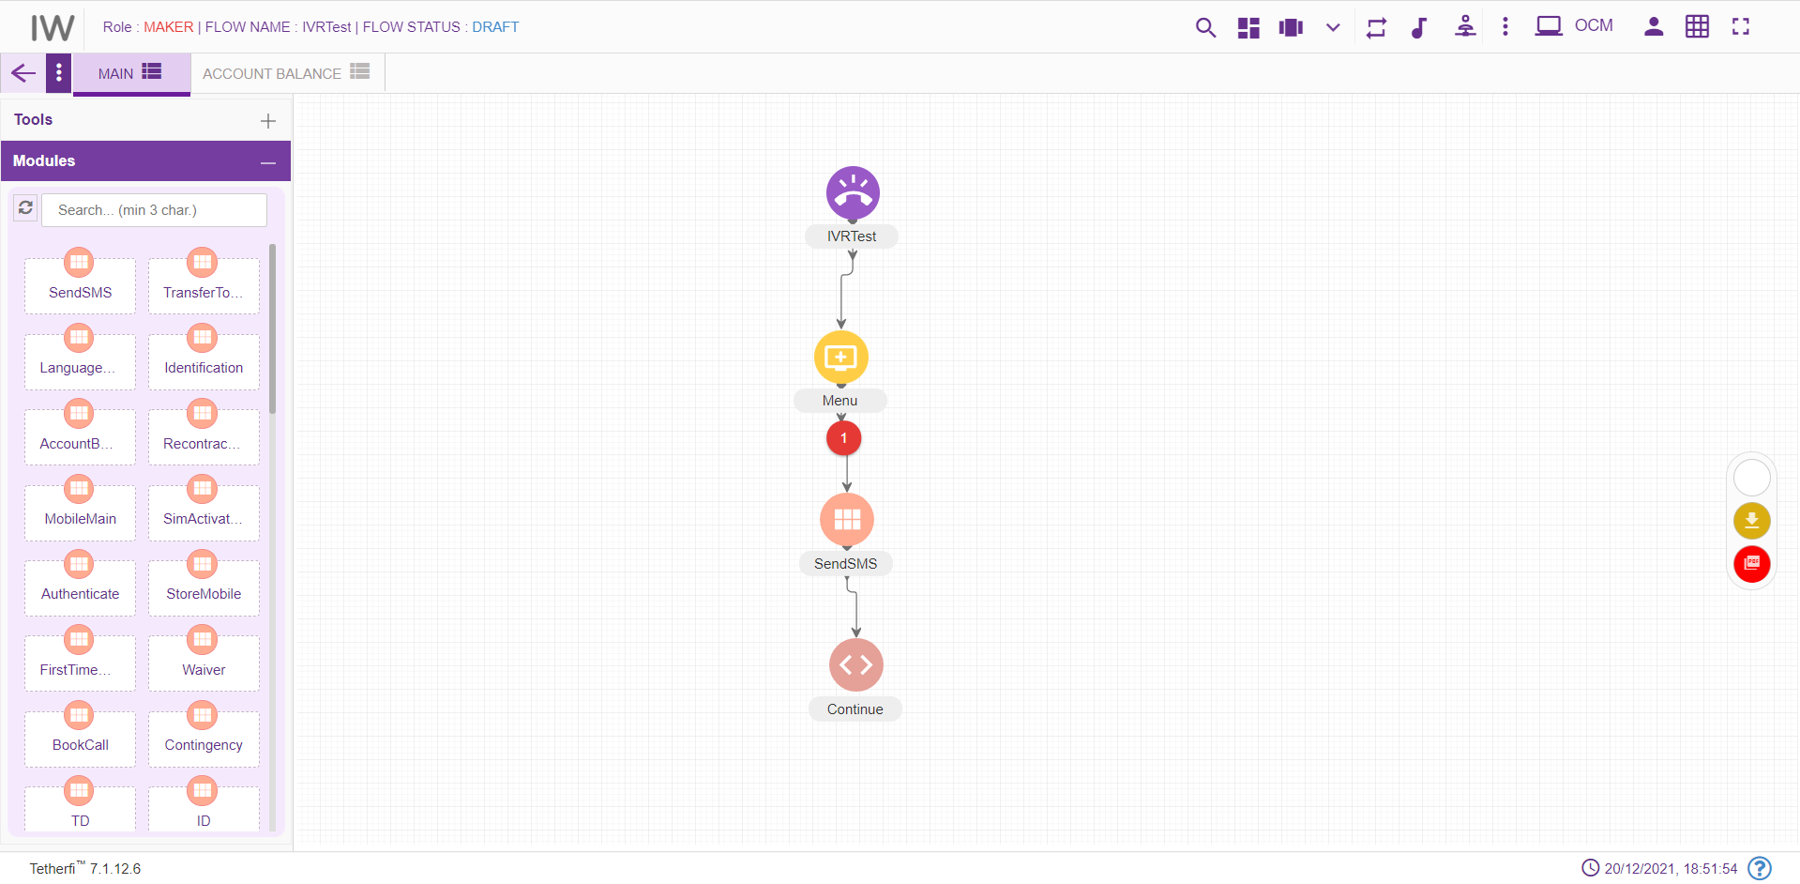
For editing/ configuring/ refreshing the Module, hover over the Module icon you added and edit/ delete functionalities for the menu will be displayed.
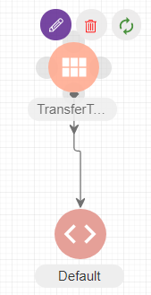
On click of edit button, module configuration details can be updated. ‘serviceID’ is the parameter for HostIntegration Module.
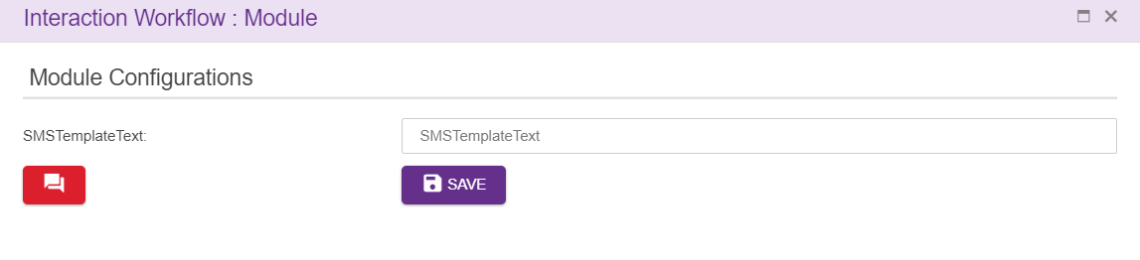
When a user adds new labels to the modules, he can update all the existing modules in the callflow by clicking refresh/reload button as shown below.
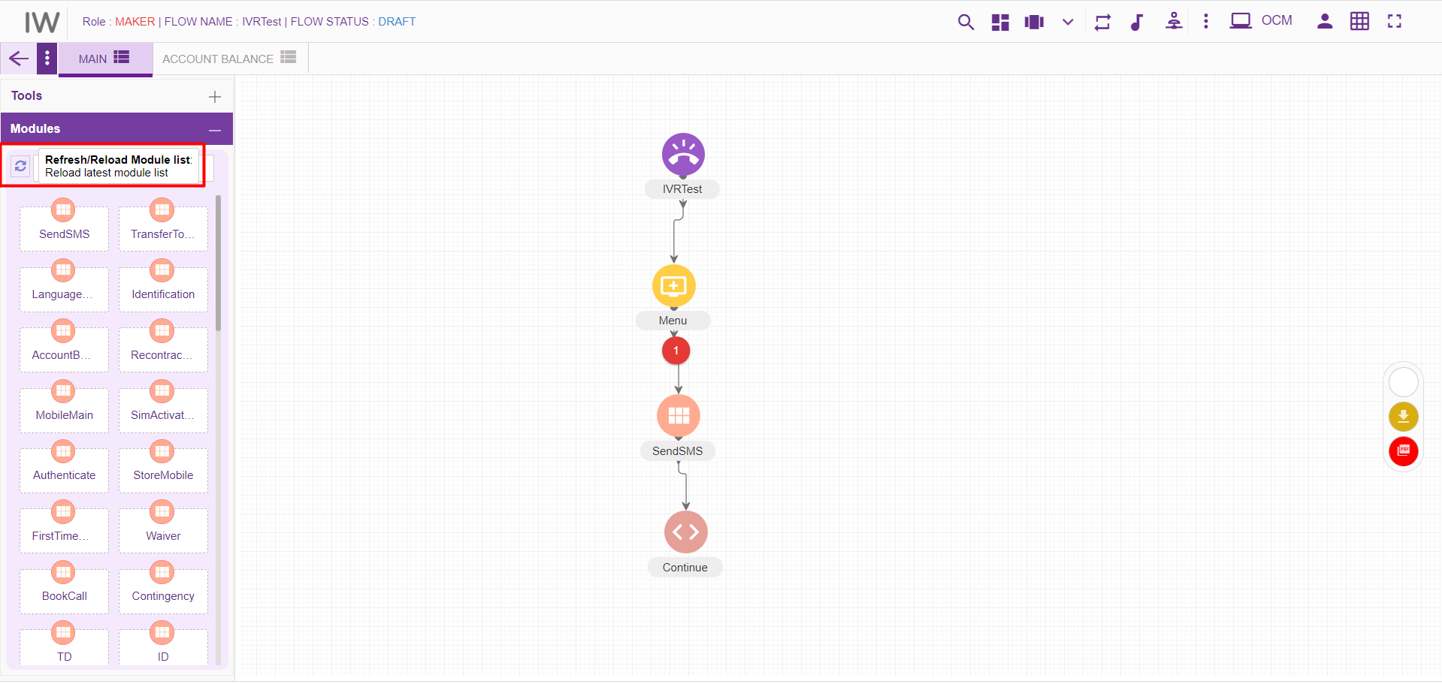
Upon clicking refresh/reload button following popup will generate to update existing modules in the callflow. Callflow must be in DRAFT status.
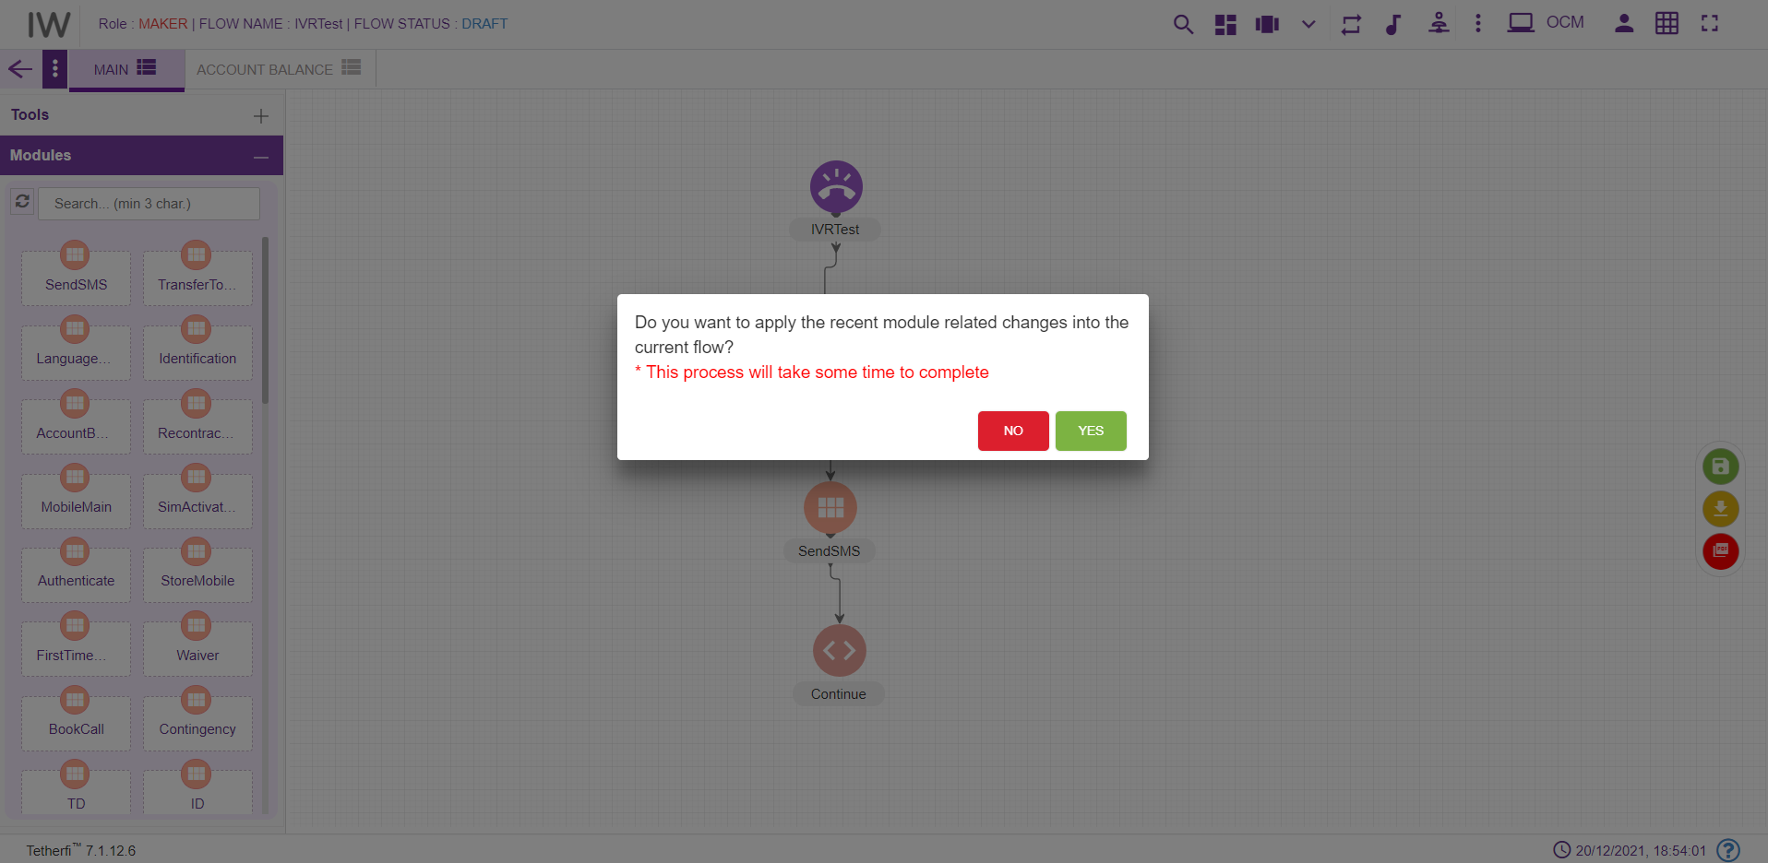
‘Yes’: all the modules present in the callflow will be updated.
‘No’: changes will not reflect in the existing modules present in the callflow.

IW Module Designer
This is the new Tetherfi application with is used to design the Module Flow. Just like Interaction workflow, there are set of nodes used to design the module flow. If there is a module flow designer in IW Module Designer application for the module dropped in IW, then IW will redirect the user to this IW Module designer application upon opening the module. If there is no Module flow designed in IW Module designer application for the module used in IW, then control will be there in IW.
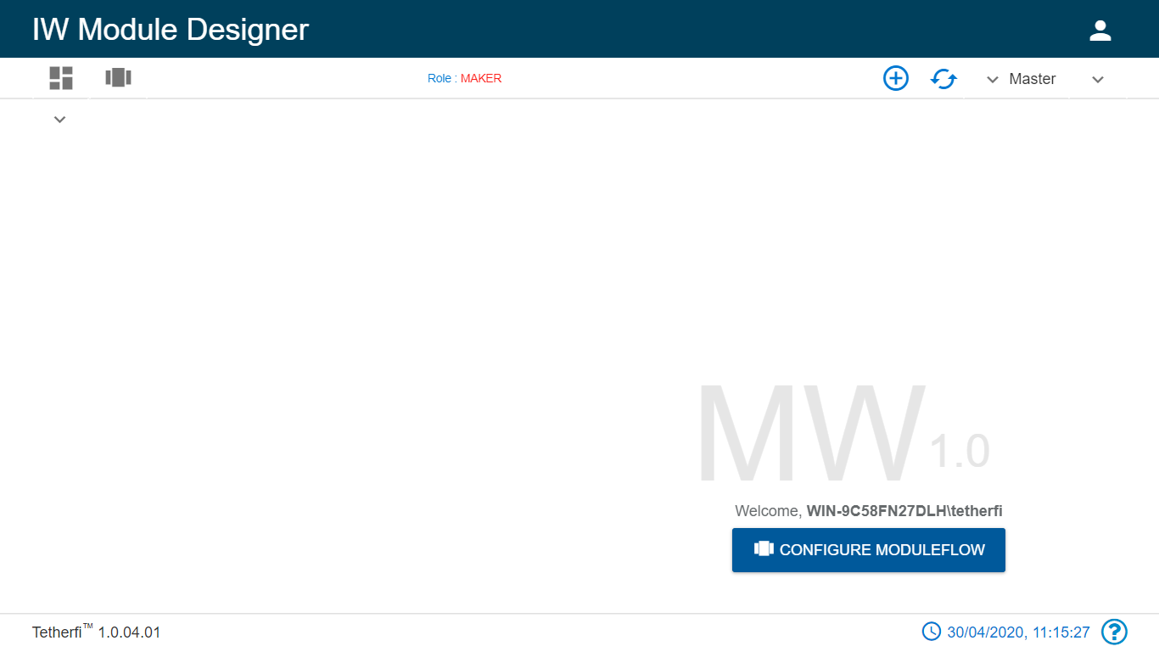
Refer the document attached.

Connecting Nodes and Modules
For interconnecting two or more Nodes/ Modules, you need drag the connecting link as shown below:
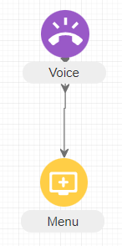

For deleting a node, double click on the connecting link and the below screen will be displayed:
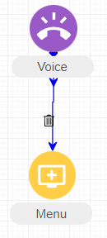
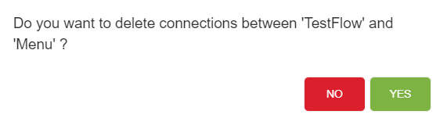

Simulation
Callflow simulation is the artificial imitation or replication of a call process to model and identify how the call travels or shifts into the different stages or levels within the company operation. The simulation will provide or demonstrate to the concerned how a call is handled by the different departments or functions that it may entail in the course.
It not only helps in identifying different elements or functions involved in a call but also clearly establish levels in the processes for optimizing the same by isolating bottlenecks in the process, anticipating potential effects and defects of new ideas or systems to be implemented, predicting future performances as well as comparing different scenarios for decision making and conducting a process analysis.
For simulating a Callflow, open a Callflow and hover over any node or module and right click. On right click, the below screen will be displayed:
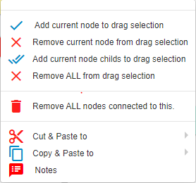

Drag Nodes
If user wants to drag the set of the nodes to a different position in a tab, they can user ‘Add current node to drag selection’ , to include child nodes while dragging, can use ‘Add current node child’s to drag selection’.
To remove the nodes from drag selection, ‘Remove current node from drag selection’ and ‘Remove ALL from drag selection’ option can be used.

Remove ALL nodes Connected to This
This option is used if the user wants to delete a node along with immediate child nodes connected to this.
As shown below, user can delete menu node along with its child node at once, using this option.
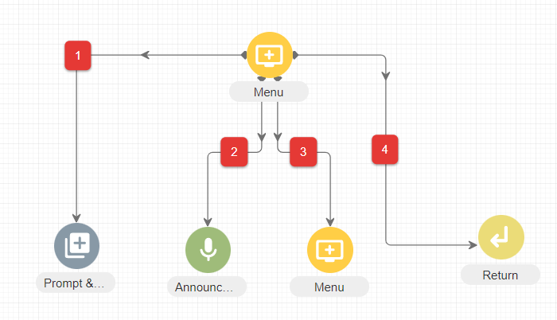

Play
A Dialler will be displayed which you can use for navigating through the entire Callflow. Both the Visual and Audio interpretation of the Callflow will be simulated. All the wav files uploaded to a particular node will be displayed in blue colour as we navigate through the callflow in the dial pad and the wav file which is currently playing will blink.
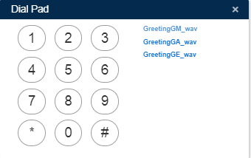
- Add current node to drag selection: Adds selected/current node to draggable
- Remove current node from drag selection removes current node from drag selection
- Add current node child’s to drag selection: Adds selected /current node and its child elements to draggable collection
- Remove all from drag selection removes all the nodes from draggable collection

Cut and Paste
User is provided with Cut and Paste feature to manage the callflow creation/updation efficiently.
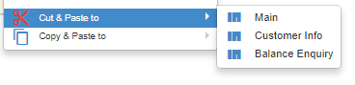
Steps to create a node/flow using Cut and Paste feature:
- Right click on the node to be copied.
- Choose the tab to which the node must be copied. It cannot be the same tab. Error message is thrown to indicate the same.
- A confirmation message pops up.
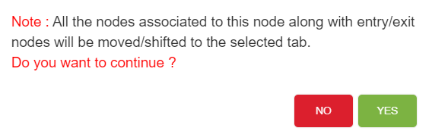
- Click on Yes to cut and paste.
- Node along with its connection will be pasted to selected tab. Node and its connection will not be available in the original tab.
- Click on No will close the window and node will not be cut and pasted.
- Node connection will be cut and pasted by default along with the node.
There are certain conditions which has to be considered while cut and pasting nodes. They are listed below.
- DNIS node cannot be cut and pasted to the same tab as well as another tab.
- Except DNIS node, all other nodes can be cut and pasted to another tab.
- No nodes can be cut and pasted to the same tab
- Cannot cut and paste Conditional rule node and Module exit nodes. This feature does not exist for these 2 nodes. Error message will be generated. ‘Cannot move/shift conditional rule node’.
- A node cannot be cut and pasted if it has a parent node. If there is an attempt to cut and paste the node, error message ‘Please break connections from this node’s parent.’ Will be displayed.

Copy and Paste
Copy and Paste feature is an important feature that can be used to ease the workload of the users. Nodes that are frequently used and need to be created multiple times with minimal changes.

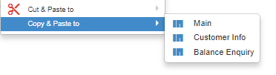
Steps to create a node/flow using Copy Paste feature:
- Right click on the node to be copied.
- Choose the tab to which the node must be copied.
- A confirmation message pops up. Include node connections can either be checked for opting node connections along with the node copy paste or not.

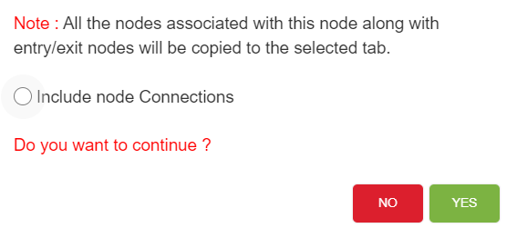
- Click on Yes to copy and paste.
- Node along with its connection will be copied to the same or another tab based on inclusion or exclusion of node connections.
- Click on No will close the window and node will not be copied.
There are certain conditions which has to be considered while copy pasting nodes. They are listed below.
- DNIS node cannot be copied to the same tab as well as another tab.
- Except DNIS node, all other nodes can be copied to the same tab as well as another tab.
- Cannot copy Conditional rule node and Module exit nodes. This feature does not exist for these 2 nodes which means user will not be able to see the copy
- A node can be copied if it has a parent node. But the copied node does not have a parent node. It will have the entire flow from the copied node.
- Node connections can be included or excluded while copying. If the node connections are excluded, all the nodes are copied from there onwards except for the node connections.
- If an exit node connected to an entry node which is present in other tab, upon coping the exit node, entry node will not be copied.
- If an exit node connected to an entry node which is present in same tab, upon coping the exit node, entry node will also be copied.

Sticky Note
User is provided with sticky note feature to add information about particular node
Steps to create sticky note:
- click on the note option and following note will appear
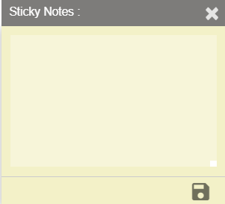
User can add notes here and save using save button which is present at right bottom of sticky note. Upon saving the note, indication will be provided in the node level as shown below.
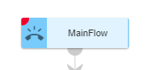
Note: User can add the sticky note to any node/node legs only in DRAFT status of the callflow. Error message is generated when user try to add sticky note to a node in a callflow whose status is not DRAFT.
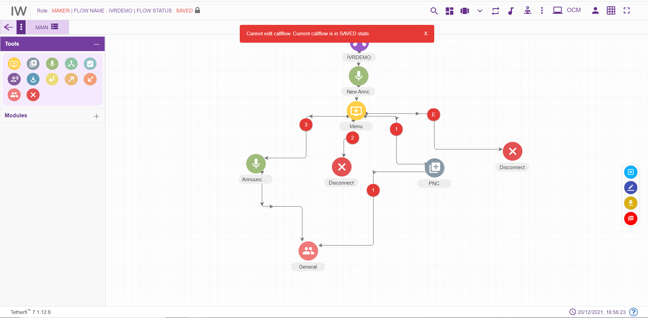

Dashboard
Upon clicking dashboard icon, following page will be displayed.
All the created as well as imported callflows will be displayed here. Callflows of all the status are displayed for Maker, Checker and Previewer.
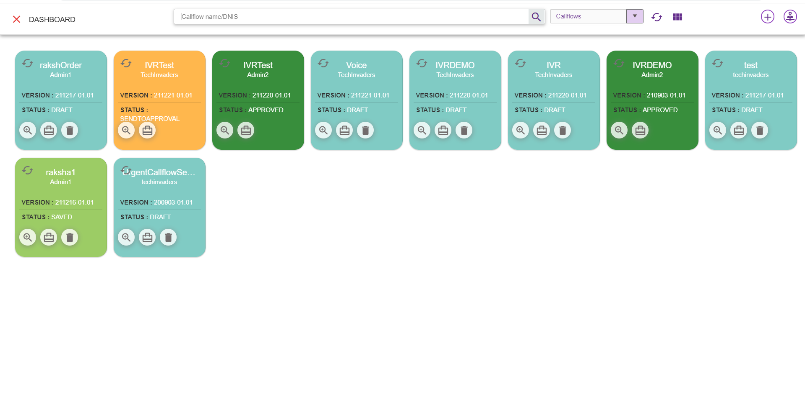
      - Callflow Name/DNIS: Enter Callflow name or Dnis number to search
      - Search for Callflow: This option is used to search the particular callflow based on callflow name and DNIS.
      - Add New IW flow: Configure a new callflow (refer section New IW Flow). This option is only provided for Maker.
      - Add New Order take flow: Create a new order take flow (refer section New Order Take Flow). This option is only provided for Maker.
      - Add New Sub flow: Create a new sub flow (refer section New Sub Flow). This option is only provided for Maker
      - Masters: Different types of master will display here
      - Refresh Dashboard: Refresh the dashboard. Update the callflow lists with latest changes
      - Refresh: This option is used to refresh individual callflow.
      - Preview Callflow: This option is used preview a callflow (refer section Preview )
      - Real-Time callflow View/Report: This option is used to view the callflow. Here user cannot change or modify any callflow. He can just view the callflows (refer section Real-Time View/Report ). This option is provided to Order take flow also.
      - Callflow Build/Package: Callflow will be packed and zip file will be downloaded. This zip file will contain callflow related data. This zip file can be imported (refer section Import Callflow) at other systems. This option is not available for previewer.
      - Delete Callflow: This option is used to delete a callflow. Only Owner of the callflow can delete callflow. And Callflow should be in DRAFT and SAVED state.
      - dropdown: This dropdown contains option to display callflow, Subflow and ordertake flow in dashboard. User can select which option is required.
Callflow: upon selecting callflow option, all the IW flows will be displayed. This callflow contains dnis numbers
Subflow: upon selecting subflow option, all the subflows flows will be displayed. This is a subflow can be used by callflow as well as other subflows. These flows do not have dnis number.
Ordertake: upon selecting ordertake flow all the ordertake flows will be displayed.

Note: callflow which has only DNIS node is cannot be deleted.
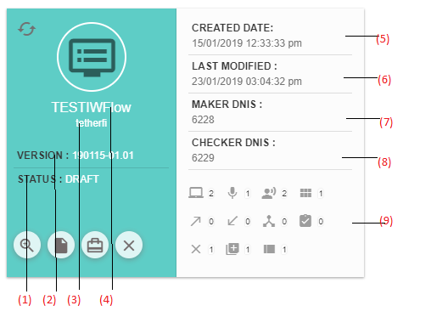
- Status: This option is used to display current status of the callflow
- Version: Current version of the callflow.
- User: Last modified user.
- Flow Name: callflow name
- Created Date: Created date and time. (during imported callflow, created and modified date and time will be same).
- Last Modified: Last modified date and time. The time at which user has saved/ sent for approval/ approved/ rejected/scheduled is updated here.
- Maker DNIS: Lists of Maker DNIS. Intent will be displayed for OrderTake flow
- Checker DNIS: Lists of Checker DNIS.
- Nodes, Modules, tab count: All the nodes/modules/tabs used in a callflow along with their count will be displayed here.
When a callflow is imported, it will be displayed in dashboard and its status will be ‘DRAFT’.
When user try to load a new callflow on top of existing active callflow, save confirmation popup will be generating as shown below.
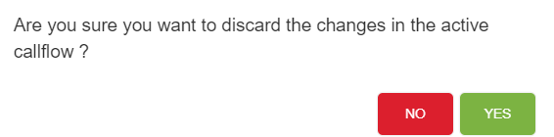
If Yes, Changes done in the active callflow will be discarded and new callflow selected here will be loaded
If No, User can continue with the existing active callflow

Flow Status

Flow status for various users

Flow Status | Previewer | Maker | Checker
DRAFT | Yes | Yes | Yes
SAVED | Yes | Yes | Yes
SENDTOAPPROVAL | Yes | Yes | Yes
CHECKERDRAFT | Yes | Yes | Yes
CHECKERSAVED | Yes | Yes | Yes
APPROVED | Yes | Yes | Yes
SCHEDULED | Yes | Yes | Yes
REJECTED | Yes | Yes | Yes

Draft
Initially when callflow is created, a status of the callflow will be in ‘DRAFT state and only the owner(maker) of the callflow can edit the callfow until owner release the callfow(callfow state to ‘SAVED).
Maker can delete a callflow whose current status is ‘DRAFT’. Callflow which has only DNIS node cannot be deleted even if it is in ‘DRAFT’ status.
In order to change the current status to ‘DRAFT’, click on ‘Edit callflow’ button as shown below. Upon clicking this button status of the flow will change to ‘DRAFT’. User can add, delete or edit a tab in draft status only.
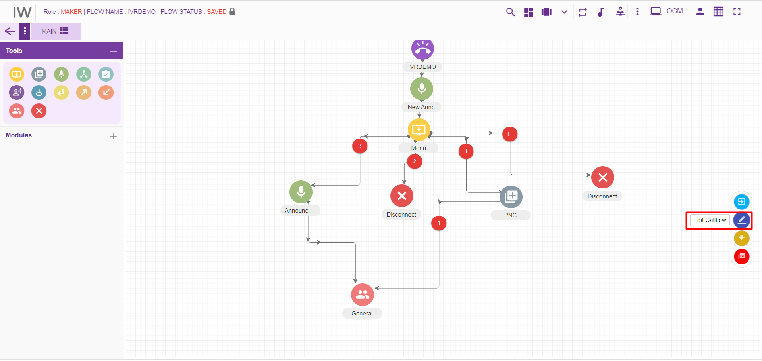

Saved
In order to run a callflow and to send a callflow for approval, its status must be in ‘SAVED’ state. Click on the ‘Save callflow’ button as shown below to save a callflow.
Upon clicking this button status of the flow will be changed to ‘SAVED’. Maker can delete a callflow whose current status is ‘SAVED’. Callflow which has only DNIS node cannot be deleted even if it is in ‘Saved’ status. Callflows whose status is saved, can be accessed by other user (other than owner) and make changes by changing its state to ‘DRAFT’.
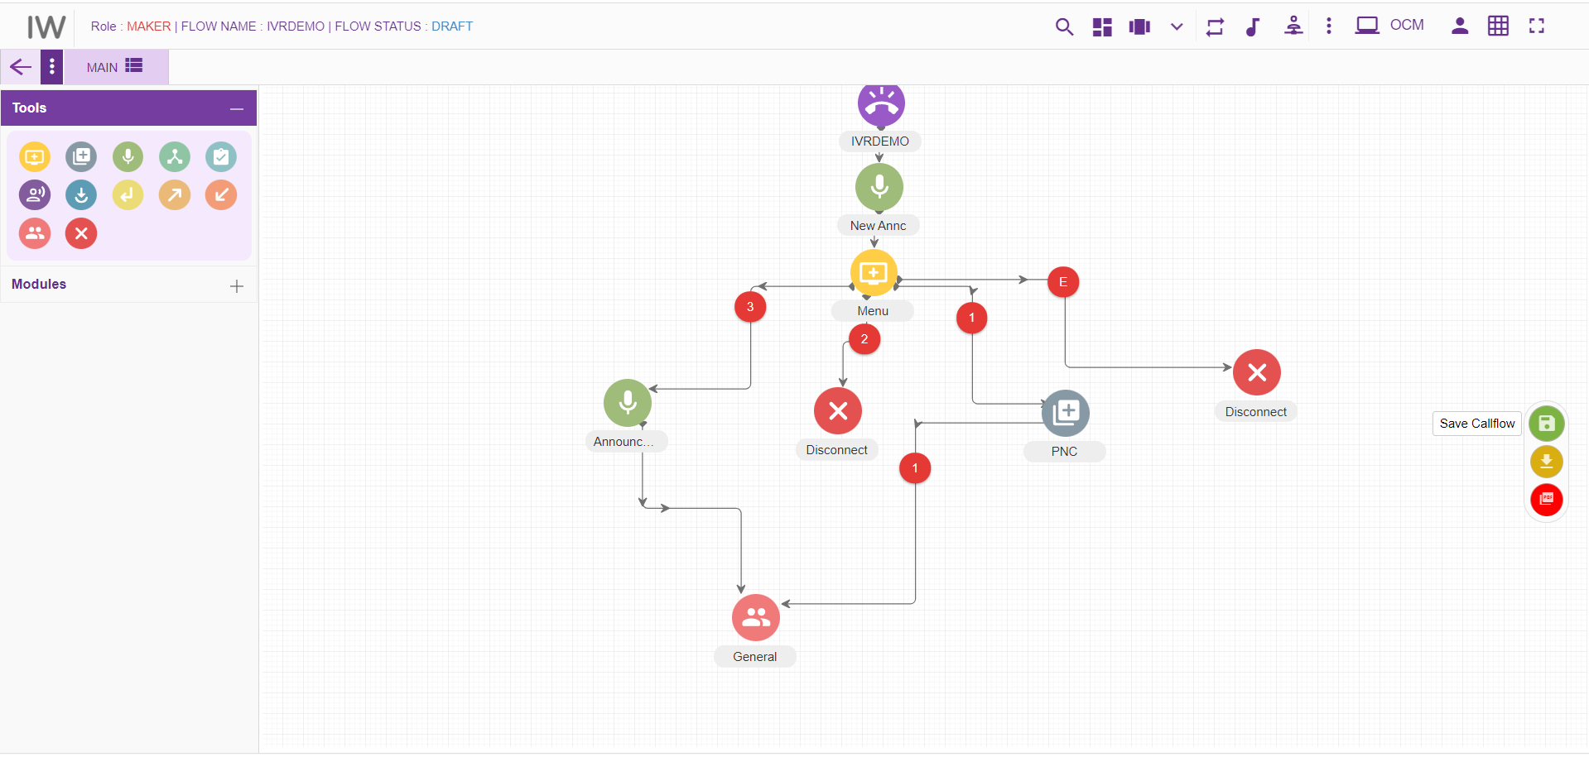

Send to approval
All the callflows created by maker must be approved by the checker to complete its cycle. ’SENDTOAPPROVAL’ option is used to send a callflow to checker for approval. Upon clicking this button status of the flow is will change to ‘SENDTOAPPROVAL’.
Maker cannot delete a callflow whose status is ‘SENDTOAPPROVAL’.
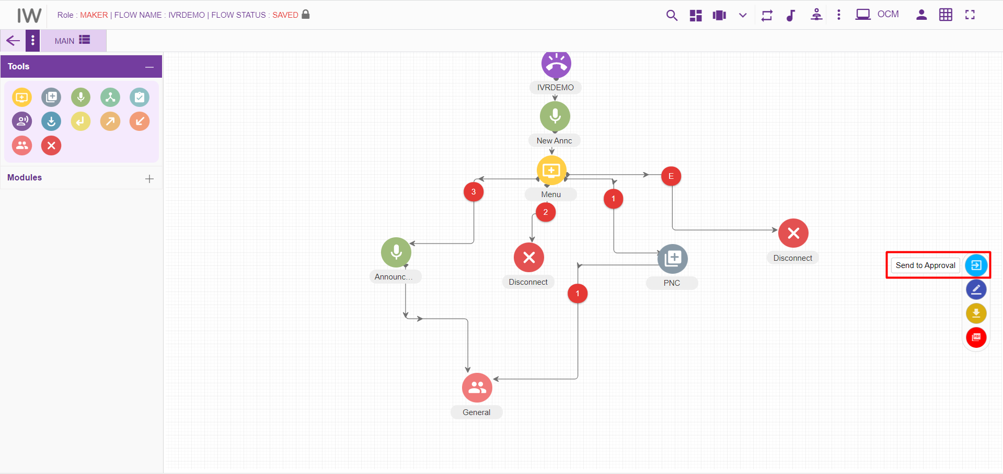

Checker Draft
A callflow will be in this status when checker edits a callflow. Note that checker can only put comments on each node. He can neither edit a callflow (i.e. adding new nodes) nor delete a flow. Upon clicking ‘Edit Callflow’ button in checker page, status of the callflow is changed to ‘CHECKERDRAFT’.
Maker cannot delete a callflow whose status is ‘CHECKERDRAFT’.
Upon clicking ‘Edit Details’ option from node level as shown above, following page will be displayed.
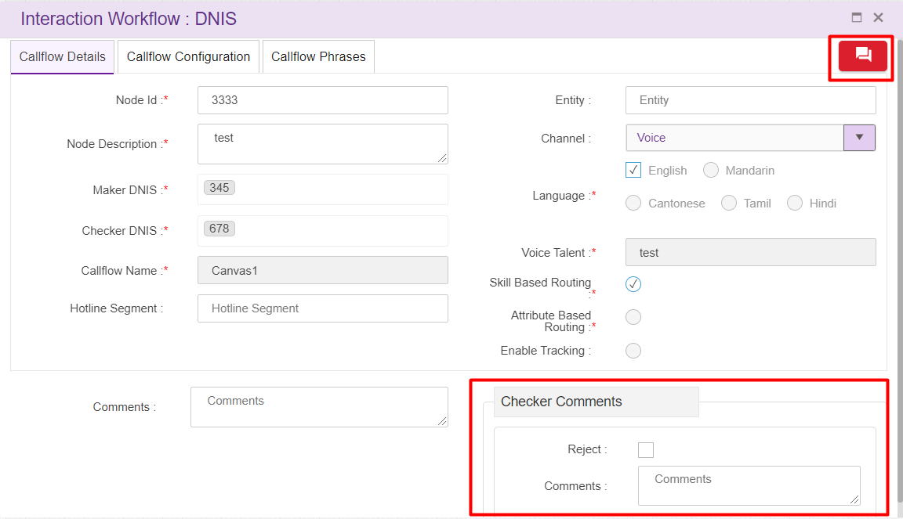
Now checker can enter ‘comments’ specific to the nodes and also can ‘view comments’ from either maker or previous checkers
Upon clicking ‘View Comments’ icon, following window will be displayed.
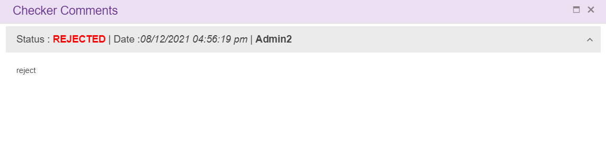

Checker Save
To approve/reject a callflow, it’s status must be either SENDTOAPPROVAL or CHECKERSAVED. When checker Clicks ‘Save callflow’ button, flow status will be changed to ‘CHECKERSAVE’. Checker can approve a callflow even after putting comments. When a Checker cancel the scheduler, callflow status will be changed to ‘CHECKERSAVED’.
Callflow whose status is ‘CHECKERSAVE’ cannot be deleted.

Approved
When a checker approves a callflow, its status will be changed to ‘APPROVED’. Click on the button as shown below in order approve a callflow. Note that, node blink will be stopped once the callflow is APPROVED.
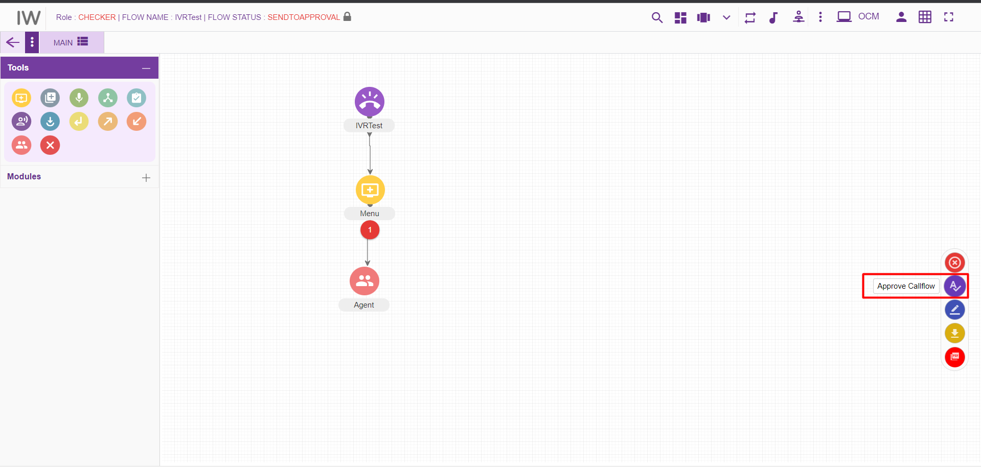
Once the checker approves a callflow, it cannot be deleted. Upon clicking on ‘Edit’ button on loading an approved callflow, new version of the callflow is created. In order to approve the callflow, there must be atleast 1 phrase uploaded to callflow.
Note: user can create only 1 draft callflow from approved callflow. User cannot create the draft version callflow from approved version if there is already a callflow with same name which is in SAVED, SENDTOAPPROVAL, CHECKERDRAFT, CHECKERSAVED, REJECTED, SCHEDULED status.
Error message will be generating when user try to create 2 nd draft version of the callflow from approved version, where first version of the callflow is still not approved.
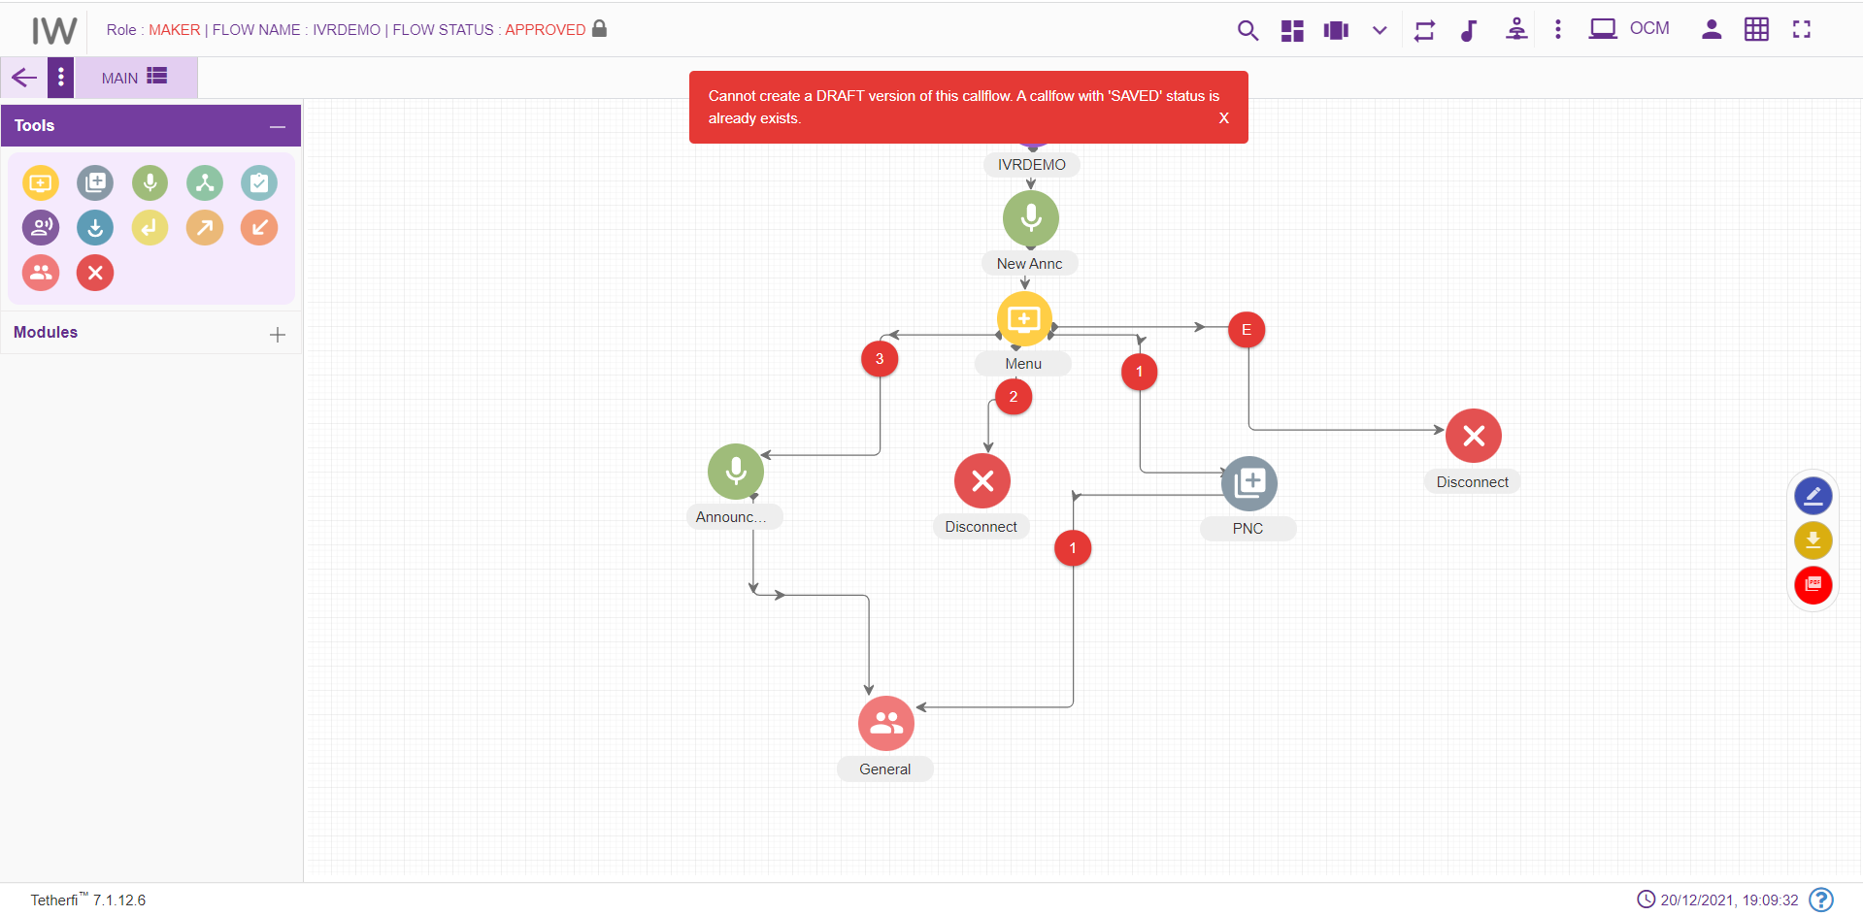If the global phrase used in the callflow is not approved, then a confirmation popup will be generated as shown below, which shows the pending phrases to approve.
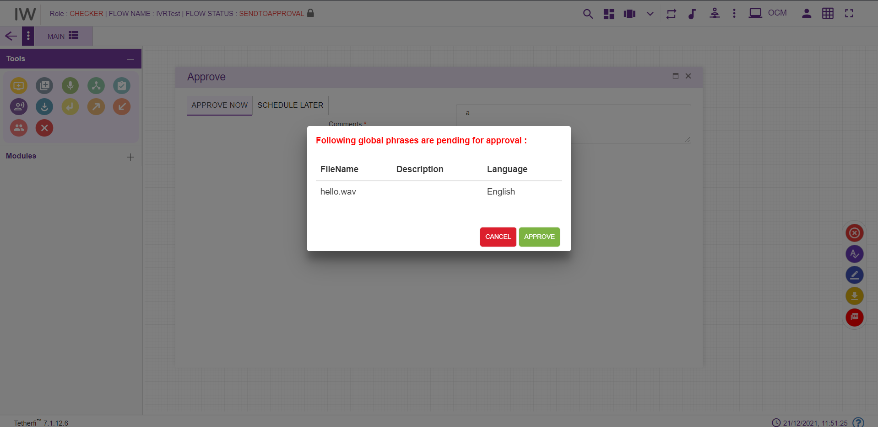

Rejected
Once the checker rejects the callflow, flow status is changed to ‘REJECTED’. Maker can again edit the rejected callflow and send for approval. Checker can reject the callflow without adding any comments to the nodes. Click on the button as shown below in order reject a callflow.
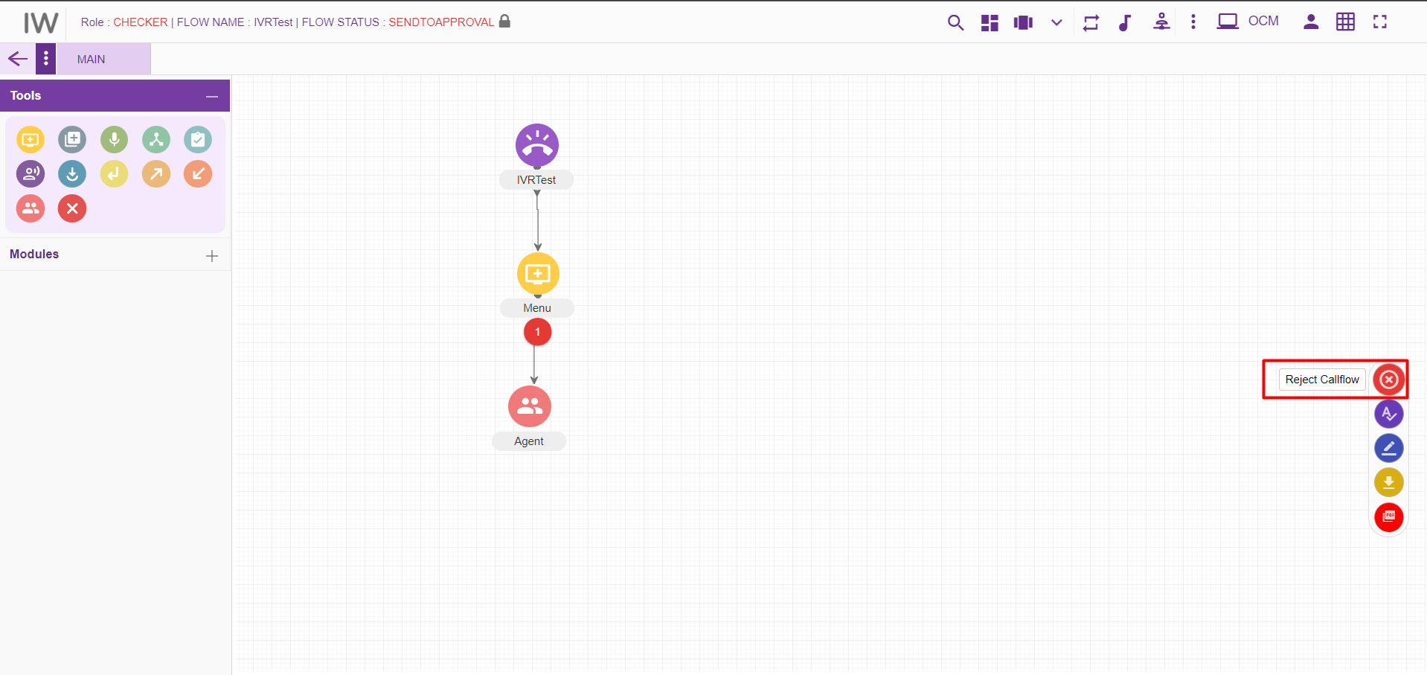

Scheduled
Checker can also schedule a callflow. Upon scheduling a callflow, it’s status is changed to ‘SCHEDULED’. Note that scheduled callflow cannot be deleted. Scheduled callflow cannot be approved by the checker. Once the checker cancels the scheduler, status of the callflow is changed to ‘CHECKERSAVED’. Then the checker can approve this callflow.
Note that, Node blink will be stopped once the callflow is SCHEDULED.
Click on the ‘Approve callflow’ button as shown below.
Click on ‘SCHEDULE LATER’ option as shown below.
Enter scheduling date and time with comments to schedule a callflow and press ‘SUBMIT’ button.
‘Cancel Schedule’ button is used to cancel a scheduled callflow. Upon cancelling the schedule, callflow status is changed to ‘CHECKERSAVED’. Once the user schedules the callflow, same user can only cancel the Scheduled callflow. Another user cannot cancel the scheduled callfow.

Static Flow related Buttons
There are static flow related buttons provided when callflows are in different status. As shown below, when callflow is in DRAFT status, ‘Save Callflow’ button will be displayed.
User can move this button to anywhere in the page and click them to perform SAVE, SEND TO APPROVAL, APPOVE operation on callflow
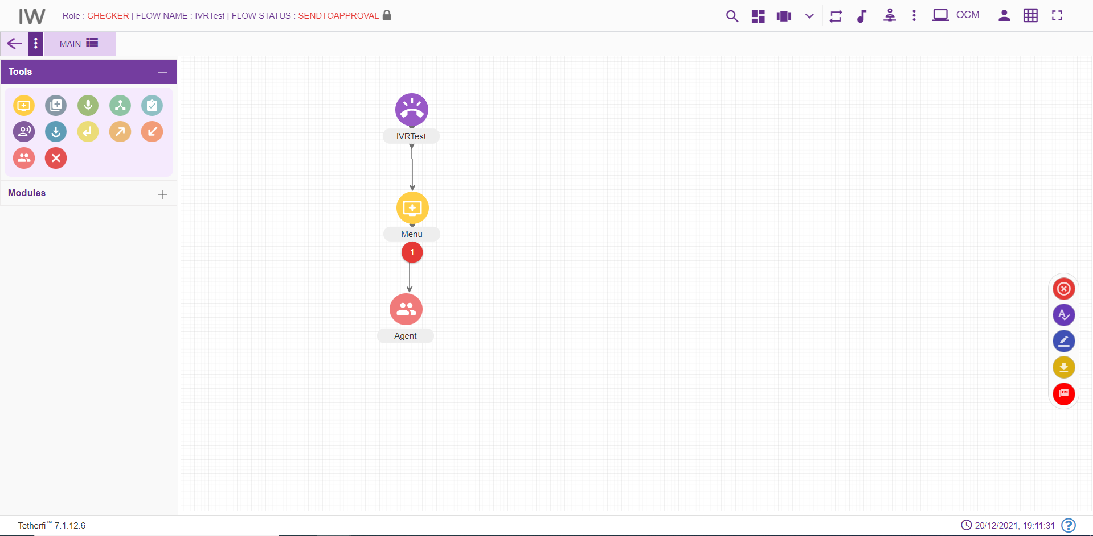
Sl.No | Callflow Status | Static Buttons Displayed
1 | DRAFT | Save Callflow
2 | SAVED | Edit Callflow, Send to approval
3 | SEND TO APPROVAL | Reject Callflow, Approve Callflow, Edit Callflow
4 | CHECKER DRAFT | Save Callflow
5 | CHECKER SAVED | Reject Callflow, Approve Callflow, Edit Callflow
6 | APPROVED | Edit Callflow
7 | REJECTED | Edit Callflow

When callflow is in DRAFT status, SAVED button will start blinking after a configured time expires, which will indicate the user to save the flow, as shown below.
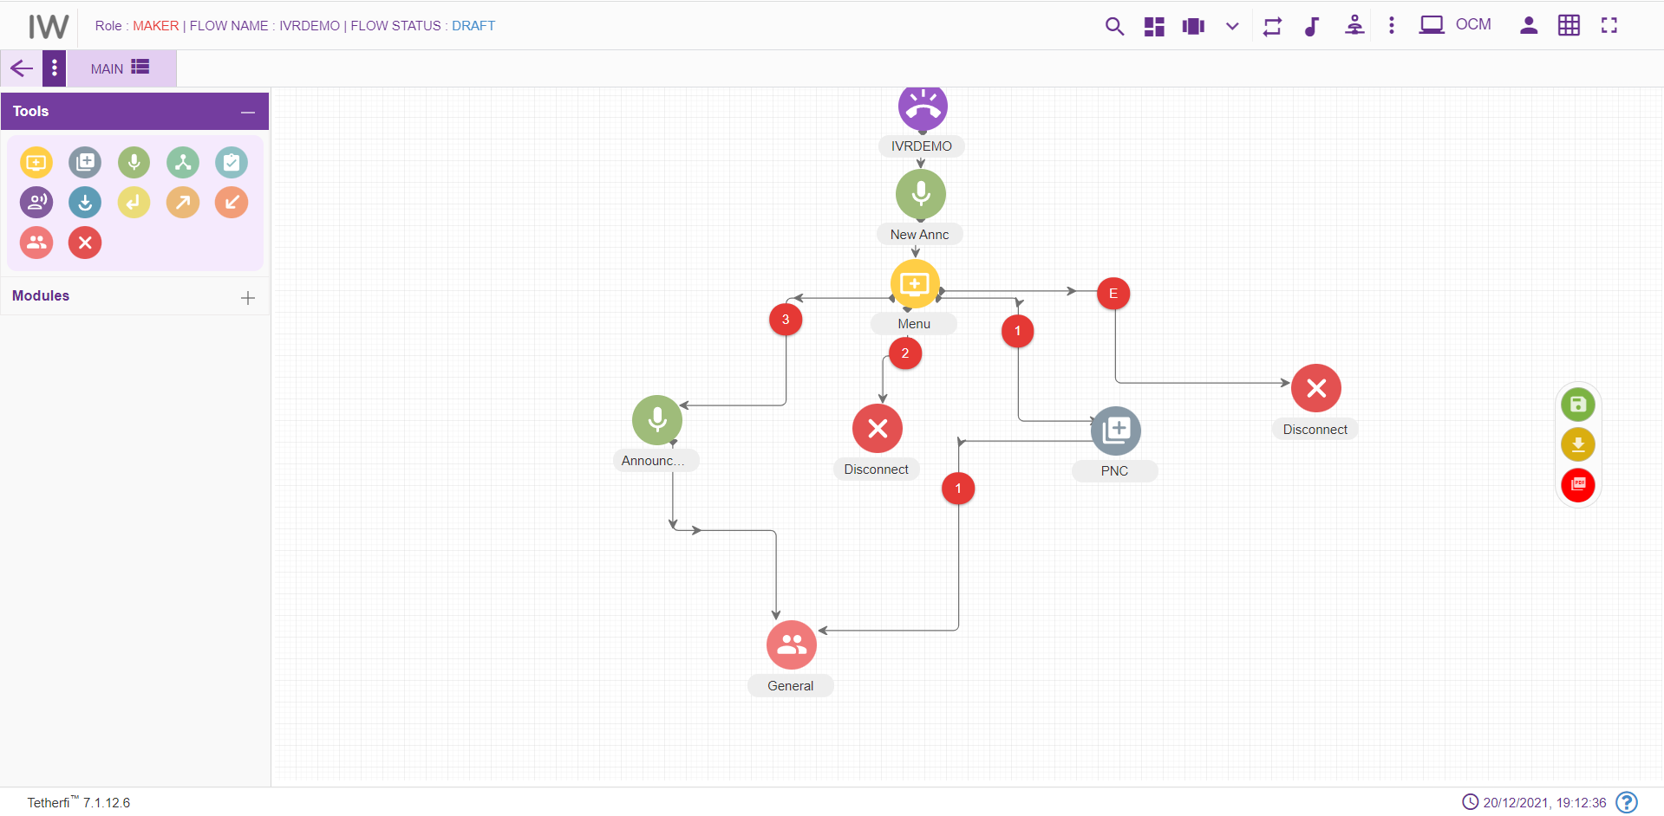

Node Blink
When checker rejects the node, node will blink in maker and maker-checker page. Tab will also blink in maker and maker-checker page, when a node in the tab is rejected by a checker.
Only maker modified nodes will blink in checker page. Note that rejected nodes will not blink in checker page unless maker modify the nodes.
For Exp: When a new callflow is created, all the nodes will blink in checker page, since all the nodes are new (i.e. modified).
When a callflow is approved / scheduled node blink will be stopped. If the callflow status changed to CHECKERSAVED after cancelling the SCHEDULE, nodes will not blink even though they are modified.

Use Case
Please consider the below shown example:
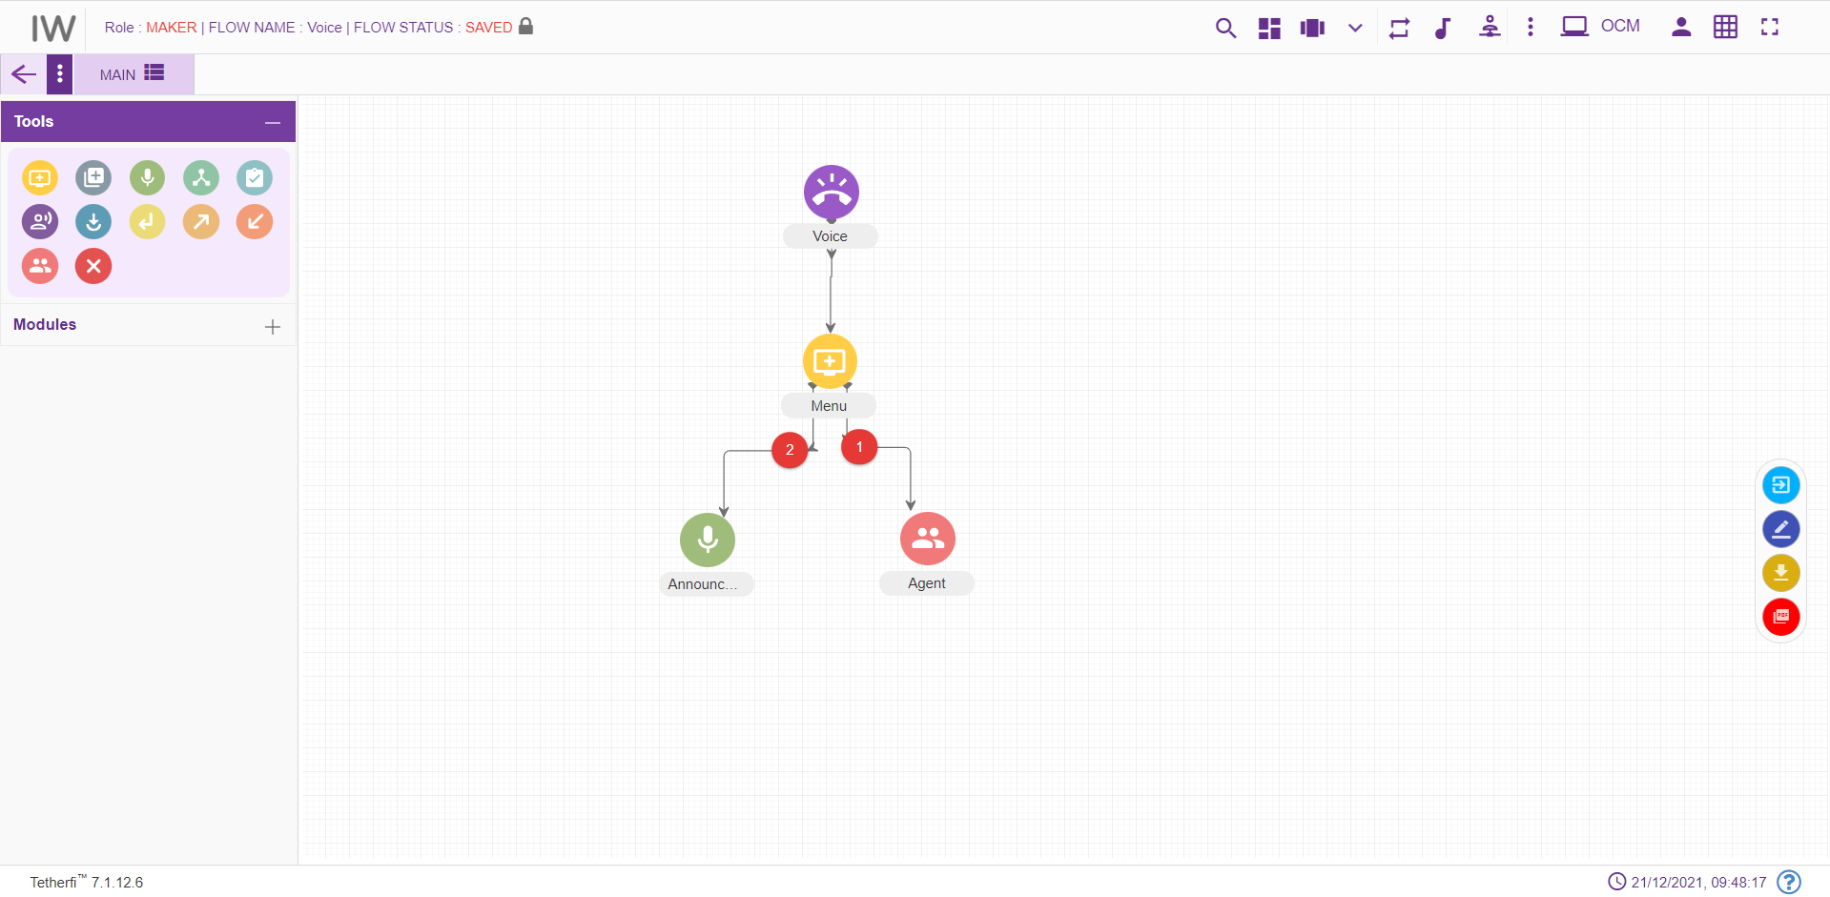
Below are the mentioned are the steps for recreating the above workflow

Step 1: Creating a new DNIS node- test (Level 1)
- On click of Configure Callflow button, the below window will pop up:
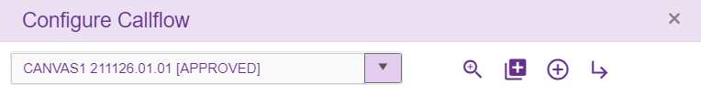
- Click on ‘Create New IW flow’
- Enter the details into the DNIS details screen as shown below:
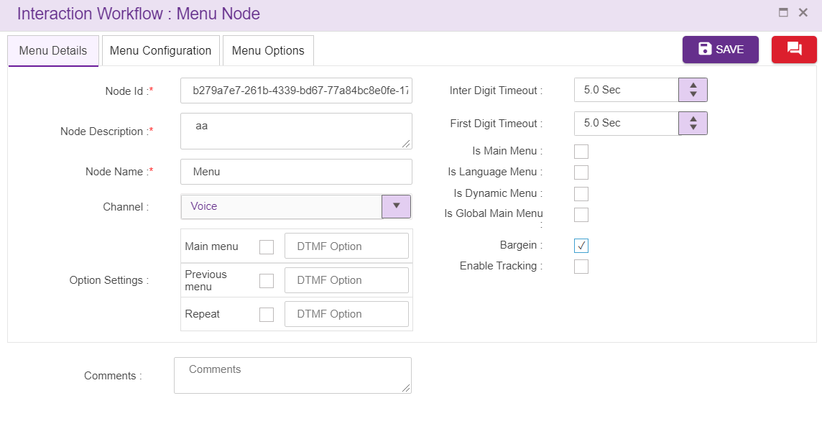
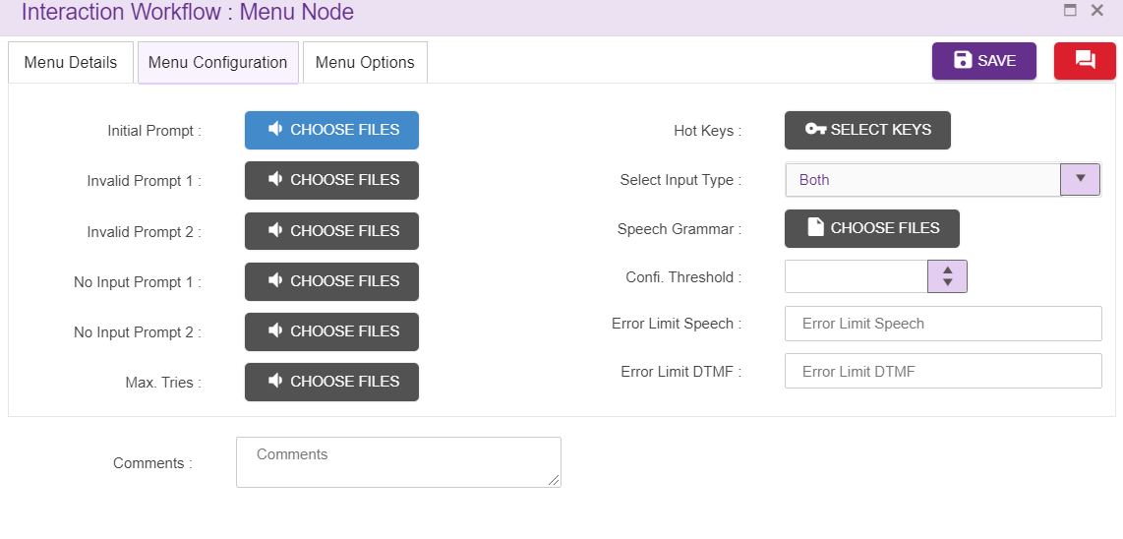
While creating a new DNIS Details please note the below points:
- Maker and Checker DNIS: The DNIS should be unique. Type the 28001 as Maker DNIS number and click “Enter” button to save the DNIS and/or click “,” (comma) to add another DNIS. Maker and Checker DNIS cannot be same. Similarly add 28002 as Checker DNIS
Note: Enter only numeric values as DNIS (Alphabets and special characters are not allowed)
- Call Flow Name: Enter “test” as call flow name
- Hotline Segment: Enter “mass” as Hotline segment
- Greeting Wave File: For selection of wav file for Greeting, click on choose file. (Validation for .wav files only) and add a file as shown below
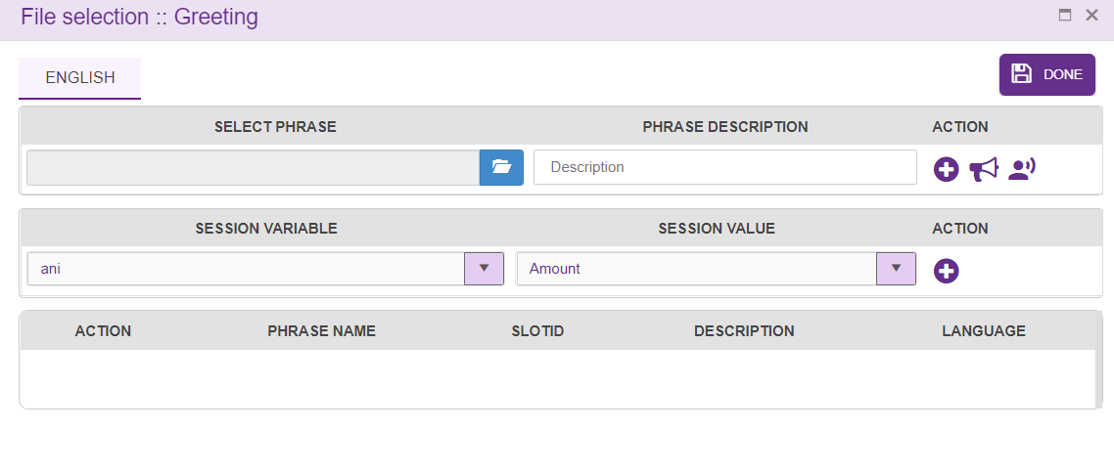
- Voice Talent: Enter folder name where all the uploaded audio files are stored. Example ‘Voice’.
- Entity: Enter “Entity” as the value
- Language: Select English as language. (Mandatory). The Language selection in Call flow configuration segment will be auto configured depending upon the languages selected in the DNIS details segment.
- Comment: Providing a comment before saving is not mandatory.
- Channel: Channel of communication for the callflow, “Voice” by default.
- Error Limit DTMF: Maximum attempts allowed in a DTMF in menu as “3”
- Invalid Prompt 1 and 2: Enter the wave file to be played on invalid prompt event as shown below:
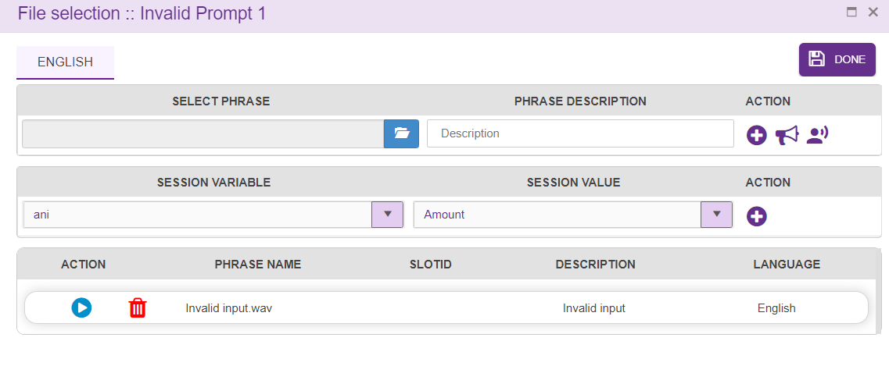

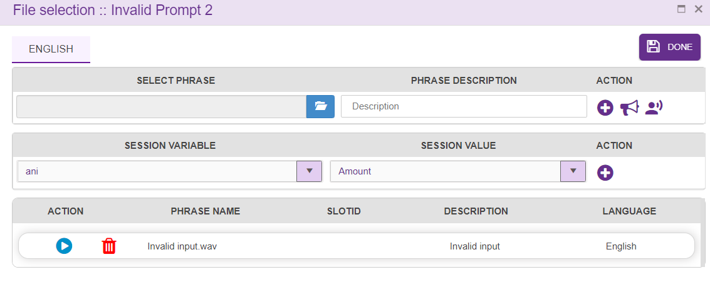
- No Input Prompt 1 and 2: Enter the wave file to be played on no input prompt event as shown below

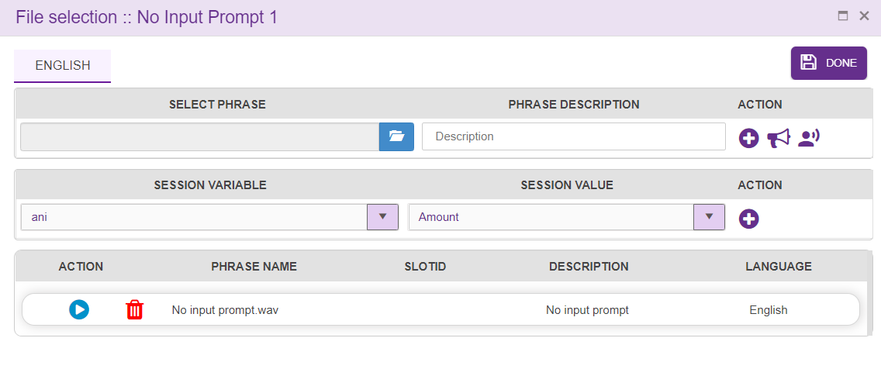

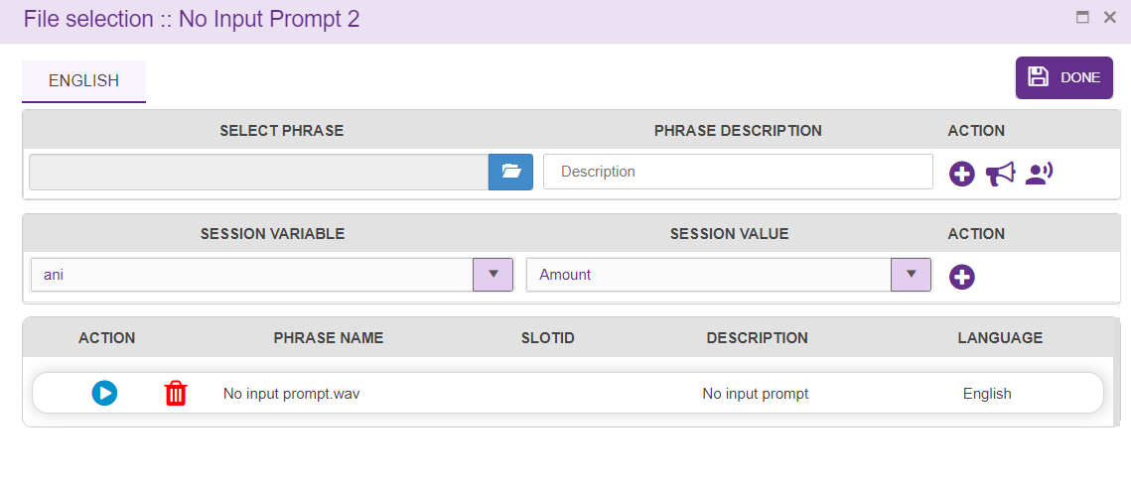

- Max Tries: Enter maximum number of tries in a menu as shown below:
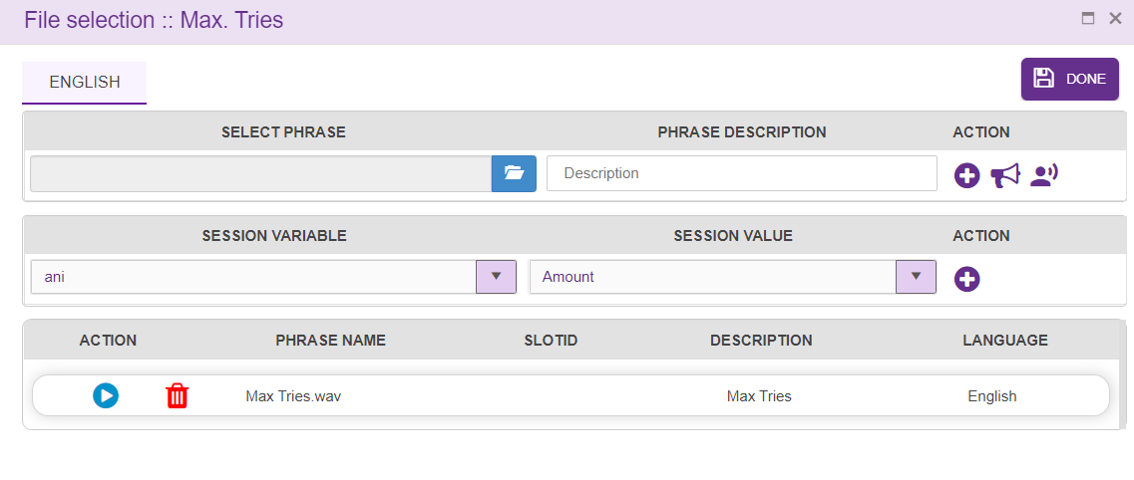

Step 2: Adding a new Menu- Language Selection (Level 2)
- For adding a new Language Selection Menu to the callflow, click on the “Menu” icon and drag it to the main screen. 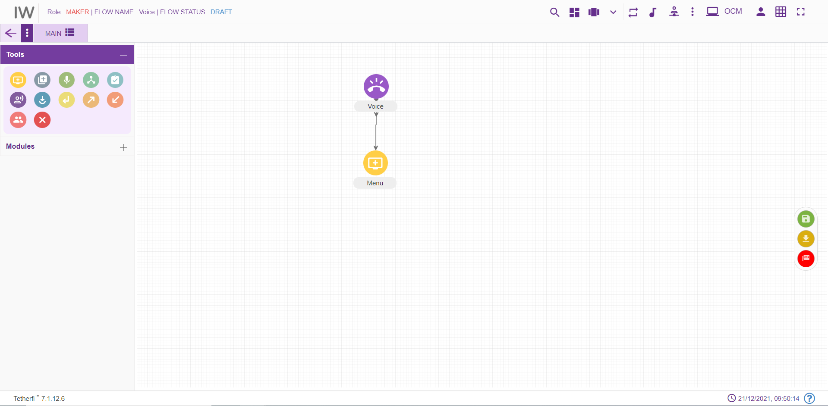
- For editing/ configuring the Menu, hover over the Menu icon you added and edit/ delete functionalities for the menu will be displayed.
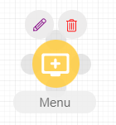
- On click of edit button, the below screen will popup. Enter the details into the Menu details screen as shown below: 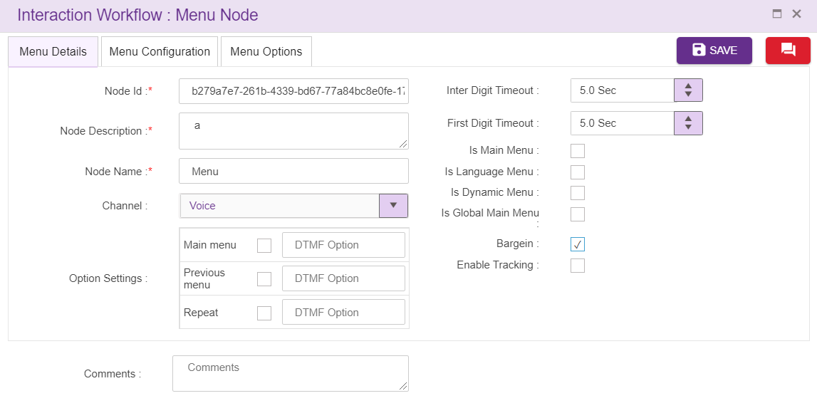
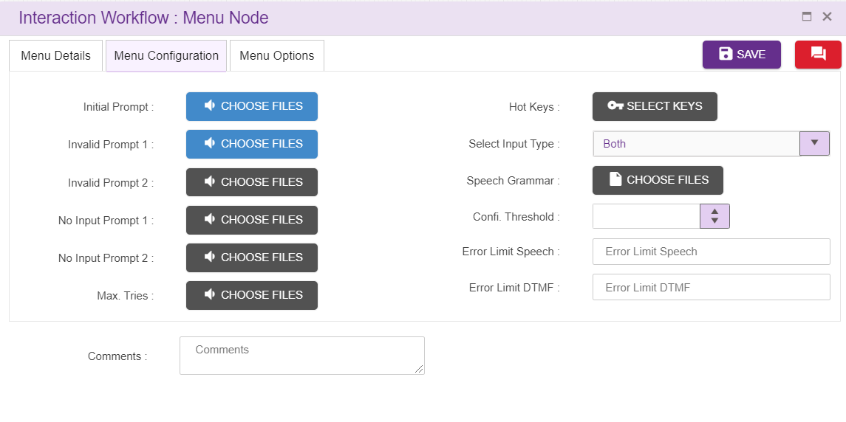
- Menu ID: By default, the Menu ID for a Menu is autogenerated, enter the Menu ID as LanguageMenu. (Mandatory)
- Menu Name: By default, the Menu Name is Menu, enter the Menu Name as LanguageMenu. (Mandatory)
- Menu Description: Enter brief characterization of the Menu as “language menu 2 option”. (Mandatory)
- Is Main Menu: Whether the Menu is the Main Menu of the callflow, click on the check box

- Invalid Prompt 1 and 2: Enter the wave file to be played on invalid prompt event as shown below:

- No Input Prompt 1 and 2: Enter the wave file to be played on no input prompt event as shown below:

- Max Tries: Enter maximum number of tries in a menu as shown below:

Step 3: Adding a new Announcement and Agent- (Level 3)
- For adding a new Agent to the callflow, click on the “Agent” icon and drag it to the main screen.
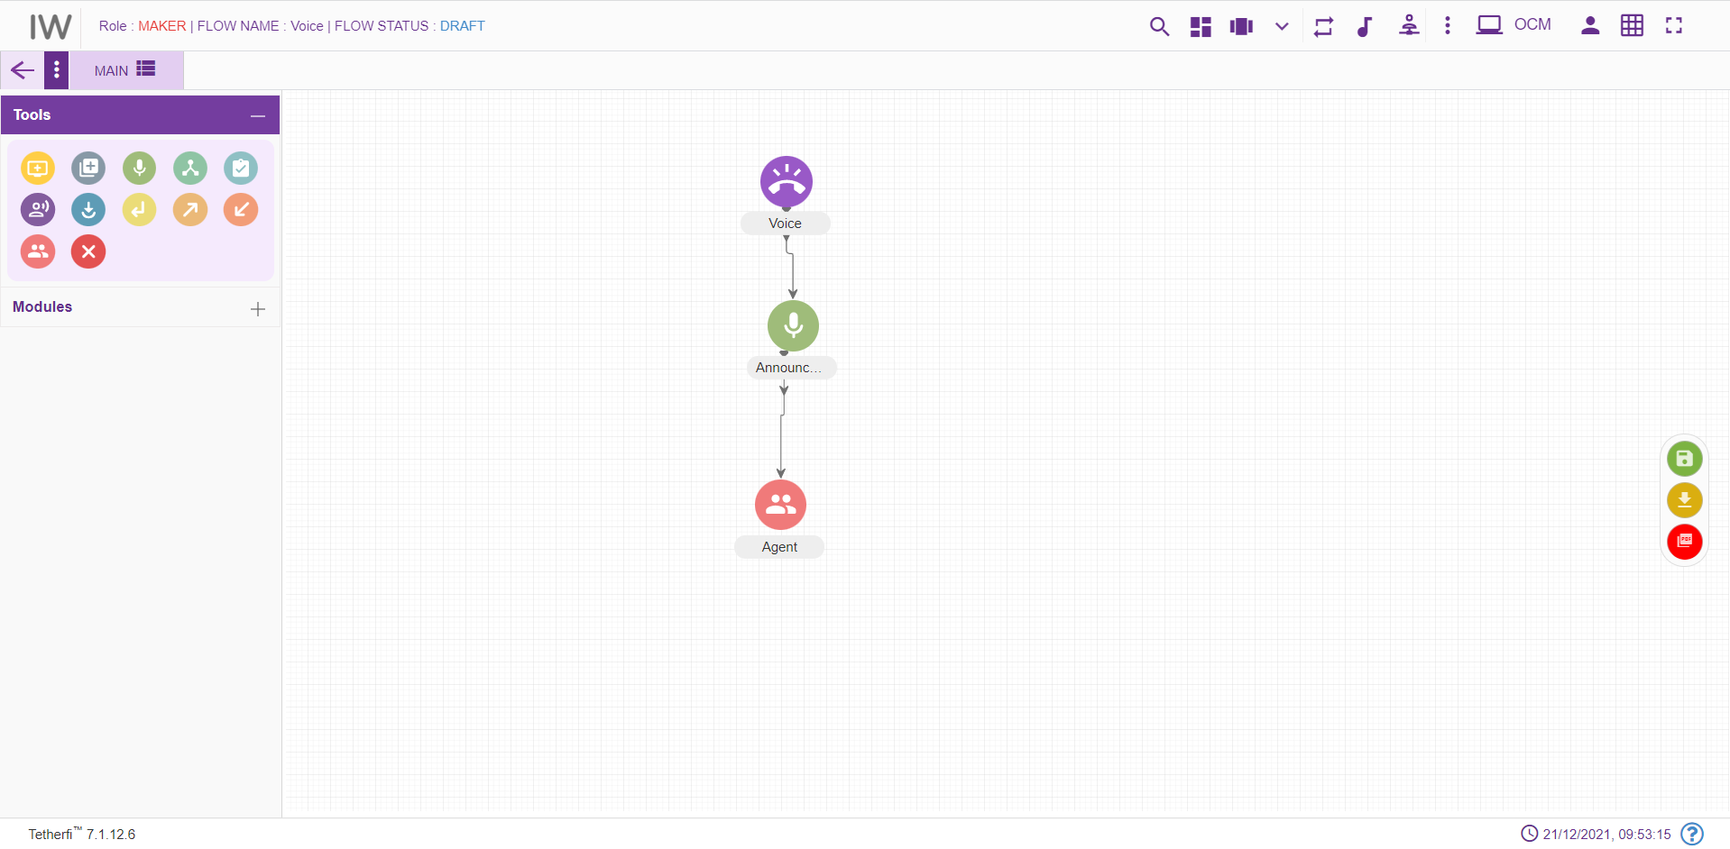
- For editing/ configuring the Agent, hover over the Agent icon you added and edit/ delete functionalities for the menu will be displayed.
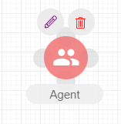
- On click of edit button, the below screen will popup. Enter the details into the Agent screen as shown below:
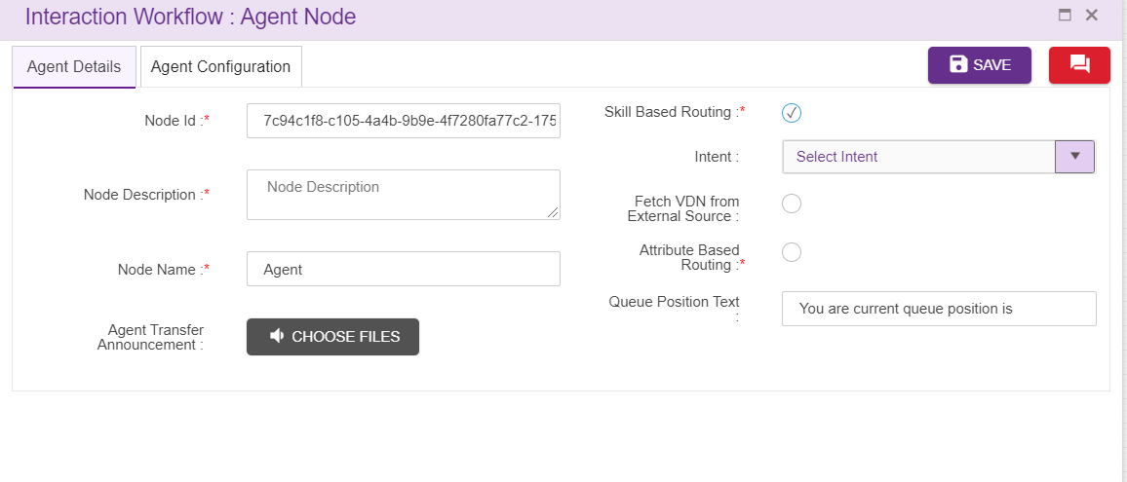
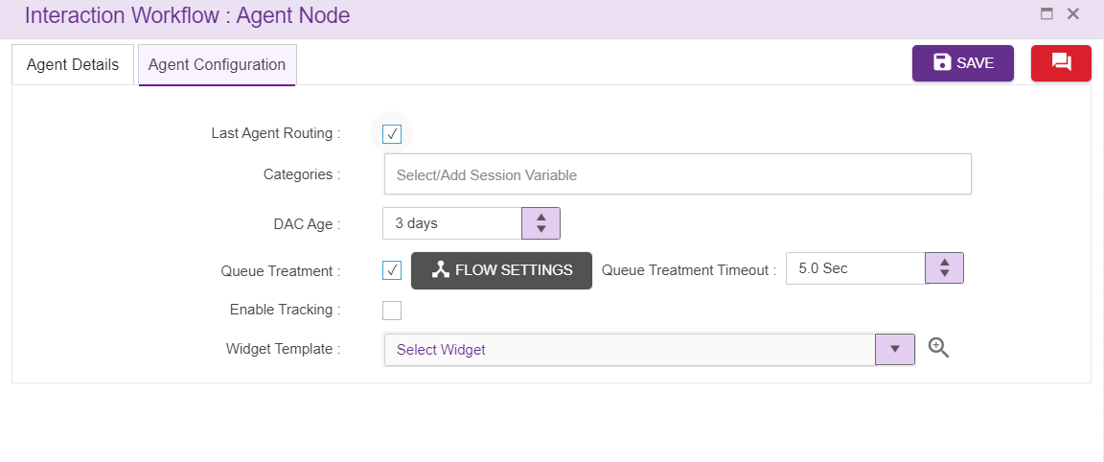
- Intent: Select the intent corresponding to the module or the intents shown in the auto populated dropdown. Note that the Intent should be unique.
- For adding a new announcement node to the callflow, click on the “Announcement” icon and drag it to the screen
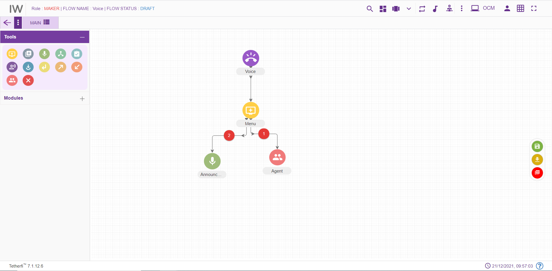
- For editing/ configuring the Announcement node, hover over the announcement icon you added and edit/ delete functionalities for the announcement will be displayed.
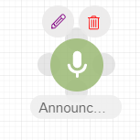
- On click of edit button, the below screen will popup. Enter the details into the announcement details screen:

Step 4: Adding tab One Alongside Main tab (Level 4)
- For adding a new tab alongside the Main tab, click on the “Add New Tab” icon present on the top left corner of the main screen.

- On click of the “Add New Tab” button a new popup will be displayed. Enter the details into the Tab details screen:

Step 5: Adding a new Entry Point and menu to Tab One (Level 5)
- For adding an Entry point to tab ONE, click on the “Entry point” icon and drag it to the Tab ONE screen.
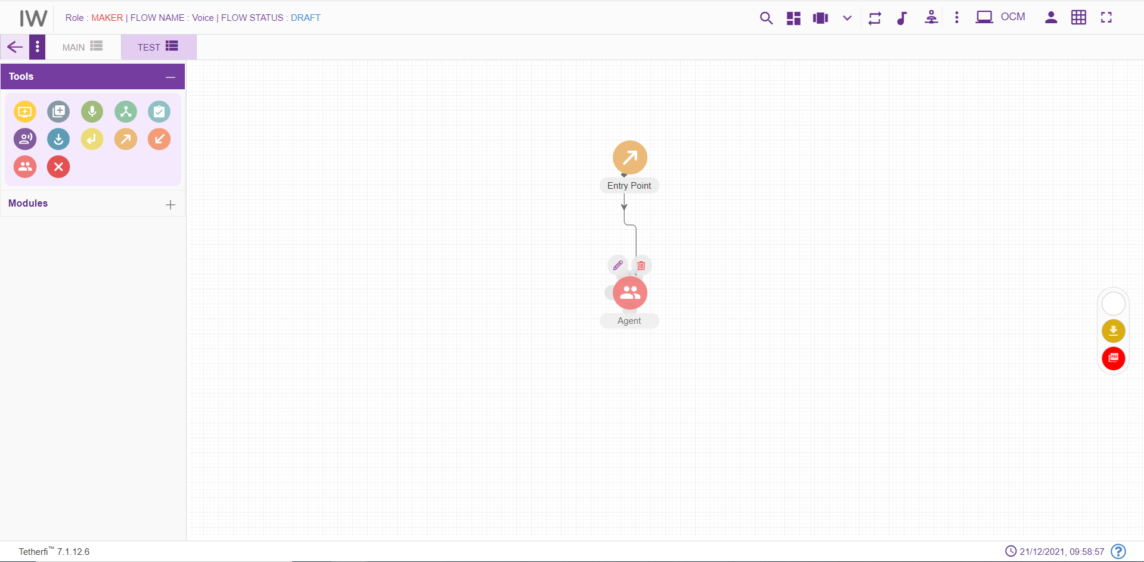
- For editing/ configuring the Entry point, hover over the Entry point icon you added and edit/ delete/ view connections functionalities for the menu will be displayed.
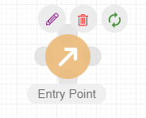
- On click of edit button, the below screen will popup wherein you need to specify the name of the Entry Point. Enter the details into the Entry Point details screen as shown below:
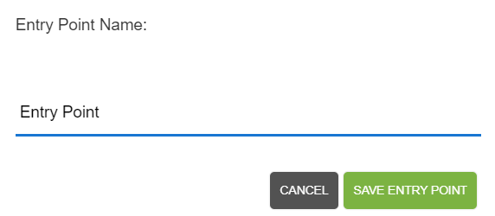
- For adding a new Continue Menu to the callflow, click on the “Menu” icon and drag it to the main screen. 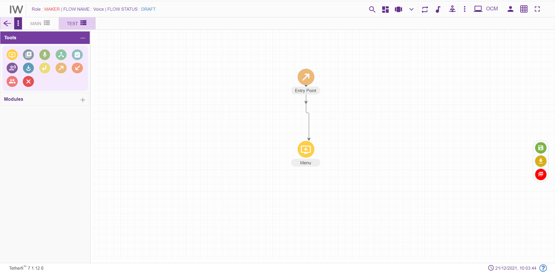
- For editing/ configuring the Menu, hover over the Menu icon you added and edit/ delete functionalities for the menu will be displayed.
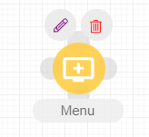
- On click of edit button, the below screen will popup. Enter the details into the Menu details screen: 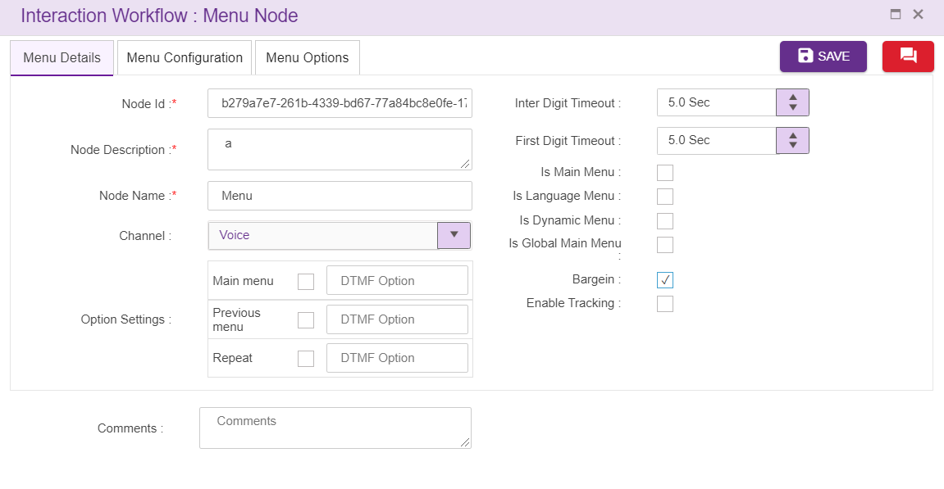

Step 6: Adding an Exit points - (Level 6)
- For adding a “continue” Exit point to Main tab, click on the “Exit point” icon and drag it to the Tab Main screen.
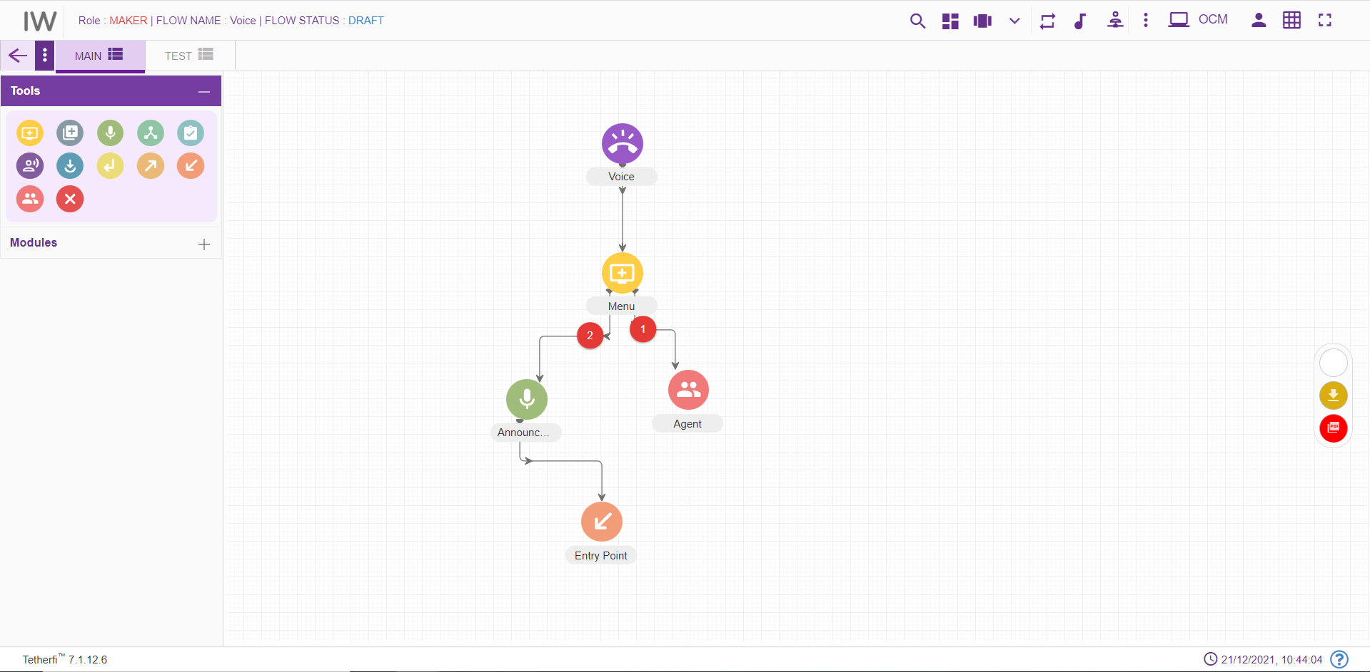
- For editing/ configuring the Exit point, hover over the Exit point icon you added and edit/ delete functionalities for the menu will be displayed.
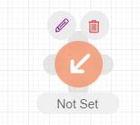
- On click of edit button, the below screen will popup wherein you need to configure the Entry point for the selected Exit point. Enter the details into the Menu details screen as shown below:
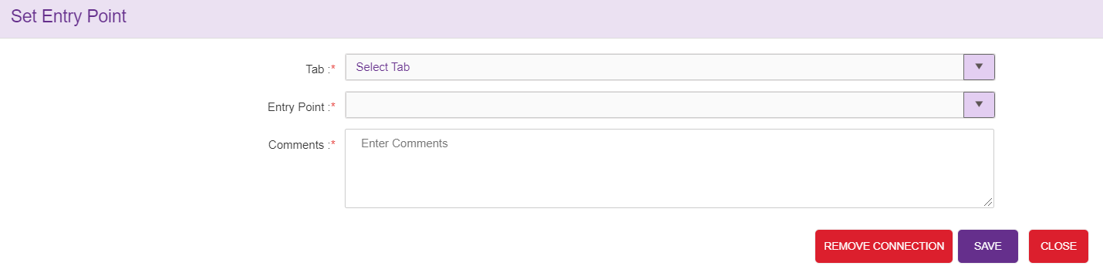

Step 7: Connecting Nodes and Modules (Level 7)
- For interconnecting two or more Nodes/ Modules, you need drag the connecting link as shown below:
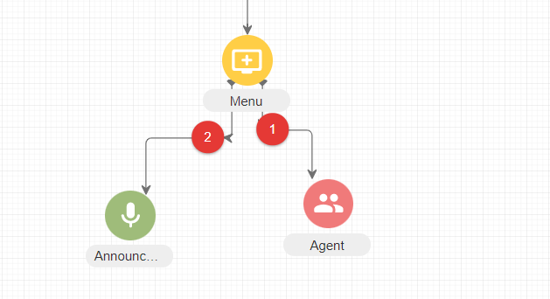
- For deleting a node, double click on the connecting and the below screen will be displayed:
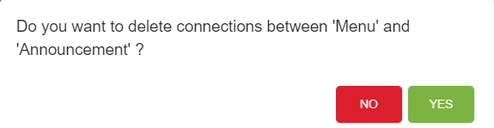

Step 9: Approval of Workflow: (Level 8)
- After Maker is done with creating and configuring a workflow, the workflow needs to be sent to Checker for approval. The Maker can do this by clicking on the “Send for Approval” button present on the top right corner of the screen.
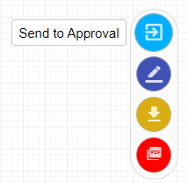
- The checker needs to select the corresponding callflow from the list of callflows, analyze the callflow and depending upon the analysis determine whether the callflow is to be approved or rejected.
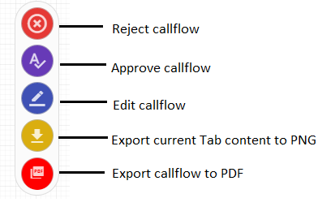
- On click of approve button, the below screen will be displayed 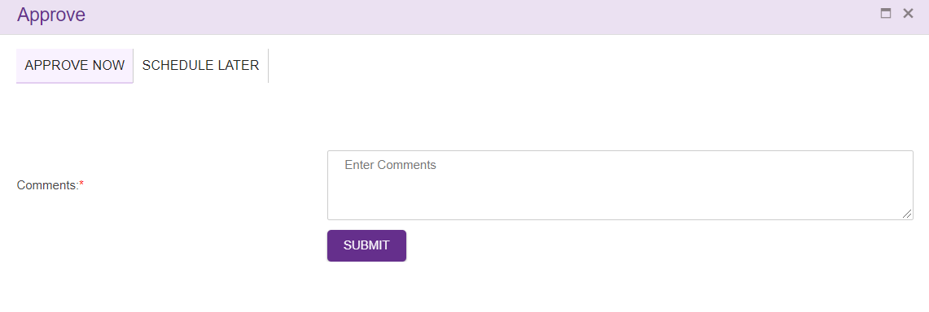
- For approving the workflow, providing comment for the approval is mandatory.
- Can also schedule the approval as shown below. Providing comment for the scheduling is also mandatory.

While Interpreter is down:
1.Adding Speech grammar in menu node
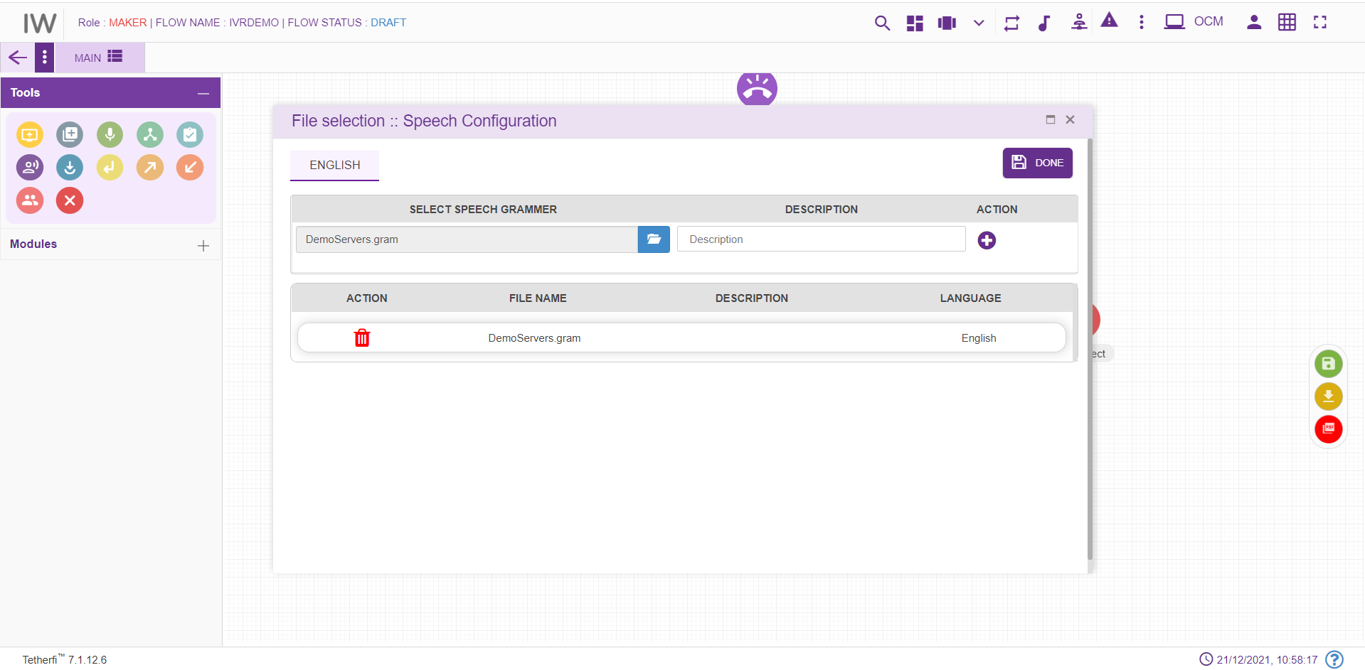
While saving menu node, it will throw error.
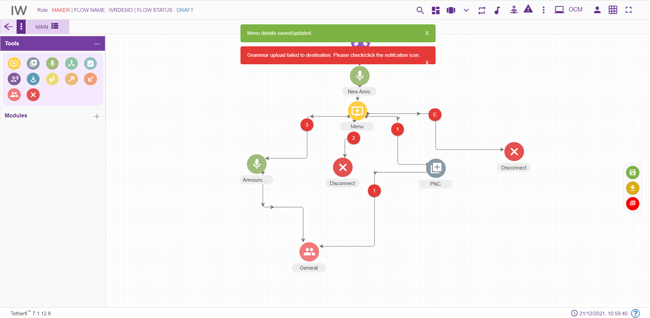

2.Adding Phrases in announcement node and while saving announcement node, it will throw error.
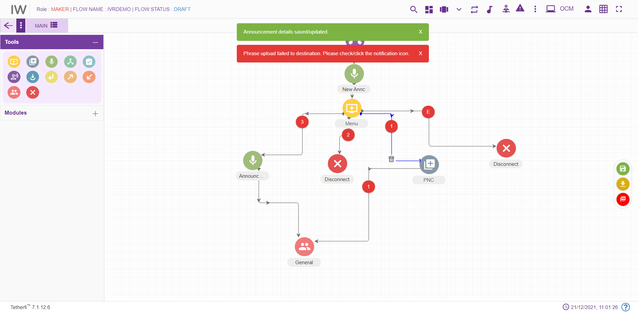
- In the sync notifications error notification will be generated.

When callFlow is sent for approval while interpreter is down.

