Interaction Workflow
Email User Guide
Document Version: 8.0.12.23
Last Updated Date: 2022 January 4



Version History
Version  # |  | Implemented  By |  | Revision  Date |  | Approved  By |  | Approval  Date |  | Description of  Change
1.0 |  | Shriraksha B Rai |  | 08/10/2020 |  |  |  |  |  | Initial version of IW Email user guide
5.0.12.25 |  | Deepthi Shetty |  | 28/12/2020 |  |  |  |  |  | 1. Added 'AutoClose' and 'IsSpam' option and CC Sender Type, BCC Sender Type, CC Pattern, BCC Pattern, CC Domain, bCC Domain, RegEx option is added for Email Rules  2. DAC Routing, Destination Agent Profile, Mapped Agent Routing and to add multiple skill routing option is provided in Route node  3. Unique intents are displayed in ' ADD Routing RULES' section  4. Option is provided to add multiple templates in Auto response node
5.1.1.4 |  | Deepthi Shetty |  | 05/01/2021 |  |  |  |  |  | 1.Copy flow and Subflow option is provided  2.Synonym master option is provided
 | 5.1.1.12 |  | Deepthi Shetty |  | 12/01/2021 |  |  |  |  |  | 1. Checkbox and radio button is provided in Route node to differentiate single selection and multi selection  2. Validation for Mailbox id is provided
 | 6.0.6.7 |  | Deepthi Shetty |  | 09/06/2021 |  |  |  |  |  | 1. Screenshots are changed  2. Updated sendtocustomer and route node.  3. Implemented dashboard in masters
6.1.7.22 |  | Deepthi Shetty |  | 22/07/2021 |  |  |  |  |  | 1.Additional parameters are added to Auto Response node i.e. Append Subject, Append Session ID, Append SR Ticket Number and Append Email Body
6.1.7.30 |  | Deepthi Shetty |  | 30/07/2021 |  |  |  |  |  | 1.Additional parameters are added to Auto Response node i.e.Enable Template Subject, Enable Original Email Trail
7.0.11.8 |  | Deepthi Shetty |  | 30/10/2021 |  |  |  |  |  | 1.Additional parameters are added to Auto Response node i.e.Append CC List and Append BCC List.
8.0.12.23 |  | Deepthi Shetty |  | 23/12/2021 |  |  |  |  |  | 1.Added new canvas changes

Copyright
All rights reserved. No part of this product may be reproduced, transmitted, transcribed, stored in a retrieval system, or translated into any language in any form by any means without the express written permission of Tetherfi.

Warranty Information
Tetherfi makes no representations or warranties with respect to the contents or use of this product and specifically disclaims any express or implied warranties of merchantability or fitness for any purpose. Information in this document is subject to change without notice and does not represent a commitment on the part of Tetherfi.

Trademark Information
Tetherfi is a registered trademark of Tetherfi. Other product names may be trademarks or registered trademarks of their respective companies.

Contact Information
For customer inquiries, contact: For technical support inquiries, call:
Tetherfi +65 6715 7408
60 Paya Lebar Road,
#06-01 Paya Lebar Square,
Singapore

Contents
1 Introduction 7
1.1 Intended Audience 7
1.2 Scope of document 7
1.3 Glossary 8
2 Overview 8
2.1 System Architecture 10
2.2 Interface Design 11
3 Access Details 12
3.1 OCM Access 12
3.1.1 Role Based Access Management 13
3.1.2 User Role Mapping 15
3.1.3 IW Role Based Access Matrix 16
3.1.4 IW Master Access Matrix 18
3.2 Database Table Access 20
4 Interaction Workflow User Roles 21
4.1 Maker 22
4.1.1 Import Flow 24
4.1.2 Copy Flow 25
4.1.3 Callflow Version Control 28
4.1.4 Rule Master 29
4.1.5 Intent Master 35
4.1.6 Rules Viewer 36
4.1.7 Comments 37
4.1.8 Search for Nodes and Modules 38
4.1.9 Search for Texts 39
4.1.10 File System Version 39
4.1.11 Synonym Master 40
4.1.12 Session Master 41
4.2 Previewer 42
5 Creating/Editing Workflows 45
5.1 Configure Emailflow 45
5.1.1 Callflow List 47
5.1.2 Preview 47
5.1.3 New IW Flow 47
5.1.4 Sub Flow 49
5.1.5 Delete 50
5.2 Designing the Workflow 51
5.2.1 Tabs 51
5.2.2 More Menu Option 56
5.2.3 Set Rules 57
5.2.4 Emailflow Sync Notification 58
6 Nodes and Modules 61
6.1 Nodes 61
6.1.1 Auto Response Node 62
6.1.2 Route Node 63
6.1.3 Send to Customer Node 66
6.1.4 Conditional Node 68
6.1.5 Flow Connector node 70
6.1.6 Return Node 71
6.1.7 Entry Point Node 73
6.1.8 Exit Point Node 74
6.1.9 Node Connectivity 76
6.1.10 Disconnect Node 78
6.1.11 Node Changes 79
6.2 Modules 80
6.2.1 IW Module Designer 83
6.3 Connecting Nodes and Modules 83
7 Context Menu 84
7.1 Drag Nodes 85
7.2 Remove ALL nodes Connected to This 85
7.3 Cut and Paste 85
7.4 Copy and Paste 86
7.5 Sticky Note 87
8 Dashboard 88
8.1 Flow status for various users 91
9 Flow Status 91
9.1 Draft 91
9.2 Saved 92
9.3 Static Flow related Buttons 93
10 Use Case 94
Step 1: Creating a new DNIS node- test (Level 1) 95
Step 2: Adding a new Route Node- (Level 2) 96
Step 3: Adding a new Auto Response node - (Level 3) 97
Step 4: Adding a new Send to Customer Node (Level 4) 99
Step 5: Connecting Nodes and Modules (Level 5) 100
Step 6: Saving the Workflow: (Level 6) 101

Introduction
Workflow is the definition, execution and automation of business processes where tasks, information or documents are passed from one participant to another for action, according to a set of procedural rules.
Tetherfi Interaction Workflow makes the process of Email workflow design more efficient, compliant, agile, and visible by ensuring that every process step is explicitly defined, monitored over time, and optimized for maximum productivity, reducing the time the process takes to complete as well as potential errors caused by human interaction. Given optimal, up-to-the-minute process data, managers and employees can take quicker action and make smarter decisions.
Tetherfi Interaction Workflow empowers business users and IT to work together to rapidly modify systems and processes to reflect changes in the business.

Intended Audience
This user guide document is intended for the following audience:
- Business Users
- IT team
- Project Manager
- Application implementation team
- Application maintenance team

Scope of document
This is a systematically written guide for users to manage the ‘Interaction Workflow’ application. By accessing and managing the Interaction Workflow application, users will be able to define/change certain behaviour of Email application according to their preferences or business requirements without needing any code change.
Web based GUI application will be provided for accessing the User Admin (Maker) & Reporting module and these modules will be deployed on the IIS web server provided by the Client.

Glossary

Term or Acronym | Definition or Description
OCM | Omni Channel Management
IW | Interaction Workflow
GUI | Graphical User Interface
UI | User Interface

Overview
An Interaction Workflow is a series of connected blocks that performs various tasks for decision making and routing. Tetherfi Interaction Workflow Designer is a powerful, integrated development environment (IDE) that you can use to create, assemble, and customize workflows. With Tetherfi Interaction Workflow, you can:
- Create the custom nodes and modules in Interaction Workflow and reuse the same in different workflows. You do not need any external tools or block definition languages.
- You do not need to convert the flowchart. You can directly integrate the newly created/ edited workflow into production.
Rearranging connection:
Any of the nodes can be moved in the Workflow Designer interface to a different part of the call flow. To move an interface element:
- Use the mouse to select and hold the items.
- Drag the element to the desired position and release.
Connection points can be rearranged, if the default connection points, on a block do not meet the needs of the workflow. For example, if the Yes connection of a decision block is on the right, that connection can be moved to the bottom.
IW Features:
List of tasks that can be achieved using interaction workflow:
- Add/Remove options.
- Rearranging the option sequence.
- Enable/disable options based on the rule.
- Attach the self-help module to an option.
- Configure the input parameters required for the modules.
- Perform conditional checks based on rule.
- Maker/Previewer.
- Copy and paste the nodes.
- Reversion/Scheduling
- Option to configure specific menu as Language Menu/main Menu
- Add rules based on time, date, date range and operational variables.
- Multiple tabs. It helps to create the reusable flows and break the complex flows into multiple tabs
- Comments from the maker is displayed under notifications.
- Rearranging Tabs
- Copy- paste Tabs
- Node search
- Sub Flow design
Workflow Preview:
The Workflow Preview is a virtual window of your workflow. Use the Workflow Preview to:
- Navigate the workflow
- Change the amount of workflow that you view at one time
- Zoom in on a section of the workflow
- See the whole workflow
Workflows save time and certainly ensure transparency and reproducibility. They also can do a lot more. Consider these ten benefits of incorporating workflows in your project management.
- Workflows reduce project risk. When a project is at risk, it elevates project complexity, and the number of team members can increase. Workflows can ensure that there are decreased delays in the schedule. It can also be responsible for reducing possible disputes and costs by limiting the need to redo work.
- Effect organizational change. When a team works cohesively, it limits the need for management to intervene on the business process side and can provide an improved understanding of the workflow.
- Implementing workflows can lead to process change. As part of developing a workflow, businesses must scrutinize their current processes. This can lead to improvements and optimizations.
- Workflows give increased access to information. Critical processes may be reviewed at every point, ensuring that there are no bottlenecks or issues. This oversight allows project managers to determine how well the process is running from end-to-end.
- Workflows delineate work responsibility to different people. Instead of your staff being uncertain about whose responsibility it is to complete a task or where their own duties lie, a workflow defines it for them.
- Improves project timeline estimates. Gives project managers a basis to estimate how long a task or the overall project will take.
- Provides visibility. Workflows are a way to visually communicate the process to stakeholders.
- Managers can focus on strategy. When a system is running smoothly, managers don’t need to spend time focusing on operations. Instead, they can pay attention to other parts of their job, which can promote business growth and development.
- Workflows provide an audit trail. This is especially true when using a workflow management software system. Records are kept of the progress and completion of tasks, along with pertinent details such as who completed the action, when it was done, and any changes made.
- Businesses can input rules. Instead of people deciding in the moment when issues arise, workflows refer to the predefined rules. This eliminates some of the guesswork, saving time and boosting confidence in the organization’s work capacity.

System Architecture
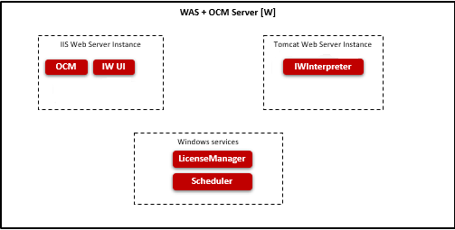
- OCM (Omni Channel Management): Web based application to administer the data and generate the reports.
- IW (Interaction Workflow): Web based application to create and manage the call flows.
- IWInterpreter: It interprets the data submitted from IW and converts it into expected format. It does flow validations.
- License Manager: It maintains the license details and indicates whether the software can run on the system.
- Scheduler: It process the scheduled task.

Interface Design
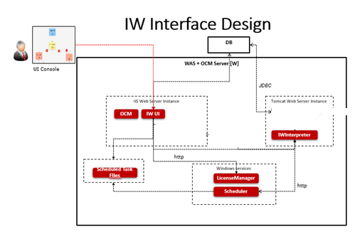
- IW UI talks to License Manager to very whether license is available when launching IW UI.
- Changes made in UI is saved locally in JSON format and submitted to IWInterpreter.
- IWInterpreter validates the JSON submitted and stores the data in memory. It also stores the data in JSON file. It would read the data from file when server restarted.
- IW UI saves the scheduled task details in JSON.
- IW Scheduler retrieves the scheduled task from JSON and submits updated flow to IWInterpreter. IWInterpreter updates the memory and local JSON file.

Access Details
Interaction Workflow is designed to be compatible with below web browser:
- Microsoft Internet Explorer (IE 11 or above)
- Google Chrome (Chrome version 23, 39, 43, 45, 50 or above)
- Firefox (version 41)
- Microsoft Internet Information Services (IIS version 7 and above)

OCM Access
For accessing Interaction Workflow, OCM must be accessed first. The procedure for accessing OCM is mentioned below.
The user must type the provided OCM link(http://IP:PORT/OCM) in the browser and press ‘Enter’ key, OCM will prompt user to enter his Windows username and password.
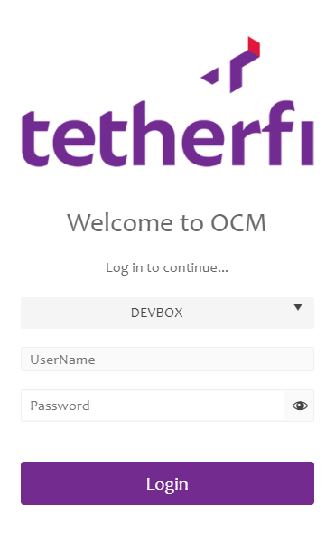
After successful authentication, the below screen will be displayed.
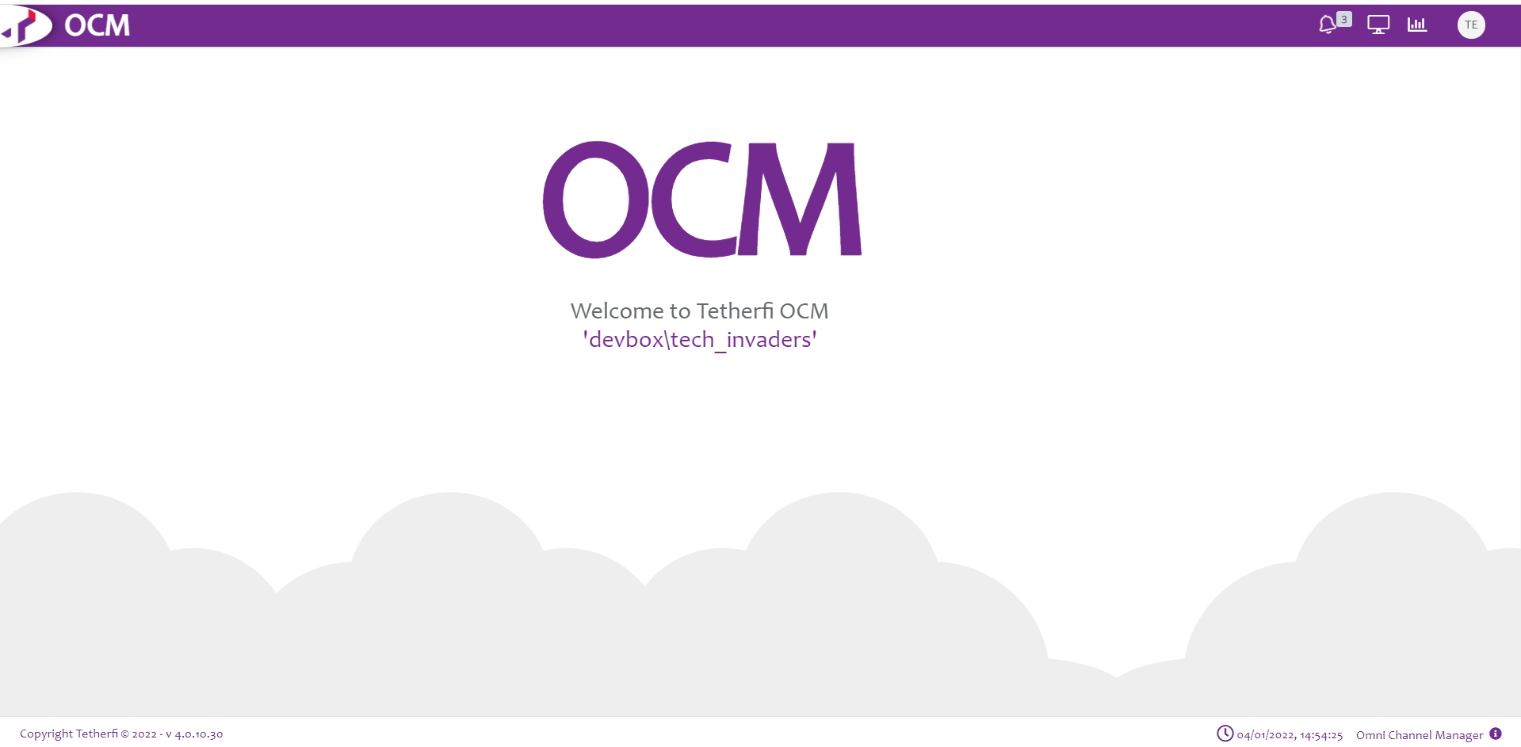
All Users will be presented with the OCM Dashboards.
Administrator is allowed to create maker/checker (or both)/previewer:
Upon logging into OCM, IW Role Based Access Matrix, Role Based Access Management and User Role Mapping modules will be displayed in Home section.
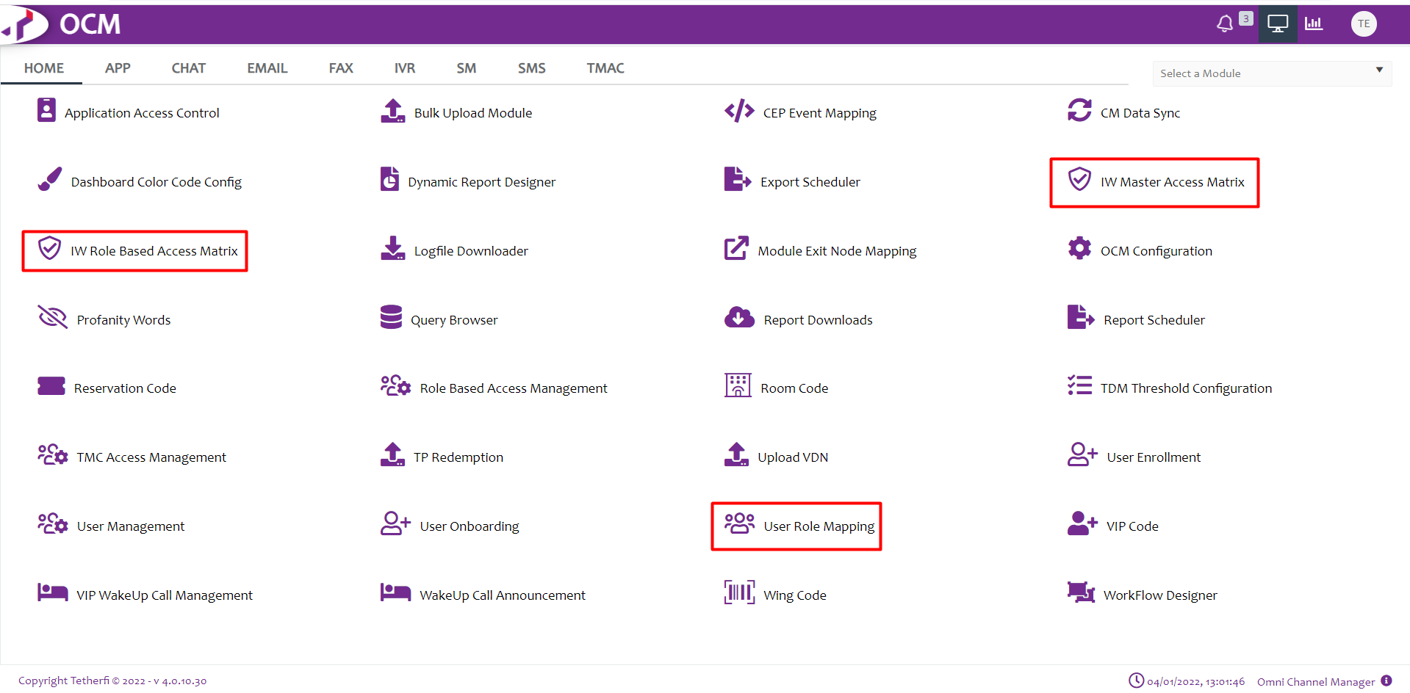

Role Based Access Management
This module is used to add the roles. Upon clicking this module following window will open and all the roles added will display here.
User can add new role, by clicking ‘Add New Role Based Access Management Record’ button present at top left corner.
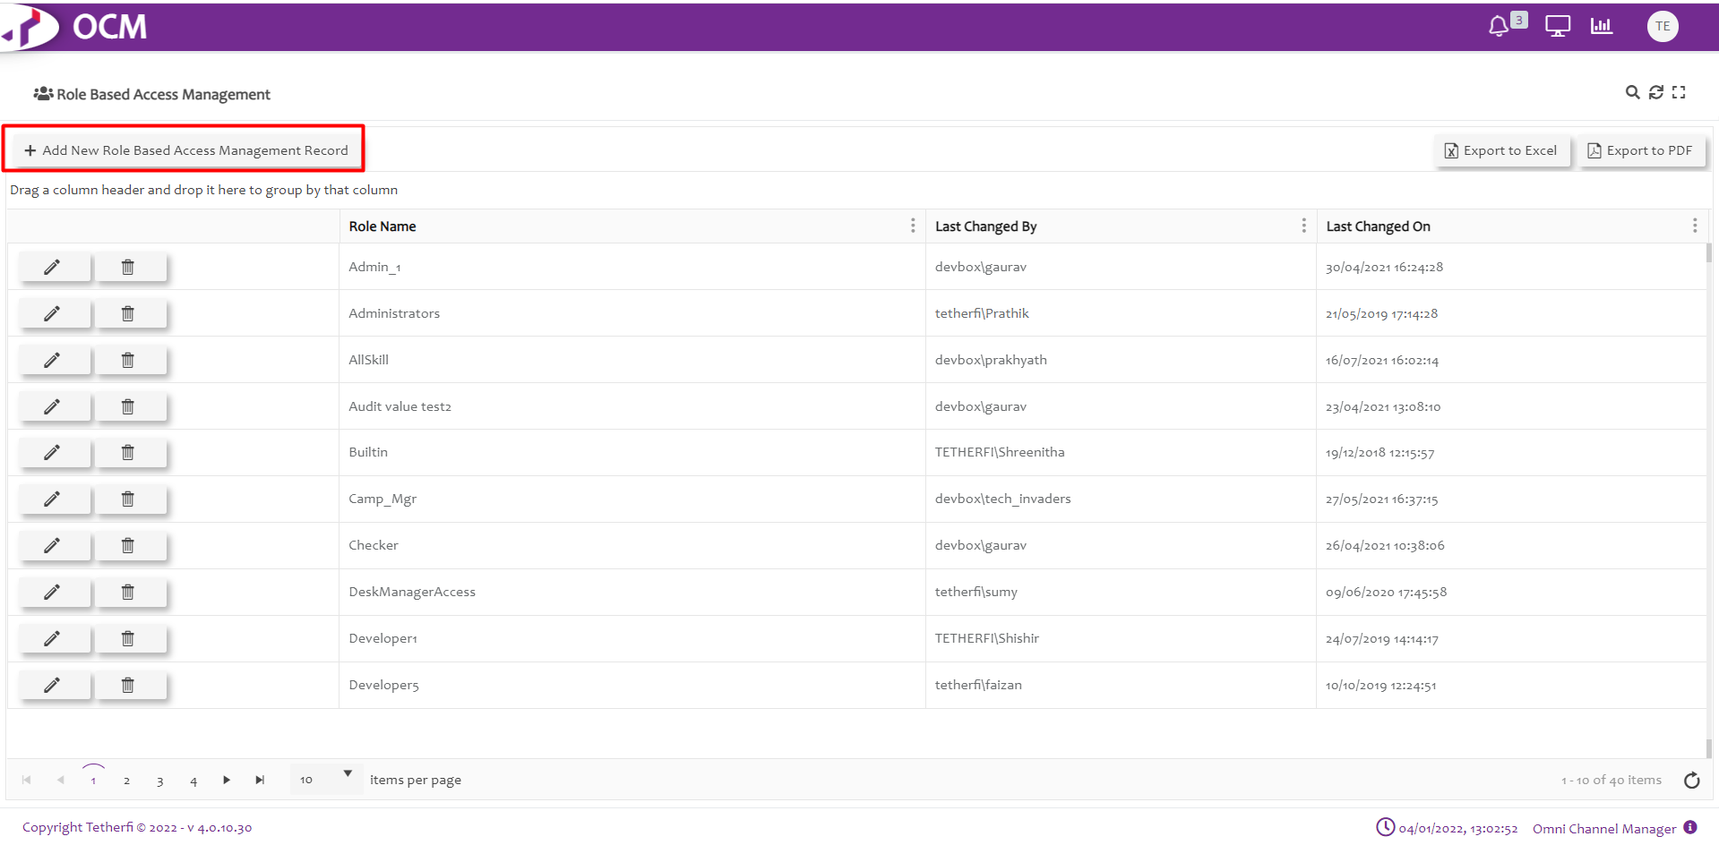
Upon clicking ‘Add New Role Based Access Management Record’, Following popup will generate. User can create new Role here.
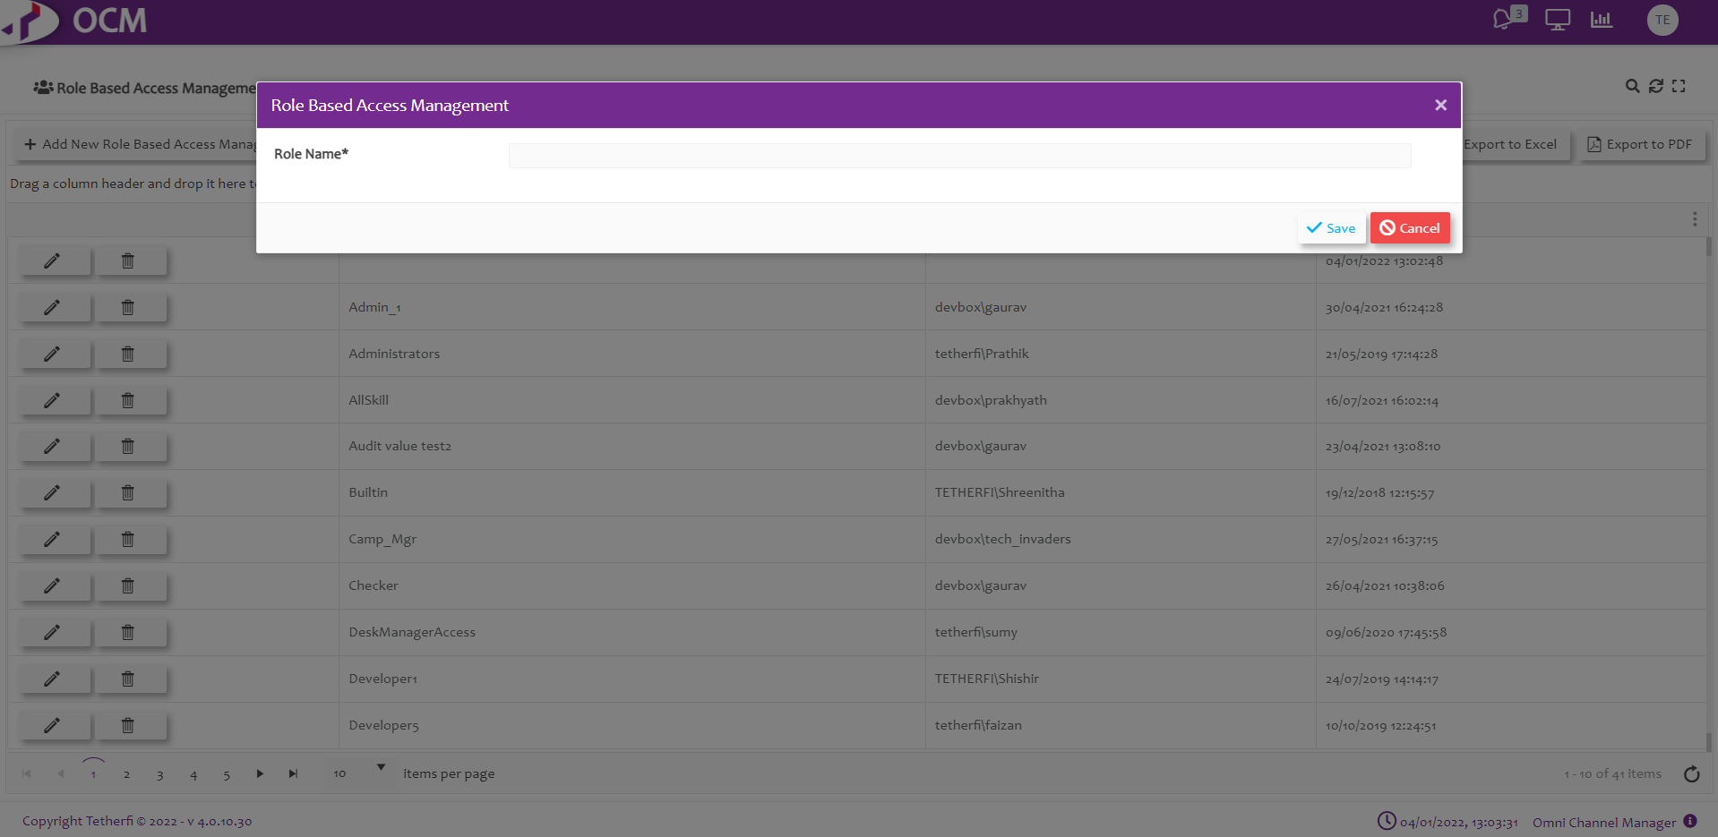
Functionalities to the newly added role can be given, by clicking on the new role added.
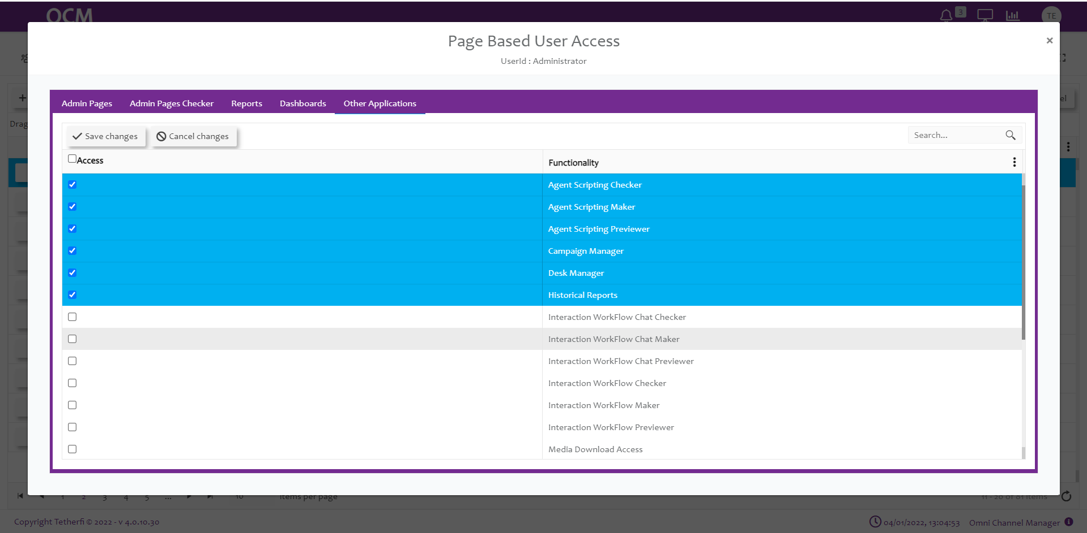

User Role Mapping
This module is used to add new role mapping record. Upon clicking this module following window will open and all the previously added records will be displayed.
User can add new role mapping record, by clicking ‘Add New User Role Mapping Record’ button present at top left corner.
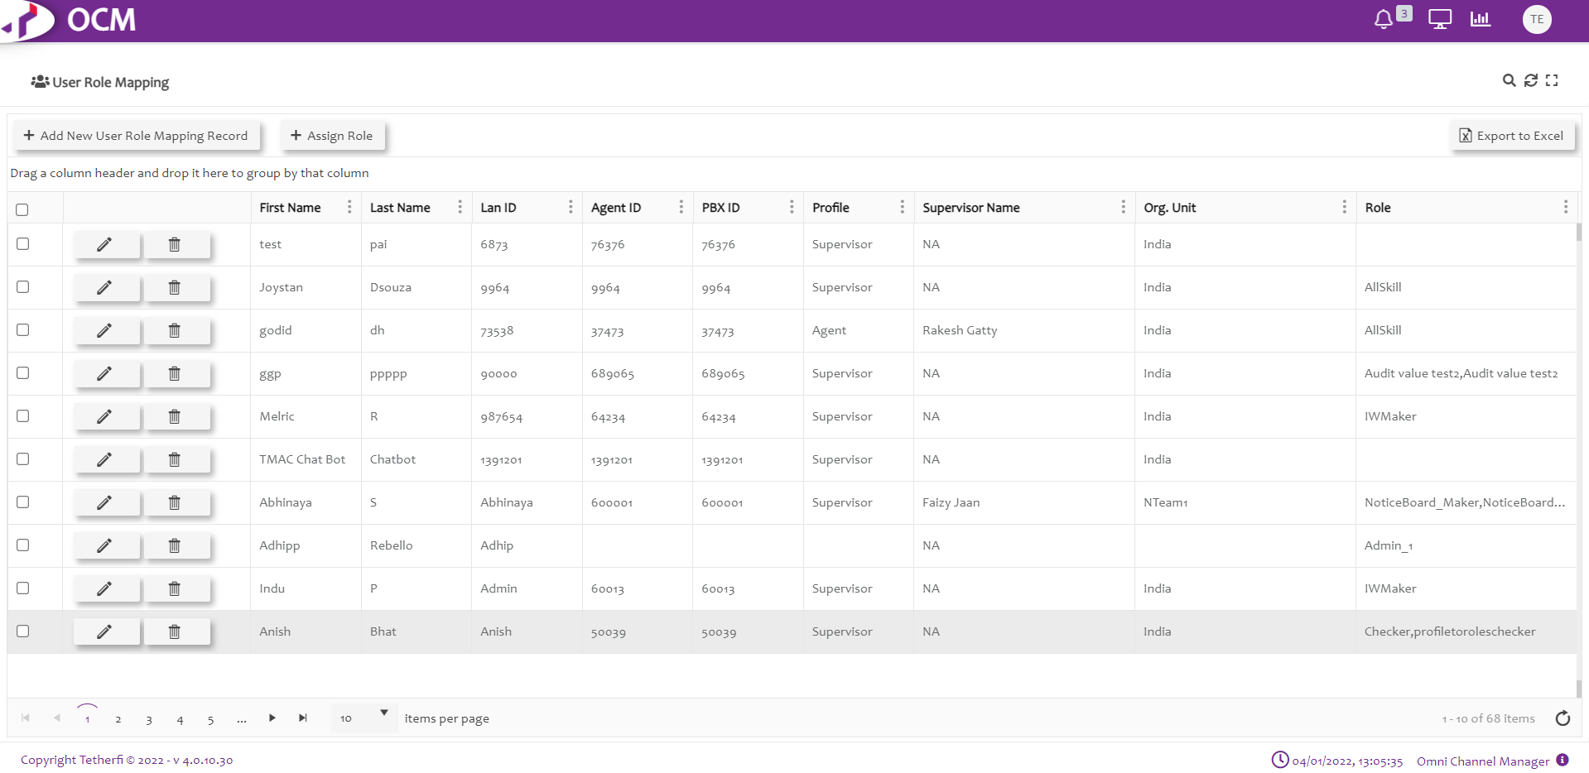
Upon clicking ‘Add New User Role Mapping Record’, Following popup will generate. User can create new Role mapping record here.
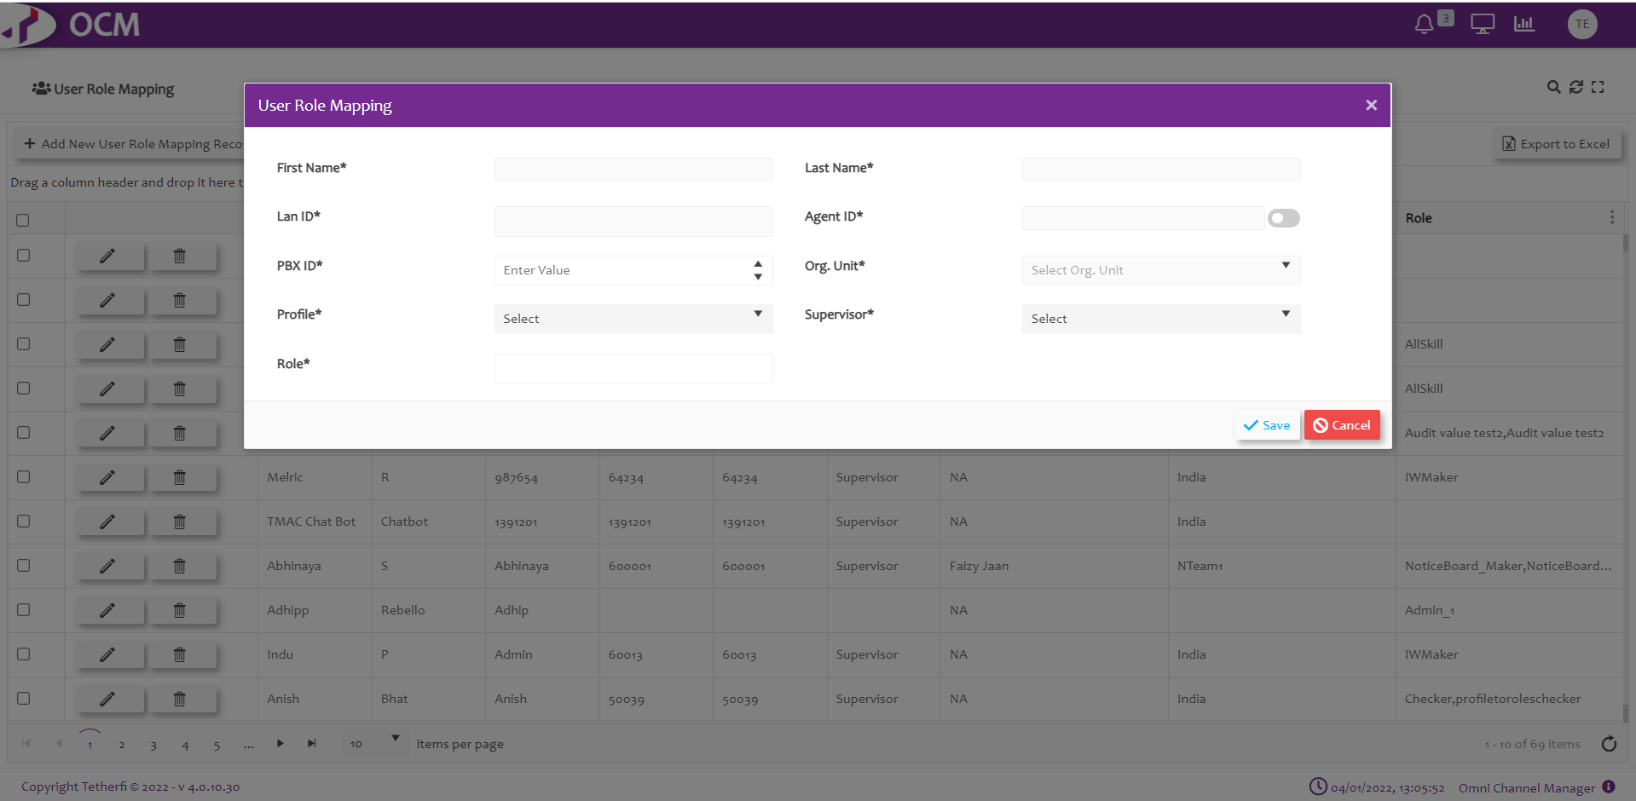
The Admin must assign a role to the user added here which is created in ‘Role Based Access Management’ module, like: Maker.

IW Role Based Access Matrix
Upon clicking ‘IW Role Based Access Matrix’ module, all the roles created will be displayed as shown below.
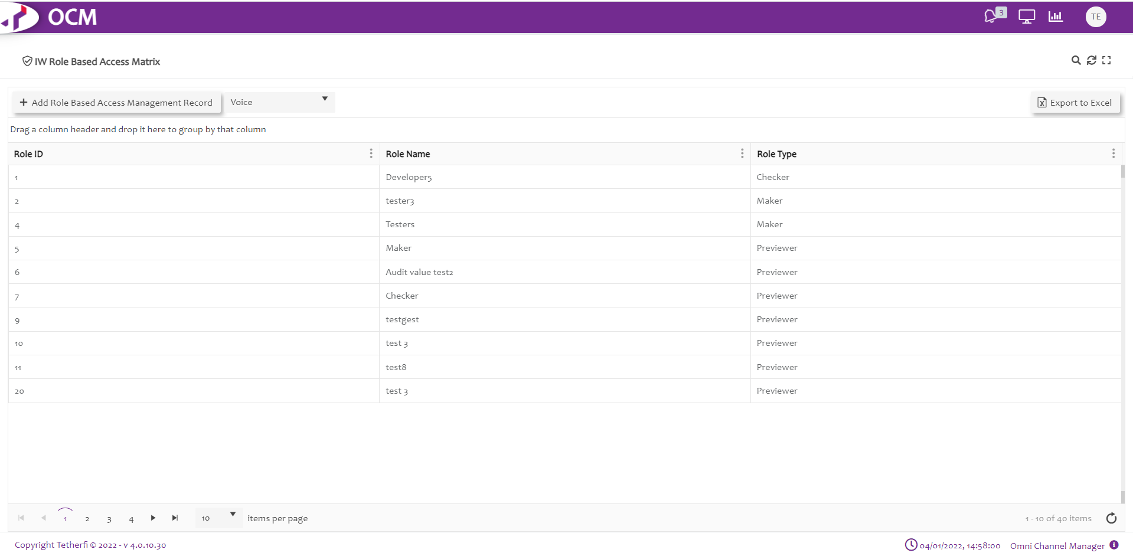
Upon selecting the any role, all the emailflows created at IW page will be displayed as shown below.
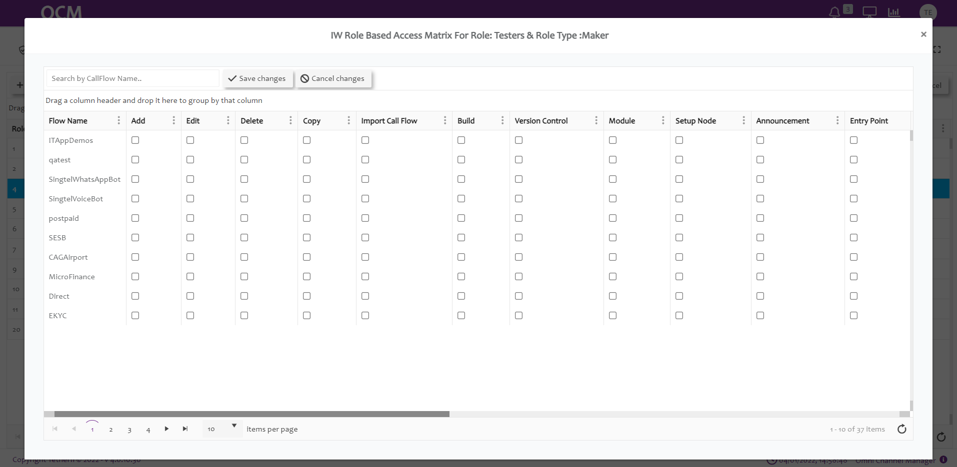
Note: For a newly created emailflows, entry will be made in OCM only after saving the emailflow in IW.
Upon saving the emailflow in IW, entry is made in ‘IW Role Based Access Matrix’ page and all the functionalities are disabled by default.
Admin must give the permission to user by checking the options provided in OCM for user to perform any activities on emailflows.
When user has 2 or more roles, access to the emailflows will be provided as per below table.
Sl.No | Role1 | Role2 | Output
1 | Maker | Previewer | Access Provided to Previewer Role will be in effect. For any combination with Previewer role, access provided to Previewer will be in effect
2 | Maker |  | Access provided to Maker Role will be in effect (Maker Role has higher priority)
3 | Maker | Maker | Query will check for the higher Role Id (2 is higher than 1) in CMM_Roles table and Access provided to that role will be in effect.
4 | Previewer | Previewer | Query will check for the higher Role Id (2 is higher than 1) in CMM_Roles table and Access provided to that role will be in effect.

Eamilflow Level Roles

Action | Description
Flow Name | Emailflow names will be displayed here after saving the emailflow
Edit | Enable or Disable Edit permission to emailflow in IW. This option must be checked in OCM page for giving the permission for the roles to edit emailflow, send the emailflow for approval, approve, schedule, reject or put checker comments to the emailflows  Upon Enabling Owner Level Emailflow option, only the emailflows for which edit option is enabled will be displayed for the user in dashboard as well as configure emailflow drop down list.
Delete | Enable or Disable Delete emailflow option in IW (ref section Delete flow)  Note: only owner of the emailflow can delete the emailflows.
Copy | Enable or disable copy emailflow in IW (ref section Copy flow)
Import flow | Enable or disable Import emailflow in IW (ref section Import flow)
Build | Enable or disable build/package a emailflow (ref. section Import flow)
Version Control: | This option must be checked in OCM page for giving the permission for the roles to revert the emailflow to previously approved version and only owner of the emailflow can revert to the previous approved version. (ref section Emailflow Version Control )
Module | This option must be checked in OCM page for giving the permission for the roles to add, edit (including adding or removing existing connections and checker comments) and delete the modules present in the emailflow.
Setup Node: | This option must be checked in OCM page for giving the permission for the roles to edit (including adding or removing existing connections) the DNIS node present in the emailflow.

IW Master Access Matrix
This option will be displayed in OCM ‘Home’ channel. This module is used to provide access to the IW Masters for a particular Roles/ security group. Upon clicking ‘IW Master Access Matrix’ module, all the roles created will be displayed as shown below.
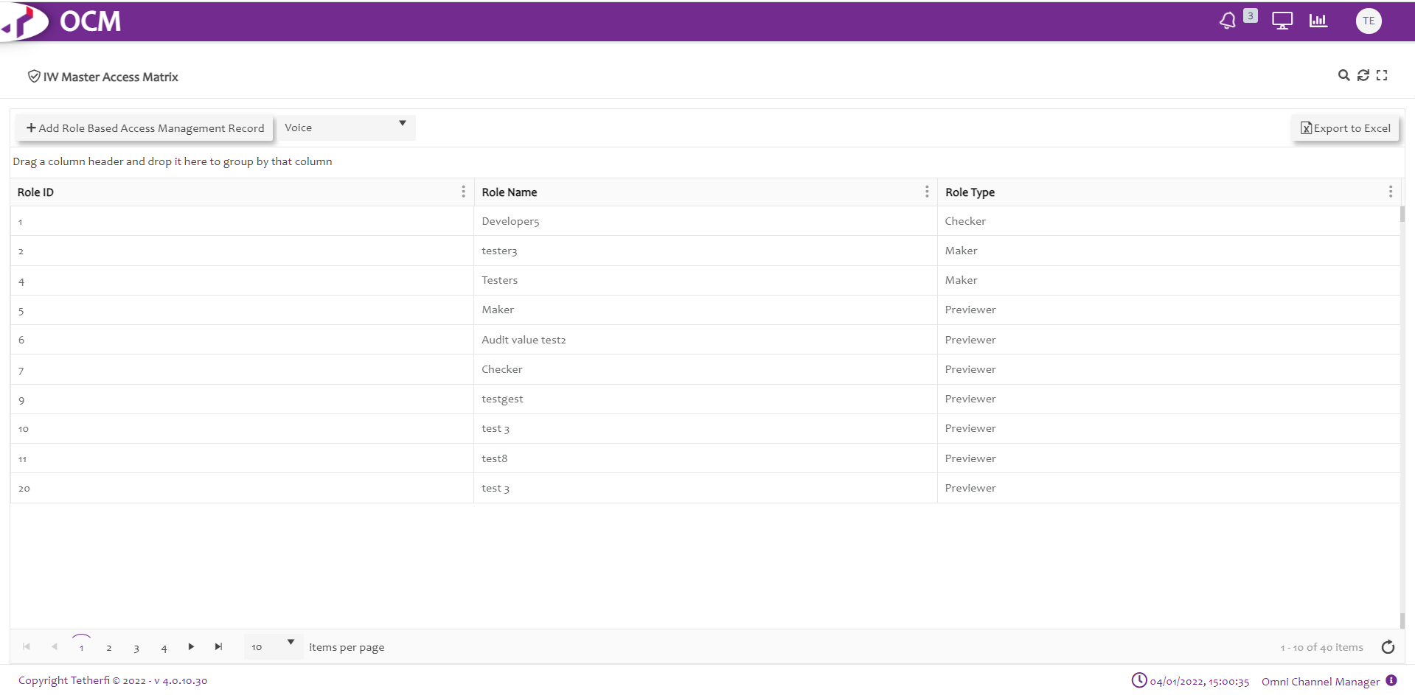
Upon selecting the any role/security group, all the masters along with Create new IWFlow and Subflow options will be displayed as shown below.
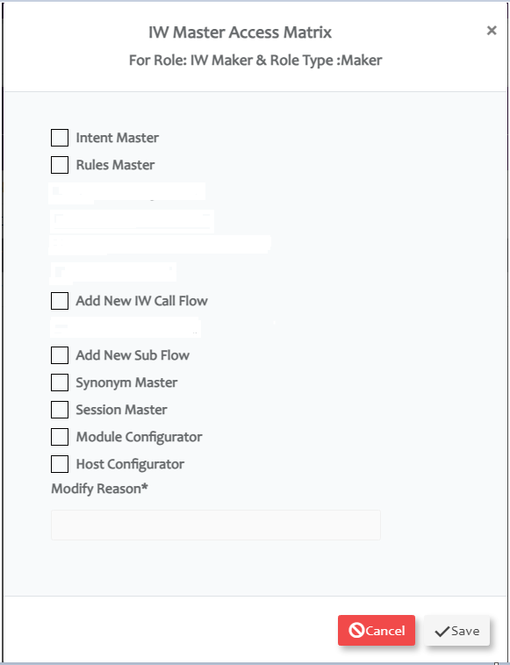
When ‘EnableAccessRules’ option in IW Webconfig is set to 1, then by default, user won’t be having access to any masters including options to create new IW or Subflows. Error toaster ‘This option is not enabled for current user’ is displayed when user clicks on any master options.
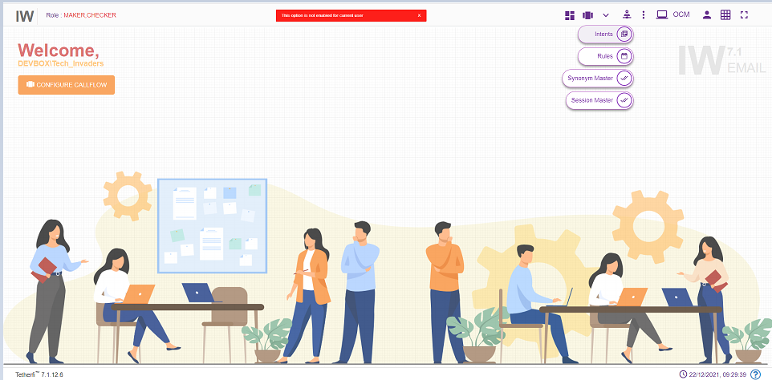
Admin must give the permission to user by checking the options provided in OCM ‘IW Master Access Matrix’ for the roles assigned to the user to edit the masters.
For Role Type Previewer, ‘Add New IW Flow’, and ‘Add New Sub Flow’ options will be disabled.

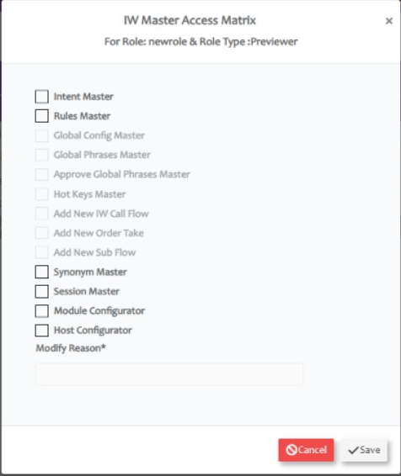
When user has 2 or more roles, access to the master will be provided as per below table.
Sl.No | Role1 | Role2 | Output
1 | Maker | Previewer | Access Provided to Previewer Role will be in effect. For any combination with Previewer role, access provided to Previewer will be in effect
2 | Maker |  | Access provided to Maker Role will be in effect (Maker Role has higher priority than Checker)
3 | Maker | Maker | Query will check for the higher Role Id (2 is higher than 1) in CMM_Roles table and Access provided to that role will be in effect.
4 | Previewer | Previewer | Query will check for the higher Role Id (2 is higher than 1) in CMM_Roles table and Access provided to that role will be in effect.

Database Table Access
To add the users directly to the db tables instead of using OCM, follow below steps
  - Add a new Role in CMM_Roles table
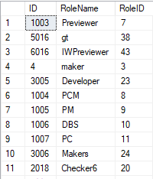
  - Provide IW Email Maker/ Previewer access to the roles in CMM_Role_Pages Table

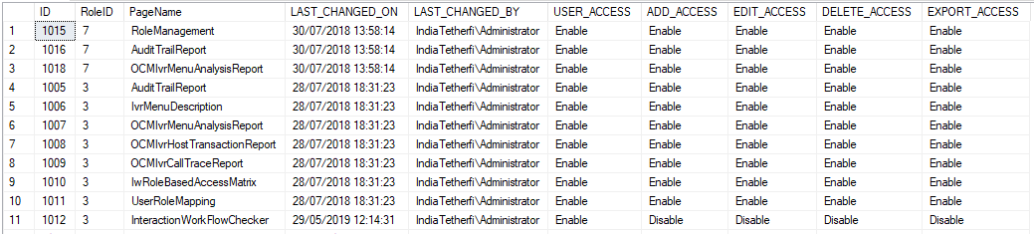

Interaction Workflow User Roles
The Interaction Workflow application will have following user roles:
- Maker
- Previewer

When the product is first delivered, the Admin user of OCM (details to be provided by business users) will allot the users as Interaction Workflow Maker/Checker (or both) by using OCM User Management module (ref section OCM Access).
Only the Admin can add new user, change user role and delete user.
User Functionality | Previewer | Maker
Create | No | Yes
Edit | No | Yes
Delete | No | Yes
Preview | Yes | Yes
Comment | No | Yes

Maker
Interaction Workflow Maker has the privileges to create / view / edit / delete workflows.
All the changes made to Interaction Workflow by Maker need to be approved by Checker before being implemented to the system.
When user login as a maker (without loading any flow), following page will be displayed.
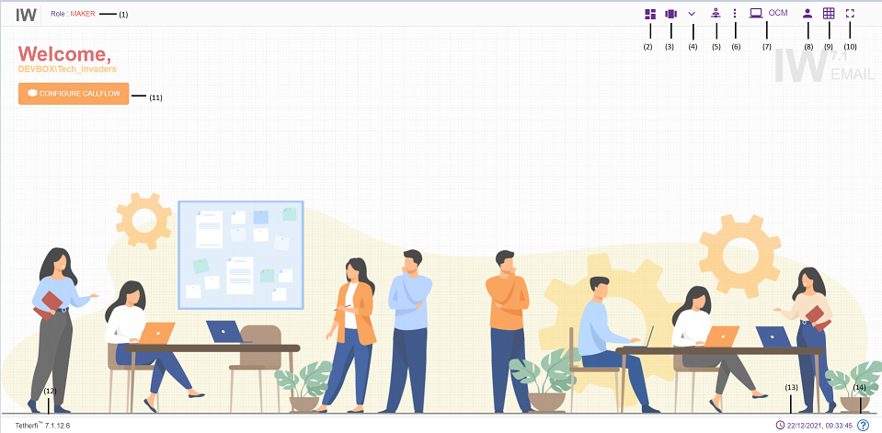
- Role: Displays the role of the user i.e. Maker
- Dashboard: Emailflow dashboard. (ref section Dashboard )
- Configure Emailflow: This option is used to create a new flow/ Preview a flow/Order Take/Delete a emailflow. (ref section Configure Emailflow)
- More Menus: Upon clicking this button following options will appear.
- Import flow: (ref section Import Emailflow)
- Copy flow: refer section Copy Emailflow
- Master: Upon clicking this button following options will appear.
    - Intents: refer section Intent Master
    - Rules: refer section Rule Master
    - Synonym Master: refer section Synonym Master
    - Session Master: refer section Session Master
- Emailflow Notifications: Notifications related to Emailflow statuses
- Redirect to OCM: This option will redirect to OCM page.
- Current User Info: User’s domain name/ username and for logging out of Interaction Workflow module.
- Grid: Grid can be enabled/disabled.
- Full Screen: This option is used to view the Interaction Workflow in full screen. (Press “Esc”/F11 button to go back to normal view)
- At the top left corner of the page, welcome message is displayed along with user’s domain name/user name. Configure emailflow option is also provided here.
- Current IW version
- System date and time will be displayed here.
- System file version will be displayed here.
When user login as a maker and load an emailflow, following page will be displayed.
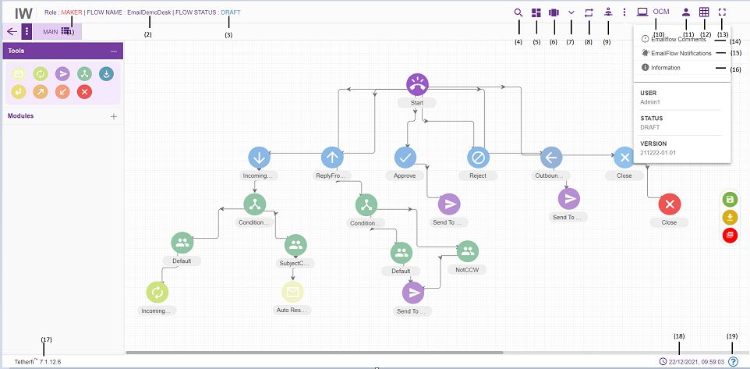
- Role: Displays role of the user i.e. Maker
- Flow Name: Name of the flow will be displayed here
- Flow Status: Current flow status will be displayed here
- Search for Nodes: refer section Search for nodes
- Dashboard: Emailflow dashboard. (ref section Dashboard )
- Configure Emailflow: This option is used to create a new flow/ Preview a flow/Order Take/Delete a Emailflow. refer section Configure Emailflow
- More Menus: Upon clicking this button following options will appear.
- Emailflow version control: refer section Emailflow Version Control
- Import flow: ref section Import flow)
- Copy flow: refer section Copy flow
- Rules Viewer: refer section Rules Viewer
- Master: Upon clicking this button following options will appear.
- Intents: refer section Intent Master
- Rules: refer section Rule Master
- Synonym Maser: refer section Synonym Master
- Session Master: refer section Session Master
- Redirect to OCM: This option will redirect to OCM page.
- Current User Info: This option is used to know User’s domain name/ user name and for logging out of Interaction Workflow module.
- Grid: Grid can be enabled/disabled.
- Full Screen: This option is used to view the Interaction Workflow in full screen. (Press “Esc”/F11 button to go back to normal view)
- Emailflow Comments: refer section Comments
- Emailflow Notifications: This option is used to check all the notifications related to Interaction Workflow.
- Information: This option is used for information related to the user and Interaction Workflow version.
- Current IW version is displayed here.
- Current system date and time will be displayed here.
- System file version will be displayed here.

Import Flow
Import flow option is used to import external flow that we build/packaged in other systems.
Click ‘More Menus’ option from top left corner in maker/maker-checker page, following popup will be generating.
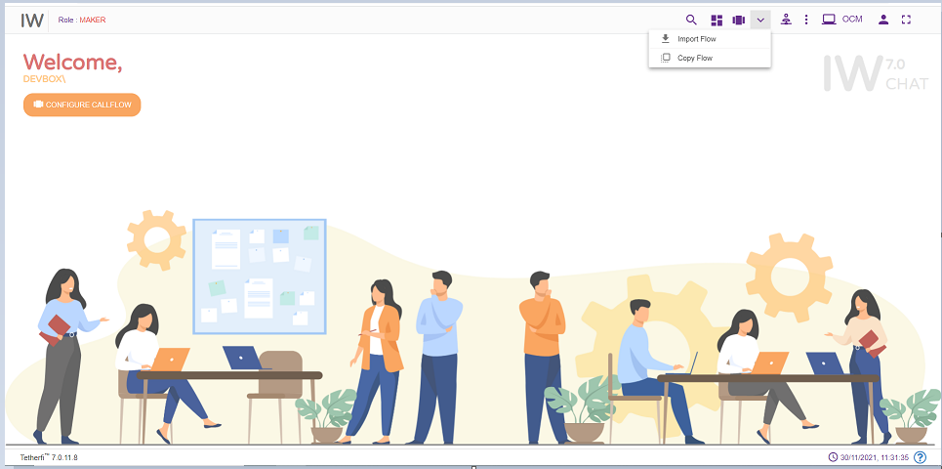
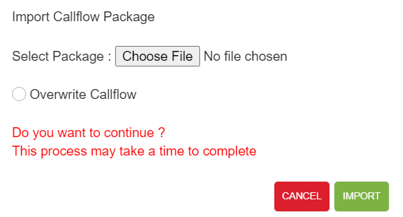
The package that is generated/zipped using ‘Emailflow Build/Package’ (refer section Dashboard) option in IW can be imported here.
Only zip files can be imported here.
User can import only the flows, whose version number is greater than the APPROVED status flow present in the system. ‘Flow with higher version number already present in the system’ error message is displayed.
If there is no APPROVED status flow for a emailflow, then UNAPPROVED version of the flow is overridden when importing the flow.
Upon successfully importing the emailflow to the system, success message will be generating in UI as shown below.
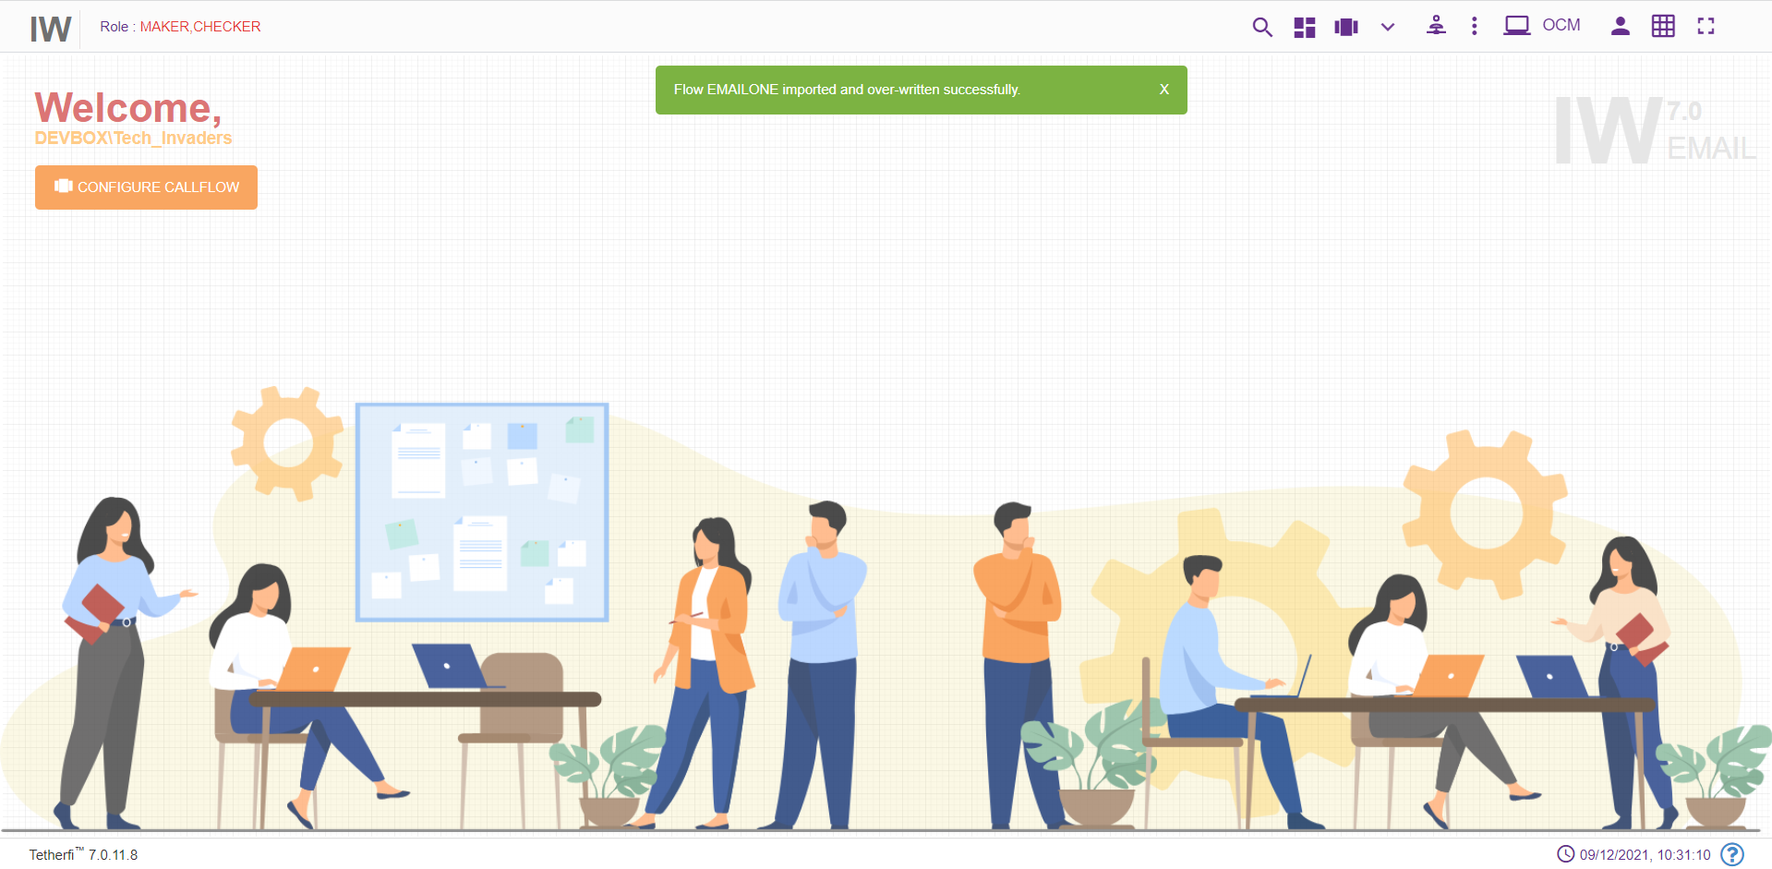

Copy Flow
This option is to create the copy of the emailflow. Copied emailflow will be in DRAFT status and created and modified date will be same.
Upon clicking on ‘More Menus’ option present at top left corner in maker/maker-checker page, following popup will be generating.
Upon clicking this option, following popup will be generated.
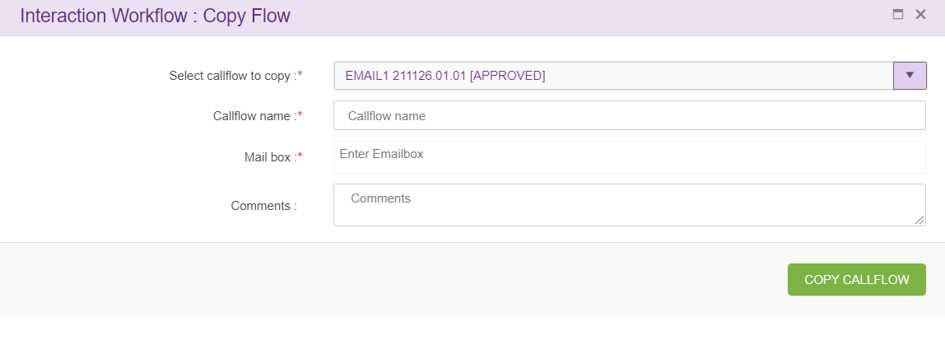
Select emailflow to copy: upon clicking on this drop down main flow, sub flows will appear as shown below.
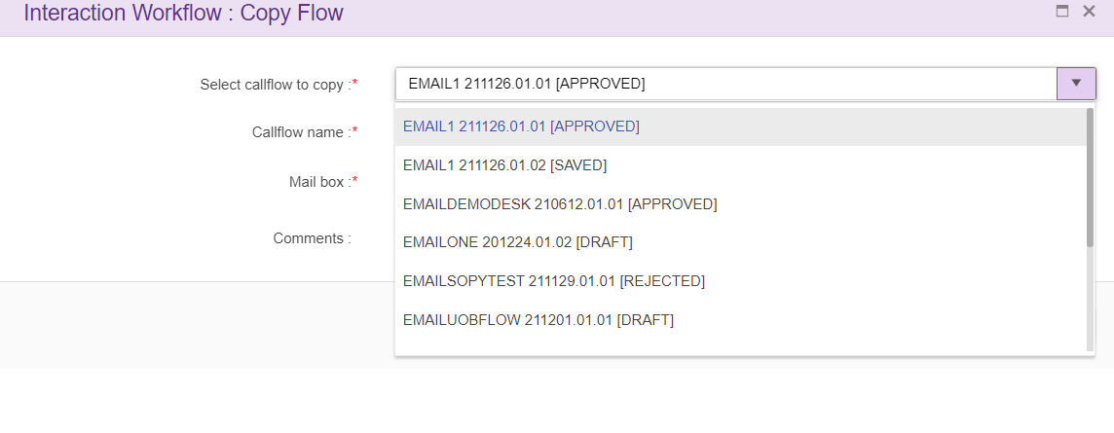

Copying IW Flow:
when user selects order take flow from the drop-down following screen will appear
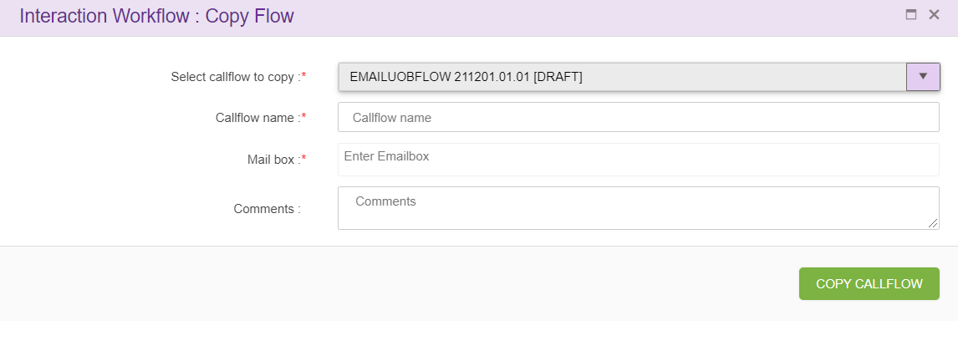
Flow name: name of the call flow.
Mail ID: Create a new emailflow with unique name and unique Mail id. Validation of mail id is done. This option is provided only for the user who has ‘Maker’ credentials and Maker can copy only emailflow with status ‘Draft’ and ‘Saved’.
Upon clicking ‘COPY FLOW’ button, new emailflow will be created based on the emailflow name specified, which will be exact copy of selected emailflow.

Copying Subflow
when user selects subflow from the drop-down following screen will appear
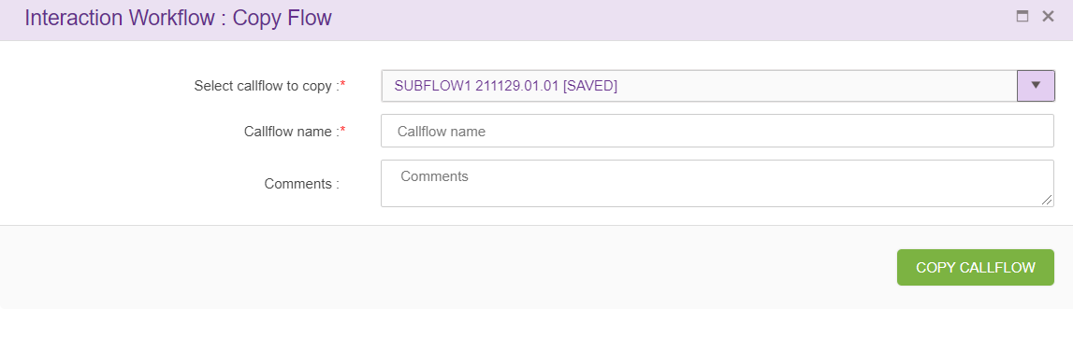
Flow name: name of the call flow to be created.
Upon clicking ‘COPY FLOW’ button, new emailflow will be created based on the emailflow name specified, which will be exact copy of selected emailflow. This option is provided only for the user who has ‘Maker’ credentials and Maker can copy only emailflow with status ‘Draft’ and ‘Saved’.

Emailflow Version Control
Emailflow version control option will appear in ‘More Menus’ option only when the selected emailflow is in ‘draft status. Version control is a system that records changes over time so that you can recall specific versions later. In emailflow version control system, user can revert their changes to specific approved version.
Only Makers have the privilege to revert emailflow that are in draft state.
Click the ‘Emaiflow version control’ option as shown below.
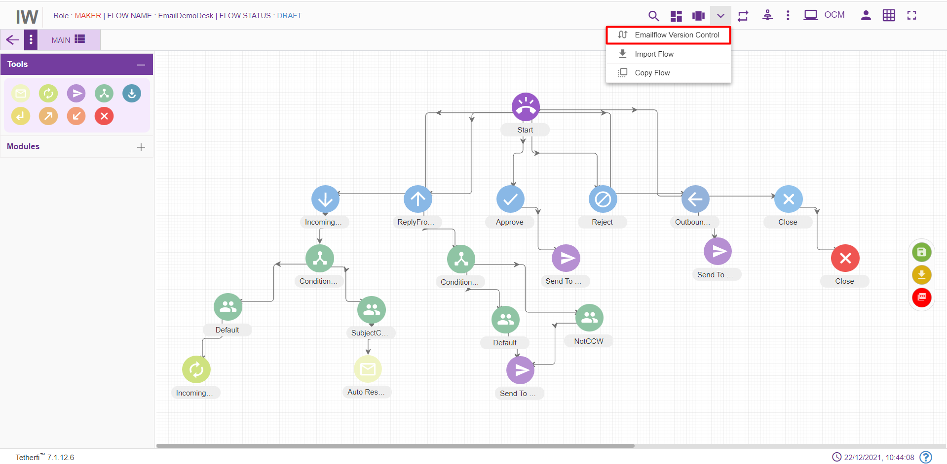

We are not approving flow in email.
Only maker functionality is required. So the option of reverting emailflow is not required.

Rule Master
This option will appear for the Maker and Previewer also. But only Maker can add rules. Previewer will be in read-only mode.
A rule is a principle or regulation or governing procedure for operation of Email with respect to a node or module.
Only Makers have the privilege of creating/ editing rules.
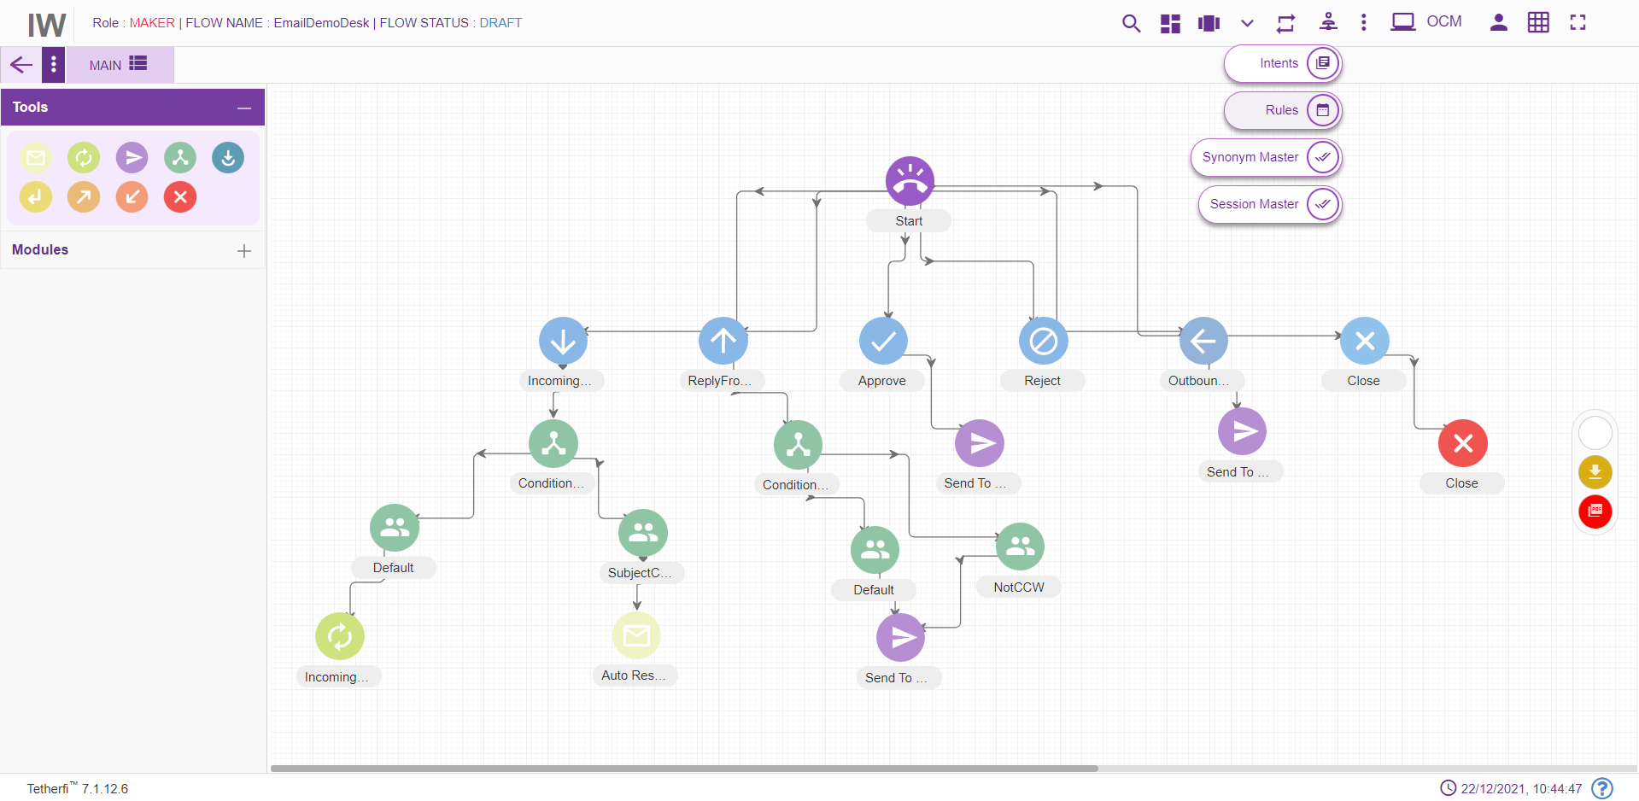
Maker can create/ edit rules by clicking on the button shown in the above figure.
Upon clicking ‘Rule Master’ icon, following popup will generate.
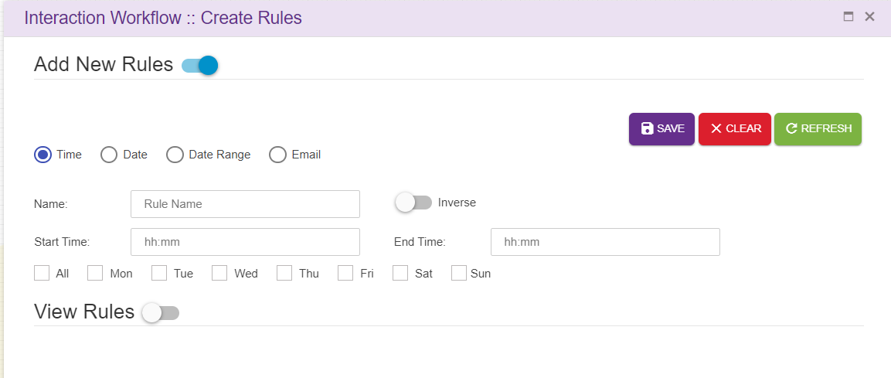Save: This button is used to add the rules to the grid i.e. Save the rule.
Clear: This option is used to clear the fields entered.
Refresh: This option is used to refresh the rule master window and load the latest rules to the grid.
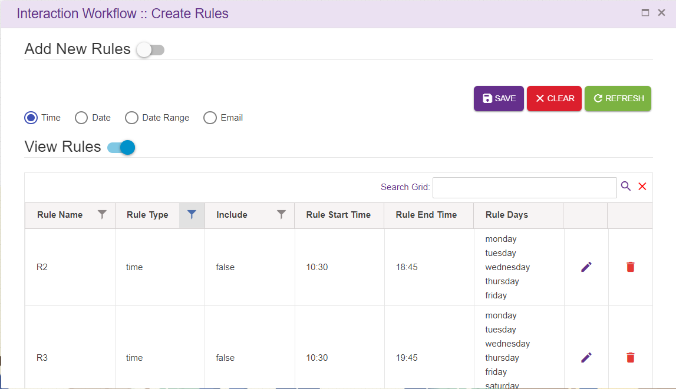
- For creating new rules, the Maker needs to select “Add new rules” option.
- There are four main types of rules: Time, Date, Date Range and Operational.
- On enabling of “Add new rules” option, the above popup will generate.
- Search Grid will help to search rules from records.

Time
You need to set the Name of this rule, Start and End time alongside the weekdays that you want the rule to be active and whether you want to include this rule in the Emailflow. You need to click Save, for saving the rule and Clear, for discarding the rule.

Date
You need to set the Name of this rule, date at which you want the rule to be active and whether you want to include this rule in the Emailflow. You need to click Save, for saving the rule and Clear, for discarding the rule.
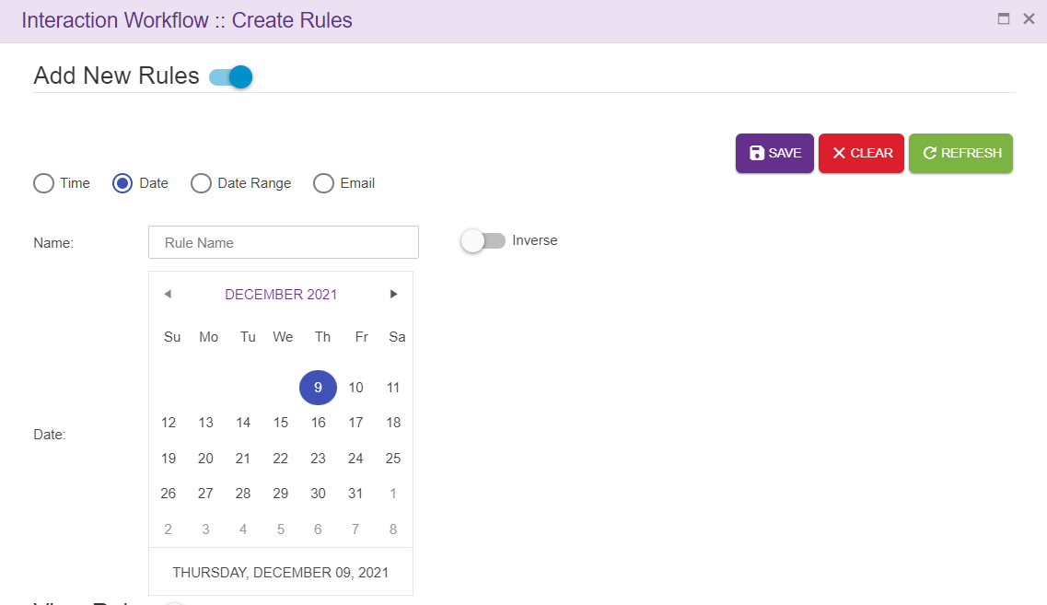

Date Range
You need to set the Name of this rule, Start and End date range you want the rule to be active. Click Save, for saving the rule and Clear, for discarding the rule.
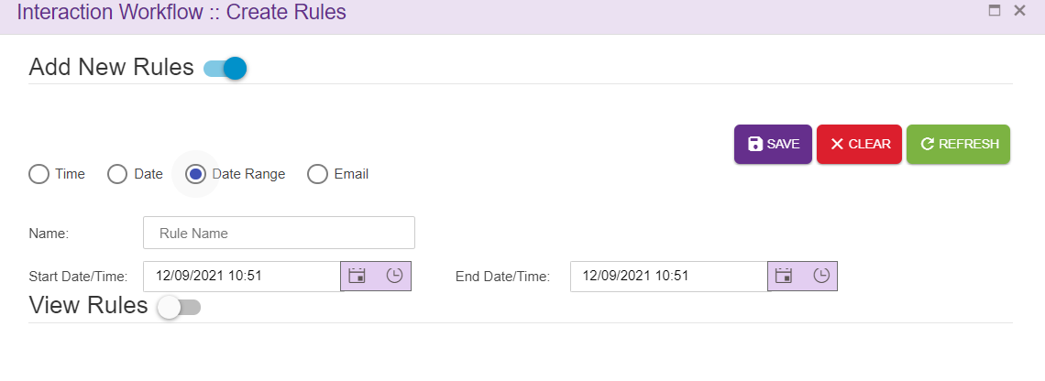

Email
You need to set the Name of this rule, Variable 1 and Variable 2 alongside the operator you want the rule to be consist of and whether you want to include this rule In the flow. You need to click Save, for saving the rule and Clear, for discarding the rule.
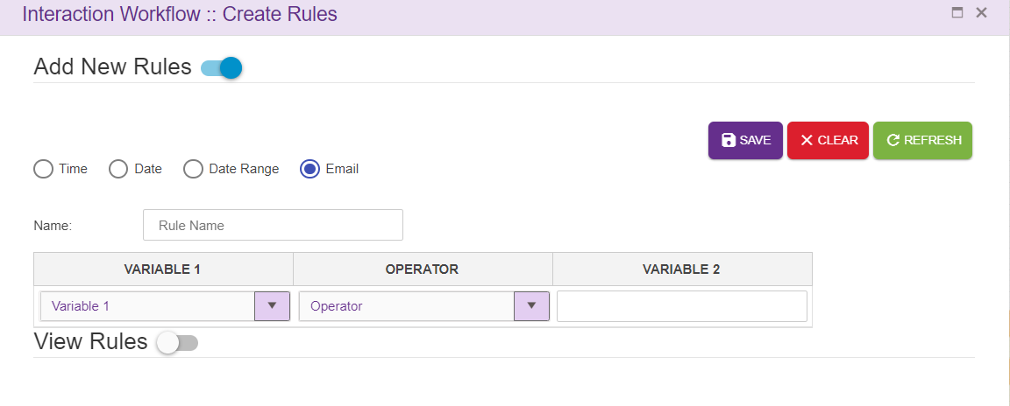
For editing/deleting the rule, click on the edit/ delete icon and make the necessary changes. Click Save, for saving the rule and Clear, for discarding the rule.
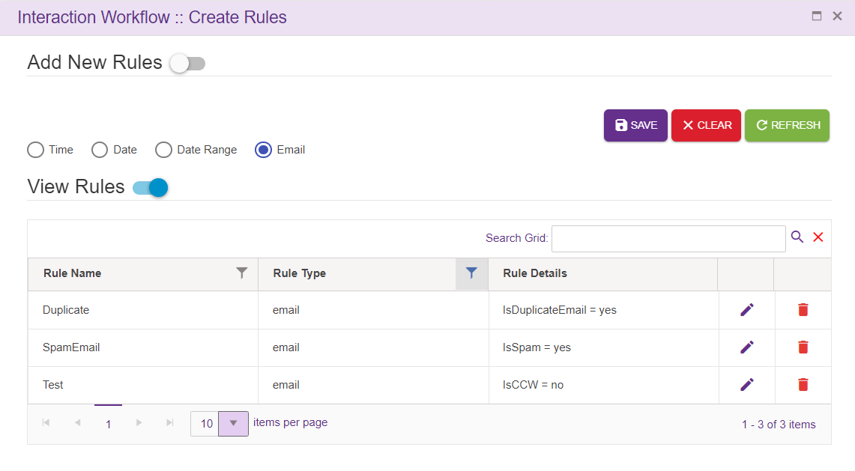
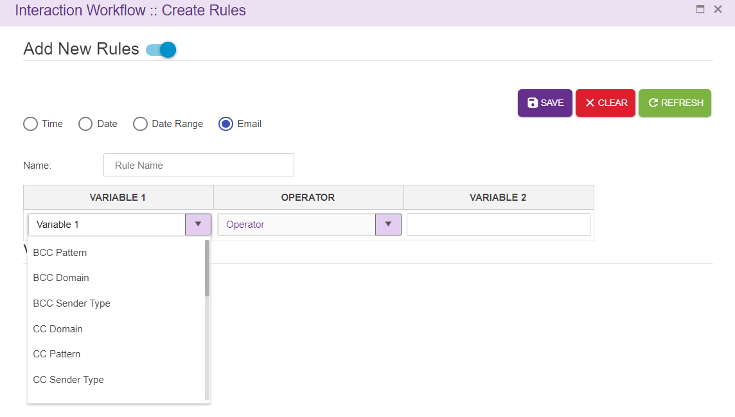

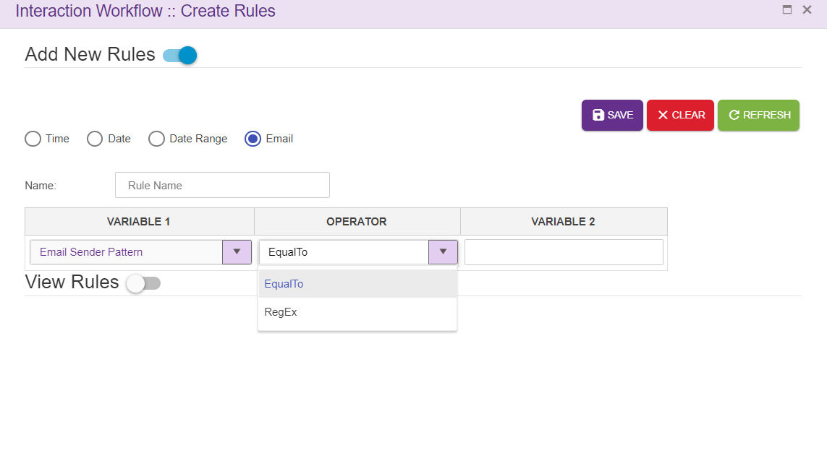

Emailflow specific Rules
Rules can also be displayed specific to the Emailflow. Upon setting Emailflow Specific the key to TRUE, only the rules specific to the Emailflow will be displayed.
In this case, upon adding a new rule. It won’t be displayed in the View Rules grid. But user can use the rules added, in nodes as well as in legs in the Emailflow.
All the Rules added in rule master will be displayed in Set Rules window and user can use the rules in the emailflow based on the requirements.
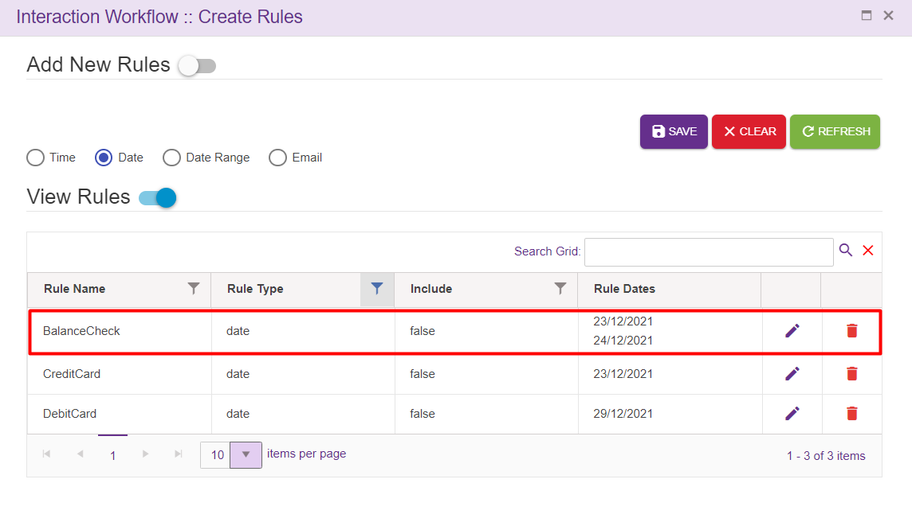
Only the rules used in the emailflow will be displayed in the rule master in emailflow specific rules option.
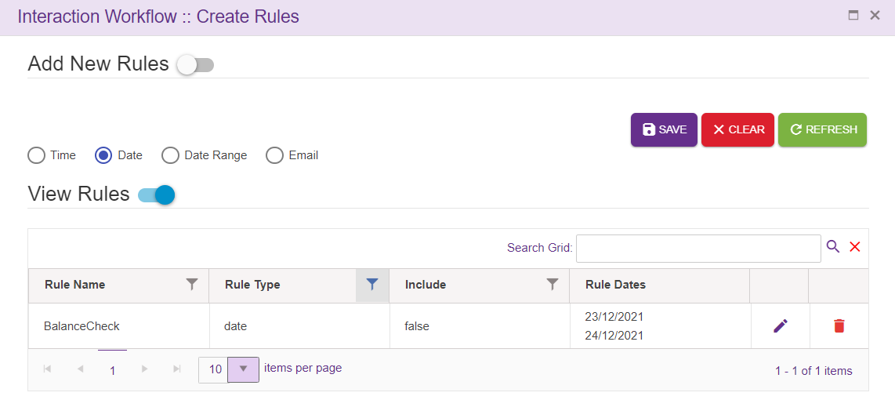

Intent Master
This option will appear for the Maker and Previewer also. But only Maker can add intents. Previewer will be in read-only mode.
Upon clicking intent master icon following page will be displayed.
Intents are mapped to the VDN in the intent master page in IW. If the user gives any intent which is not mapped to VDN in intent master, it becomes invalid flow. User can add the intents in ‘intent master’ and map to the VDN.
Search Grid will help to search intents from records.
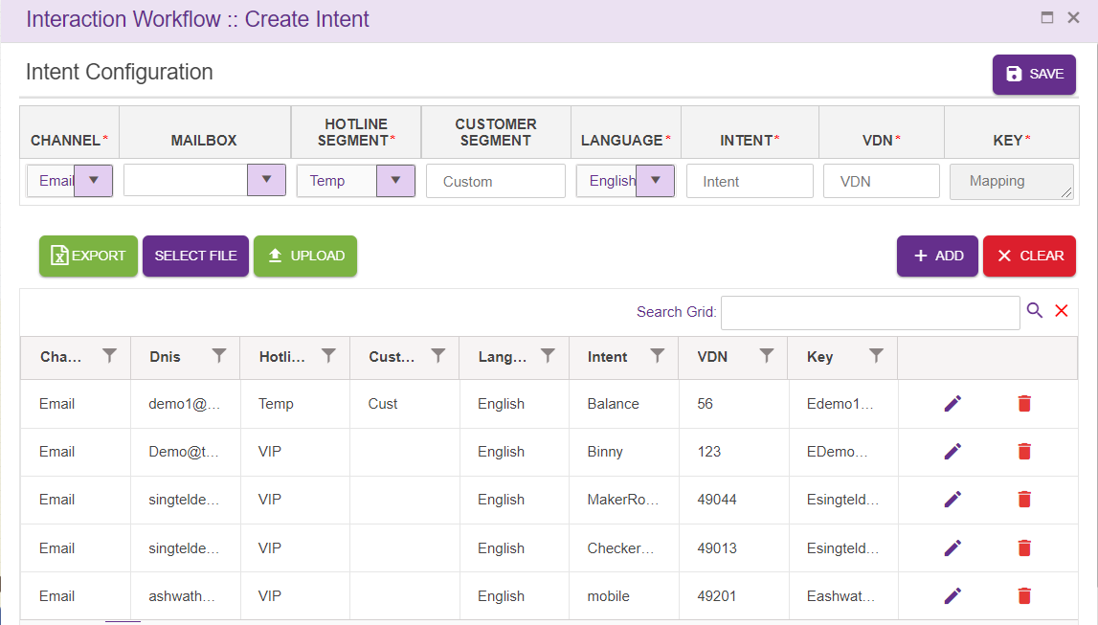
    - Channel: This drop down contains list of configured channels
    - DNIS: Mail id’s can be added here or user can select Mail id’s from the drop down.
    - Hotline Segment: User can select a Hotline segment from the drop down.
    - Customer Segment: This field accepts customer segment
    - Language: This drop down contains list of configured languages
    - Intent: Intent provided here is added to the grid as well as Agent node. Intent need not be unique.
    - VDN: This field accepts VDN.
    - Key: Unique key is provided for every entry. This key is auto generated.
ADD: Upon clicking ‘Add’ button, entries must be added to the grid.
Clear: This option is used to clear the entered field.
Export: Upon clicking this button, .csv extension file will be downloaded. This file contains all the contents of the grid.
SAVE: Pushes the record to Interpreter (Must click SAVE button, after adding the record to grid)
File Selection: This option is used to select the file to be uploaded. Note that only .csv extension file can be uploaded. User can upload bulk amount of data.
Upload: This option is used to upload selected file. Upon clicking upload option, following popup will be generated. Duplicate files will not be uploaded.

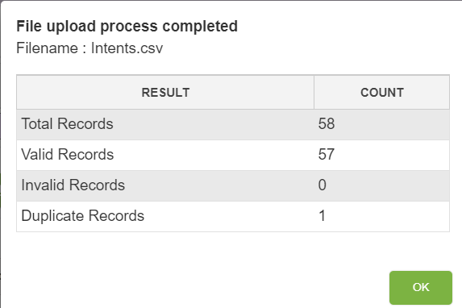
Edit: Click on the edit icon (right corner of each entry) to edit the details. User can edit only VDN field.
Must click on SAVE button, after editing the record

Rules Viewer
This option will appear for all the roles i.e. make and previewer for the emailflow of all the status.
Upon clicking rule viewer icon following pop window will be loaded.
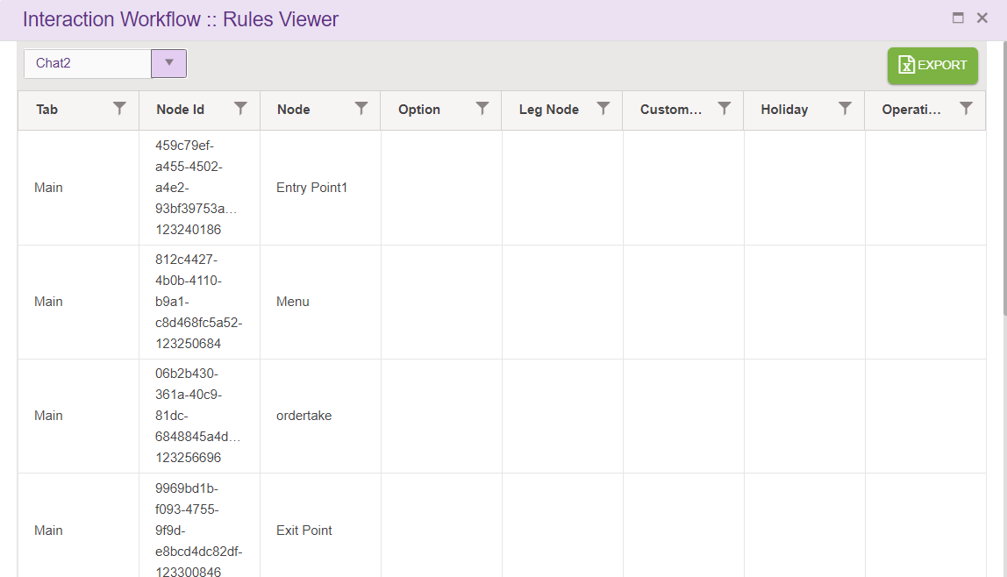
Rules viewer option shows all the rules added in conditional node legs in the emailflow along with each node id. This a common place where all the node id’s used in the emailflow can be viewed. user can select emailflow from dropdown to view rules.
- Tab: specifies the tab of emailflow
- Node Id: Id of that node.
- Node: this option displays node name.
- Option: node leg option will be displayed here.
- Leg Node: specifies leg node.
- Custom Rules: this is used to display rule name
- Holiday: this option will be true or false based on user selecting this when adding rules.
- Operating hours: this will display operating hours of rule.

Comments
Upon clicking comments icon following pop window will be displayed.
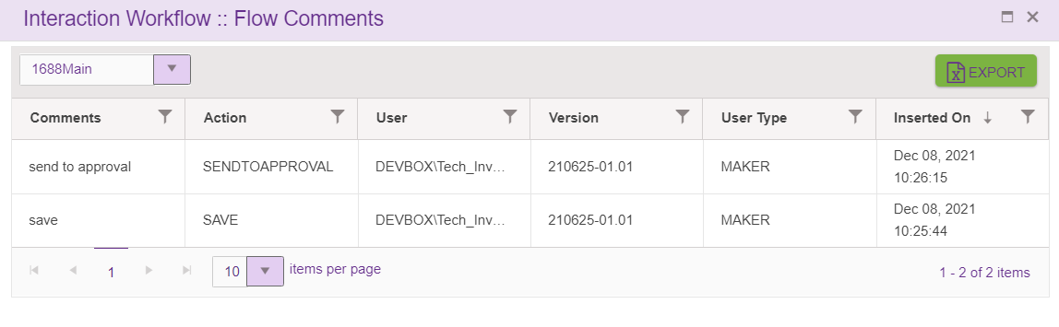
Comment option shows all the comments entered by the user(maker) whenever user does actions like ‘Save’ flow, ‘Send to approval’, ’Reject’, ’Approve’, ‘Scheduled’ the flow.
- Comments: specifies comments provided by the user.
- Action: specifies the status of the flow.
- User: shows username logged-in. The format as <Domain name \ username>.
- Version: specifies version number of the flow.
- User type: specifies type of the user like Maker, Checker.
- Inserted on specifies the date and time when user does add the comment.
Each columns header has the option to select and sort the records in ascending/descending order. These actions can be performed on clicking on table header.
Export:
Upon clicking this button, .csv extension file will be downloaded. This file contains all the contents of the grid. This option is available for all the roles i.e. maker and previewer.
Dropdown:
Upon clicking on dropdown, all subflow connected to the flow will be listed. User can view the comments added to the subflows connected to the main flow here.

Search for Nodes and Modules
This option is used to search for a node and module in a emailflow using id or name. Upon clicking ‘Search for nodes’ icon following pop window will be displayed.
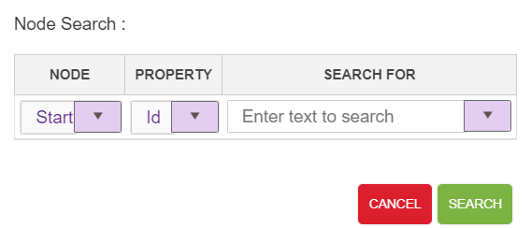
Node: This drop down contains list of nodes and module used in IW Email except Entry, Exit and flow connector nodes.
Property: This drop down contains list of search criteria used to search for a node (Id and Name)
Search For: Text area where user will provide ID/Name detail.
For a valid search, control goes to the specific node and node starts blinking.
For an invalid search, ‘Given text does not exists in the current flow’ error toaster is generated as shown below.
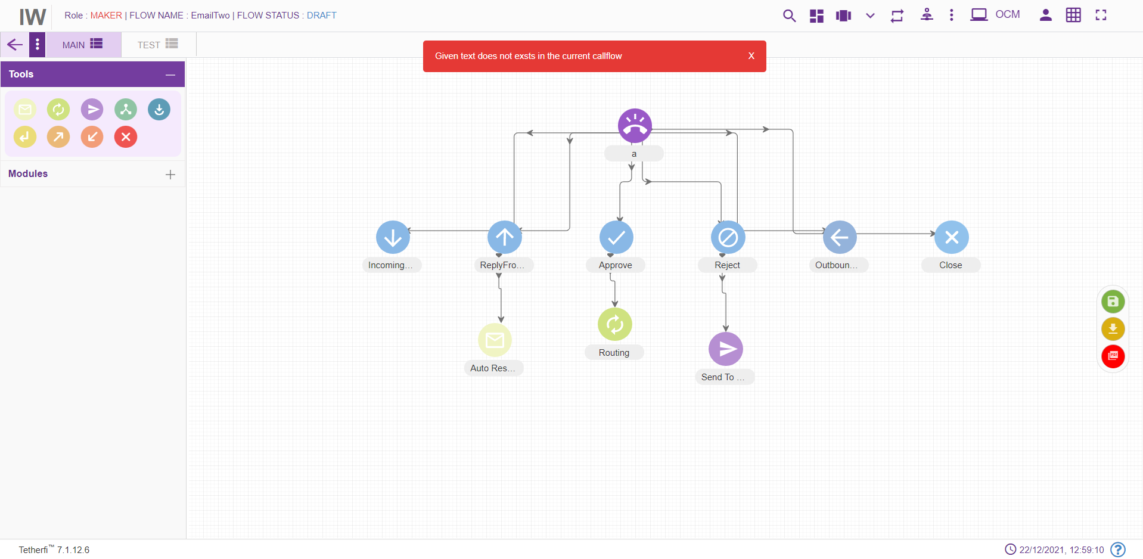

Search for Texts
This option is used to search for a text in a emailflow. Upon clicking ‘Search for Texts icon following pop window will be displayed.
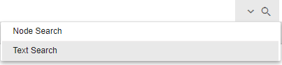

File System Version
All the server components version number, interpreter link and websync link used by the application is displayed here.
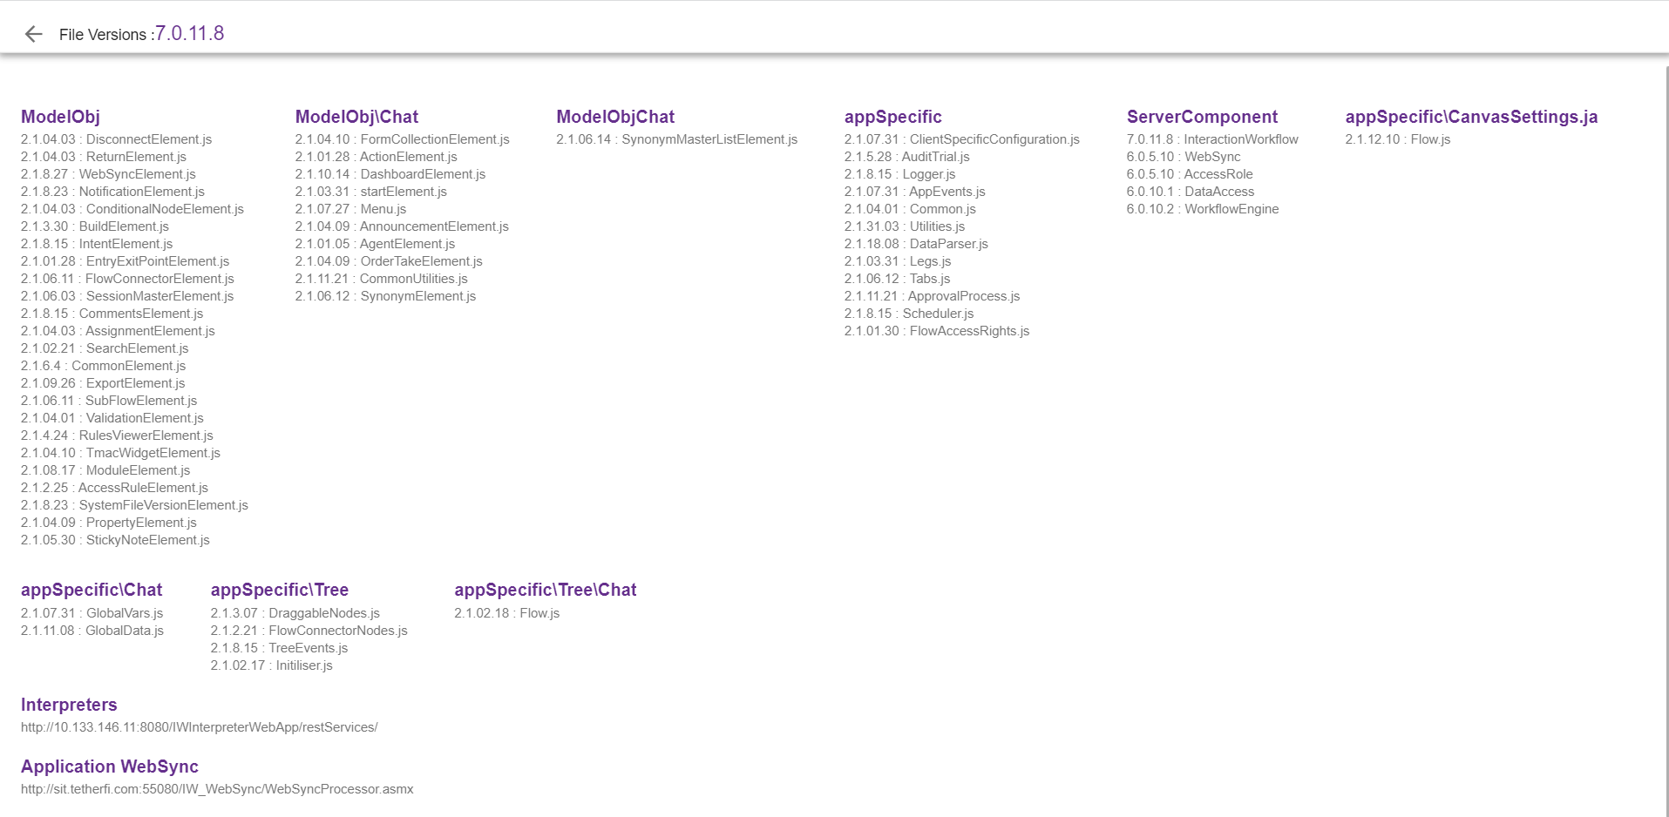

Synonym Master
This option is used for updating commonly used synonyms in global master. Here we can configure repeatedly used synonyms and can jump to a specific flow, tab and entry point based on the intent provided. This option will appear only for the Maker.
Search Grid will help to search synonyms from records.
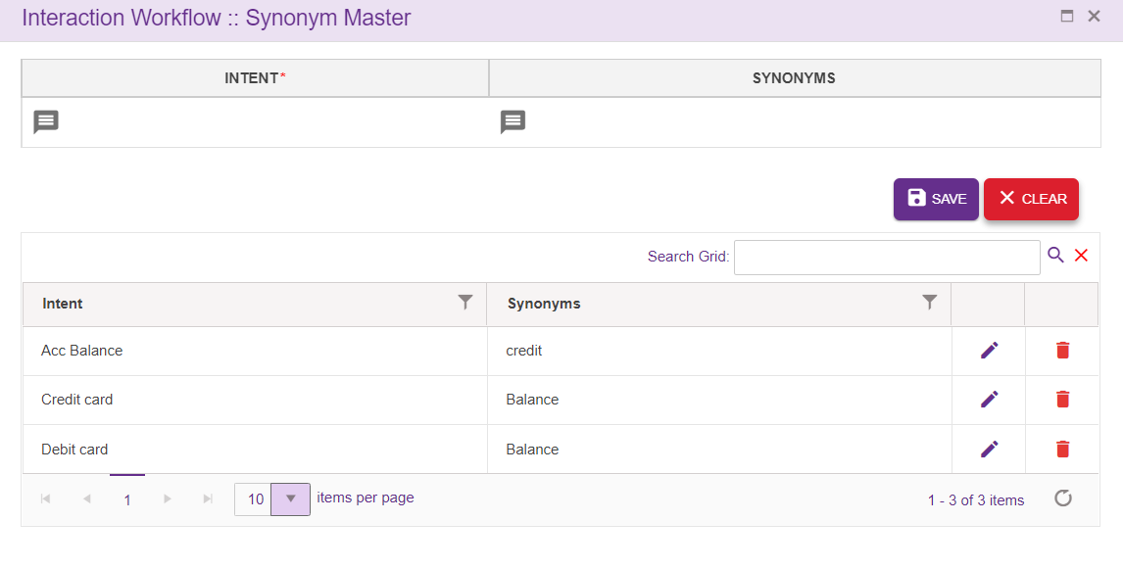
- Intent: Intents are added here. This is a mandatory field.
- Synonyms: Can add synonyms for the intent added in ‘Intent’ section specific to language
Intent addition popup:
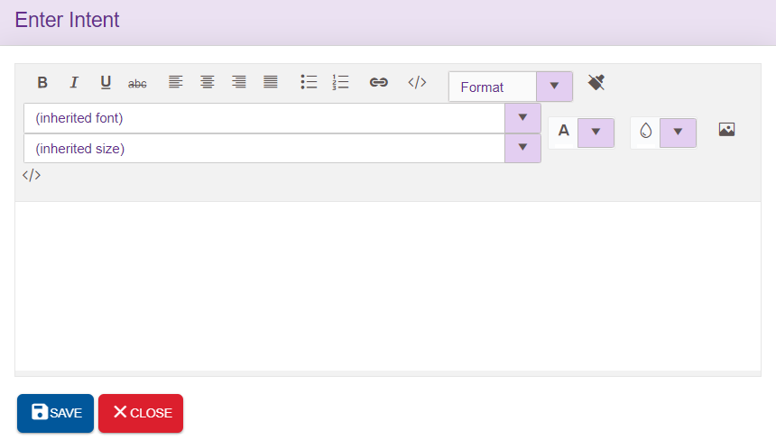
Synonym addition popup:
Synonyms related to the intents specific to the language can be added here. Upon clicking ‘ADD’ icon, synonyms will be added to the grid provided at the right end. ‘Remove’ option will clear the field.
SAVE: This icon will save the synonyms added
DELETE ALL: This option used to delete all the synonyms added at once
CLOSE: This icon is used to close the popup
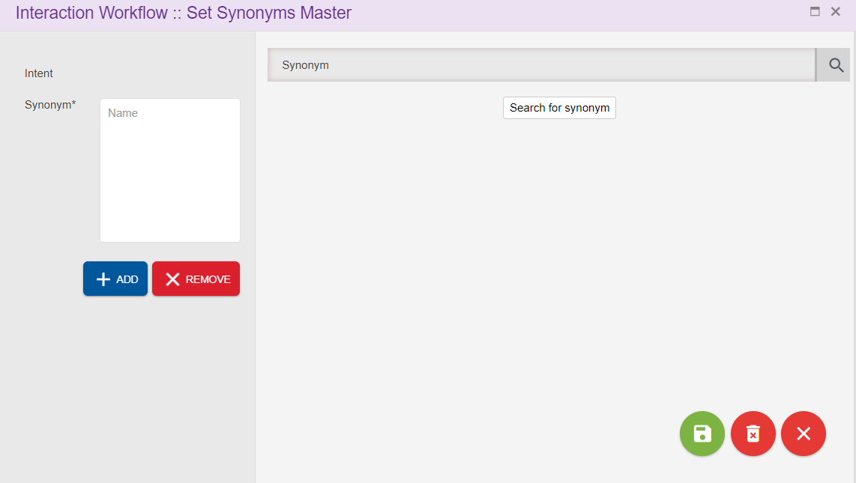

Session Master
This option will appear for the Maker and Previewer also. But only Maker can add the session variable. Previewer will be in read-only mode.
This option is used for updating commonly used session variables in global master. User can configure the operational variables here. Session variable added here will be available in Module designer too.
Upon clicking session master icon following page will be displayed.
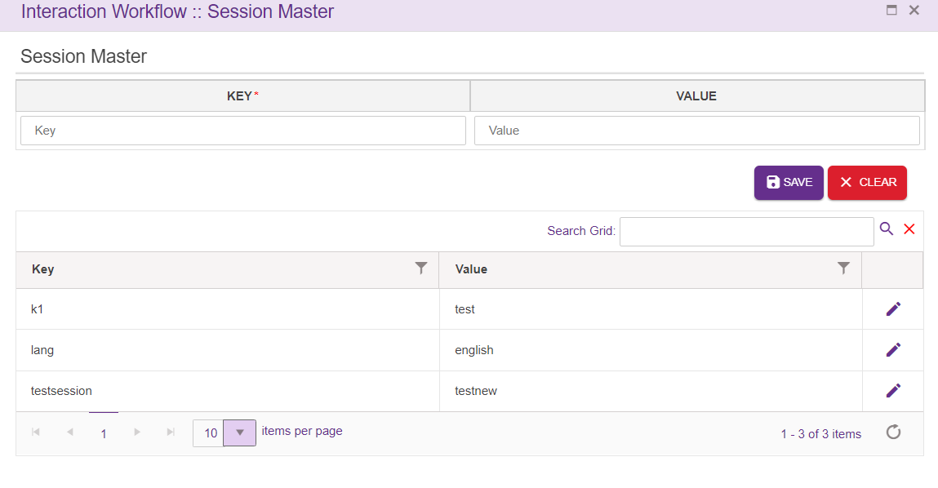
Search Grid will help to search key or values from records.
KEY: It is a mandatory field. Can accept characters as well as digits
Value: Not mandatory. Can accept characters as well as digits
ADD: Upon clicking the button, new entry will be added to the grid.
Clear: This button is used to clear the field
Edit: User can edit the Value field, except keys

Previewer
Interaction Workflow Previewer has the privilege to preview workflows.
Note: Previewer neither create the flow nor delete the flows and comments. When anonymous authentication is enabled for IW UI application, user will be redirected to Previewer page. User must login to IW only through OCM when anonymous authentication is enabled.
When a user login as a previewer (without loading a flow), following page will be displayed.

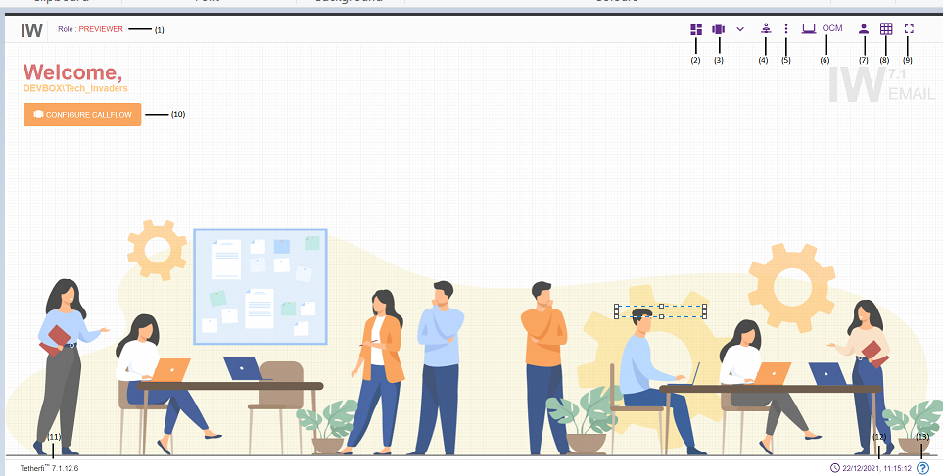

- Role: Displays the role of the user i.e. Previewer
- Dashboard: This option will redirect to dashboard. refer section Dashboard
- Configure emaillow: This option is used to Preview a flow. refer section Configure Emailflow
- Master: Upon clicking this button following options will appear.
- Intents: refer section Intent Master
- Rules: refer section Rule Master
- Synonym Maser: refer section Synonym Master
- Session Master: refer section Session Master
- Tmac Widget Master: refer section TMAC Widget Master
- Emailflow Notifications: This option is used to check all the notifications related to Interaction Workflow
- OCM: This option will redirect to OCM page.
- Current User Info: This option is used to know User’s domain name/ user name and for logging out of Interaction Workflow module.
- Grid: Grid can be enabled/disabled.
- Full Screen: This option is used to view the Interaction Workflow in full screen. (Press “Esc” button to go back to normal view)
- At the top left corner of the page, welcome message is displayed along with user’s domain name/user name. Configure emailflow option is also provided here.
- Current IW version is displayed here.
- System date and time will be displayed here.
- System file version.
When a user login as a Previewer and load a emailflow, following page will be displayed.
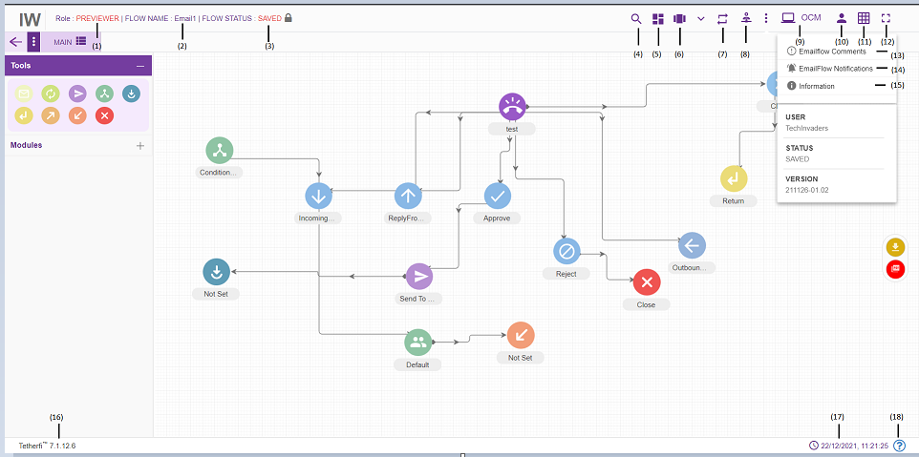
    - Role: Displays the role of the user i.e. Checker.
    - Flow Name: Flow name will be displayed here.
    - Flow Status: Current emailflow status will be displayed here.
    - Search for Nodes: refer section Search for nodes
    - Dashboard: This option will redirect to dashboard. refer section Dashboard
    - Configure emailflow: This option is used to Preview a flow. refer section Configure Emailflow
    - Rules Viewer: refer section Rules Viewer
    - Phrases: refer section Phrases
    - Master: Upon clicking this button following options will appear.
  - Intents: refer section Intent Master
  - Rules: refer section Rule Master
  - Synonym Maser: refer section Synonym Master
  - Session Master: refer section Session Master
    - Comments: refer section Comments
    - Emailflow Notifications: This option is used to check all the notifications related to Interaction Workflow
    - Information: This option is used for information related to the user and Interaction Workflow version.
    - OCM: This option will redirect to OCM page
    - Current User Info: This option is used to know User’s domain name/ user name and for logging out of Interaction Workflow module.
    - Grid: Grid can be enabled/disabled.
    - Full Screen: This option is used to view the Interaction Workflow in full screen. (Press “Esc” button to go back to normal view)
    - Current IW version is displayed here.
    - Current system date and time will be displayed here.
When user login as Previewer and load the dashboard, following page will be displayed.’ Emailflow Build/Package’ and delete option won’t be appear for Previewer in dashboard.
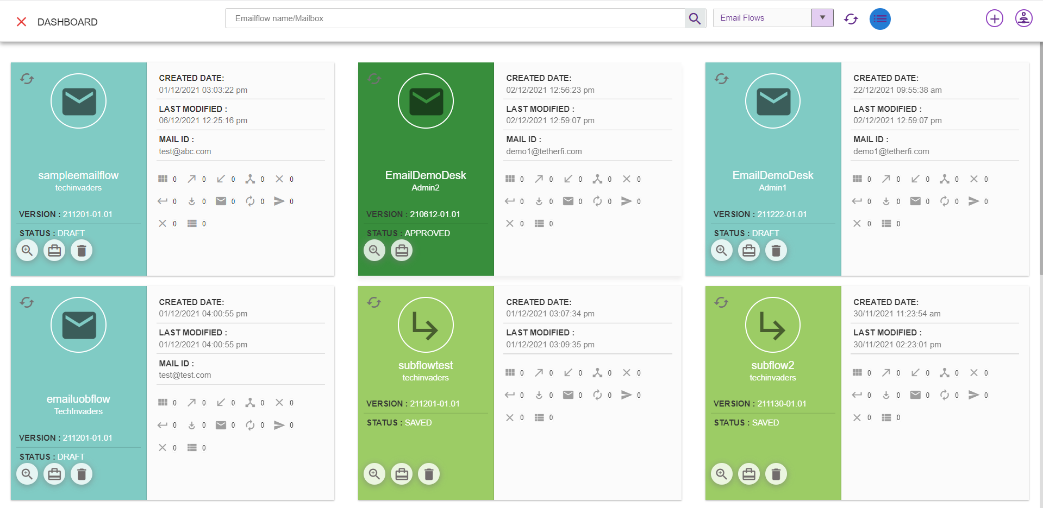

Creating/Editing Workflows

Configure Emailflow
Configure emailflow option is provided for Maker and Previewer. This option will be displayed at the centre of the page in IW landing page as well as right next to dashboard icon.
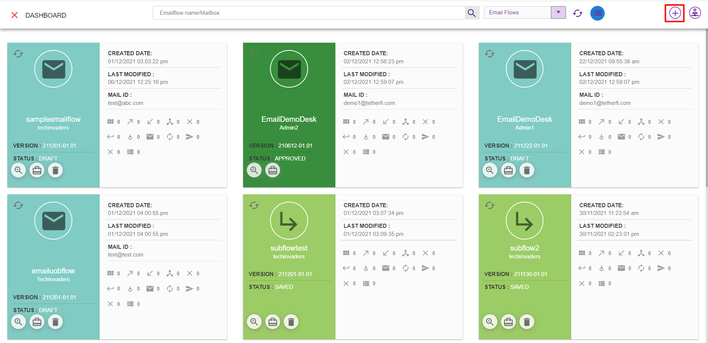

Upon clicking ‘Configure Emailflow button in maker page and maker-checker page, below window will popup.
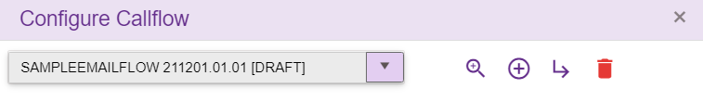
In maker page upon clicking on ‘Configure emailflow button following options will appear.
- Emailflow List: refer section Emailflow List
- Preview: refer section Preview
- New IW Flow: refer section New IW Flow
- Delete Flow: refer section Delete
- Sub Flow: refer section Sub Flow
Upon clicking ‘Configure Emailflow button in Previewer page, below window will popup.
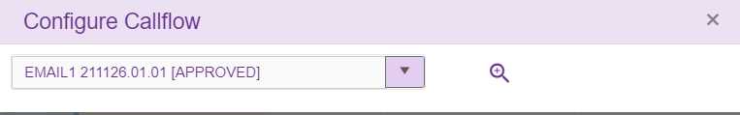
In previewer page, upon clicking on ‘Configure emailflow button following options will appear.
- Flow List: refer section Emailflow List
- Preview: refer section Preview

Emailflow List
This list consists of all the flows created using Tetherfi Interaction Workflow which is also displayed in dashboard.
On click of the dropdown button, the below screen will be displayed.
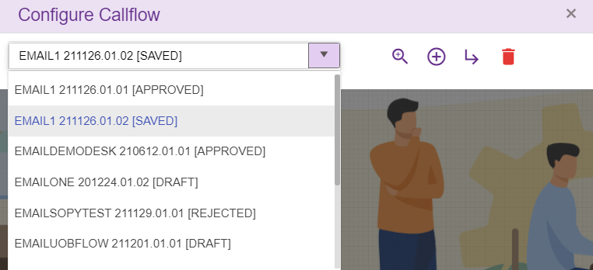

Preview
Select the emailflow from emailflow list dropdown and click preview icon/button to load emailflow data
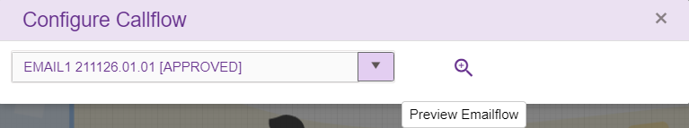
When user try to load a new emailflow on top of existing active emailflow, save confirmation popup will be generating as shown below.
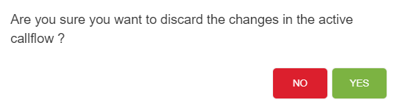
If Yes, Changes done in the active flow will be discarded and new flow selected here will be loaded.
If No, User can continue with the existing active flow.

New IW Flow
This option is only provided for ‘Maker’. On click of the “₊” button, the below screen will be displayed:
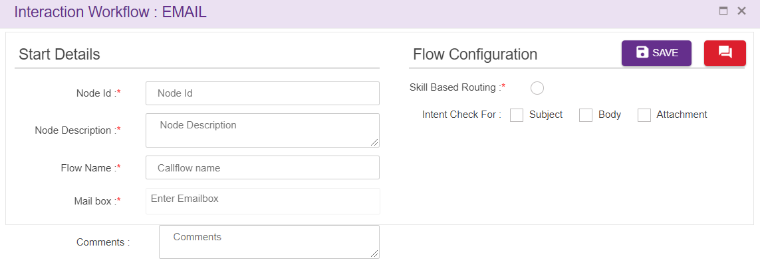
- Node Id: Accepts characters, numbers and special characters too. This option is used to track the announcements played.
- Node Description: Description about the node
- Flow Name: Name of the Call Flow should be unique.
- Mailbox: Unique mailbox id. Validation of mail id is done.
- Skill based routing: Enabled for skill-based routing, its inherited to all the route nodes
- Attribute based routing: List of attributes are displayed here
- Intent Check For: This will help the designer to decide, where to check for intent. Subject, body or attachment
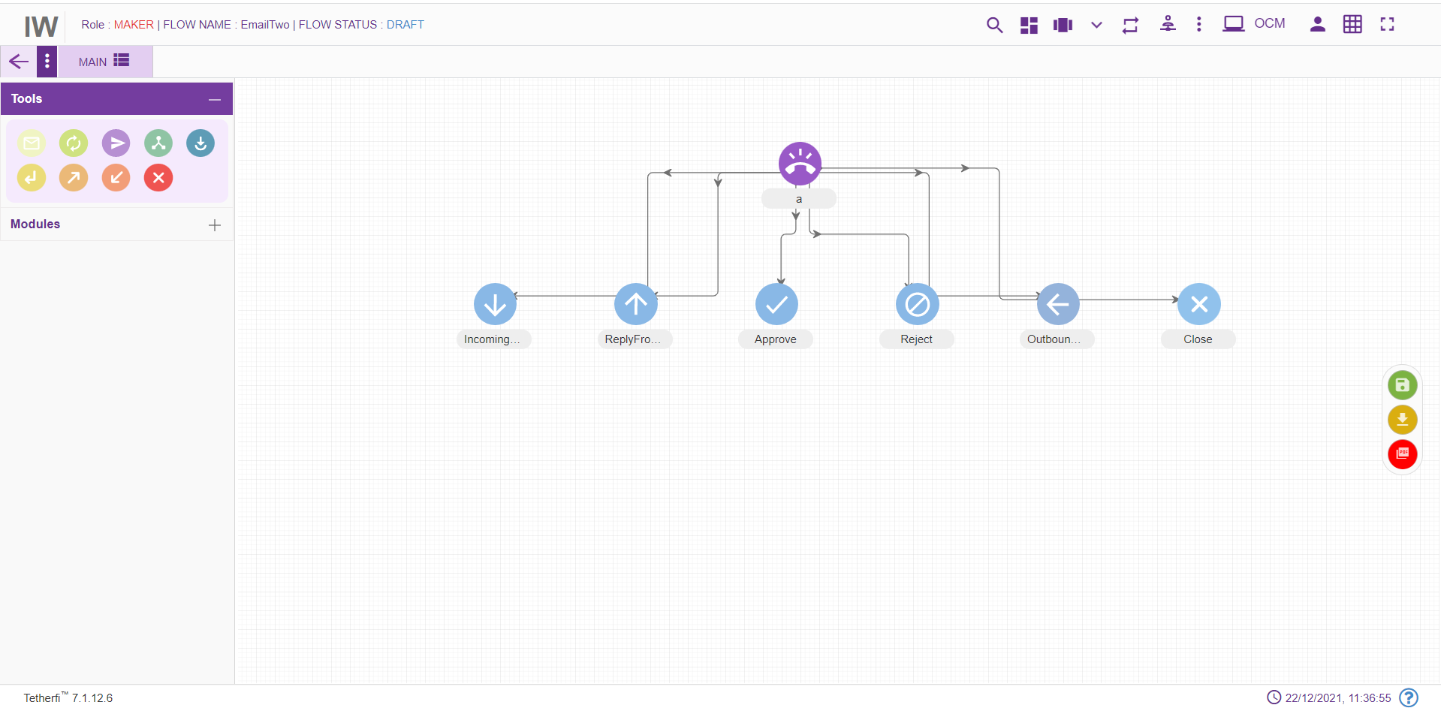
- IncomingEmail: Emails received from customer.
- ReplyFromAgent: An agent interaction with the customer for first mail received.
- Approve: Approving mail sent by customer.
- Reject: Rejecting invalid email.
- OutboundEmail: An outbound email is any email sends out to a potential customer who didn’t request the email.
- Close: Closing a received mail.

Sub Flow
Sub Flow icon is used to create new sub flow which can be used by main email flows and other sub flows. User can create the commonly used modules in a separate flow and can call from main flow. There is no dnis node in this subflow.
On clicking this subflow icon, empty page should open as shown below.
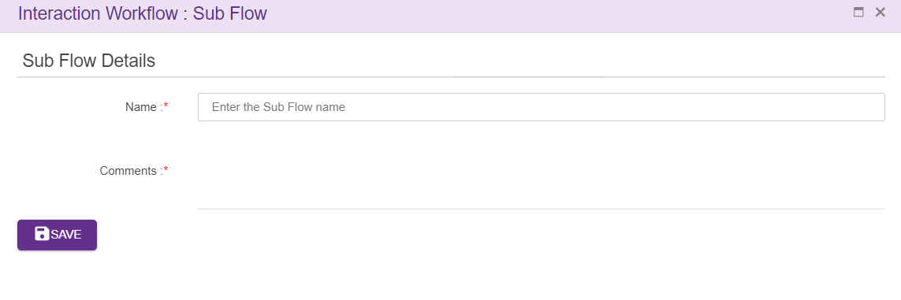
Name: Name of the Sub Flow can be added here. Sub flow name must be unique and should not accept any special characters

Comments: After entering all the details as mentioned above click on save button. Upon clicking on save button, empty page will be displayed as shown below, where user can create the emailflow by dragging the nodes present in toolbox.
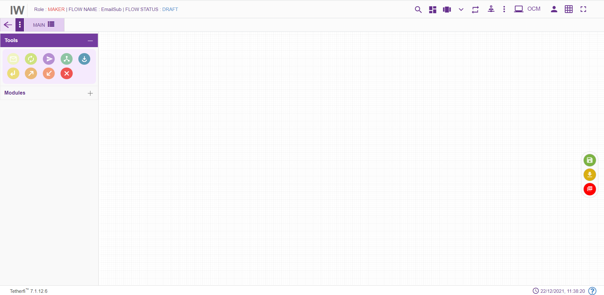
User can create the sub flow here by dragging and dropping available nodes from toolbox. The nodes used in the subflow has override configuration option which will override the calling flow configuration in subflow.
To jump to the sub flow, flow connector node must be used. To jump back to the main flow (where subflow is being called) from sub flow, return node can be used Multiple main emailflows can be connected to single subflow and all the feature as that of main flow is provided to subflow

5.1.5 Delete
Delete option will appear only when emailflow is in DRAFT and SAVED status. Selected emailflow from the drop down in ‘Emailflow List’ in Maker page.
Note that only owner of the emailflow can delete his emailflow in DRAFT and SAVED status.

Designing the Workflow
After successfully saving the DNIS Details, you can create/ edit the workflow depending on your requirement.

Tabs
The new Workflow will have the TAB functionalities. It would help to break the bigger call flows into multiple tabs. User can add the tabs only when the emailflow is in ‘Draft’ status.
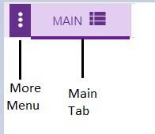
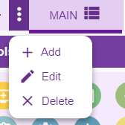
The above shown toolbar has the following functionalities:
- Main button can be used for navigating back to the Main tab.
- Add new tab button can be used when there is a need to create a new section of workflow by adding a new tab.
- Edit tab button can be used for making changes to the selected tab of workflow
- Remove tab button can be used for deleting the selected tab of workflow
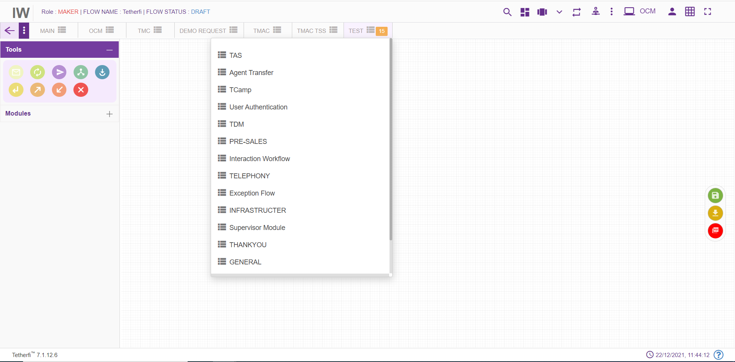
When a tab is selected from the dropdown, its name will be displayed at the top as shown above and Configured number of Tab are set in horizontal, and all other tabs should be displayed in drop down list.

Add New Tab
This button is shown when the flow is in ‘Draft’ status. When clicked on ‘Add new Tab’ button Tab pop window is generated
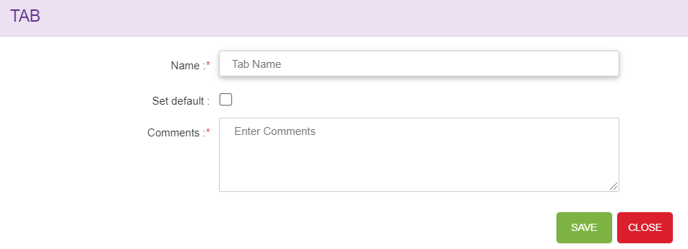
    - Name: Name of Tabs should be unique.
    - Set default: Checkbox is used to set the Tab as default Tab, whenever user views the flow default tab is shown, only one tab can be set as default. ‘MAIN’ tab will be set as default for the first time. When a new tab is set as default, previous tab set option will be cleared i.e. latest entry will be updated.
    - Comments: User can set add suitable comments regarding to the Tab.
Save: Upon clicking ‘Save’ button, Tab entries must be saved.
Close: Upon clicking ‘Close’ button, Tab pop window must be closed.
When new tab is added to the flow, newly created tab should be open by-default upon clicking ‘Yes’ as shown below.
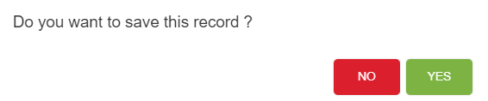

Edit Tab
Upon clicking the ‘Edit selected tab’ button to make changes to the selected tab, Tab pop window is open.
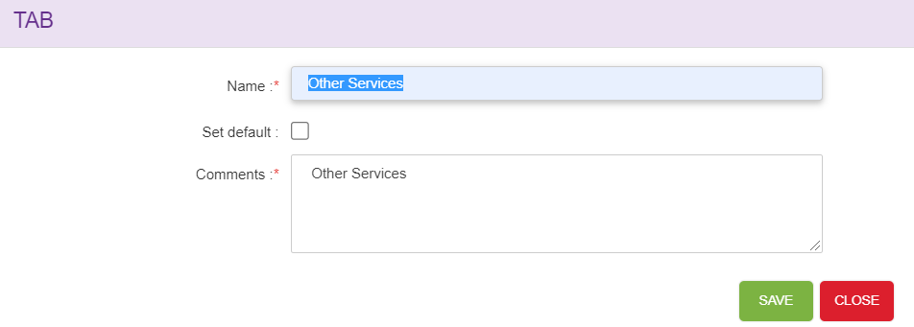
- Name: Edit the new tab name.
- Set default: Checkbox is used to set the Tab as default Tab, whenever user views the flow default tab is shown. ‘MAIN’ tab will be set as default for the first time. When a new tab is set as default, previous tab set option will be cleared i.e. latest entry will be updated.
- Comments: User can set edit the suitable comments regarding to the Tab.
Save: Upon clicking ‘Save’ button, Tab entries must be saved.
Close: Upon clicking ‘Close’ button, Tab pop window must be closed.

Delete/Remove Tab
Upon clicking on ‘Remove Selected tab’ confirmation pop window must generate.
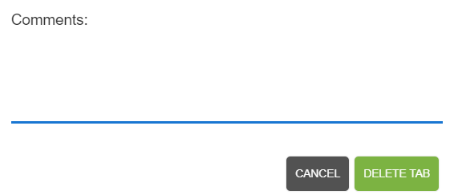
Delete Tab button: Upon clicking ‘Delete Tab’, tab will be successfully deleted.
Cancel button: Upon clicking ‘Cancel’, delete tab window will closed.
Default tabs cannot be deleted. Error message will be shown when try to delete default tab.

Copy Tab
Tab contents can be copied from one emailflow to another emailflow or other tabs within same emailflow using Ctrl +C and Ctrl+V options (other than IE browsers).
Upon copying the tab contents using Ctrl+C option, confirmation popup will generate. Note that user can copy the tab contents of a emailflow at any emailflow status.
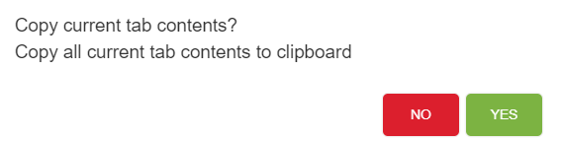
Upon successfully copying tab contents, success message will generate.
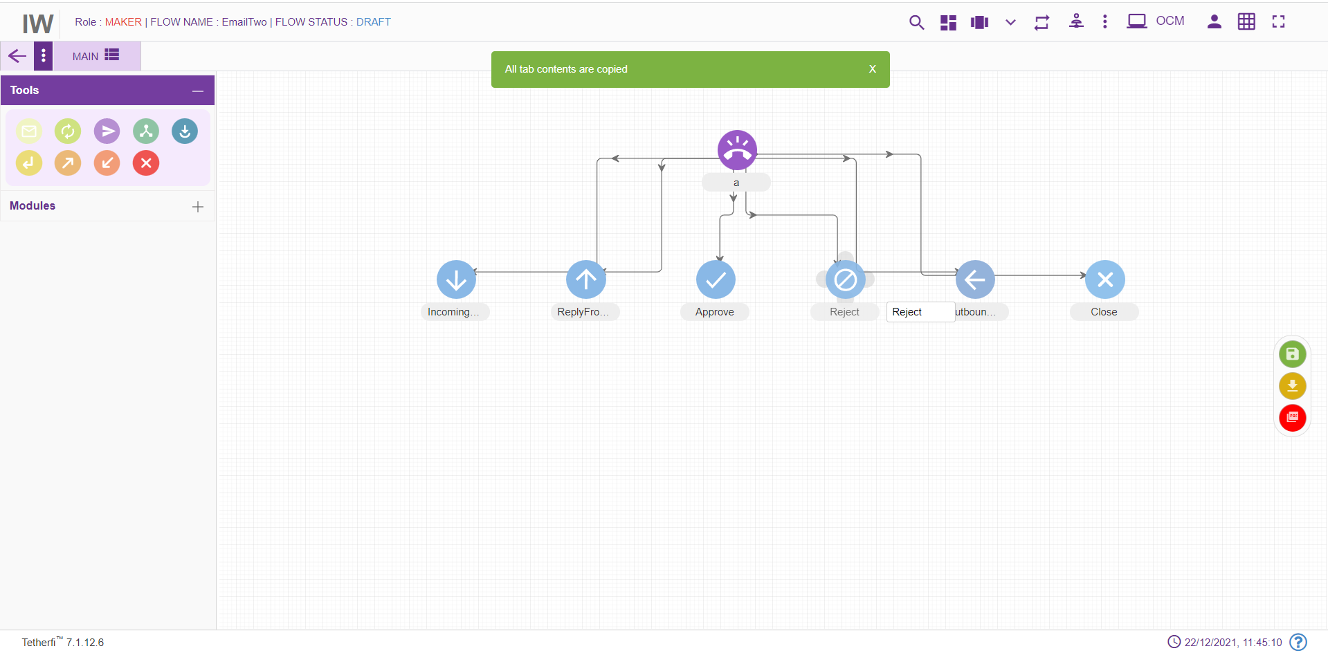
Ctrl+V option is used to paste the tab contents copied. Upon pasting the tab contents using Ctrl+V option, following confirmation popup will generate.
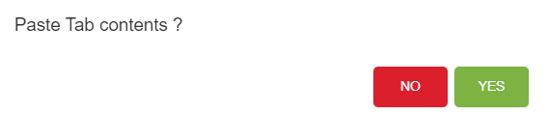
Upon clicking “Yes”, copied contents will be pasted to the respected tabs.
Note that user can paste the tab contents only in DRAFT emailflow status. Copy tab feature not only copies the structure but also copies phrases, rules and other related information set for each node.
User cannot copy-paste the tab which has DNIS node. Upon pasting the tab contents which has DNIS node, ‘dnis node already exists in this emailflow. cannot copy-paste data’ error message will generate.
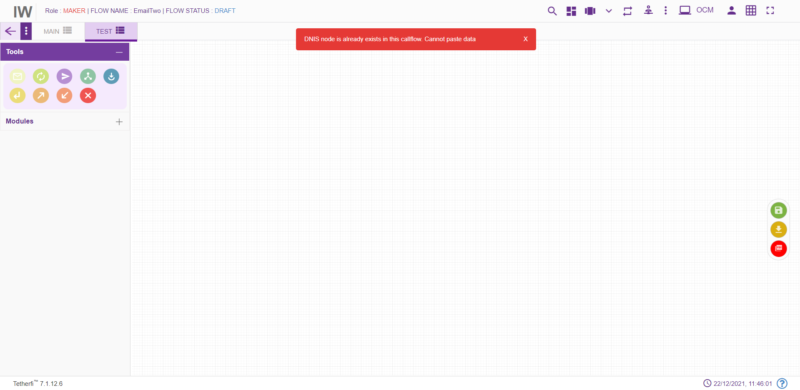

Tab Shuffling
User can move/shuffle the tabs present in the emailflow. User can shuffle only the tabs present in drop down as shown below.
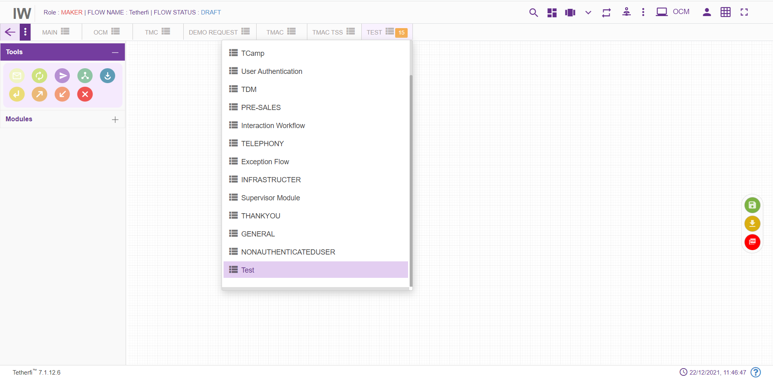
The new tab added after shuffling the tabs present in the drop down, will be added at the beginning of the drop down as shown above.

More Menu Option
Upon clicking more menu option, present at top right and left corner at different status of the emailflow, following options will appear. refer section Flow Status:
When user loads is own emailflow:
User Permission |  | Emailflow Status | More Menu(left) | More Menu(right)
Maker | Draft |  | 1.Callflow Version Control  2.Import flow  3.Copy flow | Save flow
Maker | Saved |  | 1.Import flow  2.Copy flow | 1.Send to approval  2.Edit flow
Previewer | Draft |  |  | No options
Previewer | Saved |  |  | No options

When user loads some other user’s emailflow:
User Permission | Emailflow Status | More Menu(left) | More Menu(right)
Maker | Draft | 1.Import flow  2.Copy flow | Save flow
Maker | Saved | 1.Import flow  2.Copy flow  3.Text to Voice | 1.Send to approval  2.Edit flow

Set Rules
User can set the rules in Conditional, Announcement, menu node. ‘Set Rule’ icon will be displayed in these nodes to set the rules as shown below.
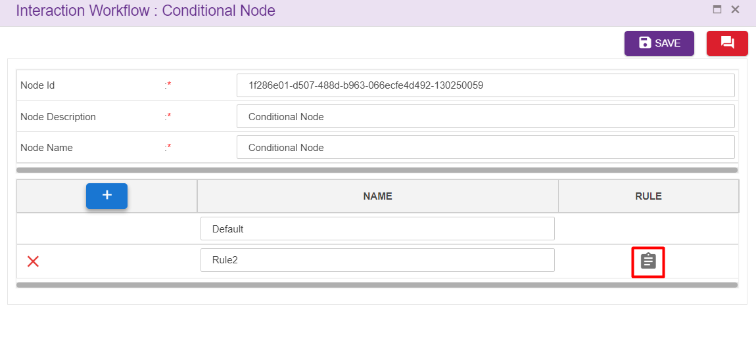
Upon clicking set rules icon following window will popup.
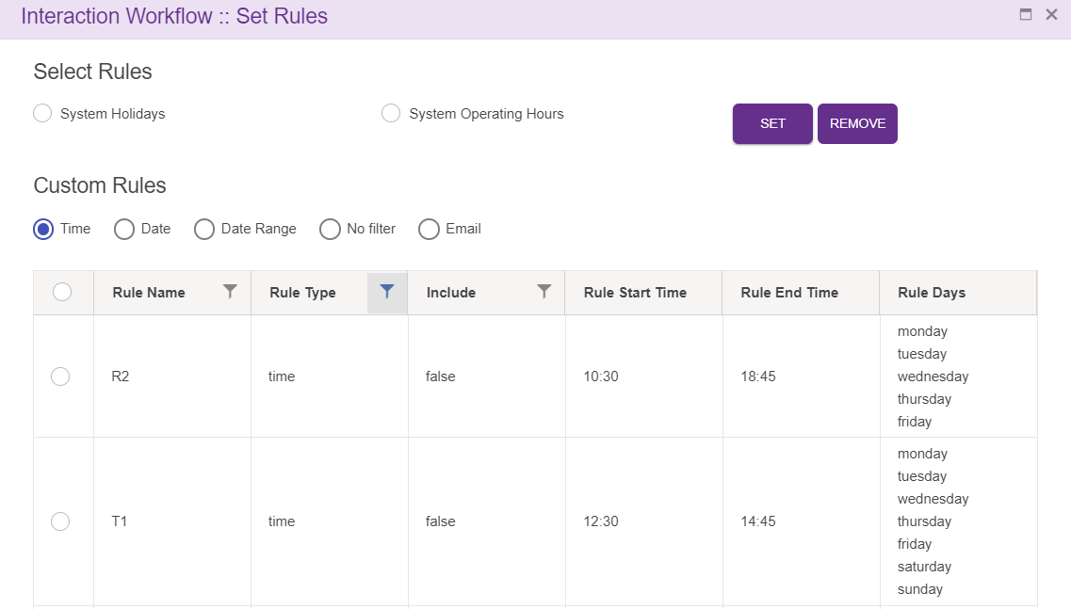
Rules added at ‘Rule Master’ will be displayed here. User can set these rules for the nodes.
Upon clicking ‘SET’ after selecting the rules, following confirmation popup will generate.
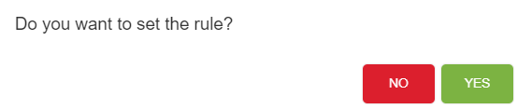
Upon clicking ‘YES’, rule will be successfully set to the nodes.
User can set the rules for the AutoResponse node, Route node and Conditional node.
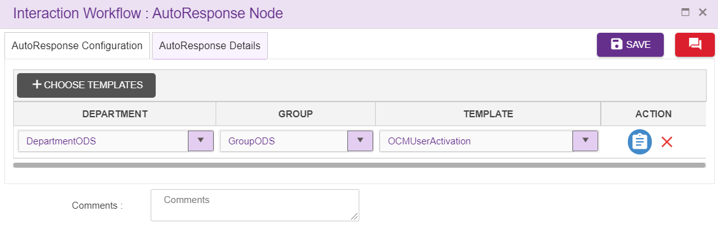

Emailflow Sync Notification
While saving emailflow, adding/editing intents, adding/editing rules, adding global phrase, adding/editing global configuration if the interpreter is down, data will not reflected in IVR. At those situation ‘Emailflow sync notification’ icon will appear in UI as shown below.
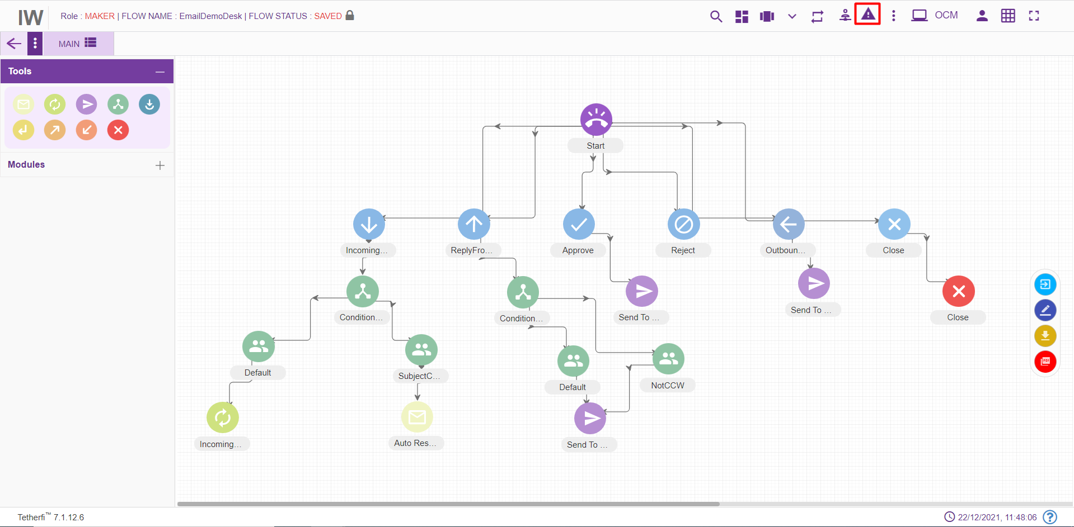
In this situation user can upload these files to interpreter once it is up, by clicking ‘Resubmit’ button. ’Clear’ option is also provided here to remove the notification.
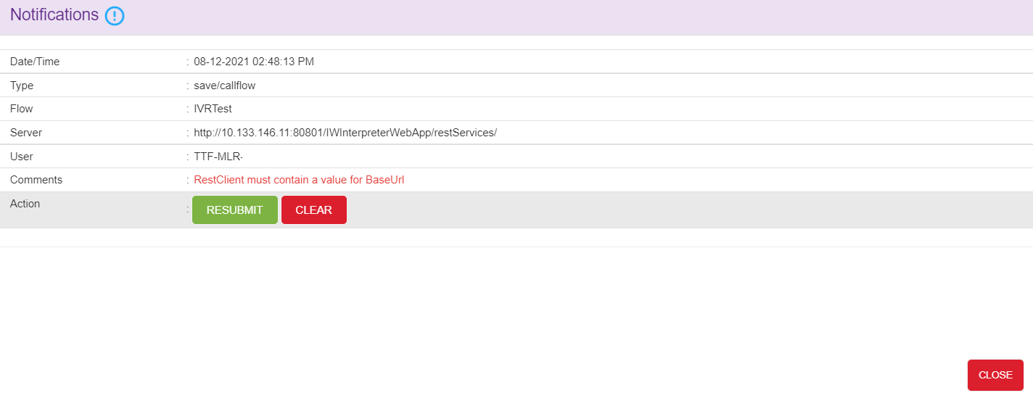
Sync notification icon also displayed in landing page if the interpreter was down while updating intent master rule master, global configuration, global phrases. User can resubmit the data to interpreter from landing page too. Emailflow specific resubmit sync notification will appear only after loading the emailflow in UI.
Intent master and rule master sync notification
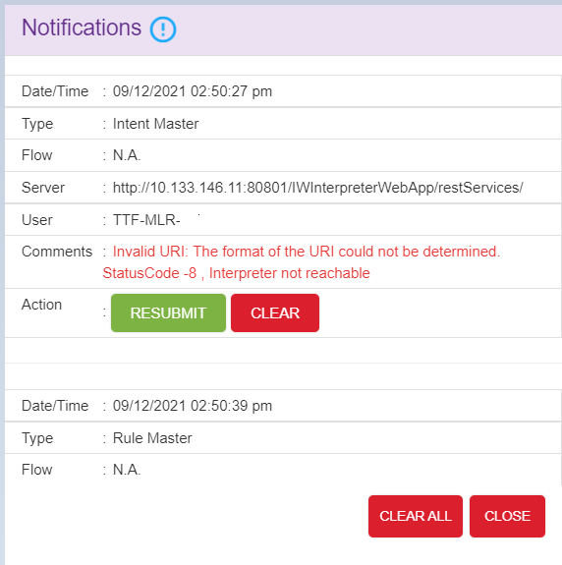

Note: This option will appear in UI, only when interpreter is down. ‘CLEAR ALL’ option is provided to remove all the notification.

Nodes and Modules

Nodes
Nodes are often arranged into tree structures. These structures are binary trees.
A node represents the information contained in a single structure. These nodes may contain a value or condition, or possibly serve as another independent data structure. There are nine types of nodes in Interaction Workflow:
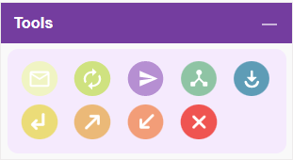

Auto Response Node
For adding a new transfer to auto response section to the emailflow, click on the “Auto Response” icon and drag it to the main screen.
For editing/ configuring the auto response node, hover over the auto response icon you added and edit/ delete functionalities for the menu will be displayed.
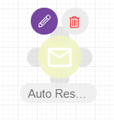

On click of edit button, the below screen will pop up and node will be popped till node window is open.
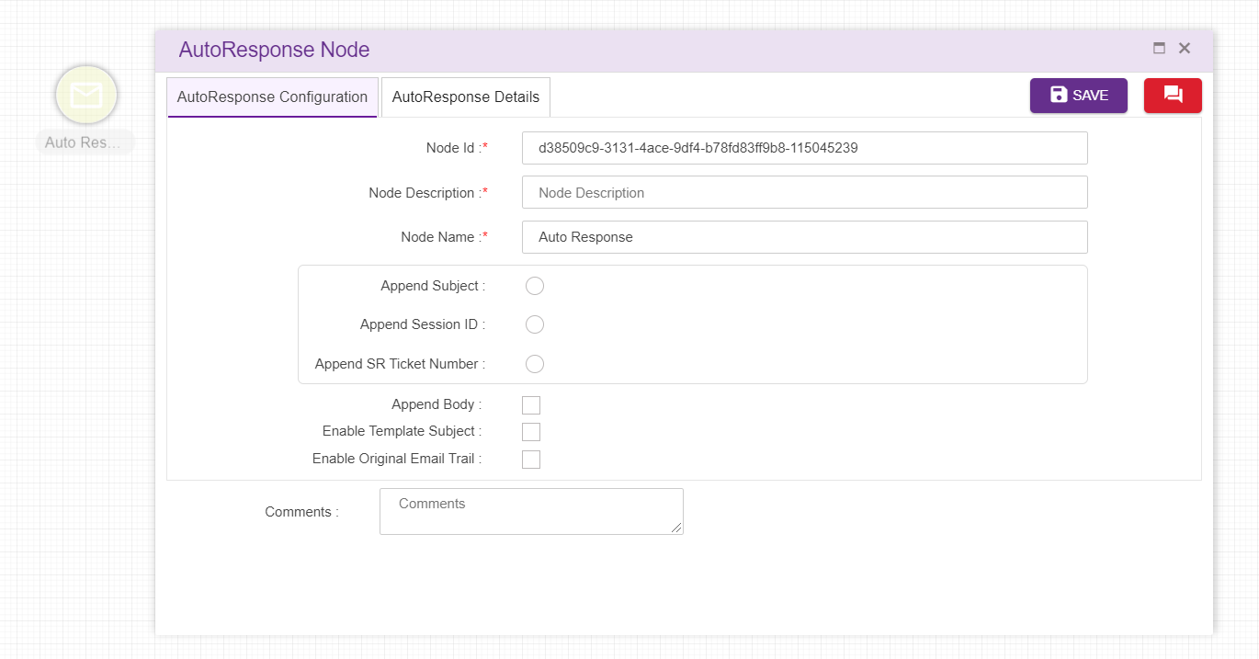
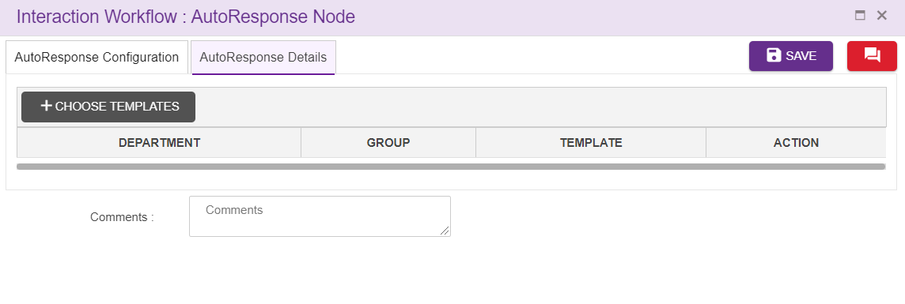
Node ID: By default, the node ID for an Agent node is autogenerated, but the Users have the privilege to assign their own ID. Each node ID should be unique. (Mandatory)
Node Description: Brief characterization of the agent Node. (Mandatory)
Node Name: This is a mandatory field. Name provided here will be reflected in UI
Append Subject: Email subject can be configured here.
Append Body: Email Body can be configured here.
Append Session ID: This is a unique id created for each session.
Append SR Ticket Number: This is the ticket number assigned per each issue(email) request.
Enable Template Subject: Data will be taken from OCM to append subject.
Enable Original Email Trail: Data will be taken from OCM to append body.
Department: Data is displayed here from OCM
Group: Data is displayed here from OCM
Template: Data is displayed here from OCM
Auto Response Details: Can add multiple templates for auto response node
Delete Auto Response Node:
On click of delete button, the below screen will popup
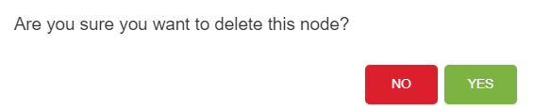

Route Node
For adding a new Route Node to the emailflow, click on the “Route node” icon and drag it to the main screen.
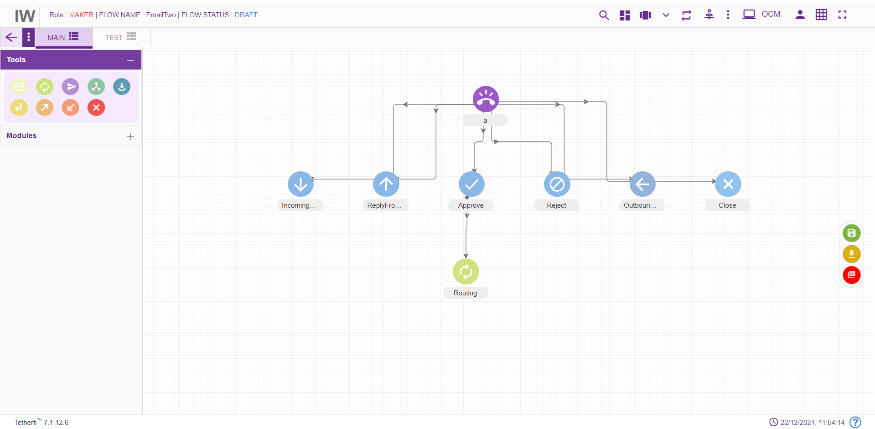
For editing/ configuring the Route Node, hover over the route Node icon you added and edit/ delete functionalities for the Route node will be displayed
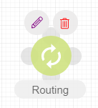
On click of edit button, the below screen will popup
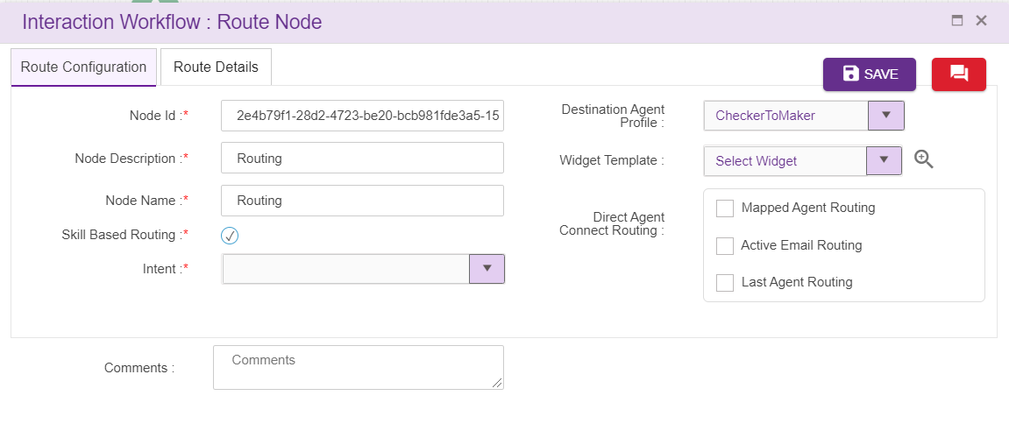
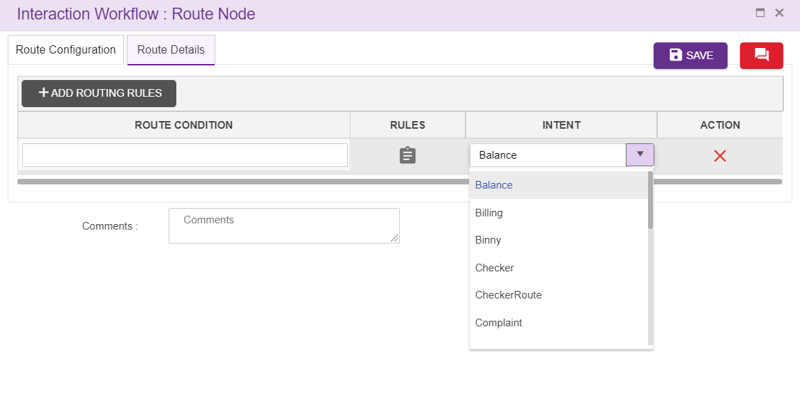
- Node id: This field accepts characters, numbers and special characters too. This option is used to track the announcements played.
- Node Description: Brief characterization of the announcement Node. (Mandatory)
- Node Name: This field refers to the name of the route node. By default, name is Routing. but the Users have the privilege to assign their own name.
- Skill Based Routing: Check box need to be enabled
- Mapped Agent Routing: Check box need to be enabled
- Attribute Based Routing: Check box need to be enabled
- Last Agent Routing: Check box need to be checked for last agent routing
- Active Email Routing: Check box need to be checked for active email routing
- DAC Parameters: Age od the email can be set here.
- DAC Routing: One among last or active agent should be selected
- Destination agent profile: Can be maker, checker or vetter_DAP
- Intent: Intents for skill based routing is configured here
- Widget Template: Widgets added in master, will be displayed here
Delete Route node
On click of delete button, the below screen will popup

Send to Customer Node
For adding a new send to customer Node to the emailflow, click on the “Send to Customer” icon and drag it to the main screen.
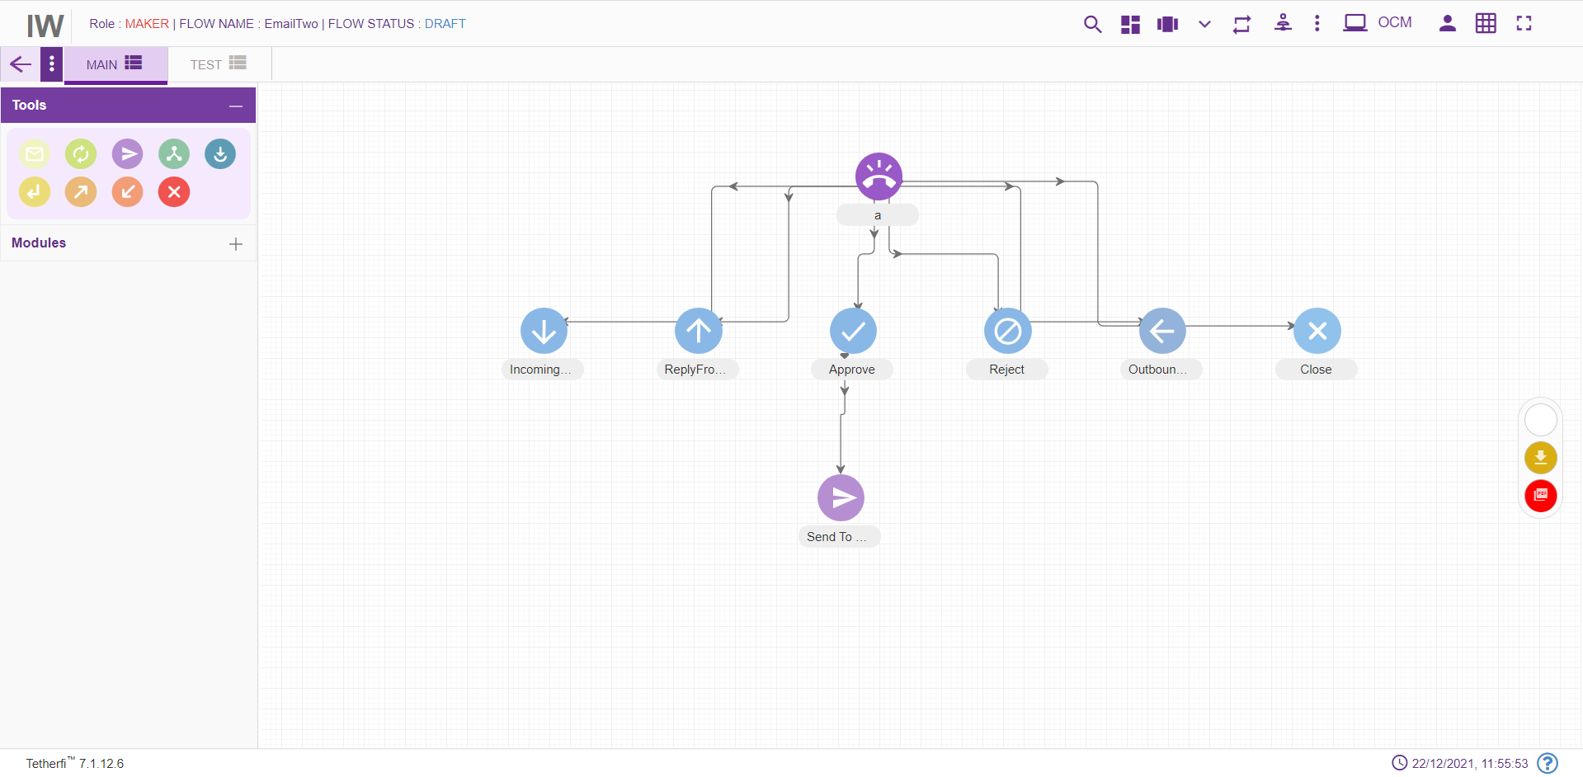
For editing/ configuring the Send to customer Node, hover over the Node icon you added and edit/ delete functionalities for the Send to customer node will be displayed
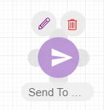
On click of edit button, the below screen will popup.
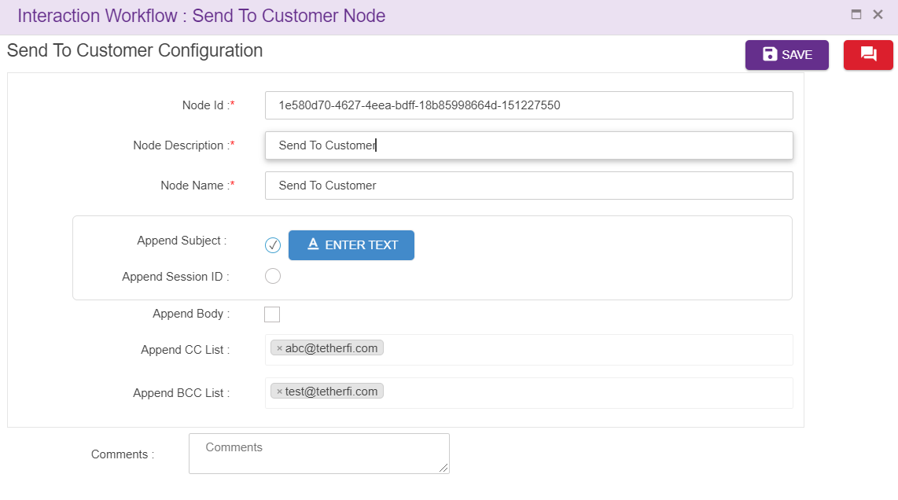
Node ID: By default, the node ID is autogenerated, but the Users have the privilege to assign their own ID. Each node ID should be unique. (Mandatory)
Node Description: Brief characterization of the Node. (Mandatory)
Node Name: Node name is provided here
Append Subject: Email subject can be configured here.
Append Body: Email Body can be configured here.
Append Session ID: This is a unique id created for each session.
Append SR Ticket Number: This is the ticket number assigned per each issue(email) request.
Append CC List: To append additional CC Email Id while sending mail.
Append BCC List: To append additional BCC Email Id while sending mail.
Delete node:
On click of delete button, the below screen will popup

Conditional Node
For adding a new Conditional Node to the emailflow, click on the “Conditional Node” icon and drag it to the main screen. Conditional node is associated with a default node.
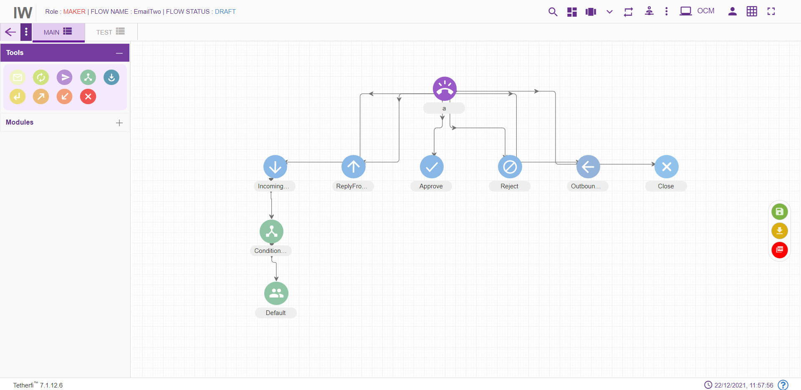
For editing/ configuring the Conditional Node, hover over the Conditional Node icon you added and edit/ delete functionalities for the menu will be displayed.
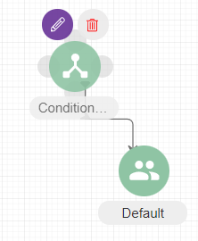
On click of edit button, the below screen will popup
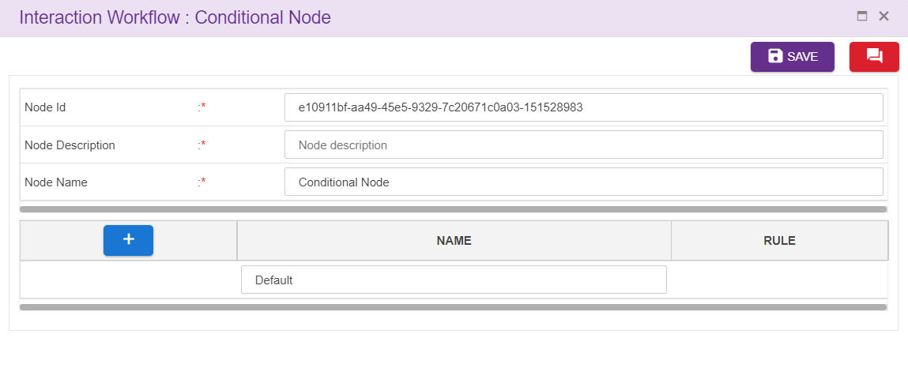
Node ID: By default, the node ID for a Conditional node is autogenerated, but the Users have the privilege to assign their own ID. Each node ID should be unique. (Mandatory)
Node Description: Brief characterization of the conditional Node. (Mandatory)
Name: This is a mandatory field. Name provided here will be reflected in UI. By default, the name is Conditional Node. but the Users have the privilege to assign their own name.
Adding Rules:
Click on “+” icon, to add rules.
Click on the ’Set Rules’ icon present at the Rule column to add conditional rules. refer section Set Rules
Upon clicking this icon following popup will be displayed and rule leg will be shown in UI. Conditional node is associated with default node. User should not be allowed to connect to default node directly from other nodes.

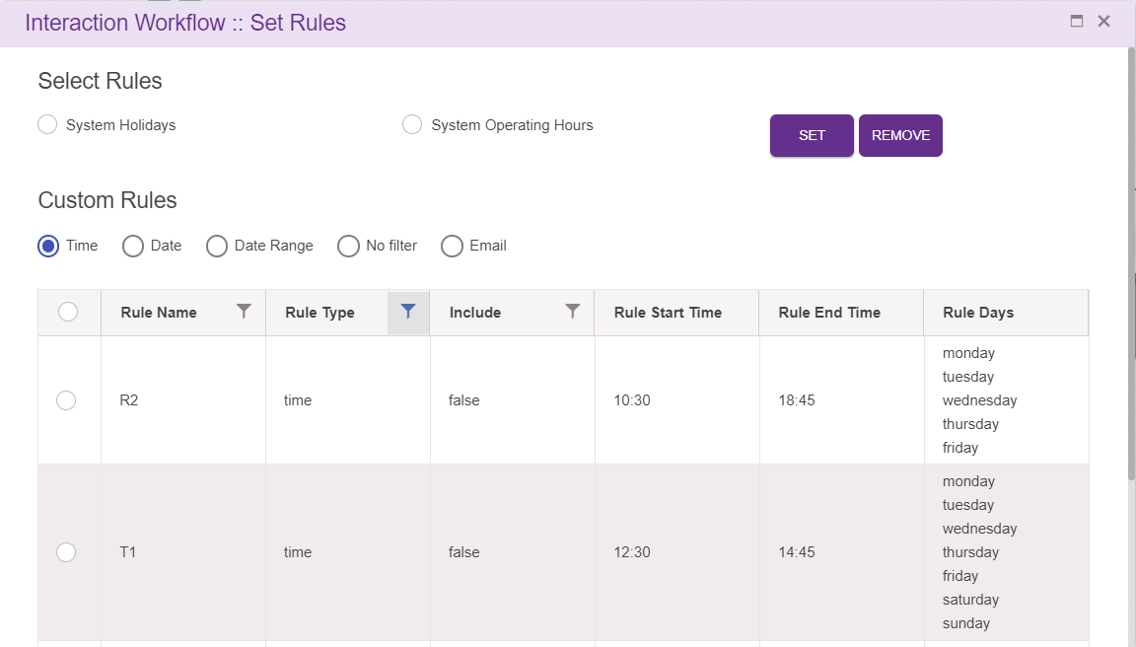
Delete Conditional Node:
On click of delete button, the below screen will popup

Flow Connector node
Flow connector node is used to jump to subflow. Every Flow connector will be pointing to the next Entrys Point. This navigation details are provided by editing the flow connector and then setting the entry point. Flow connector node can be connected to only 1 node and it is a default connection (without label).
For adding a new flow connector to the flow, click on the “flow connector” icon and drag it to the main screen.
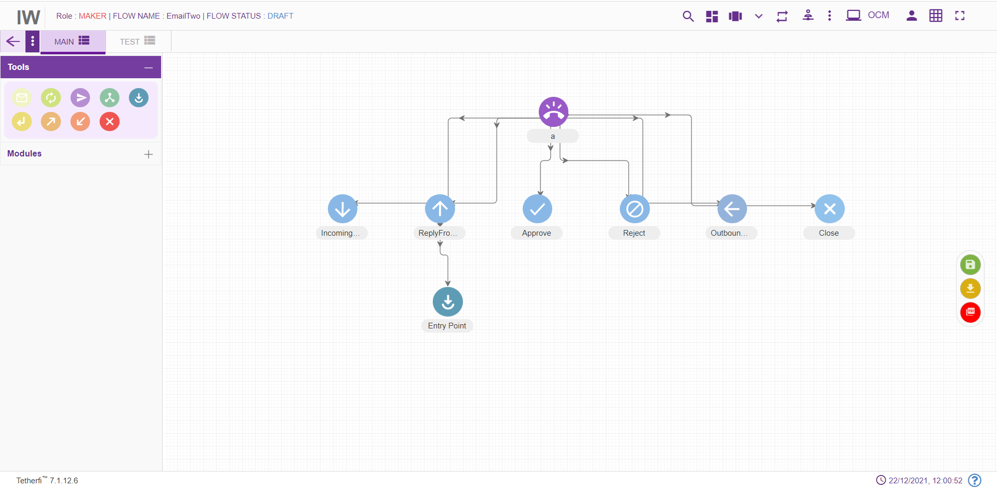
For editing/ configuring, hover over the flow icon you added and edit/ delete functionalities for the flow icon will be displayed.

On click of edit button, the below screen will popup
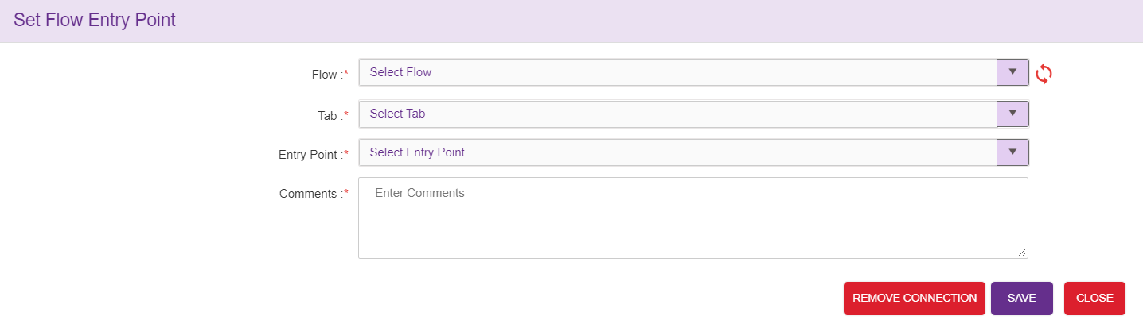

To set the Flow Entry Point:
- Drag and drop flow connector node and click on the ‘Edit details’ icon
- ‘Set Flow Entry Point’ pop up window will be displayed. This window has Flow name, tab name, Entry Point name and Comments. All the fields are mandatory. By default, the tab name will have ‘select tab’ in the drop down.
- Choose the subflow/mainflow name and tab name to which the control must navigate from flow connector Point. All the approved/saved subflows/mainflows will be displayed here. After choosing the tab name, only then the ‘Entry Point name’ will be populated. It will have all the entry points for the selected tab.
- Enter the comments and save. Flow connector node will have the name of the set Entry point.
- If there is both SAVED and APPROVED copy of the flow, then SAVED copy information will be displayed in the dropdown

Flow connector can have only one Entry Point set. It cannot be set to multiple entry points. Set connections can be deleted.
To remove the connections:
- Click on edit details button of the flow connector. It should have the set Entry Point.
- Click on remove connections’ button.
- ‘Are you sure you want to remove this flow connection?’ confirmation message should be displayed. On clicking Yes, the connection will be removed between the flow connector and Entry Point.
- ‘Flow connection removed’ message will be displayed confirming the deletion.

Return Node
Return node should be the last node of a emailflow. This node is used to return the control to the calling flow. Upon encountering this node in the subflow, control will be redirect to flow connector node where the subflow is being called.
For adding a new Return Node to the emailflow, click on the “Return” icon and drag it to the main screen.
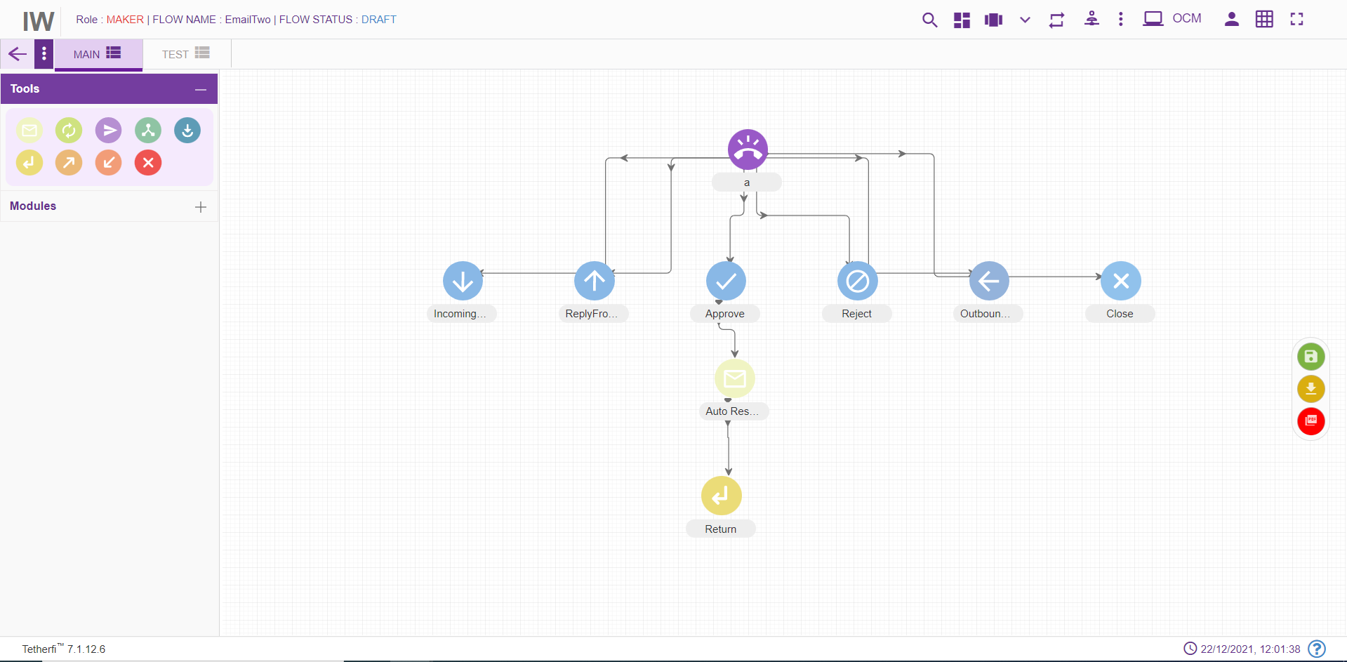

For editing/ configuring the return node, hover over the return node icon you added and edit/ delete functionalities for the return icon will be displayed.
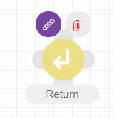
On click of edit button, the below screen will popup
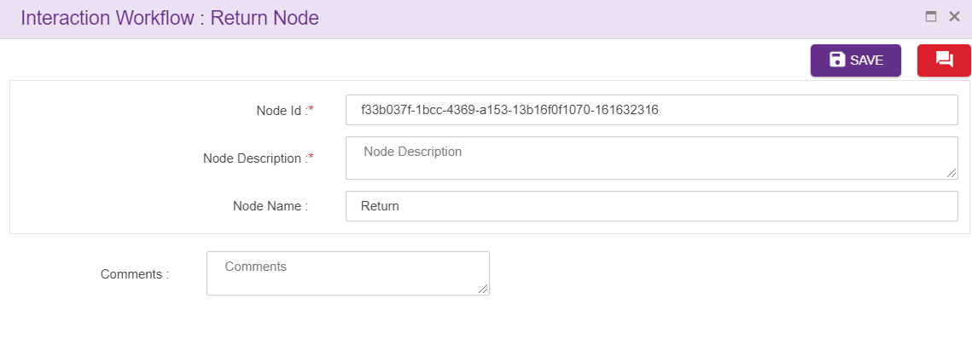
Node ID: By default, the node ID for a return node is autogenerated, but the Users have the privilege to assign their own ID. Each node ID should be unique. (Mandatory)
Node Description: Brief characterization of the announcement return Node. (Mandatory)
Name: Name of return node.
Delete Return Node
On click of delete button, the below screen will popup

Entry Point Node
Some of the emailflows can contain many nodes. It becomes difficult to manage or fit the entire emailflow in a single screen. Such emailflows are broken into smaller flows for better readability and to also reduce frequent scrolls on the page. Each of these small flows are connected through the Entry and Exit node.
To add an Entry Point:
- Click on the node menu and drag and drop the Entry point to the screen
- Click on the three dots and then click on Edit details icon
- Entry Point pop up box is displayed
- Enter the Entry Point name and save
- Entry Point node should have the Entry Point name updated

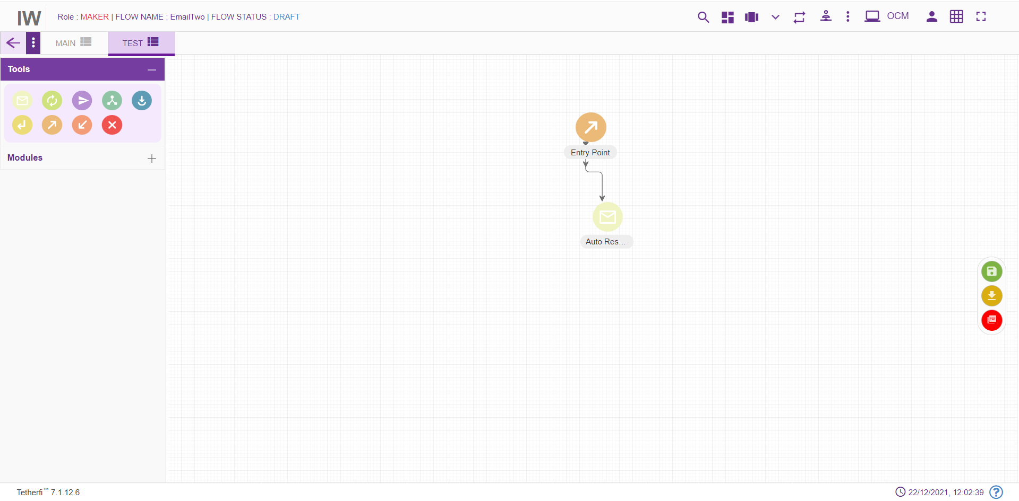

Entry Points can be connected to multiple flows which means technically multiple exits points are connected to entry points. To view the connections to the Entry Point, ‘view connection’ option is provided.
To view Entry Point connections:
- Click on the three dots on the Entry Point node and then click on View Connections icon
- ‘Following Connections found:’ pop up window with the Tab name and Entry Point name will be displayed.
- Tab name will have the tabs which are connected to this flow. There can be multiple tab names and exit points connected to a single-entry point.

Entry Point should not have any incoming connections. Alert message ‘Entry Point should not have any incoming connections’ will be displayed when try to connect a node to Entry point node.
For editing/ configuring the Entry point, hover over the Entry point icon you added and edit/ delete/ view connections functionalities for the menu will be displayed.
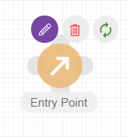
On click of edit button, the below screen will popup wherein you need to specify the name of the Entry Point.
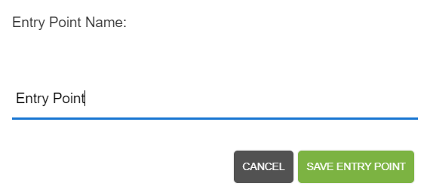
To delete the Entry Point:
- Double click on each connection of the Entry Point and delete them individually.
- When all the connections are broken then click on ‘delete details’ icon on the node
- Entry Point will be deleted. This Entry Point will not be available for setting entry point for any of the exit points.

Exit Point Node
Exit Node cannot be a source node. It is the last node of the flow. If there is an effort to set connection between Exit node to any of the nodes, an alert message ‘Source can’t be an exit point. Exit point cannot have any exits.’ Will be displayed.
Every Exit Point will be pointing to the next Entry Point. This navigation details are provided by editing the Exit Point and then setting the entry point.
For adding a new Exit point to the emailflow, click on the “Exit point” icon and drag it to the main screen. 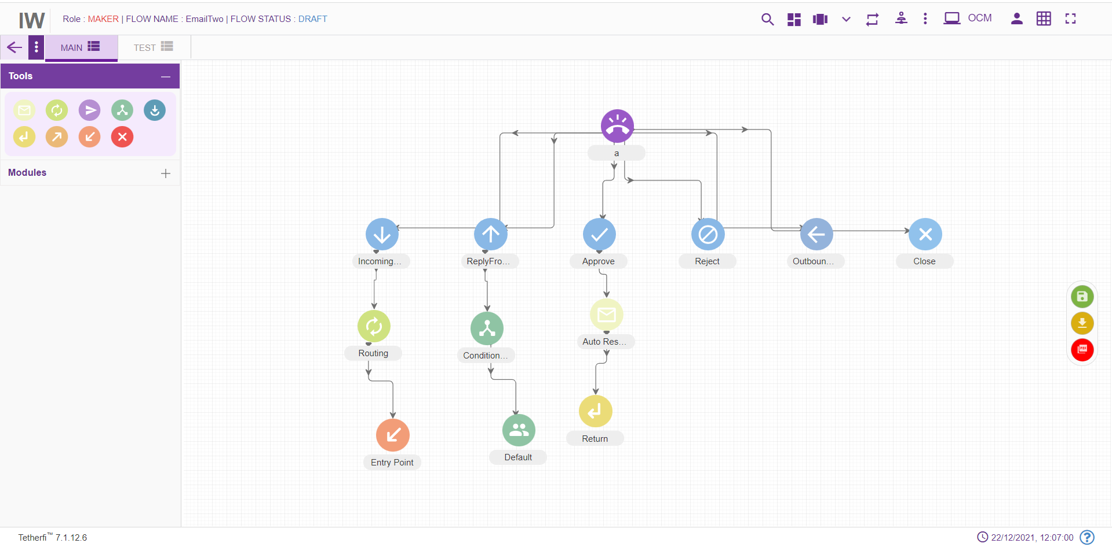
For editing/ configuring the Exit point, hover over the Exit point icon you added and edit/ delete functionalities for the menu will be displayed.
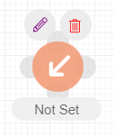
To set the Entry Point:
- Click on the Exit Point to which the entry point has to be set and click on the ‘Edit details’ icon
- Set Entry Point’ pop up window will be displayed. This window has tab name, Entry Point name and Comments. All the fields are mandatory. By default, the tab name will have ‘select tab’ in the drop down.
- Choose the tab name to which the control has to navigate from Exit Point. After choosing the tab name, only then the ‘Entry Point name’ will be populated. It will have all the entry points for the selected tab.
- Enter the comments and save. Exit Point node will have the name of the set Entry point.

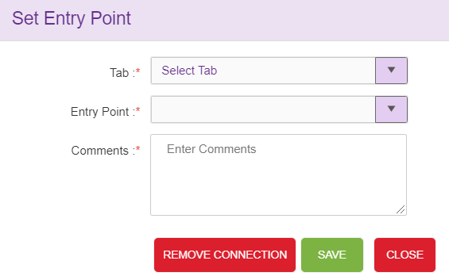

Exit Point can have only one Entry Point set. It cannot be set to multiple entry points. Set connections can be deleted.
To remove the connections:
- Click on edit details button of the Exit Point. It should have the set Entry Point.
- Click on remove connections’ button.
- ‘Are you sure you want to remove this Entry point connection?’ confirmation message should be displayed. On clicking Yes, the connection will be removed between the Exit Point and set Entry Point.
- ‘Entry Point connection removed’ message will be displayed confirming the deletion.
- If the ‘edit details’ button is clicked again, ‘Set entry point’ window will not have connection details. Also, ‘Remove connections’ button will not be present.

Exit Point can be deleted.
To delete the Exit Point:
- Double click on each connection of the Exit Point and delete them individually.
- When all the connections are broken then click on ‘delete details’ icon on the node
- Exit Point will be deleted.

Node Connectivity

Start Node | End Node | Connection status (outgoing) | Connection status (incoming)
DNIS |  | Single connection | No incoming connection to DNIS node
DNIS Leg | All other nodes except Entry point node, module exit and conditional exit nodes | Single connection | Single connection from DNIS
Auto Response | All other nodes (including auto response node) except Entry point node, module exit and conditional exit nodes | Multiple connection from auto response node | Multiple connection to auto response node
Route | All other nodes (including route node) except Entry point node, module exit and conditional exit nodes | Single connection from route node | Multiple connection to route node
Send to Customer | All other nodes (including send to customer node) except Entry point node, module exit and conditional exit nodes | Single connection | Multiple connection
Conditional node |  | No outgoing connection from conditional node | Multiple connection to conditional node
Conditional node legs | All other nodes (including Conditional node) except Entry point node, module exit and conditional exit nodes | Single connection from one leg of the conditional node | No incoming connection to Conditional node legs
Entry Point Node | All other nodes except Entry point node, module exit and conditional exit nodes | Single connection from Entry point node | No incoming connection to Entry Point node
Disconnect Node |  | No outgoing connection from Disconnect node | Multiple connection to disconnect node
Exit Point Node |  | No outgoing connection from Exit point node | Multiple connection to Exit Point node
Module Node |  | No outgoing connection from Module node | Multiple connection to Module node
Module Node legs | All other nodes (including Module node) except Entry point node, module exit and conditional exit nodes | Single connection from one leg of the Module node | No incoming connection to Module node legs
Return Node |  | No outgoing connection from Return node | Multiple connection to return node
Flow Connector Node | All other nodes (including Module node) except Entry point node, module exit and conditional exit nodes | Single connection from flow connector node | Multiple connection to flow connector node

Disconnect Node
Disconnect node should be the last node in a emailflow and user should not be able to connect other nodes after that. For adding a new Disconnect Node to the emailflow, click on the “Disconnect” icon and drag it to the main screen.
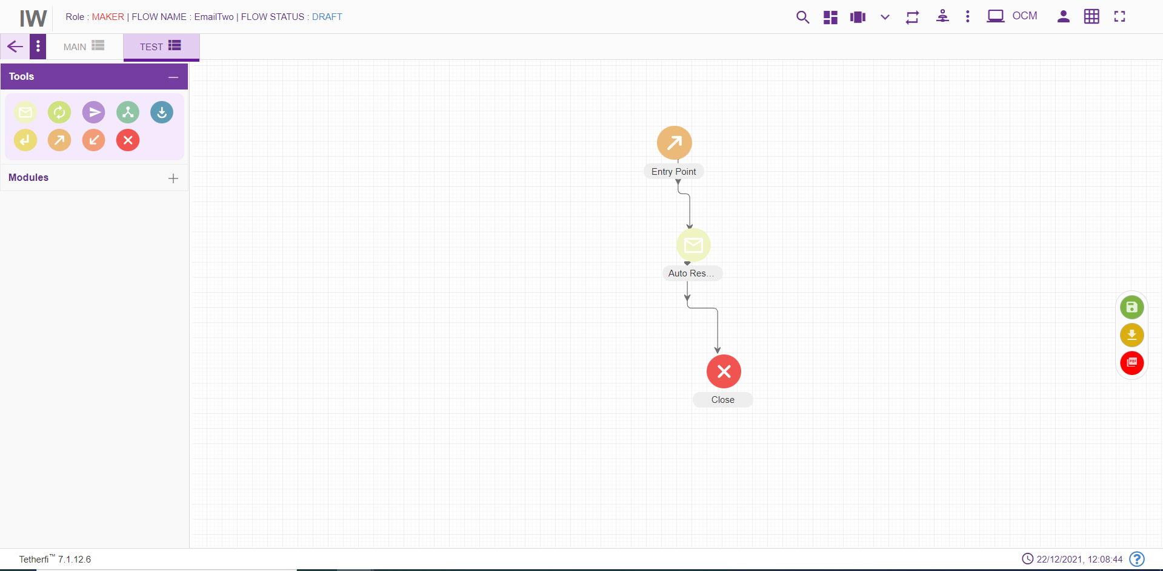
For editing/ configuring the Disconnect Node, hover over the Disconnect Node icon you added and edit/ delete functionalities for the disconnect node will be displayed.
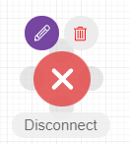
On click of edit button, the below screen will popup
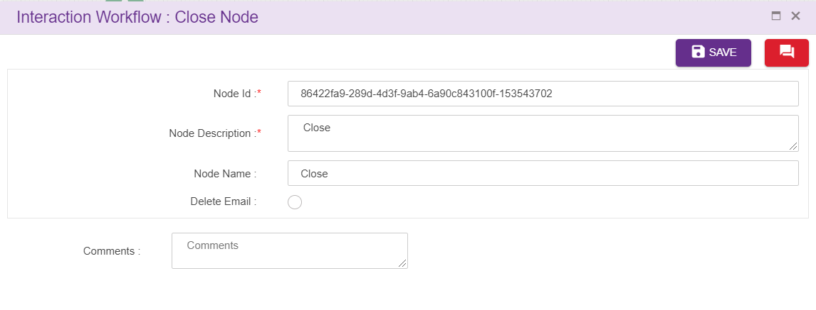
Node ID: By default, the node ID for an Agent node is autogenerated, but the Users have the privilege to assign their own ID. Each node ID should be unique. (Mandatory)
Node Description: Brief characterization of the agent Node. (Mandatory)
Delete Disconnect Node
On click of delete button, the below screen will popup

Node Changes
Different types if icons can be configured for node in Email which is available in folder.
- Dark icons
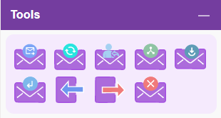
- Light icons
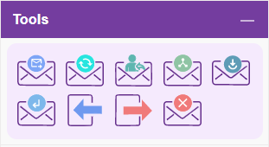

Modules

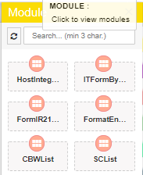
Modules are separable component, frequently one that is interchangeable with others, for assembly into units of differing size, complexity or function. Self-service transactions are implemented in module. Size of the default node which is associated with module node is smaller than module node.
For adding a new Module to the emailflow, click on the “Module” icon and drag it to the main screen.
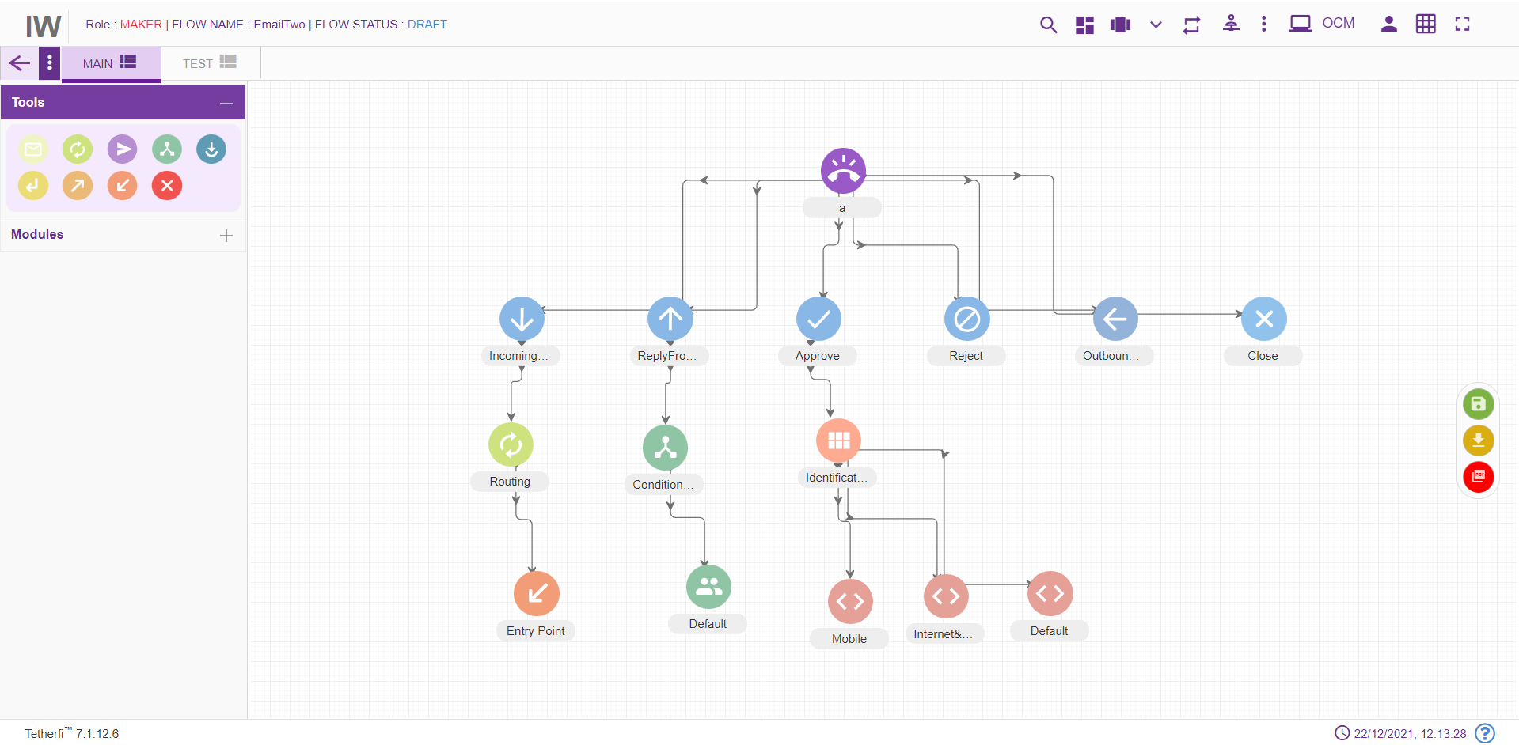
For editing/ configuring/ refreshing the Module, hover over the Module icon you added and edit/ delete functionalities for the menu will be displayed.
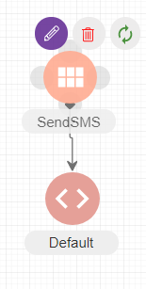
On click of edit button, module configuration details can be updated. ‘serviceID’ is the parameter for HostIntegration Module.
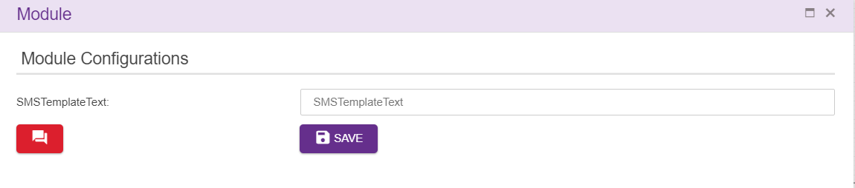
When a user adds new labels to the modules, he can update all the existing modules in the emailflow by clicking refresh/reload button as shown below.
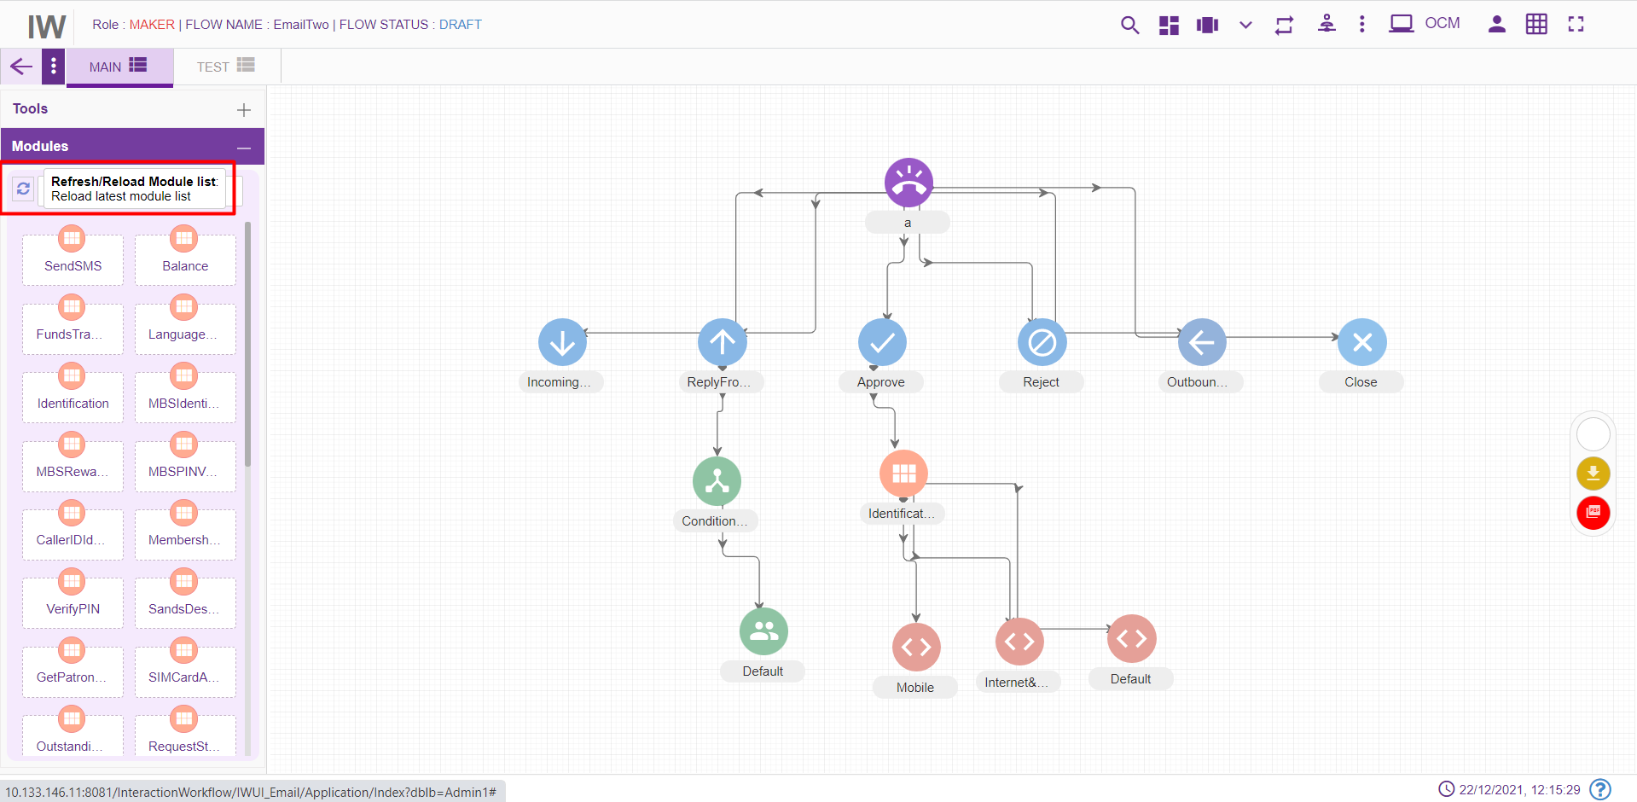
Upon clicking refresh/reload button following popup will generate to update existing modules in the emailflow. Emailflow must be in DRAFT status.
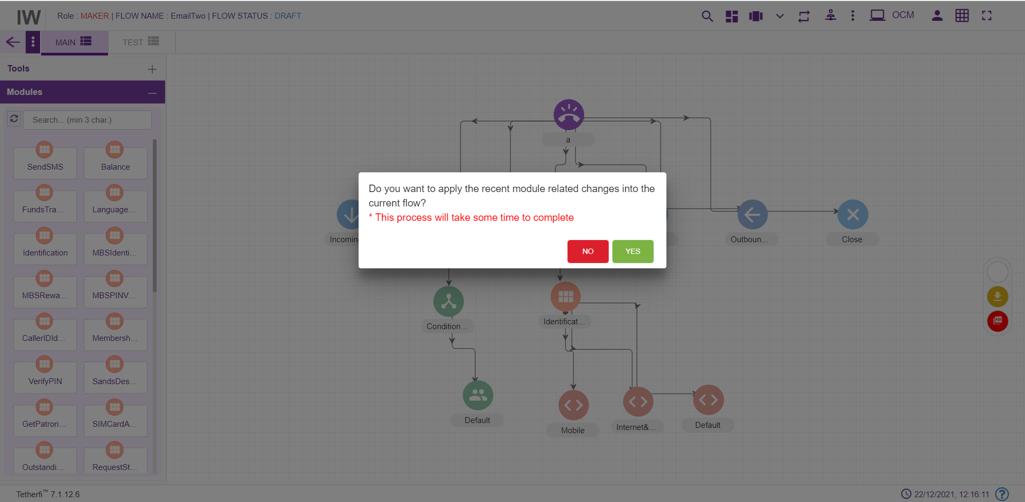
‘Yes’: all the modules present in the emailflow will be updated.
‘No’ changes will not reflect in the existing modules present in the emailflow.

IW Module Designer
This is the new Tetherfi application with is used to design the Module Flow. Just like Interaction workflow, there are set of nodes used to design the module flow. If there is a module flow designer in IW Module Designer application for the module dropped in IW, then IW will redirect the user to this IW Module designer application upon opening the module. If there is no Module flow designed in IW Module designer application for the module used in IW, then control will be there in IW.
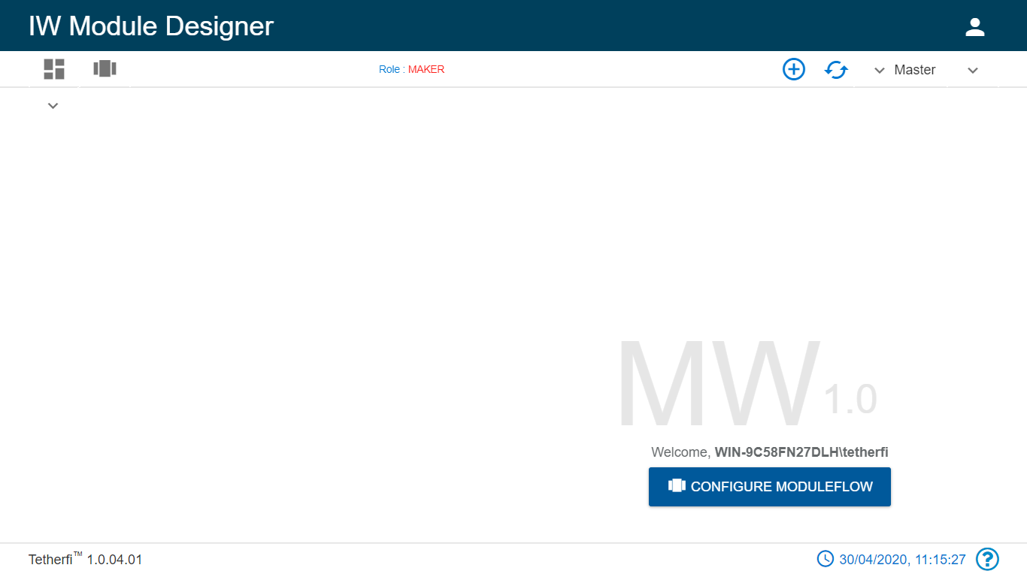
Refer the document attached.

Connecting Nodes and Modules
For interconnecting two or more Nodes/ Modules, you need drag the connecting link as shown below:
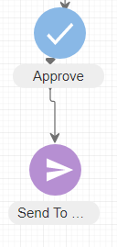
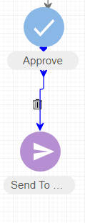
For deleting a node, double click on the connecting link and the below screen will be displayed:
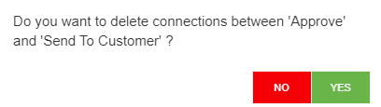

Context Menu
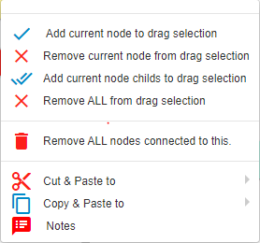
- Add current node to drag selection: Adds selected/current node to draggable. refer section Drag Nodes
- Remove current node from drag selection removes current node from drag selection. refer section Drag Nodes
- Add current node child’s to drag selection: Adds selected /current node and its child elements to draggable collection. refer section Drag Nodes
- Remove all from drag selection removes all the nodes from draggable collection. refer section Drag Nodes
- Cut and Paste: refer section Cut and Paste
- Copy and Paste: refer section Copy and Paste

Drag Nodes
If user wants to drag the set of the nodes to a different position in a tab, they can user ‘Add current node to drag selection’, to include child nodes while dragging, can use ‘Add current node child’s to drag selection’.
To remove the nodes from drag selection, ‘Remove current node from drag selection’ and ‘Remove ALL from drag selection’ option can be used.

Remove ALL nodes Connected to This
This option is used if the user wants to delete a node along with immediate child nodes connected to this.
As shown below, user can delete both the nodes at once, using this option.

Cut and Paste
User is provided with Cut and Paste feature to manage the emailflow creation/updation efficiently.
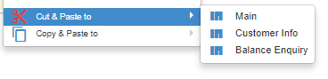
Steps to create a node/flow using Cut and Paste feature:
- Right click on the node to be copied.
- Choose the tab to which the node must be copied. It cannot be the same tab. Error message is thrown to indicate the same.
- A confirmation message pops up.
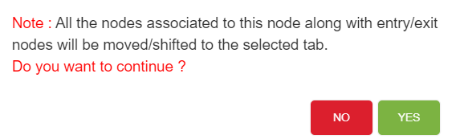
- Click on Yes to cut and paste.
- Node along with its connection will be pasted to selected tab. Node and its connection will not be available in the original tab.
- Click on No will close the window and node will not be cut and pasted.
- Node connection will be cut and pasted by default along with the node.
There are certain conditions which has to be considered while cut and pasting nodes. They are listed below.
- DNIS node cannot be cut and pasted to the same tab as well as another tab.
- Except DNIS node, all other nodes can be cut and pasted to another tab.
- No nodes can be cut and pasted to the same tab
- Cannot cut and paste Conditional rule node and Module exit nodes. This feature does not exist for these 2 nodes. Error message will be generated. ‘Cannot move/shift conditional rule node’.
- A node cannot be cut and pasted if it has a parent node. If there is an attempt to cut and paste the node, error message ‘Please break connections from this node’s parent.’ Will be displayed.

Copy and Paste
Copy and Paste feature is an important feature that can be used to ease the workload of the users. Nodes that are frequently used and need to be created multiple times with minimal changes.

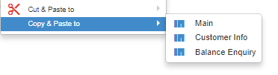
Steps to create a node/flow using Copy Paste feature:
- Right click on the node to be copied.
- Choose the tab to which the node must be copied.
- A confirmation message pops up. Include node connections can either be checked for opting node connections along with the node copy paste or not.

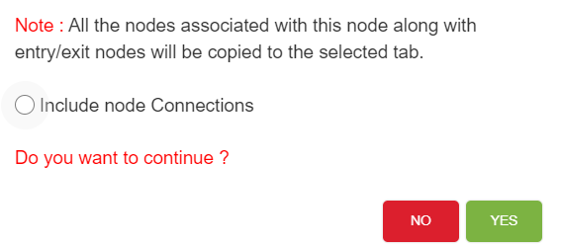
- Click on Yes to copy and paste.
- Node along with its connection will be copied to the same or another tab based on inclusion or exclusion of node connections.
- Click on No will close the window and node will not be copied.
There are certain conditions which has to be considered while copy pasting nodes. They are listed below.
- DNIS node cannot be copied to the same tab as well as another tab.
- Except DNIS node, all other nodes can be copied to the same tab as well as another tab.
- Cannot copy Conditional rule node and Module exit nodes. This feature does not exist for these 2 nodes which means user will not be able to see the copy
- A node can be copied if it has a parent node. But the copied node does not have a parent node. It will have the entire flow from the copied node.
- Node connections can be included or excluded while copying. If the node connections are excluded, all the nodes are copied from there onwards except for the node connections.
- If an exit node connected to an entry node which is present in other tab, upon coping the exit node, entry node will not be copied.
- If an exit node connected to an entry node which is present in same tab, upon coping the exit node, entry node will also be copied.

Sticky Note
User is provided with sticky note feature to add information about particular node
Steps to create sticky note:
- click on the note option and following note will appear
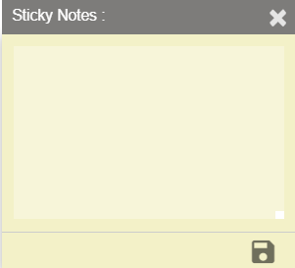
User can add notes here and save using save button which is present at right bottom of sticky note. Upon saving the note, indication will be provided in the node level as shown below.
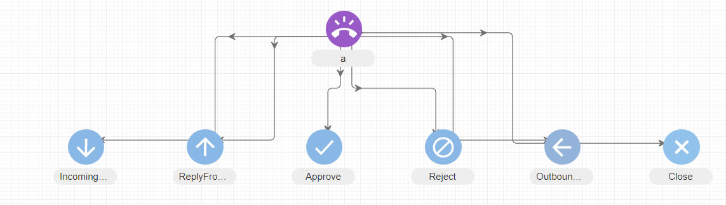
Note: User can add the sticky note to any node/node legs only in DRAFT status of the emailflow. Error message is generated when user try to add sticky note to a node in a emailflow whose status is not DRAFT.
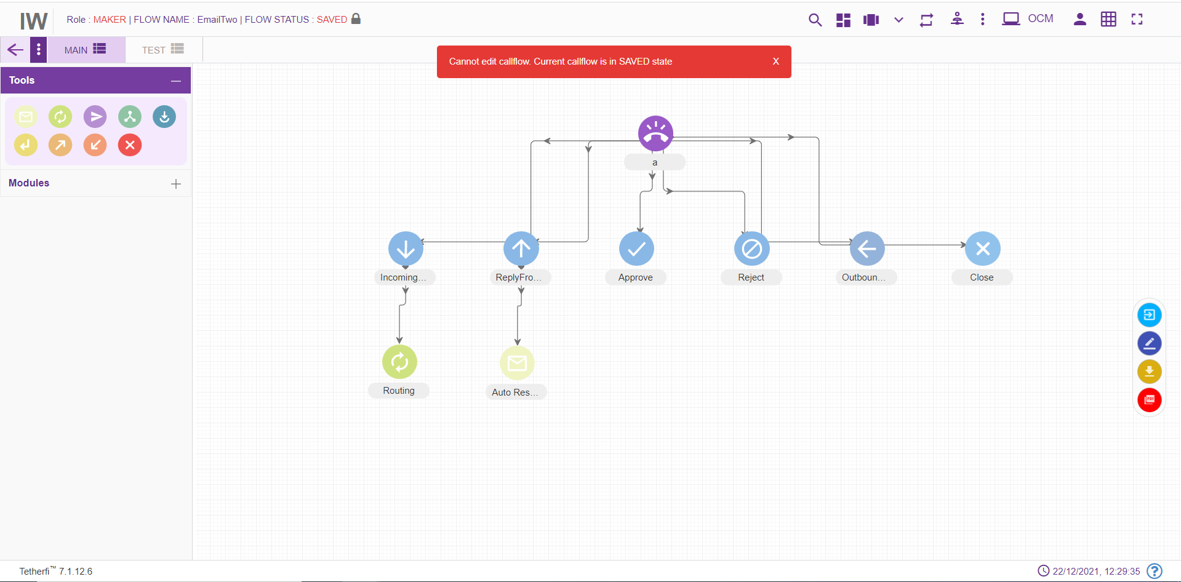

Dashboard
Upon clicking dashboard icon, following page will be displayed.
All the created as well as imported emailflows will be displayed here. Emailflows of all the status are displayed for Maker and Previewer.
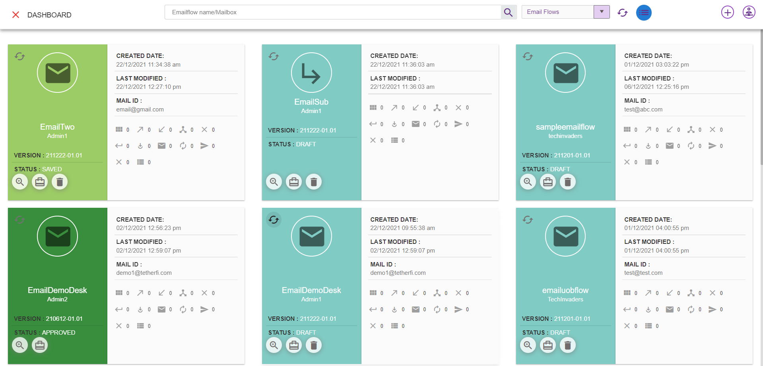

Grid view of the emailflow where emailflow name, user, versions and status are displayed for quick reference.
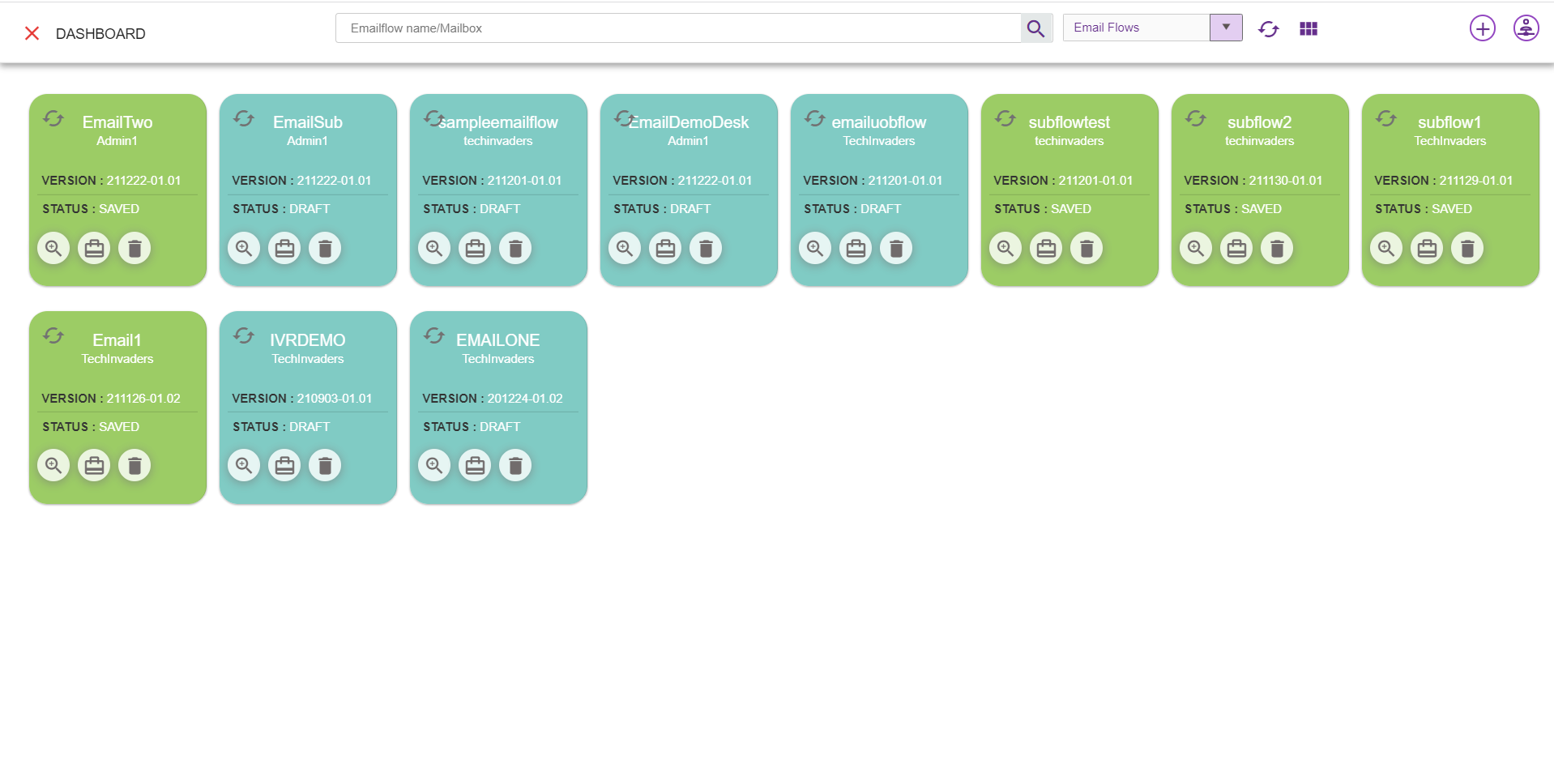
      - Emailflow Name/Mailbox: Enter Emailflow name or Mailid to search
      - Search for Emailflow: This option is used to search the particular flow based on emailflow name and DNIS.
      - Add New IW flow: Configure a new emailflow (refer section New IW Flow). This option is only provided for Maker.
      - Add New Sub flow: Create a new sub flow (refer section New Sub Flow). This option is only provided for Maker
      - Masters: Masters can be accessed in dashboard.
      - Refresh Dashboard: Refresh the dashboard.Update the emailflow lists with latest changes
      - Grid View: Can maximize or minimize the emailflows.
      - Refresh: This option is used to refresh individual emailflow.
      - Preview Emailflow: This option is used preview a emailflow (refer section Preview )
      - Emailflow Build/Package: Emailflow will be packed and zip file will be downloaded. This zip file will contain emailflow related data. This zip file can be imported (refer section Import flow) at other systems. This option is not available for previewer.
      - Delete Emailflow: This option is used to delete a emailflow. Only Owner of the emailflow can delete flow. And Emailflow should be in DRAFT and SAVED state.
      - Dropdown: This dropdown contains option to display Emailflow, Subflow flow in dashboard. User can select which option is required.
Emailflow: upon selecting emailflow option, all the IW flows will be displayed. This emailflow contains dnis numbers
Subflow: upon selecting subflow option, all the subflows flows will be displayed. This is a subflow can be used by emailflow as well as other subflows. These flows do not have dnis number.

Note: Emailflow which has only DNIS node cannot be deleted.
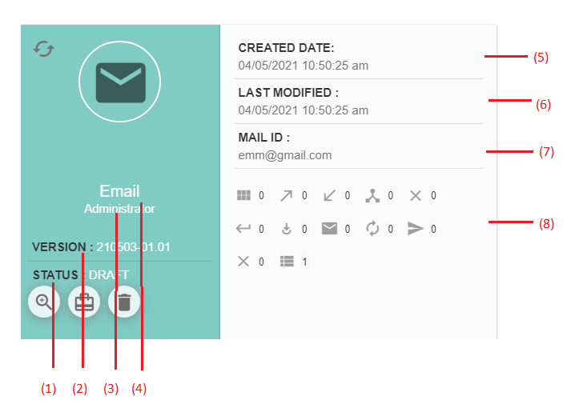
- Status: This option is used to display current status of the emailflow
- Version: Current version of the emailflow.
- User: Last modified user.
- Flow Name: Emailflow name
- Created Date: Created date and time. (during imported emailflow, created and modified date and time will be same).
- Last Modified: Last modified date and time. The time at which user has saved/ sent for approval/ approved/ rejected/scheduled is updated here.
- MaIL ID: Mail id will be displayed here
- Nodes, Modules, tab count: All the nodes/modules/tabs used in a emailflow along with their count will be displayed here.
When a emailflow is imported, it will be displayed in dashboard and its status will be ‘DRAFT’.
When user try to load a new emailflow on top of existing active emailflow, save confirmation popup will be generating as shown below.
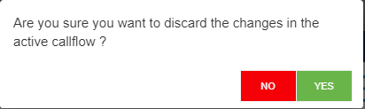
If Yes, Changes done in the active emailflow will be discarded and new emailflow selected here will be loaded
If No, User can continue with the existing active emailflow

Flow status for various users

Flow Status | Previewer | Maker
DRAFT | Yes | Yes
SAVED | Yes | Yes

Flow Status

Draft
Initially when emailflow is created, a status of the emailflow will be in ‘DRAFT state and only the owner(maker) of the emailflow can edit the emailflow until owner release the emailflow(emailflow state to ‘SAVED).
Maker can delete a emailflow whose current status is ‘DRAFT’. Emailflow which has only DNIS node cannot be deleted even if it is in ‘DRAFT’ status.
In order to change the current status to ‘DRAFT’, click on ‘Edit emailflow’ button as shown below. Upon clicking this button status of the flow will change to ‘DRAFT’. User can add, delete or edit a tab in draft status only.
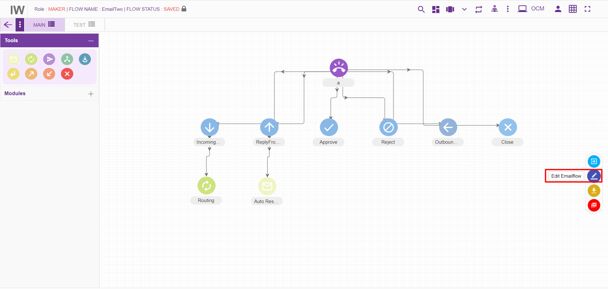

Saved
In order to run a emailflow and to send a emailflow for approval, its status must be in ‘SAVED’ state. Click on the ‘Save emailflow’ button as shown below to save a emailflow.
Upon clicking this button status of the flow will be changed to ‘SAVED’. Maker can delete a emailflow whose current status is ‘SAVED’. Emailflow which has only DNIS node cannot be deleted even if it is in ‘Saved’ status. Emailflows whose status is saved, can be accessed by other user (other than owner) and make changes by changing its state to ‘DRAFT’.
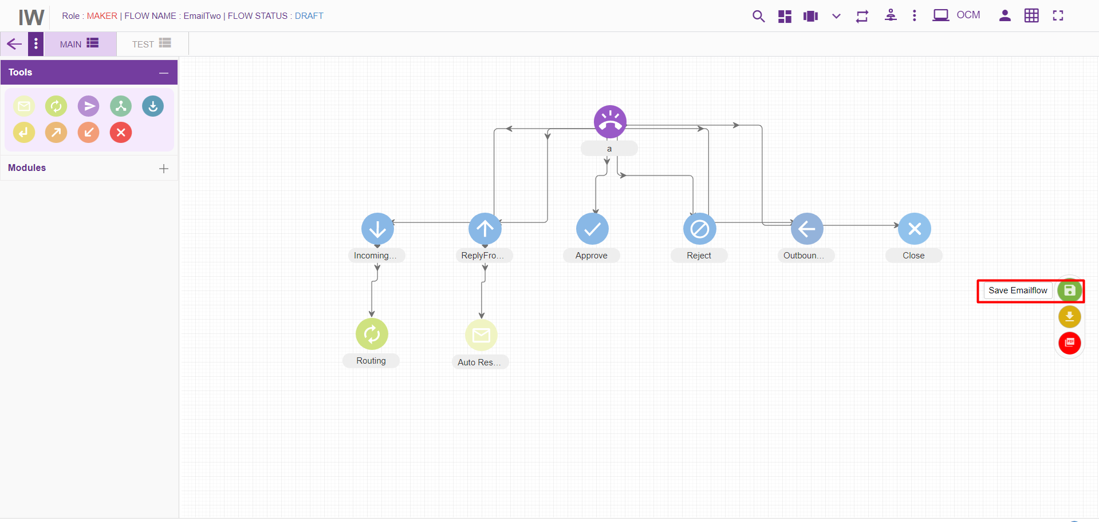

Static Flow related Buttons
There are static flow related buttons provided when emailflows are in different status. As shown below, when emailflow is in DRAFT status, ‘Save Emailflow’ button will be displayed.
User can move this button to anywhere in the page and click them to perform SAVE, EDIT operation on emailflow
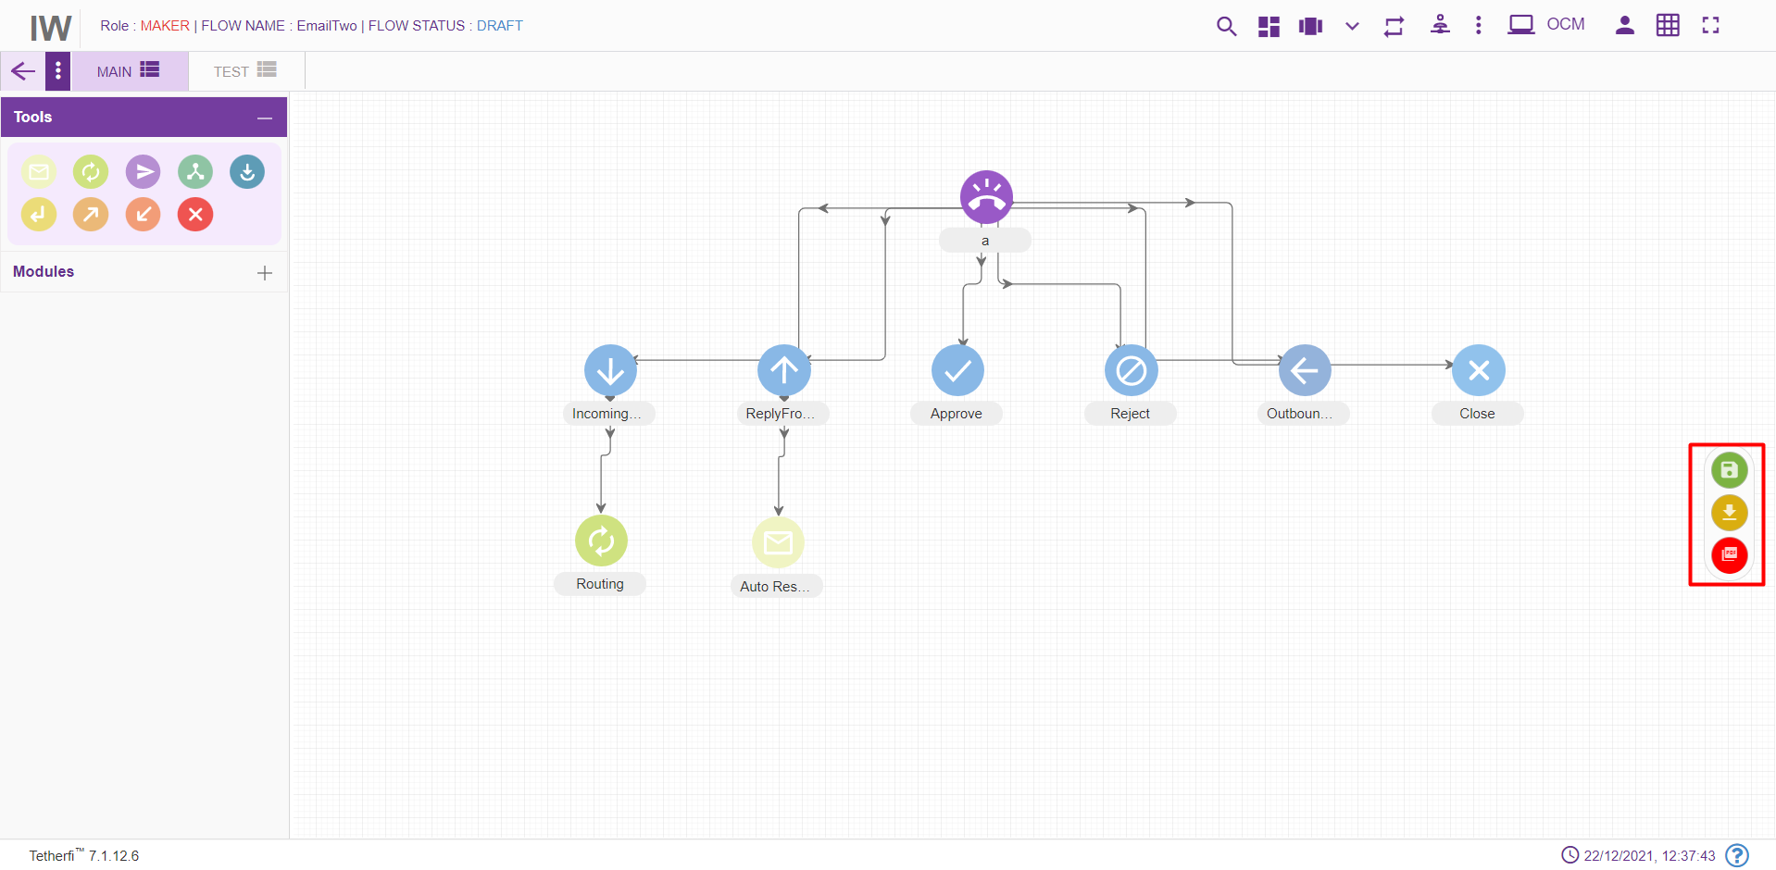
Sl.No | Emailflow Status | Static Buttons Displayed
1 | DRAFT | Save Emailflow
2 | SAVED | Edit Emailflow, Send to approval
3 | Export current tab content to PNG | Current page will be downloaded in the form of PNG
4 | Export emailflow to PDF | Entire emailflow will be downloaded in the form of PDF. This process can take some time

When emailflow is in DRAFT status, SAVED button will start blinking after a configured time expires, which will indicate the user to save the flow, as shown below.

Use Case
Please consider the below shown example:
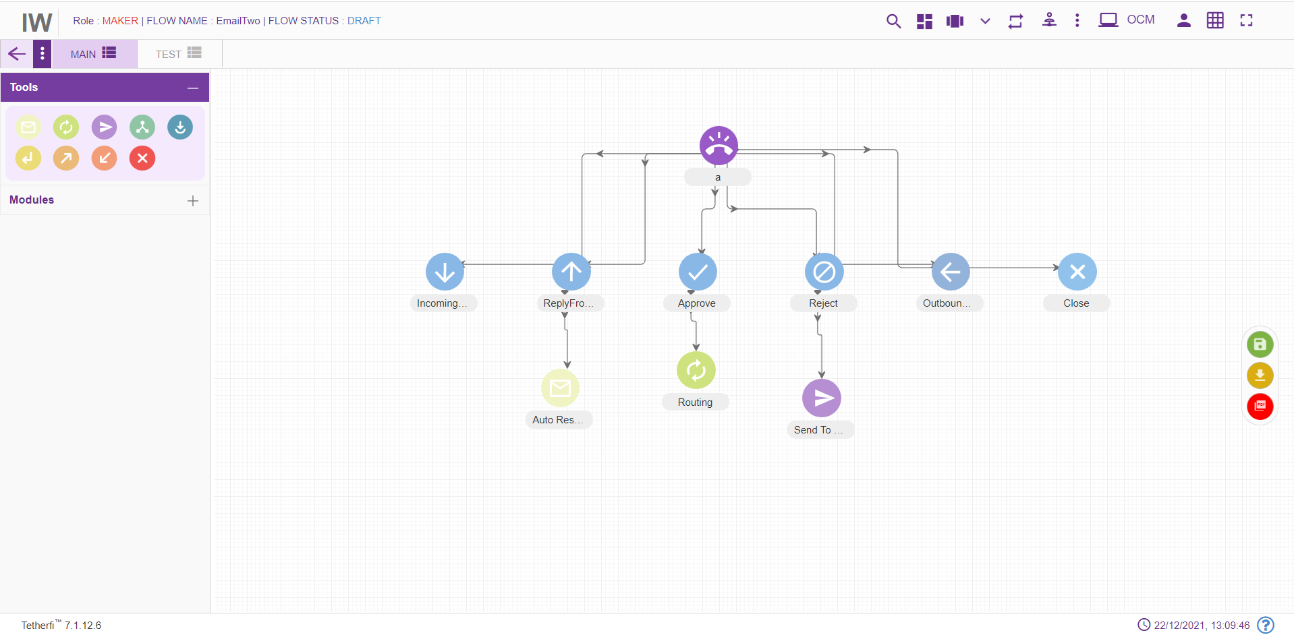
Below are the mentioned are the steps for recreating the above workflow

Step 1: Creating a new DNIS node- test (Level 1)
- On click of Configure emailflow button, the below window will pop up:
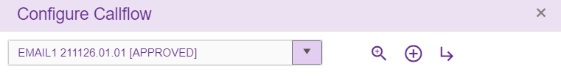
- Click on ‘Create New IW flow’
- Enter the details into the DNIS details screen as shown below:
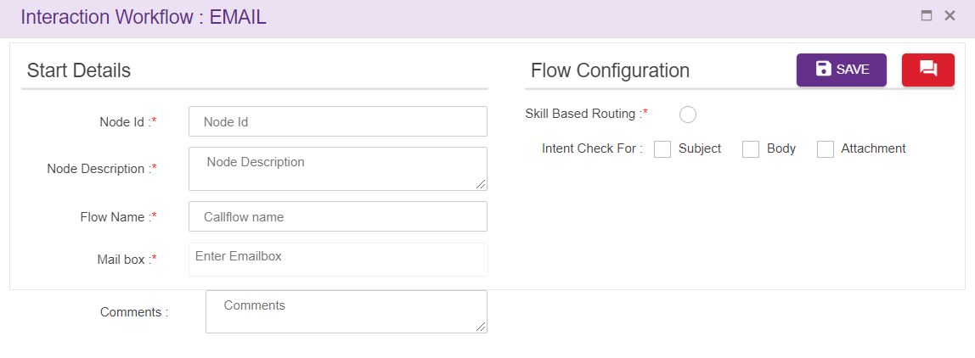
While creating a new DNIS Details please note the below points:
- Mail ID: Should be unique. Type the test@gmail.com as mail id DNIS and click “Enter” button to save the DNIS and/or click “,” (comma) to add another mail id.
- Intent check for: Select intent like subject, body, attachment
- Call Flow Name: Enter “test” as call flow name
- Language: Select English as language. (Mandatory). The Language selection in Call flow configuration segment will be auto configured depending upon the languages selected in the DNIS details segment.
- Comment: Providing a comment before saving is not mandatory.

Step 2: Adding a new Route Node- (Level 2)
- For adding a new route node to the emailflow, click on the “Route” icon and drag it to the main screen. 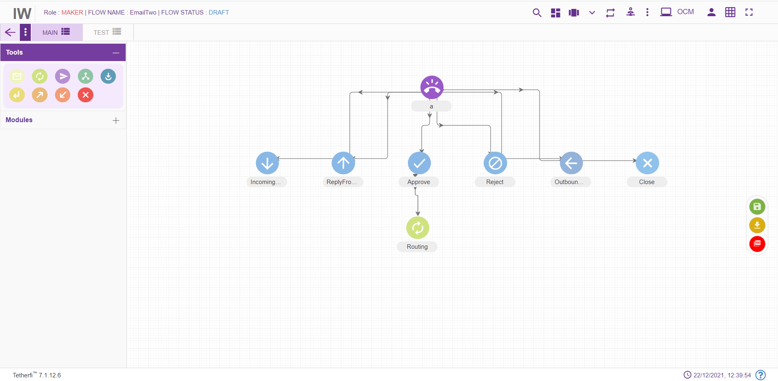
- For editing/ configuring the Menu, hover over the Menu icon you added and edit/ delete functionalities for the menu will be displayed.
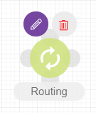
- On click of edit button, the below screen will popup. Enter the details into the route details screen as shown below:
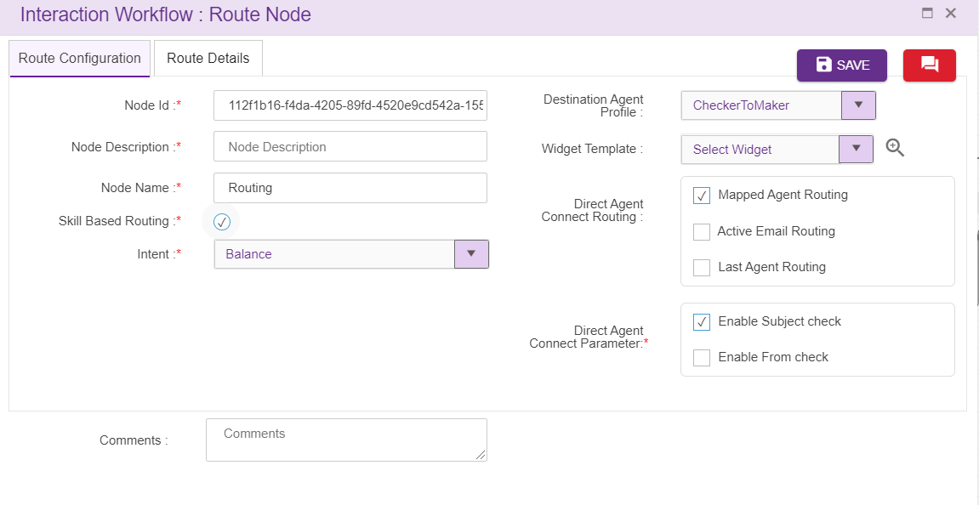
- Node id: This field accepts characters, numbers and special characters too. This option is used to track the announcements played.
- Node Description: Brief characterization of the announcement Node. (Mandatory)
- Node Name: This field refers to the name of the route node. By default, name is Routing. but the Users have the privilege to assign their own name.
- Skill Based Routing: Check box need to be enabled
- Intent: Intents for skill based routing is configured here
- Attribute Based Routing: Check box need to be enabled
- Last Agent Routing: Check box need to be checked for last agent routing
- Active Email Routing: Check box need to be checked for active email routing
- Widget Template: Widgets added in master, will be displayed here
- DAC Parameters: Age od the email can be set here.

Step 3: Adding a new Auto Response node - (Level 3)
- For adding a new Auto response to the emailflow, click on the “Auto Response” icon and drag it to the main screen.
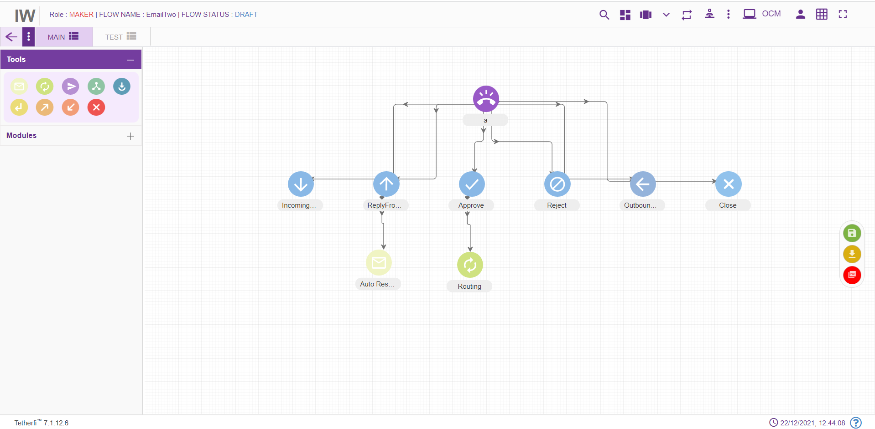
- For editing/ configuring the auto response, hover over the Agent icon you added and edit/ delete functionalities for the menu will be displayed.
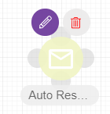

- On click of edit button, the below screen will popup
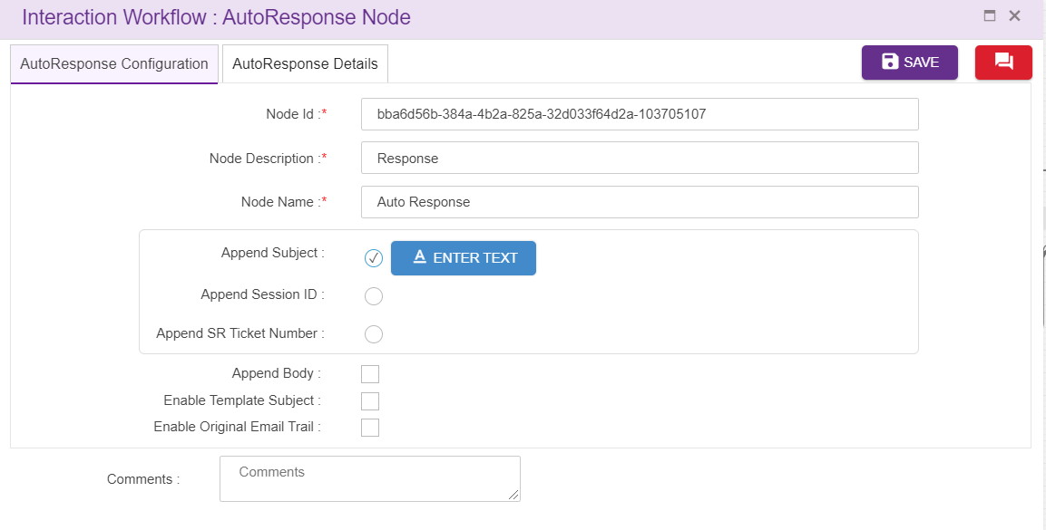

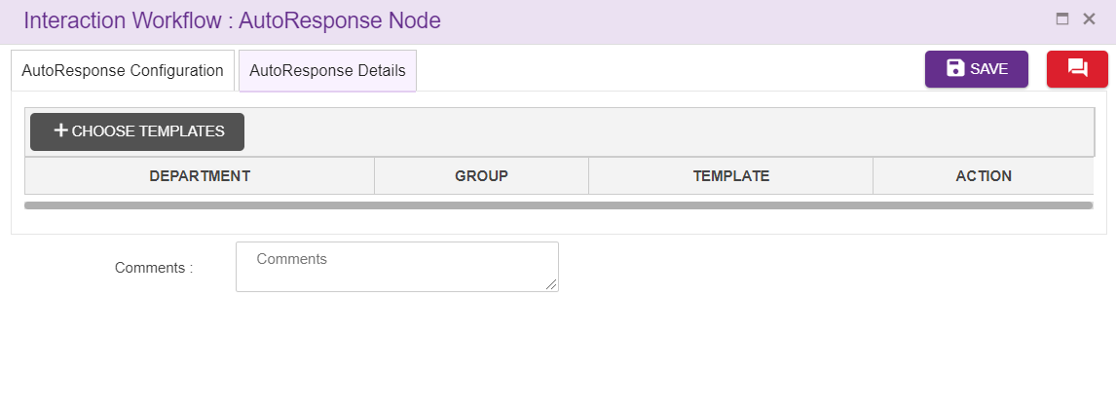
- Node ID: By default, the node ID for an Agent node is autogenerated, but the Users have the privilege to assign their own ID. Each node ID should be unique. (Mandatory)
- Node Description: Brief characterization of the agent Node. (Mandatory)
- Node Name: This is a mandatory field. Name provided here will be reflected in UI
- Department: Data is displayed here from OCM
- Group: Data is displayed here from OCM
- Template: Data is displayed here from OCM

Step 4: Adding a new Send to Customer Node (Level 4)
  - For adding a new send to customer to the emailflow, click on the “Auto Response” icon and drag it to the screen.
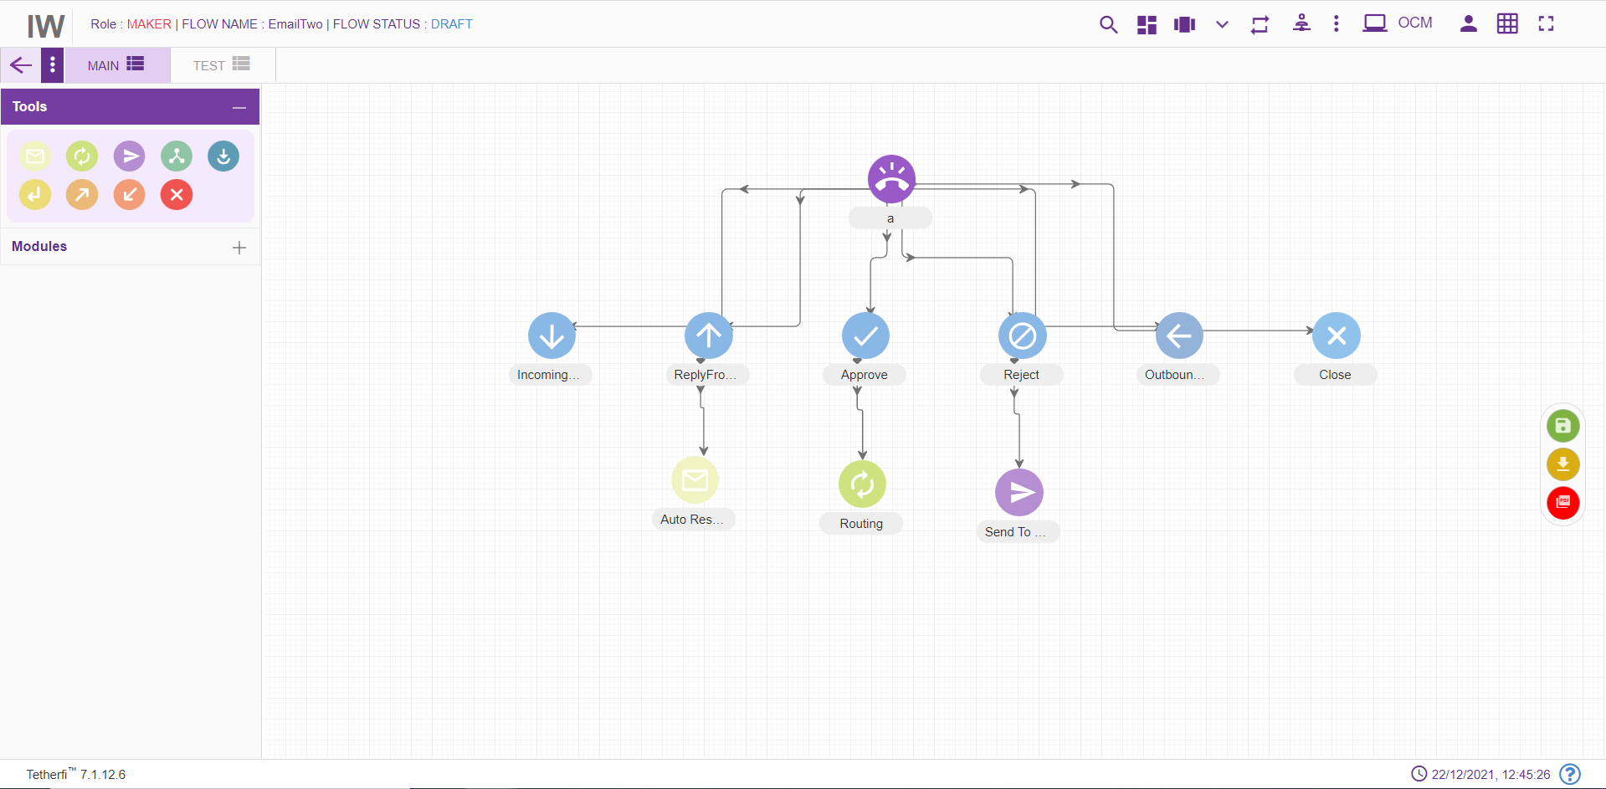
For editing/ configuring the Send to customer Node, hover over the Node icon you added and edit/ delete functionalities for the Send to customer node will be displayed
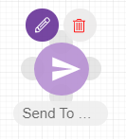
2.On click of edit button, the below screen will popup.
- Node ID: By default, the node ID is autogenerated, but the Users have the privilege to assign their own ID. Each node ID should be unique. (Mandatory)
- Node Description: Brief characterization of the Node. (Mandatory)
- Node Name: Node name is provided here
- Email Subject: Email subject can be configured here.
- Email Body: Email Body can be configured here.
- Session ID: This is a unique id created for each session.
- SR Ticket Number: This is the ticket number assigned per each issue(email) request.

Step 5: Connecting Nodes and Modules (Level 5)
- For interconnecting two or more Nodes/ Modules, you need drag the connecting link as shown below:
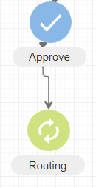
- For deleting a node, double click on the connecting and the below screen will be displayed:
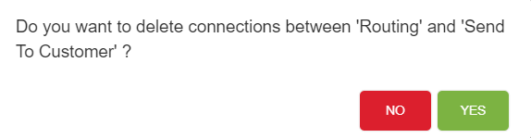

Step 6: Saving the Workflow: (Level 6)
- After Maker is done with creating and configuring a workflow, the workflow needs to be saved. The Maker can do this by clicking on the “Save” button present on the top right corner of the screen.
