In TMAC UI, call outbound/outbound call aux status to make an outbound call. If make call button is not enabled.
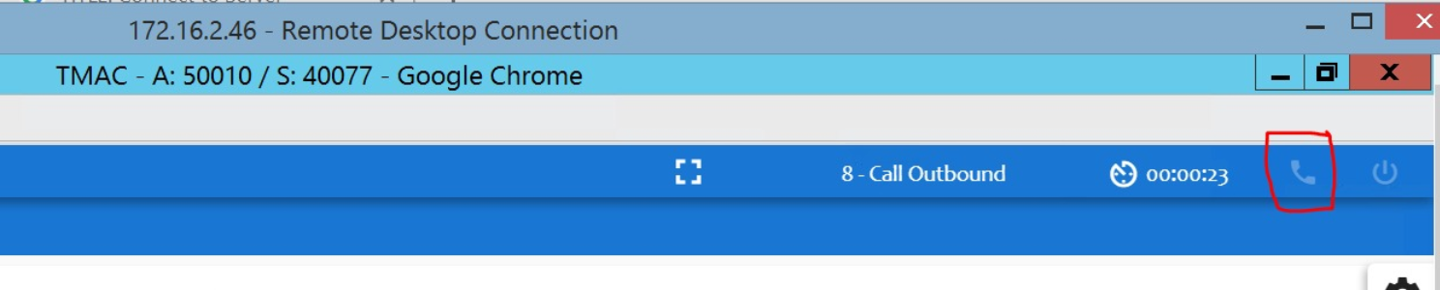
Please follow the below steps:
- In TMAC UI folder, inside tmac scripts folder open “global_vars”.js file.
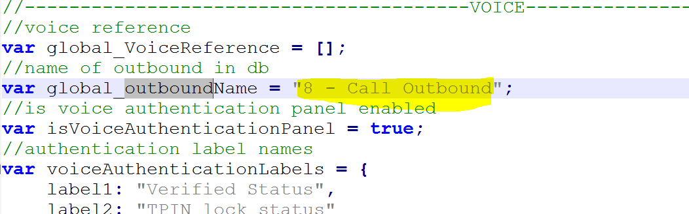
- Open “AGT_AUX_Codes” table in respective DB.

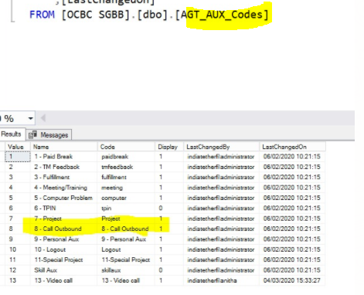

- In aux codes and global_outboundName both should be same. If not, Change the name in global var file based on aux codes.
- Open IIS, recycle application pool of TMAC UI and clear browser history in the browser.
- Login to TMAC UI, change the aux status to Call outbound and Make call button will enabled.

TMAC server code will check the below details to make a call from TMAC UI
  - Read from AGT_TMACAgentProfile table for agent ID.

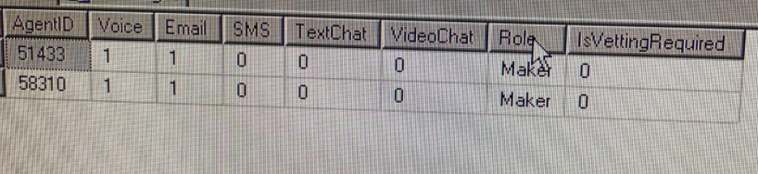
  - If agent id is there, then use the table values, else use tmac config default values
  - Then check if AGT_ChannelCount table data is there for agent
  - If it is there, the values assigned above will be overwritten.
  - Else the tab counts will use values from AGT_TMACAgentProfile table or from AMACWebServerWin.exe/template.config file.
  - Also, based on GeneriRouter channel enablement in AMACWebServerWin.exe/
template.config file., the channels will be removed if AMACWebServerWin.exe/template.config file does not have that generic routing.
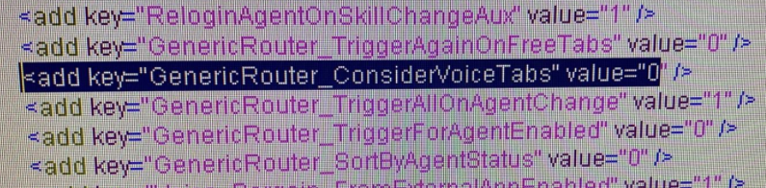
  - If agent id not there in any of above tables, then use tmac config default values.

