**Creating Freeswitch AWS instance**

Go to amazon AWS EC2 dashboard page, below is the URL to start with,

<https://signin.aws.amazon.com/signin?redirect_uri=https%3A%2F%2Fconsole.aws.amazon.com%2Fec2%2Fhome%3Fstate%3DhashArgs%2523%26isauthcode%3Dtrue&client_id=arn%3Aaws%3Aiam%3A%3A015428540659%3Auser%2Fec2&forceMobileApp=0>

Once you create an account and login you can see a page like below,

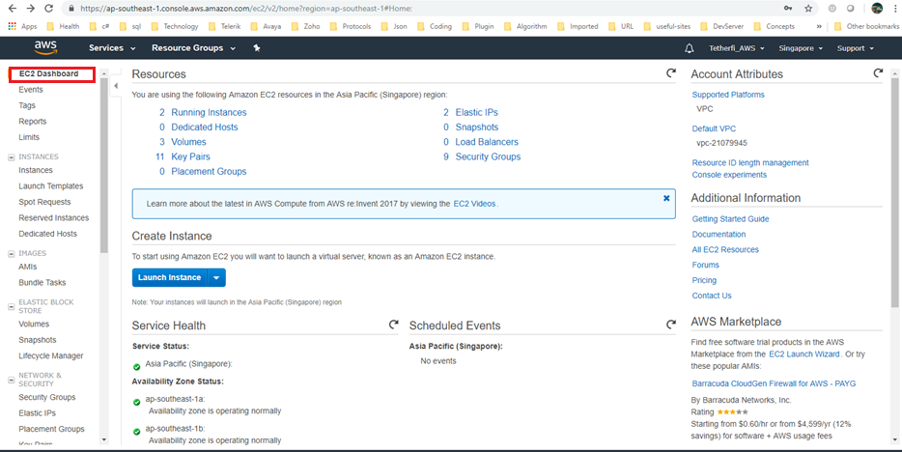

Click on **Launch Instance** button, you will be routed to below page where you can search available product in the market space of AWS to select.

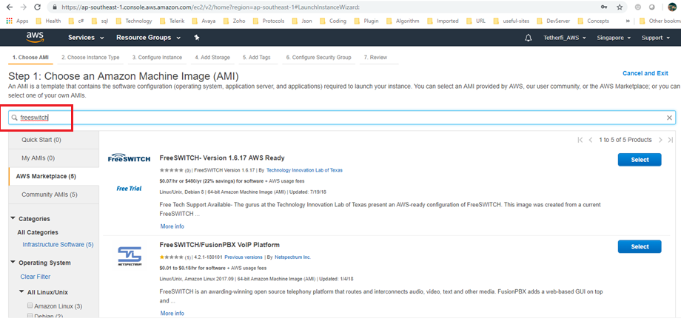

We can see two products available in AWS market space for search of keyword “freeswitch”.

Click on Select button for the one which you are looking for and proceed with further steps.

As shown in below screen on click of select, AWS will show you the details on product and its **pricing** details. Have a look at it and then click **cancle** or **continue**.

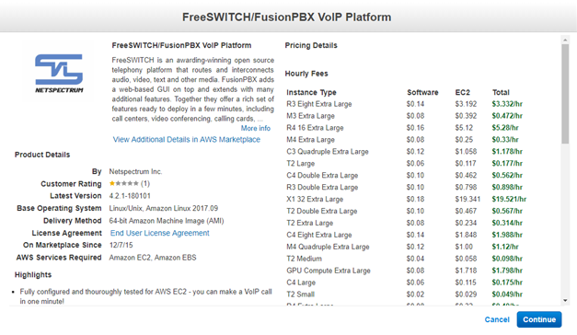

**On continue**, we need to next select an instance type (micro,medium,small,large etc) based on your requirement. Below screen shows clear picture of how the AWS page look like,

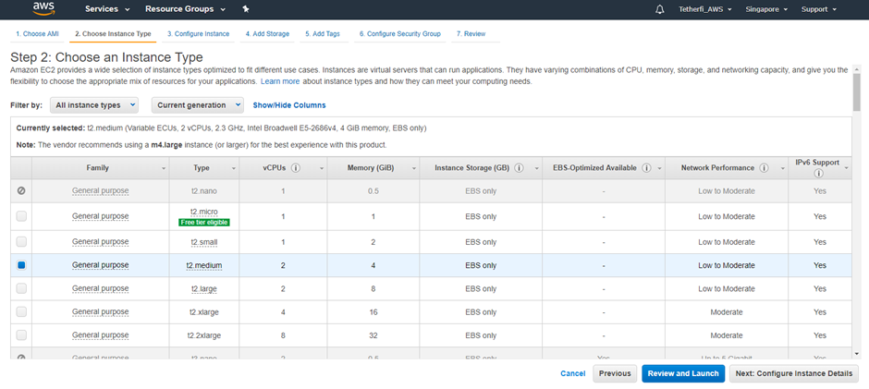

**Next**, you need to **configure** **instance** **specific details** like total number of instances required, subnet to choose, network etc. If there is no network or subnet created, you can create a new one by clicking on the link given respective to fields. For more information refer AWS documentation. Link for same is given below,

<https://docs.aws.amazon.com/vpc/latest/userguide/vpc-subnets-commands-example.html>

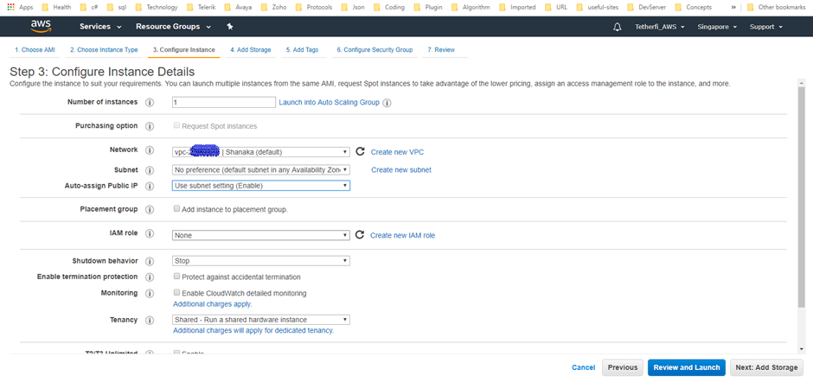

Next click on Add storage button,

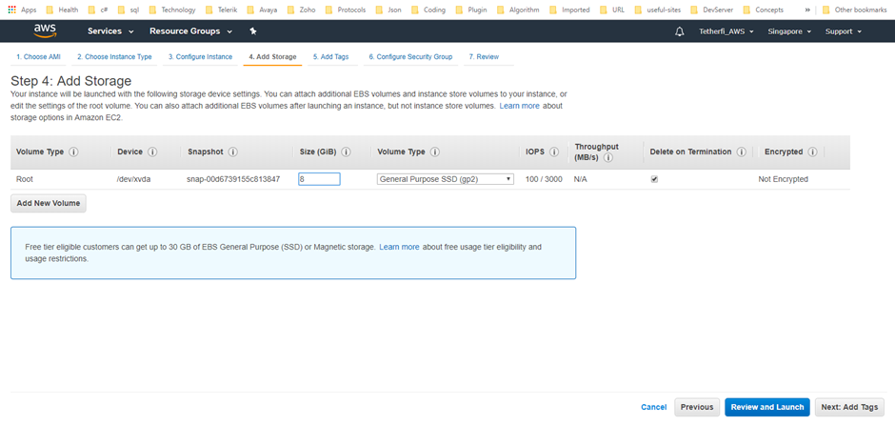

This is a very straight forward approach, just select the number of storage GB required and then click next.

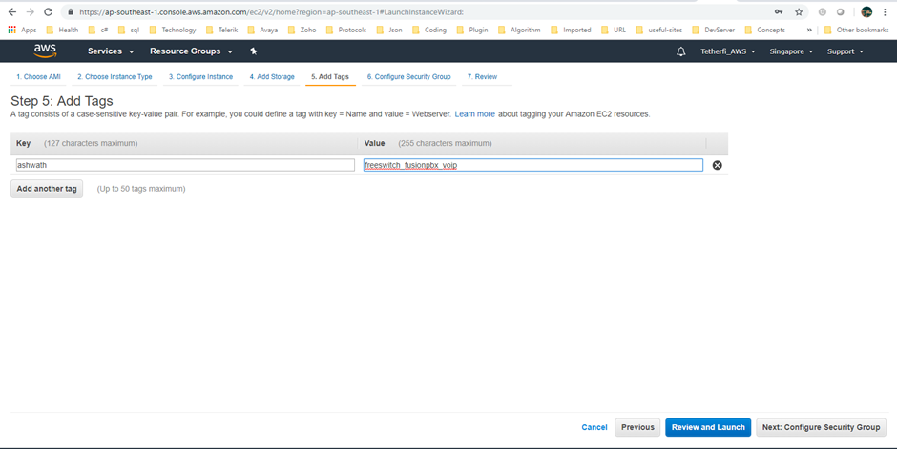

As shown above, we need to create a tag for an instance. Just provide any meaning full name and click next to configure security group.

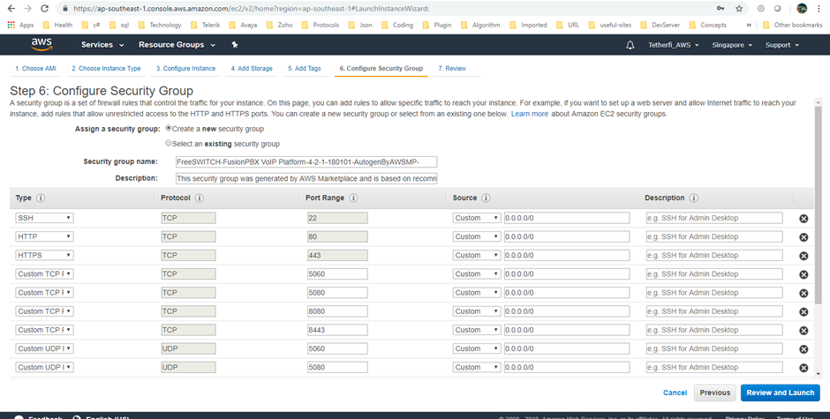

You can select security group from existing or can create new by just clicking the radio button as shown above.

Then Allow or Block types of protocols as required and then click on **Review and Launch**.

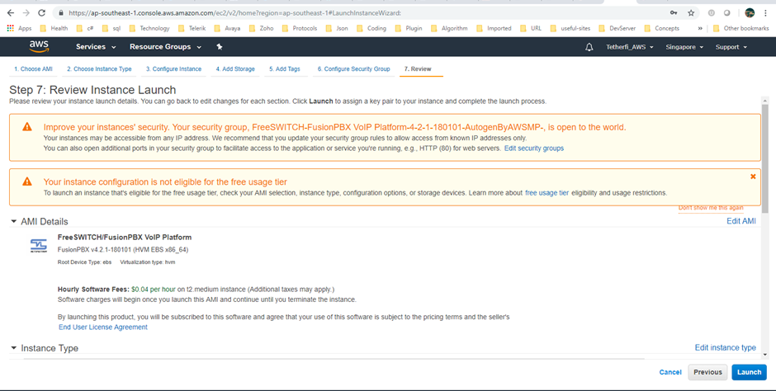

Click on Launch button to launch the instance. At this point, AWS will show a pop up to choose or create a new key pair and then download.

**Please note it is very important to download this key pair as it is required at later stage**. Once downloaded you can launch the instance.

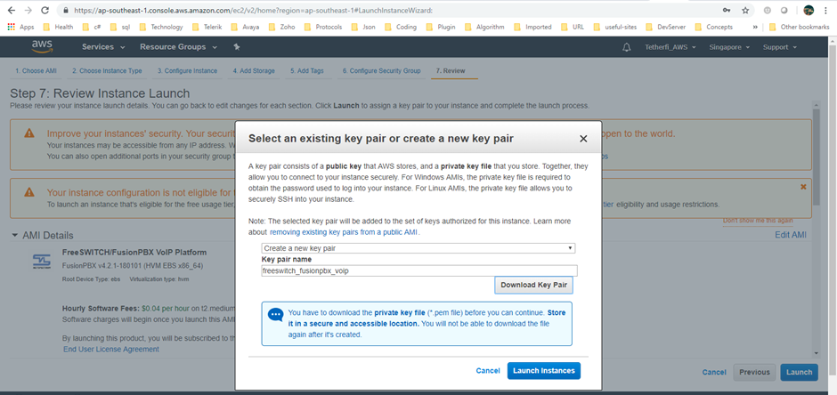

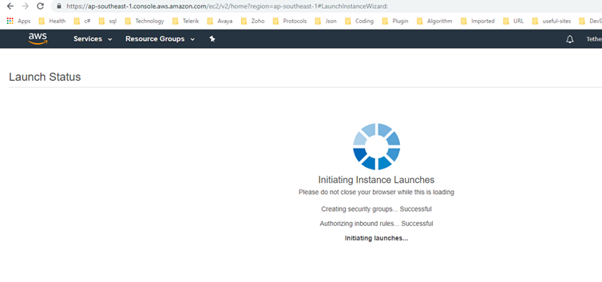

Below screen will appear after launch is success.

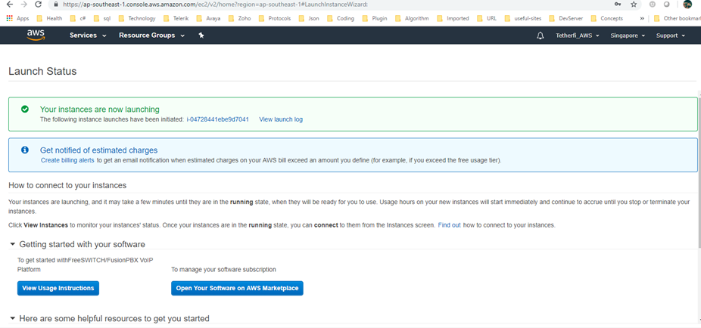

To make sure instance is up and running, go back to AWS EC2 dashboard page and there you can select **instances** which will show you all old and newly created instances as below.

