**AVAYA Communicator Manager**

**Holiday table and Vector**

**Create Holiday table:**

**Step 1:** type ‘change holiday-table x’ where x is holiday table number. Name the holiday table. Set interval for the holiday and press F3

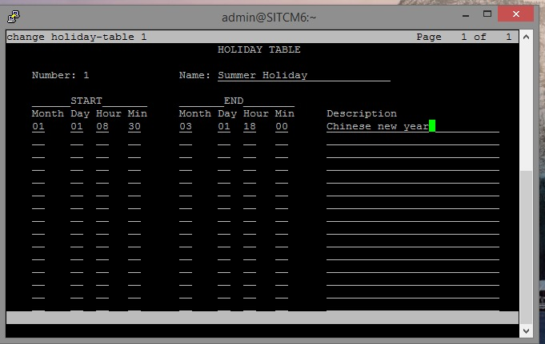

**Step 2:**  type ‘list vector’ to list out the vector. Run “change vector 15” and add your holiday table check based on the vector steps.

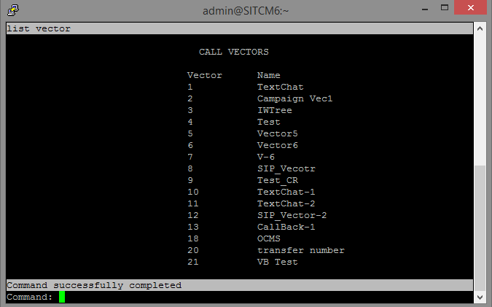

press F5 to know the allowed commands

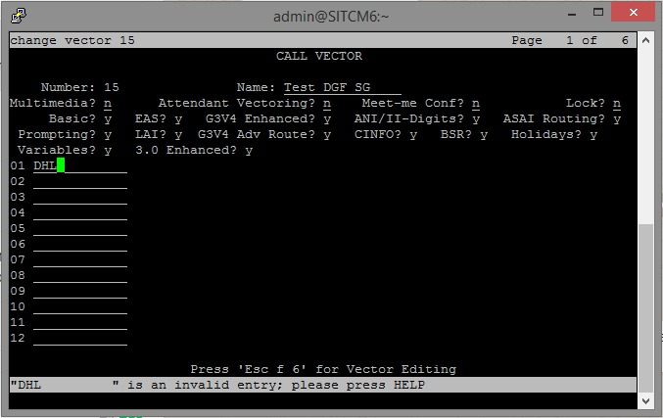

**Configure Vector:**

1. Type wait and enter tab. Enter the time and ‘Ring back’
2. Go-to-step 10 if holiday in table 1.
3. Route to extension 40002 if unconditionally.
4. Type ‘stop’.
5. Step 10 type, ’Disconnect’.
6. Type F3 to save.

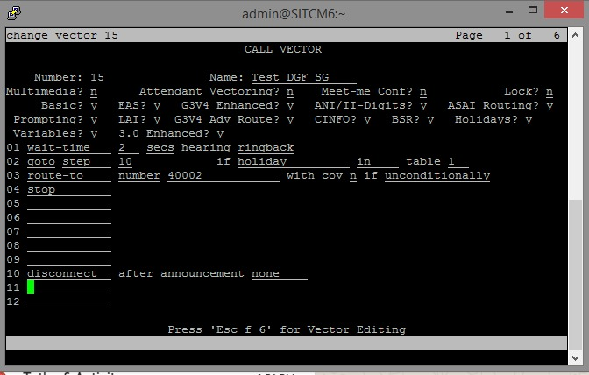

**Check for the configured Announcement:**

Type ‘list announcement’ and enter.

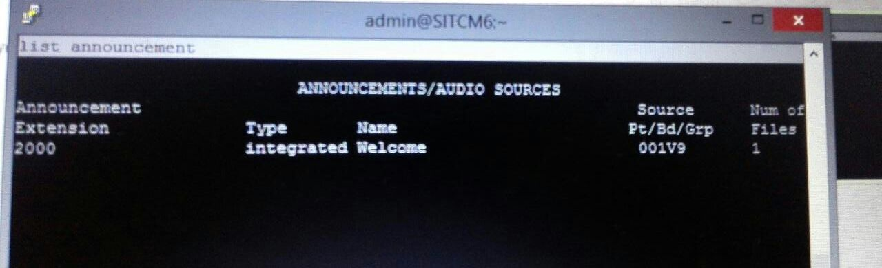

To listen the announcement ‘dial to extension 2000’.

**Adding the Announcement.**

multiple ways:

1) using VAL Manager you can upload a wav file or

2) you can use the extension to record by dialing the announcement using a Feature Access Code (FAC)... you should have "announcement access code" inside "display feature-access-code"

Go through the below link for further detailed steps

<https://www.youtube.com/watch?v=VEq_-NzwNPQ>

**Using Feature access code**

1. Check for the already existing announcement using ‘list announcement’.
2. Next add the new announcement using ‘ch announcement’. Give announcement extension, COR(Class Of Restriction) number along with appropriate name for extension. Input the board number where you want to store the announcement and press ‘F3’ to save.
3. Change the configuration using ‘list config all’ and to change the COS use ‘change COS (number)’ where COS is class of service which normally used grant the various permission to the station.

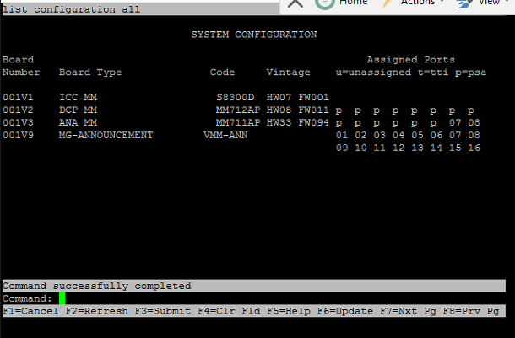

1. In COS configuration disable all the ‘console permission’ (say ‘n’) till 12 and enable(y) to 13, this enables user to record the announcement etc.

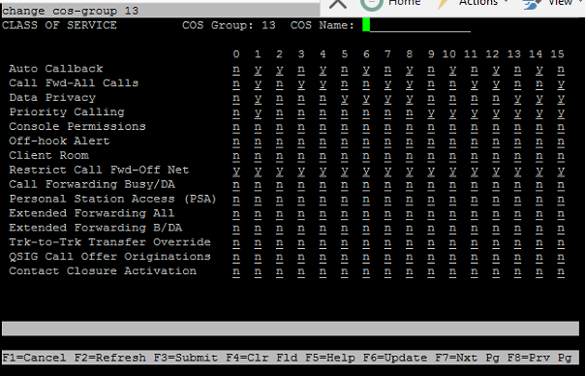

1. Do ‘display station (number)’, check for the COS and COR value which has be the same as you given before.

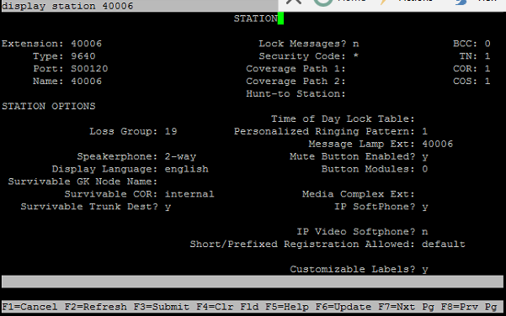

1. Next step is to enable feature access code(FAC) to record the announcement via phone. Give *(any number). (Note: Check in the dial plan for the FAC numbers). Command: ‘change feature-access-code’. Change the field “Announcement Access code”

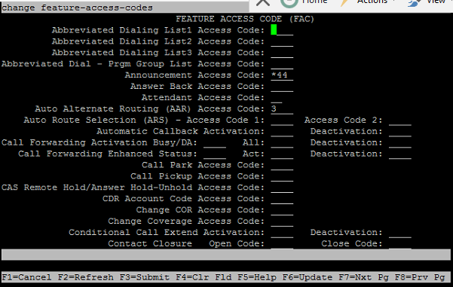

1. Now station is ready to record the announcement. Dial out the announcement extension from phone with prefix of FAC and you will hear the dial tone. Now record the voice(announcement) and disconnect. if you dial immediately you will hear busy tone means that system uploading voice file. After few minute when you dial (without FAC) you will hear the recorded announcement.

**--------------------------------------------End of the document--------------------------------------------------**