Interaction Workflow
Chat User Guide
Document Version: 8.0.12.23
Last Updated Date: 2022 January 4

Version History
Version  # | Implemented  By | Revision  Date | Approved  By | Approval  Date | Description of  Change
1.0 | Shriraksha B Rai | 14/11/2018 | Prakash Dsouza | 15/11/2018 | Initial version of Interaction Workflow Chat user guide
1.1 | Shriraksha B Rai | 11/12/2018 |  |  | Node ID field is added for all the node except Entry and Exit node
1.2 | Shriraksha B Rai | 28/12/2018 |  |  | Node search feature is implemented
1.3 | Kavya Nayak | 18/03/2019 |  |  | Subflow option  Updated screenshots of callflows  Added flow connector node and return node  Updated Comments, Dashboard, Node connectivity, Node level roles and Phrase section  Updated overview section  Updated copy callflow section
3.0.04.04 | Shriraksha B Rai | 10/4/2019 |  |  | Sticky note section added  Updated real time session dashboard section.  Subflow feature is implemented  Added flow connector node and return node  Updated copy callflow section
3.1.6.11 | Shriraksha B Rai | 11/6/2019 |  |  | Global synonyms section added  Rules viewer section is added.  Updated Real time session dashboard Section  Updated Comment Section
3.1.7.4 | Shriraksha B Rai | 18/7/2019 |  |  | File system version section added  Database Table Access  Import section is updated
3.1.7.30 | Shriraksha B Rai | 31/7/2019 |  |  | Session Dashboard:  - Flow name is displayed in the grid.  - Following KPI's are displayed: Total Time Spent, Average Time Spent, Total Interactions Transferred to Agent, Total Self-Service Interactions  - Clear option is provided  - Transfer Skill and Transfer VDN option is provided
3.1.08.02 | Shriraksha B Rai | 02/08/2019 |  |  | - Search option is provided in Real time session dashboard
3.1.08.13 | Shriraksha B Rai | 13/08/2019 |  |  | - IW Master Access matrix
3.1.09.05 | Shriraksha B Rai | 05/09/2019 |  |  | - New UI for Historical KPI Dashboard is provided
3.1.10.17 | Shriraksha B Rai | 17/10/2019 |  |  | Enable Tracking Property introduced for Menu, Announcements, PNC and Agent nodes to track in real-time reporting
3.2.01.31 | Shriraksha B Rai | 17/2/2020 |  |  | - Synonym master option is provided  Flow connector node will display mainflows too along with subflows
3.2.04.23 | Shriraksha b rai | 23/4/2020 |  |  | - Option to delete multiple nodes at a time is provided  - Save confirmation popup  - ‘Is Global Main Menu’ option in all the nodes  - DTMF display option  - Order of the nodes displayed in node panel is changed  - Form node  - Agent queue and video option is provided in Agent node  - Header-Footer option
3.2.04.29 | Shriraksha B Rai | 30/4/2020 |  |  | - Same callflow size is maintained for subflow as well as main flow in dashboard.  - Redirect to IW Module Designer page
3.2.05.07 | Shriraksha B Rai | 08/05/2020 |  |  | - Rules viewer section is updated  - Header-Footer option is displayed in all the nodes only after enabling the checkbox.  - Maker level node comments are displayed in all the nodes along with checker comments.  - Intent added in menu and PNC node will highlight in UI immediately
3.2.06.08 | Shriraksha B Rai | 08/06/2020 |  |  | - Additional form control options like Face Capture, Image Capture, Image Upload, Record Audio, Record Video and File Upload are provided
4.0.07.07 | Shriraksha B Rai | 07/07/2020 |  |  | - Static flow related buttons  - Session Master  - Additional form control options are provided  - Menu and form leg option section is added  - Button Type option is provided in Menu, PNC and Form node
5.0.12.25 | Deepthi Shetty | 28/12/2020 |  |  | - Updated additional features of Agent node
6.0.6.7 | Deepthi Shetty | 09/06/2021 |  |  | - Updated screenshots  - Implemented masters in dashboard
6.1.7.22 | Deepthi Shetty | 22/07/2021 |  |  | - Updated additional features of Menu node, Form Node and Prompt and Collect Node
8.0.12.23 | Deepthi Shetty | 23/12/2021 |  |  | - Added new canvas changes
Copyright
All rights reserved. No part of this product may be reproduced, transmitted, transcribed, stored in a retrieval system, or translated into any language in any form by any means without the express written permission of Tetherfi.

Warranty Information
Tetherfi makes no representations or warranties with respect to the contents or use of this product and specifically disclaims any express or implied warranties of merchantability or fitness for any purpose. Information in this document is subject to change without notice and does not represent a commitment on the part of Tetherfi.

Trademark Information
Tetherfi is a registered trademark of Tetherfi. Other product names may be trademarks or registered trademarks of their respective companies.

Contact Information
For customer inquiries, contact: For technical support inquiries, call:
Tetherfi +65 6715 7408
60 Paya Lebar Road,
#06-01 Paya Lebar Square,
Singapore

Contents
1 Introduction 9
1.1 Intended Audience 9
1.2 Scope of document 9
1.3 Glossary 9
2 Overview 11
2.1 System Architecture 13
2.2 Interface Design 14
3 Access Details 15
3.1 OCM Access 15
3.1.1 Role Based Access Management 16
3.1.2 User Role Mapping 18
3.1.3 IW Role Based Access Matrix 19
3.1.4 IW Master Access Matrix 24
3.2 Database Table Access 27
4 Interaction Workflow User Roles 28
4.1 Maker 29
4.1.1 Import Chatflow 31
4.1.2 Copy Chatflow 32
4.1.3 Chatflow Version Control 34
4.1.4 Rule Master 35
4.1.5 Intent Master 41
4.1.6 Rules Viewer 42
4.1.7 Comments 44
4.1.8 Search for Nodes and Modules 45
4.1.9 Global Synonyms 46
4.1.9 File System Version 48
4.1.10 Synonym Master 49
4.1.11 Session Master 51
4.1.12 TMAC Widget Master 52
4.2 Checker 53
4.2.1 Approve Now 55
4.2.2 Scheduled Later 56
4.3 Previewer 57
4.4 Maker and Checker 59
5 Creating/Editing Workflows 62
5.1 Configure Chatflow 62
5.1.1 Chatflow List 63
5.1.2 Preview 63
5.1.3 New IW Flow 64
5.1.4 Sub Flow 66
5.1.5 Delete 67
5.1.6 Text Selection Window 67
5.1.7 Header 68
5.1.8 Footer 71
5.1.9 Branding Icon 73
5.2 Designing the Workflow 75
5.2.1 Tabs 75
5.2.2 More Menu Option 80
5.2.3 Set Rules 84
5.2.4 Chatflow Sync Notification 86
6 Nodes and Modules 88
6.1 Nodes 88
6.1.1 Menu Node 88
6.1.2 Agent Node 94
6.1.3 Conditional Node 102
6.1.4 Announcement Node 104
6.1.4 Assignment Node 108
6.1.5 Prompt and Collect Node 110
6.1.6 Entry Point Node 115
6.1.7 Disconnect Node 116
6.1.8 Exit Point Node 118
6.1.9 Flow Connector node 121
6.1.10 Return Node 123
6.1.11 Action node 124
6.1.12 Form Node 126
6.1.13 Node Changes 130
6.1.14 Node Connectivity 131
6.2 Modules 134
6.2.1 IW Module Designer 137
6.3 Connecting Nodes and Modules 137
7 Context Menu 138
7.1 Drag Nodes 139
7.2 Remove ALL nodes Connected to This 139
7.3 Copy and Paste 139
7.4 Cut and Paste 140
7.5 Sticky Note 141
8 Dashboard 142
9 Flow Status 145
9.1 Flow status for various users 145
9.2 Draft 146
9.3 Saved 146
9.4 Send to approval 147
9.5 Checker Draft 147
9.6 Checker Save 148
9.7 Approved 148
9.8 Rejected 150
9.9 Scheduled 150
9.10 Static Flow related Buttons 151
9.11 Node Blink 153
10 Use Case 153
Step 1: Creating a new MAIN NODE node- TestChatFlow (Level 1) 154
Step 2: Adding a new Menu (Level 2) 158
Step 3: Adding a new Announcement, Agent (Level 3) 163
Step 4: Adding tab One Alongside Main tab 165
Step 5: Adding a new Entry Point to Tab One 166
Step 6: Adding an Exit points (Level 4) 168
Step 7: Connecting Nodes and Modules 170
Step 9: Approval of Workflow 170

Introduction
Workflow is the definition, execution and automation of business processes where tasks, information or documents are passed from one participant to another for action, according to a set of procedural rules.
Tetherfi Interaction Workflow makes the process of Chat workflow design more efficient, compliant, agile, and visible by ensuring that every process step is explicitly defined, monitored over time, and optimized for maximum productivity, reducing the time the process takes to complete as well as potential errors caused by human interaction. Given optimal, up-to-the-minute process data, managers and employees can take quicker action and make smarter decisions.
Tetherfi Interaction Workflow empowers business users and IT to work together to rapidly modify systems and processes to reflect changes in the business.

Intended Audience
This user guide document is intended for the following audience:
- Business Users
- IT team
- Project Manager
- Application implementation team
- Application maintenance team

Scope of document
This is a systematically written guide for users to manage the ‘Interaction Workflow Chat’ application. By accessing and managing the Interaction Workflow application, users will be able to define/change certain behaviour of Chat application according to their preferences or business requirements without needing any code change.
Web based GUI application will be provided for accessing the User Admin (Maker/Checker) & Reporting module and these modules will be deployed on the IIS web server provided by the Client.

Glossary

Term or Acronym | Definition or Description
OCM | Omni Channel Management
IW | Interaction Workflow
GUI | Graphical User Interface
UI | User Interface
PNC | Prompt and Collect
VDN | Vector Directory Number
DTMF | Dual tone multi frequency

Overview
An Interaction Workflow is a series of connected blocks that performs various tasks for decision making and routing. Tetherfi Interaction Workflow Designer is a powerful, integrated development environment (IDE) that you can use to create, assemble, and customize workflows. With Tetherfi Interaction Workflow, you can:
- Create the custom nodes and modules in Interaction Workflow and reuse the same in different workflows. You do not need any external tools or block definition languages.
- You do not need to convert the flowchart. You can directly integrate the newly created/ edited workflow into production.
Rearranging connection:
Any of the nodes can be moved in the Workflow Designer interface to a different part of the call flow. To move an interface element:
- Use the mouse to select and hold the items.
- Drag the element to the desired position and release.
Connection points can be rearranged, if the default connection points, on a block do not meet the needs of the workflow. For example, if the Yes connection of a decision block is on the right, that connection can be moved to the bottom.
IW Features:
List of tasks that can be achieved using interaction workflow:
- Create menus with options.
- Add/Remove options.
- Rearranging the option sequence.
- Configure the initial, invalid and no input texts in a menu.
- Enable/disable options based on the rule.
- Attach the self-help module to an option.
- Configure the input parameters required for the modules.
- Perform conditional checks based on rule.
- Maker/Checker/Previewer.
- Copy and paste the nodes.
- Reversion/Scheduling
- Option to configure specific menu as Global Menu
- Add announcement texts between nodes. Up to 5 texts can be configured based on the rule. It helps to configure different texts for specific date ranges.
- Highlight the specific changes when submitted to checker. This would avoid the need to look at each node to understand the changes.
- Add rules based on time, date, date range and operational variables.
- Multiple tabs. It helps to create the reusable flows and break the complex flows into multiple tabs
- Comments from the maker/checker is displayed under notifications.
- Text to Voice option is provided.
- Anonymous user Access
- IW Role Based Access Matrix
- Rearranging Tabs
- Copy- paste Tabs
- Node search
- Sub Flow design

Workflow Preview:
The Workflow Preview is a virtual window of your workflow. Use the Workflow Preview to:
- Navigate the workflow
- Change the amount of workflow that you view at one time
- Zoom in on a section of the workflow
- See the whole workflow
Workflows save time and certainly ensure transparency and reproducibility. They also can do a lot more. Consider these ten benefits of incorporating workflows in your project management.
- Workflows reduce project risk. When a project is at risk, it elevates project complexity and the number of team members can increase. Workflows can ensure that there are decreased delays in the schedule. It can also be responsible for reducing possible disputes and costs by limiting the need to redo work.
- Effect organizational change. When a team works cohesively, it limits the need for management to intervene on the business process side and can provide an improved understanding of the workflow.
- Implementing workflows can lead to process change. As part of developing a workflow, businesses must scrutinize their current processes. This can lead to improvements and optimizations.
- Workflows give increased access to information. Critical processes may be reviewed at every point, ensuring that there are no bottlenecks or issues. This oversight allows project managers to determine how well the process is running from end-to-end.
- Workflows delineate work responsibility to different people. Instead of your staff being uncertain about whose responsibility it is to complete a task or where their own duties lie, a workflow defines it for them.
- Improves project timeline estimates. Gives project managers a basis to estimate how long a task or the overall project will take.
- Provides visibility. Workflows are a way to visually communicate the process to stakeholders.
- Managers can focus on strategy. When a system is running smoothly, managers don’t need to spend time focusing on operations. Instead, they can pay attention to other parts of their job, which can promote business growth and development.
- Workflows provide an audit trail. This is especially true when using a workflow management software system. Records are kept of the progress and completion of tasks, along with pertinent details such as who completed the action, when it was done, and any changes made.
- Businesses can input rules. Instead of people deciding in the moment when issues arise, workflows refer to the predefined rules. This eliminates some of the guesswork, saving time and boosting confidence in the organization’s work capacity.

System Architecture
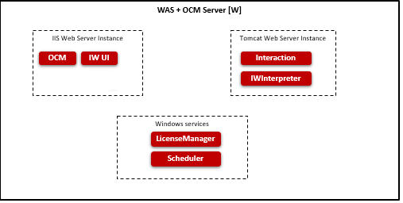
- OCM (Omni Channel Management): Web based application to administer the data and generate the reports.
- IW (Interaction Workflow): Web based application to create and manage the call flows.
- IWInterpreter: It interprets the data submitted from IW and converts it into expected format. It does Callflow validations.
- Interaction: It process the call flows configured using IW.
- License Manager: It maintains the license details and indicates whether the software can run on the system.
- Scheduler: It process the scheduled task.
- Simulator: It provides the details required to enable simulator.

Interface Design
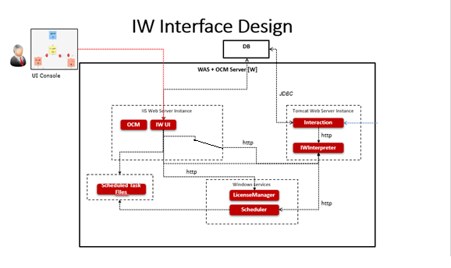
- IW Chat UI talks to License Manager to very whether license is available when launching IW Chat UI.
- Changes made in Chat UI is saved locally in JSON format and submitted to IWInterpreter.
- IWInterpreter validates the JSON submitted and stores the data in memory. It also stores the data in JSON file. It would read the data from file when server restarted.
- Interaction Engine retrieves the Callflow details from IWInterpreter.
- IW UI saves the scheduled task details in JSON.
- IW Scheduler retrieves the scheduled task from JSON and submits/APPROVE Callflow to IWInterpreter. IWInterpreter updates the memory and local JSON file.
- Reporting information is stored in DB.

Access Details
Interaction Workflow is designed to be compatible with below web browser:
- Microsoft Internet Explorer (IE 11 or above)
- Google Chrome (Chrome version 23, 39, 43, 45, 50 or above)
- Firefox (version 41)
- Microsoft Internet Information Services (IIS version 7 and above)

OCM Access
For accessing Interaction Workflow, OCM must be accessed first. The procedure for accessing OCM is mentioned below.
The user must type the provided OCM link(http://IP:PORT/OCM) in the browser and press ‘Enter’ key, OCM will prompt user to enter his Windows username and password.
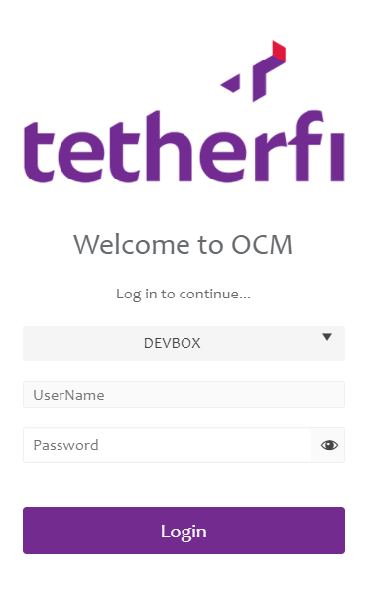
After successful authentication, the below screen will be displayed.
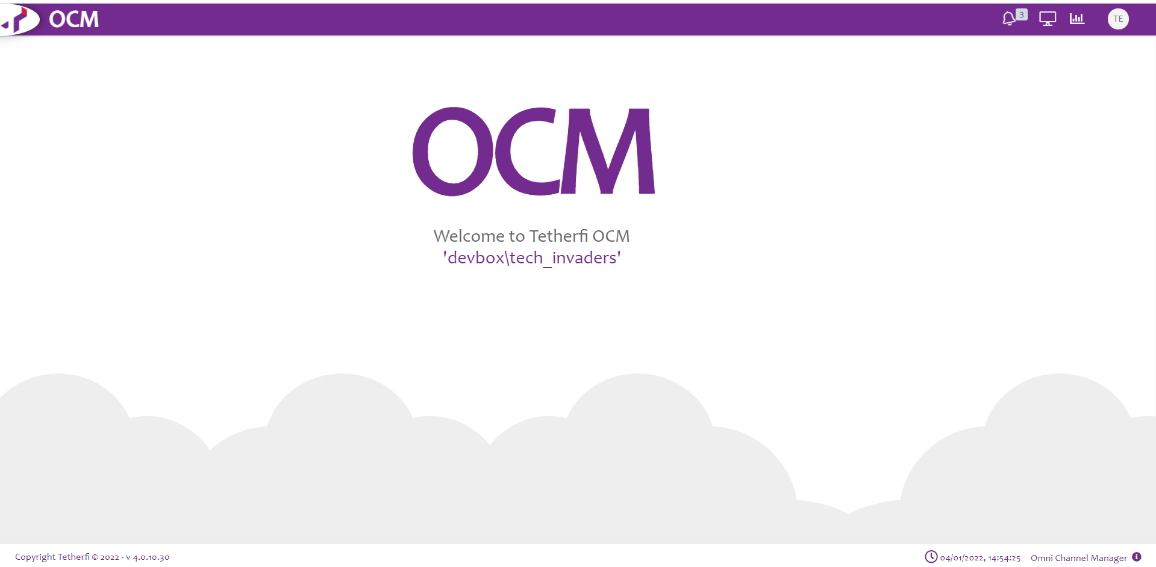
All Users will be presented with the OCM Dashboards.
Administrator is allowed to create maker/checker (or both)/previewer:
Upon logging into OCM, IW Role Based Access Matrix, Role Based Access Management and User Role Mapping modules will be displayed in Home section.
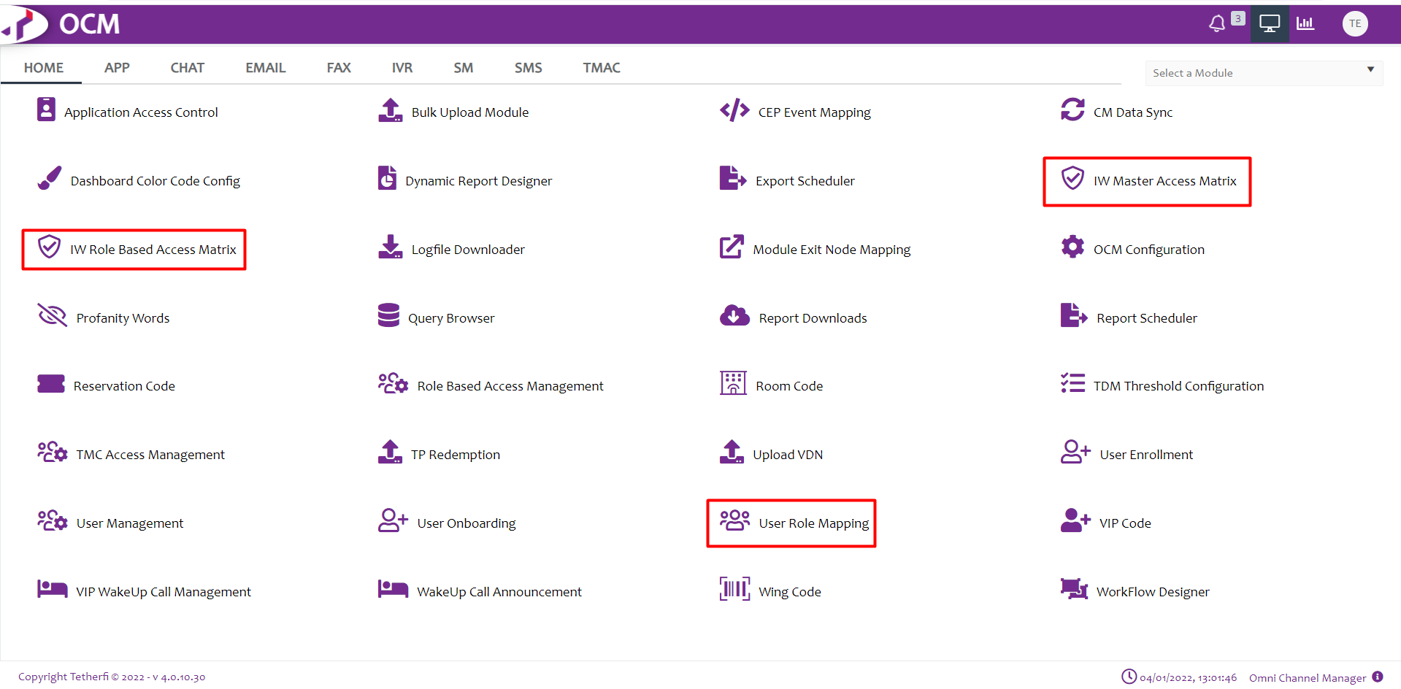

Role Based Access Management
This module is used to add the roles. Upon clicking this module following window will open and all the roles added will display here.
User can add new role, by clicking ‘Add New Role Based Access Management Record’ button present at top left corner.
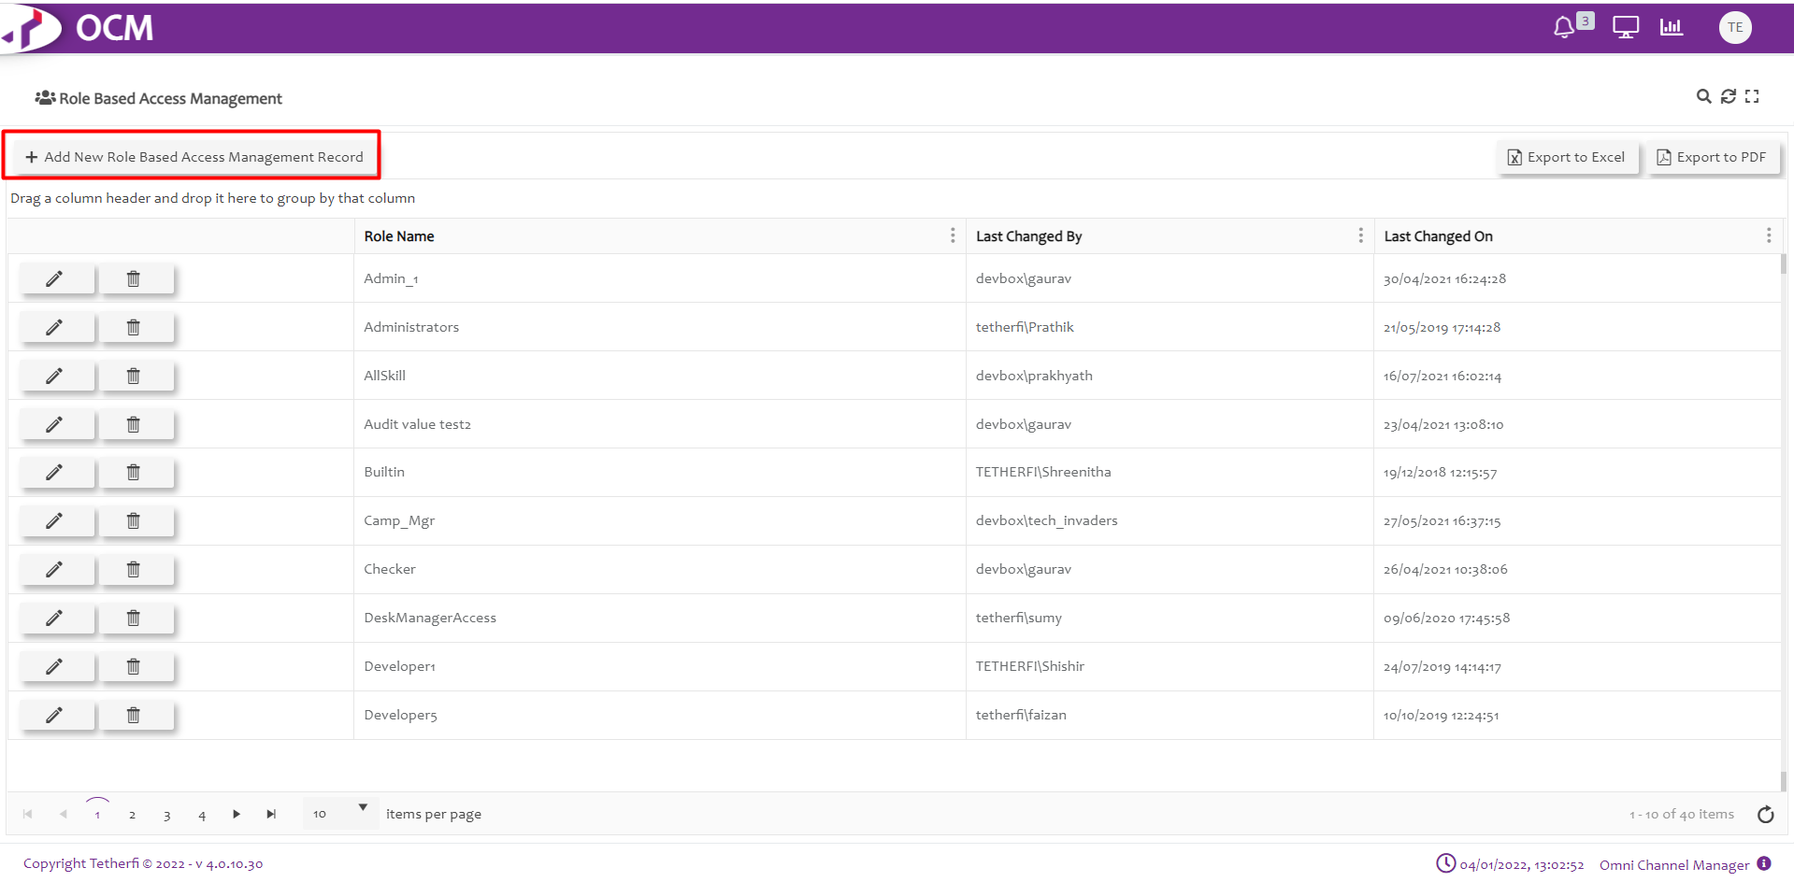
Upon clicking ‘Add New Role Based Access Management Record’, Following popup will generate. User can create new Role here.
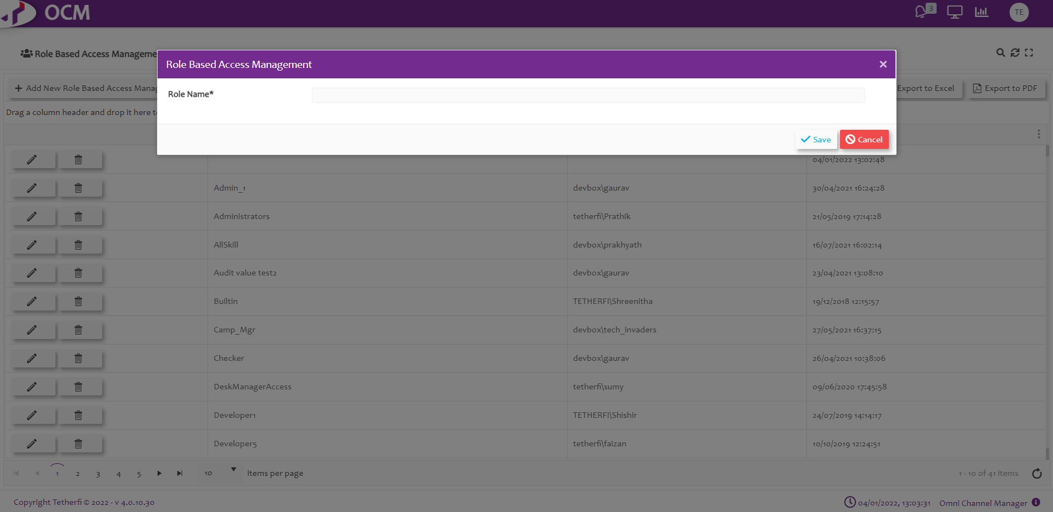
Functionalities to the newly added role can be given, by clicking on the new role added.
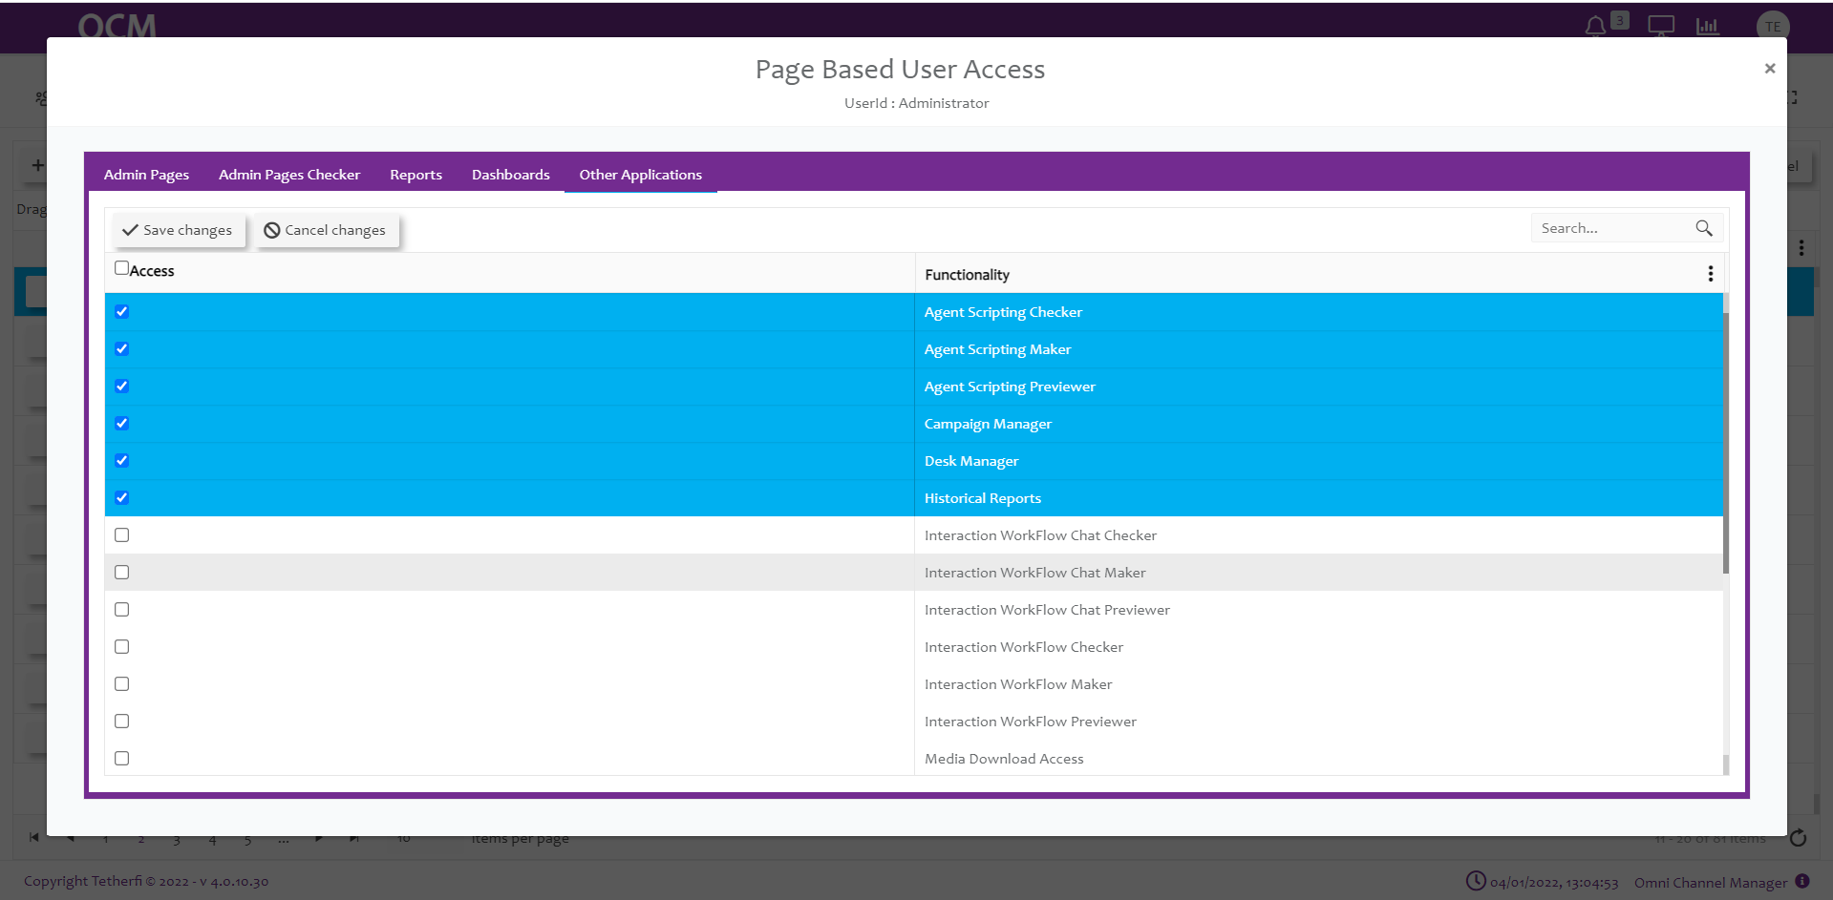

User Role Mapping
This module is used to add new role mapping record. Upon clicking this module following window will open and all the previously added records will be displayed.
User can add new role mapping record, by clicking ‘Add New User Role Mapping Record’ button present at top left corner.
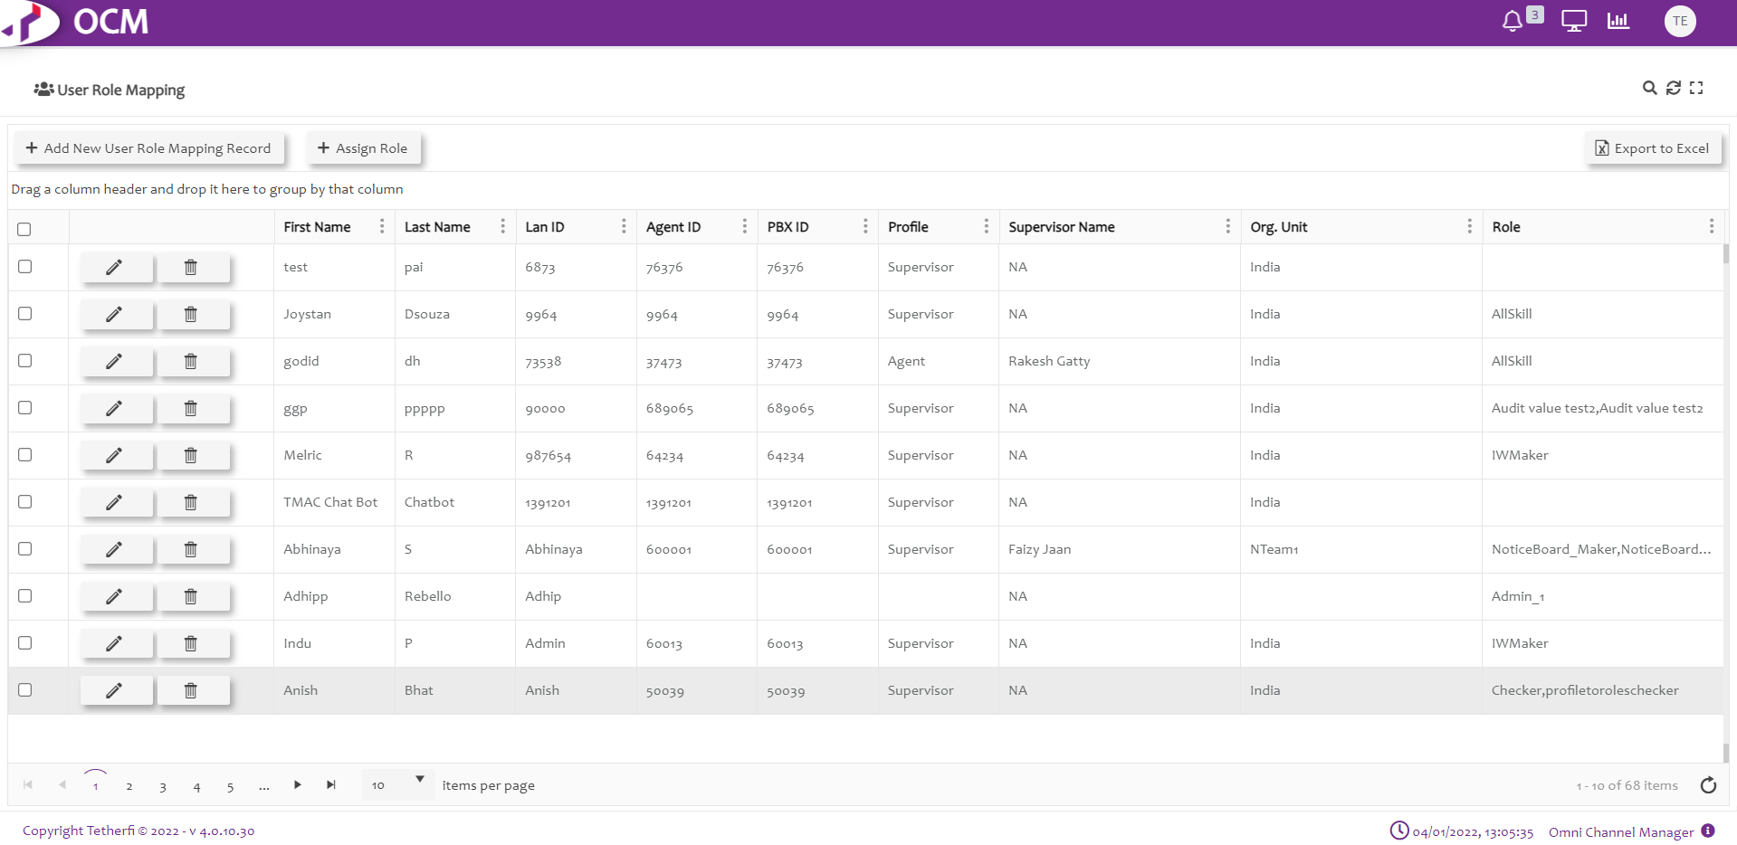
Upon clicking ‘Add New User Role Mapping Record’, Following popup will generate. User can create new Role mapping record here.
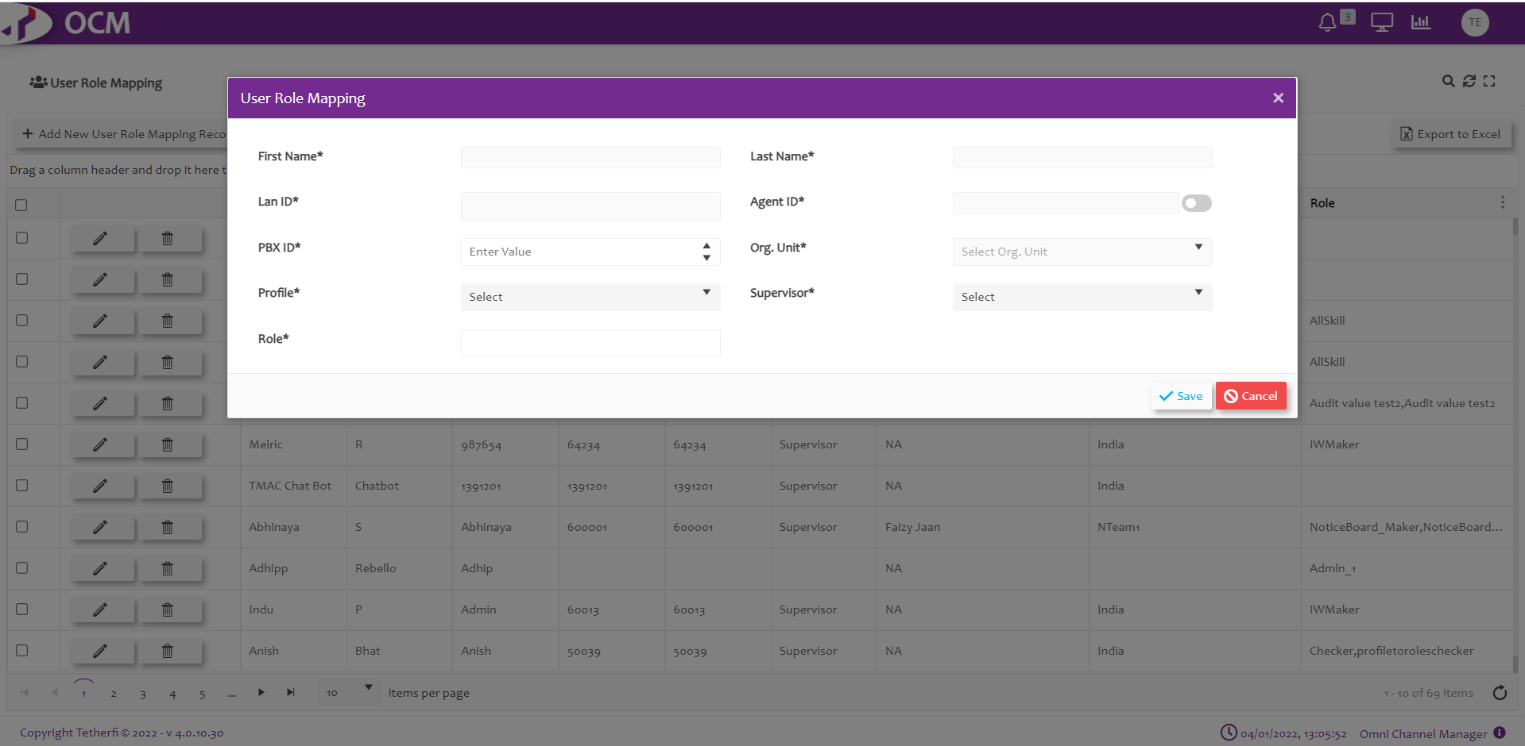
The Admin must assign a role to the user added here which is created in ‘Role Based Access Management’ module, like: Maker, Checker etc

IW Role Based Access Matrix
Upon clicking ‘IW Role Based Access Matrix’ module, all the roles created will be displayed as shown below.
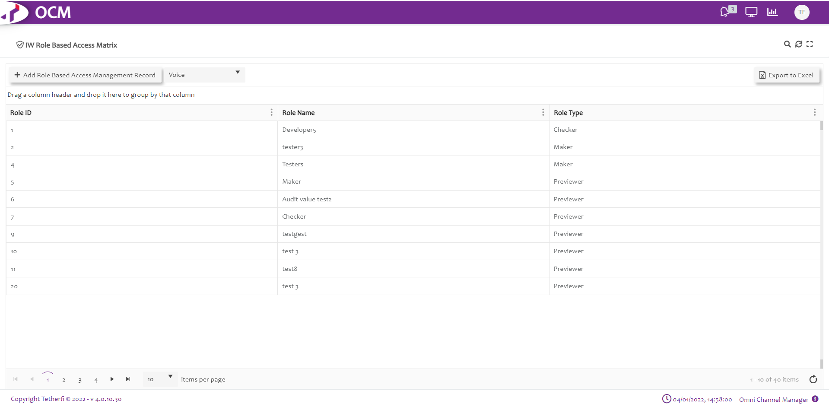
Upon selecting the any role, all the callflows created at IW Chat UI page will be displayed as shown below.
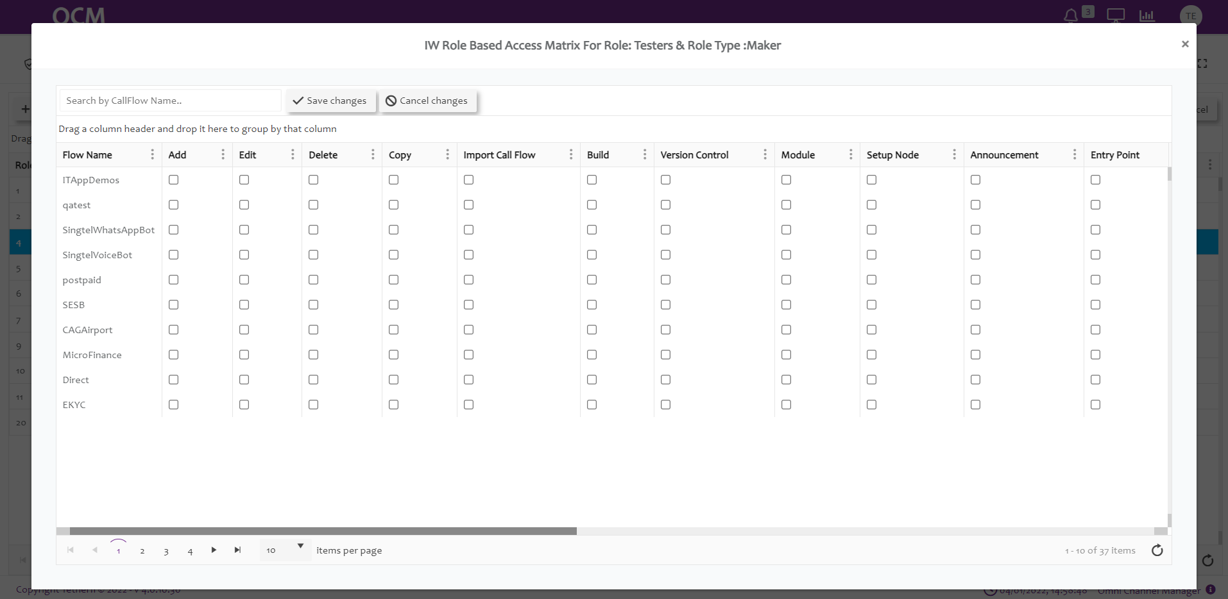
Note: For a newly created callflows, entry will be made in OCM only after saving the callflow in IW.
Upon saving the callflow in IW, entry is made in ‘IW Role Based Access Matrix’ page and all the functionalities are disabled by default.
Admin must give the permission to user by checking the options provided in OCM for user to perform any activities on callflows.
When user has 2 or more roles, access to the callflows will be provided as per below table.
Sl.No | Role1 | Role2 | Role3 | Output
1 | Maker | Checker | Previewer | Access Provided to Previewer Role will be in effect. For any combination with Previewer role, access provided to Previewer will be in effect
2 | Maker | Checker |  | Access provided to Maker Role will be in effect (Maker Role has higher priority than Checker)
3 | Maker | Maker |  | Query will check for the higher Role Id (2 is higher than 1) in CMM_Roles table and Access provided to that role will be in effect.
4 | Checker | Checker |  | Query will check for the higher Role Id (2 is higher than 1) in CMM_Roles table and Access provided to that role will be in effect.
5 | Previewer | Previewer |  | Query will check for the higher Role Id (2 is higher than 1) in CMM_Roles table and Access provided to that role will be in effect.

Callflow Level Roles

Action | Description
Flow Name | Callflow names will be displayed here after saving the callflow
Edit | Enable or Disable Edit permission to callflow in IW. This option must be checked in OCM page for giving the permission for the roles to edit callflow, send the callflow for approval, approve, schedule, reject or put checker comments to the callflows  Upon Enabling Owner Level Callflow option, only the callflows for which edit option is enabled will be displayed for the user in dashboard as well as configure callflow drop down list.
Delete | Enable or Disable Delete callflow option in IW (ref section Delete Callflow)  Note: only owner of the callflow can delete the callflows.
Copy | Enable or disable copy callflow in IW (ref section Copy Callflow)
Import Callflow | Enable or disable Import callflow in IW (ref section Import Callflow)
Real Time View | Enable or disable Realtime callflow view in IW (ref section Real-Time View/Report)
Build | Enable or disable build/package a callflow (ref. section Import Callflow)
Version Control: | This option must be checked in OCM page for giving the permission for the roles to revert the callflow to previously approved version and only owner of the callflow can revert to the previous approved version. (ref section Callflow Version Control )
Module | This option must be checked in OCM page for giving the permission for the roles to add, edit (including adding or removing existing connections and checker comments) and delete the modules present in the callflow.
Main Node: | This option must be checked in OCM page for giving the permission for the roles to edit (including adding or removing existing connections and checker comments) the Main node present in the callflow.

Node Level Roles

Action | Decryptions
Announcement | This option must be checked in OCM page for giving the permission for the roles to add, edit (including adding or removing existing connections and checker comments) and delete the announcement nodes present in the callflow. (ref section Announcement Node )
Entry Point | This option must be checked in OCM page for giving the permission for the roles to add, edit (including adding or removing existing connections and checker comments) and delete the entry nodes present in the callflow. (ref section Entry Point Node)
Menu | This option must be checked in OCM page for giving the permission for the roles to add, edit (including adding or removing existing connections and checker comments) and delete the menu nodes present in the callflow. (ref section Menu node)
Assignment | This option must be checked in OCM page for giving the permission for the roles to add, edit (including adding or removing existing connections and checker comments) and delete the assignment nodes present in the callflow. (ref section Assignment Node)
Conditional | This option must be checked in OCM page for giving the permission for the roles to add, edit (including adding or removing existing connections and checker comments) and delete the conditional nodes present in the callflow. (ref section Conditional Node)
Disconnect | This option must be checked in OCM page for giving the permission for the roles to add, edit (including adding or removing existing connections and checker comments) and delete the disconnect nodes present in the callflow.(ref section Disconnect Node)
Agent | This option must be checked in OCM page for giving the permission for the roles to add, edit (including adding or removing existing connections and checker comments) and delete the Agent nodes present in the callflow. (ref section Agent Node)
Exit Point | This option must be checked in OCM page for giving the permission for the roles to add, edit (including adding or removing existing connections and checker comments) and delete the Exit point nodes present in the callflow.(ref section Exit Point Node)
Prompt and Collect | This option must be checked in OCM page for giving the permission for the roles to add, edit (including adding or removing existing connections and checker comments) and delete the announcement nodes present in the callflow.(ref section Prompt and Collect Node)
Action | This option must be checked in OCM page for giving the permission for the roles to add, edit (including adding or removing existing connections and checker comments) and delete the action nodes present in the callflow.(ref section Action node)
Return | This option must be checked in OCM page for giving the permission for the roles to add, edit (including adding or removing existing connections and checker comments) and delete the Return nodes present in the callflow. (ref section Return Node)
Flow Connector | This option must be checked in OCM page for giving the permission for the roles to add, edit (including adding or removing existing connections and checker comments) and delete the Flow connector nodes present in the callflow. (ref section Flow Connector node)

IW Master Access Matrix
This option will be displayed in OCM ‘Home’ channel. This module is used to provide access to the IW Masters for a particular Roles/ security group. Upon clicking ‘IW Master Access Matrix’ module, all the roles created will be displayed as shown below.
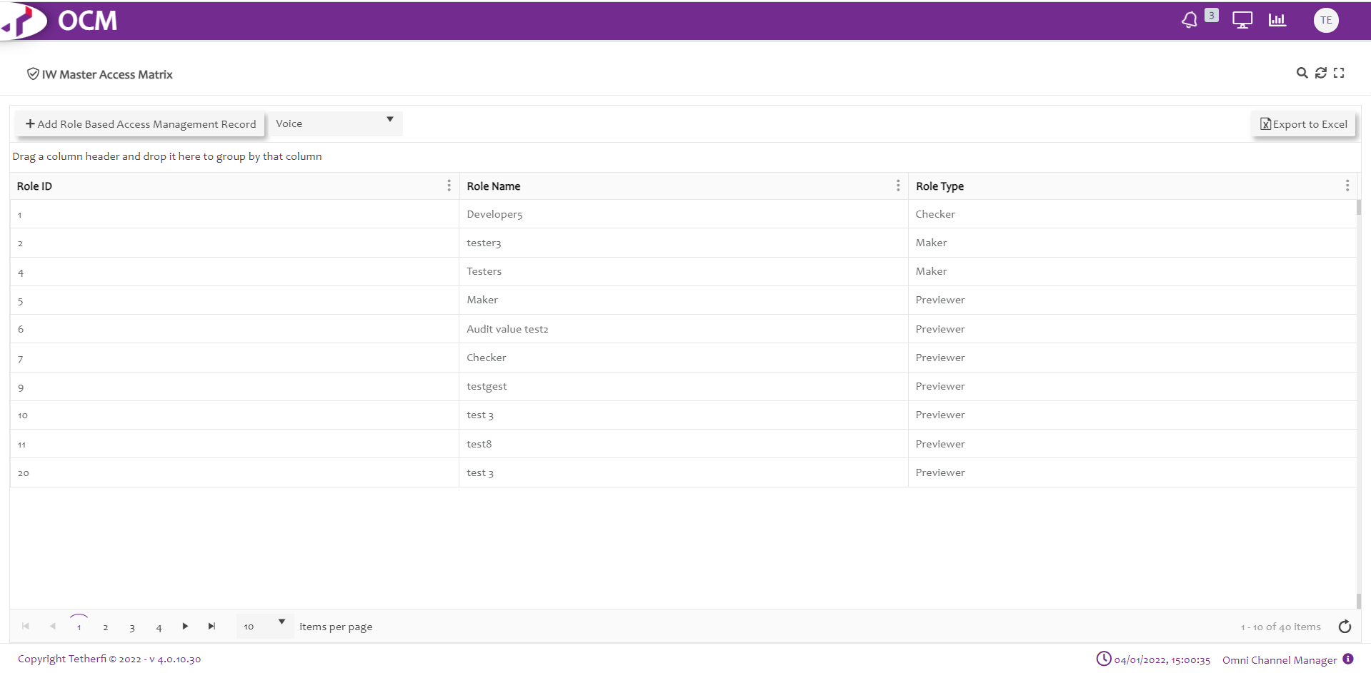
Upon selecting the any role/security group, all the masters along with Create new IWFlow, OrderTake Flow and Subflow options will be displayed as shown below.
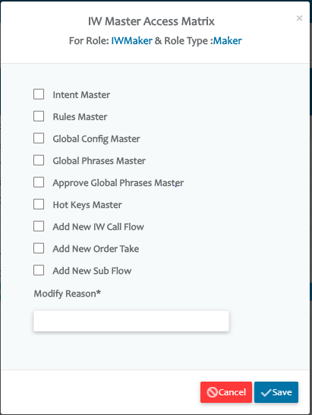
When ‘EnableAccessRules’ option in IW Webconfig is set to 1, then by default, user won’t be having access to any masters including options to create new IW, OrderTake or Subflows. Error toaster ‘This option is not enabled for current user’ is displayed when user clicks on any master options.
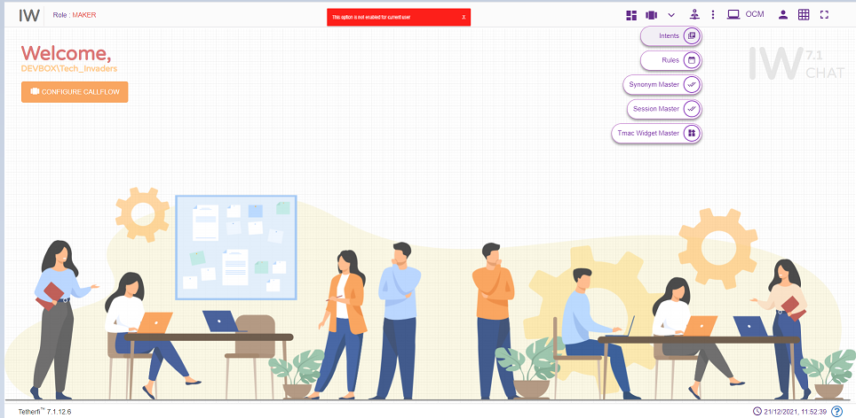
Admin must give the permission to user by checking the options provided in OCM ‘IW Master Access Matrix’ for the roles assigned to the user to edit the masters.
For Role Type Checker and Previewer, ‘Add New IW Callflow’, ‘Add New OrderTake’ and ‘Add New Sub Flow’ options will be disabled.
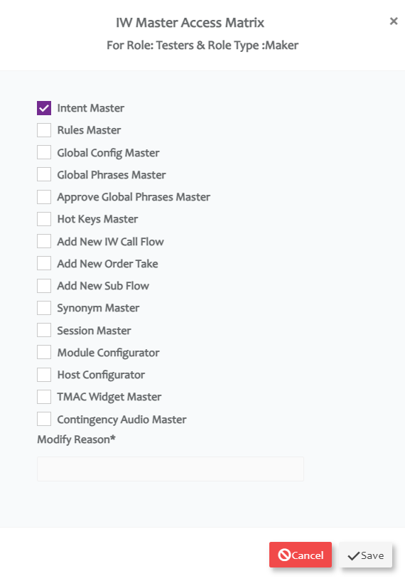
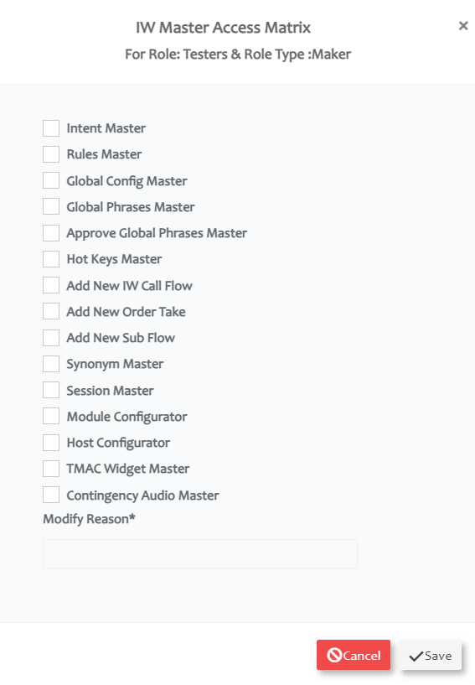
When user has 2 or more roles, access to the master will be provided as per below table.
Sl.No | Role1 | Role2 | Role3 | Output
1 | Maker | Checker | Previewer | Access Provided to Previewer Role will be in effect. For any combination with Previewer role, access provided to Previewer will be in effect
2 | Maker | Checker |  | Access provided to Maker Role will be in effect (Maker Role has higher priority than Checker)
3 | Maker | Maker |  | Query will check for the higher Role Id (2 is higher than 1) in CMM_Roles table and Access provided to that role will be in effect.
4 | Checker | Checker |  | Query will check for the higher Role Id (2 is higher than 1) in CMM_Roles table and Access provided to that role will be in effect.
5 | Previewer | Previewer |  | Query will check for the higher Role Id (2 is higher than 1) in CMM_Roles table and Access provided to that role will be in effect.

Database Table Access
To add the users directly to the db tables instead of using OCM, follow below steps
  - Add a new Role in CMM_Roles table
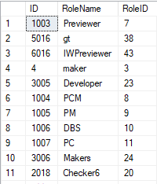
  - Provide IW Chat Maker/ Checker/ Previewer access to the roles in CMM_Role_Pages Table

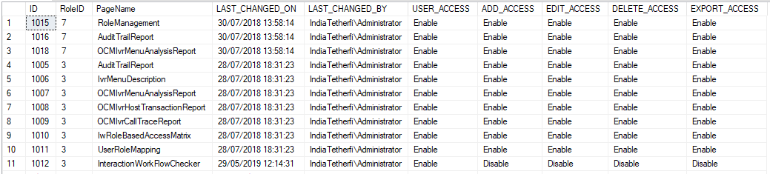

Interaction Workflow User Roles
The Interaction Workflow application will have following user roles:
- Maker
- Checker
- Previewer
- Maker and Checker

When the product is first delivered, the Admin user of OCM (details to be provided by business users) will allot the users as Interaction Workflow Maker/Checker (or both) by using OCM User Management module (ref section OCM Access).
Only the Admin can add new user, change user role and delete user.
User Functionality | Previewer | Maker | Checker | Maker and Checker
Create | No | Yes | No | Yes
Edit | No | Yes | No | Yes
Delete | No | Yes | No | Yes
Schedule | No | No | Yes | Yes
Approve | No | No | Yes | Yes
Reject | No | No | Yes | Yes
Preview | Yes | Yes | Yes | Yes
Comment | No | Yes | Yes | Yes

Maker
Interaction Workflow Maker has the privileges to create / view / edit / delete workflows.
All the changes made to Interaction Workflow by Maker need to be approved by Checker before being implemented to the system.
When user login as a maker (without loading any callflow), following page will be displayed.
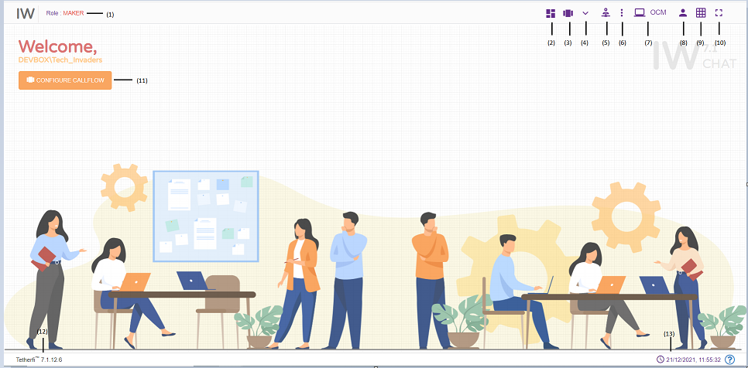
- Role: Displays the role of the user i.e. Maker
- Dashboard: callflow dashboard. (ref section Dashboard )
- Configure Callflow: This option is used to create a new flow/ Preview a flow/Sub Flow/Delete a callflow. (ref section Configure Callflow)
- More Menus: Upon clicking this button following options will appear.
- Import callflow: (ref section Import Callflow)
- Copy callflow: refer section Copy Callflow
- Master: Upon clicking this button following options will appear.
- Intents: refer section Intent Master
- Rules: refer section Rule Master
- Synonym Maser: refer section Synonym Master
- Session Master: refer section Session Master
- Tmac Widget Master: refer section TMAC Widget Master
- Callflow Notifications: Notifications related to Callflow statuses
- Redirect to OCM: This option will redirect to OCM page.
- Current User Info: User’s domain name/ user name and for logging out of Interaction Workflow module.
- Grid: Grid can be enabled/disabled.
- Full Screen: This option is used to view the Interaction Workflow in full screen. (Press “Esc”/F11 button to go back to normal view)
- At the top left corner of the page, welcome message is displayed along with user’s domain name/user name. Configure callflow option is also provided here.
- Current IW version
- System date and time will be displayed here.
When user login as a maker and load a callflow, following page will be displayed.
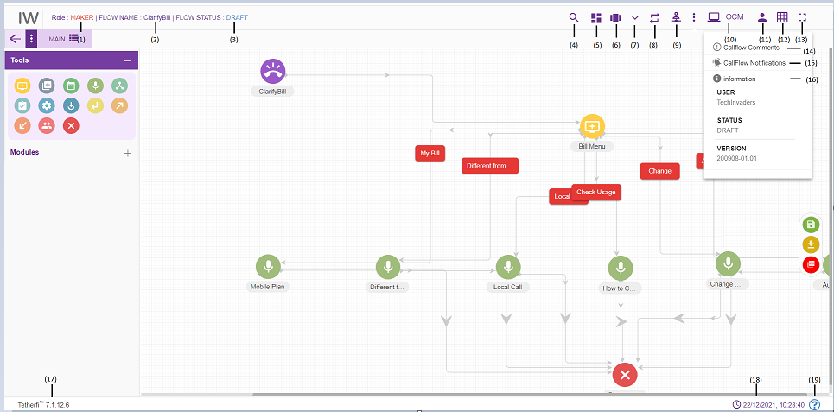
- Role: Displays role of the user i.e. Maker
- Flow Name: Name of the flow will be displayed here
- Flow Status: Current chatflow flow status will be displayed here
- Search for Nodes: refer section Search for nodes
- Dashboard: chatflow dashboard. (ref section Dashboard )
- Configure Chatflow: This option is used to create a new flow/ Preview a flow/Order Take/Delete a chatflow. refer section Configure Chatflow
- More Menus: Upon clicking this button following options will appear.
- Chatflow version control: refer section Chatflow Version Control
- Import chatflow: ref section Import Chatflow)
- Copy chatflow: refer section Copy Chatflow
- Rules Viewer: refer section Rules Viewer
- Master: Upon clicking this button following options will appear.
- Intents: refer section Intent Master
- Rules: refer section Rule Master
- Synonym Maser: refer section Synonym Master
- Session Master: refer section Session Master
- Tmac Widget Master: refer section TMAC Widget Master
- Redirect to OCM: This option will redirect to OCM page.
- Current User Info: This option is used to know User’s domain name/ user name and for logging out of Interaction Workflow module.
- Grid: Grid can be enabled/disabled.
- Full Screen: This option is used to view the Interaction Workflow in full screen. (Press “Esc”/F11 button to go back to normal view)
- Callflow Comments: refer section Comments
- Callflow Notifications: This option is used to check all the notifications related to Interaction Workflow.
- Information: This option is used for information related to the user and Interaction Workflow version.
- Current IW version is displayed here.
- Current system date and time will be displayed here.
- System file version will be displayed here.
There are modules and nodes available here. Maker can make use of these nodes/module as per requirement

Import Chatflow
Import chatflow option is used to import external chatflow that we build/packaged in other systems.
Click ‘More Menus’ option from top left corner in maker/maker-checker page, following popup will be generating.
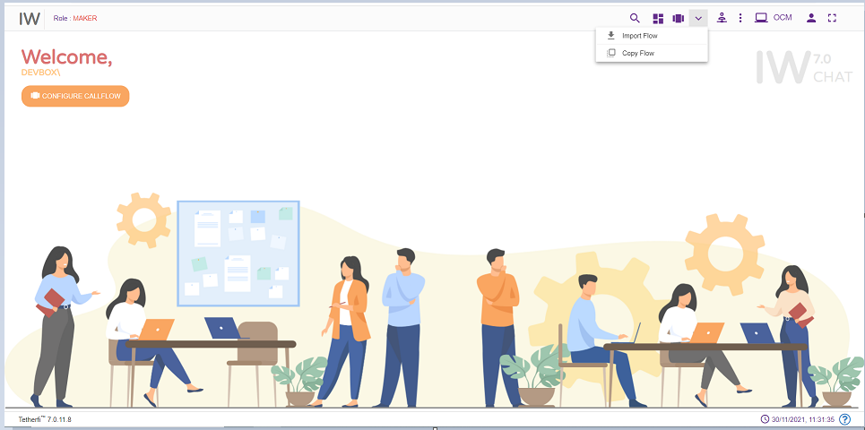
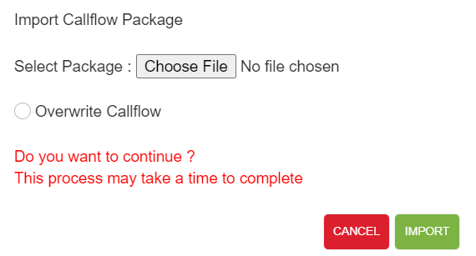
The package that is generated/zipped using ‘Callflow Build/Package’ (refer section Dashboard) option in IWChat can be imported here. If there is already a callflow with same name, it can be overwritten by checking ‘Overwrite Callflow’ option. Only zip files can be imported here.
User can import only the flows, whose version number is greater than the APPROVED status flow present in the system. ‘Flow with higher version number already present in the system’ error message is displayed.
If there is no APPROVED status flow for a callflow, then UNAPPROVED version of the flow is overridden when importing the flow.
Upon successfully importing the callflow to the system, success message will be generating in UI as shown below.
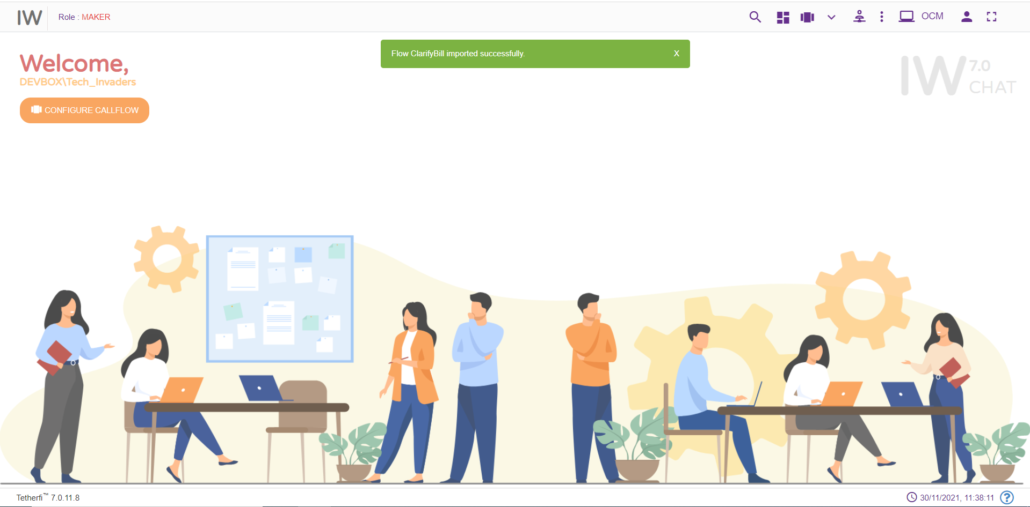

Copy Chatflow
This option is to create the copy of the chatflow. Copied chatflow will be in DRAFT status and created and modified date will be same.
Upon clicking on ‘More Menus’ option present at top left corner in maker/maker-checker page, following popup will be generating.
Upon clicking this option, following popup will be generated.
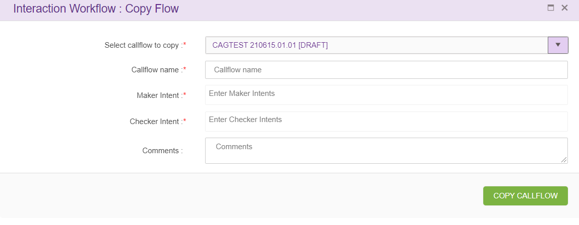
Select callflow to copy: upon clicking on this drop down main flow, sub flows and order take flows will appear as shown below.
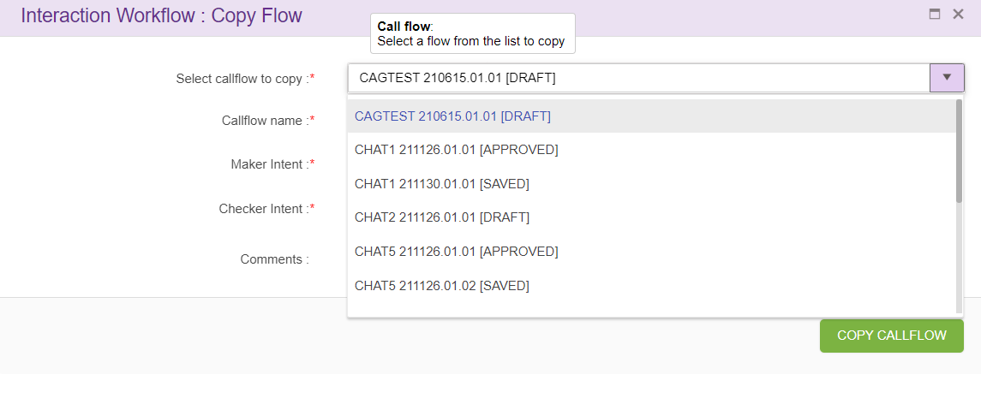

Copying IW Flow:
when user selects chat flow from the drop-down following screen will appear
Flow name: name of the call flow.
Maker DNIS and Checker DNIS: Create a new callflow with unique name and DNIS (Maker and Checker DNIS should be unique throughout callflow). This option is provided only for the user who has ‘Maker’ credentials and Maker can copy only callflow with status ‘Draft’ and ‘Saved’.
Upon clicking ‘COPY FLOW’ button, new callflow will be created based on the callflow name specified, which will be exact copy of selected callflow.

Copying Subflow
when user selects subflow from the drop-down following screen will appear
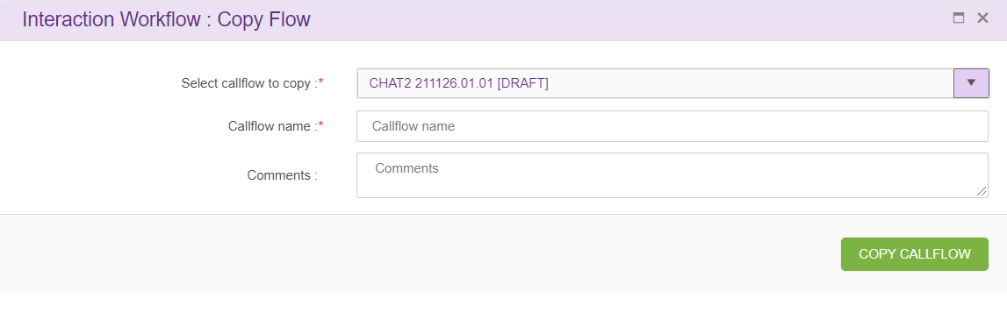
Flow name: name of the call flow to be created.
Upon clicking ‘COPY FLOW’ button, new callflow will be created based on the callflow name specified, which will be exact copy of selected callflow. This option is provided only for the user who has ‘Maker’ credentials and Maker can copy only callflow with status ‘Draft’ and ‘Saved’.

Chatflow Version Control
Chatflow version control option will appear in ‘More Menus’ option only when the selected chatflow is in ‘draft status. Version control is a system that records changes over time so that you can recall specific versions later. In chatflow version control system, user can revert their changes to specific approved version.
Only Makers have the privilege to revert chatflows that are in draft state.
Click the ‘Chatflow version control’ option as shown below.
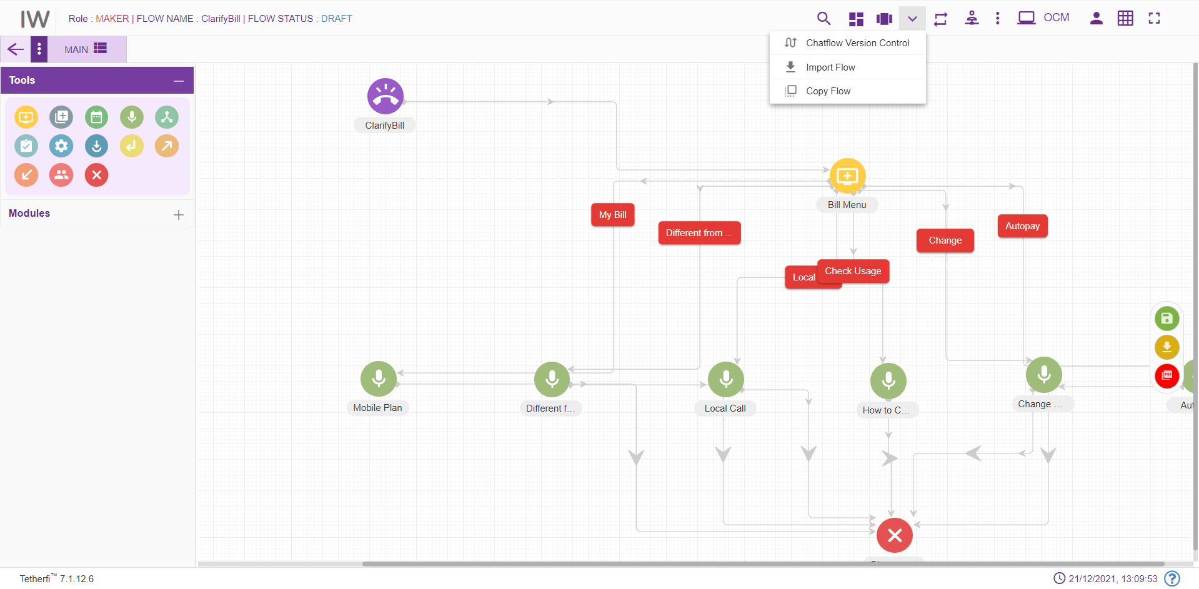
On click of “Call flow version control” button, below screen will be displayed.
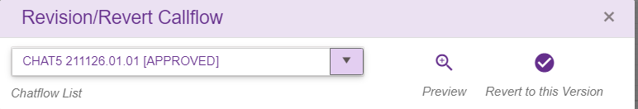
- Select the workflow that has to be revised/ reverted from the “Chatflow List”. The previously ‘approved’ chatflow names will be shown in the chatflow list.
- “Preview” helps the users to confirm to which chatflow they want to revert.
- ‘Revert to this version’ – Reverts the opened DRAFT chatflow to selected APPROVED chatflow.
Upon clicking ‘Revert to this Version’ button, following confirmation popup will generate.
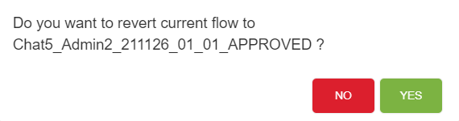
Upon reverting, chatflow will be in saved status.
If there is no previous APPROVED version of the selected DRAFT chatflow, then ‘Reversion Chatflow does not exist’ error message will be shown.

Rule Master
This option will appear for the Maker, Checker and Previewer also. But only Maker can add rules. Checker and Previewer will be in read-only mode.
A rule is a principle or regulation or governing procedure for operation of Chat with respect to a node or module.
Only Makers have the privilege of creating/ editing rules.
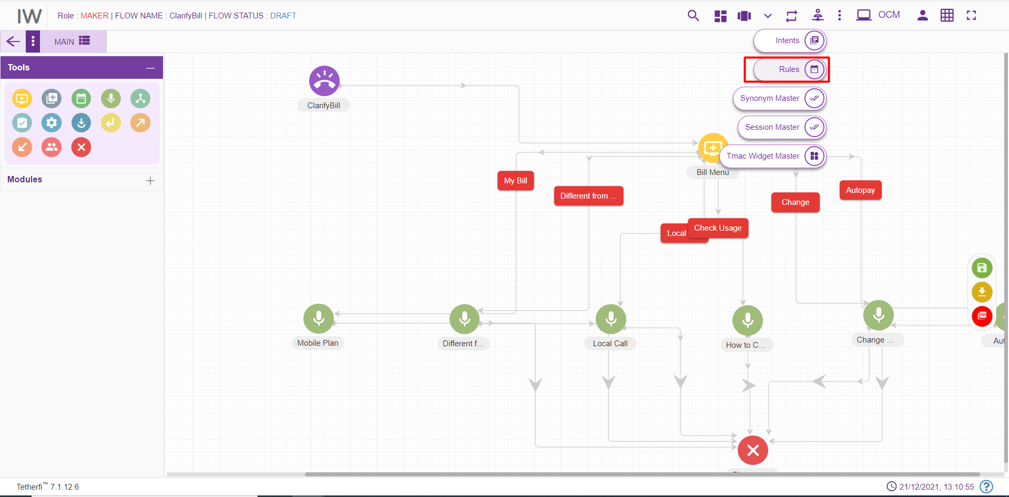
Maker can create/ edit rules by clicking on the button shown in the above figure.
Upon clicking ‘Rule Master’ icon, following popup will generate.
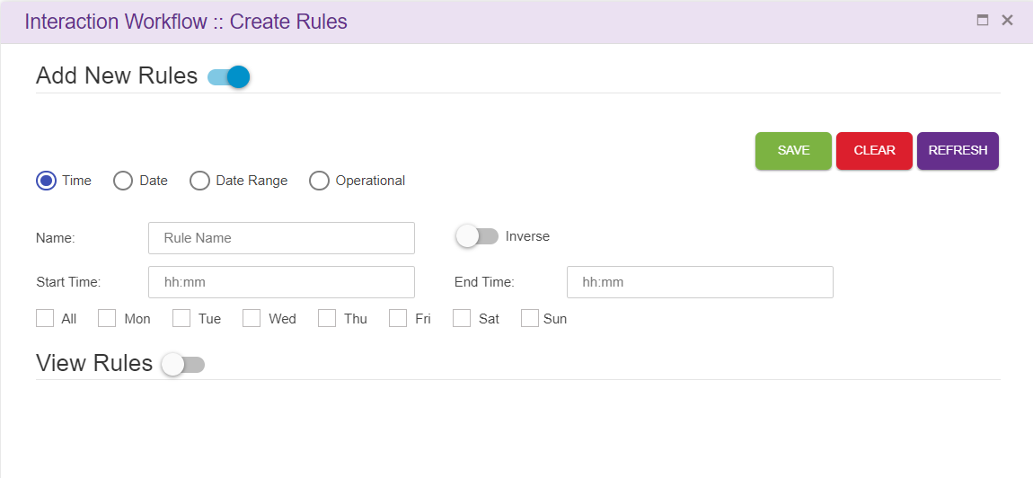
Save: This button is used to add the rules to the grid i.e. Save the rule.
Clear: This option is used to clear the fields entered.
Refresh: This option is used to refresh the rule master window and load the latest rules to the grid.
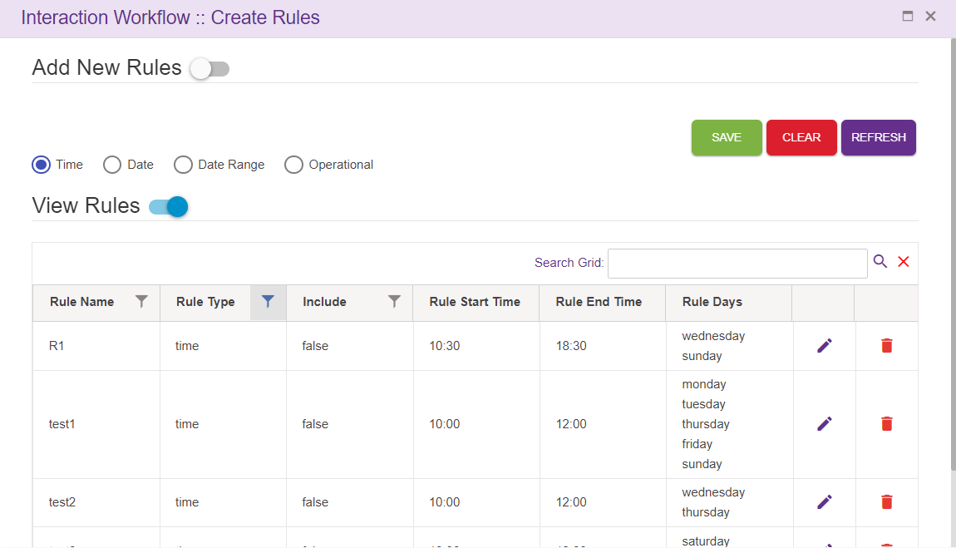
- Search Grid will help to search rules from records.
- For creating new rules, the Maker needs to select “Add new rules” option.
- There are four main types of rules: Time, Date, Date Range and Operational.
- On enabling of “View Rules” option, the above popup will generate

Time
You need to set the Name of this rule, Start and End time alongside the weekdays that you want the rule to be active and whether you want to include this rule in the chatflow. You need to click Save, for saving the rule and Clear, for discarding the rule.

Date
You need to set the Name of this rule, date at which you want the rule to be active and whether you want to include this rule in the chatflow. You need to click Save, for saving the rule and Clear, for discarding the rule.
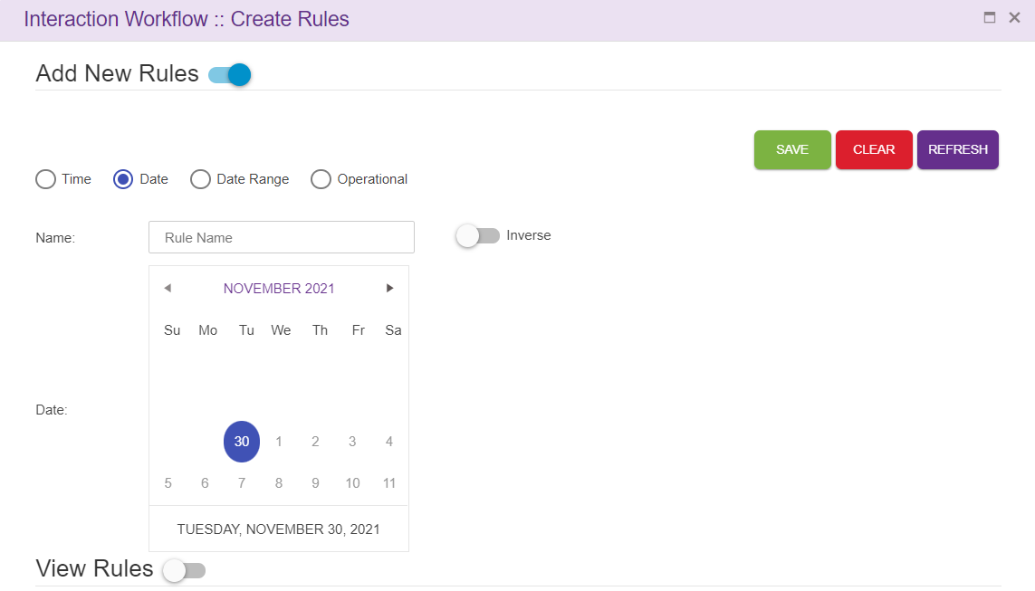

Date Range
You need to set the Name of this rule, Start and End date range you want the rule to be active. Click Save, for saving the rule and Clear, for discarding the rule.
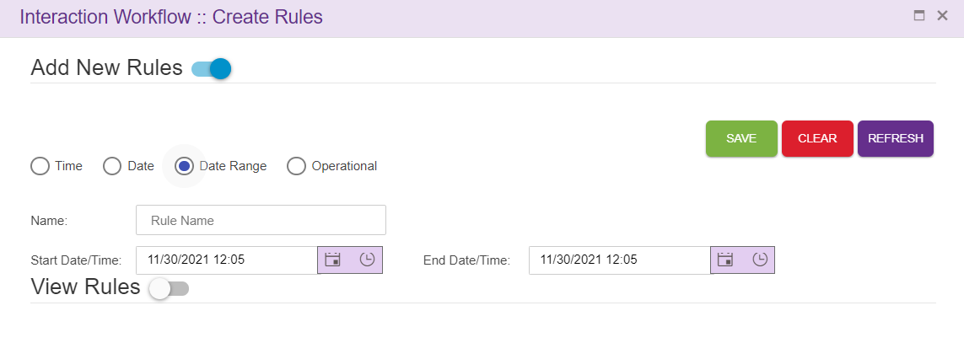

Operational
You need to set the Name of this rule, Variable 1 and Variable 2 alongside the operator you want the rule to be consist of and whether you want to include this rule In the chatflow. You need to click Save, for saving the rule and Clear, for discarding the rule.
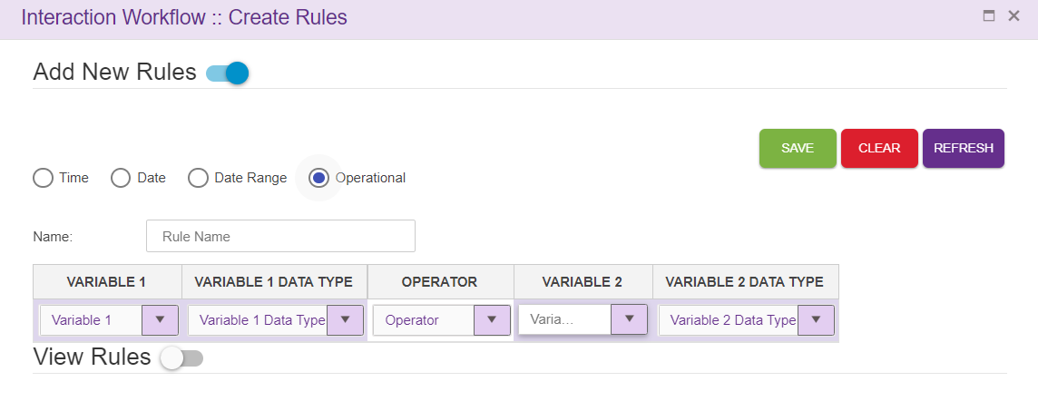
For editing/deleting the rule, click on the edit/ delete icon and make the necessary changes. Click Save, for saving the rule and Clear, for discarding the rule.
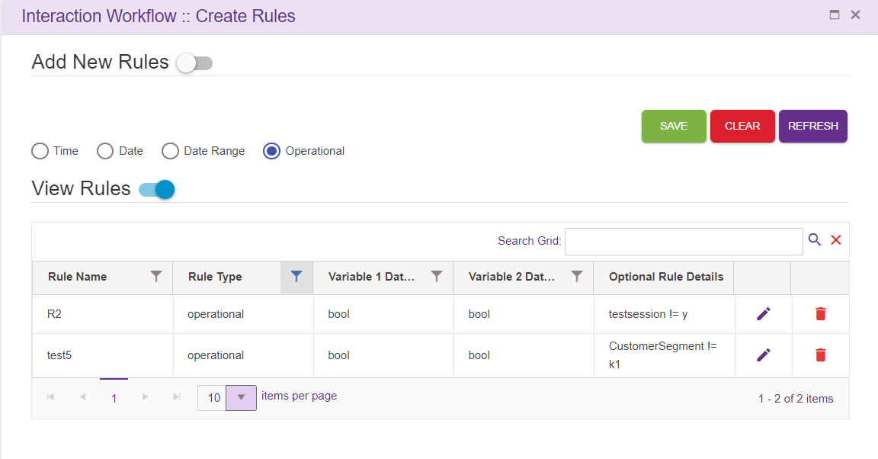

Chatflow specific Rules
Rules can also be displayed specific to the chatflow. Upon setting ChatflowSpecific the key to TRUE in ClientSpecificConfiguration.json file, only the rules specific to the chatflow will be displayed.
In this case, upon adding a new rule. It won’t be displayed in the View Rules grid. But user can use the rules added, in nodes as well as in legs in the chatflow.
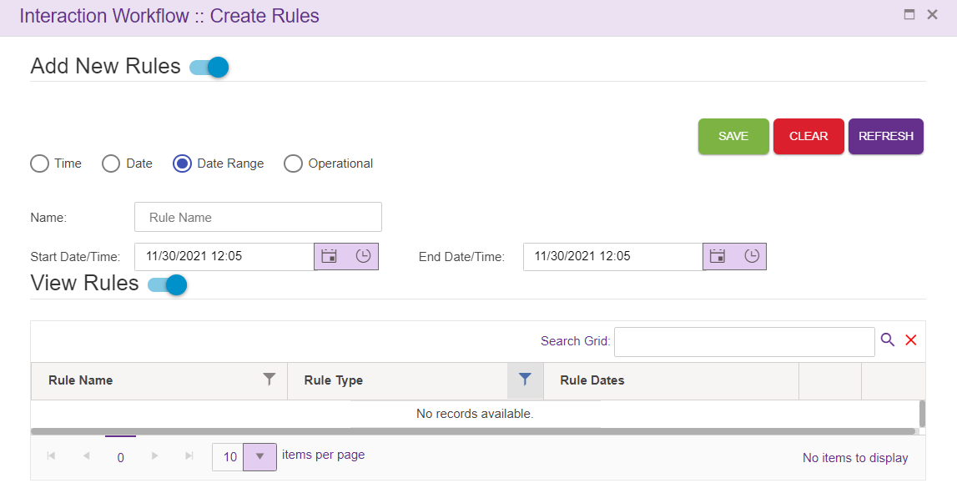
All the Rules added in rule master will be displayed in Set Rules window and user can use the rules in the chatflow based on the requirements.
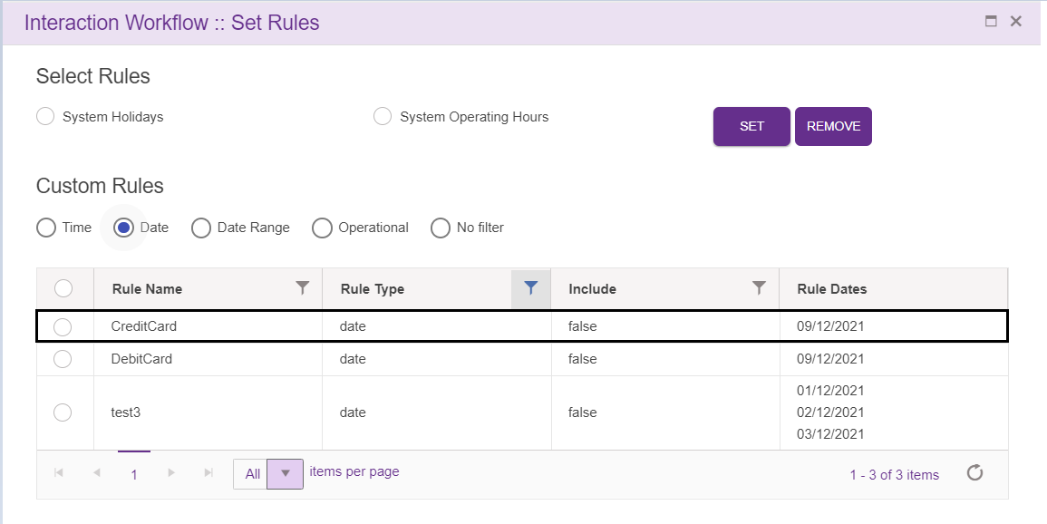
Only the rules used in the chatflow will be displayed in the rule master in chatflow specific rules option.
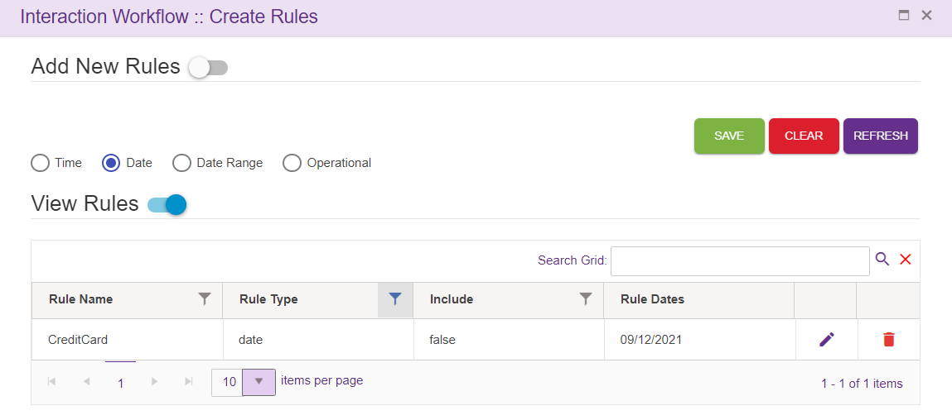

Intent Master
This option will appear for the Maker, Checker and Previewer also. But only Maker can add intents. Checker and Previewer will be in read-only mode.
Upon clicking intent master icon following page will be displayed.
Intents are mapped to the VDN in the intent master page in IW. If the user gives any intent which is not mapped to VDN in intent master, it becomes invalid flow. User can add the intents in ‘intent master’ and map to the VDN.
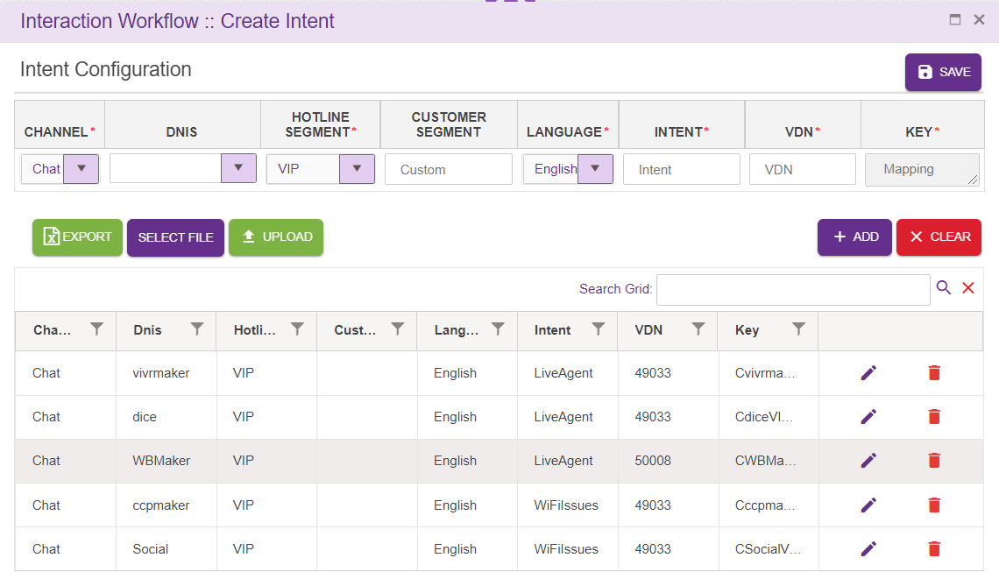
    - Channel: This drop down contains list of configured channels
    - Dnis: Dnis is added here, or user can select Dnis from the drop down.
    - Hotline Segment: User can select a Hotline segment from the drop down.
    - Customer Segment: This field accepts customer segment
    - Language: This drop down contains list of configured languages
    - Intent: Intent provided here is added to the grid as well as Agent node. Intent need not be unique.
    - VDN: This field accepts VDN.
    - Key: Unique key is provided for every entry. This key is auto generated.

Search Grid will help to search intents from records.
Save: Upon clicking ‘Save’ button, entries must be added to the grid and intent must be shown in Agent drop down.
Clear: This option is used to clear the entered field.
Export: Upon clicking this button, .csv extension file will be downloaded. This file contains all the contents of the grid.
File Selection: This option is used to select the file to be uploaded. Note that only .csv extension file can be uploaded. User can upload bulk amount of data.
Upload: This option is used to upload selected file. Upon clicking upload option, following popup will be generated. Duplicate files will not be uploaded.

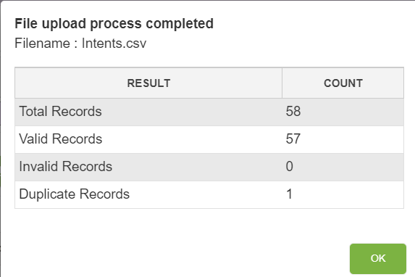
Edit: Click on the edit icon (right corner of each entry) to edit the details. User can edit only VDN field.

Rules Viewer
This option will appear for all the roles i.e. maker, checker and previewer for the chatflows of all the status.
Upon clicking rule viewer icon following pop window will be loaded.
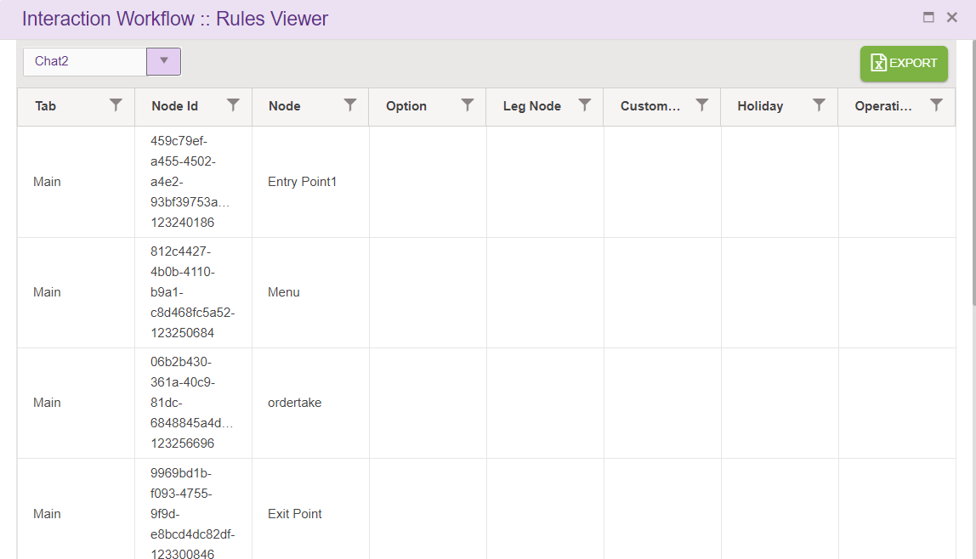
Rules viewer option shows all the rules added in menu leg, pnc leg and Validation, announcement and conditional node legs in the chatflow along with each node id. This a a common place where all the node id’s used in the chatflow can be viewed. user can select chatflow from dropdown to view rules.
- Tab: specifies the tab of chatflow
- NodeId: Id of that node.
- Node: this option displays node name.
- Option: node leg option will be displayed here.
- Leg Node: specifies leg node.
- Custom Rules: this is used to display rule name
- Holiday: this option will be true or false based on user selecting this when adding rules.
- Operating hours: this will display operating hours of rule.
Rule set for Menu Node leg will be displayed like this:
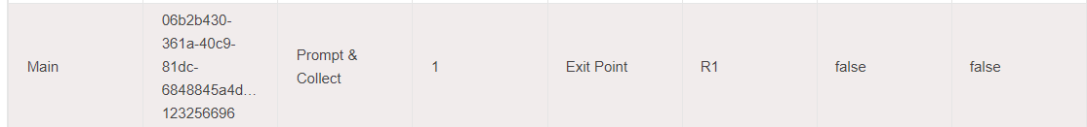
Rule set for PNC Node leg and validation will be displayed like this:
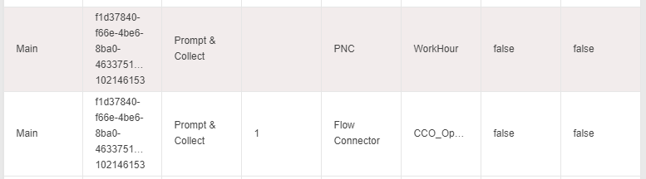
Rule set for Announcement Node will be displayed like this:
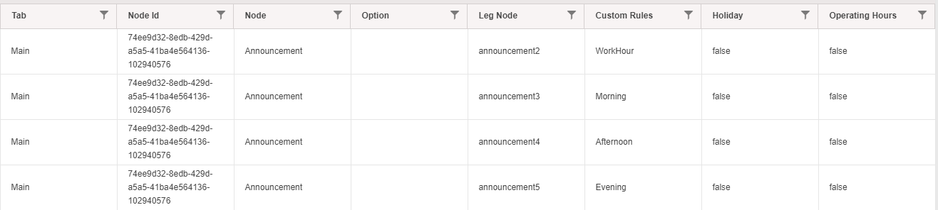

Comments
Upon clicking comments icon following pop window will be displayed.
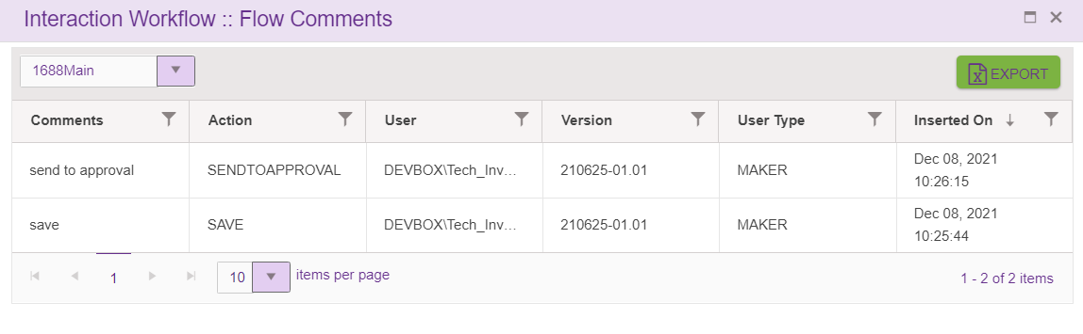
Comment option shows all the comments entered by the user whenever he does actions like ‘Save’ (both maker and checker) chatflow, ‘Send to approval’, ’Reject’, ’Approve’, ‘Scheduled’ the chatflow.
- Comments: specifies comments provided by the user.
- Action: specifies the status of the chatflow.
- User: shows username logged-in. The format as <Domain name \ username>.
- Version: specifies version number of the chatflow.
- User type: specifies type of the user like Maker, Checker.
- Inserted on specifies the date and time when user does add the comment.
Each columns header has the option to select and sort the records in ascending/descending order. These actions can be performed on clicking on table header.
Export:
Upon clicking this button, .csv extension file will be downloaded. This file contains all the contents of the grid. This option is available for all the roles i.e. maker, checker and previewer.
Dropdown:
Upon clicking on dropdown, all subflow connected to the flow will be listed. User can view the comments added to the subflows connected to the main flow here.

Search for Nodes and Modules
This option is used to search for a node/module in a chatflow using node id or name. Upon clicking ‘Search for nodes’ icon following pop window will be displayed.
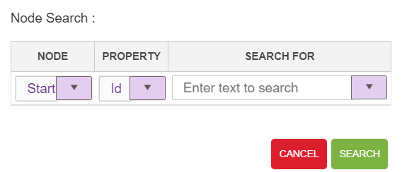
Node: This drop down contains list of nodes/modules used in IW Chat except Entry , exit and flow connector nodes.
Property: This drop down contains list of search criteria used to search for a node/module (Id and Name)
Search For: Text area where user will provide ID/Name detail.
For a valid search, control goes to the specific node and node starts blinking.
For an invalid search, ‘Given text does not exists in the current chatflow error toaster is generated as shown below.
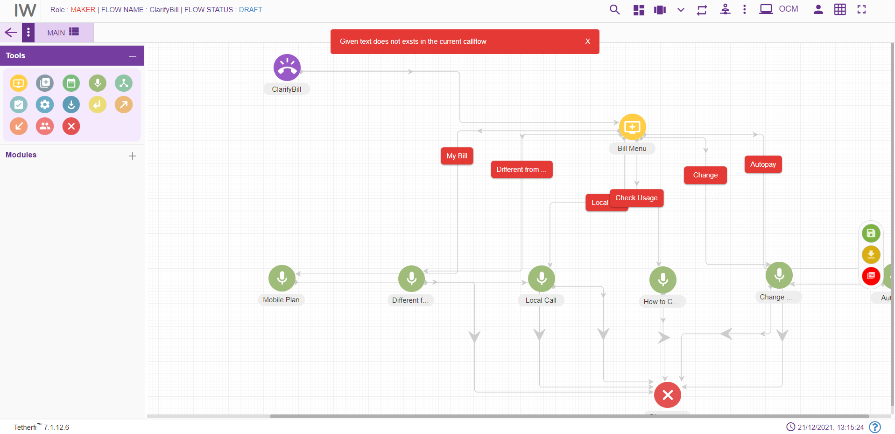

4.1.9 Global Synonyms
This option is used for updating commonly used synonyms in global master. Here we can configure repeatedly used synonyms and can jump to a specific chatflow, tab and entry point based on the intent provided. This option will appear only for the Maker.
Upon clicking global synonyms icon following page will be displayed.
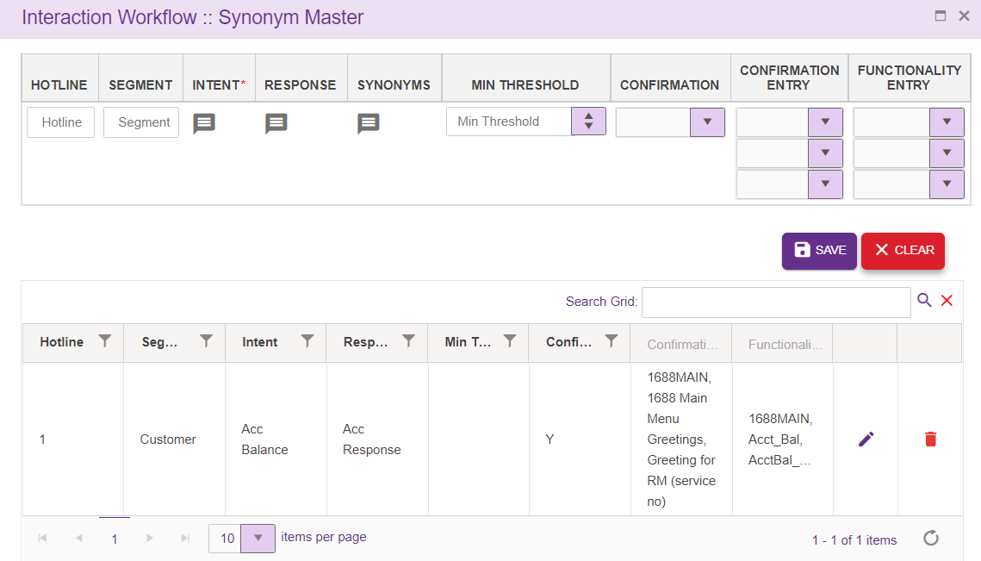
- Intent: Intents are added here. This is a mandatory field
- Response: Response for the Intents, added in ‘Intent’ field is added here
- Synonyms: Can add synonyms for the intent added in ‘Intent’ section
- Flow name: Lists all SAVED/APPROVED subflows and main flows
- Tab: Lists all the tabs present in the flow selected in ‘Flow name’ dropdown
- Entry Point: Lists all the entry points present in the tabs selected in ‘Tabs’ dropdown
Intent addition popup:
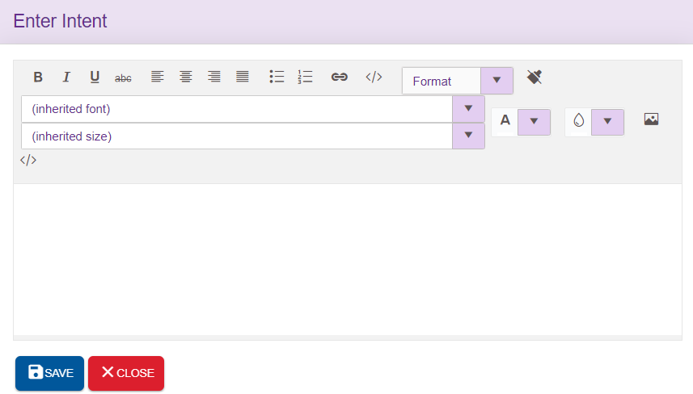

Response addition popup:
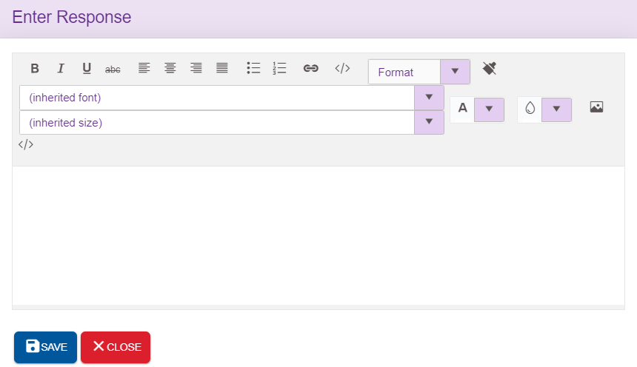
Synonym addition popup:
Synonyms related to the intents specific to the language can be added here. Upon clicking ‘ADD’ icon, synonyms will be added to the grid provided at the right end. ‘Remove’ option will clear the field.
SAVE: This icon will save the synonyms added
DELETE ALL: This option used to delete all the synonyms added at once
CLOSE: This icon is used to close the popup
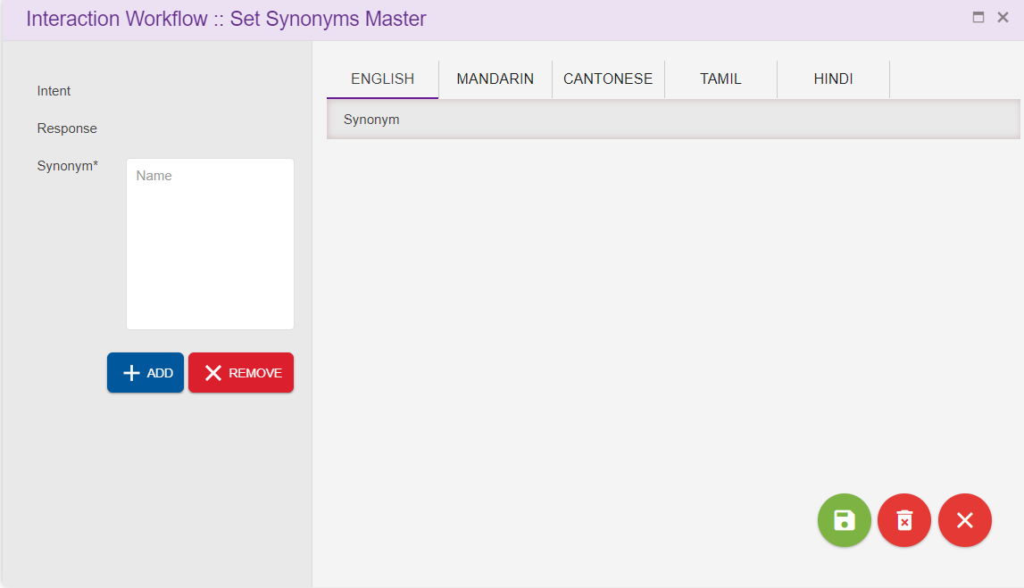
Save: Upon clicking ‘Save’ button, entries will be added to the grid
Clear: This option is used to clear the entered field.
Edit: Click on the edit icon (right corner of each entry) to edit the details. User can edit all the fields.

File System Version
All the server components version number, interpreter link and websync link used by the application is displayed here.
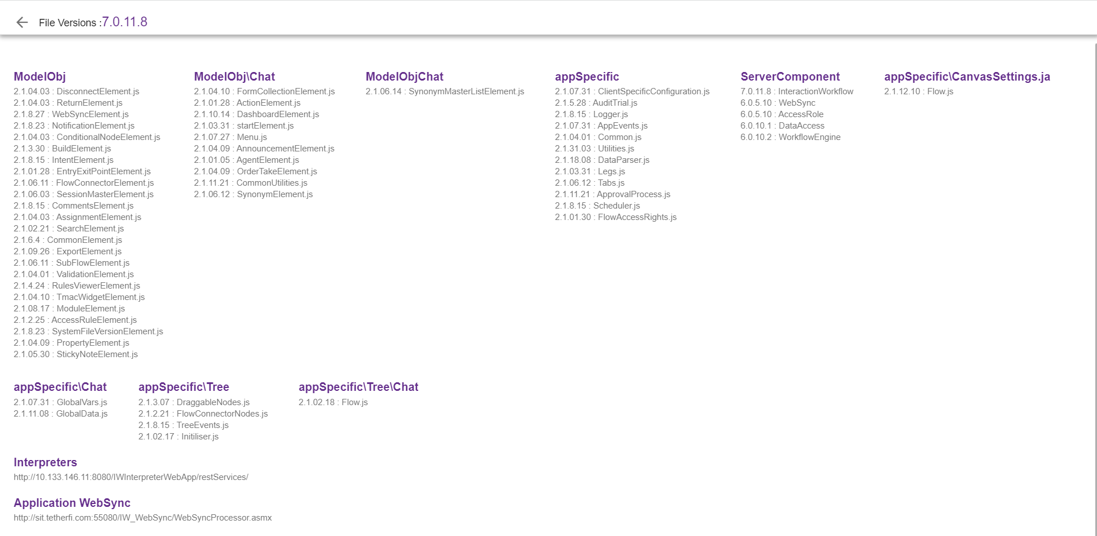

Synonym Master
This option is used for updating commonly used synonyms in global master. Here we can configure repeatedly used synonyms and can jump to a specific callflow, tab and entry point based on the intent provided. This option will appear only for the Maker.
Upon clicking global synonyms icon following page will be displayed.
Search Grid will help to search synonyms from records.
- Intent: Intents are added here. This is a mandatory field.
- Response: Response for the Intents, added in ‘Intent’ field is added here
- Synonyms: Can add synonyms for the intent added in ‘Intent’ section specific to language
- Flow name: Lists all SAVED/APPROVED subflows and main flows
- Tab: Lists all the tabs present in the flow selected in ‘Flow name’ dropdown
- Entry Point: Lists all the entry points present in the tabs selected in ‘Tabs’ dropdown
For Each intent added, Designer can also add set of synonyms. Upon clicking synonym option, following popup will be generated
Intent: Intent added will be displayed here
Response: Response for the Intents, added in ‘Intent’ field is added here
Synonym: It’s a mandatory field. Synonym specific to the intent can be added here
Description: Synonym description can be added here
SAVE: This is used to save the entries added
Remove All Synonyms: This option is used to remove all the synonyms added at once
Close : This option is used to close the synonym window.
In the below case, ‘Account Balance’ is the intent as ‘Acc Bal’ and ‘Balance’ are the synonyms
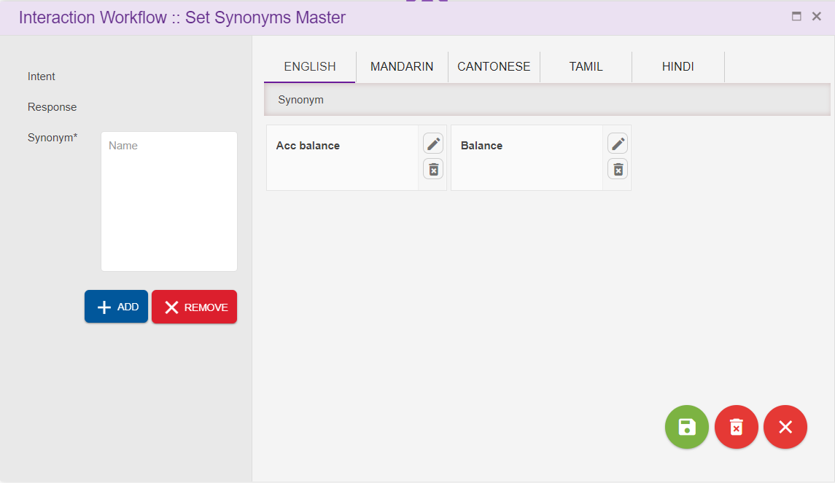

Session Master
This option will appear for the Maker, Checker and Previewer also. But only Maker can add the session variable. Checker and Previewer will be in read-only mode.
This option is used for updating commonly used session variables in global master. User can configure the operational variables here. Session variable added here will be available in Module designer too.
Upon clicking session master icon following page will be displayed.
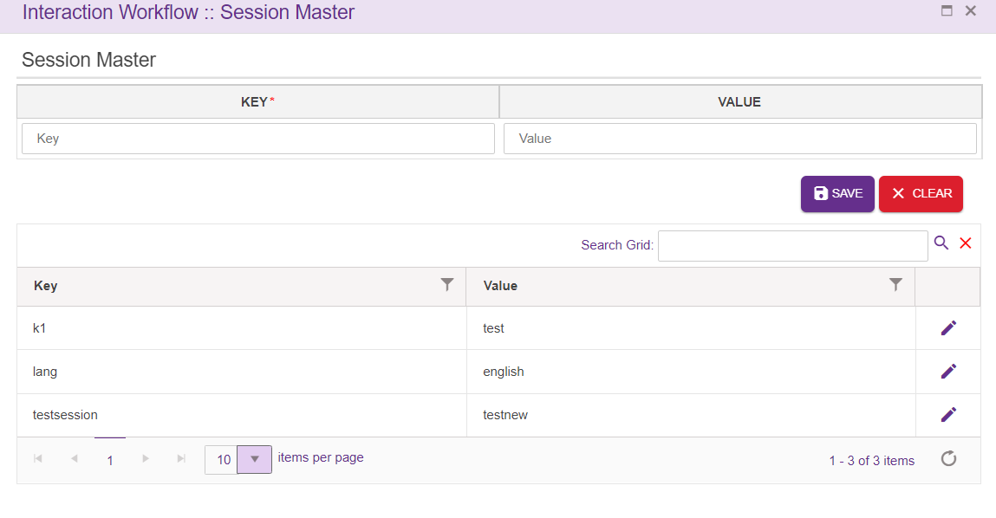
Search Grid will help to search keys or values from records.
KEY: It is a mandatory field. Can accept characters as well as digits
Value: Not mandatory. Can accept characters as well as digits
ADD: Upon clicking the button, new entry will be added to the grid.
Clear: This button is used to clear the field
Edit: User can edit the Value field, except keys

TMAC Widget Master
This option will appear for the Maker, Checker and Previewer also. But only Maker can add the Tmac widgets and templates here. Checker and Previewer will be in read-only mode. This option is used for updating tmac widgets which will be displayed in Agent dashboard.
Upon clicking session master icon following page will be displayed.
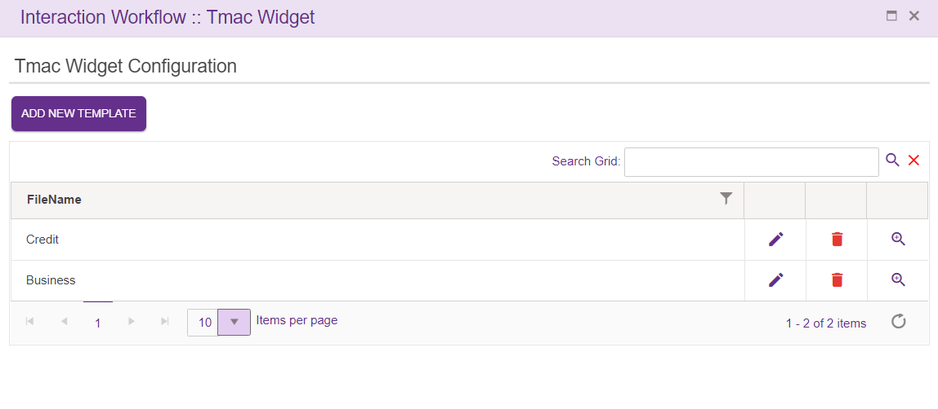
User can add the new template, edit existing one or delete template from the grid.
Upon clicking ‘ADD NEW TEMPLATE’ icon, following popup will generate, where user can select from list of key and widget configuration and save the template. Templates added here will display in Route node.
Search Grid will help to search FileName from records.

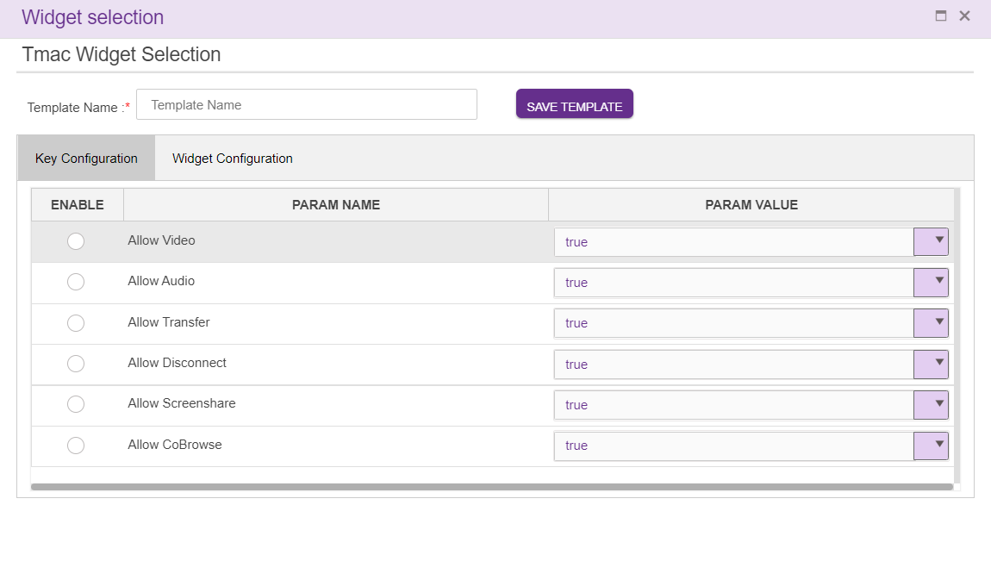

Checker
Interaction Workflow Checker has the privilege to preview/ approve / reject / schedule workflows.
Note: Checker cannot delete the callflows.
When a user login as a checker (without loading any callflow), following page will be displayed.
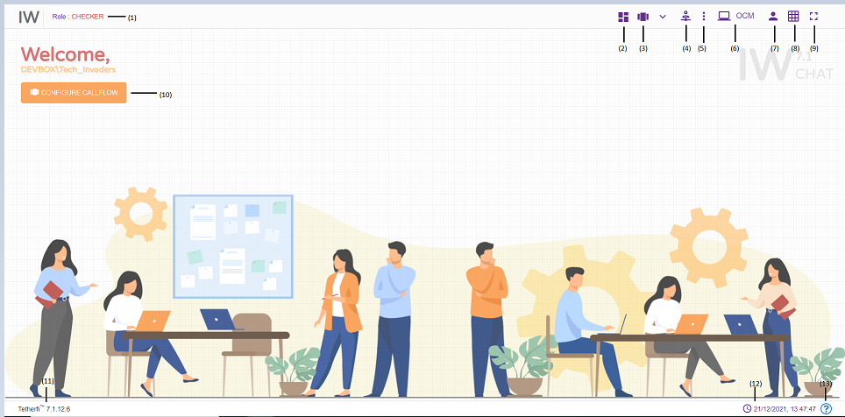
- Role: Displays the role of the user i.e. Maker
- Dashboard: chatflow dashboard. (ref section Dashboard )
- Configure Chatflow: This option is used to create a new flow/ Preview a flow/Order Take/Delete a chatflow. (ref section Configure Chatflow)
- More Menus: Upon clicking this button following options will appear.
- Import chatflow: (ref section Import Flow)
- Copy chatflow: refer section Copy Flow
- Master: Upon clicking this button following options will appear.
- Intents: refer section Intent Master
- Rules: refer section Rule Master
- Synonym Maser: refer section Synonym Master
- Session Master: refer section Session Master
- Tmac Widget Master: refer section TMAC Widget Master
- Chatflow Notifications: Notifications related to chatflow statuses
- Redirect to OCM: This option will redirect to OCM page.
- Current User Info: User’s domain name/ user name and for logging out of Interaction Workflow module.
- Grid: Grid can be enabled/disabled.
- Full Screen: This option is used to view the Interaction Workflow in full screen. (Press “Esc”/F11 button to go back to normal view)
- At the top left corner of the page, welcome message is displayed along with user’s domain name/user name. Configure chatflow option is also provided here.
- Current IW version
- System date and time will be displayed here.

When a user login as a checker and load a chatflow, following page will be displayed.

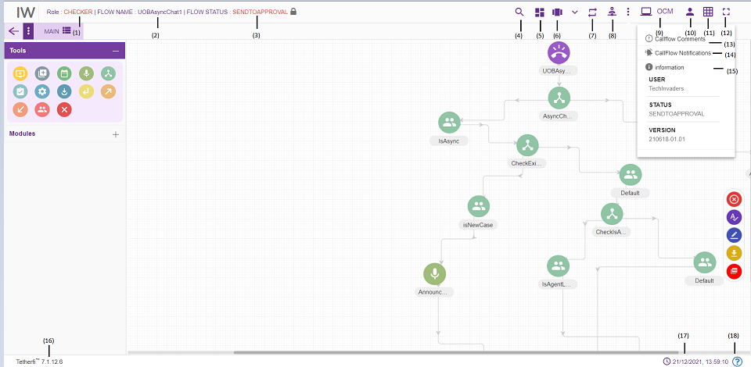
    - Role: Displays the role of the user i.e. Checker.
    - Flow Name: Flow name will be displayed here.
    - Flow Status: Current chatflow status will be displayed here.
    - Search for Nodes: refer section Search for nodes
    - Dashboard: This option will redirect to dashboard. refer section Dashboard
    - Configure chatflow: This option is used to Preview a flow. refer section Configure Callflow
    - Rules Viewer: refer section Rules Viewer
    - Master: Upon clicking this button following options will appear.
  - Intents: refer section Intent Master
  - Rules: refer section Rule Master
  - Synonym Maser: refer section Synonym Master
  - Session Master: refer section Session Master
  - Tmac Widget Master: refer section TMAC Widget Master
    - Comments: refer section Comments
    - Chatflow Notifications: This option is used to check all the notifications related to Interaction Workflow
    - Information: This option is used for information related to the user and Interaction Workflow version.
    - OCM: This option will redirect to OCM page
    - Current User Info: This option is used to know User’s domain name/ user name and for logging out of Interaction Workflow module.
    - Grid: Grid can be enabled/disabled.
    - Full Screen: This option is used to view the Interaction Workflow in full screen. (Press “Esc” button to go back to normal view)
    - Current IW version is displayed here.
    - Current system date and time will be displayed here.
There are modules and nodes available here. But checker cannot use them (Checker cannot modify any chatflow. He can either approve or reject a chatflow)

          - The Maker is notified about Checker’s verification activity.
          - The Nodes/Modules to be modified/rechecked are highlighted.
          - Once the changes are approved or rejected it will reflect in IW- Maker as “Approved” or “Rejected”
          - All the changes and modifications done in Interaction Workflow will be displayed in OCM’s Audit trail report.

Approve Now
Approve a chatflow immediately. Checker has to enter comment section before approving any chatflows and chatflow should be in SENTTOAPPROVAL or CEHCKERSAVED State before approving.
Upon approving, chatflow status will be changed to APPROVED.

Scheduled Later
A Checker can schedule a chatflow approval to a specific date time
When we select schedule later option tab, following popup is generated. Checker has to enter comments before scheduling a chatflow approval.
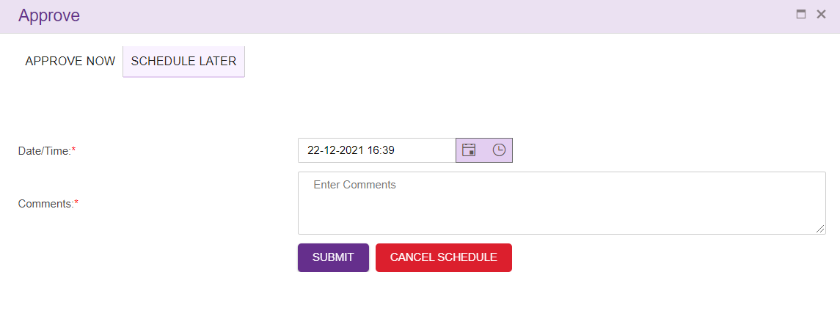
- Select scheduling date and time with comments
- Press ‘SUBMIT’ button.
- ‘CANCEL SCHEDULE’ button is used to cancel a scheduled chatflow. This button will be disabled once chatflow is added to schedule process.
Upon clicking ‘SUBMIT’ button, following confirmation popup will generate.
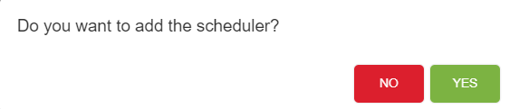
Note:
- Scheduled chatflow cannot be approved by the checker.
- Once the checker cancels the scheduler, status of the chatflow is changed to ‘CHECKERSAVED’ Once the chatflow status changed to CHECKERSAVED, the checker can approve that chatflow.
- Only checker who schedule the chatflow can cancel the scheduler.

Previewer
Interaction Workflow Previewer has the privilege to preview workflows.
Note: Previewer neither create the chatflow nor delete the chatflows and comments. When anonymous authentication is enabled for IW Chat UI application, user will be redirected to Previewer page. User must login to IW only through OCM when anonymous authentication is enabled.
When a user login as a previewer (without loading a chatflow), following page will be displayed.

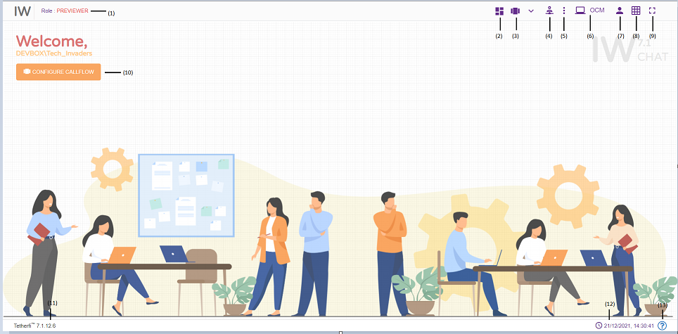
- Role: Displays the role of the user i.e. Previewer
- Dashboard: This option will redirect to dashboard. refer section Dashboard
- Configure chatflow: This option is used to Preview a flow. refer section Configure Flow
- Master: Upon clicking this button following options will appear.
- Intents: refer section Intent Master
- Rules: refer section Rule Master
- Synonym Maser: refer section Synonym Master
- Session Master: refer section Session Master
- Tmac Widget Master: refer section TMAC Widget Master
- Chatflow Notifications: This option is used to check all the notifications related to Interaction Workflow
- OCM: This option will redirect to OCM page.
- Current User Info: This option is used to know User’s domain name/ user name and for logging out of Interaction Workflow module.
- Grid: Grid can be enabled/disabled.
- Full Screen: This option is used to view the Interaction Workflow in full screen. (Press “Esc” button to go back to normal view)
- At the top left corner of the page, welcome message is displayed along with user’s domain name/user name. Configure chatflow option is also provided here.
- Current IW version is displayed here.
- System date and time will be displayed here.
- System file version.
When a user login as a Previewer and load a chatflow, following page will be displayed.

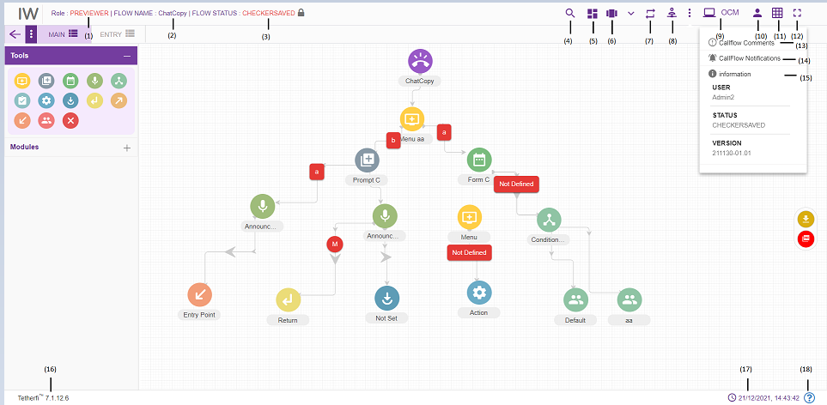
    - Role: Displays the role of the user i.e. Checker.
    - Flow Name: Flow name will be displayed here.
    - Flow Status: Current chatflow status will be displayed here.
    - Search for Nodes: refer section Search for nodes
    - Dashboard: This option will redirect to dashboard. refer section Dashboard
    - Configure chatflow: This option is used to Preview a flow. refer section Configure Callflow
    - Rules Viewer: refer section Rules Viewer
    - Phrases: refer section Phrases
    - Master: Upon clicking this button following options will appear.
  - Intents: refer section Intent Master
  - Rules: refer section Rule Master
  - Synonym Maser: refer section Synonym Master
  - Session Master: refer section Session Master
  - Tmac Widget Master: refer section TMAC Widget Master
    - Comments: refer section Comments
    - Chatflow Notifications: This option is used to check all the notifications related to Interaction Workflow
    - Information: This option is used for information related to the user and Interaction Workflow version.
    - OCM: This option will redirect to OCM page
    - Current User Info: This option is used to know User’s domain name/ user name and for logging out of Interaction Workflow module.
    - Grid: Grid can be enabled/disabled.
    - Full Screen: This option is used to view the Interaction Workflow in full screen. (Press “Esc” button to go back to normal view)
    - Current IW version is displayed here.
    - Current system date and time will be displayed here.
There are modules and nodes available here. But previewer cannot use them (Previewer cannot modify any chatflow. He can just preview the chatflow)
When user login as Previewer and load the dashboard, following page will be displayed.’ Chatflow Build/Package’ and delete option won’t be appear for Previewer in dashboard.
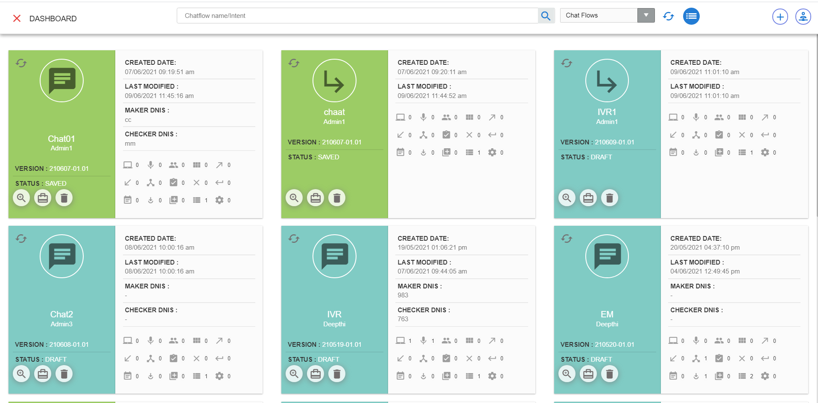

Maker and Checker
Interaction Workflow Maker-Checker has the privilege to create / view / edit /approve/schedule/delete workflows.
Note: Owner of the chatflow can only delete the chatflows. Owner of the chatflow cannot approve his chatflow even though he is a checker. Once the user rejects a chatflow, he cannot edit that same chatflow. But once the user approves a chatflow, he can edit that same chatflow.
User who has both the roles i.e. maker-checker, can edit any chatflow other than the chatflows rejected by him.
When a user has both the roles i.e maker and checker, user role will be shown as MAKER, CHECKER. This will be configurable, and we can even set visible false in Configuration.
User cannot do any changes with the chatflow with the status ‘Checkersaved’, when chatflow status is Checkersaved by some other user.
When user login as a maker-checker (without loading any chatflow), following page will be displayed.
- Role: Displays the role of the user i.e. Maker-Checker
- Dashboard: Chatflow dashboard. (ref section Dashboard )
- Configure Chatflow: This option is used to create a new flow/ Preview a flow/Order Take/Delete a chatflow. (ref section Configure Chatflow)
- More Menus: Upon clicking this button following options will appear.
- Import chatflow: (ref section Import Chatflow)
- Copy chatflow: refer section Copy Chatflow
- Master: Upon clicking this button following options will appear.
- Global Configuration: refer section Global Configuration
- Intents: refer section Intent Master
- Rules: refer section Rule Master
- Global Phrases: refer section Global Phrases
- Hot Keys: refer section Hot Keys
- Synonym Maser: refer section Synonym Master
- Session Master: refer section Session Master
- Tmac Widget Master: refer section TMAC Widget Master
- Contingency Audio Master: refer section Contingency Audio Master
- Chatflow Notifications: Notifications related to Chatflow statuses
- Redirect to OCM: This option will redirect to OCM page.
- Current User Info: User’s domain name/ user name and for logging out of Interaction Workflow module.
- Grid: Grid can be enabled/disabled.
- Full Screen: This option is used to view the Interaction Workflow in full screen. (Press “Esc”/F11 button to go back to normal view)
- At the top left corner of the page, welcome message is displayed along with user’s domain name/user name. Configure chatflow option is also provided here.
- Current IW version
- System date and time will be displayed here.

When user login as a maker-checker and load a callflow, following page will be displayed.
- Role: Displays role of the user i.e. Maker
- Flow Name: Name of the flow will be displayed here
- Flow Status: Current chatflow flow status will be displayed here
- Search for Nodes: refer section Search for nodes
- Dashboard: chatflow dashboard. (ref section Dashboard )
- Configure Chatflow: This option is used to create a new flow/ Preview a flow/Order Take/Delete a chatflow. refer section Configure Chatflow
- More Menus: Upon clicking this button following options will appear.
- Chatflow version control: refer section Chatflow Version Control
- Import chatflow: ref section Import Chatflow)
- Copy chatflow: refer section Copy Chatflow
- Rules Viewer: refer section Rules Viewer
- Master: Upon clicking this button following options will appear.
- Intents: refer section Intent Master
- Rules: refer section Rule Master
- Synonym Maser: refer section Synonym Master
- Session Master: refer section Session Master
- Tmac Widget Master: refer section TMAC Widget Master
- Redirect to OCM: This option will redirect to OCM page.
- Current User Info: This option is used to know User’s domain name/ user name and for logging out of Interaction Workflow module.
- Grid: Grid can be enabled/disabled.
- Full Screen: This option is used to view the Interaction Workflow in full screen. (Press “Esc”/F11 button to go back to normal view)
- Callflow Comments: refer section Comments
- Callflow Notifications: This option is used to check all the notifications related to Interaction Workflow.
- Information: This option is used for information related to the user and Interaction Workflow version.
- Current IW version is displayed here.
- Current system date and time will be displayed here.
- System file version will be displayed here
There are modules and nodes available here. Maker can make use of these nodes/module as per requirement.

Creating/Editing Workflows

Configure Chatflow
Configure chatflow option is provided for Maker, Checker and Previewer. This option will be displayed at the bottom right corner of the page in IW Chat landing page as well as right next to dashboard icon.
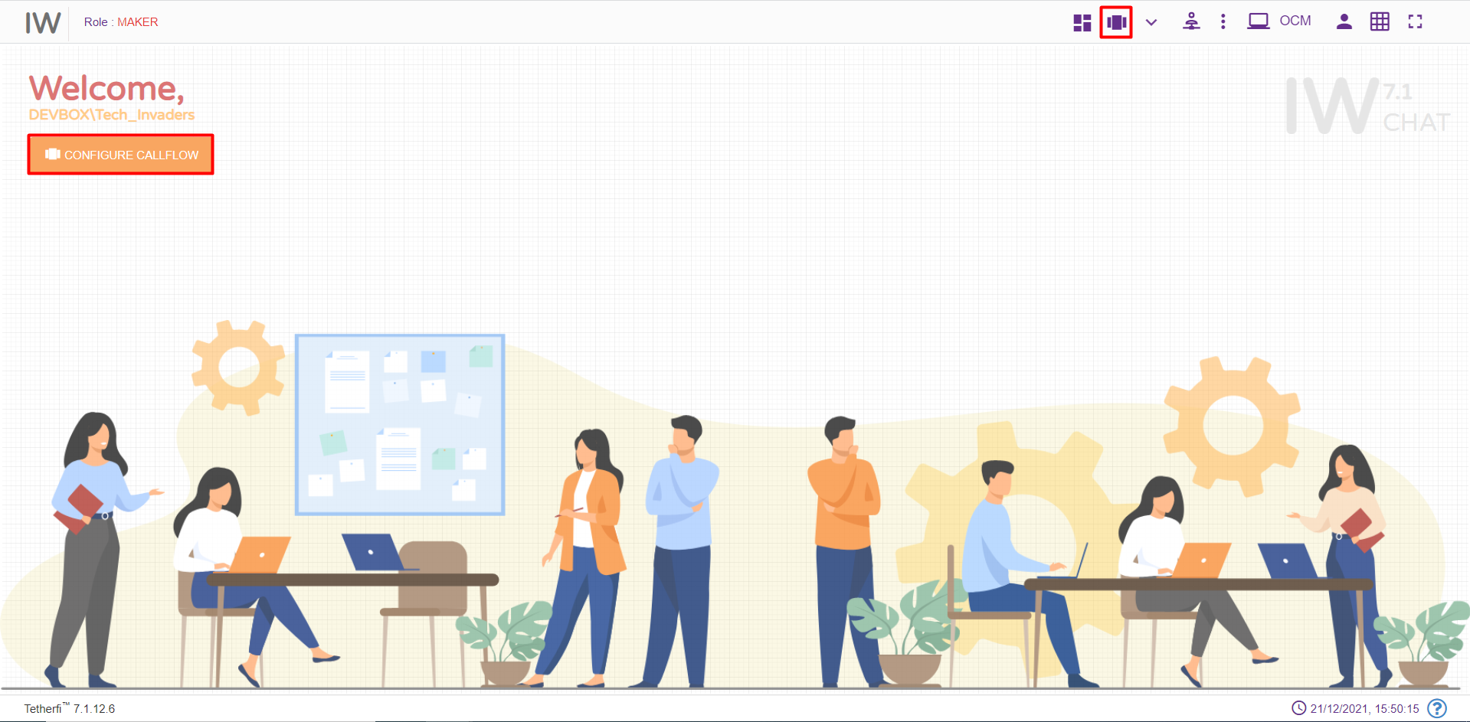

Upon clicking ‘Configure Callflow’ button in maker page and maker-checker page, below window will popup.

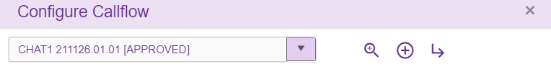
In maker page upon clicking on ‘Configure chatflow’ button following options will appear.
- Chatflow List: refer section Chatflow List
- Preview: refer section Preview
- New IW Flow: refer section New IW Flow
- Delete Flow: refer section Delete
Upon clicking ‘Configure Chatflow’ button in checker/Previewer page, below window will popup.
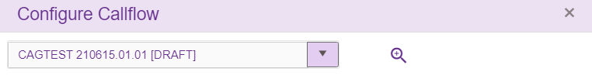
In checker and previewer page, upon clicking on ‘Configure callflow’ button following options will appear.
- Chatflow List: refer section Chatflow List
- Preview: refer section Preview

Chatflow List
This list consists of all the chatflows created using Tetherfi Interaction Workflow Chat UI, which is also displayed in dashboard.
On click of the dropdown button, the below screen will be displayed.
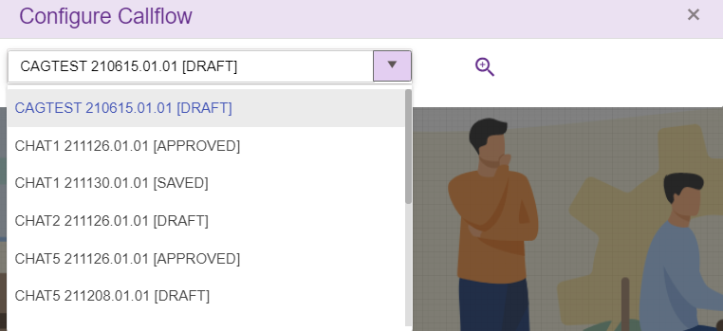

Preview
Select the chatflow from chatflow list dropdown and click preview icon/button to load callfow data
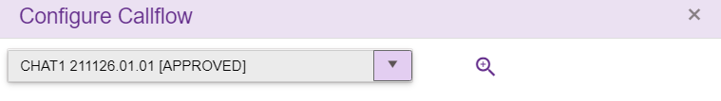
When user try to load a new chatflow on top of existing active chatflow, save confirmation popup will be generating as shown below.
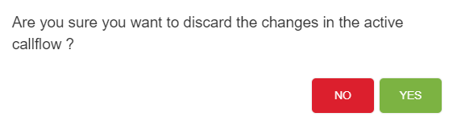
If Yes, Changes done in the active chatflow will be discarded and new chatflow selected here will be loaded
If No, User can continue with the existing active chatflow

New IW Flow
This option is only provided for ‘Maker’. On click of the “₊” button, the below screen will be displayed:
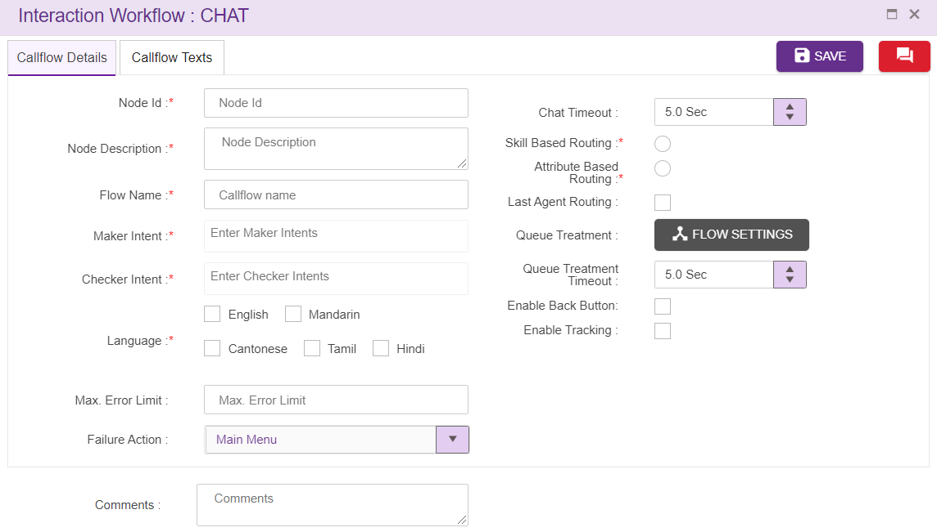
- Node ID: Users have the privilege to assign their own ID.
- Flow Name: Name of the Flow should be unique and will not accept any special characters, spaces or digits
- Maker and Checker Intents: The Intents should be unique. Type the Maker/ Checker intents and click “Enter” button to apply the intents and/or type “,” (comma) to add another intent. Maker and Checker intents cannot be same.
- Greeting: Text added here will be displayed to the user as a greeting text. (refer section Text Selection window)
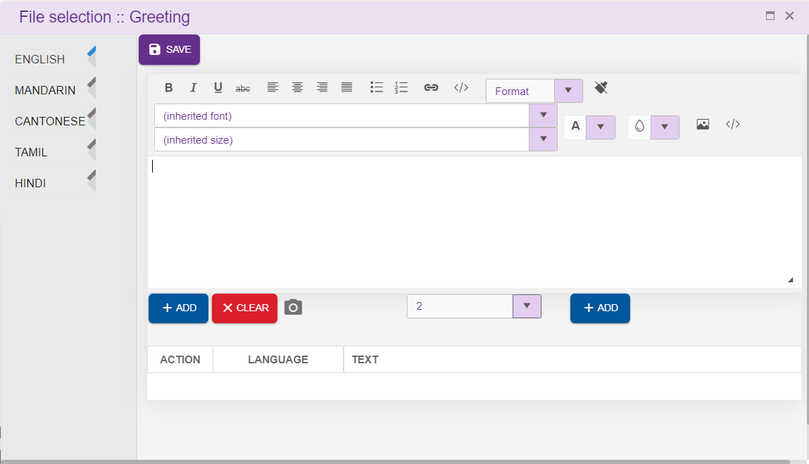
Text to be displayed to the user is written in the space provided as shown above. Click on ‘ADD’ button, to add the text in Action column.
Click on ‘SAVE’ button, to save the text.
- Language: The Language selection in Call flow configuration segment will be auto configured depending upon the languages selected in the MAIN NODE details segment.
- Comment: Providing a comment before saving is not mandatory.
- Max Error Limit: Maximum attempts allowed in a DTMF in menu
- Failure Action: This field is to specify the action to be taken after exceeded Error Limit DTMF value. It can be transferred to ‘main menu’ or disconnect the chat.
- Option Settings: we can set different DTMF options for main menu, previous menu and repeat here.
- Interval Timeout: This specifies the elapse time to enter user input. This field accepts decimal values too.
- Invalid Text 1 and 2: Allows the flow designer to add the texts and these texts are displayed when there is invalid input from user. The text to be displayed on invalid prompt event. The Language section in Call flow configuration segment is auto configured depending upon the languages selected in the MAIN NODE details segment. (refer section Text Selection Window). Texts added here will be copied to newly added menu and PNC node.
- No Input Prompt 1 and 2: Allows the flow designer to add the texts and these texts are displayed when there is no input from user. The text to be displayed on no input prompt event. The Language section in Call flow configuration segment is auto configured depending upon the languages selected in the MAIN NODE details segment. (refer section Text Selection Window). Texts added here will be copied to newly added menu and PNC node.
- Max Tries: Allows the flow designer to add the texts and these texts are displayed when user exceeds maximum try limits. The text to be displayed when max tries exceeded. The Language section in Call flow configuration segment is auto configured depending upon the languages selected in the MAIN NODE details segment. (refer section Text Selection Window), Texts added here will be copied to newly added menu and PNC node.
- Agent Transfer Text: Allows the flow designer to add the texts and these texts are displayed when before chat transfer to an Agent. The text to be displayed before call transfer to an Agent. The Language section in Call flow configuration segment is auto configured depending upon the languages selected in the MAIN NODE details segment. (refer section Text Selection Window). Texts added here will be copied to newly added menu and PNC node.
- Header: refer section Header
- Footer. refer section Footer
- Enable Tracking: When this option is checked, this node is tracked in session dashboard.

Sub Flow
Sub Flow icon is used to create new sub flow which can be used by main call flows and other sub flows. User can create the commonly used modules in a separate flow and can call from main flow. There is no dnis node in this subflow.
On clicking this subflow icon, empty page should open as shown below.
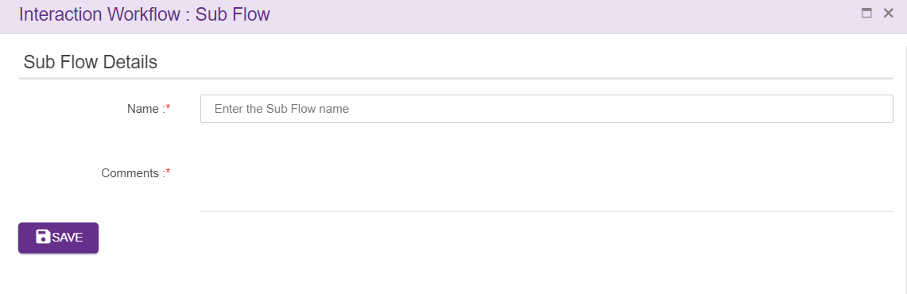
Name: Name of the Sub Flow can be added here. Sub flow name must be unique and should not accept any special characters

Comments: After entering all the details as mentioned above click on save button. Upon clicking on save button, empty page will be displayed as shown below, where user can create the chatflow by dragging the nodes present in toolbox.
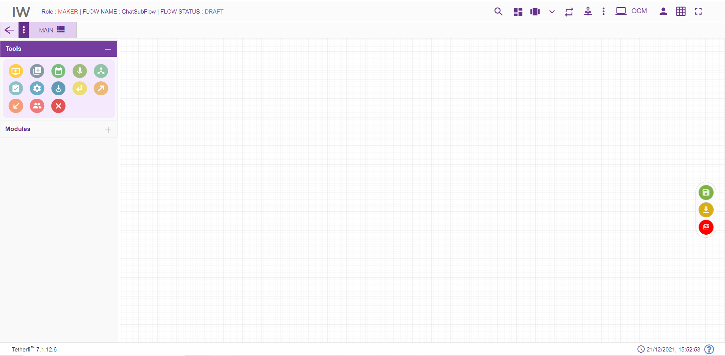
User can create the sub flow here by dragging and dropping available nodes from toolbox. The nodes used in the subflow has override configuration option which will override the calling flow configuration in subflow.
To jump to the sub flow, flow connector node must be used. To jump back to the main flow (where subflow is being called) from sub flow, return node can be used Multiple main chatflows can be connected to single subflow and all the feature as that of main flow is provided to subflow

Delete
Delete option will appear only when chatflow is in DRAFT and SAVED status. Selected chatflow from the drop down in ‘Chatflow List’ in Maker page.
Note that only owner of the chatflow can delete his chatflow in DRAFT and SAVED status.

Text Selection Window
Upon clicking ‘ENTER TEXT’ button in any node, text selection grid will be displayed.
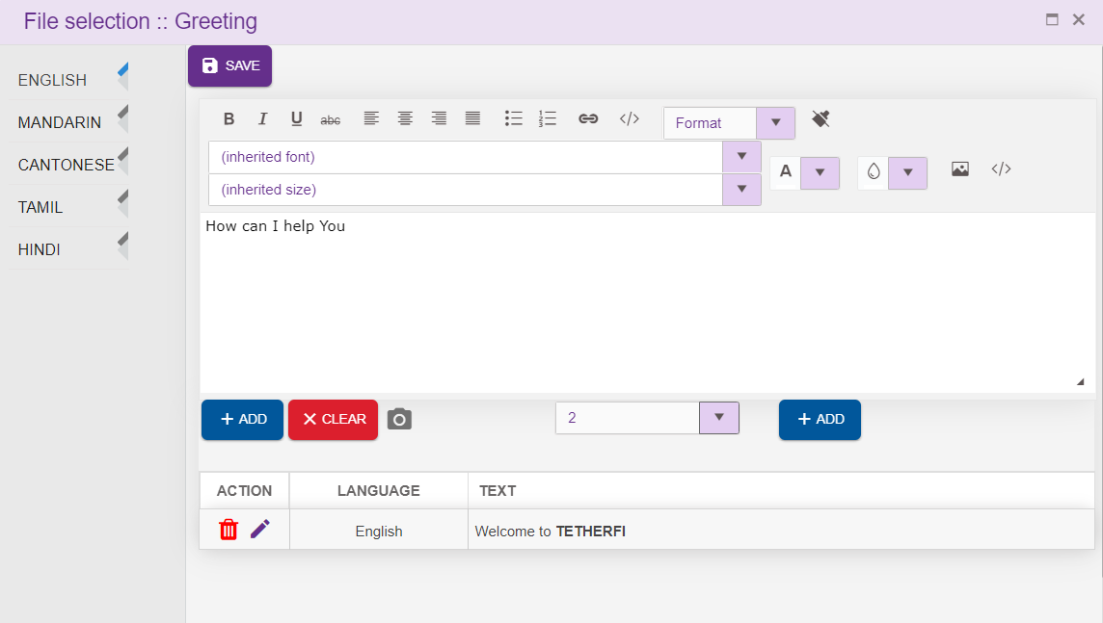
User can write the texts in the space provided as shown above. click on the “ADD” icon to add the text in the grid. Click on ‘SAVE’ button to save the text in the grid.
User can edit or delete the text added by clicking edit/delete button.
Texts added in Greeting field will be displayed when the control comes to the node for the first time.
Texts added to the Invalid Text 1 will be displayed when user enters invalid input for the first time. Text added to the Invalid Text 2 will be displayed when user enters invalid input for the second time. Text added to the No Input Text 1 will be displayed when user does not enter any value for the first time. If user does not enter any value after displaying No Input Text 1, Text added to No Input Text 2 will be displayed.
Text added to Max Tries will be displayed when user exceeds maximum try limits, which is set in ‘Error Limit DTMF’ field in MAIN NODE node. Text added to Agent Transfer Announcement field will be displayed when chat transfer to an Agent.
Time limit to collect the input from the user is set in interval timeout field.
Text added to the node need not be unique. User can add same text again to the node.

Header
Header option is provided in dnis node which will be inherited to menu, PNC, Agent, Form and Announcement node. In menu, PNC, Agent, Form and Announcement node, this option will appear in UI only after enabling the checkbox.
In Dnis node, Header footer option appears like below.
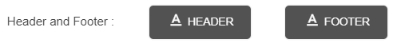
In menu, PNC, Agent, Form and Announcement node, Header footer option appears like below.
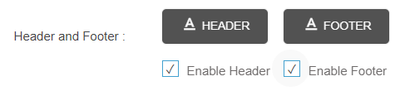
Upon clicking Header option, following popup will generate
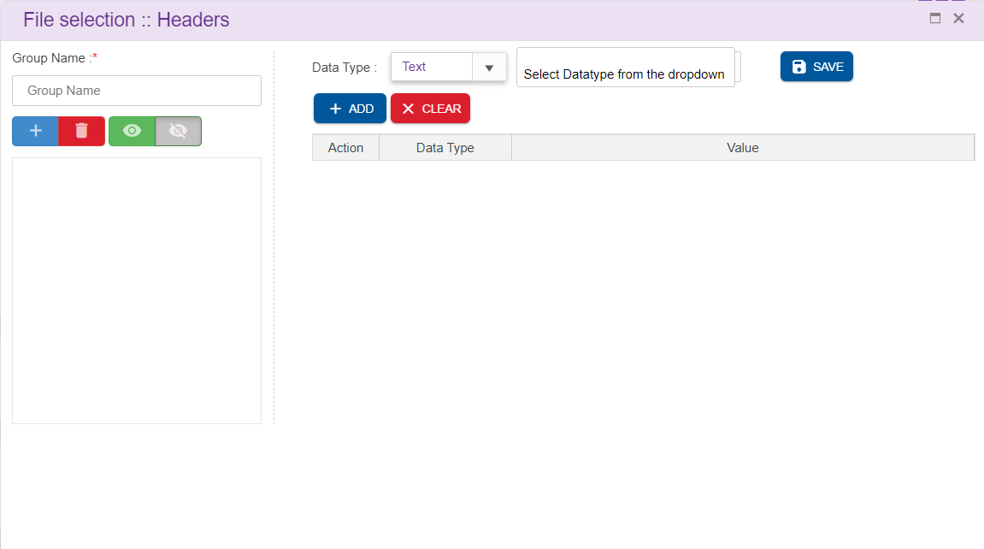
Group Name: This is the mandatory field and each group name should be unique. This option is used to group the multiple headers as one.
There are 4 options, specific to each group
- Add New Group: This option allows user to add new group name
- Delete Group: This option allows user to delete a group. Note that items added to the group must be removed first before deleting the group. ‘Unable to delete the group. Please remove all the items associated with the selected group error toaster is displayed.
- Enable: This option is used to enable the groups. By default, all the newly added groups will be enabled
- Disable: This option is used to disable the groups. Only enabled groups will be in effect as headers
There are 4 datatypes available
- Text: Texts can be added here
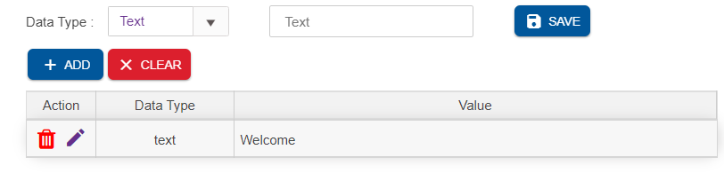
- HTML: html contents can be added as headers by selecting this datatype
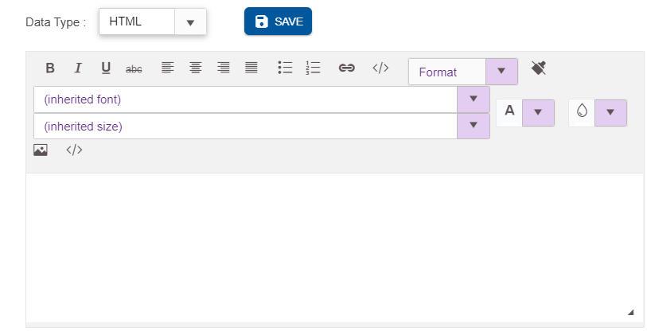
- Session: session variables can be added in the header. This will list the session and operational variables used in the chatflow
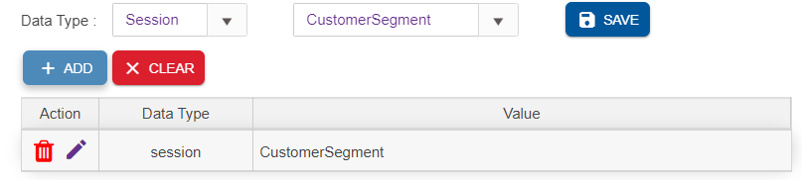
- New Line: This is used to insert a new line in the header
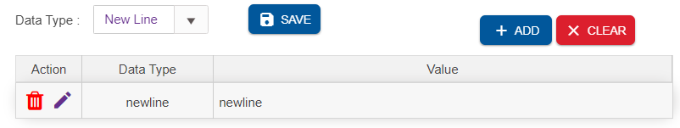
Delete: This option is used to remove the record from each group. Upon clicking ‘Delete’ button, following delete confirmation popup is generated
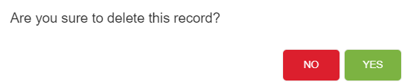
Save: User need to click ‘Save’ button, in order to save the entries

Footer
Footer option is provided in dnis node which will be inherited to menu, PNC, Agent, Form and Announcement node
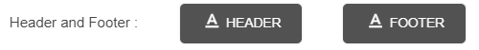
Upon clicking Footer option, following popup will generate
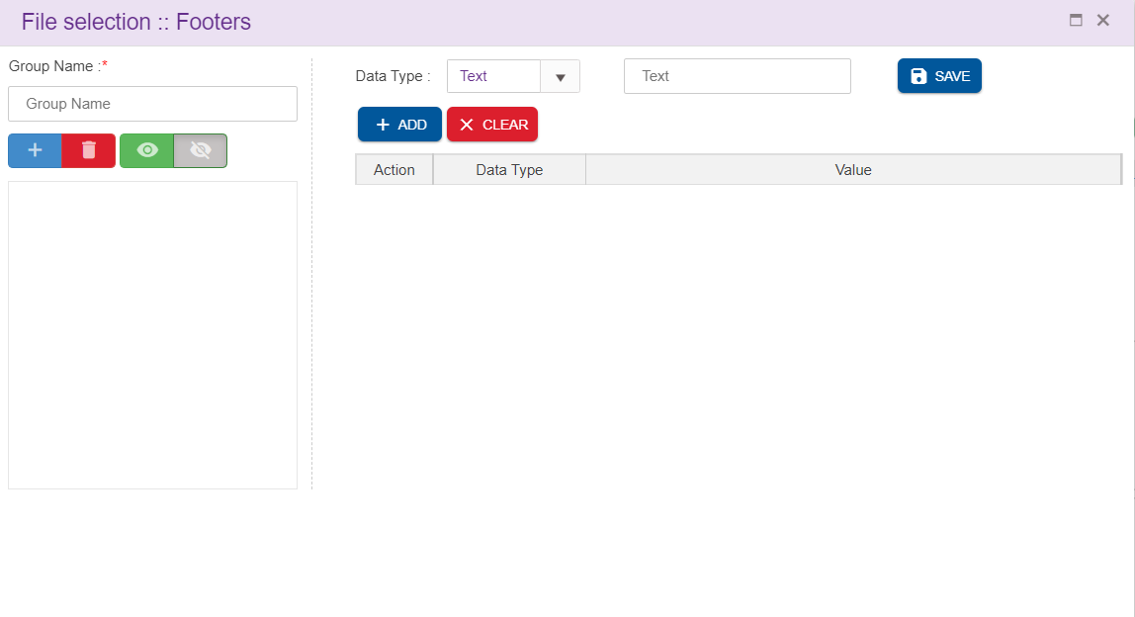
Group Name: This is the mandatory field and each group name should be unique. This option is used to group the multiple headers as one.
There are 4 options, specific to each group
- Add New Group: This option allows user to add new group name
- Delete Group: This option allows user to delete a group. Note that items added to the group must be removed first before deleting the group. ‘Unable to delete the group. Please remove all the items associated with the selected group error toaster is displayed.
- Enable: This option is used to enable the groups. By default, all the newly added groups will be enabled
- Disable: This option is used to disable the groups. Only enabled groups will be in effect as headers
There are 4 datatypes available
- Text: Texts can be added here
- HTML: html contents can be added as headers by selecting this datatype
- Session: session variables can be added in the header. This will list the session and operational variables used in the chatflow
- New Line: This is used to insert a new line in the header
Delete: This option is used to remove the record from each group. Upon clicking ‘Delete’ button, following delete confirmation popup is generated
Save: User need to click ‘Save’ button, in order to save the entries

Branding Icon
Branding Icon option is provided in dnis node.
In Dnis node, Branding Icon option appears like below.
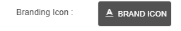
Upon clicking Branding icon option, following popup will generate
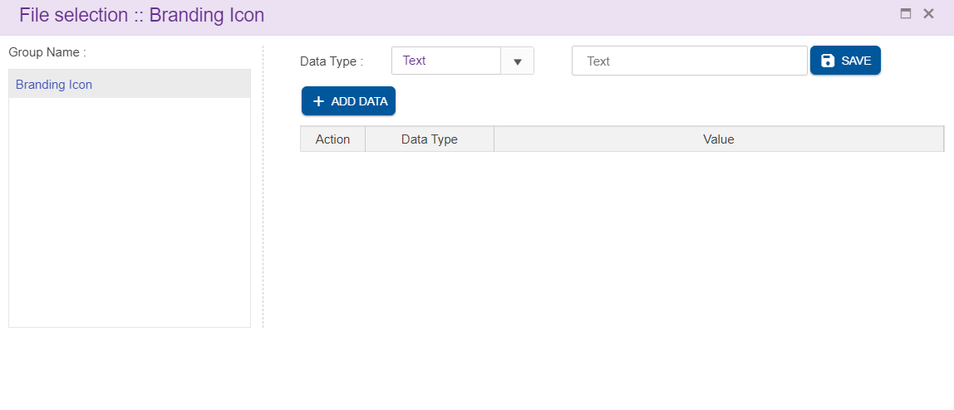
There are 4 datatypes available
- Text: Texts can be added here
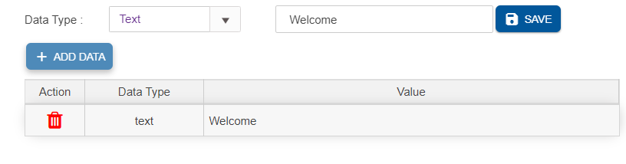
- HTML: html contents can be added as headers by selecting this datatype
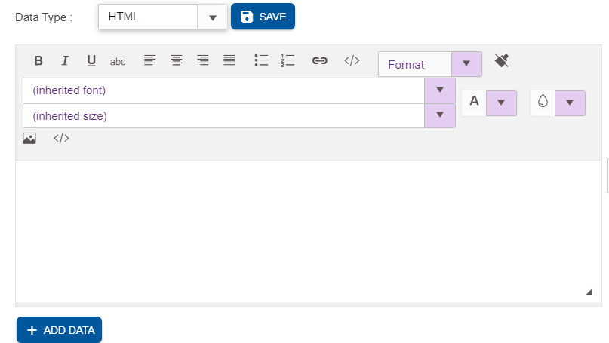
- Session: session variables can be added in the header. This will list the session and operational variables used in the chatflow
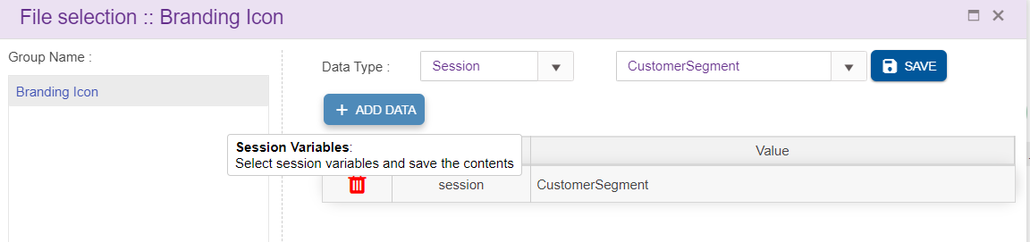
- New Line: This is used to insert a new line in the header
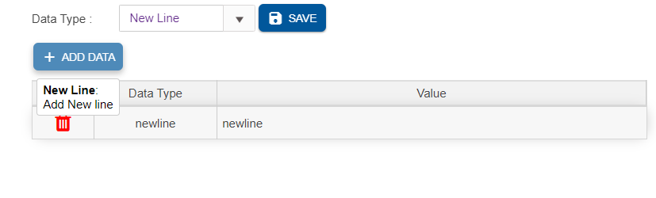
Delete: This option is used to remove the record from each group. Upon clicking ‘Delete’ button, following delete confirmation popup is generated
Save: User need to click ‘Save’ button, in order to save the entries

Designing the Workflow
After successfully saving the MAIN NODE Details, you can create/ edit the workflow depending on your requirement. 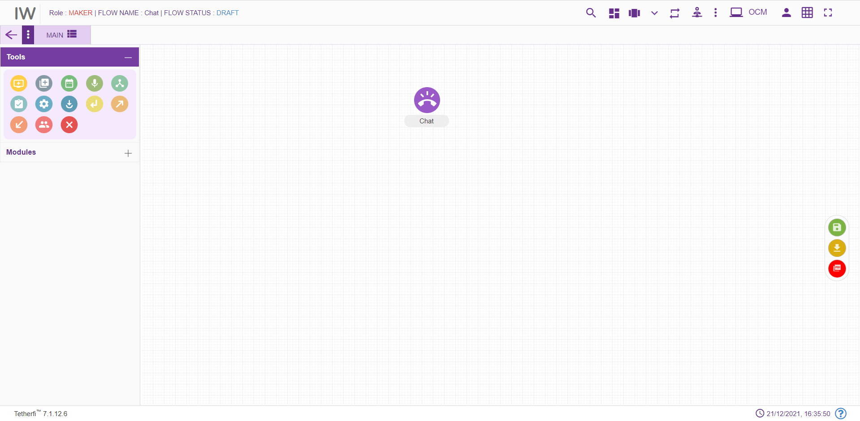

Tabs
The new Workflow will have the TAB functionalities. It would help to break the bigger call flows into multiple tabs. User can add the tabs only when the chatflow is in ‘Draft’ status.
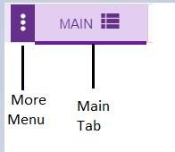
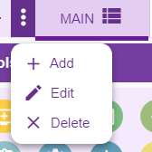

The above shown toolbar has the following functionalities:
- Main button can be used for navigating back to the Main tab.
- Add new tab button can be used when there is a need to create a new section of workflow by adding a new tab.
- Edit tab button can be used for making changes to the selected tab of workflow
- Remove tab button can be used for deleting the selected tab of workflow
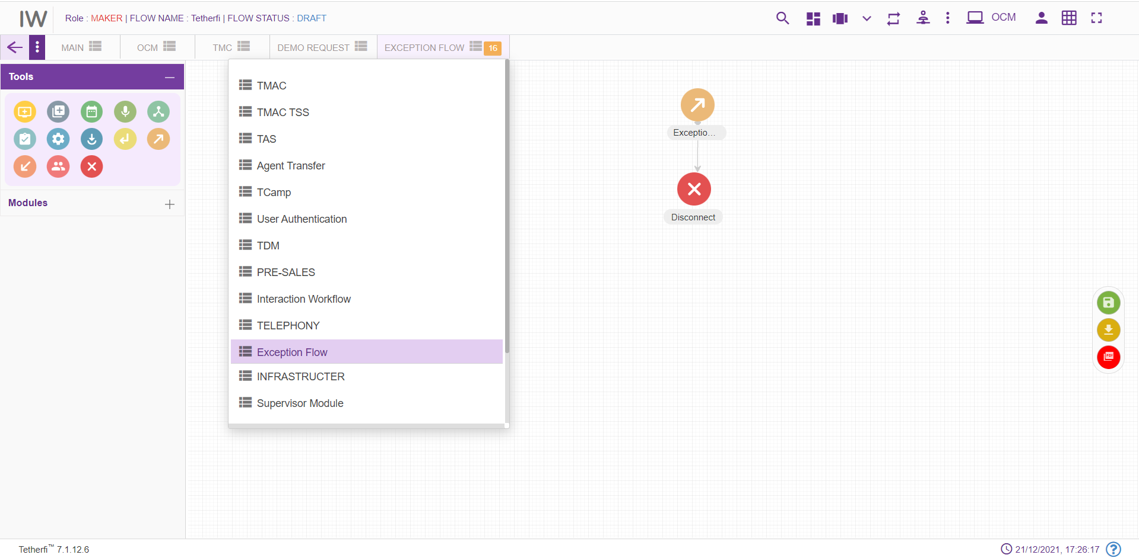 When a tab is selected from the dropdown, its name will be displayed at the top as shown above and configured number of Tabs are set in horizontal and all other tabs should be displayed in drop down list.

Add New Tab
This button is shown when the chatflow is in ‘Draft’ status. When clicked on ‘Add new Tab’ button Tab pop window is generated
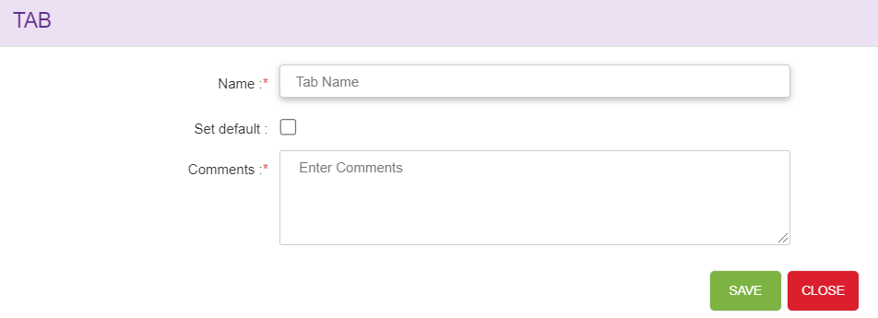
    - Name: Name of Tabs should be unique.
    - Set default: Checkbox is used to set the Tab as default Tab, whenever user views the callflow default tab is shown, only one tab can be set as default. ‘MAIN’ tab will be set as default for the first time. When a new tab is set as default, previous tab set option will be cleared i.e. latest entry will be updated.
    - Comments: User can set add suitable comments regarding to the Tab.
Save: Upon clicking ‘Save’ button, Tab entries must be saved.
Close: Upon clicking ‘Close’ button, Tab pop window must be closed.
When new tab is added to the chatflow, newly created tab should be open by-default upon clicking ‘Yes’ as shown below.
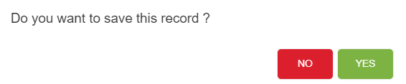

Edit Tab
Upon clicking the ‘Edit selected tab’ button to make changes to the selected tab, Tab pop window is open.
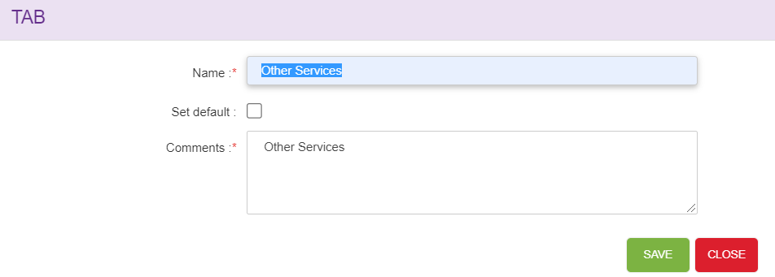
- Name: Edit the new tab name.
- Set default: Checkbox is used to set the Tab as default Tab, whenever user views the callflow default tab is shown. ‘MAIN’ tab will be set as default for the first time. When a new tab is set as default, previous tab set option will be cleared i.e. latest entry will be updated.
- Comments: User can set edit the suitable comments regarding to the Tab.
Save: Upon clicking ‘Save’ button, Tab entries must be saved.
Close: Upon clicking ‘Close’ button, Tab pop window must be closed.

Delete/Remove Tab
Upon clicking on ‘Remove Selected tab’ confirmation pop window must generate.
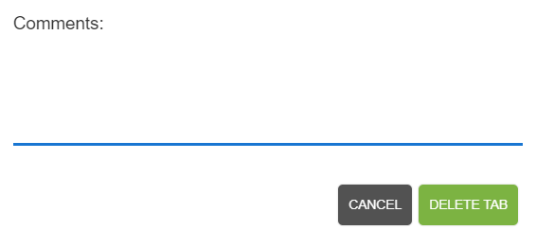
Delete Tab button: Upon clicking ‘Delete Tab’, tab will be successfully deleted.
Cancel button: Upon clicking ‘Cancel’, delete tab window will closed.
Default tabs cannot be deleted. Error message will be shown when try to delete default tab.

Copy Tab
Tab contents can be copied from one chatflow to another chatflow or other tabs within same chatflow using Ctrl +C and Ctrl+V options (other than IE browsers).
Upon copying the tab contents using Ctrl+C option, confirmation popup will generate. Note that user can copy the tab contents of a chatflow at any chatflow status.
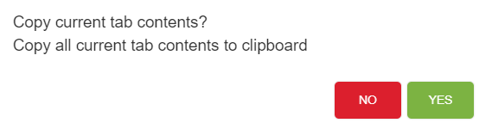
Upon successfully copying tab contents, success message will generate.
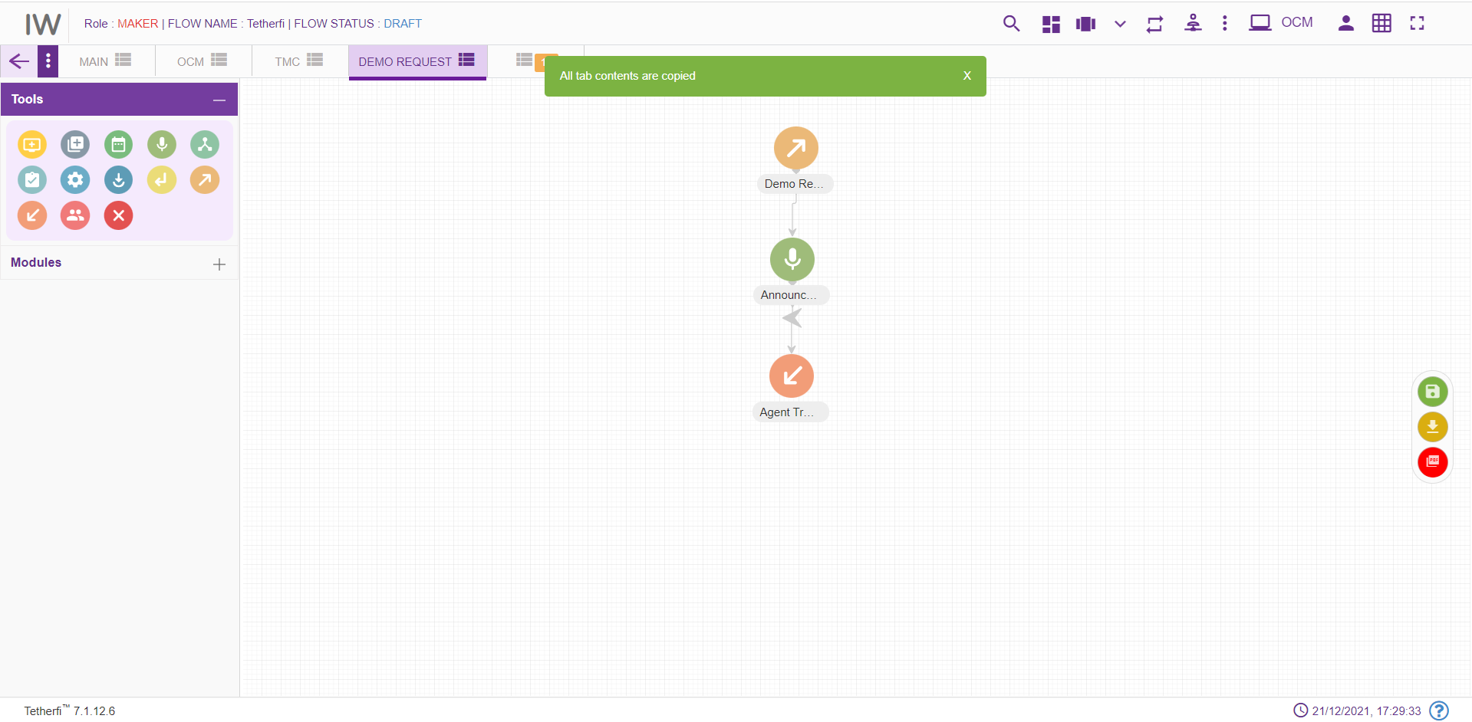
Ctrl+V option is used to paste the tab contents copied. Upon pasting the tab contents using Ctrl+V option, following confirmation popup will generate.
Upon clicking “Yes”, copied contents will be pasted to the respected tabs.
Note that user can paste the tab contents only in DRAFT chatflow status. Copy tab feature not only copies the structure but also copies texts, rules and other related information set for each node.
User cannot copy-paste the tab which has MAIN NODE node. Upon pasting the tab contents which has MAIN NODE node, ‘Main node node already exists in this callflow. cannot copy-paste data’ error message will generate.
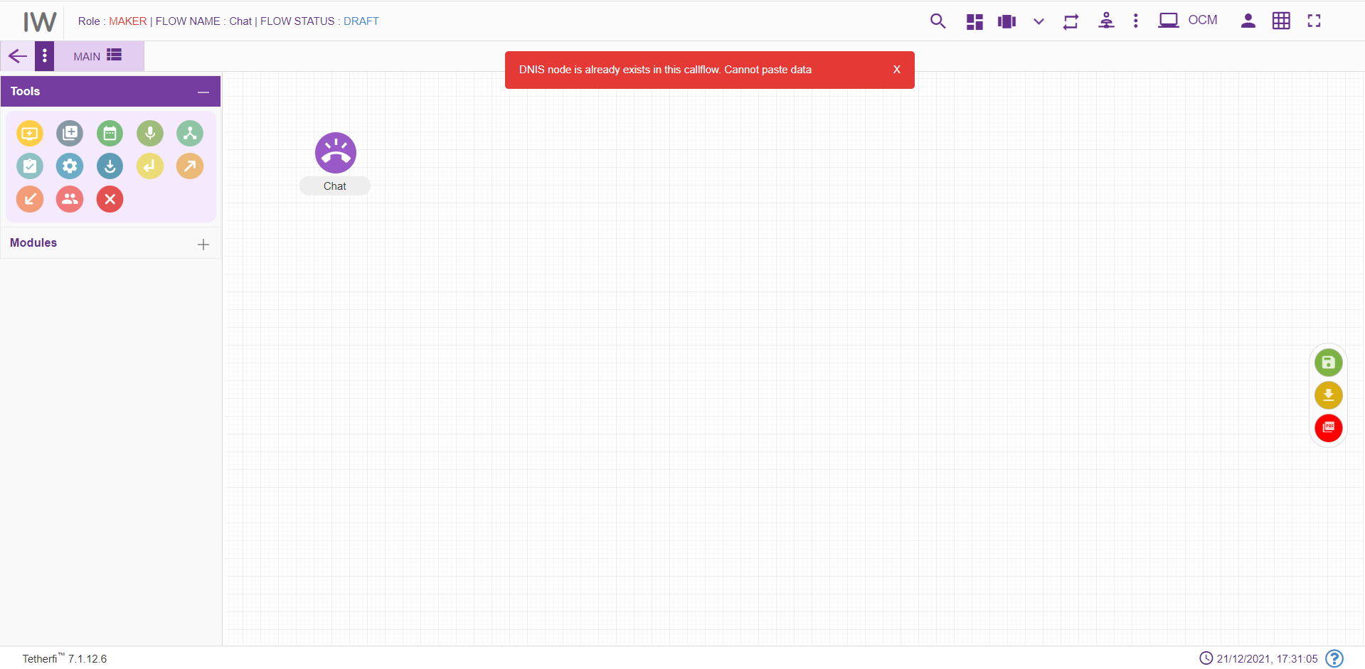

Tab Shuffling
User can move/shuffle the tabs present in the chatflow. User can shuffle only the tabs present in drop down as shown below.
The new tab added after shuffling the tabs present in the drop down, will be added at the beginning of the drop down as shown above.

More Menu Option
Upon clicking more menu option, present at top right and left corner at different status of the chatflow, following options will appear. refer section Flow Status:
When user loads his own chatflow:
User Permission |  | Callflow Status | More Menu(left) | More Menu(right)
Maker | Draft |  | 1.Callflow Version Control  2.Import Chatflow  3.Copy Chatflow | Save chatflow
Maker | Saved |  | 1.Import Chatflow  2.Copy Chatflow | 1.Send to approval  2.Edit chatflow
Maker | Send to Approval |  | 1.Import Chatflow  2.Copy Chatflow | No options appeared
Maker | Checker Draft |  | 1.Import Chatflow  2.Copy Chatflow | No options appeared
Maker | Checker Saved |  | 1.Import Chatflow  2.Copy Chatflow | No options appeared
Maker | Approved |  | 1.Import Chatflow  2.Copy Chatflow | Edit chatflow
Maker | Scheduled |  | 1.Import Chatflow  2.Copy Chatflow | No options appeared
Maker | Rejected |  | 1.Import Chatflow  2.Copy Chatflow | Edit chatflow
Checker | Send to Approval |  |  | 1.Reject  2.Approve  3.Edit
Checker | Checker Draft |  |  | Save chatflow
Checker | Checker Saved |  |  | 1.Reject chatflow  2.Approve chatflow  3.Edit chatflow
Checker | Approved |  |  | No options
Checker | Rejected |  |  | No options
Checker | Scheduled |  |  | Approve chatflow
Previewer | Draft |  |  | No options
Previewer | Saved |  |  | No options
Previewer | Send to Approval |  |  | No options
Previewer | Checker Draft |  |  | No options
Previewer | Checker Saved |  |  | No options
Previewer | Approved |  |  | No options
Previewer | Rejected |  |  | No options
Previewer | Scheduled |  |  | No options

When user loads some other user’s callflow:
User Permission | Callflow Status | More Menu(left) | More Menu(right)
Maker | Draft | 1.Import Chatflow  2.Copy Chatflow | Save chatflow
Maker | Saved | 1.Import Chatflow  2.Copy Chatflow | 1.Send to approval  2.Edit chatflow
Maker | Send to Approval | 1.Import Chatflow  2.Copy Chatflow | No options
Maker | Checker Draft | 1.Import Chatflow  2.Copy Chatflow | No options
Maker | Checker Saved | 1.Import Chatflow  2.Copy Chatflow | No options
Maker | Approved | 1.Import Chatflow  2.Copy Chatflow | Edit chatflow
Maker | Scheduled | 1.Import Chatflow  2.Copy Chatflow | No options
Maker | Rejected | 1.Import Chatflow  2.Copy Chatflow | Edit chatflow
Checker | Send to Approval |  | 1.Reject  2.Approve  3.Edit
Checker | Checker Draft |  | Save chatflow
Checker | Checker Saved |  | 1.Reject chatflow  2.Approve chatflow  3.Edit chatflow
Checker | Approved |  | No options
Checker | Rejected |  | No options
Checker | Scheduled |  | Approve chatflow

When user with Maker-Checker role loads his own chatflow:

User Permission |  | Callflow Status |  | More Menu(left) |  | More Menu(right)
Maker-Checker | Draft |  | 1.Callflow version control  2.Import Chatflow  3.Copy Chatflow  4.Text to Voice |  | Save chatflow
Maker-Checker | Saved |  | 1.Import Chatflow  2.Copy Chatflow  3.Text to Voice |  | 1.Send to approval  2.Edit chatflow
Maker-Checker | Send to Approval |  | 1.Import Chatflow  2.Copy Chatflow  3.Text to Voice |  | 1.Reject  2.Approve  3.Edit
Maker-Checker | Checker Draft |  | 1.Import Chatflow  2.Copy Chatflow  3.Text to Voice |  | Save
Maker-Checker | Checker Saved |  | 1.Import Chatflow  2.Copy Chatflow  3.Text to Voice |  | 1.Reject  2.Approve  3.Edit
Maker-Checker | Approved |  | 1.Import Chatflow  2.Copy Chatflow  3.Text to Voice |  | Edit chatflow
Maker-Checker | Scheduled |  | 1.Import Chatflow  2.Copy Chatflow  3.Text to Voice |  | Approved
Maker-Checker | Rejected |  | 1.Import Chatflow  2.Copy Chatflow  3.Text to Voice |  | Edit chatflow

When user with Maker-Checker role loads some other User’s callflow:

User Permission |  | Callflow Status |  | More Menu(left) |  | More Menu(right)
Maker-Checker | Draft |  | 1.Import Chatflow  2.Copy Chatflow  3.Text to Voice |  | Save chatflow
Maker-Checker | Saved |  | 1.Import Chatflow  2.Copy Chatflow  3.Text to Voice |  | 1.Send to approval  2.Edit chatflow
Maker-Checker | Send to Approval |  | 1.Import Chatflow  2.Copy Chatflow  3.Text to Voice |  | 1.Reject  2.Approve  3.Edit
Maker-Checker | Checker Draft |  | 1.Import Chatflow  2.Copy Chatflow  3.Text to Voice |  | Save
Maker-Checker | Checker Saved |  | 1.Import Chatflow  2.Copy Chatflow  3.Text to Voice |  | 1.Reject  2.Approve  3.Edit
Maker-Checker | Approved |  | 1.Import Chatflow  2.Copy Chatflow  3.Text to Voice |  | Edit chatflow
Maker-Checker | Scheduled |  | 1.Import Chatflow  2.Copy Chatflow  3.Text to Voice |  | Approved
Maker-Checker | Rejected |  | 1.Import Chatflow  2.Copy Chatflow  3.Text to Voice |  | Edit chatflow

Set Rules
User can set the rules in Conditional, Announcement, menu node leg, PNC node leg. ‘Set Rule’ icon will be displayed in these nodes to set the rules as shown below.
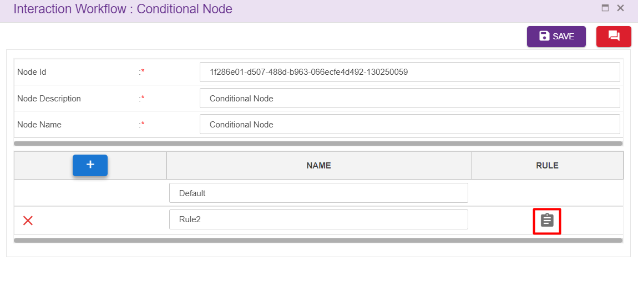
Upon clicking set rules icon following window will popup.
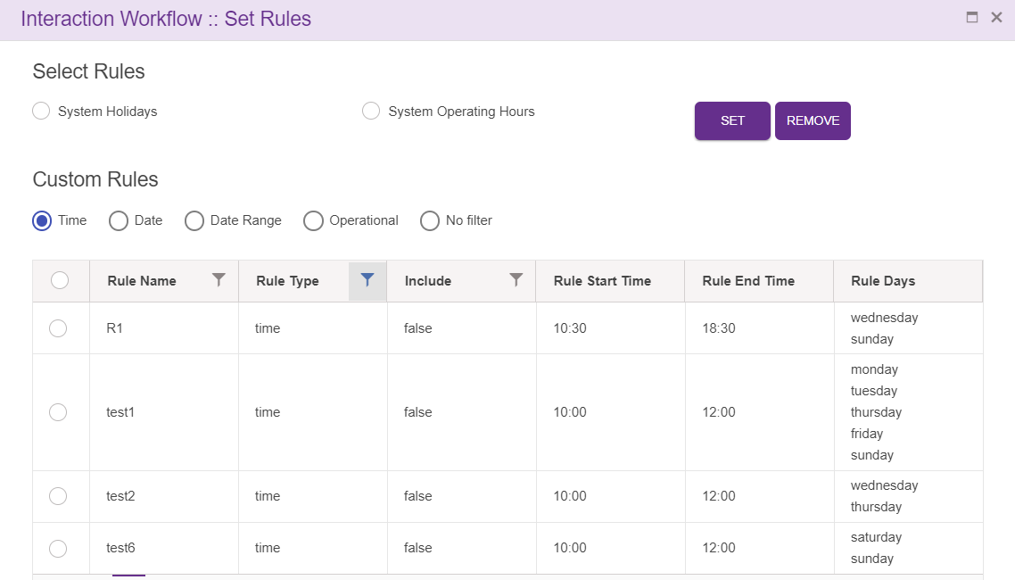
Rules added at ‘Rule Master’ will be displayed here. User can set these rules for the nodes.
Upon clicking ‘SET’ after selecting the rules, following confirmation popup will generate.
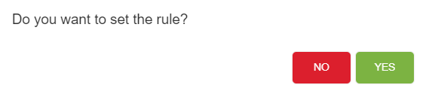
Upon clicking ‘YES’, rule will be successfully set to the nodes.
User can set the rules for the nodes which are connected to menu and PNC node as shown below. Upon hovering on menu/PNC node, name of the nodes connected to them will be displayed along with the options set rules.
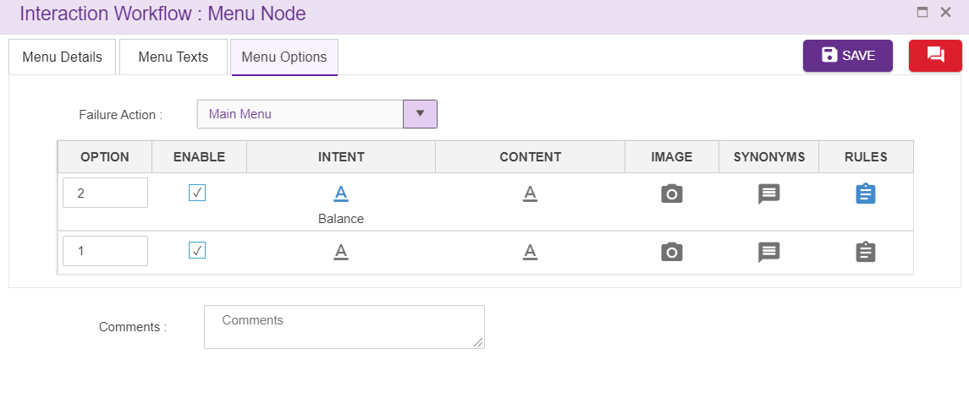

Chatflow Sync Notification
While saving a chatflow, adding/editing intents, adding/editing rules if the interpreter is down, data will not be saved in interpreter. At those situation ‘chatflow sync notification’ icon will appear in UI as shown below.
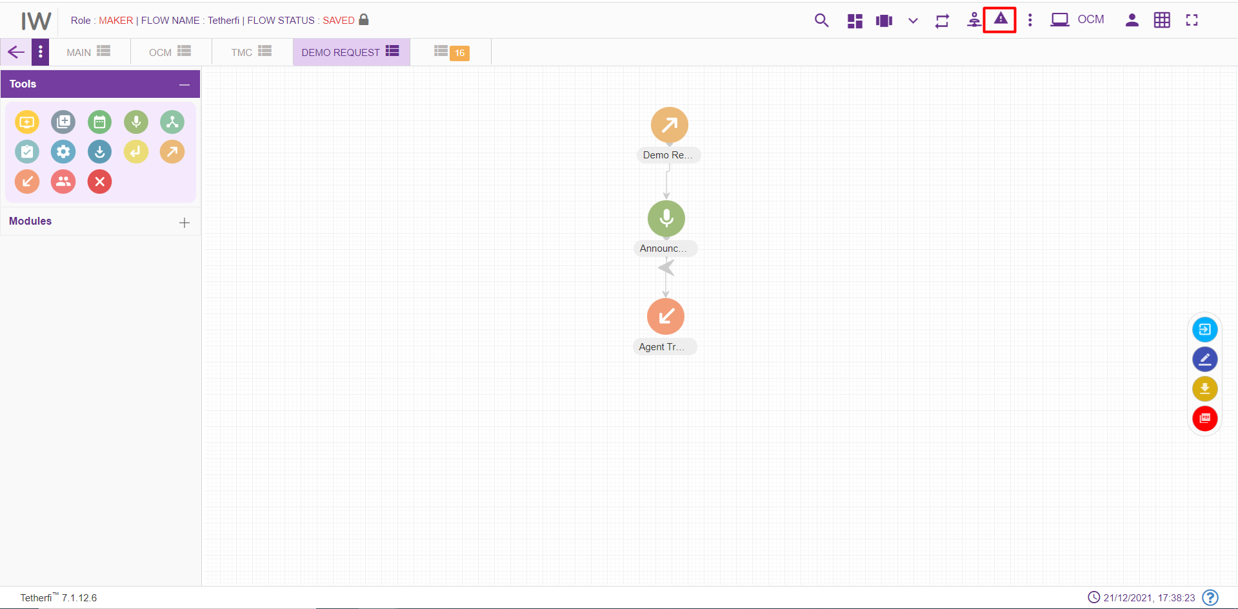
In this situation user can upload the files to interpreter once it is up, by clicking ‘Resubmit’ button. ’Clear’ option is also provided here to remove the notification.
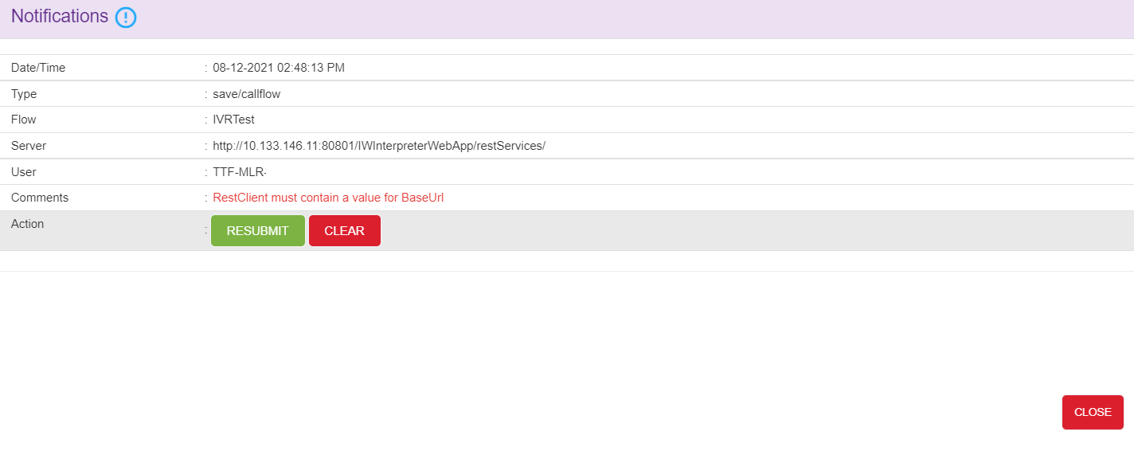
Sync notification icon also displayed in landing page if the interpreter was down while updating intent master and rule master. User can resubmit the data to interpreter from landing page too. Chatflow specific resubmit sync notification will appear only after loading the chatflow in UI.
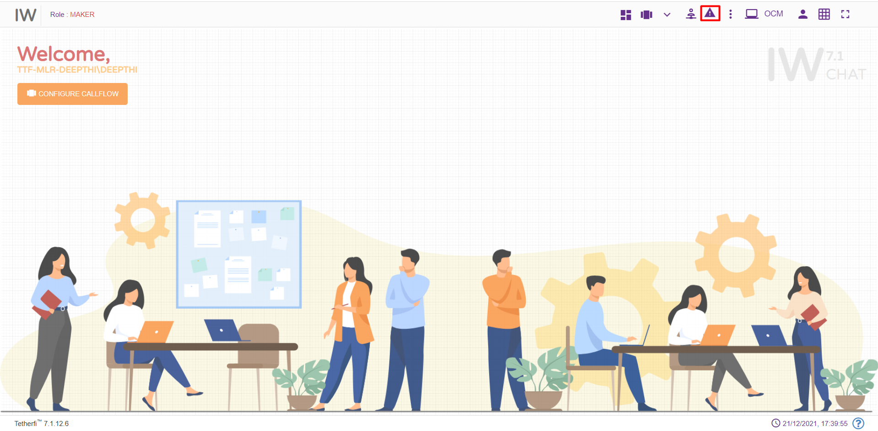

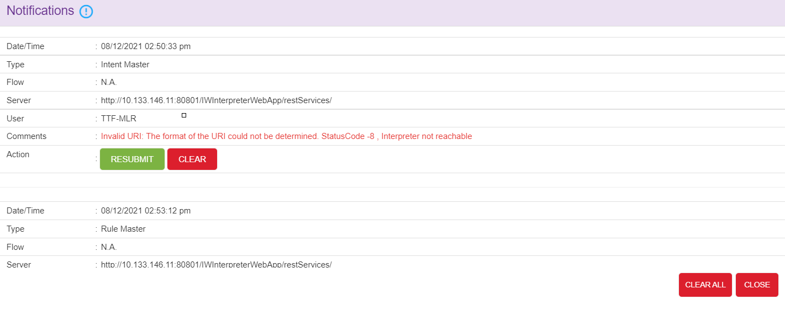
Following error message will be generating if the synonyms are not saved in interpreter successfully. ‘CLEAR ALL’ option is provided to remove all the notification.

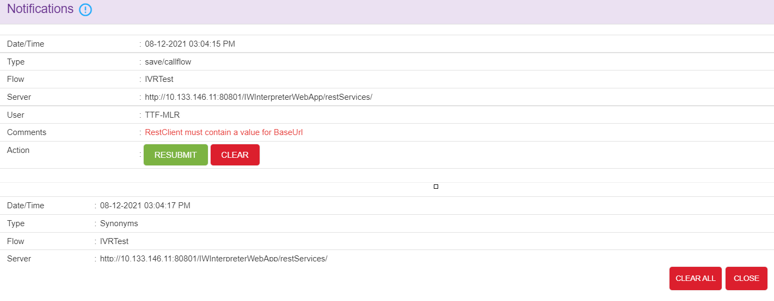
Note: This option will appear in UI, only when interpreter is down.

Nodes and Modules

Nodes
Nodes are often arranged into tree structures. These structures are binary trees.
A node represents the information contained in a single structure. These nodes may contain a value or condition, or possibly serve as another independent data structure. There are nine types of nodes in Interaction Workflow:
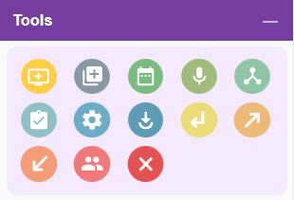

Menu Node
For adding a new Menu to the chatflow, click on the “Menu” icon and drag it to the main screen.
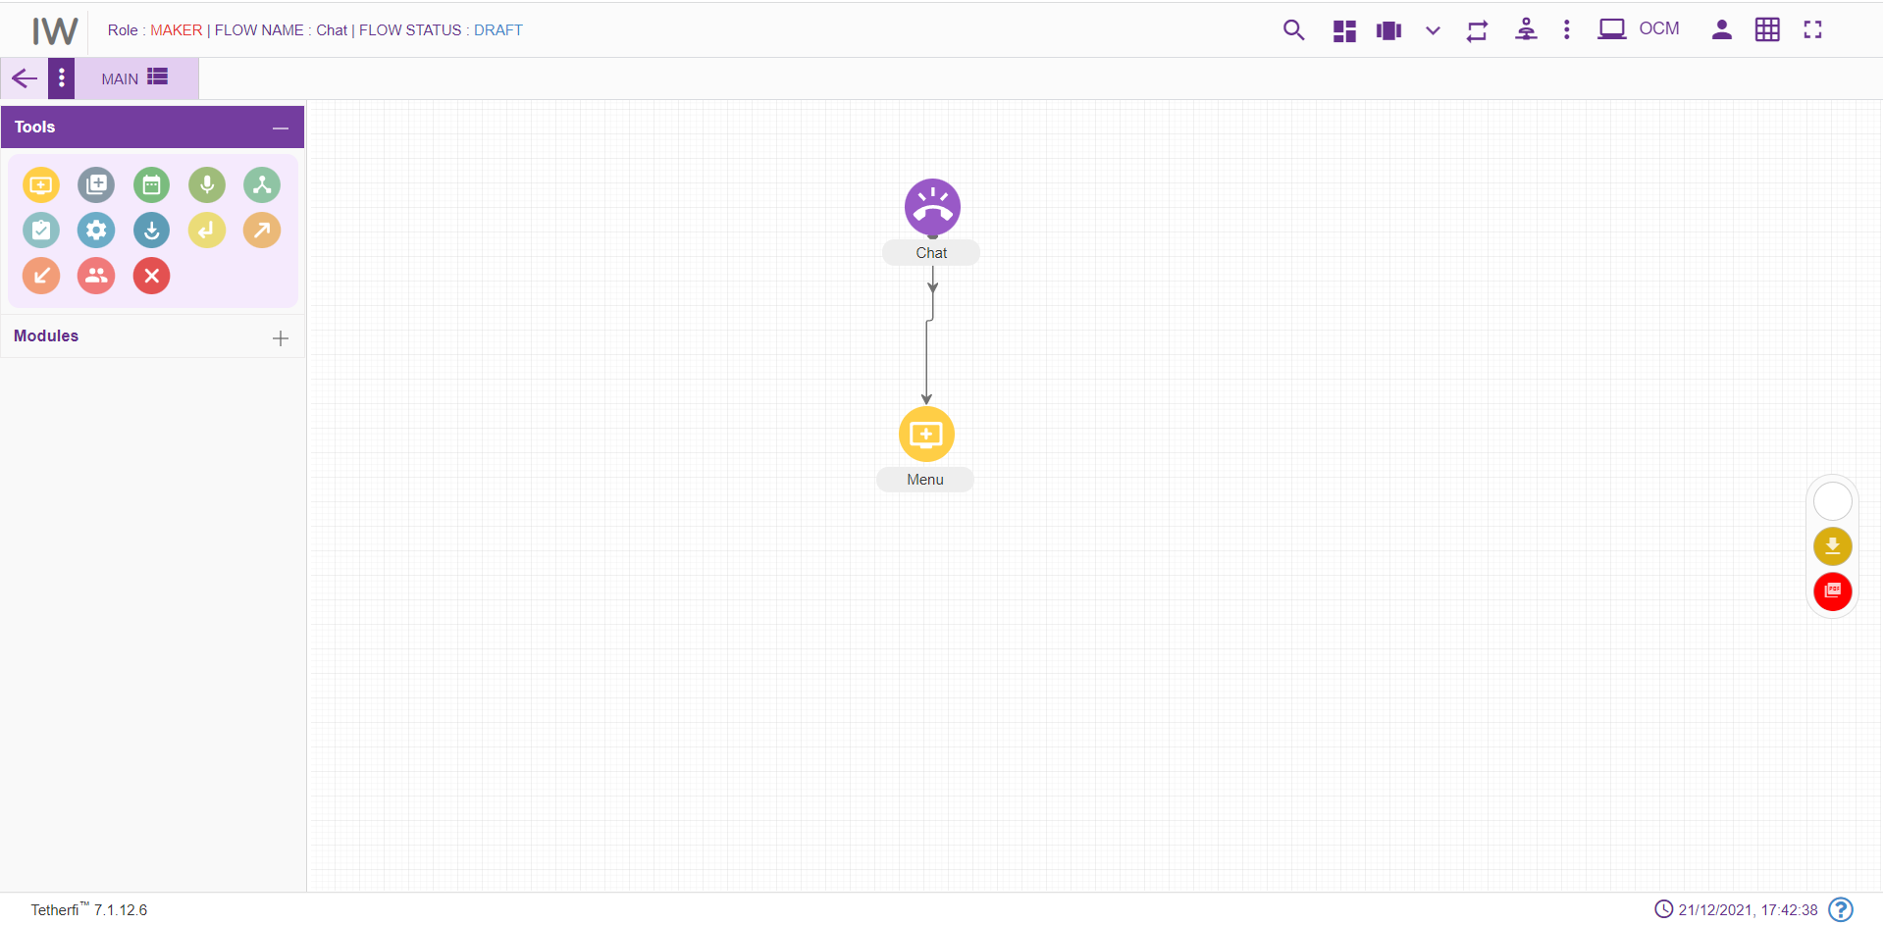For editing/ configuring the Menu, hover over the Menu icon you added and edit/ delete functionalities for the menu will be displayed.
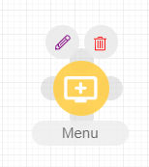
On click of edit button, the below screen will pop up and node will be popped till node window is open.

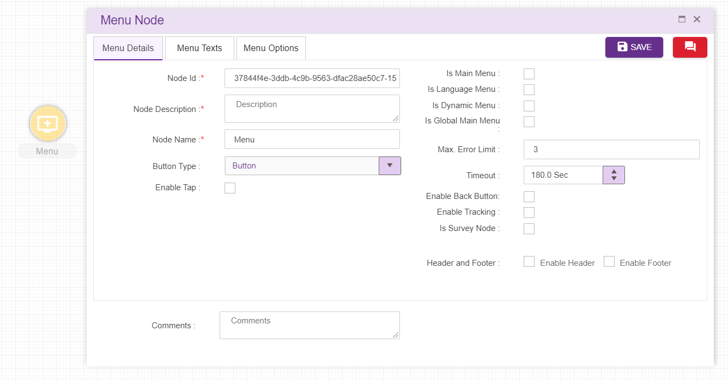
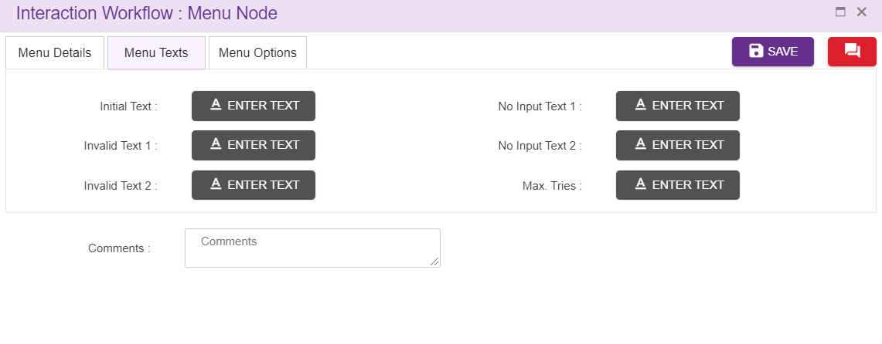
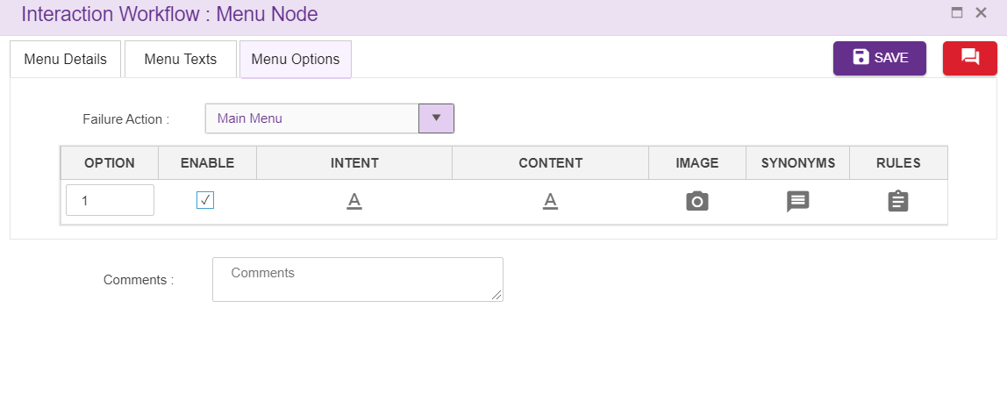

  - Node ID: By default, the node ID for a Menu is autogenerated, but the Users have the privilege to assign their own Menu ID. Each node ID should be unique. (Mandatory)
  - Name: By default, the Menu Name is Menu, but the Users have the privilege to assign their own Menu Name. Each Menu Name should be unique. This Menu Name will only be displayed in the Interaction workflow’s UI (Mandatory)
  - Description: Brief characterization of the Menu. (Mandatory)
  - Button Type: User can select the button type from the dropdown provided
  - Is Main Menu: Checked indicates that suggestion is global. A single chatflow may have multiple global Menus.
  - Is Language Menu: Whether the Menu is the language Menu of the chatflow. This option present only for IW flow and only 1 node can be set as a language menu in a chatflow.
  - Is Global Main Menu: Whether the Menu is the Global main menu of the chatflow. This option is present for both IW flow as well as subflow flow and only 1 node can be set as a Global Main menu in a chatflow.
  - Is Dynamic Menu: Upon setting a menu as dynamic menu, Texts added to the options can be dynamically altered/shuffled.
  - Initial Text: Text added here will be displayed to the user as an initial text. (refer section Text Selection window)
  - Invalid Text 1 and 2: Allows the flow designer to add the texts and these texts are displayed when there is invalid input from user. The text to be displayed on invalid prompt event. The Language section in Call flow configuration segment is auto configured depending upon the languages selected in the Main node. (refer section Text Selection Window). For the new menu node, these texts are copied from Main node.
  - No Input text 1 and 2: Allows the flow designer to add the texts and these texts are displayed when there is no input from user. The text to be displayed on no input prompt event. The Language section in Call flow configuration segment is auto configured depending upon the languages selected in the Main node. (refer section Text Selection Window). For the new menu node, these texts are copied from Main node.
  - Max Tries: Allows the flow designer to add the texts and these texts are displayed when user exceeds maximum try limits. The text to be displayed when max tries exceeded. The Language section in Call flow configuration segment is auto configured depending upon the languages selected in the Main node. (refer section Text Selection Window). For the new menu node, these texts are copied from Main node.
  - Comment: This field is used to write comments
  - Max Error Limit: Maximum attempts allowed in a DTMF in menu
  - Failure Action: Upon failure action provided here will be performed
  - Interval Timeout: This specifies the elapse time to enter user input. This field accepts decimal values too.
  - Enable Tracking: When this option is checked, this node is tracked in session dashboard.
  - Is Survey Node: Checked indicates survey is enabled. If the Is Survey Node is enabled, there is restriction of node for some of the survey types.
  - Survey Type: User can select the survey type from the dropdown provided which is used to measure customer experience.
  - Question Type: When user select the survey type ‘long form’ from the dropdown provided, question type dropdown will display which is used to measure customer experience.
  - Header: refer section Header
  - Footer. refer section Footer
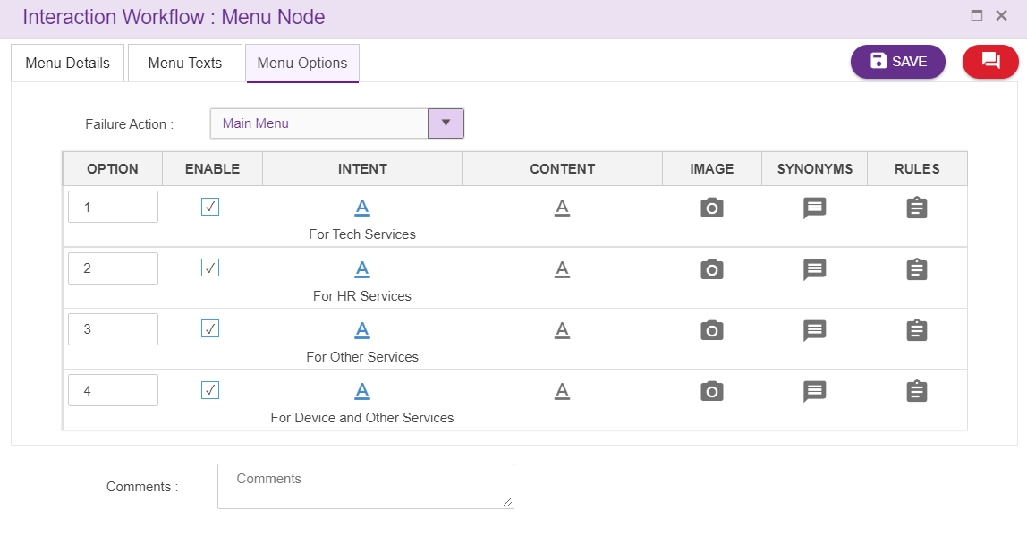
Delete Menu Node:
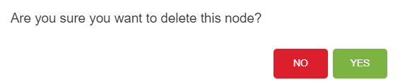

Menu Leg Options
When a designer connects other nodes to menu node as a leg, options will appear inside menu node as shown above.
Option: DTMF will be displayed here by defaults starting from 1. Designer has the privilege to change the dtmf used. These DTMF’s provided will not be displayed in UI in IW Chat. Designer can enter 1 or 2 digit numbers here along with options E, H and M
E- This alphabet stands for Exception. ‘Failure Action’ in menu node must set to ‘Exception’ when Option ‘E’ is used as an option for menu legs.
H- This alphabet stands for Hold.
M- This alphabet stands for Maskable. When all the options/legs are disabled/masked, system will allow 'M' option node as shown above.
Enable: This option is used to enable or disable the menu legs. Only enabled menu legs will be displayed in bot.
User can either enable/disable the options/legs by unchecking the checkbox provided as shown above. The checkbox will be checked by default.
DTMF will be in grey colour in UI when options are disabled as shown below. In the below figure, option 4 is disabled and option E, M and H are enabled by default. User cannot disable these options.
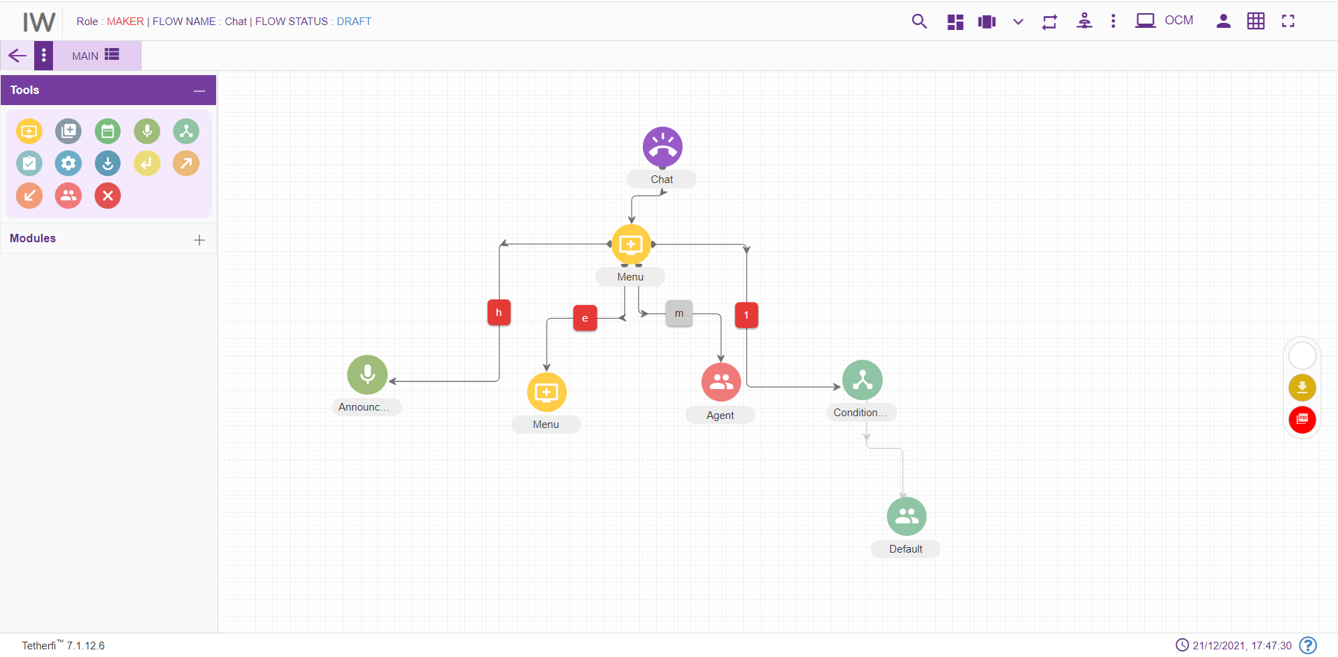
Mapping: When Is Survey Node is checked, mapping will be enabled.
Intent: Intents provided here will be displayed in Chatbot as a menu option. Upon clicking intent option following popup will generate.
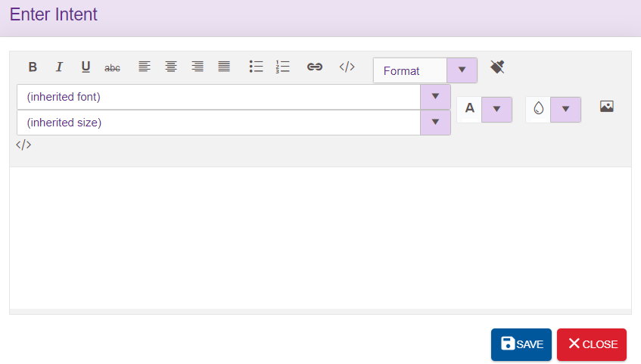
Designer can enter either text or html content here. Intents used in the node will be displayed in the UI as shown below. ‘Not Defined’ is displayed in UI when no intents are provided.
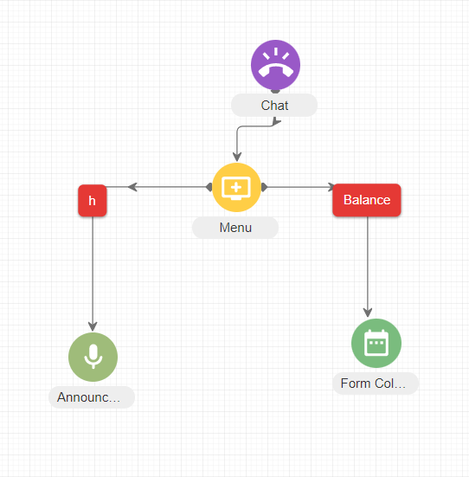

Image: For each intent which will be displayed in Chatbot UI can associate with the image. Image specific to each intent can be added here. Upon clicking image option, following popup will generate. User can enter the html content to show the image here
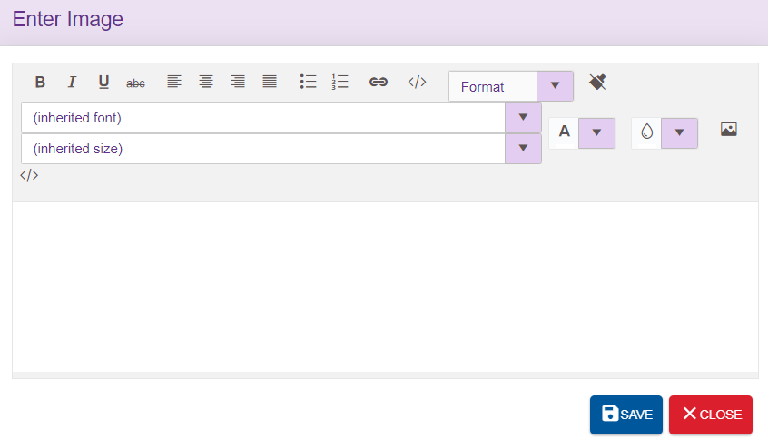
Synonyms: refer section Synonym
Rules: User can also set the rules specific to menu leg. refer section Set Rules
Callflow designers can easily shuffle menu legs by using drag and drop feature.

Agent Node
For adding a new transfer to Agent section to the chatflow, click on the “Agent” icon and drag it to the main screen. Agent node should be the last node in a chatflow (like Disconnect node).
Note that Agent node is not required, if the external module is called to perform agent transfer.
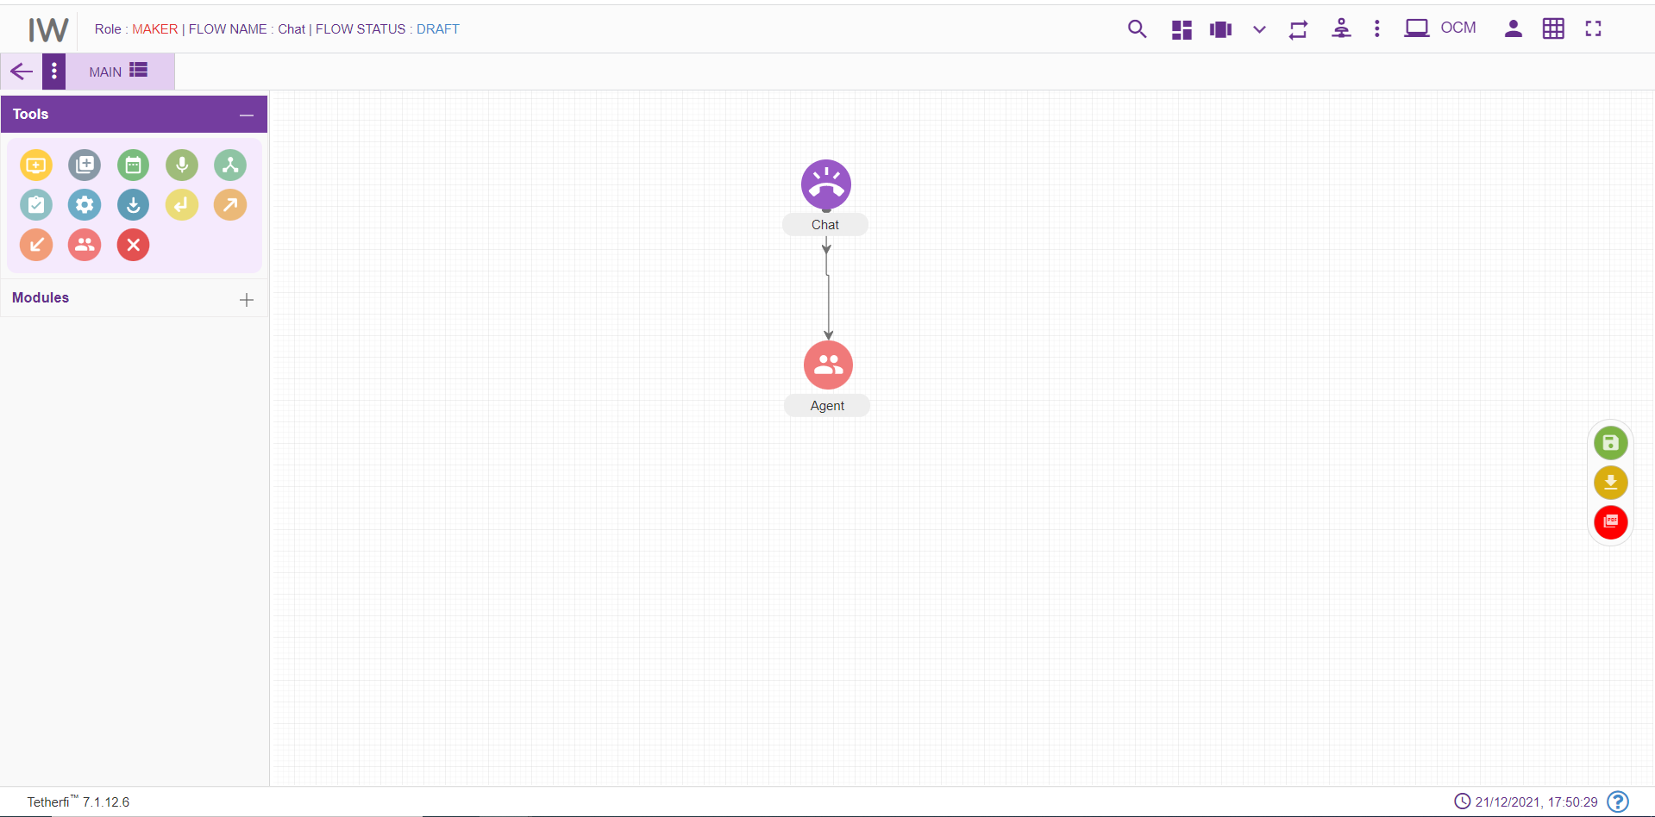
For editing/ configuring the Agent, hover over the Agent icon you added and edit/ delete functionalities for the menu will be displayed.
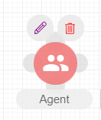

On click of edit button, the below screen will popup
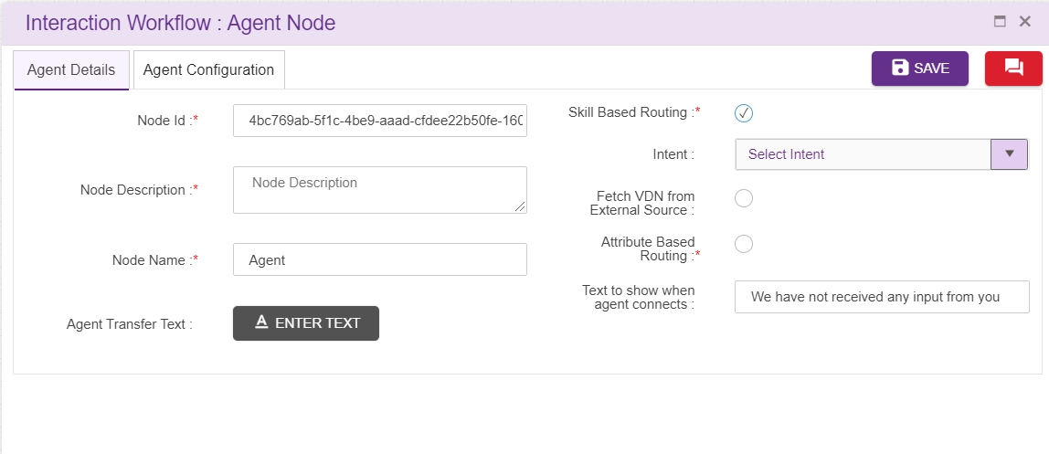
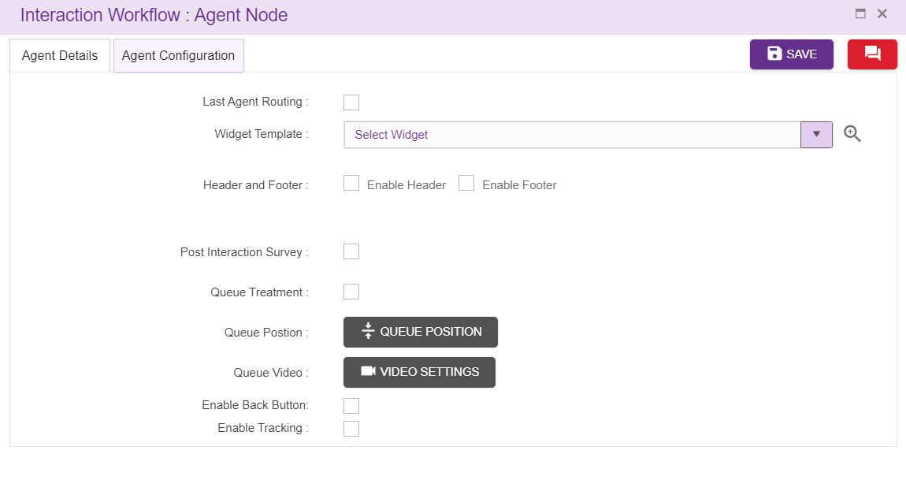
Node ID: By default, the node ID for an Agent node is autogenerated, but the Users have the privilege to assign their own ID. Each node ID should be unique. (Mandatory)
Node Description: Brief characterization of the agent Node. (Mandatory)
Name: This is a mandatory field. Name provided here will be reflected in UI, only when there are no intents
Skill Based Routing: Based on skill configured call will be routed
Intent: User can the specify the intent in this field. These intents are mapped to the VDN in the intent master page in IW. If the user is gives intent which is not mapped to VDN in intent master, it becomes invalid flow. User can also add the intents in ‘intent master’ and map to the VDN.
Fetch VDN from External Source: Fetching VDN from external source in Agent node
Session variables: Session variables and operational variables are displayed in the drop down
Attribute Based Routing: Route will happen based on attributes selected
Last Agent Routing: Call will be transferred to agent who have already interacted with same customer
When last agent routing is not available, chat will be transferred to agent based on skill.
Enable Tracking: When this option is checked, this node is tracked in session dashboard
Widget Template: Agent desktop template.
Agent Transfer Text: Text added here will be displayed when control transfer to the Agent. refer section Text Selection Window. For the new Agent node, these texts are copied from Main node.
Upon clicking this option, following popup will generate
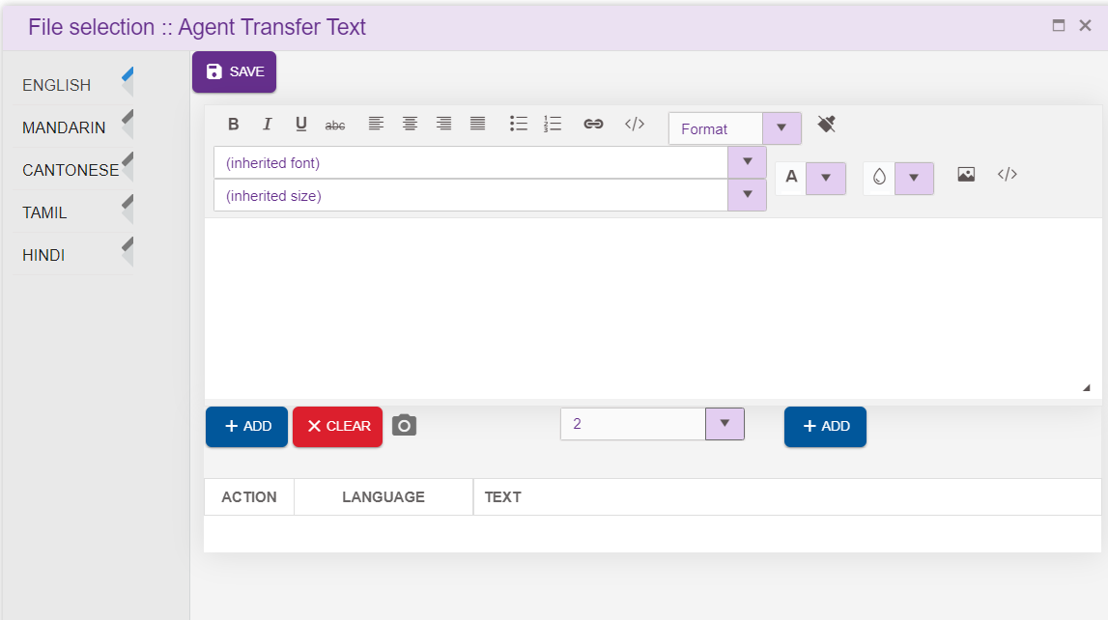
Intent: Select one of the intents that corresponds to the purpose of selection of Agent shown in the auto populated dropdown. Intents present in intent master are displayed here. Intent selected here will be displayed in the label once the chatflow is loaded.
Header: refer section Header
Footer. refer section Footer
Post Interaction Survey: Upon checking post interaction Survey checkbox, Flow setting option will highlight. This option is used to redirect the customer to post interaction survey flow, once the call is been attended by Agent
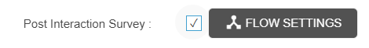
Upon clicking ‘FLOW SETTINGS’ option following popup will generate, where user can select the callflow, tab and entry point to for post interaction survey.
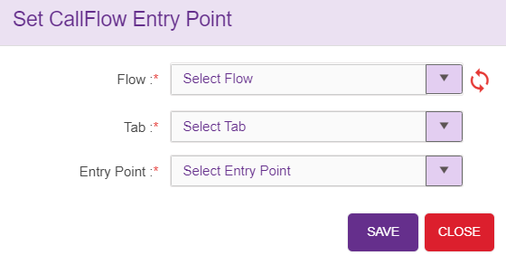
Flow: Lists both IW Flow as well as Subflow
Tab: Lists the tab present in the chatflow selected
Entry Point: Lists the entry points present in the tab
Queue Treatment: Upon checking Queue treatment checkbox, Flow setting option will highlight. This option is used to provide queue treatment when the customer is on queue
Upon clicking ‘FLOW SETTINGS’ option following popup will generate, where user can select the callflow, tab and entry point to for queue treatment
Flow: Lists both IW Flow as well as Subflow
Tab: Lists the tab present in the chatflow selected
Entry Point: Lists the entry points present in the tab
Queue Treatment Timeout: This option is used to configure the timeout option for the customer in queue. Once this time elapses, call will be transferred to the Agent.
Dynamic Configuration: Agent node support dynamic configuration. User can configure the values to be displayed GlobalData.js file.
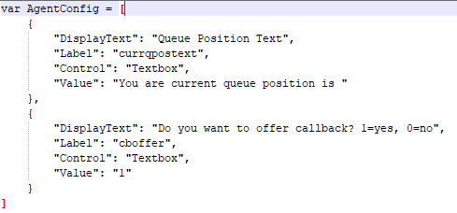
Queue Position: This option is used to configure the queue position of the customer.
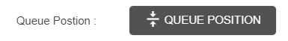
Upon clicking this option, following popup will generate, where user can configure the text to be displayed along with the queue position present in a session variable.
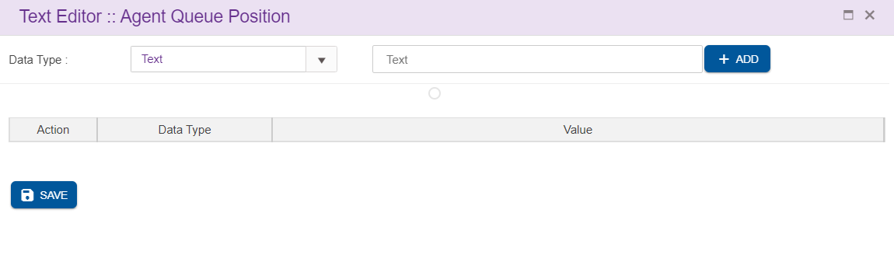
There are 4 datatypes available
- Text: Texts can be added here
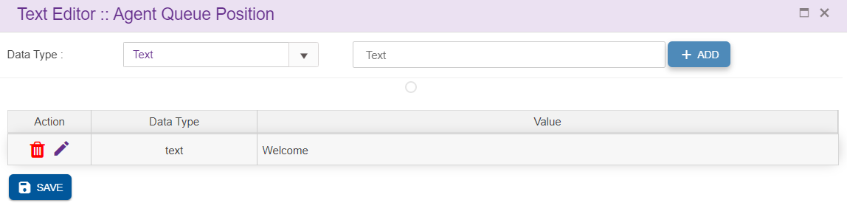
- HTML: html contents can be added by selecting this datatype
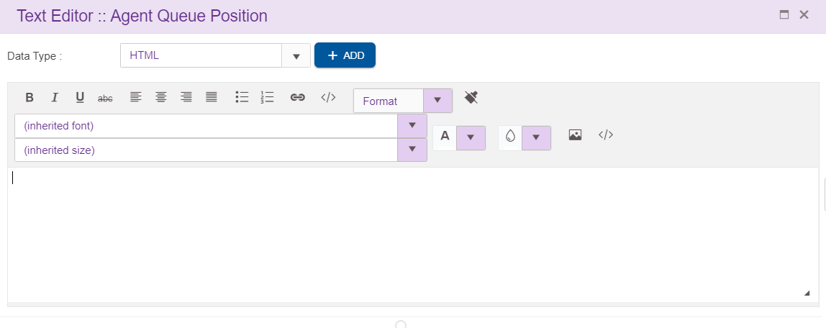
- Session: session variables can be added in the here. This will list the session and operational variables used in the chatflow
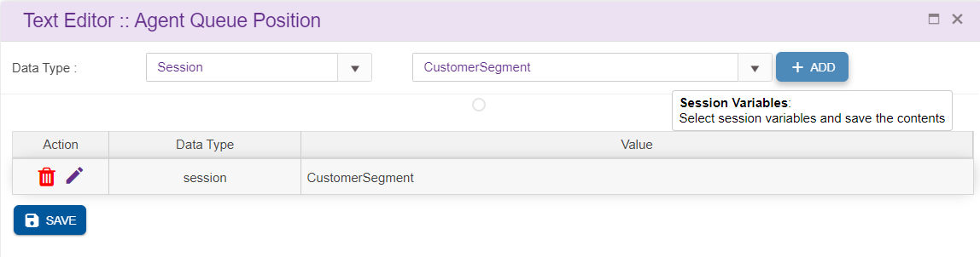
- New Line: This is used to insert a new line in the queue position
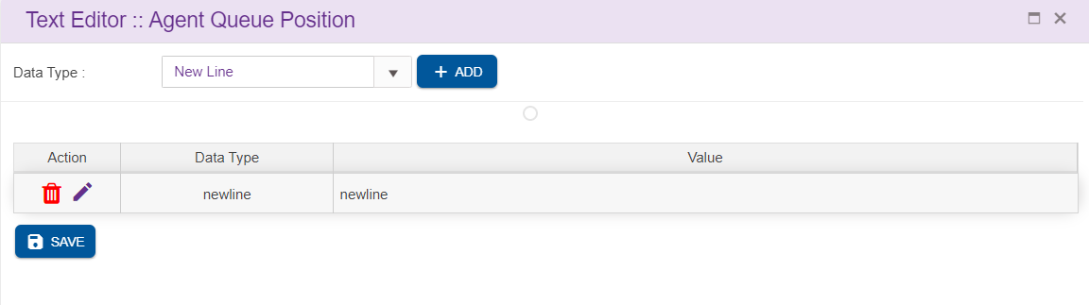
Queue Video: This option is used to configure the queue video for the customer.
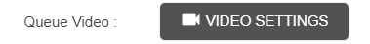
Upon clicking this option, following popup will generate, where user can configure the text to be displayed along with the queue position present in a session variable.
There are 4 datatypes available
- Text: Texts can be added here
- HTML: html contents can be added by selecting this datatype
- Session: session variables can be added in the here. This will list the session and operational variables used in the chatflow.
- New Line: This is used to insert a new line in the queue position
Delete Agent Node:
On click of delete button, the below screen will popup

Conditional Node
For adding a new Conditional Node to the callflow, click on the “Conditional Node” icon and drag it to the main screen. Conditional node is associated with a default node.
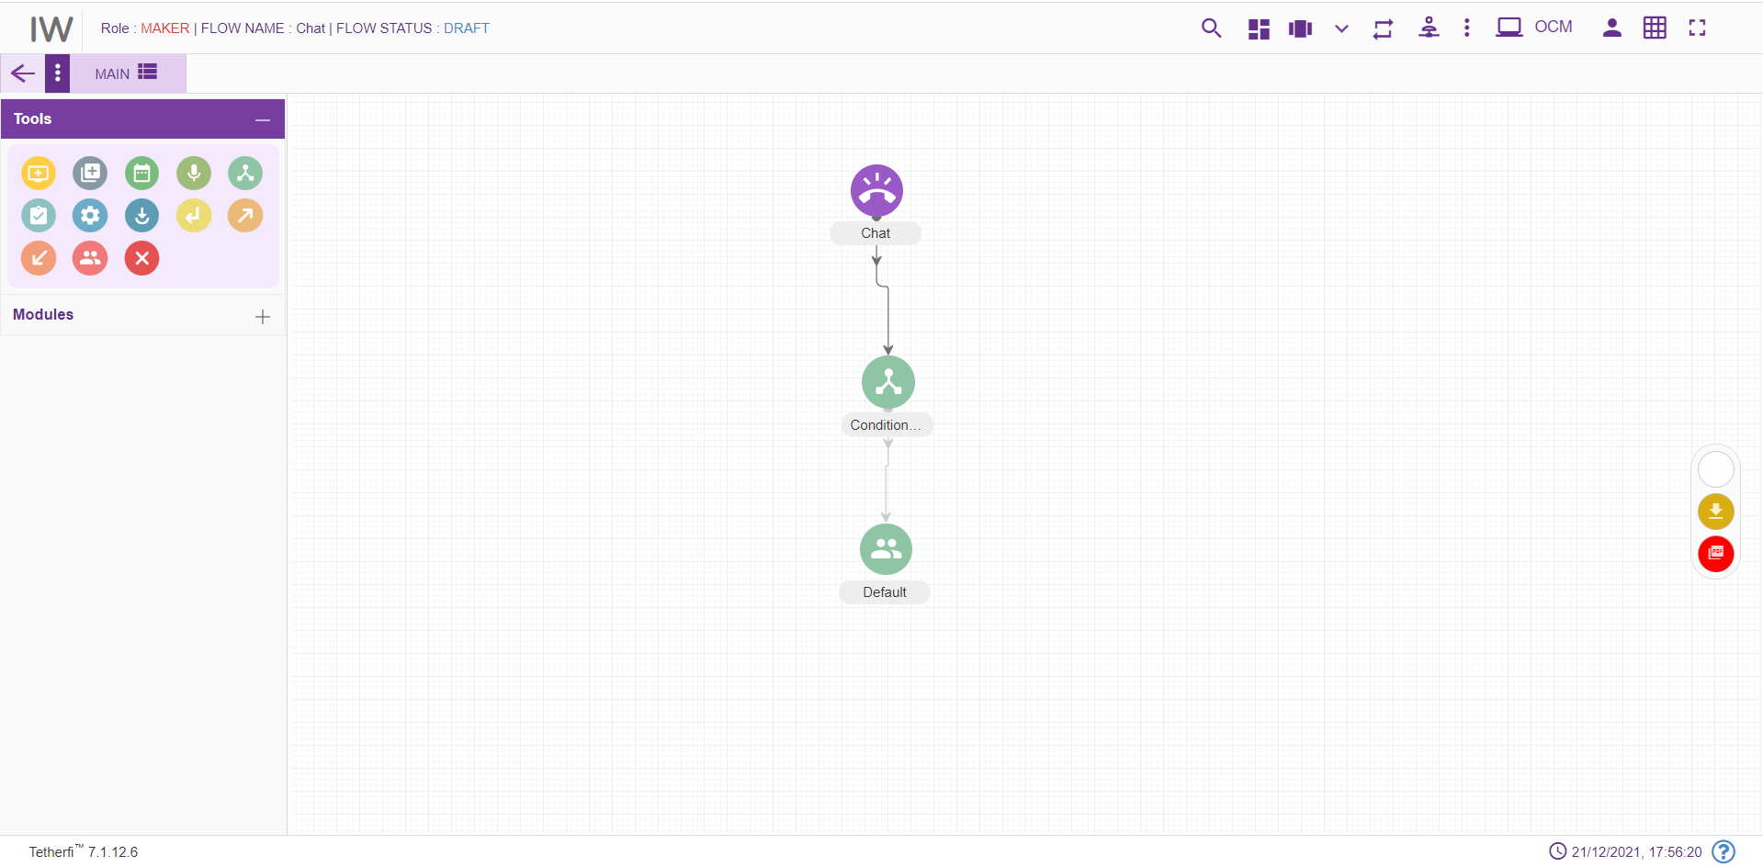
For editing/ configuring the Conditional Node, hover over the Conditional Node icon you added and edit/ delete functionalities for the menu will be displayed.
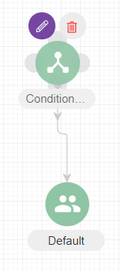
On click of edit button, the below screen will popup
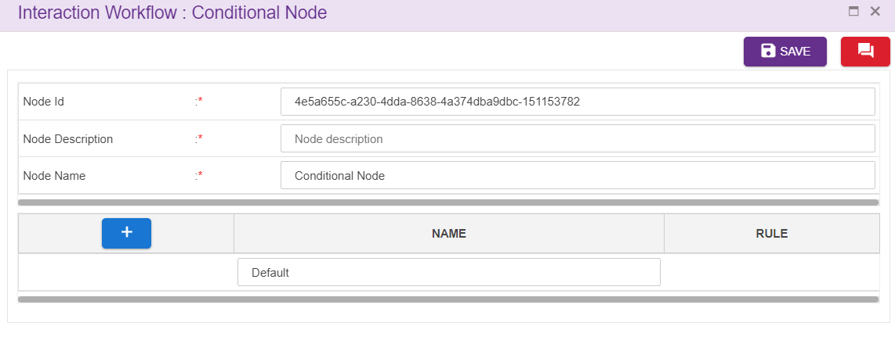Node ID: By default, the node ID for a Conditional node is autogenerated, but the Users have the privilege to assign their own ID. Each node ID should be unique. (Mandatory)
Node Description: Brief characterization of the conditional Node. (Mandatory)
Name: This is a mandatory field. Name provided here will be reflected in UI. By default, the name is Conditional Node. but the Users have the privilege to assign their own name.
Adding Rules:
Click on “+” icon, to add rules.
Click on the ’Set Rules’ icon present at the Rule column to add conditional rules. refer section Set Rules
Upon clicking this icon following popup will be displayed and rule leg will be shown in UI. Conditional node is associated with default node. User should not be allowed to connect to default node directly from other nodes.
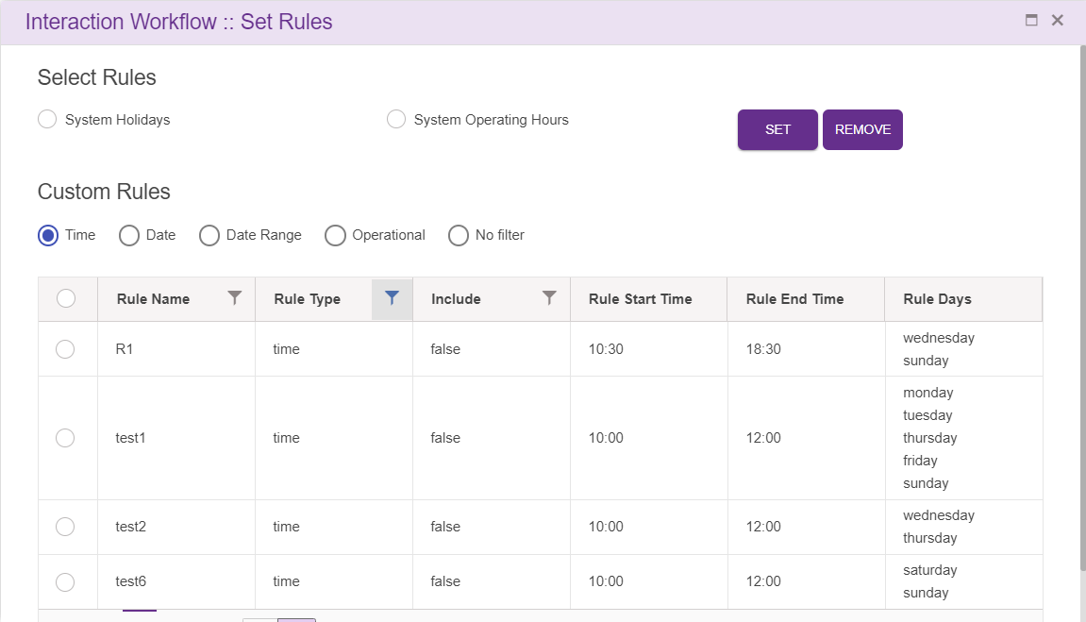
Delete Conditional Node:
On click of delete button, the below screen will popup

6.1.4 Announcement Node
For adding a new Announcement Node to the chatflow, click on the “Announcement” icon and drag it to the main screen.
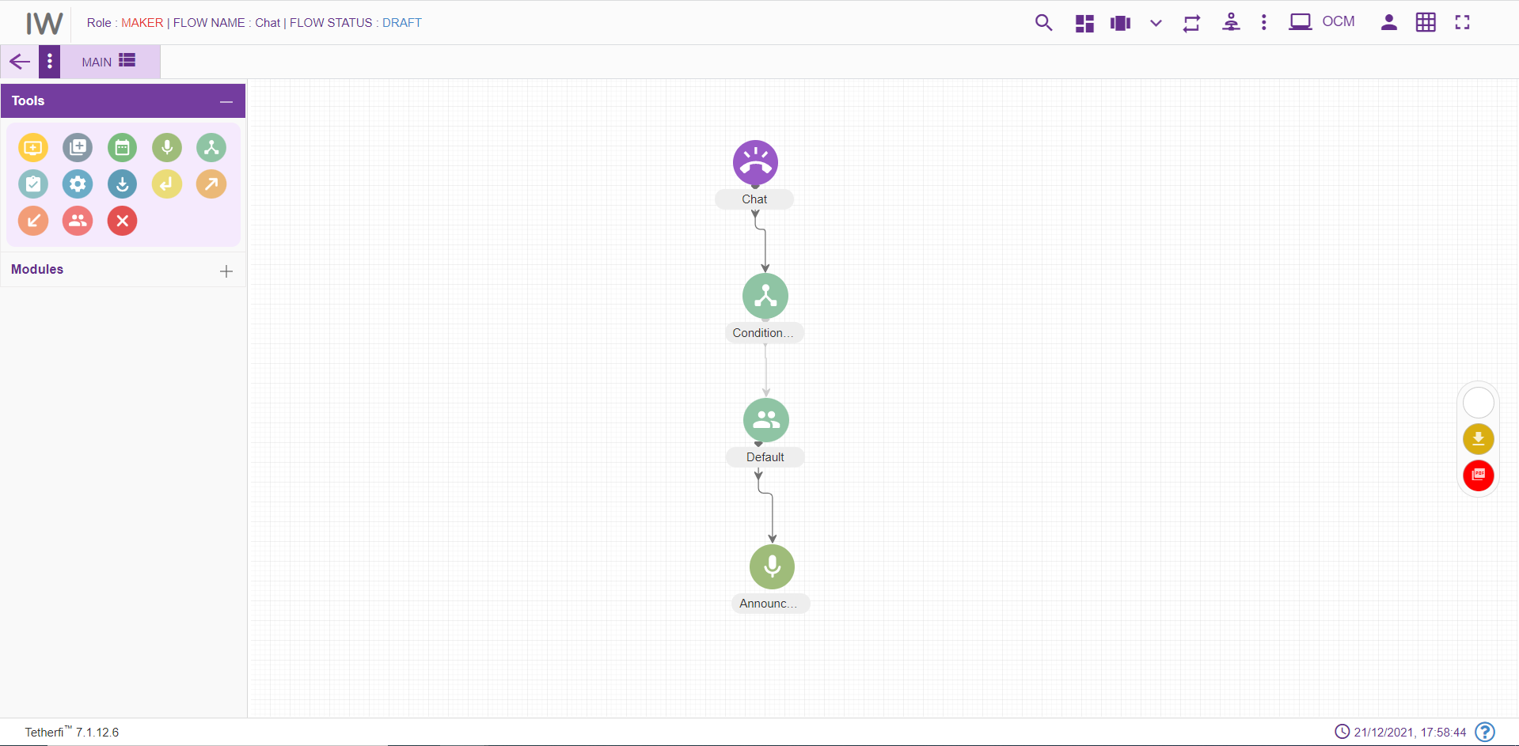
For editing/ configuring the Announcement Node, hover over the Announcement Node icon you added and edit/ delete functionalities for the Announcement node will be displayed
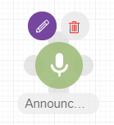
On click of edit button, the below screen will popup
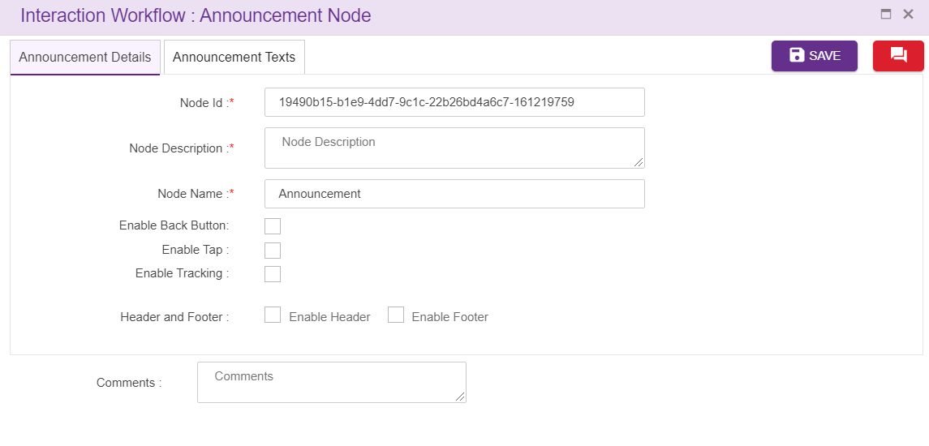
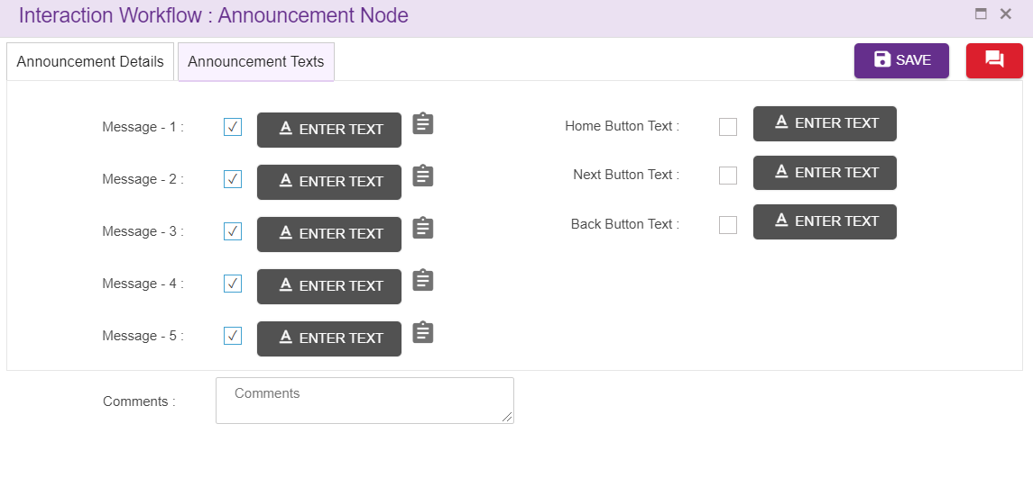
Node ID: By default, the node ID for an Announcement node is autogenerated, but the Users have the privilege to assign their own ID. Each node ID should be unique. (Mandatory). This option is used to track the announcements played.
Node Description: Brief characterization of the agent Node. (Mandatory)
Name: This is a mandatory field. Name provided here will be reflected in UI. By default, the name is Conditional Node. but the Users have the privilege to assign their own name.
Enable Tracking: When this option is checked, this node is tracked in session dashboard.
Header: refer section Header
Footer. refer section Footer

Announcements:
Mask- unmask option is given to all the five announcements in Announcement node as shown above. User need to check the checkbox to enable/mask the announcement. These checkboxes will be checked by default.
First connection from announcement node is a default connection and second connection are considered as masked connection which will be enabled when all the 5 announcements are disabled in Announcement node as shown below.
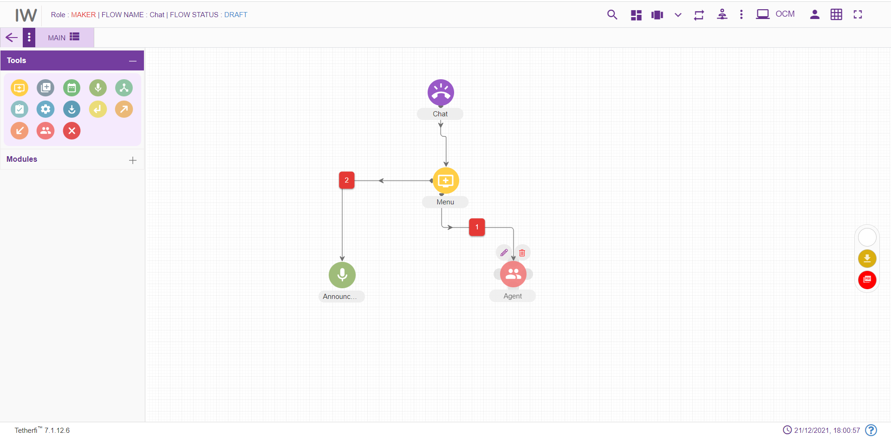
Upon clicking ‘ENTER TEXT’ option, following popup will generate. Here user can add the text which should be displayed. section Text Selection Window
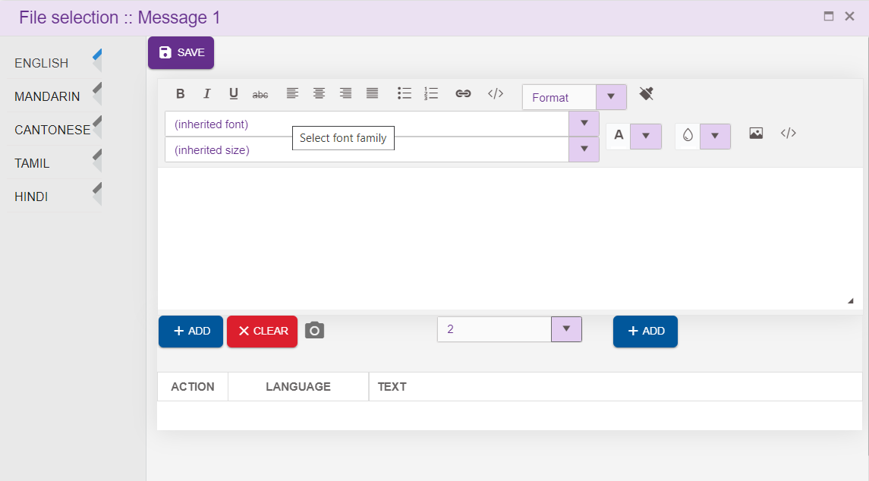
User can set the rules related to specific announcement by clicking the icon present at each announcement tag. refer section Set Rules

Upon clicking set rule icon following popup will be displayed
Delete Announcement node
On click of delete button, the below screen will popup

Assignment Node
For adding a new Assignment Node to the chatflow, click on the “Assignment” icon and drag it to the main screen. Assignment node can be connected to only 1 node and it is a default connection (without label).
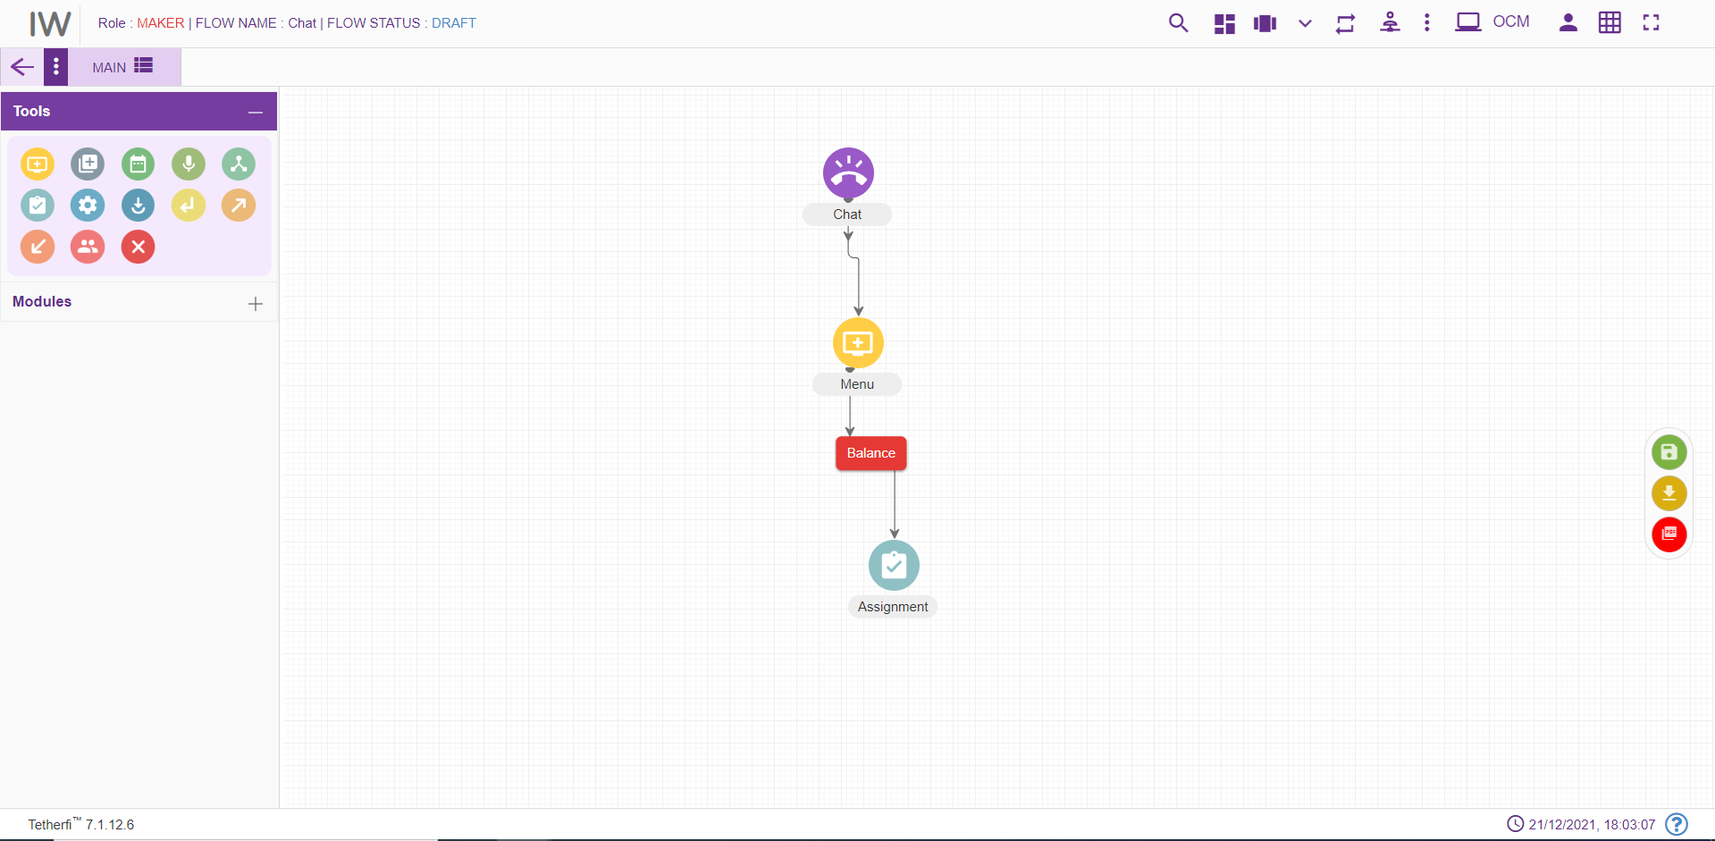
For editing/ configuring the Assignment Node, hover over the Assignment Node icon you added and edit/ delete functionalities for the Assignment node will be displayed
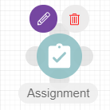
On click of edit button, the below screen will popup. Operational variables will be displayed in both the drop downs.
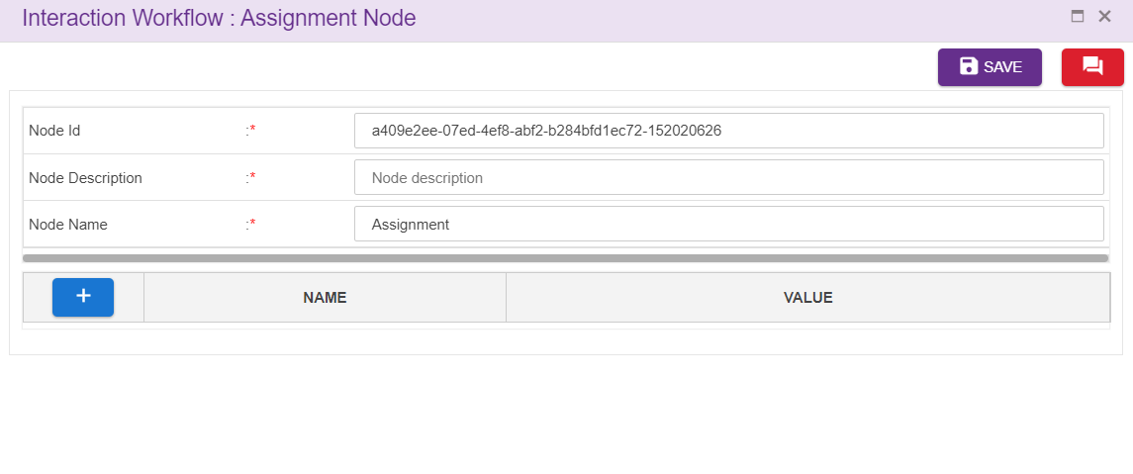
Node ID: This is a mandatory field. By default, the node ID for an Assignment node is autogenerated, but the Users have the privilege to assign their own ID. Each node ID should be unique. (Mandatory).
Node Description: Brief characterization of the agent Node. (Mandatory)

Name: This is a mandatory field. Name provided here will be reflected in UI. By default, the name is ‘Assignment’. But the Users have the privilege to assign their own name
User can select the operational variables added at the backend from the first drop down and assign the values to them in the value field provided. User can also select operational variables for value field by clicking drop down icon shown above.
User can configure the values to be displayed in the drop down in GlobalData.js file.
Delete Announcement node:
On click of delete button, the below screen will popup

Prompt and Collect Node
For adding a new Prompt and Collect Node to the chatflow, click on the “Prompt and Collect” icon and drag it to the main screen. First connection from the PNC node is a default connection (without label) and when there is no default connection between PNC and node, immediate connection will be the default connection.
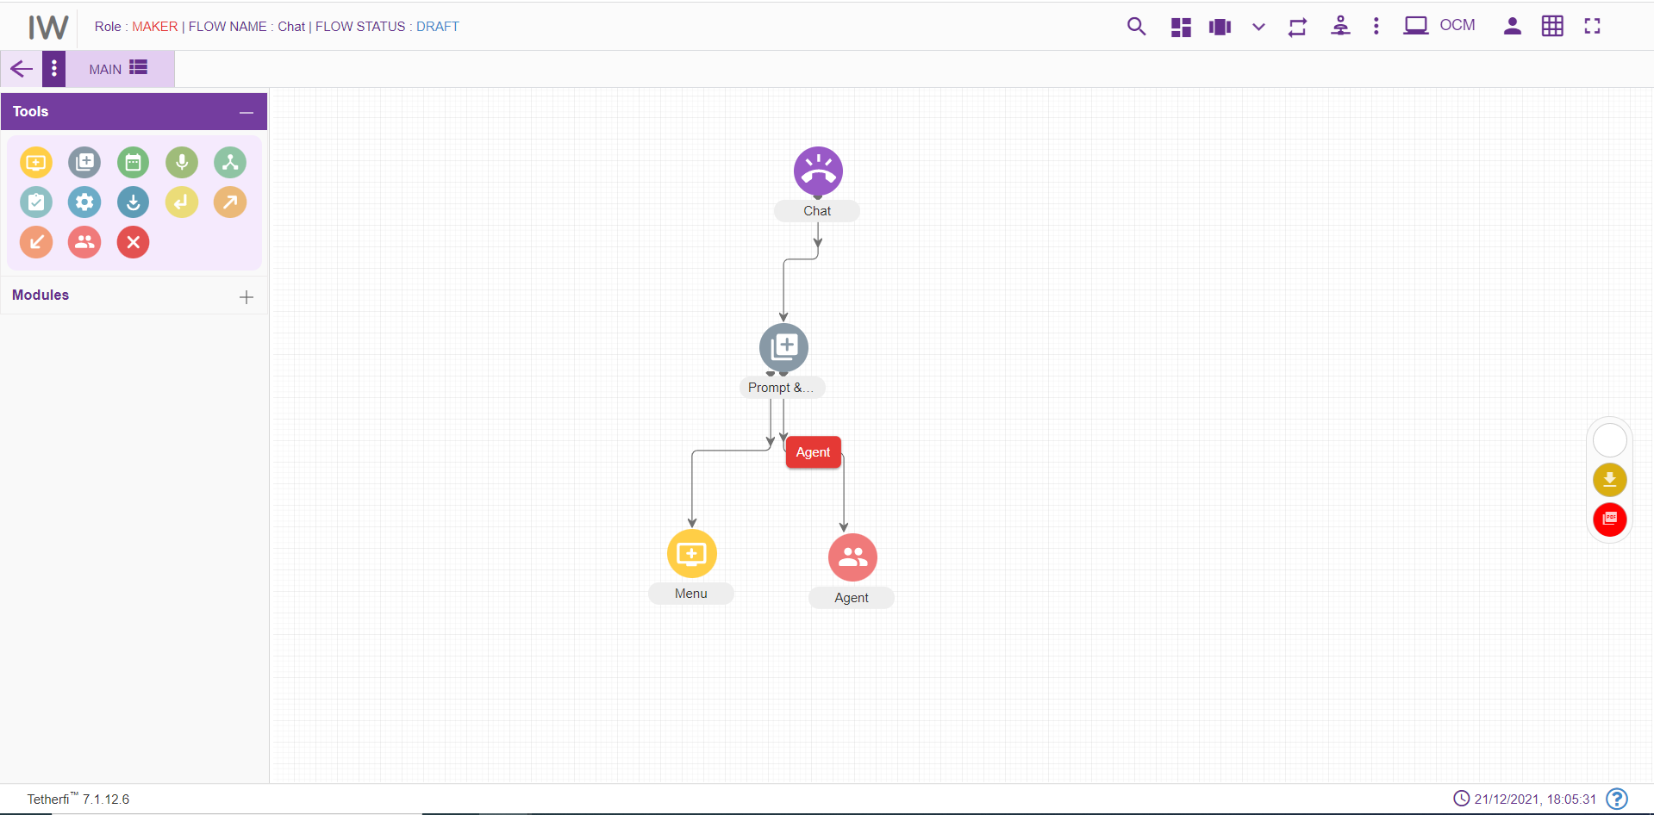
For editing/ configuring the prompt and collect Node, hover over the P&C Node icon you added and edit/ delete functionalities for the P&C node will be displayed
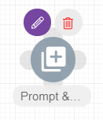
On click of edit button, the below screen will popup
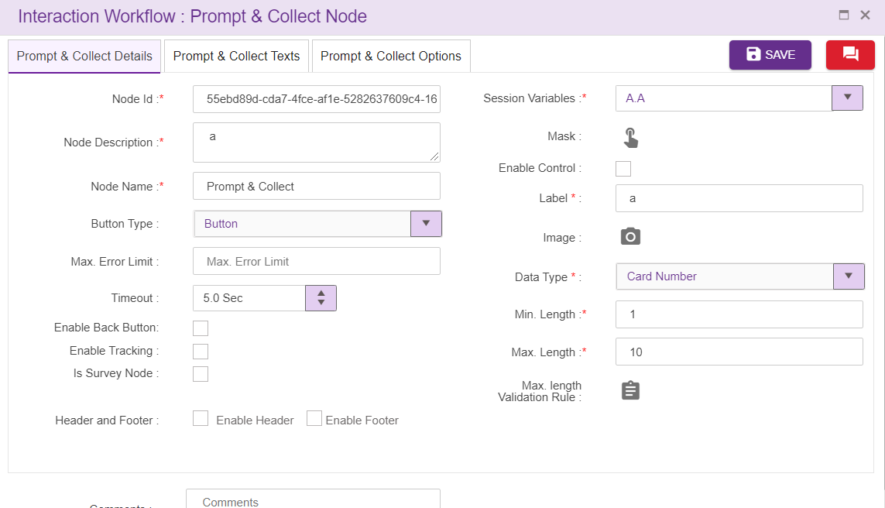
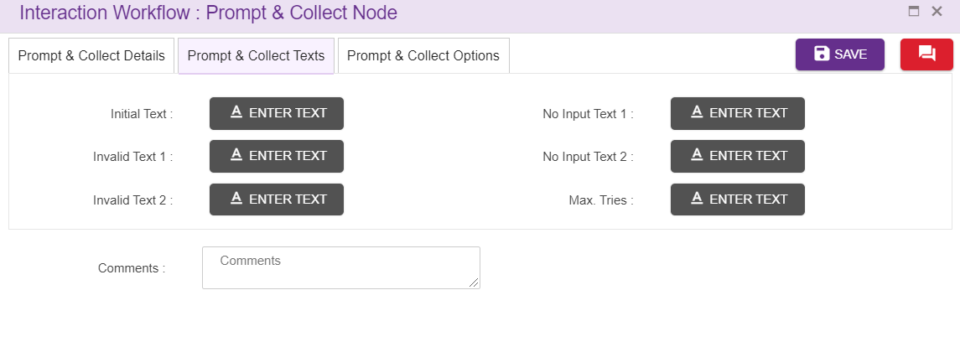
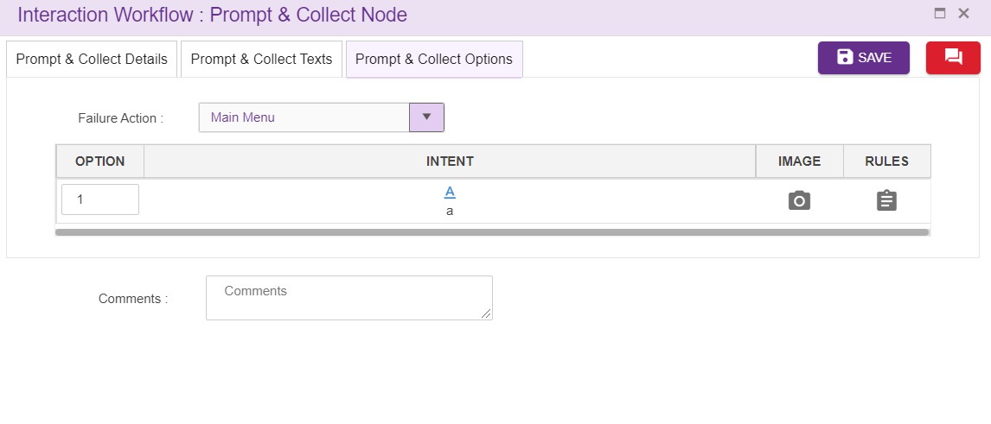
  - Prompt and Collect Id: These id’s are auto generated
  - Prompt and Collect Name: User can give names specific to the node in this field
  - Description: Description about P&C node is given here.
  - Button Type: User can select the button type from the dropdown provided
  - Session Variables: These are the variables corresponds to a chat. This is a mandatory field. User can add session variable or select from the drop down. Duplicate session variables are not allowed here
  - Min. Length and Max. Length: This fields are the dialogues and collected from Prompt & Collect node. These fields are the allowed range for data e.g. for entering phone number and the allowed digits can be configurable to certain range.
  - Max length Validation Rule: Rule can be set here to validate data entered.
  - Initial Text: Text added here will be displayed to the user as an initial text. (refer section Text Selection window)
  - Invalid Text 1 and 2: Allows the flow designer to add the texts and these texts are displayed when there is invalid input from user. The text to be displayed on invalid prompt event. The Language section in Call flow configuration segment is auto configured depending upon the languages selected in the Main node. (refer section Text Selection Window). For the new PNC node, these texts are copied from Main node.
  - No Input Text 1 and 2: Allows the flow designer to add the texts and these texts are displayed when there is no input from user. The text to be displayed on no input prompt event. The Language section in Call flow configuration segment is auto configured depending upon the languages selected in the Main node. (refer section Text Selection Window). For the new PNC node, these texts are copied from Main node.
  - Max Tries: Allows the flow designer to add the texts and these texts are displayed when user exceeds maximum try limits. The text to be displayed when max tries exceeded. The Language section in Call flow configuration segment is auto configured depending upon the languages selected in the Main node. (refer section Text Selection Window). For the new PNC node, these texts are copied from Main node.
  - Comment: This field is used to write comments
  - Max Error Limit: Maximum attempts allowed in a DTMF in PNC
  - Failure Action: Upon failure action provided here will be performed
  - Interval Timeout: This specifies the elapse time to enter user input. This field accepts decimal values too.
  - Enable Tracking: When this option is checked, this node is tracked in session dashboard.
  - Is Survey Node: Checked indicates survey is enabled.
  - Survey Type: User can select the survey type from the dropdown provided which is used to measure customer experience.
  - Question Type: When user select the survey type ‘long form’ from the dropdown provided, question type dropdown will display which is used to measure customer experience.
  - Header: refer section Header
  - Footer. refer section Footer
When a designer connects other nodes to pnc node as a leg, options will appear inside pnc node as shown above for second connection.
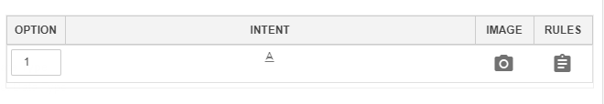
Option: DTMF will be displayed here by defaults starting from 1. Designer has the privilege to change the dtmf used. These DTMF’s provided will not be displayed in UI in IW Chat. Designer can enter 1 or 2 digit numbers here along with options E, H and M
- E- This alphabet stands for Exception. ‘Failure Action’ in menu node must set to ‘Exception’ when Option ‘E’ is used as an option for menu legs.
- H- This alphabet stands for Hold.
- M- This alphabet stands for Maskable. When all the options/legs are disabled/masked, system will allow 'M' option node as shown above.
Intent: Intents provided here will be displayed in Chatbot as a menu option. Upon clicking intent option following popup will generate.
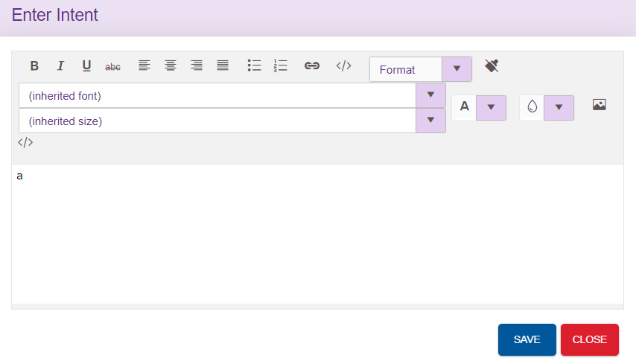
Designer can enter either text or html content here. Intents used in the node will be displayed in the UI as shown below. ‘Not Defined’ is displayed in UI when no intents are provided.
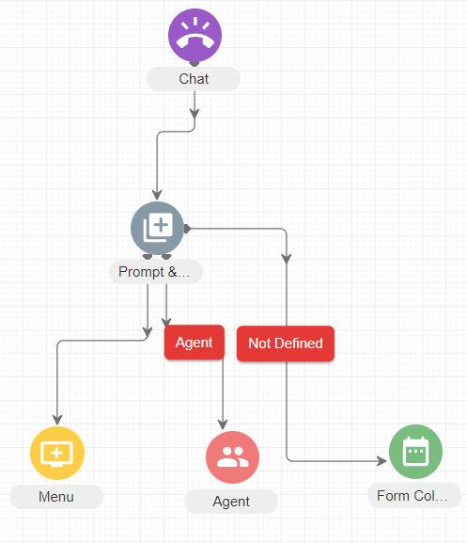
Image: For each intent which will be displayed in Chatbot UI can associate with the image. Image specific to each intent can be added here. Upon clicking image option, following popup will generate. User can enter the html content to show the image here
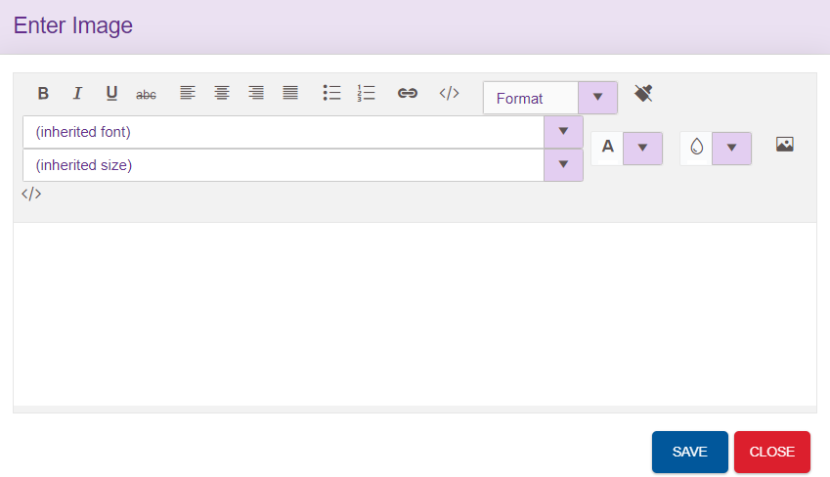

Rules: User can also set the rules specific to menu leg. refer section Set Rules
Chatflow designers can easily shuffle menu legs by using drag and drop feature.

Delete Prompt and Collect:
On click of delete button, the below screen will popup

Entry Point Node
Some of the chatflows can contain many nodes. It becomes difficult to manage or fit the entire chatflow in a single screen. Such chatflows are broken into smaller flows for better readability and to also reduce frequent scrolls on the page. Each of these small flows are connected through the Entry and Exit node.
To add an Entry Point:
- Click on the node menu and drag and drop the Entry point to the screen
- Click on the three dots and then click on Edit details icon
- Entry Point pop up box is displayed
- Enter the Entry Point name and save
- Entry Point node should have the Entry Point name updated

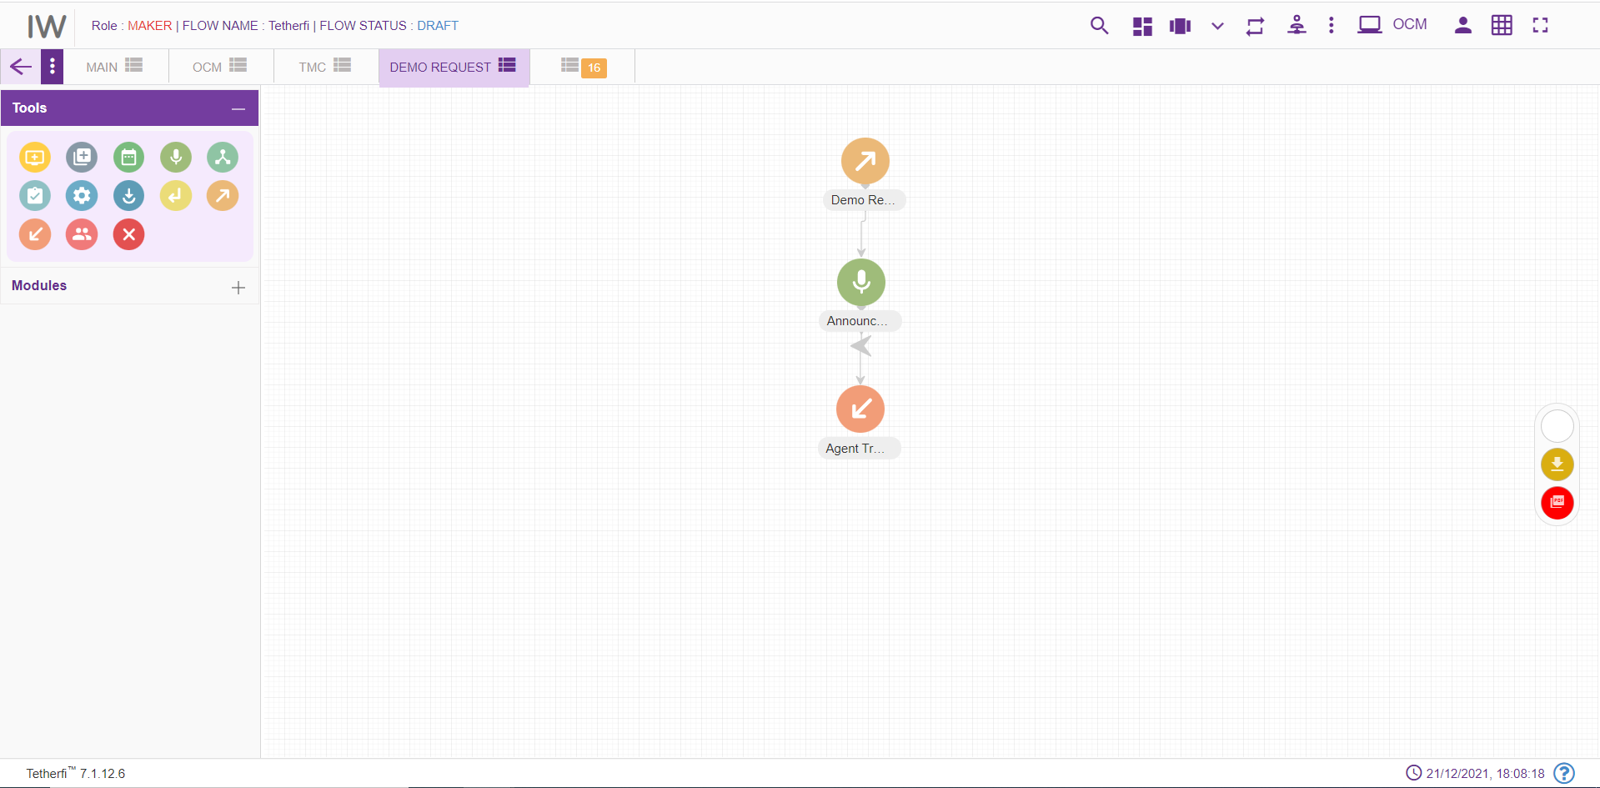

Entry Points can be connected to multiple flows which means technically multiple exits points are connected to entry points. To view the connections to the Entry Point, ‘view connection’ option is provided.
To view Entry Point connections:
- Click on the three dots on the Entry Point node and then click on View Connections icon
- ‘Following Connections found:’ pop up window with the Tab name and Entry Point name will be displayed
- Tab name will have the tabs which are connected to this flow. There can be multiple tab names and exit points connected to a single-entry point.

Entry Point should not have any incoming connections. Alert message ‘Entry Point should not have any incoming connections’ will be displayed when try to connect a node to Entry point node.
For editing/ configuring the Entry point, hover over the Entry point icon you added and edit/ delete/ view connections functionalities for the menu will be displayed.
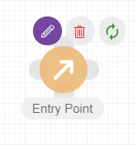
On click of edit button, the below screen will popup wherein you need to specify the name of the Entry Point.
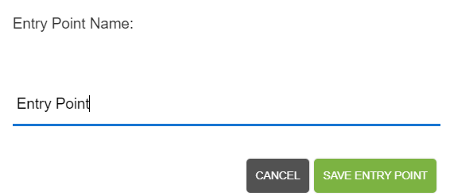
To delete the Entry Point:
- Double click on each connection of the Entry Point and delete them individually.
- When all the connections are broken then click on ‘delete details’ icon on the node
- Entry Point will be deleted. This Entry Point will not be available for setting entry point for any of the exit points.

Disconnect Node
Disconnect node should be the last node in a chatflows and user should not be able to connect other nodes after that. For adding a new Disconnect Node to the chatflow, click on the “Disconnect” icon and drag it to the main screen.
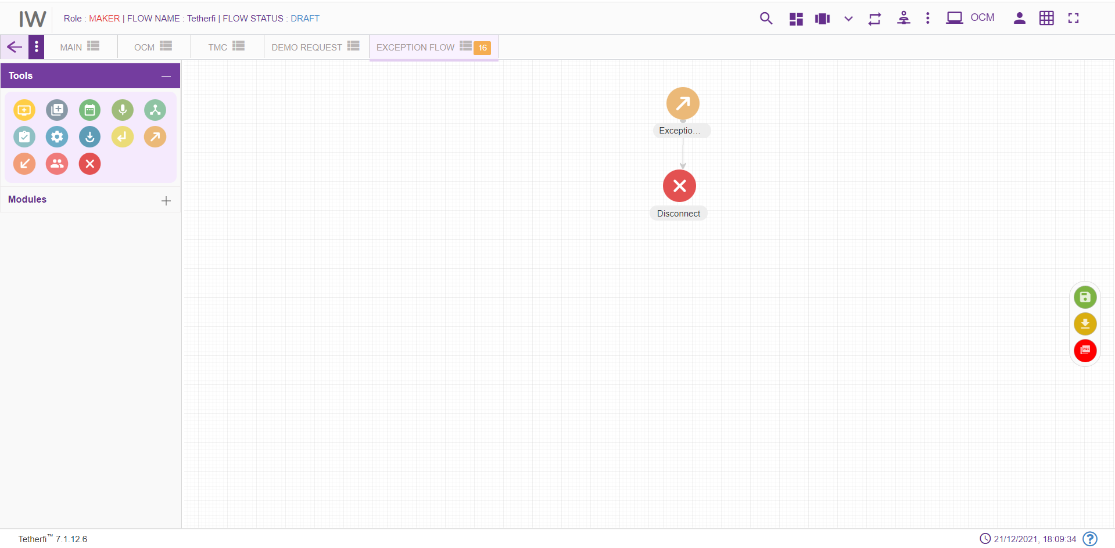
For editing/ configuring the Disconnect Node, hover over the Disconnect Node icon you added and edit/ delete functionalities for the disconnect node will be displayed.
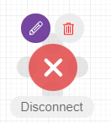
On click of edit button, the below screen will popup
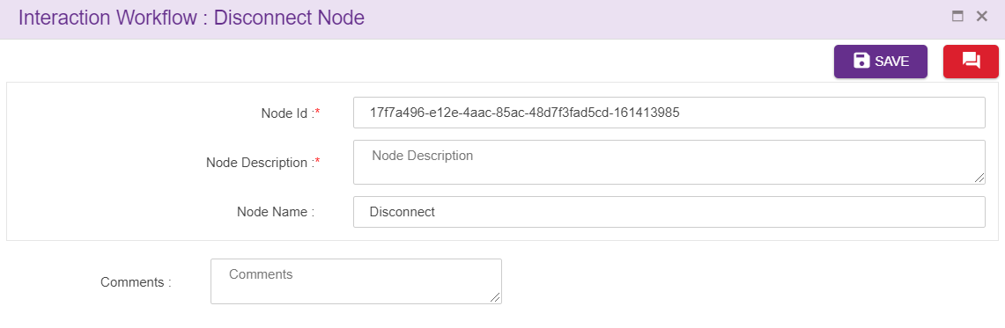
Node ID: This is a mandatory field. By default, the node ID for an Disconnect node is autogenerated, but the Users have the privilege to assign their own ID. Each node ID should be unique. (Mandatory).
Node Description: Brief characterization of the agent Node. (Mandatory)

Delete Disconnect Node
On click of delete button, the below screen will popup

Exit Point Node
Exit Node cannot be a source node. It is the last node of the flow. If there is an effort to set connection between Exit node to any of the nodes, an alert message ‘Source can’t be an exit point. Exit point cannot have any exits.’ Will be displayed.
Every Exit Point will be pointing to the next Entry Point. This navigation details are provided by editing the Exit Point and then setting the entry point.
For adding a new Exit point to the chatflow, click on the “Exit point” icon and drag it to the main screen. 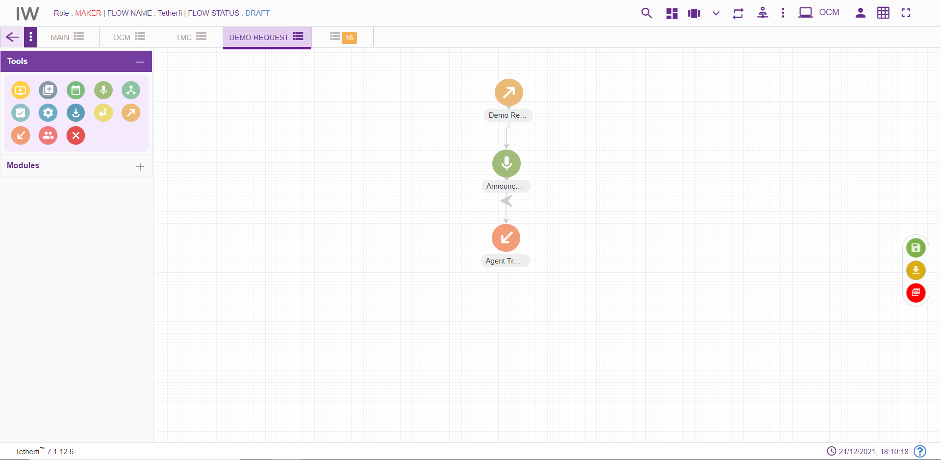
For editing/ configuring the Exit point, hover over the Exit point icon you added and edit/ delete functionalities for the menu will be displayed.
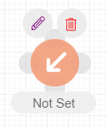

To set the Entry Point:
- Click on the Exit Point to which the entry point has to be set and click on the ‘Edit details’ icon
- Set Entry Point’ pop up window will be displayed. This window has tab name, Entry Point name and Comments. All the fields are mandatory. By default, the tab name will have ‘select tab’ in the drop down.
- Choose the tab name to which the control has to navigate from Exit Point. After choosing the tab name, only then the ‘Entry Point name’ will be populated. It will have all the entry points for the selected tab.
- Enter the comments and save. Exit Point node will have the name of the set Entry point.

Exit Point can have only one Entry Point set. It cannot be set to multiple entry points. Set connections can be deleted.
To remove the connections:
- Click on edit details button of the Exit Point. It should have the set Entry Point.
- Click on remove connections’ button.
- ‘Are you sure you want to remove this Entry point connection?’ confirmation message should be displayed. On clicking Yes, the connection will be removed between the Exit Point and set Entry Point.
- ‘Entry Point connection removed’ message will be displayed confirming the deletion.
- If the ‘edit details’ button is clicked again, ‘Set entry point’ window will not have connection details. Also, ‘Remove connections’ button will not be present.

Exit Point can be deleted.
To delete the Exit Point:
- Double click on each connection of the Exit Point and delete them individually.
- When all the connections are broken then click on ‘delete details’ icon on the node
- Exit Point will be deleted.
Flow connector node is used to jump to subflow. Every Flow connector will be pointing to the next Entry Point. This navigation details are provided by editing the flow connector and then setting the entry point. Flow connector node can be connected to only 1 node and it is a default connection (without label).
For adding a new flow connector to the chatflow, click on the “flow connector” icon and drag it to the main screen.
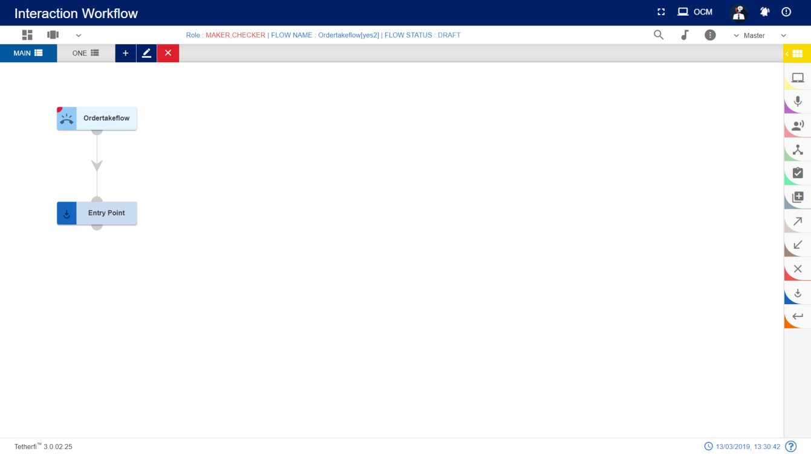
For editing/ configuring, hover over the flow icon you added and edit/ delete functionalities for the flow icon will be displayed.

On click of edit button, the below screen will popup
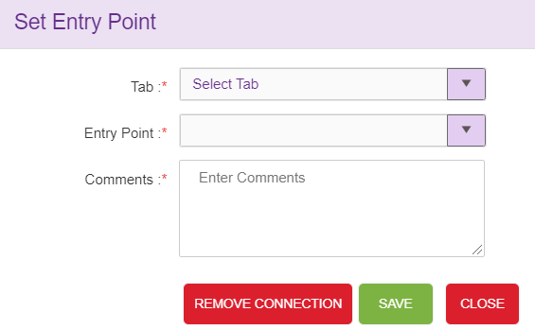

To set the Flow Entry Point:
- Drag and drop flow connector node and click on the ‘Edit details’ icon
- ‘Set Flow Entry Point’ pop up window will be displayed. This window has Flow name, tab name, Entry Point name and Comments. All the fields are mandatory. By default, the tab name will have ‘select tab’ in the drop down.
- Choose the flow name and tab name to which the control must navigate from flow connector Point. All the approved subflows will be displayed here. After choosing the tab name, only then the ‘Entry Point name’ will be populated. It will have all the entry points for the selected tab.
- Enter the comments and save. Flow connector node will have the name of the set Entry point.

Flow connector can have only one Entry Point set. It cannot be set to multiple entry points. Set connections can be deleted.
To remove the connections:
- Click on edit details button of the flow connector. It should have the set Entry Point.
- Click on remove connections’ button.
- ‘Are you sure you want to remove this Entry point connection?’ confirmation message should be displayed. On clicking Yes, the connection will be removed between the flow connector and set Entry Point.
- ‘Entry Point connection removed’ message will be displayed confirming the deletion.
- If the ‘edit details’ button is clicked again, ‘Set entry point’ window will not have connection details. Also, ‘Remove connections’ button will not be present.

Flow Connector node
Flow connector node is used to jump to subflow. Every Flow connector will be pointing to the next Entry Point. This navigation details are provided by editing the flow connector and then setting the entry point. Flow connector node can be connected to only 1 node and it is a default connection (without label).
For adding a new flow connector to the chatflow, click on the “flow connector” icon and drag it to the main screen.
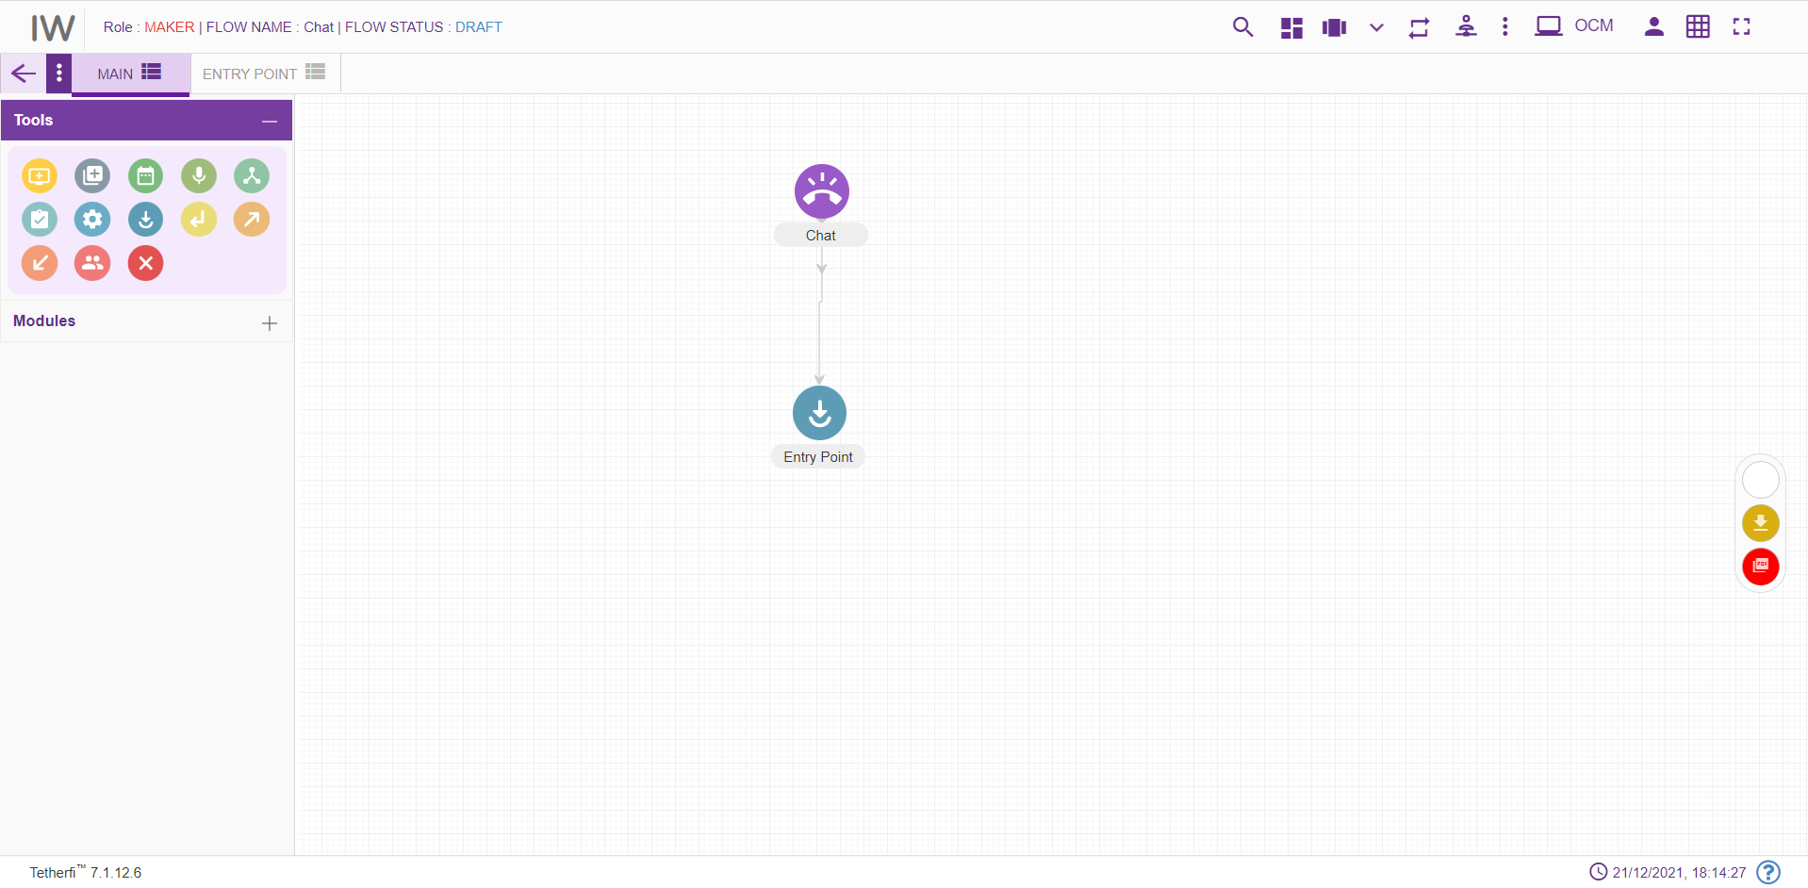
For editing/ configuring, hover over the flow icon you added and edit/ delete functionalities for the flow icon will be displayed.

On click of edit button, the below screen will popup
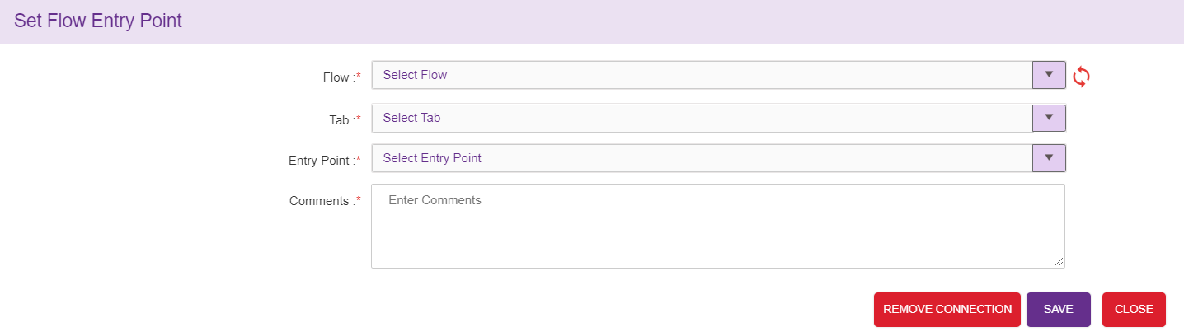

To set the Flow Entry Point:
- Drag and drop flow connector node and click on the ‘Edit details’ icon
- ‘Set Flow Entry Point’ pop up window will be displayed. This window has Flow name, tab name, Entry Point name and Comments. All the fields are mandatory. By default, the tab name will have ‘select tab’ in the drop down.
- Choose the flow name and tab name to which the control must navigate from flow connector Point. All the subflows and main flows will be displayed here. After choosing the tab name, only then the ‘Entry Point name’ will be populated. It will have all the entry points for the selected tab.
- Enter the comments and save. Flow connector node will have the name of the set Entry point.

Flow connector can have only one Entry Point set. It cannot be set to multiple entry points. Set connections can be deleted.
To remove the connections:
- Click on edit details button of the flow connector. It should have the set Entry Point.
- Click on remove connections’ button.
- ‘Are you sure you want to remove this Entry point connection?’ confirmation message should be displayed. On clicking Yes, the connection will be removed between the flow connector and set Entry Point.
- ‘Entry Point connection removed’ message will be displayed confirming the deletion.
- If the ‘edit details’ button is clicked again, ‘Set entry point’ window will not have connection details. Also, ‘Remove connections’ button will not be present.

Return Node
Return node should be the last node of a chatflow. This node is used to return the control to the calling flow. Upon encountering this node in the subflow, control will be redirect to node which is connected to flow connector node where the subflow is being called.
For adding a new Return Node to the chatflow, click on the “Return” icon and drag it to the main screen.
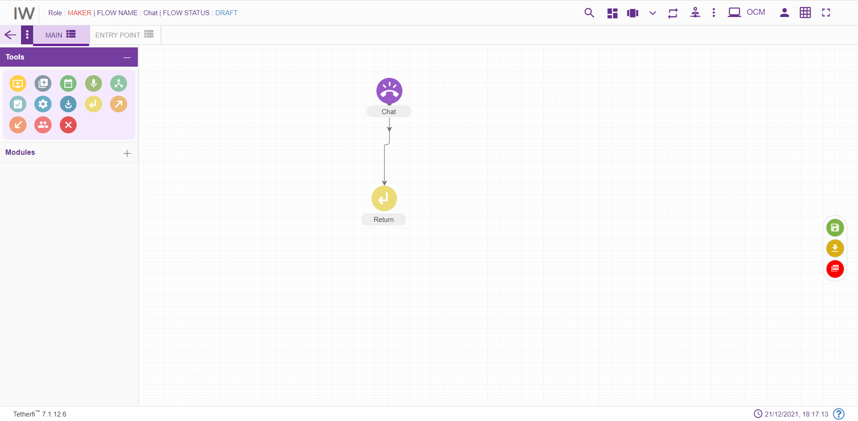

For editing/ configuring the return node, hover over the return node icon you added and edit/ delete functionalities for the return icon will be displayed.
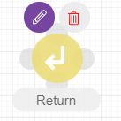
On click of edit button, the below screen will popup
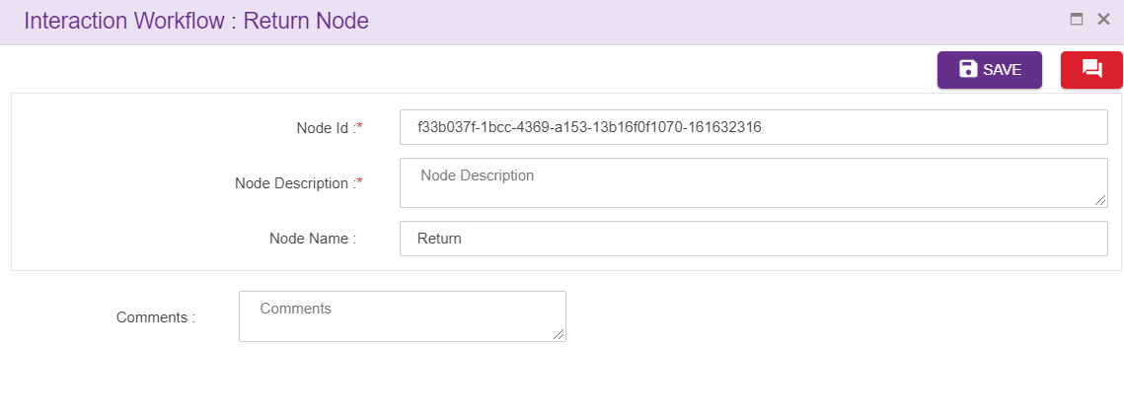
Node ID: By default, the node ID for a return node is autogenerated, but the Users have the privilege to assign their own ID. Each node ID should be unique. (Mandatory)
Node Description: Brief characterization of the agent Node. (Mandatory)
Name: Name of return node.
Delete Return Node
On click of delete button, the below screen will popup

Action node
For adding a new Action node to the chatflow, click on the “Action” icon and drag it to the main screen. Action node can be connected to only 1 node and it is a default connection (without label).
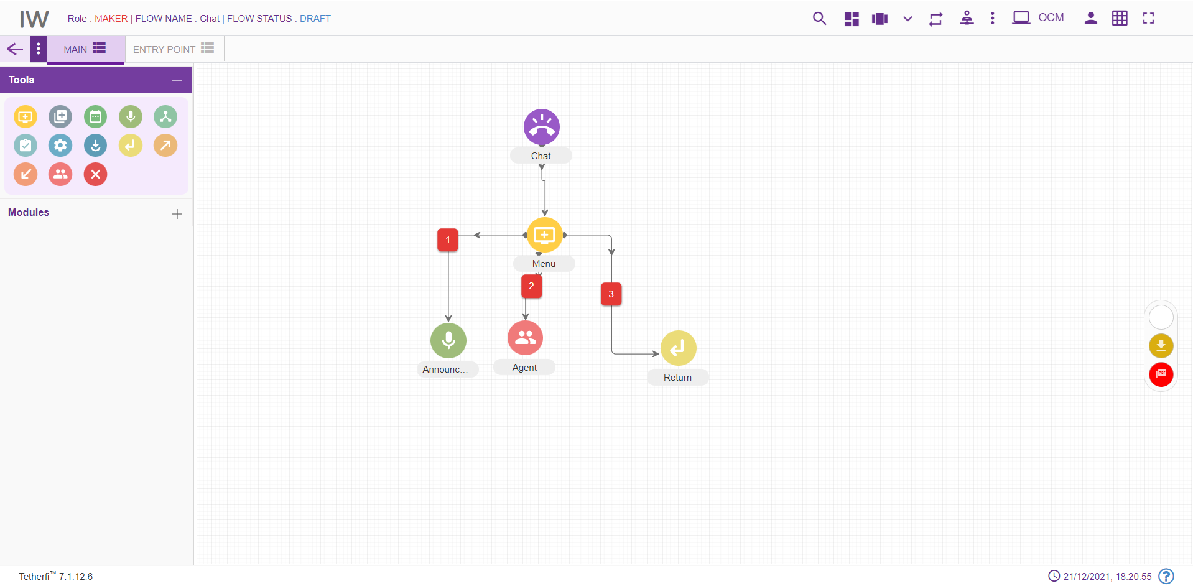
For editing/ configuring the Action, hover over the Action icon you added and edit/ delete functionalities for the Action will be displayed.
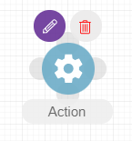
On click of edit button, the below screen will popup
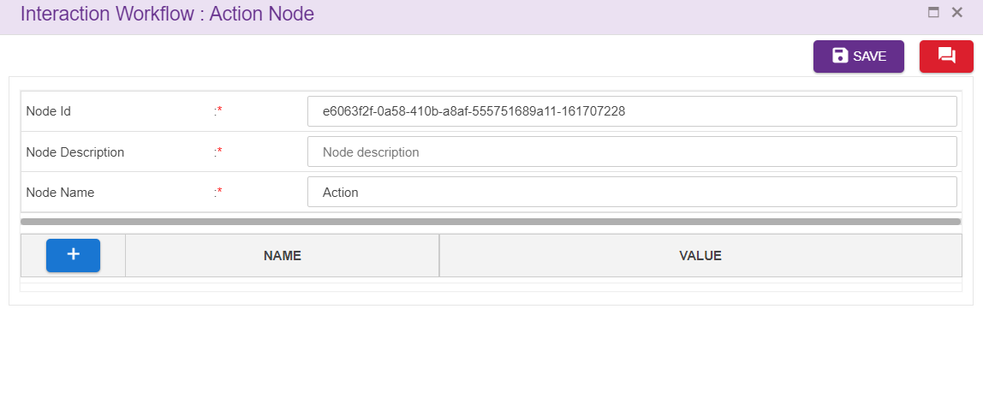
Node ID: This is a mandatory field. By default, the node ID for an Action node is autogenerated, but the Users have the privilege to assign their own ID. Each node ID should be unique. (Mandatory).
Node Description: Brief characterization of the agent Node. (Mandatory)
Name: This is a mandatory field. Name provided here will be reflected in UI. By default, the name is ‘Action’. But the Users have the privilege to assign their own name
’NAME’ field will display action variables, where ‘VALUE’ field displays both action and operational variables in the drop downs.
User can select the action variables added at the backend from the first drop down and assign the values to them in the value field provided. User can also select operational and action variables for value field by clicking drop down icon shown above.
User can configure the values to be displayed in the drop down in GlobalData.js file.
Delete Action node:
On click of delete button, the below screen will popup

Form Node
For adding a new Form node to the chatflow, click on the “Form” icon and drag it to the main screen. First connection from the Form node is a default connection (without label) and when there is no default connection between form and node, immediate connection will be the default connection.

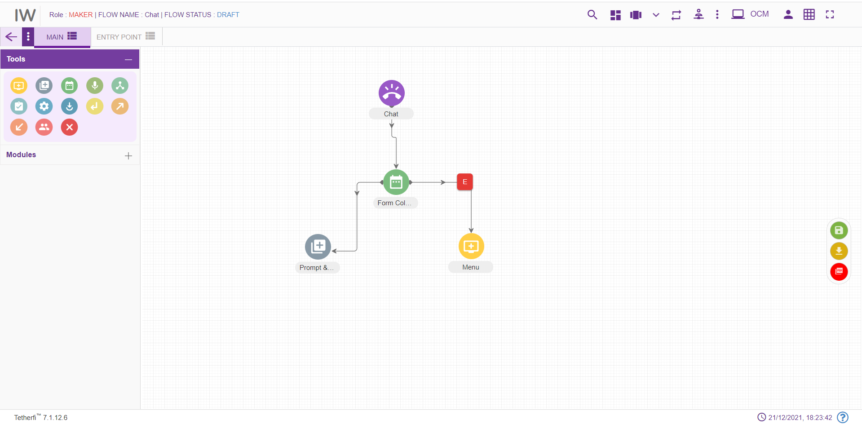
For editing/ configuring the Form, hover over the form icon you added and edit/ delete functionalities for the form will be displayed.
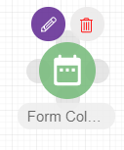
On click of edit button, the below screen will popup
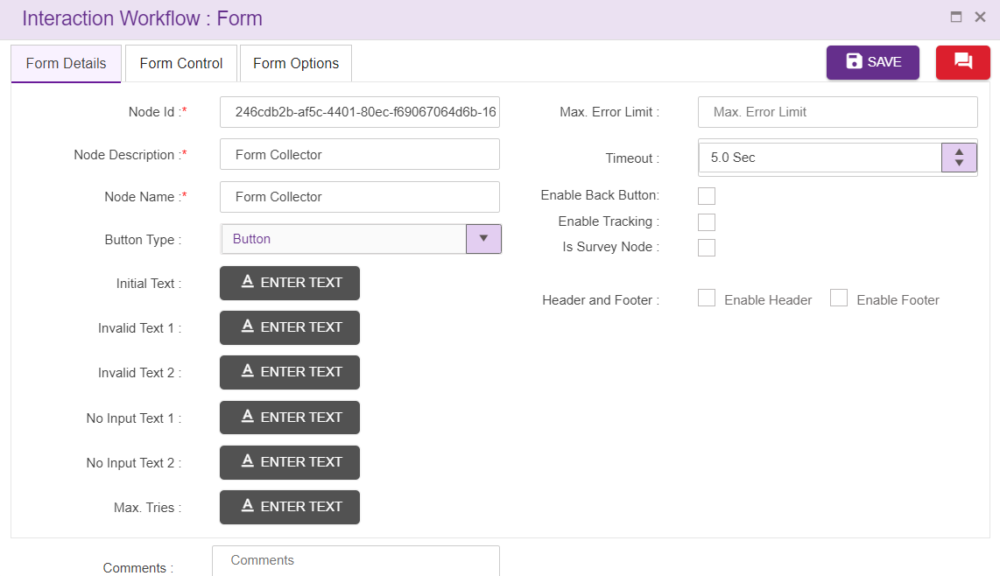
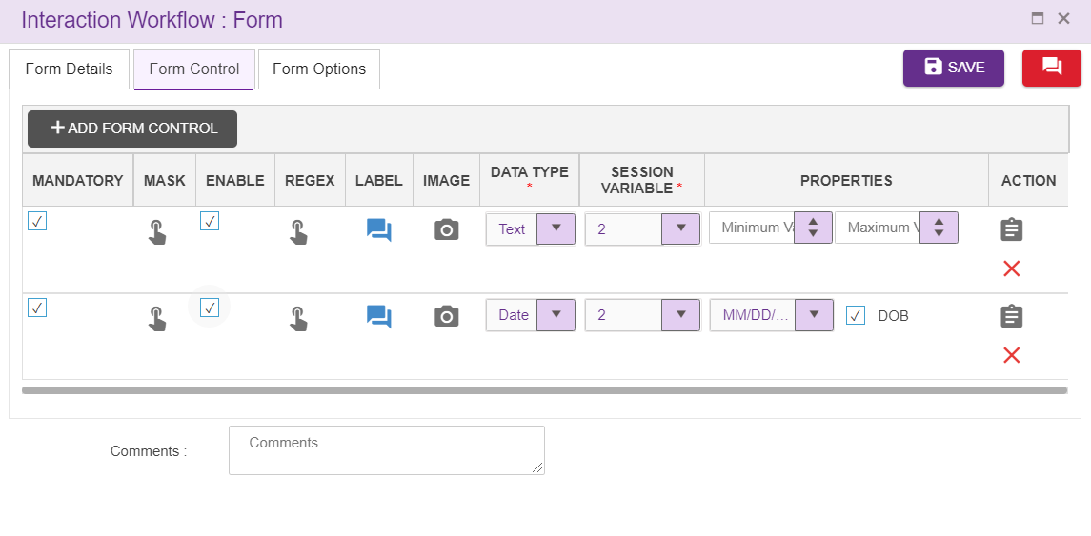
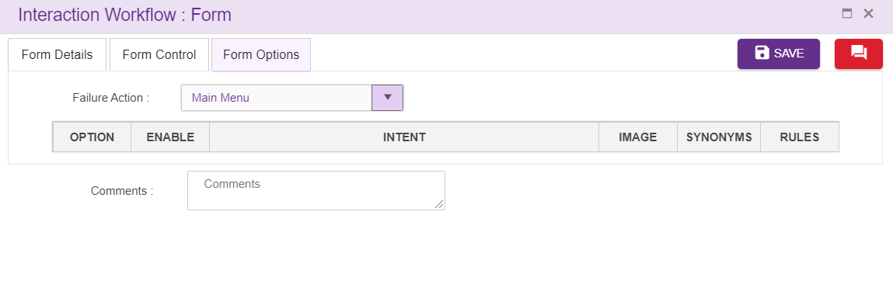

- Node ID: This is a mandatory field. By default, the node ID for an form node is autogenerated, but the Users have the privilege to assign their own ID. Each node ID should be unique. (Mandatory).
- Node Description: Brief characterization of the form Node. (Mandatory)
- Name: By default, the form Name is Form collector, but the Users have the privilege to assign their own form node Name. Each form node Name should be unique. This form Name will only be displayed in the Interaction workflow’s UI (Mandatory)
- Button Type: User can select the button type from the dropdown provided
- Initial Text: Text added here will be displayed to the user as an initial text. (refer section Text Selection window)
- Invalid Text 1 and 2: Allows the flow designer to add the texts and these texts are displayed when there is invalid input from user. The text to be displayed on invalid prompt event. The Language section in Call flow configuration segment is auto configured depending upon the languages selected in the Main node. (refer section Text Selection Window). For the new form node, these texts are copied from Main node.
- No Input text 1 and 2: Allows the flow designer to add the texts and these texts are displayed when there is no input from user. The text to be displayed on no input prompt event. The Language section in Call flow configuration segment is auto configured depending upon the languages selected in the Main node. (refer section Text Selection Window). For the new form node, these texts are copied from Main node.
- Max Tries: Allows the flow designer to add the texts and these texts are displayed when user exceeds maximum try limits. The text to be displayed when max tries exceeded. The Language section in Call flow configuration segment is auto configured depending upon the languages selected in the Main node. (refer section Text Selection Window). For the new form node, these texts are copied from Main node.
- Comment: This field is used to write comments
- Max Error Limit: Maximum attempts allowed in a DTMF in form
- Failure Action: Upon failure action provided here will be performed
- Timeout: This specifies the elapse time to enter user input. This field accepts decimal values too.
- Enable Tracking: When this option is checked, this node is tracked in session dashboard.
- Is Survey Node: Checked indicates survey is enabled.
- Survey Type: User can select the survey type from the dropdown provided which is used to measure customer experience.
- Question Type: When user select the survey type ‘long form’ from the dropdown provided, question type dropdown will display which is used to measure customer experience.
- Header: refer section Header
- Footer. refer section Footer
- Form Legs: refer section Menu Leg Options
Form Control Options:
Upon clicking ‘ADD FORM CONTROL’ option, fields to enter the form control option will be displayed as shown below.
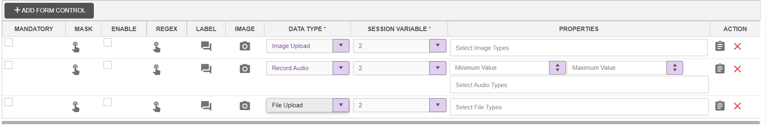
Mask: This option is used to mask the form control options. Upon clicking mask option, following popup will be generated.
- Session Variable: Session variable selected to store the value will be displayed here automatically
- Mask Filter: mask filet like first digit, last digit or position can be selected by the user
- Mask Length: length can be specified here. Note that, if Mask Filter is first digit / last digit, then 'Length' should be single integer value and if it is Position then, length should be comma separated integer value
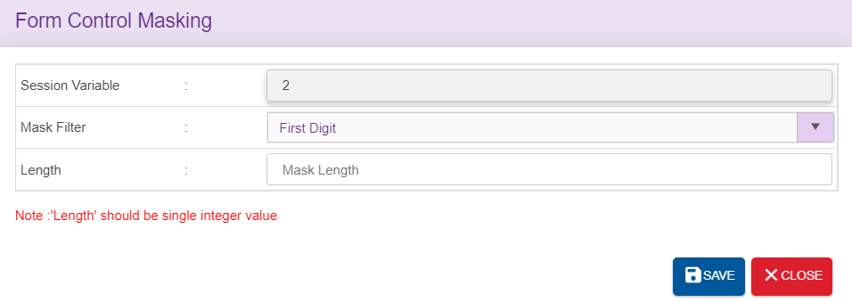
Enable: This option is used to Enable or disable the form option
Label: Text entered here will be displayed as form option in bot UI
Image: Image specific to each label can be added here
Data type: There are multiple data types supported here. Based on the datatype selected, property keys will be displayed.
Sl.No | Data Type | Properties
1 | Text | Min Length, Max Length
2 | Date | Min Length, Max Length
3 | Textbox | Min Length, Max Length
4 | Face Capture | Face Frame, Identity Frame
5 | Image Capture | Back Camera, Front Camera, Local Image Upload
6 | Image Upload | Select Multiple image types from the configured values
7 | Record Audio | Min Length, Max Length and Select Multiple audio types from the configured values
8 | Record Video | Min Length, Max Length and Select Multiple audio types from the configured values
9 | File Upload | Select Multiple file types from the configured values
10 | Security | Text/Password, Min Length
11 | Card Number | Amex, CVV, Expiry Date
12 | Date | Date Format, DOB
13 | Address | Street Line1, Street Line2, City, State, Zip Code
14 | Slider | Min Value, Max Value

Session Variable: Session variable is selected from the dropdown to store the value collected.

Node Changes
Different types if icons can be configured for node in Email which is available in folder.
- Dark icons
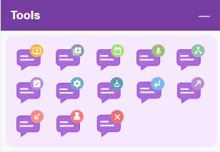
- Light icons
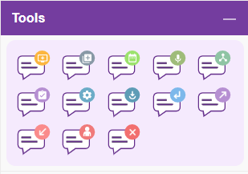

Node Connectivity

Start Node | End Node | Connection status (outgoing) | Connection status (incoming)
Main Node | All other nodes except Entry point node, module exit and conditional exit nodes | Single connection from main node | No incoming connection to Main node
Menu | All other nodes (including menu node) except Entry point node, module exit and conditional exit nodes | Multiple connection from menu node | Multiple connection to menu node
Announcement | All other nodes (including announcement node) except Entry point node, module exit and conditional exit nodes | Single connection from announcement node | Multiple connection to announcement node
Agent |  | No outgoing connection from Agent node | Multiple connection to agent node
Conditional node |  | No outgoing connection from conditional node | Multiple connection to conditional node
Conditional node legs | All other nodes (including Conditional node) except Entry point node, module exit and conditional exit nodes | Single connection from one leg of the conditional node | No incoming connection to Conditional node legs
Assignment | All other nodes (including assignment node) except Entry point node, module exit and conditional exit nodes | Single connection from assignment node | Multiple connection to assignment node
Prompt and Collect Node | All other nodes (including prompt and collect node) except Entry point node, module exit and conditional exit nodes | Multiple connection from menu node | Multiple connection to prompt and collect node
Entry Point Node | All other nodes except Entry point node, module exit and conditional exit nodes | Single connection from Entry point node | No incoming connection to Entry Point node
Disconnect Node |  | No outgoing connection from Disconnect node | Multiple connection to disconnect node
Exit Point Node |  | No outgoing connection from Exit point node | Multiple connection to Exit Point node
Module Node |  | No outgoing connection from Module node | Multiple connection to Module node
Module Node legs | All other nodes (including Module node) except Entry point node, module exit and conditional exit nodes | Single connection from one leg of the Module node | No incoming connection to Module node legs
Action Node | All other nodes (including action node) except Entry point node, module exit and conditional exit nodes | Single connection from action node | Multiple connection to action node
Return Node |  | No outgoing connection from Return node | Multiple connection to return node
Flow Connector Node | All other nodes (including Module node) except Entry point node, module exit and conditional exit nodes | Single connection from flow connector node | Multiple connection to flow connector node

Modules
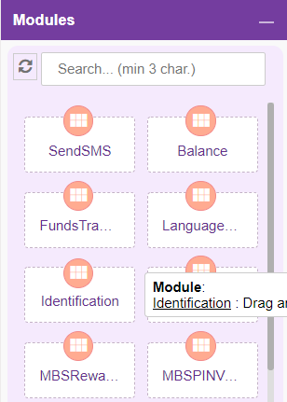
Modules are separable component, frequently one that is interchangeable with others, for assembly into units of differing size, complexity or function. Self-service transactions are implemented in module. Size of the default node which is associated with module node is smaller than module node.
For adding a new Module to the chatflow, click on the “Module” icon and drag it to the main screen.
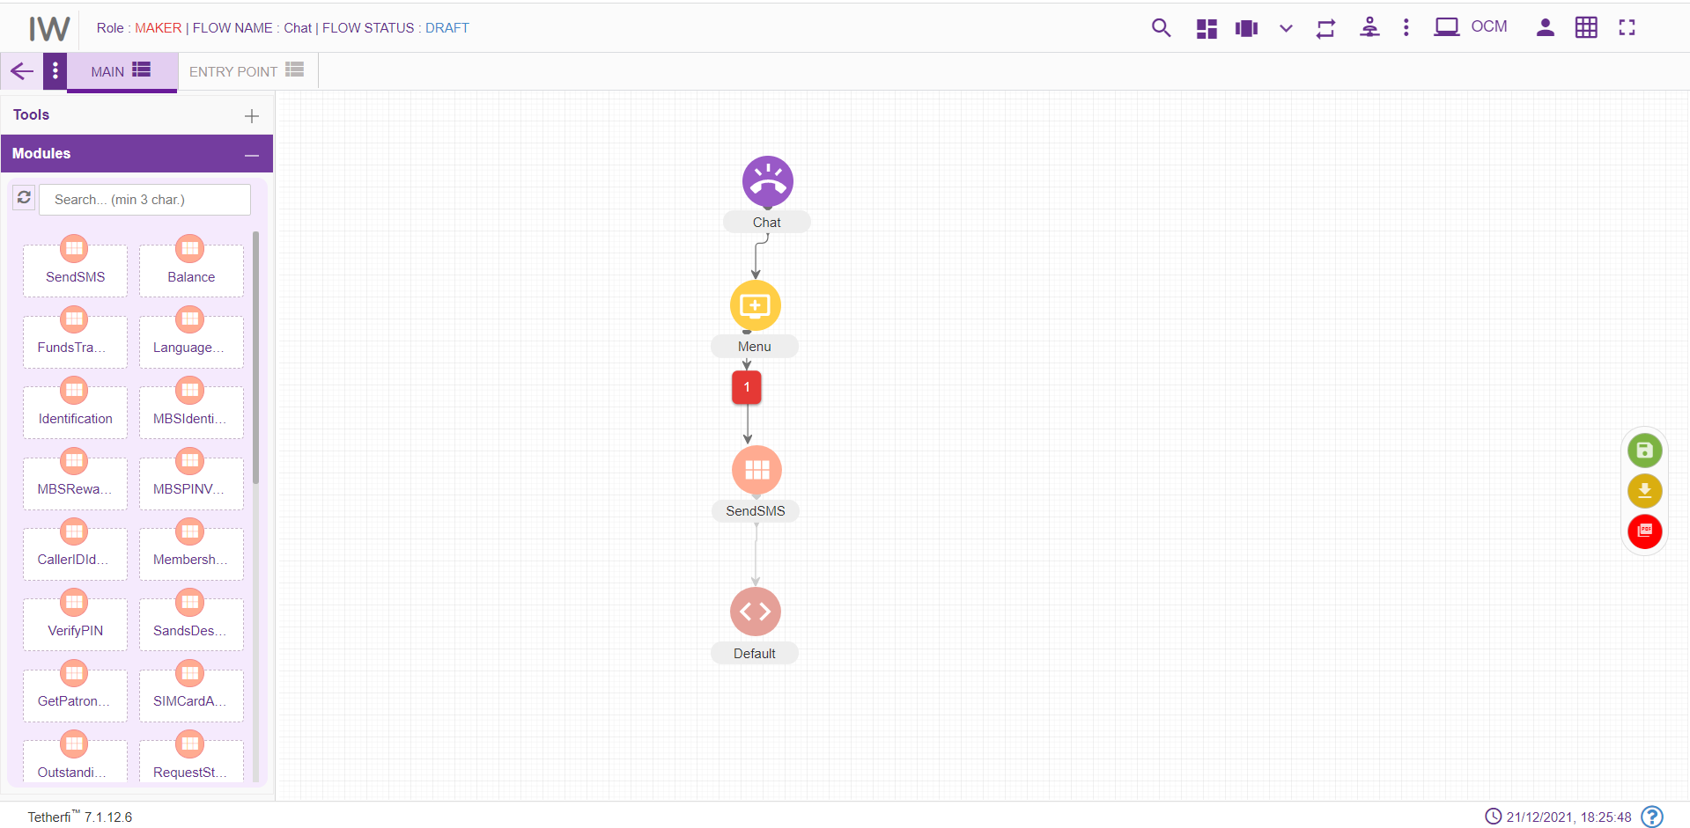
For editing/ configuring/ refreshing the Module, hover over the Module icon you added and edit/ delete functionalities for the menu will be displayed.
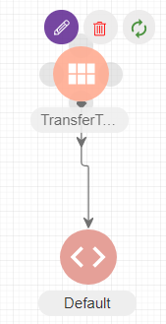
On click of edit button, module configuration details can be updated. ‘serviceID is the parameter for HostIntegration Module.
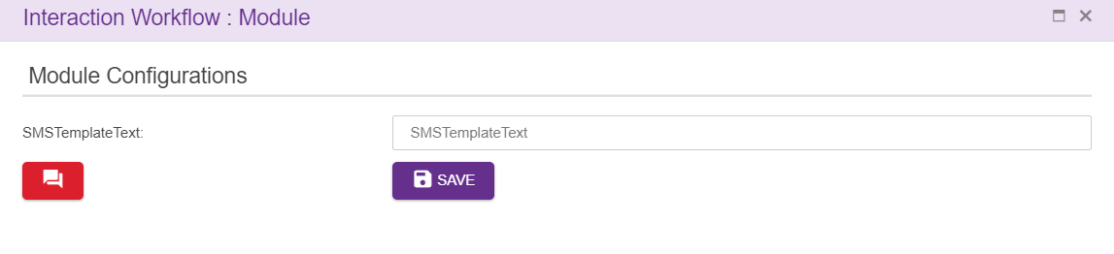
When a user adds new labels to the modules, he can update all the existing modules in the chatflow by clicking refresh/reload button as shown below.
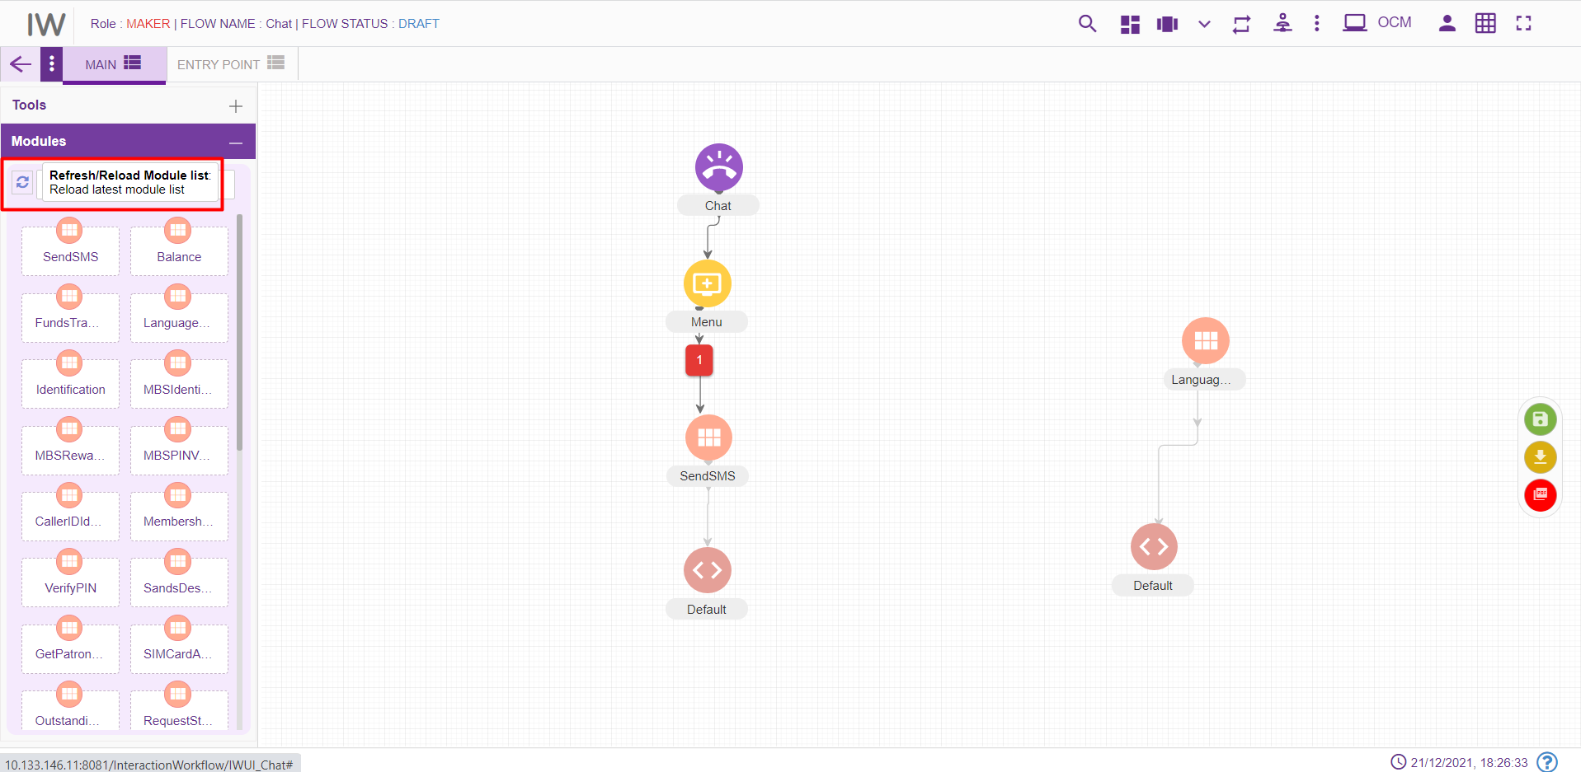

Upon clicking refresh/reload button following popup will generate to update existing modules in the chatflow. Chatflow must be in DRAFT status.
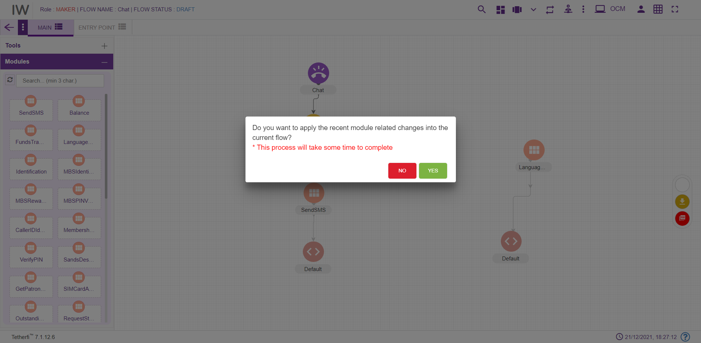
‘Yes’: all the modules present in the chatflow will be updated.
‘No’: changes will not reflect in the existing modules present in the chatflow.

IW Module Designer
This is the new Tetherfi application with is used to design the Module Flow. Just like Interaction workflow, there are set of nodes used to design the module flow. If there is a module flow designer in IW Module Designer application for the module dropped in IW, then IW will redirect the user to this IW Module designer application upon opening the module. If there is no Module flow designed in IW Module designer application for the module used in IW, then control will be there in IW.
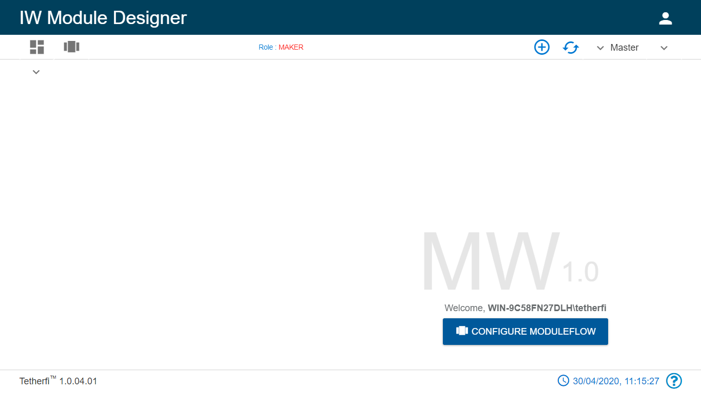
Refer the document attached.

Connecting Nodes and Modules
For interconnecting two or more Nodes/ Modules, you need drag the connecting link as shown below:
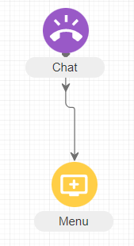

For deleting a node, double click on the connecting link and the below screen will be displayed:
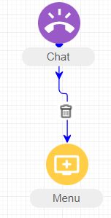
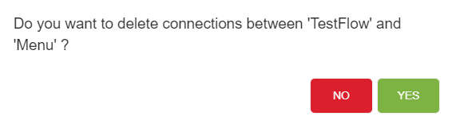

Context Menu
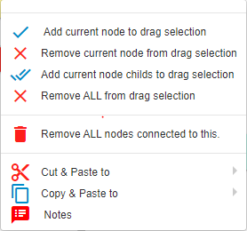

- Add current node to drag selection: Adds selected/current node to draggable. refer section Drag Nodes
- Remove current node from drag selection removes current node from drag selection. refer section Drag Nodes
- Add current node child’s to drag selection: Adds selected /current node and its child elements to draggable collection. refer section Drag Nodes
- Remove all from drag selection removes all the nodes from draggable collection. refer section Drag Nodes
- Cut and Paste: refer section Cut and Paste
- Copy and Paste: refer section Copy and Paste

Drag Nodes
If user wants to drag the set of the nodes to a different position in a tab, they can user ‘Add current node to drag selection’ , to include child nodes while dragging, can use ‘Add current node child’s to drag selection’.
To remove the nodes from drag selection, ‘Remove current node from drag selection’ and ‘Remove ALL from drag selection’ option can be used.

Remove ALL nodes Connected to This
This option is used if the user wants to delete a node along with immediate child nodes connected to this.
As shown below, user can delete menu node along with its child node at once, using this option.
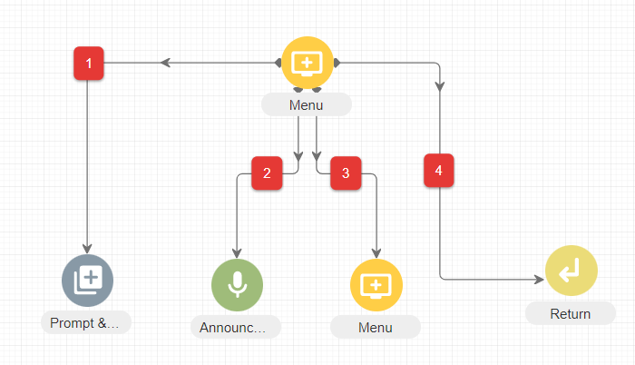

Copy and Paste
Copy and Paste feature is an important feature that can be used to ease the workload of the users. Nodes that are frequently used and need to be created multiple times with minimal changes.

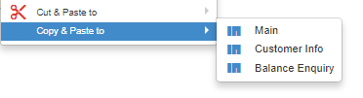
Steps to create a node/flow using Copy Paste feature:
- Right click on the node to be copied.
- Choose the tab to which the node must be copied.
- A confirmation message pops up. Include node connections can either be checked for opting node connections along with the node copy paste or not.

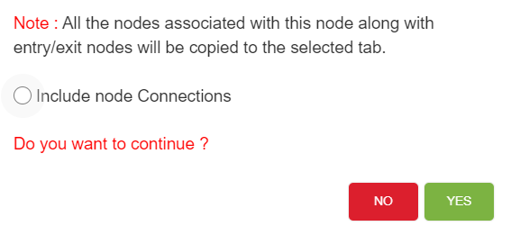
- Click on Yes to copy and paste.
- Node along with its connection will be copied to the same or another tab based on inclusion or exclusion of node connections.
- Click on No will close the window and node will not be copied.
There are certain conditions which has to be considered while copy pasting nodes. They are listed below.
- Main node cannot be copied to the same tab as well as another tab.
- Except Main node, all other nodes can be copied to the same tab as well as another tab.
- Cannot copy Conditional rule node and Module exit nodes. This feature does not exist for these 2 nodes which means user will not be able to see the copy
- A node can be copied if it has a parent node. But the copied node does not have a parent node. It will have the entire flow from the copied node.
- Node connections can be included or excluded while copying. If the node connections are excluded, all the nodes are copied from there onwards except for the node connections.
- If an exit node connected to an entry node which is present in other tab, upon coping the exit node, entry node will not be copied.
- If an exit node connected to an entry node which is present in same tab, upon coping the exit node, entry node will also be copied.

Cut and Paste
User is provided with Cut and Paste feature to manage the callflow creation/updation efficiently.
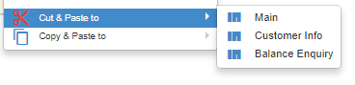
Steps to create a node/flow using Cut and Paste feature:
- Right click on the node to be copied.
- Choose the tab to which the node must be copied. It cannot be the same tab. Error message is thrown to indicate the same.
- A confirmation message pops up.

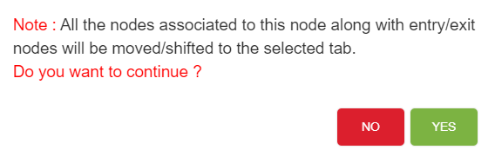

- Click on Yes to cut and paste.
- Node along with its connection will be pasted to selected tab. Node and its connection will not be available in the original tab.
- Click on No will close the window and node will not be cut and pasted.
- Node connection will be cut and pasted by default along with the node.
There are certain conditions which has to be considered while cut and pasting nodes. They are listed below.
- Main node cannot be cut and pasted to the same tab as well as another tab.
- Except Main node, all other nodes can be cut and pasted to another tab.
- No nodes can be cut and pasted to the same tab
- Cannot cut and paste Conditional rule node and Module exit nodes. This feature does not exist for these 2 nodes. Error message will be generated. ‘Cannot move/shift conditional rule node’.
- A node cannot be cut and pasted if it has a parent node. If there is an attempt to cut and paste the node, error message ‘Please break connections from this node’s parent.’ Will be displayed.

Sticky Note
User is provided with sticky note feature to add information about particular node
Steps to create sticky note:
- click on the note option and following note will appear
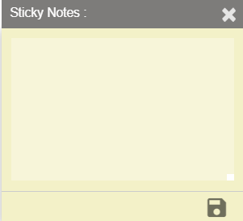
User can add notes here and save using save button which is present at right bottom of sticky note. Upon saving the note, indication will be provided in the node level as shown below.
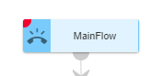
Note: User can add the sticky note to any node/node legs only in DRAFT status of the callflow. Error message is generated when user try to add sticky note to a node in a callflow whose status is not DRAFT.
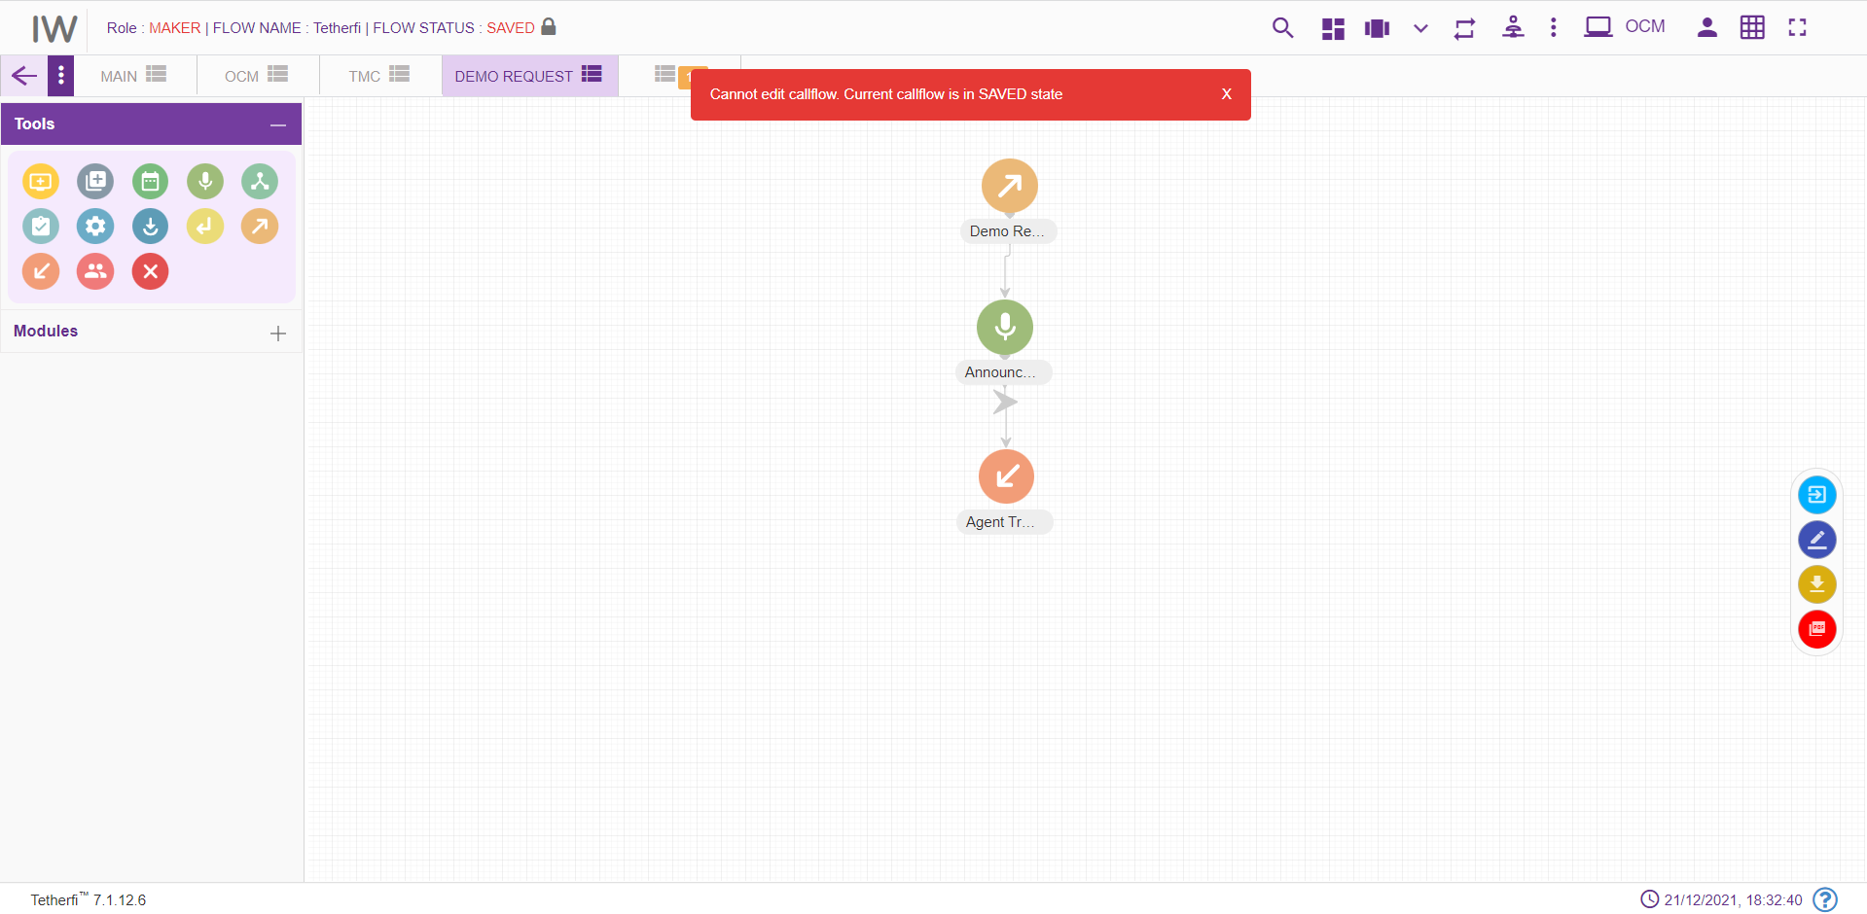

Dashboard
Upon clicking dashboard icon, following page will be displayed.
All the created as well as imported chatflows will be displayed here. In dashboard, chatflows of all the status are displayed for maker, checker and previewer.
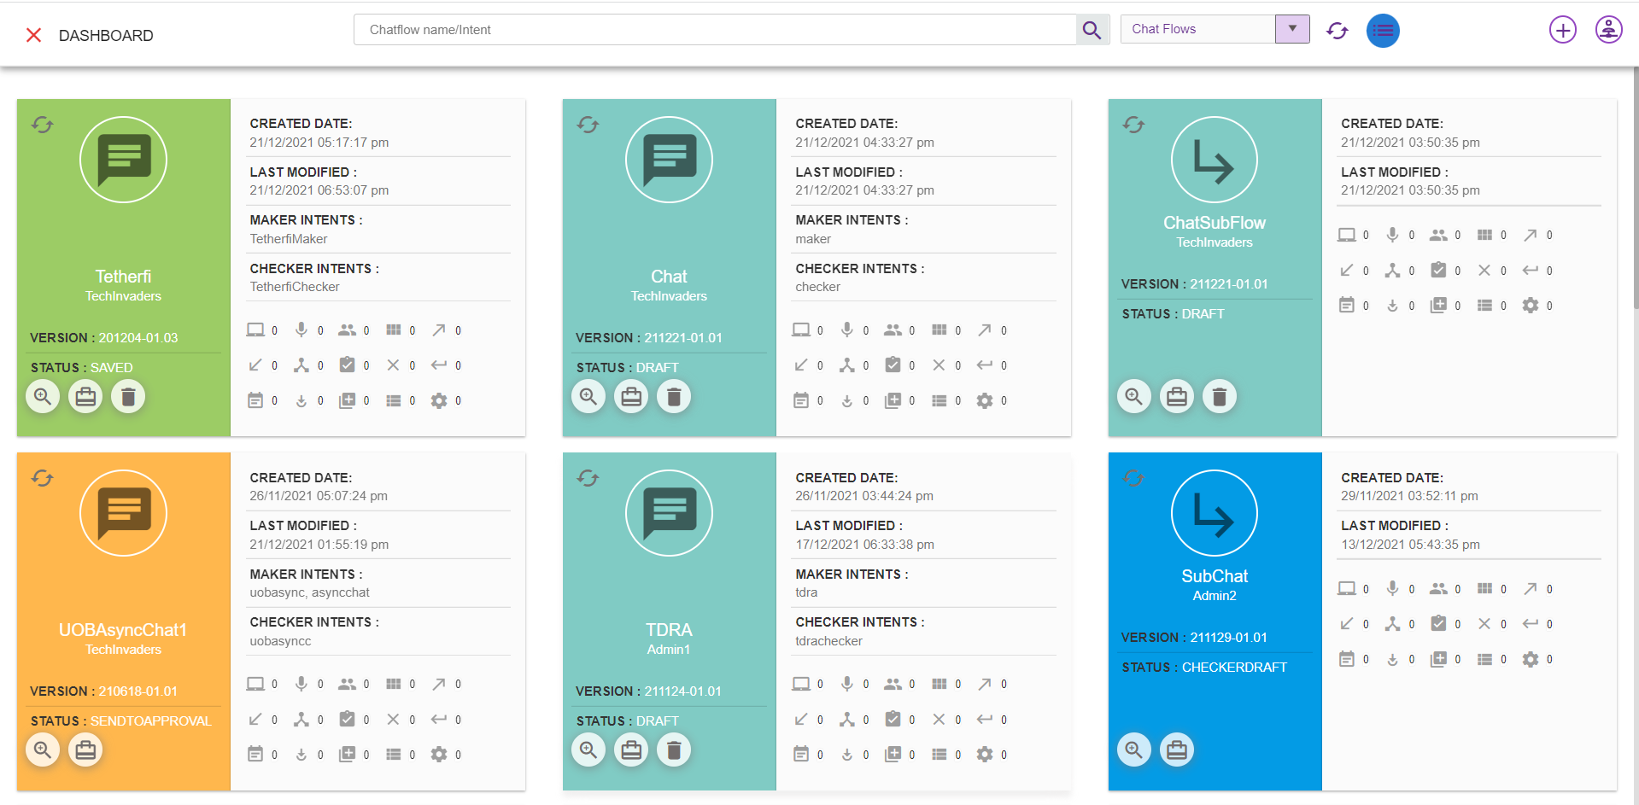
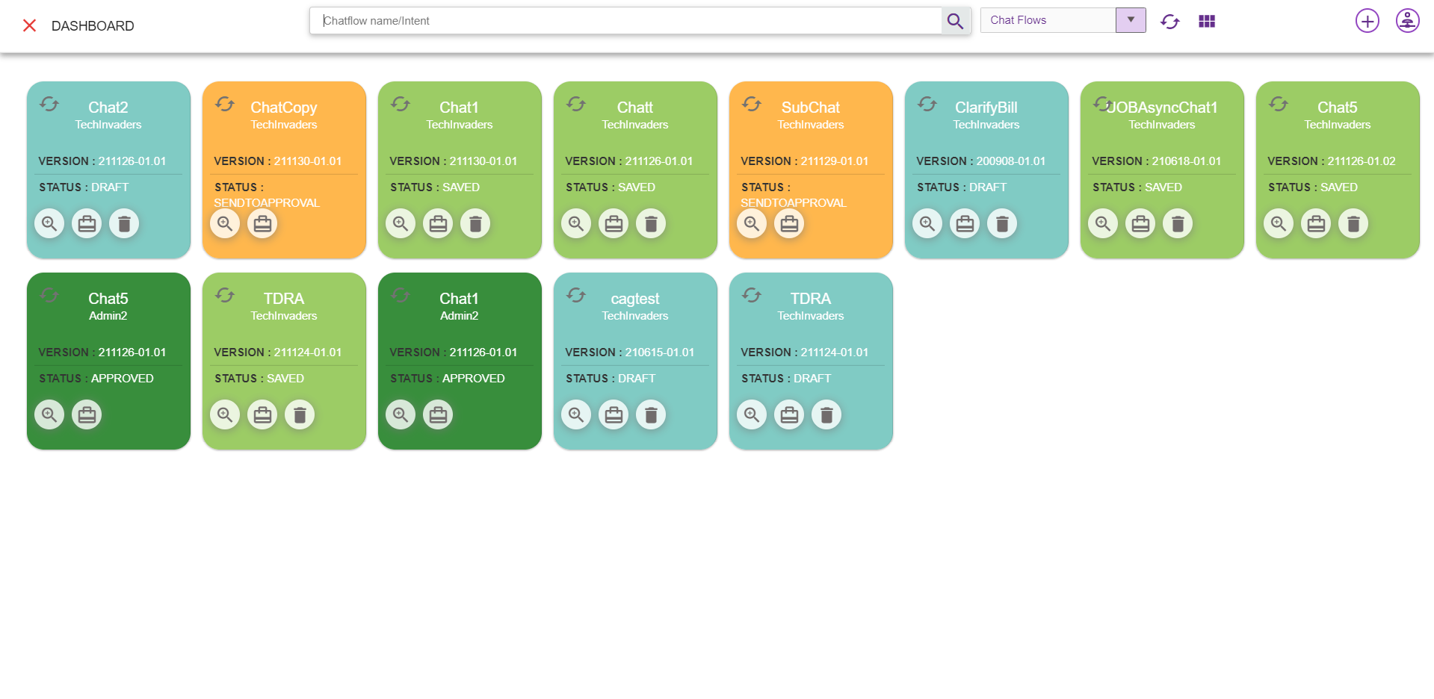
      - Chatflow Name/Intent: Enter Callflow name or Intent to search
Search for Chatflow: This option is used to search the particular chatflow based on chatflow name and intents.
      - Add New IW flow: Configure a new chatflow (refer section New IW Flow). This option is only provided for Maker.
      - Masters: Masters can be accessed in dashboard
      - Refresh Dashboard: Refresh the dashboard. Updates the chatflow lists with latest changes
      - Preview Chatflow: This option is used preview a chatflow (refer section Preview )
      - Real-Time chatflow View/Report: This option is used to view the callflow. Here user cannot change or modify any callflow. He can just view the chatflows (refer section Real-Time View/Report ).
      - Chatflow Build/Package: Chatflow will be packed, and zip file will be downloaded. This zip file will contain chatflow related data. This zip file can be imported (refer section Import Chatflow) at other systems. This option is not available for previewer.
      - Delete Chatflow: This option is used to delete a chatflow. Only Owner of the chatflow can delete chatflow. And chatflow should be in DRAFT and SAVED state.
      - dropdown: This dropdown contains option to display chatflow, Subflow and ordertake flow in dashboard. User can select which option is required.
Chatflow: upon selecting callflow option, all the IW flows will be displayed. This chatflow contains dnis numbers
Subflow: upon selecting subflow option, all the subflows flows will be displayed. This is a subflow can be used by callflow as well as other subflows. These flows do not have dnis number.
Ordertake: upon selecting ordertake flow all the ordertake flows will be displayed

- Note: chatflow which has only Main node cannot be deleted.

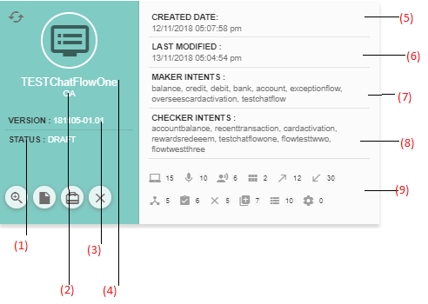
- Status: This option is used to display current status of the chatflow
- User: Last modified user.
- Version: Current version of the flow.
- Flow Name: Chatflow name
- Created Date: Created date and time. (during imported chatflow, created and modified date and time will be same).
- Last Modified: Last modified date and time. The time at which user has saved/ sent for approval/ approved/ rejected/scheduled is updated here.
- Maker Intents: Lists of Maker intents.
- Checker Intents: Lists of Checker intents.
- Nodes, Modules, tab count: All the nodes/modules/tabs used in a chatflow along with their count will be displayed here.
When a chatflow is imported, it will be displayed in dashboard and its status will be ‘DRAFT’.
When user try to load a new chatflow on top of existing active chatflow, save confirmation popup will be generating as shown below.
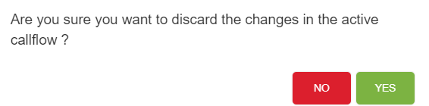
If Yes, Changes done in the active chatflow will be discarded and new chatflow selected here will be loaded.
If No, User can continue with the existing active chatflow.

Flow Status

Flow status for various users

Flow Status | Previewer | Maker | Checker
DRAFT | Yes | Yes | Yes
SAVED | Yes | Yes | Yes
SENDTOAPPROVAL | Yes | Yes | Yes
CHECKERDRAFT | Yes | Yes | Yes
CHECKERSAVED | Yes | Yes | Yes
APPROVED | Yes | Yes | Yes
SCHEDULED | Yes | Yes | Yes
REJECTED | Yes | Yes | Yes

Draft
Initially when chatflow is created, a status of the chatflow will be in ‘DRAFT state and only the owner(maker) of the chatflow can edit the chatflow until owner release the chatflow (chatflow state to ‘SAVED).
Maker can delete a chatflow whose current status is ‘DRAFT’. Chatflow which has only MAIN NODE node cannot be deleted even if it is in ‘DRAFT’ status.
In order to change the current status to ‘DRAFT’, click on ‘Edit chatflow button as shown below. Upon clicking this button status of the flow will change to ‘DRAFT’. User can add, delete or edit a tab in draft status only.
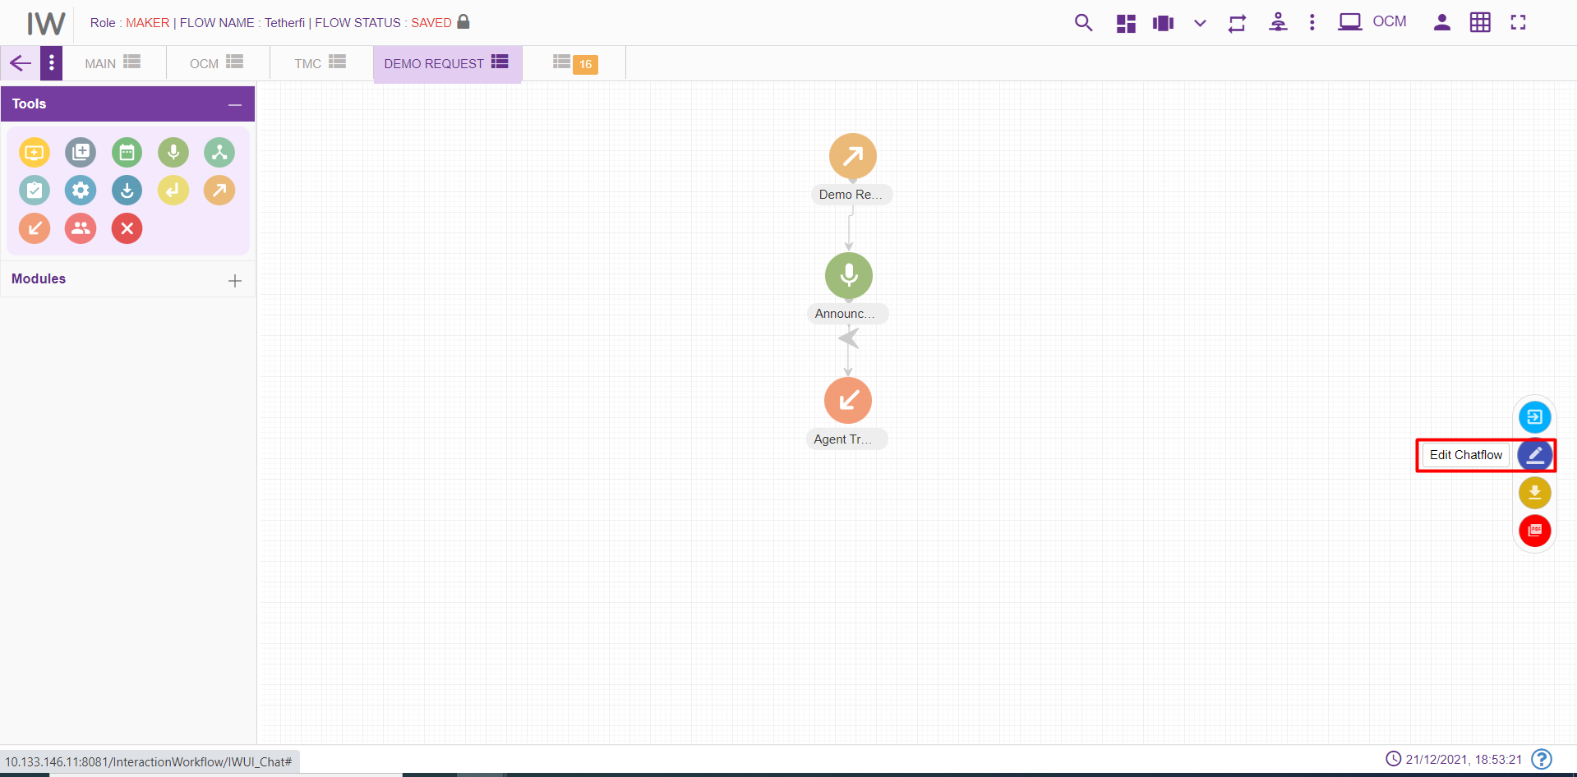

Saved
In order to run a chatflow and to send a chatflow for approval, its status must be in ‘SAVED’ state. Click on the ‘Save chatflow button as shown below to save a chatflow.
Upon clicking this button status of the flow will be changed to ‘SAVED’. Maker can delete a chatflow whose current status is ‘SAVED’. Chatflow which has only MAIN NODE node cannot be deleted even if it is in ‘Saved’ status. Chatflows whose status is saved, can be accessed by other user (other than owner) and make changes by changing its state to ‘DRAFT’.
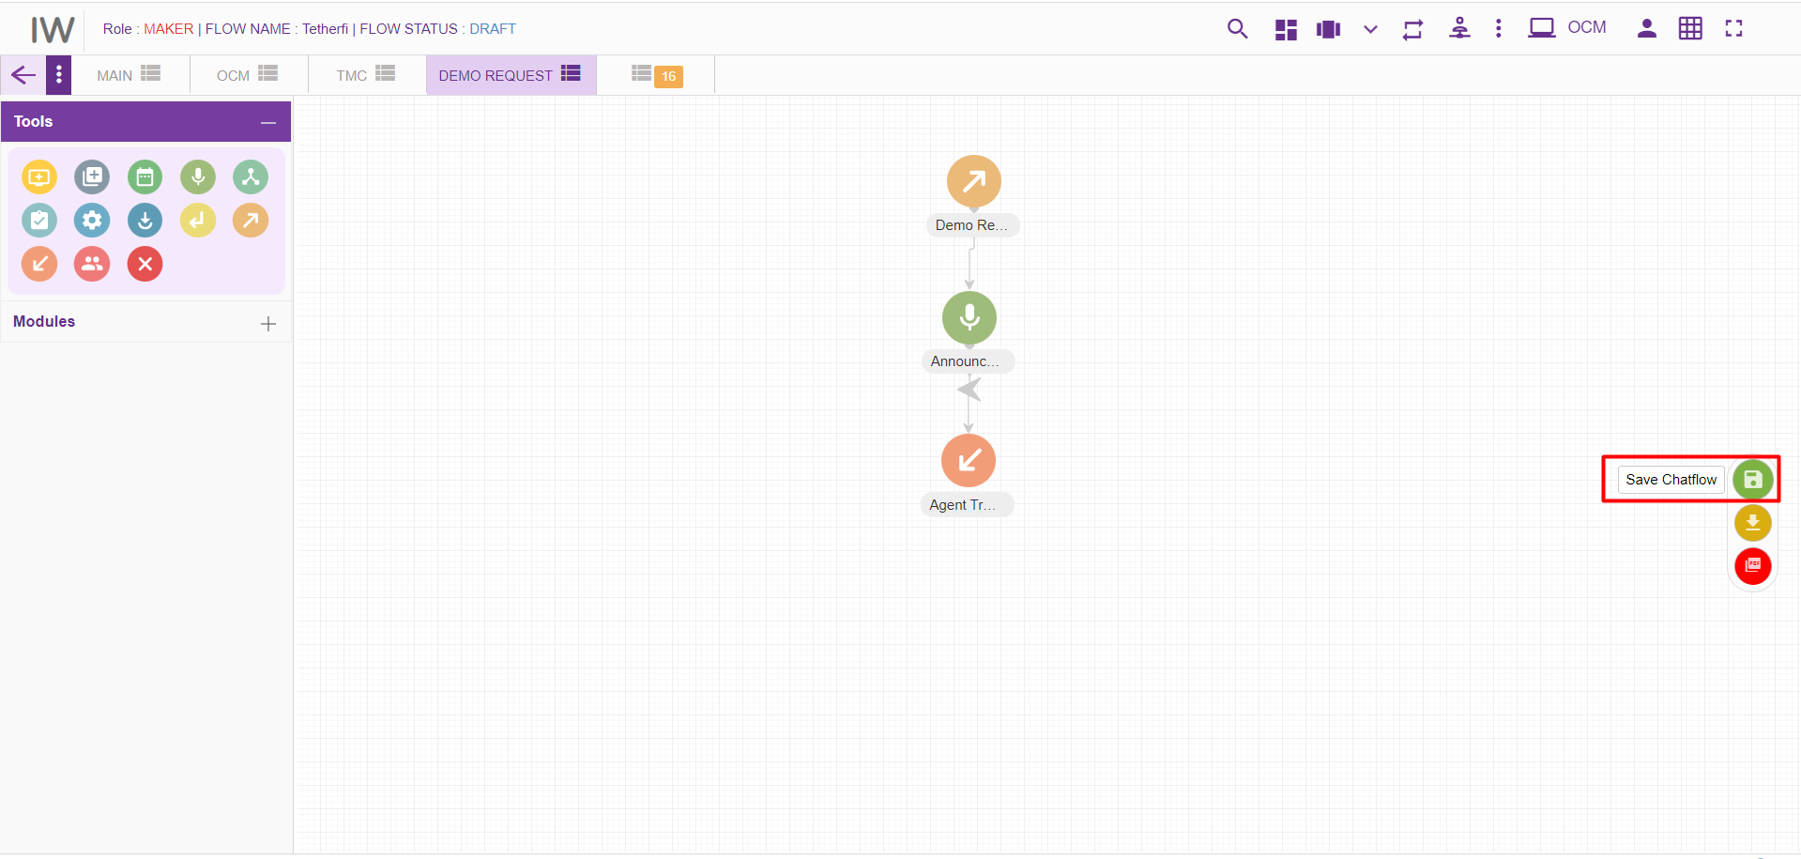

Send to approval
All the chatflows created by maker must be approved by the checker to complete its cycle. ’SENDTOAPPROVAL’ option is used to send a chatflow to checker for approval. Upon clicking this button status of the flow is will change to ‘SENDTOAPPROVAL’.
Maker cannot delete a chatflow whose status is ‘SENDTOAPPROVAL’.
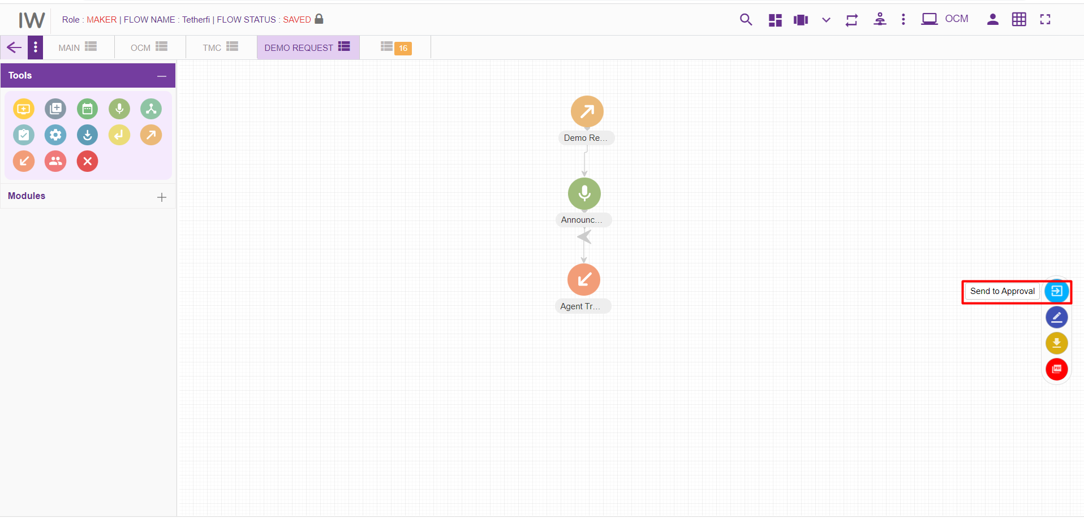

Checker Draft
A chatflow will be in this status when checker edits a chatflow. Note that checker can only put comments on each node. He can neither edit a chatflow (i.e. adding new nodes) nor delete a flow. Upon clicking ‘Edit Chatflow button in checker page, status of the chatflow is changed to ‘CHECKERDRAFT’.
Maker cannot delete a chatflow whose status is ‘CHECKERDRAFT’.
Upon clicking ‘Edit Details’ option from node level as shown above, following page will be displayed.
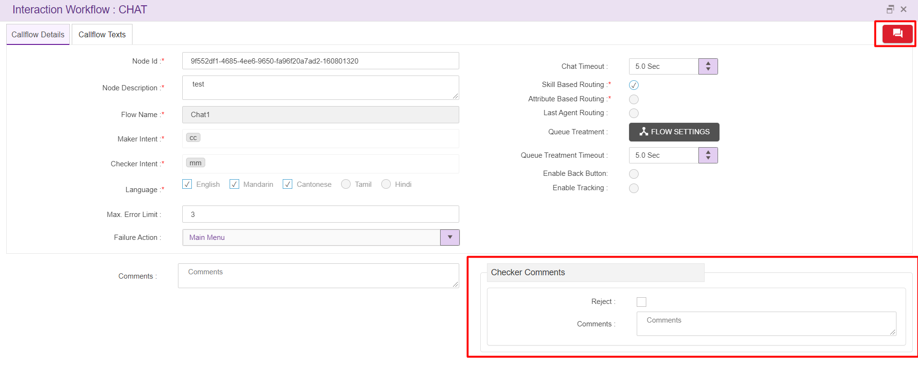
Now checker can enter ‘comments’ specific to the nodes and also can ‘view comments’ from either maker or previous checkers.
Upon clicking ‘View Comments’ icon, following window will be displayed.

Checker Save
To approve/reject a chatflow, it’s status must be either SENDTOAPPROVAL or CHECKERSAVED. When checker Clicks ‘Save chatflow button, flow status will be changed to ‘CHECKERSAVE’. Checker can approve a chatflow even after putting comments. When a Checker cancel the scheduler, chatflow status will be changed to ‘CHECKERSAVED’.
Chatflow whose status is ‘CHECKERSAVE’ cannot be deleted.

Approved
When a checker approves a chatflow, its status will be changed to ‘APPROVED’. Click on the button as shown below in order approve a chatflow. Note that, node blink will be stopped once the chatflow is APPROVED.
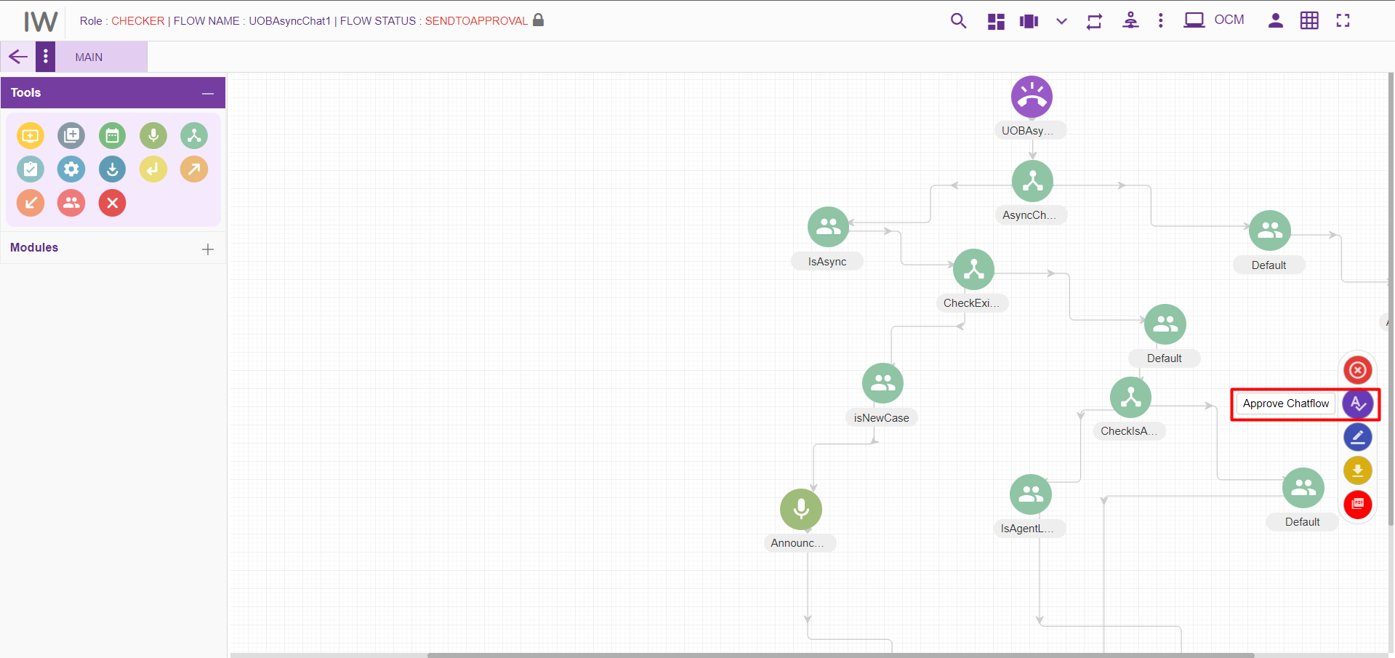
Once the checker approves a chatflow, it cannot be deleted. Upon clicking on ‘Edit’ button on loading an approved chatflow, new version of the chatflow is created.
Note: user can create only 1 draft chatflow from approved chatflow. User cannot create the draft version chatflow from approved version if there is already a chatflow with same name which is in SAVED, SENDTOAPPROVAL, CHECKERDRAFT, CHECKERSAVED, REJECTED, SCHEDULED status.
Error message will be generating when user try to create 2nd draft version of the chatflow from approved version, where first version of the chatflow is still not approved.
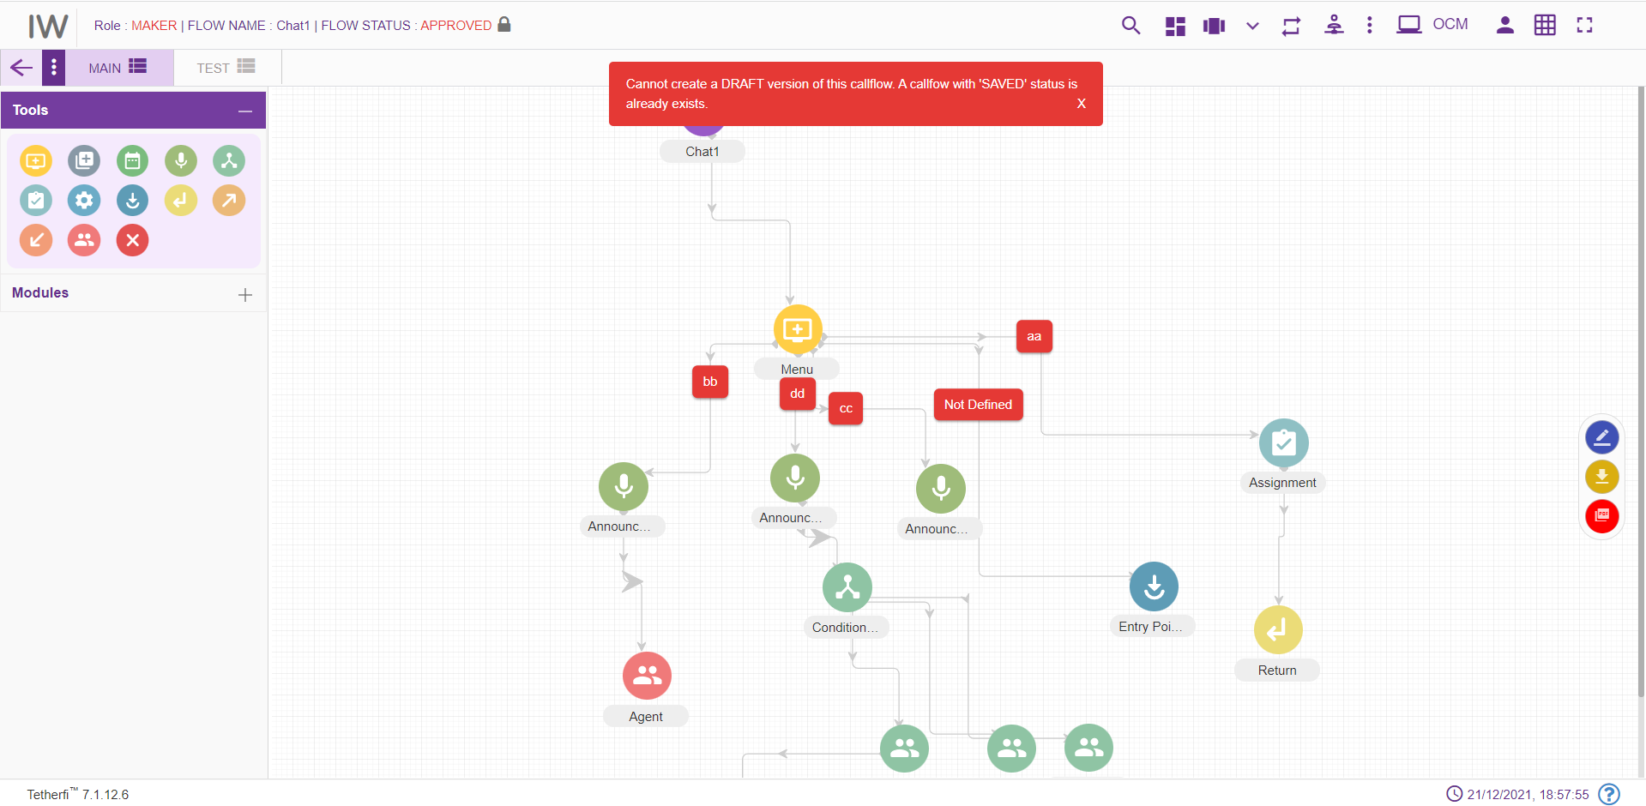

Rejected
Once the checker rejects the chatflow, flow status is changed to ‘REJECTED’. Maker can again edit the rejected chatflow and send for approval. Checker can reject the chatflow without adding any comments to the nodes. Click on the button as shown below in order reject a chatflow.
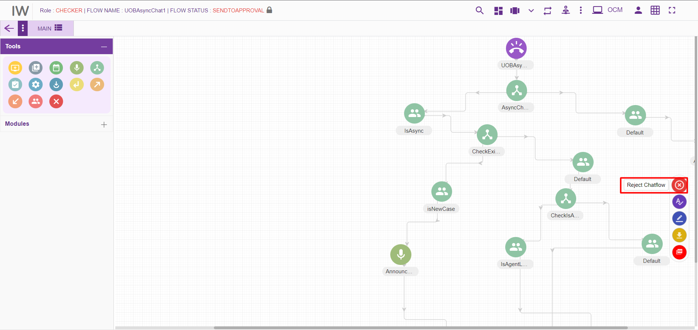

Scheduled
Checker can also schedule a chatflow. Upon scheduling a chatflow, its status is changed to ‘SCHEDULED’. Note that scheduled chatflow cannot be deleted. Scheduled chatflow cannot be approved by the checker. Once the checker cancels the scheduler, status of the chatflow is changed to ‘CHECKERSAVED’. Then the checker can approve this chatflow.
Note that, Node blink will be stopped once the chatflow is SCHEDULED.
Click on the ‘Approve callflow’ button as shown below.
Click on ‘SCHEDULE LATER’ option as shown below.
Enter scheduling date and time with comments to schedule a chatflow and press ‘SUBMIT’ button.
‘Cancel Schedule’ button is used to cancel a scheduled chatflow. Upon cancelling the schedule, chatflow status is changed to ‘CHECKERSAVED’. Once the user schedules the chatflow, same user can only cancel the Scheduled callflow. Another user cannot cancel the scheduled chatflow.

Static Flow related Buttons
There are static flow related buttons provided when chatflows are in different status. As shown below, when chatflow is in DRAFT status, ‘Save Chatflow button will be displayed.
User can move this button to anywhere in the page and click them to perform SAVE, SEND TO APPROVAL, APPOVE operation on chatflow.
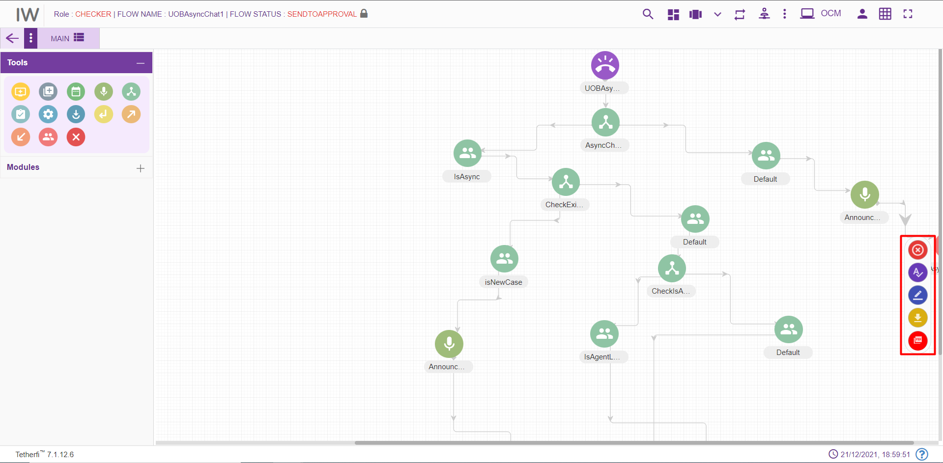
Sl.No | Chatflow Status | Static Buttons Displayed
1 | DRAFT | Save Chatflow
2 | SAVED | Edit Chatflow, Send to approval
3 | SEND TO APPROVAL | Reject Chatflow, Approve Chatflow, Edit Chatflow
4 | CHECKER DRAFT | Save Chatflow
5 | CHECKER SAVED | Reject Chatflow, Approve Chatflow, Edit Chatflow
6 | APPROVED | Edit Chatflow
7 | REJECTED | Edit Chatflow

When chatflow is in DRAFT status, SAVED button will start blinking after a configured time expires, which will indicate the user to save the flow, as shown below.
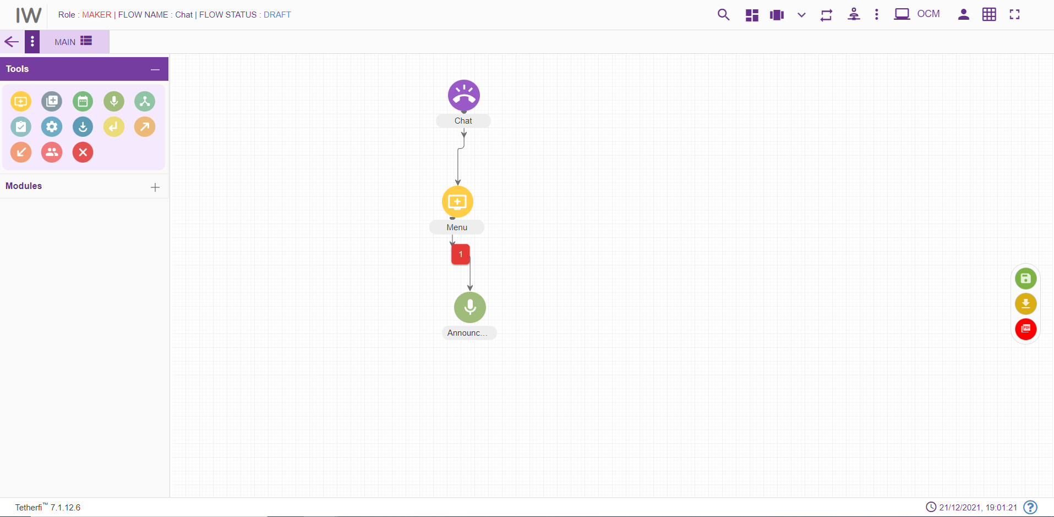

Node Blink
When checker rejects the node, node will blink in maker and maker-checker page. Tab will also blink in maker and maker-checker page, when a node in the tab is rejected by a checker.
Only maker modified nodes will blink in checker page. Note that rejected nodes will not blink in checker page unless maker modify the nodes.
For Exp: When a new chatflow is created, all the nodes will blink in checker page, since all the nodes are new (i.e. modified).
When a chatflow is approved / scheduled node blink will be stopped. If the chatflow status changed to CHECKERSAVED after cancelling the SCHEDULE, nodes will not blink even though they are modified.

Use Case
Please consider the below shown example:
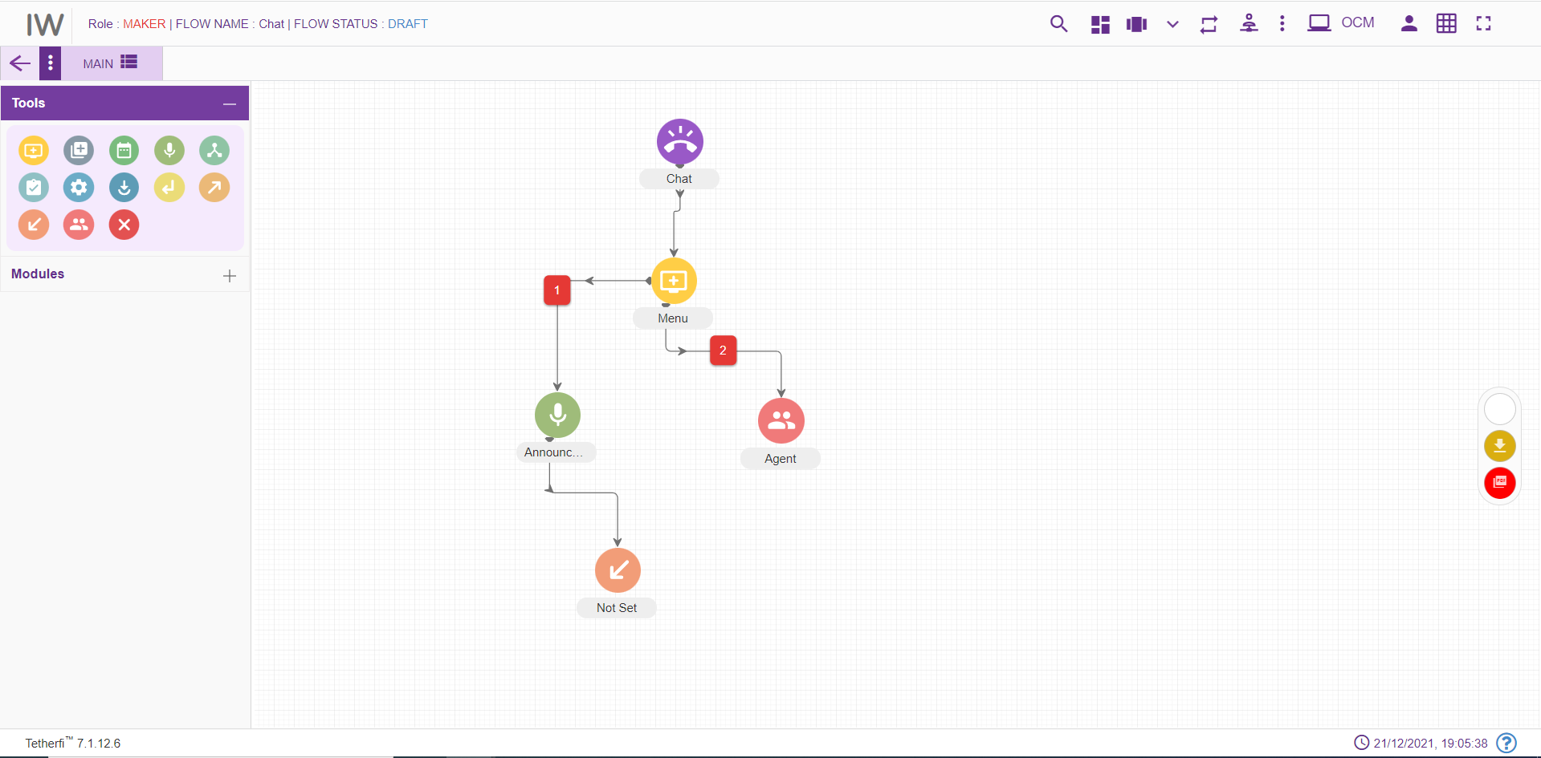
Below are the mentioned are the steps for recreating the above workflow

Step 1: Creating a new MAIN NODE node- TestChatFlow (Level 1)
- On click of Configure Callflow button, the below window will pop up:
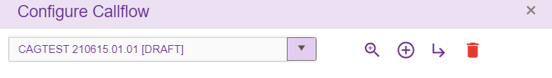
- Click on ‘Create New IW flow’
- Enter the details into the MAIN NODE details screen as shown below:
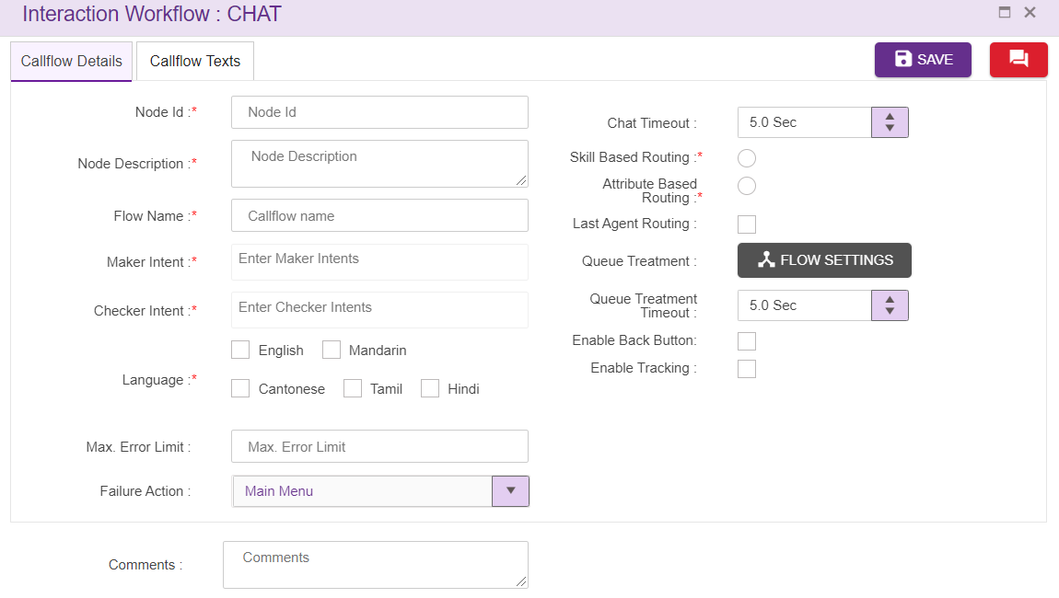
While creating a new MAIN NODE Details please note the below points:
- Maker and Checker Intents: The intents should be unique. Type the ‘DefaultMaker’ as Maker intent and click “Enter” button to save the intent and/or click “,” (comma) to add another intent. Maker and Checker intents cannot be same. Similarly add ‘DefaultChecker’ as Checker intent
- Flow Name: Enter “TestChatFlow” as call flow name
- Greeting: For addition of texts for Greeting, click on ‘ENTER TEXT’ and add a text as shown below
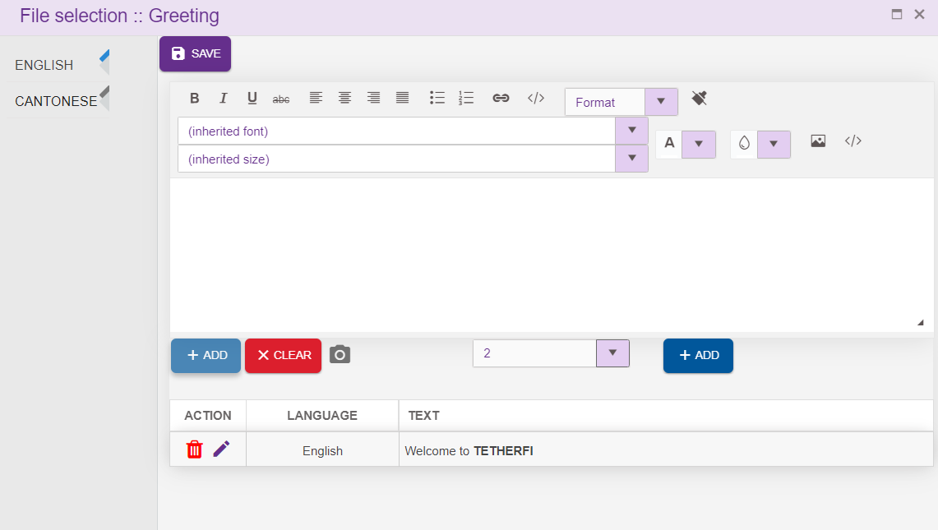
- Language: Select English as language. (Mandatory). The Language selection in Call flow configuration segment will be auto configured depending upon the languages selected in the Main node.
- Comment: Providing a comment before saving is not mandatory.
- Max Error Limit: Maximum attempts allowed in a DTMF in menu as “3”
- Set failure action as ‘main menu’
- Set Interval Timeout as 5 sec
- Invalid Texts 1 and 2: Enter the text to be displayed on invalid prompt event as shown below:
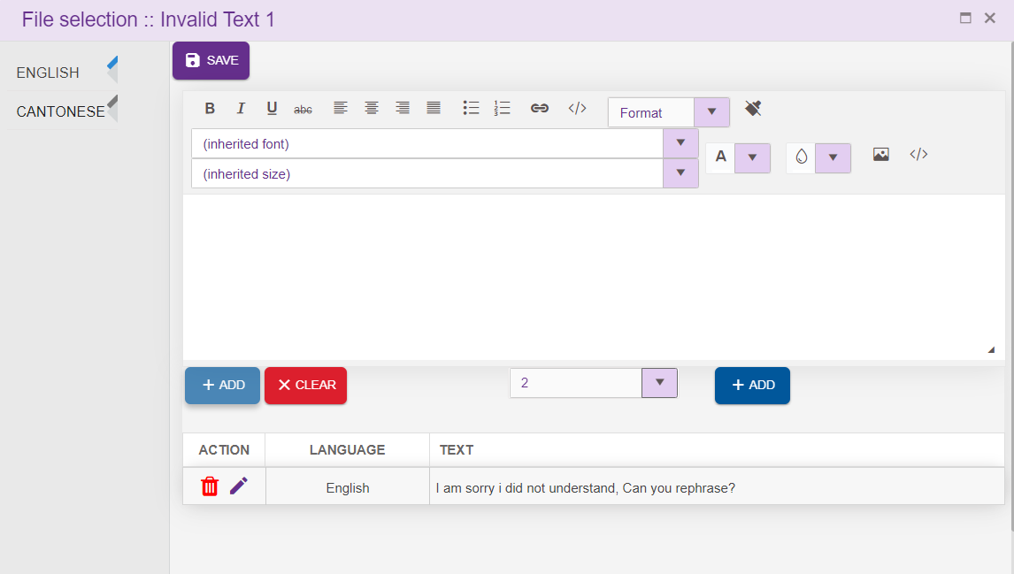

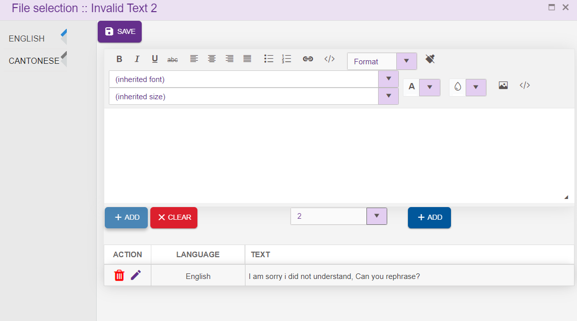
- No Input Text 1 and 2: Enter the text to be displayed on no input prompt event as shown below

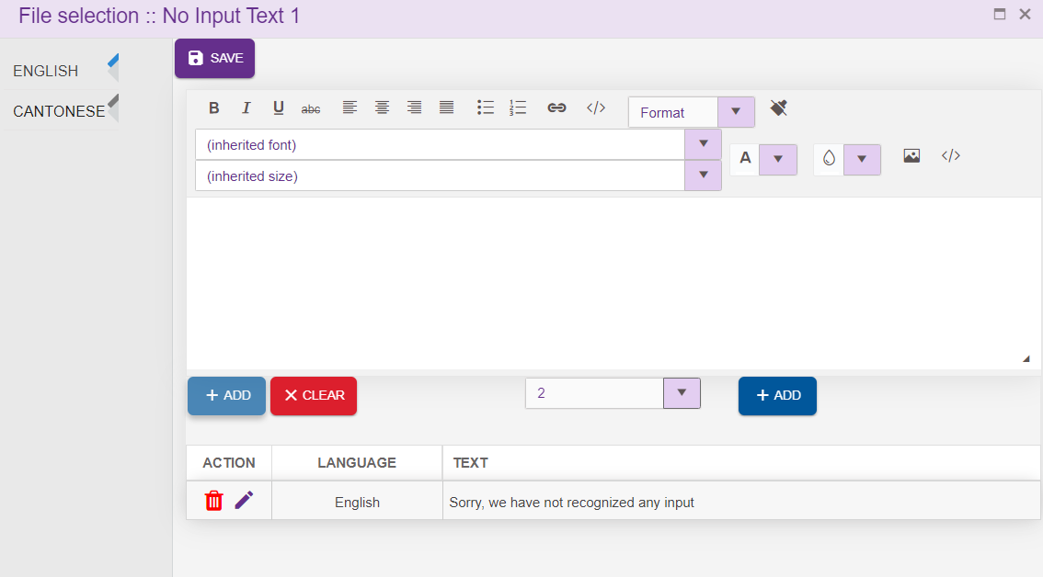

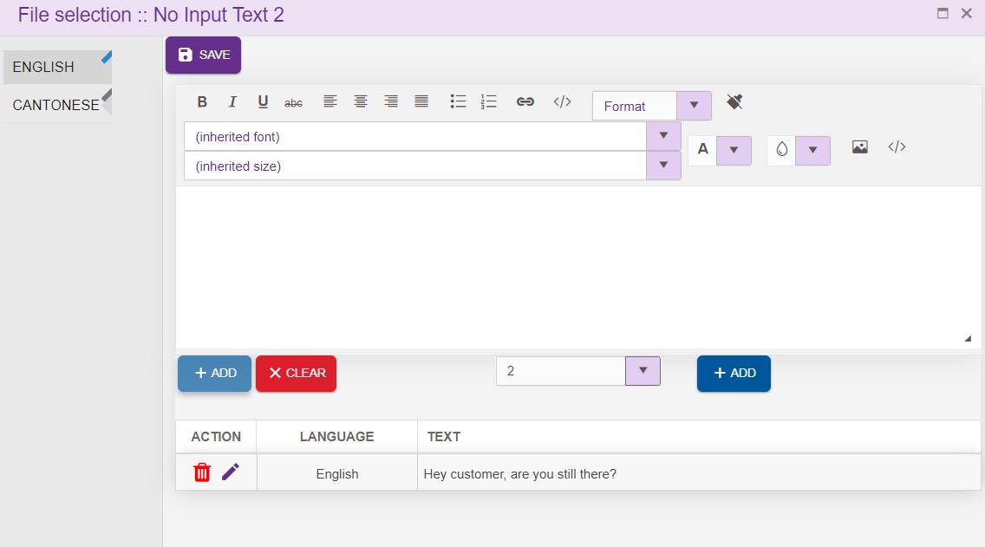

- Max Tries: Enter the text to be displayed when customer exceeds maximum try limits

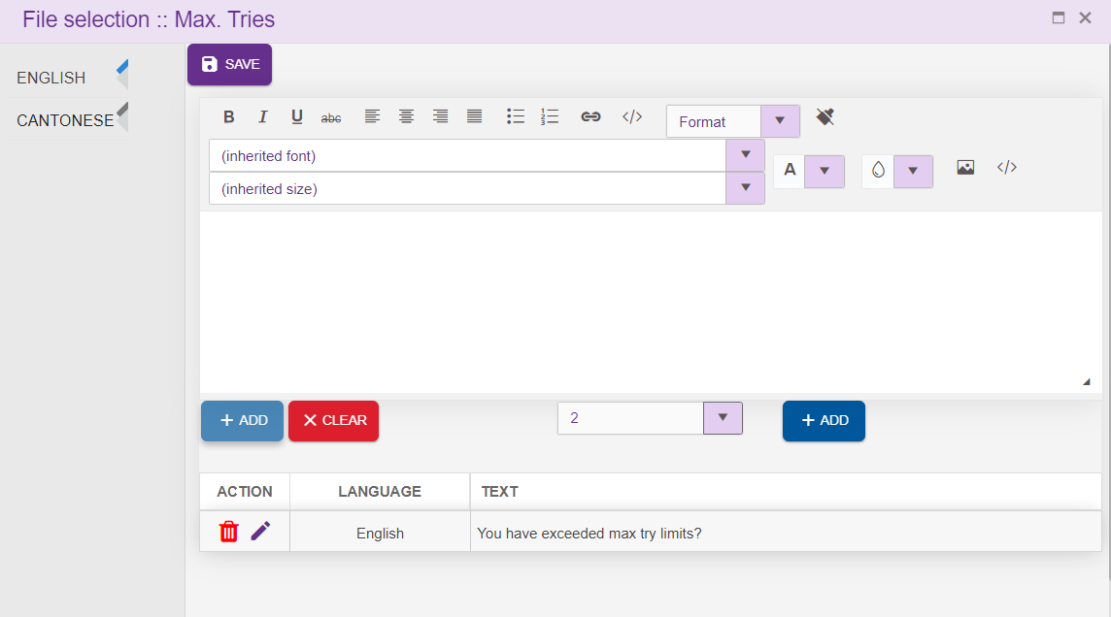

Step 2: Adding a new Menu (Level 2)
- For adding a new global Menu to the callflow, click on the “Menu” icon and drag it to the main screen.
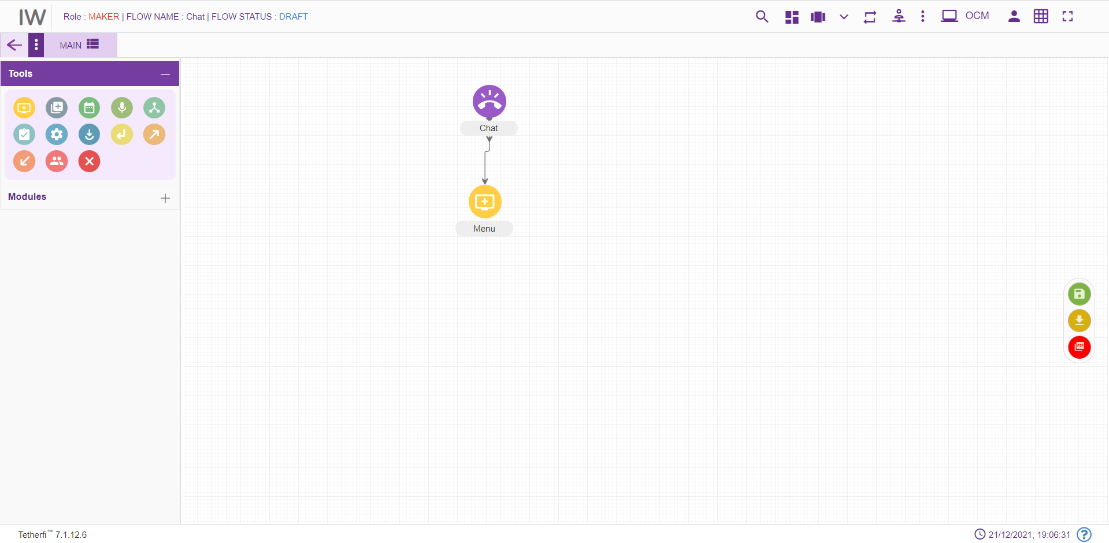
- For editing/ configuring the Menu, hover over the Menu icon you added and edit/ delete functionalities for the menu will be displayed.
- On click of edit button, the below screen will popup. Enter the details into the Menu details screen as shown below:
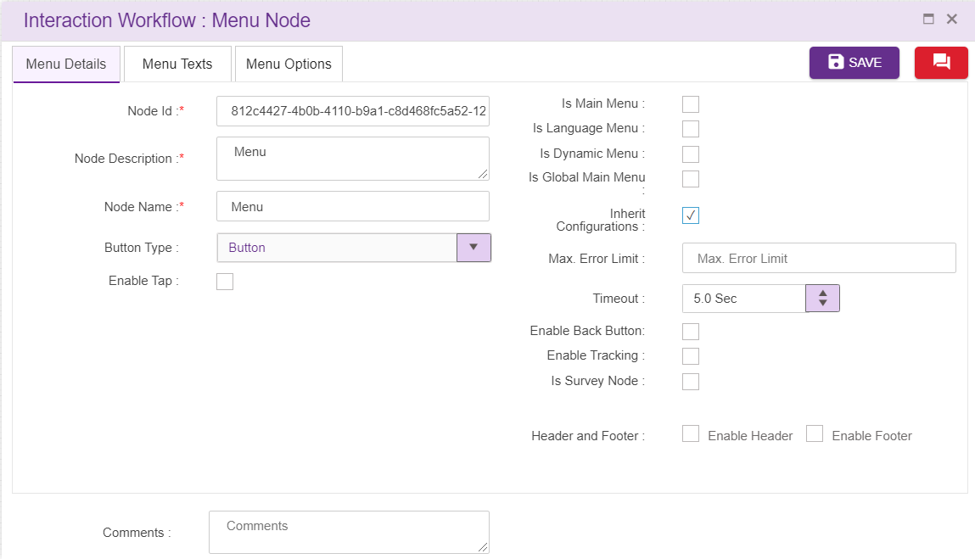
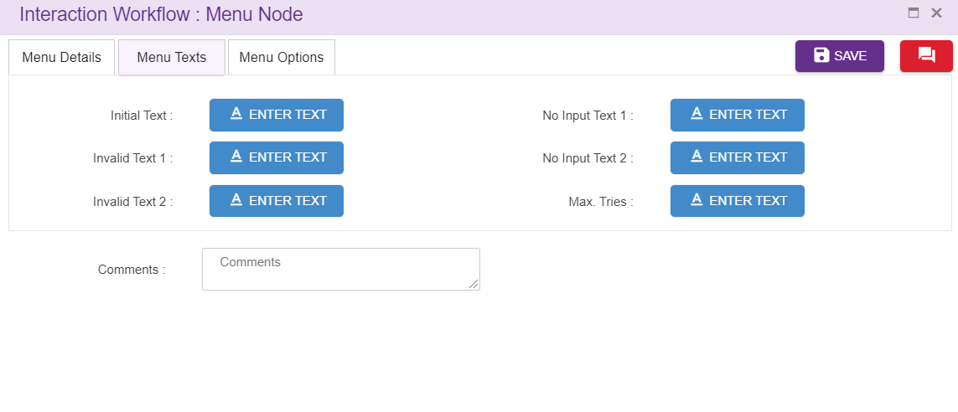
- Node ID: By default, the Node ID for a Menu is autogenerated, enter the Menu ID as GlobalMenu. (Mandatory)
- Name: By default, the Menu Name is Menu, enter the Menu Name as GlobalMenu. (Mandatory)
- Description: Enter brief characterization of the Menu as “global menu 2 option”. (Mandatory)
- Global: Whether the Menu is the global Menu of the callflow, click on the check box
- Initial text: Enter the text to be displayed initially as shown below:

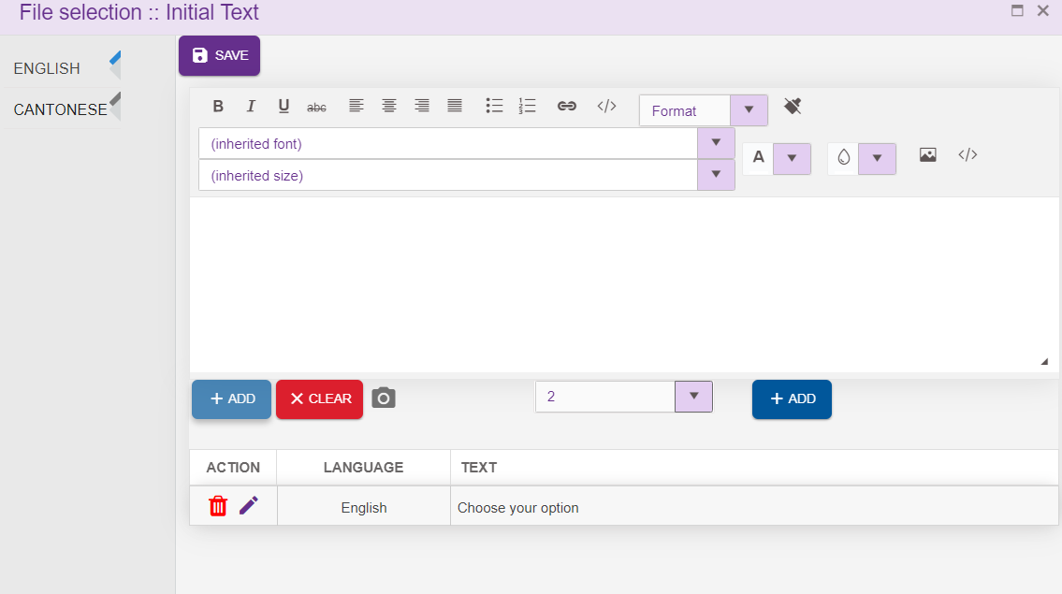

- Invalid Texts 1 and 2: Enter the text to be displayed on invalid prompt event as shown below:

- No Input Text 1 and 2: Enter the text to be displayed on no input prompt event as shown below

- Max Tries: Enter the text to be displayed when customer exceeds maximum try limits

Step 3: Adding a new Announcement, Agent (Level 3)
- For adding a new Agent to the callflow, click on the “Agent” icon and drag it to the main screen.
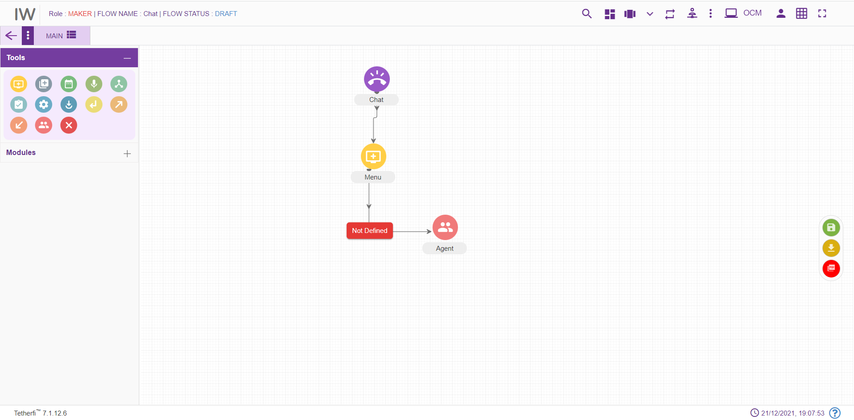
- For editing/ configuring the Agent, hover over the Agent icon you added and edit/ delete functionalities for the menu will be displayed.
- On click of edit button, the below screen will popup. Enter the details into the Agent screen as shown below:
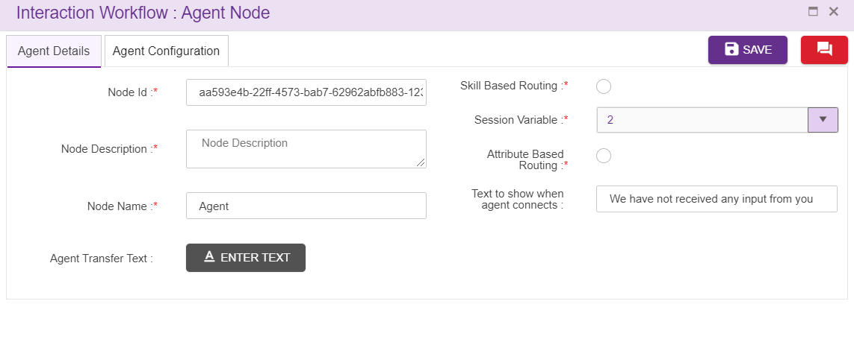
- Intent: Select the intent corresponding to the module or the intents shown in the auto populated dropdown. Note that the Intent should be unique.
- For adding a new announcement node to the callflow, click on the “announcement” icon and drag it to the main screen. 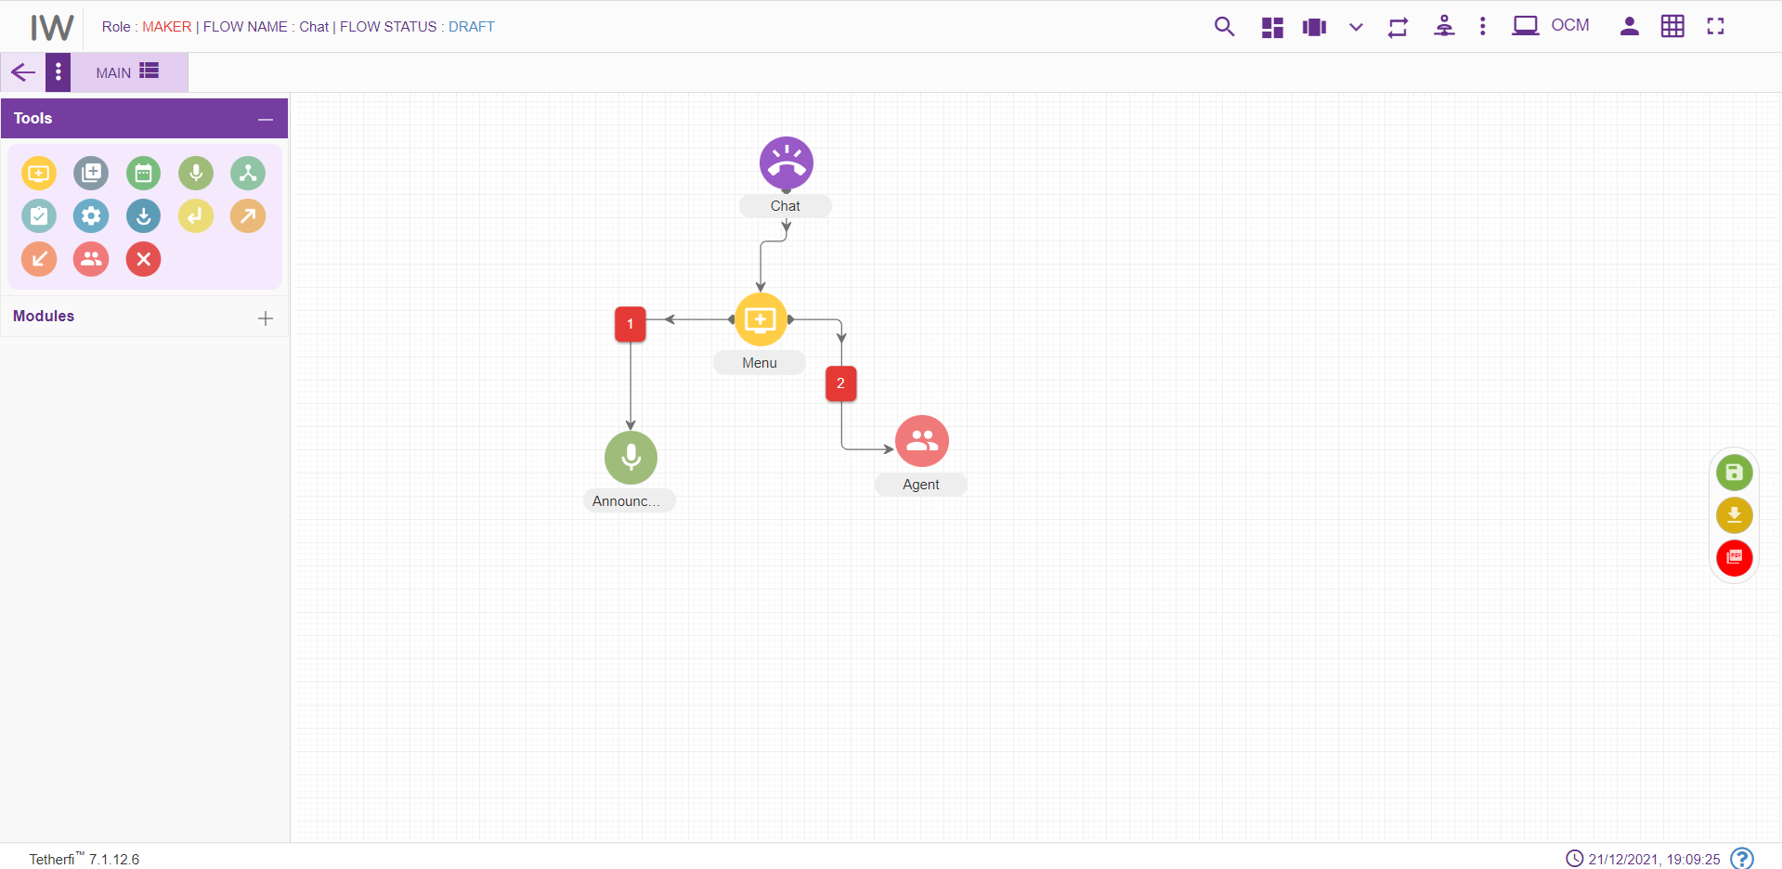
- For editing the announcement, hover over the Module icon you added and edit/ elete functionalities for the menu will be displayed.

- On click of edit button, announcement configuration details can be updated. Enter the details into the node screen as shown below:
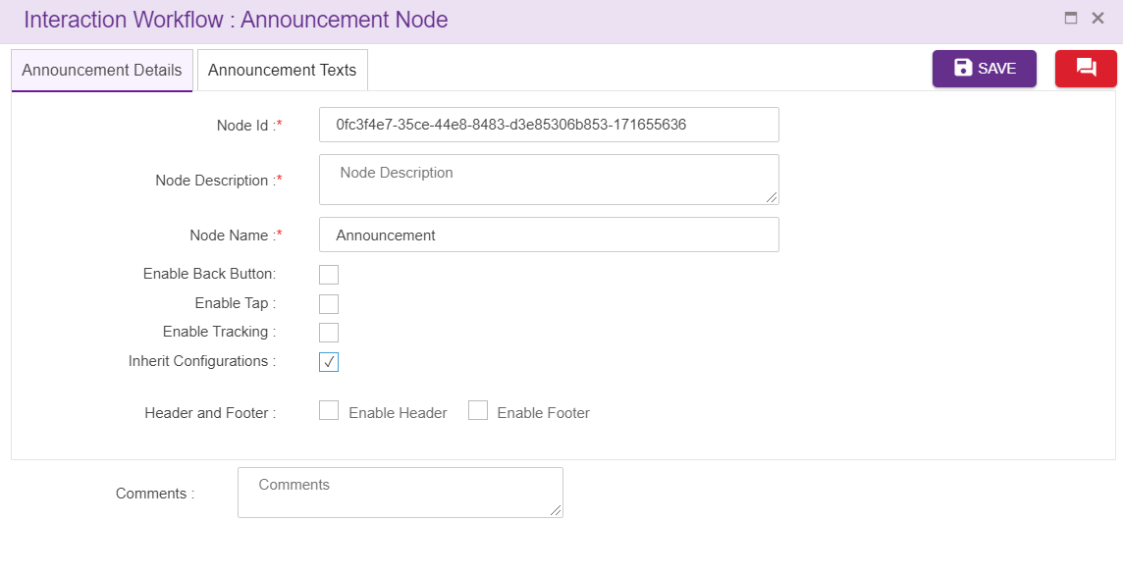
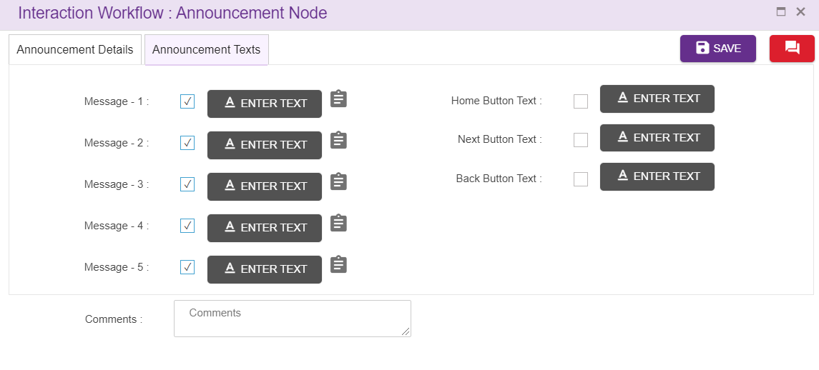

Step 4: Adding tab One Alongside Main tab
- For adding a new tab alongside the Main tab, click on the “Add New Tab” icon present on the top left corner of the main screen.

- On click of the “Add New Tab” button a new popup will be displayed. Enter the details into the Tab details screen:

Step 5: Adding a new Entry Point to Tab One
- For adding an Entry point to tab ONE, click on the “Entry point” icon and drag it to the Tab ONE screen.
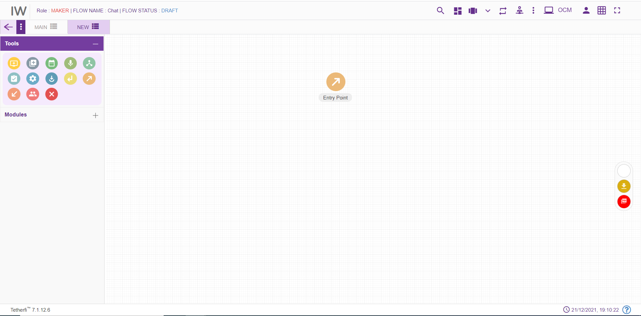
- For editing/ configuring the Entry point, hover over the Entry point icon you added and edit/ delete/ view connections functionalities for the menu will be displayed.
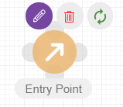
- On click of edit button, the below screen will popup wherein you need to specify the name of the Entry Point. Enter the details into the Entry Point details screen as shown below:
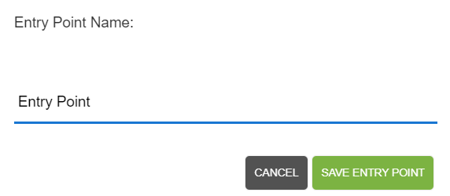

- For adding a new Continue Menu to the callflow, click on the “Menu” icon and drag it to the main screen. 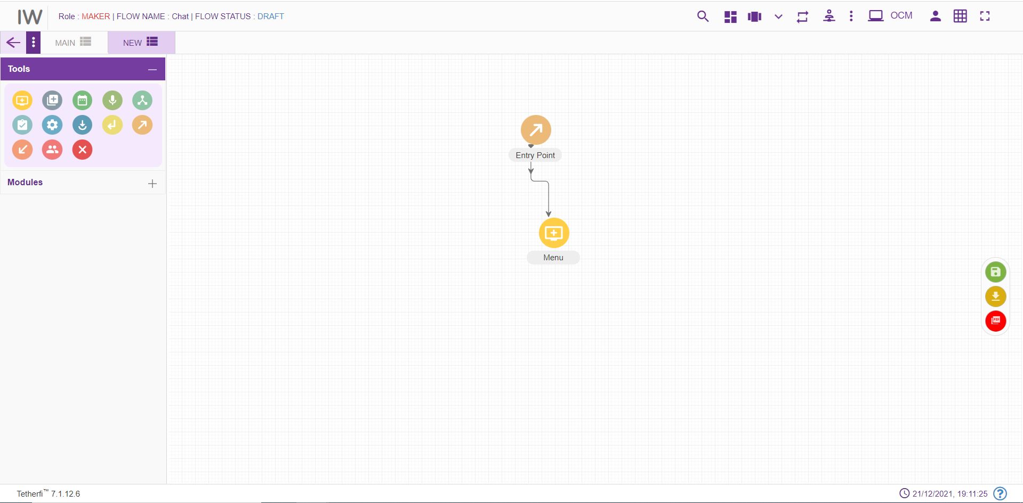
- For editing/ configuring the Menu, hover over the Menu icon you added and edit/ delete functionalities for the menu will be displayed.
- On click of edit button, the below screen will popup. Enter the details into the Menu details screen:

Step 6: Adding an Exit points (Level 4)
- For adding a “continue” Exit point to Main tab, click on the “Exit point” icon and drag it to the Tab Main screen.
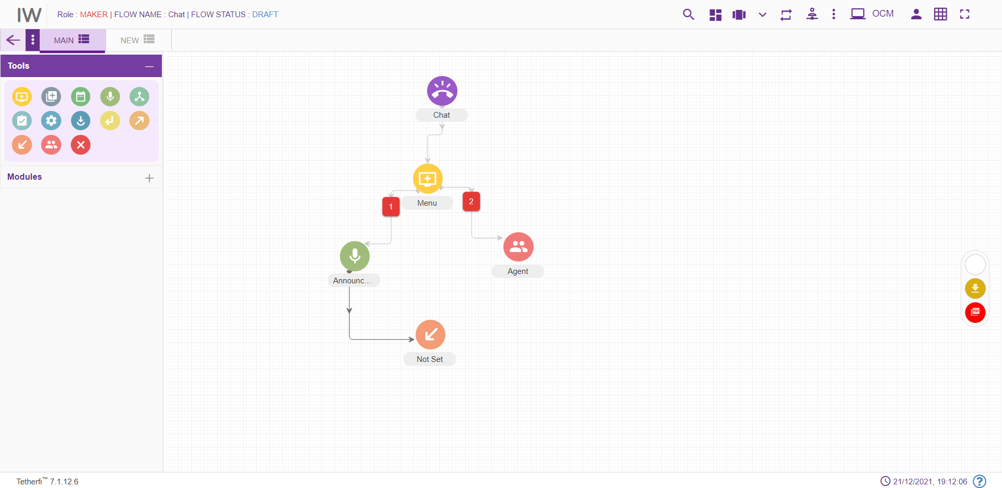
- For editing/ configuring the Exit point, hover over the Exit point icon you added and edit/ delete functionalities for the menu will be displayed.
- On click of edit button, the below screen will popup wherein you need to configure the Entry point for the selected Exit point. Enter the details into the Menu details screen as shown below:
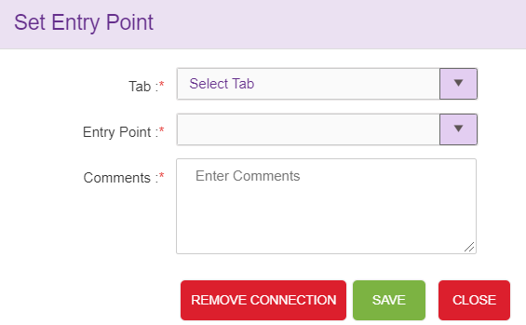

Step 7: Connecting Nodes and Modules
- For interconnecting two or more Nodes/ Modules, you need drag the connecting link as shown below:
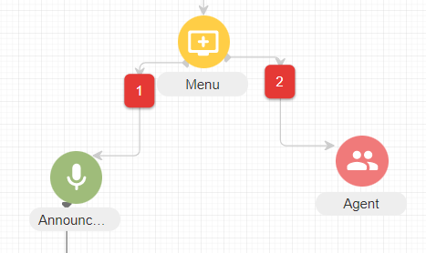
- For deleting a node, double click on the connecting and the below screen will be displayed:
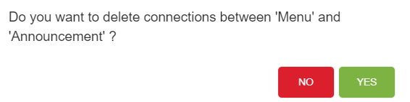

Step 9: Approval of Workflow
- After Maker is done with creating and configuring a workflow, the workflow needs to be sent to Checker for approval. The Maker can do this by clicking on the “Send for Approval” button present on the top right corner of the screen.
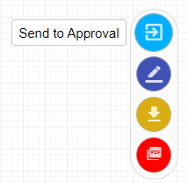
- The checker needs to select the corresponding callflow from the list of callflows, analyze the callflow and depending upon the analysis determine whether the callflow is to be approved or rejected.
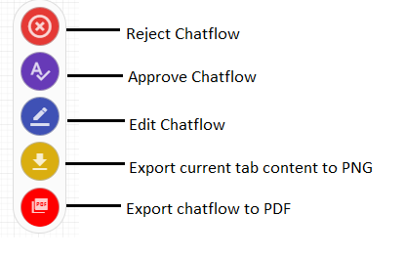
- On click of approve button, the below screen will be displayed
- For approving the workflow, providing comment for the approval is mandatory.
- Can also schedule the approval as shown below. Providing comment for the scheduling is also mandatory.

