ADD AND MANAGE THE VXML ERROR HANDLERS IN MPP
Author: Rakshith Shetty
Approver: Vinoth Raj
Date: 09-May-2019

Issue:
When the MPP could not hit the Web Application Server(WAS) to fetch the VoiceXML files from IVR results in technical error message to the caller.

Description:
The Incoming calls to the Contact Centre (CC) will be routed to the Avaya Experience Portal (AEP) and then through the configured Media Processing Platform (MPP) to handle the call session. The MPP will request to the IVR application deployed in the Web Application Server (WAS) and in return the IVR respond to the MPP with specified VXML file.
In certain scenarios like network connectivity glitch or issue in server performance, the MPP’s request not able to reach to WAS server and results in the request time out error or 905 bad fetch error in case of VXML format error which triggers the technical difficulty message.
We can handle such MPP errors by adding the error event handlers VXML in the MPP event handlers. When the call session receives this kind of error MPP will call the specified error handler and executes the VXML to handle the calls (action like transfer to agent after announcement , play some announcements or provide menu option along with dtmf inputs etc.)

Method to Add/Manage the error VXMLs
- There will be two type of files for the error handler
- vxml_errorhandler_***.vxml
- ***_FailoverFlow.vxml
Initially login to EPM and open “EPM Servers” section on the left hand side
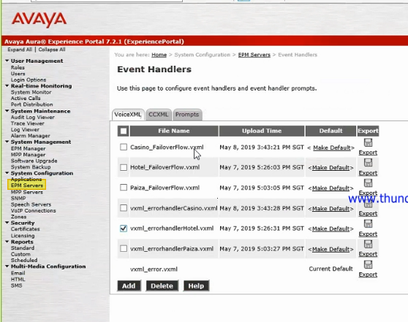

- In order to add both files on the VoiceXML tab click on Add. Then pick the vxml handler files click ‘Install’.
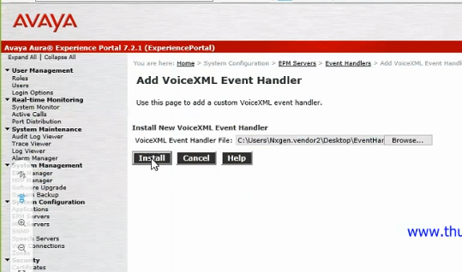

- You can verify the updated file based on the upload time on the table or you can use the export function provided.
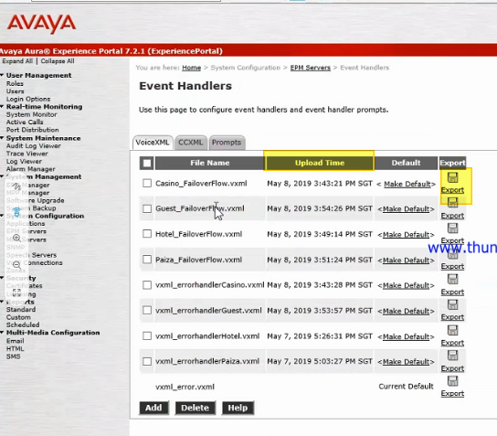
- If you want play any announcement in this scenario then mention the phrase in ***_FailoverFlow.vxml under the prompt tag (Note: make sure the audio file name in the flow file is given same as the audio file )
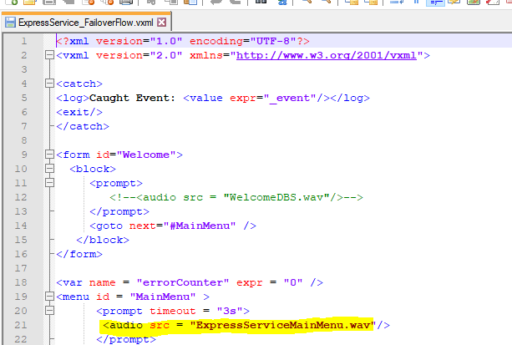

- Upload the phrase files to MPP prompt list in ‘Event Handler’ page. Navigate to the Event Handlers->prompt tab. Choose the phrase file and upload.
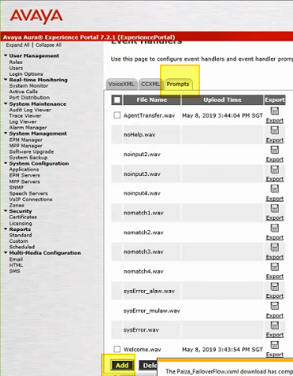

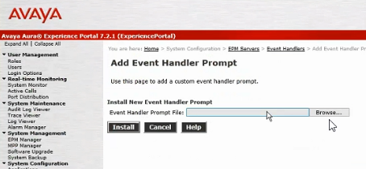

- Map the VoiceXML error handler to the application : navigate to the System Configuration -> Applications on the left pane of EPM. Click on the application from the list and find the ‘Advance Parameters’
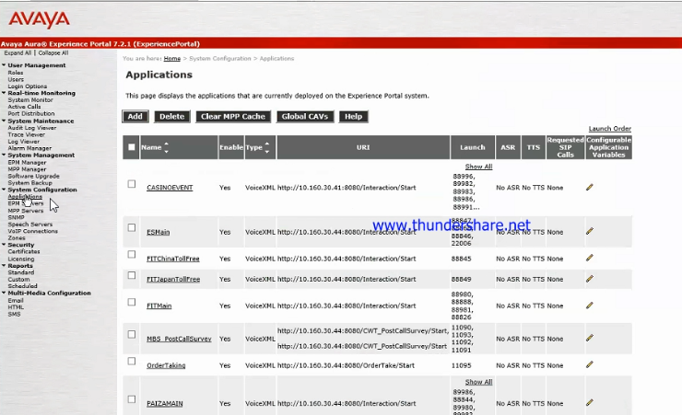

In the VoiceXML Event Handler choose the corresponding VXML file from the drop down and save (Note: Choose the corresponding vxml_errorhandler_***.vxml from the drop down list)

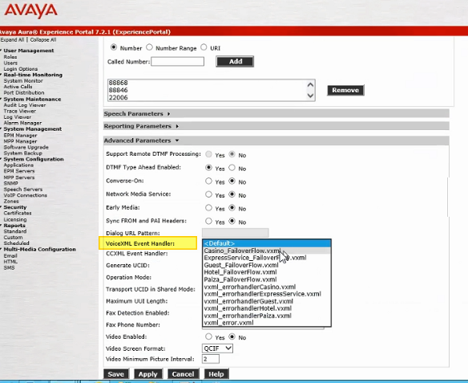
-------------------------------------- End of the Document --------------------------------------------------------------

